Table of Contents

# Sensitivity Analysis

## Sensitivity Analysis for Raltegravir 10 mg (lactose formulation)

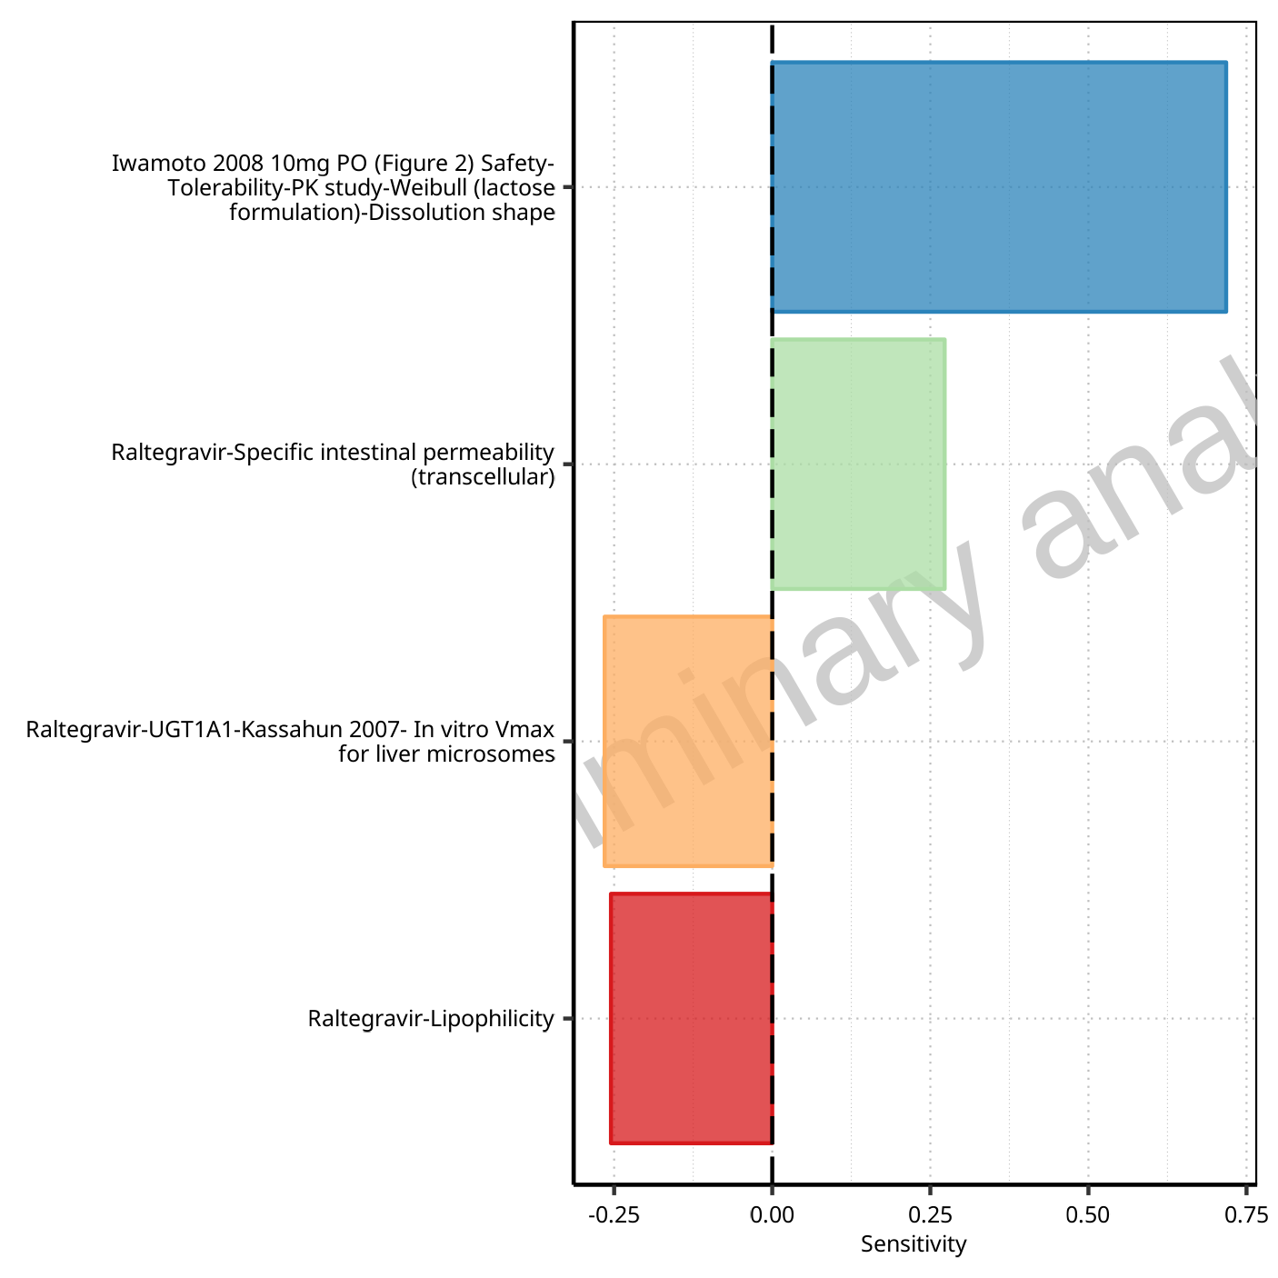

**Figure 1-1: Most sensitive parameters for C_max of Raltegravir.**

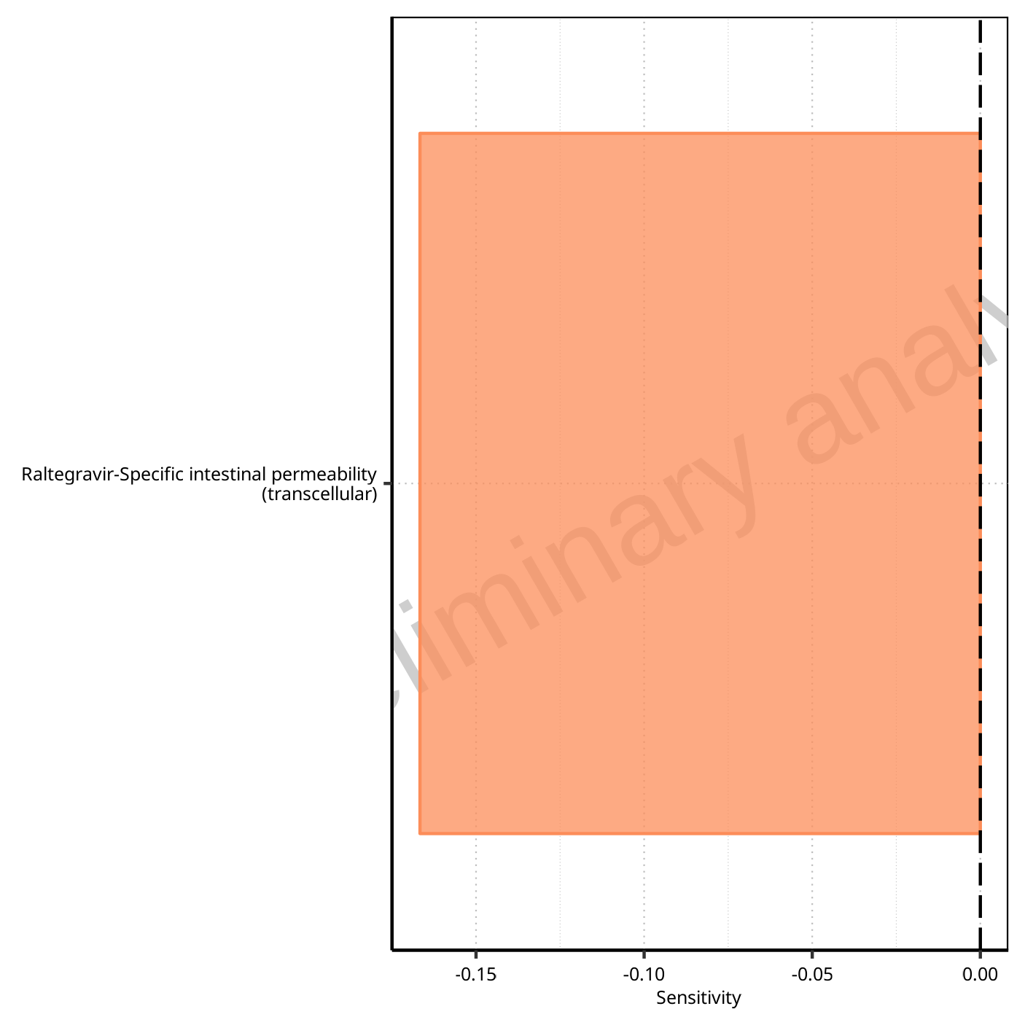

**Figure 1-2: Most sensitive parameters for t_max of Raltegravir.**

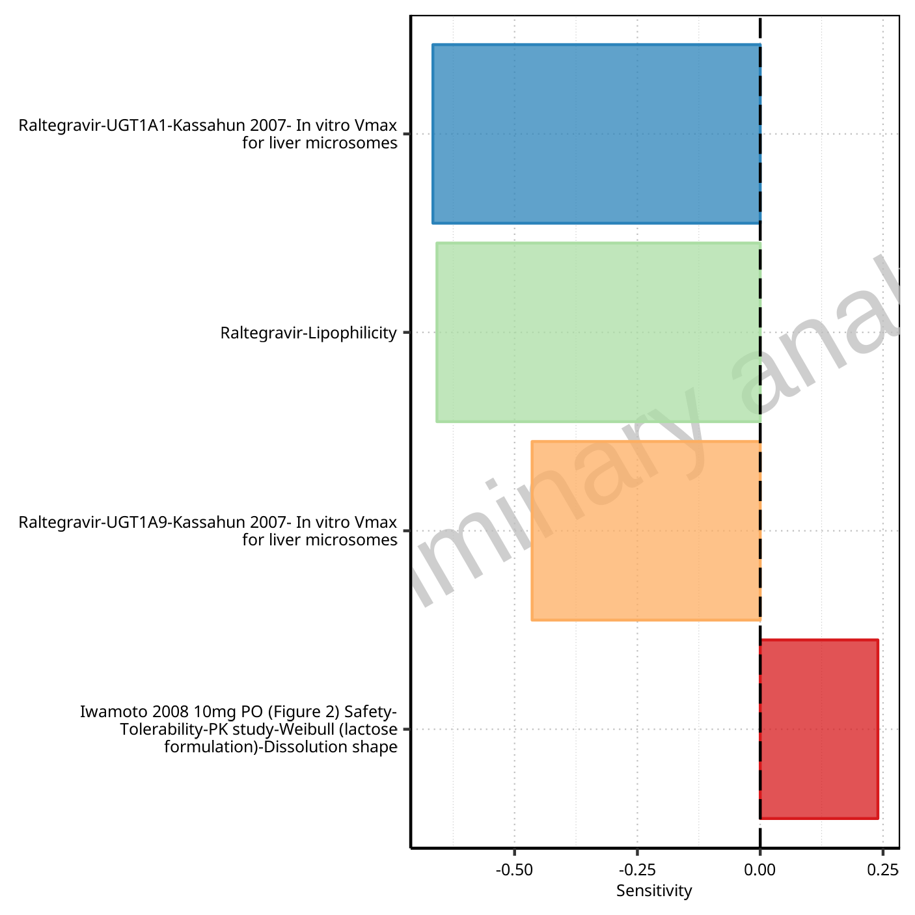

**Figure 1-3: Most sensitive parameters for C_tEnd of Raltegravir.**

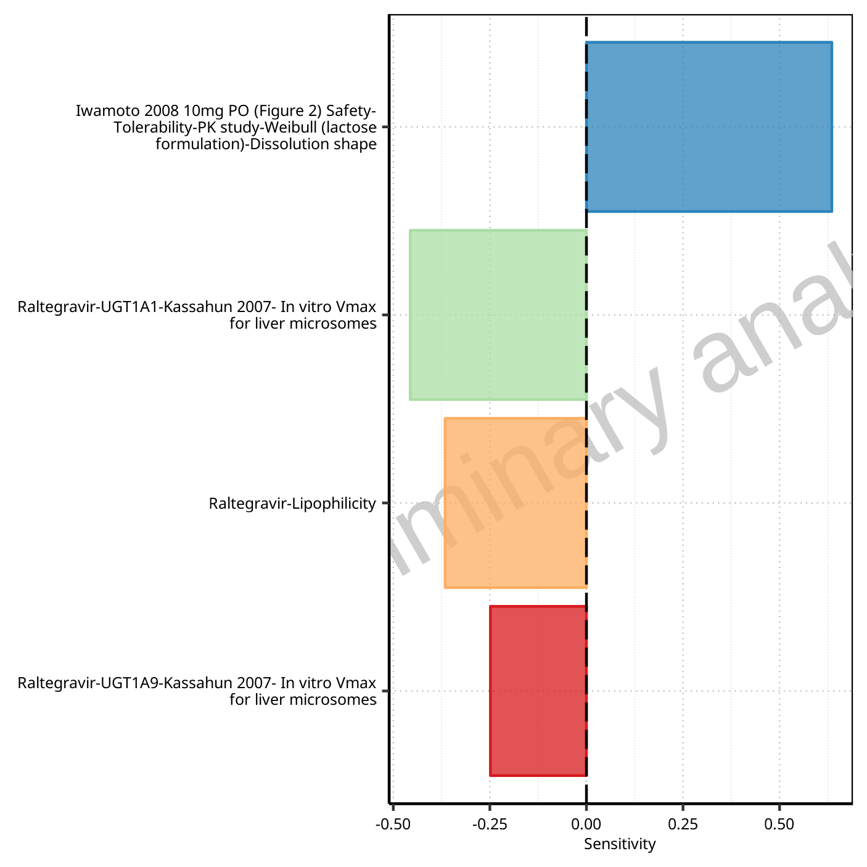

**Figure 1-4: Most sensitive parameters for AUC of Raltegravir.**

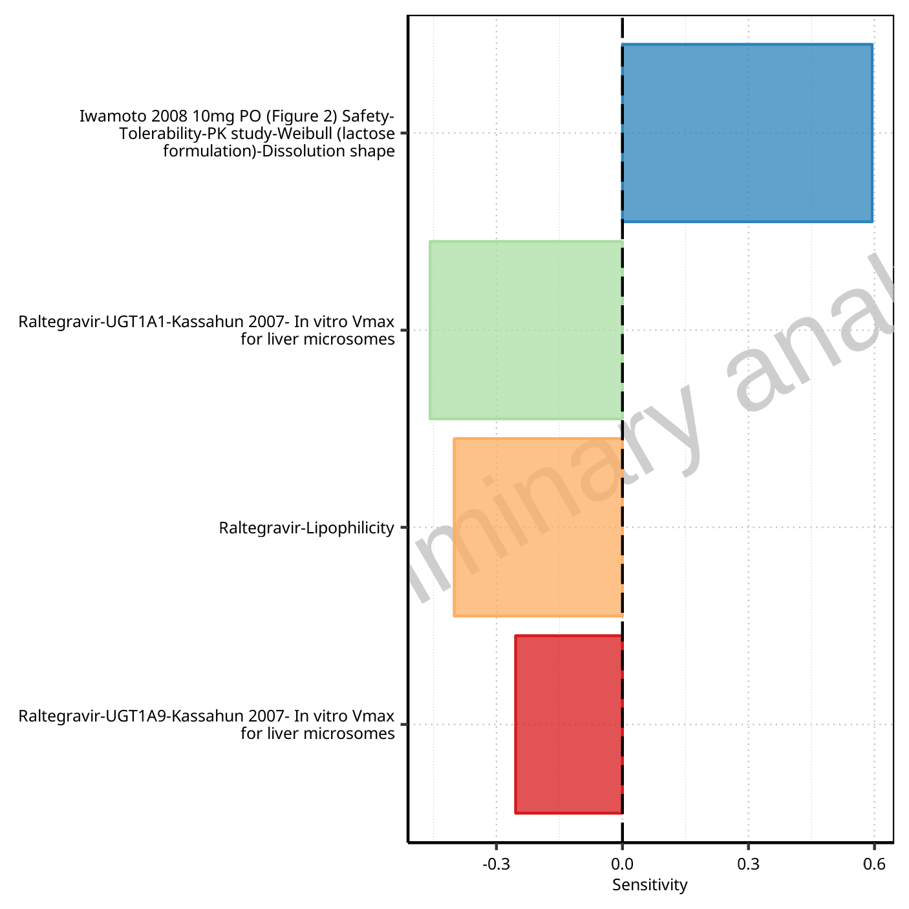

**Figure 1-5: Most sensitive parameters for AUC_inf of Raltegravir.**

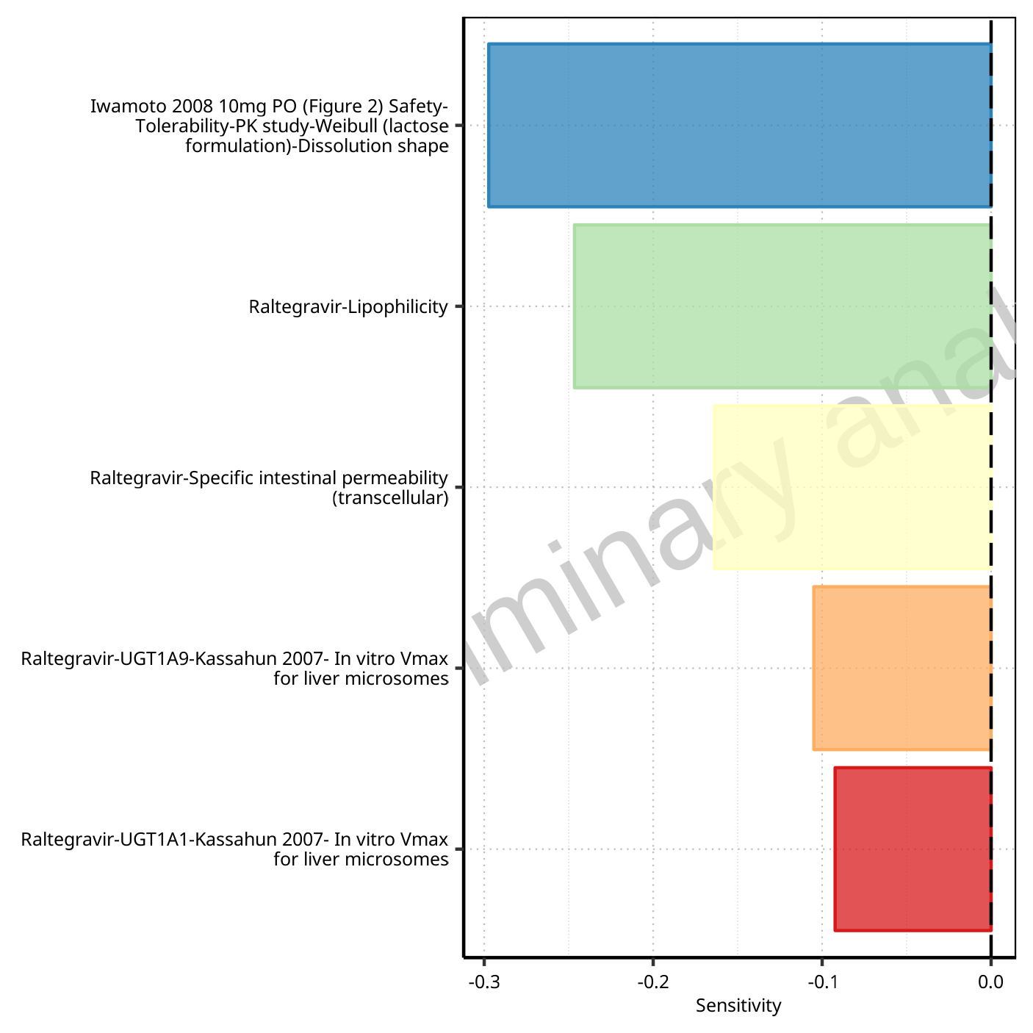

**Figure 1-6: Most sensitive parameters for MRT of Raltegravir.**

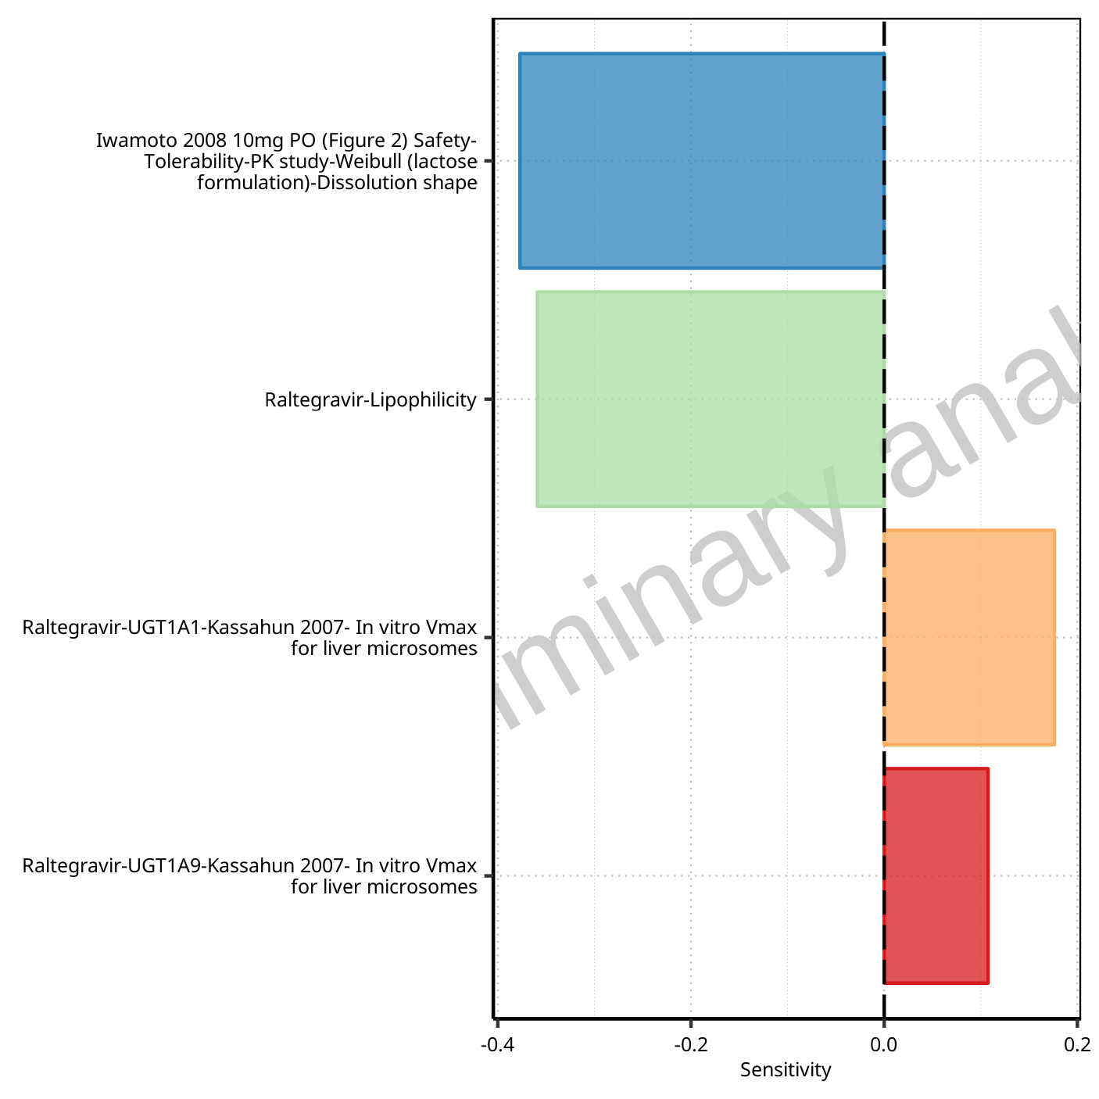

**Figure 1-7: Most sensitive parameters for Thalf of Raltegravir.**

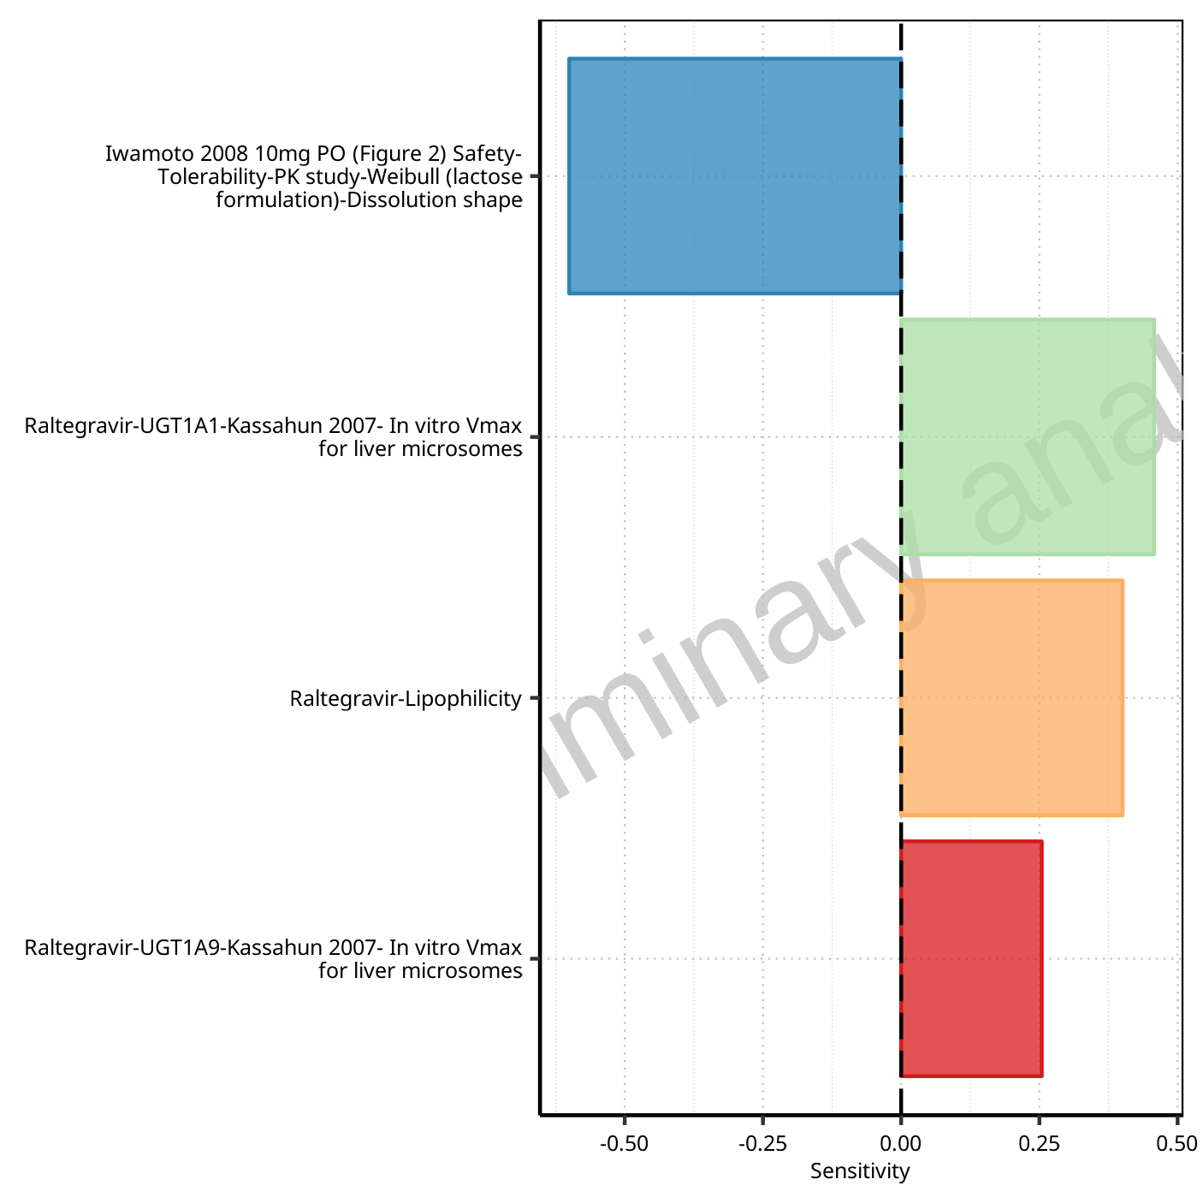

**Figure 1-8: Most sensitive parameters for CL of Raltegravir.**

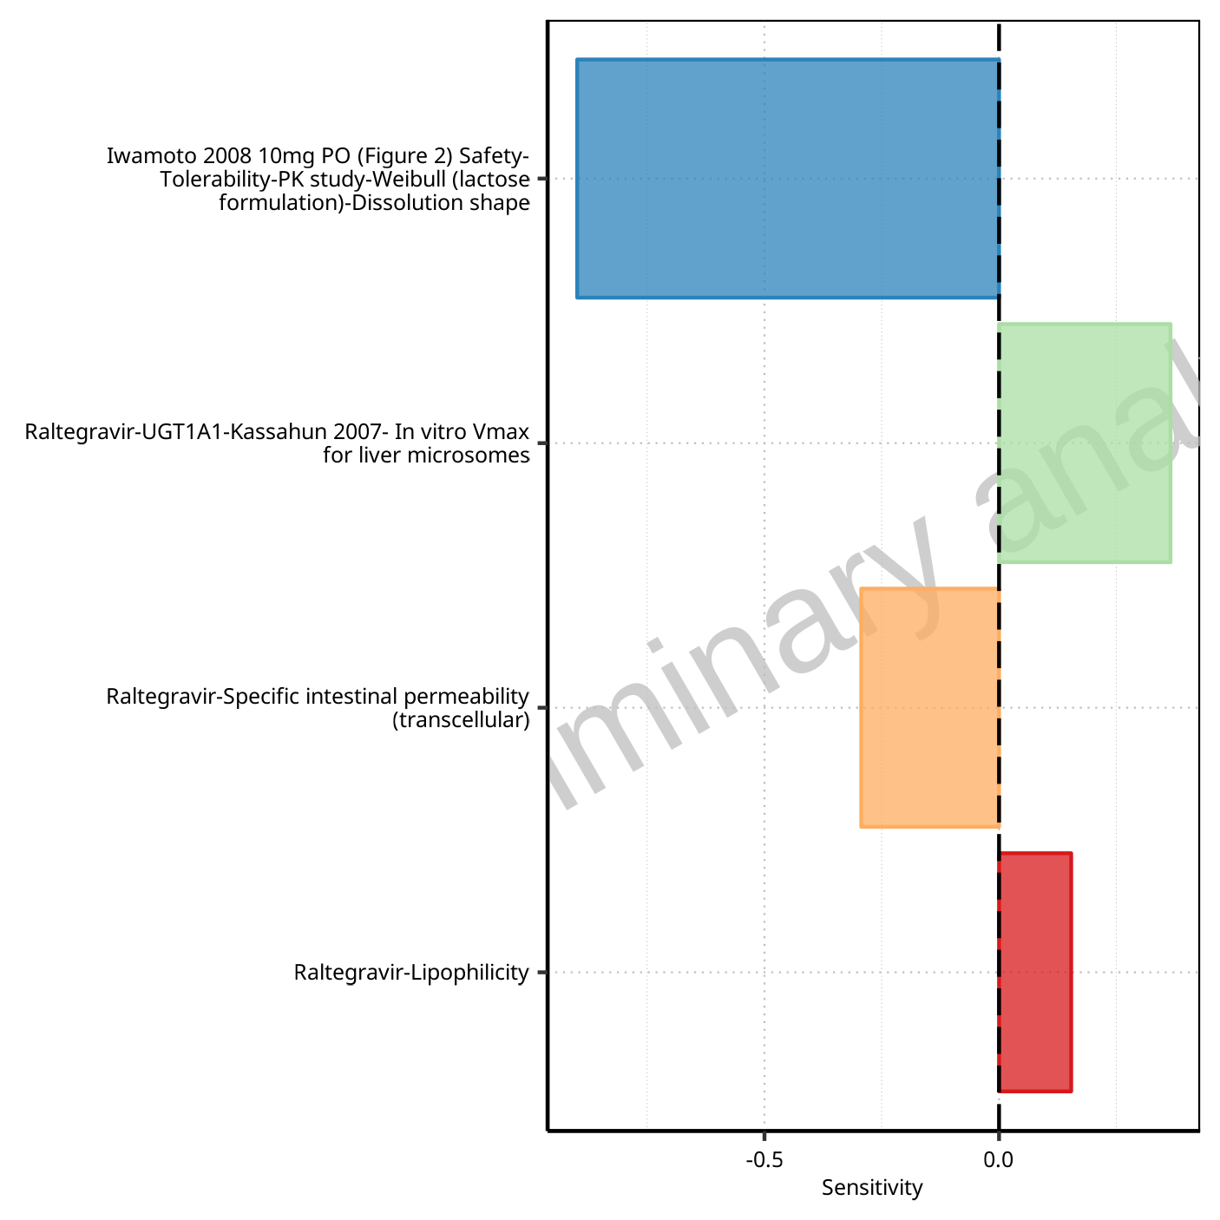

**Figure 1-9: Most sensitive parameters for Vss of Raltegravir.**

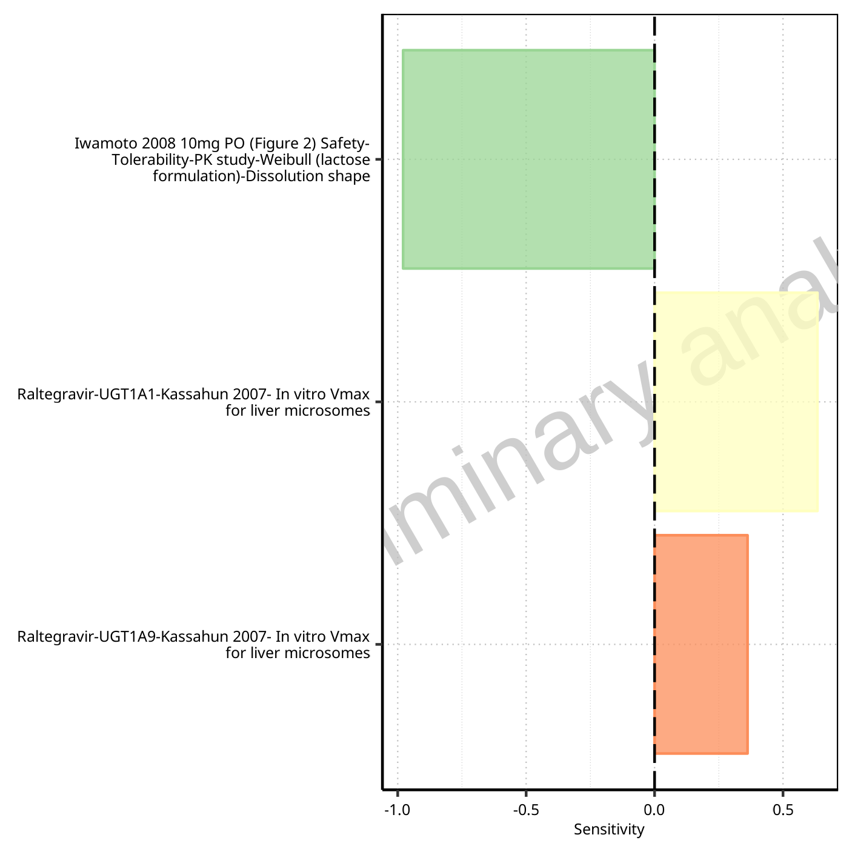

**Figure 1-10: Most sensitive parameters for Vd of Raltegravir.**

## Sensitivity Analysis for Raltegravir 25 mg (lactose formulation)

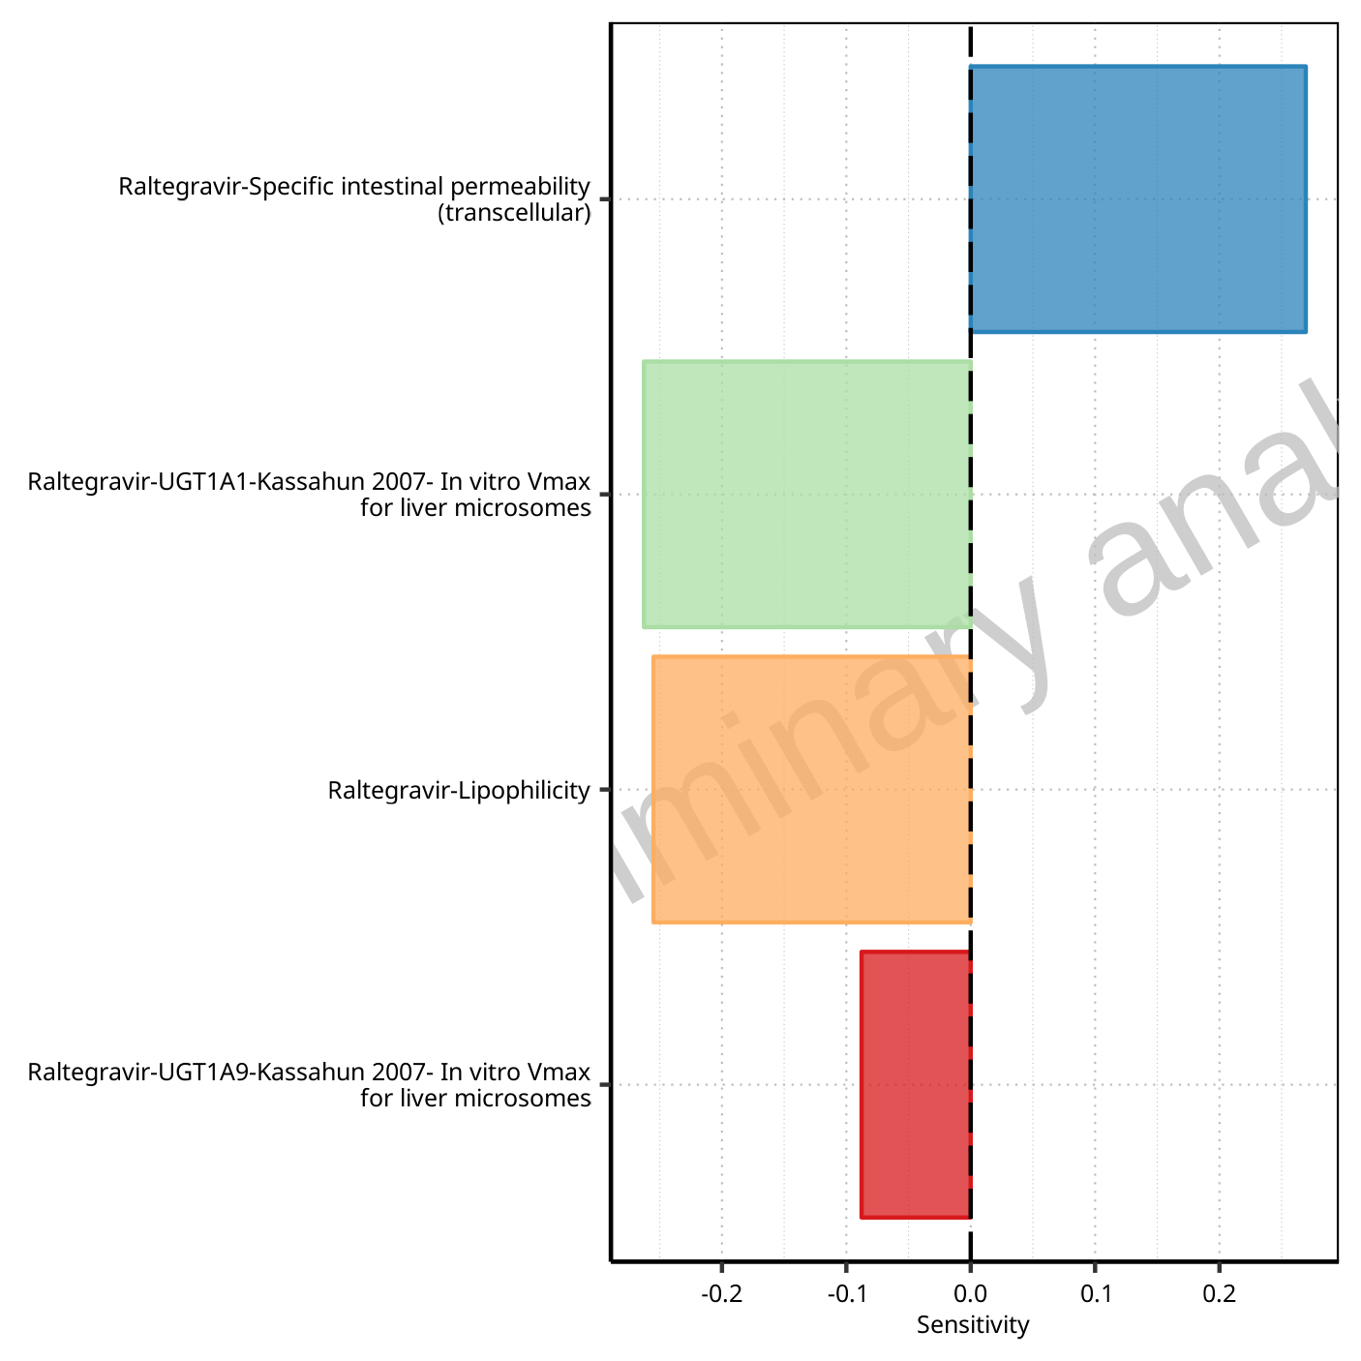

**Figure 1-11: Most sensitive parameters for C_max of Raltegravir.**



**Figure 1-12: Most sensitive parameters for t_max of Raltegravir.**

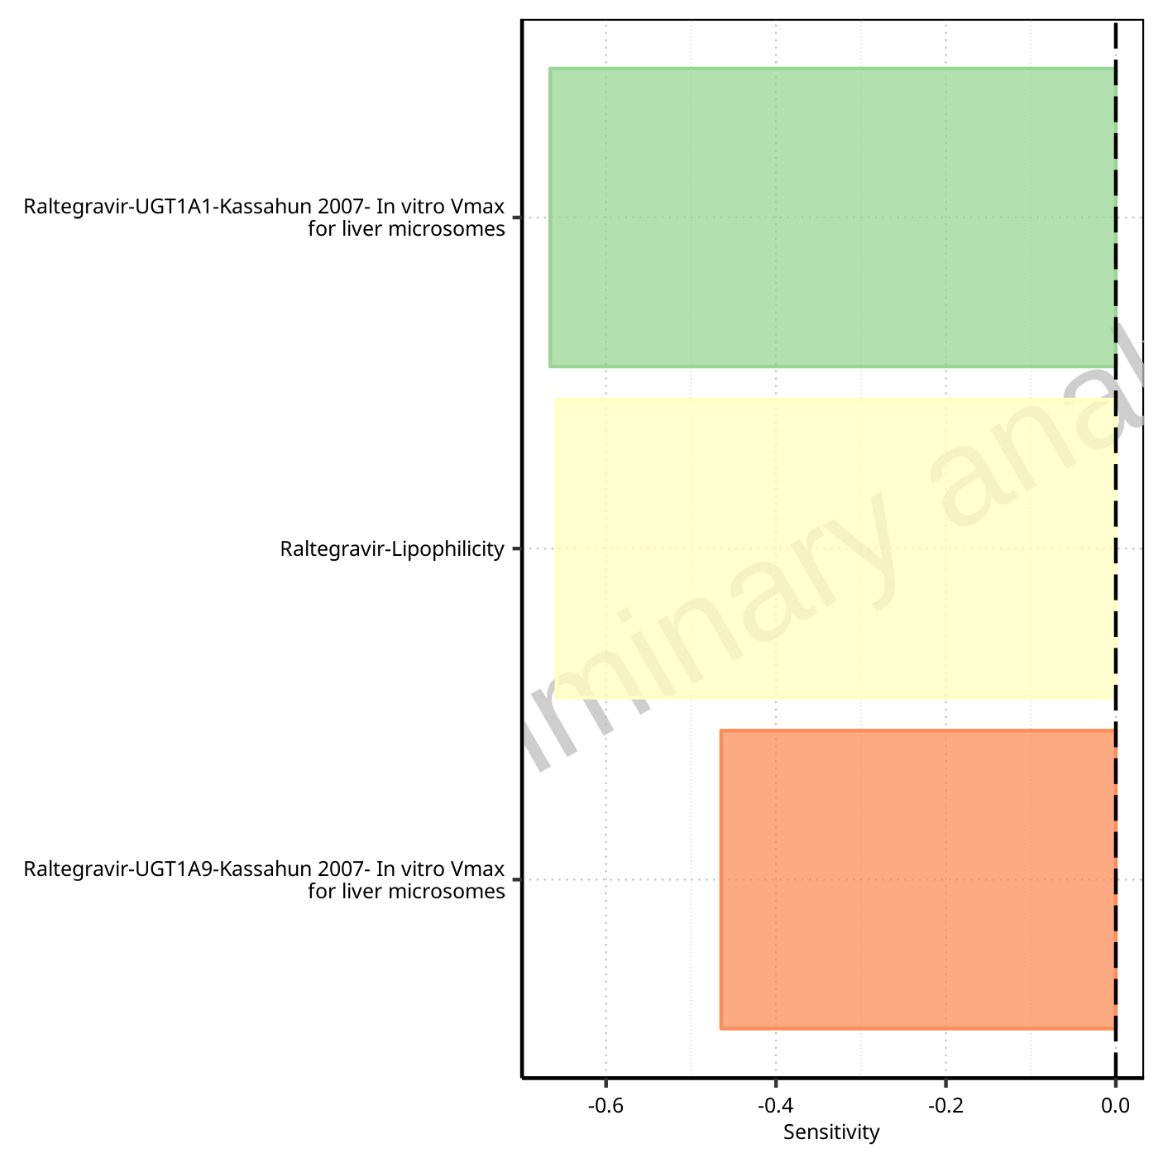

**Figure 1-13: Most sensitive parameters for C_tEnd of Raltegravir.**

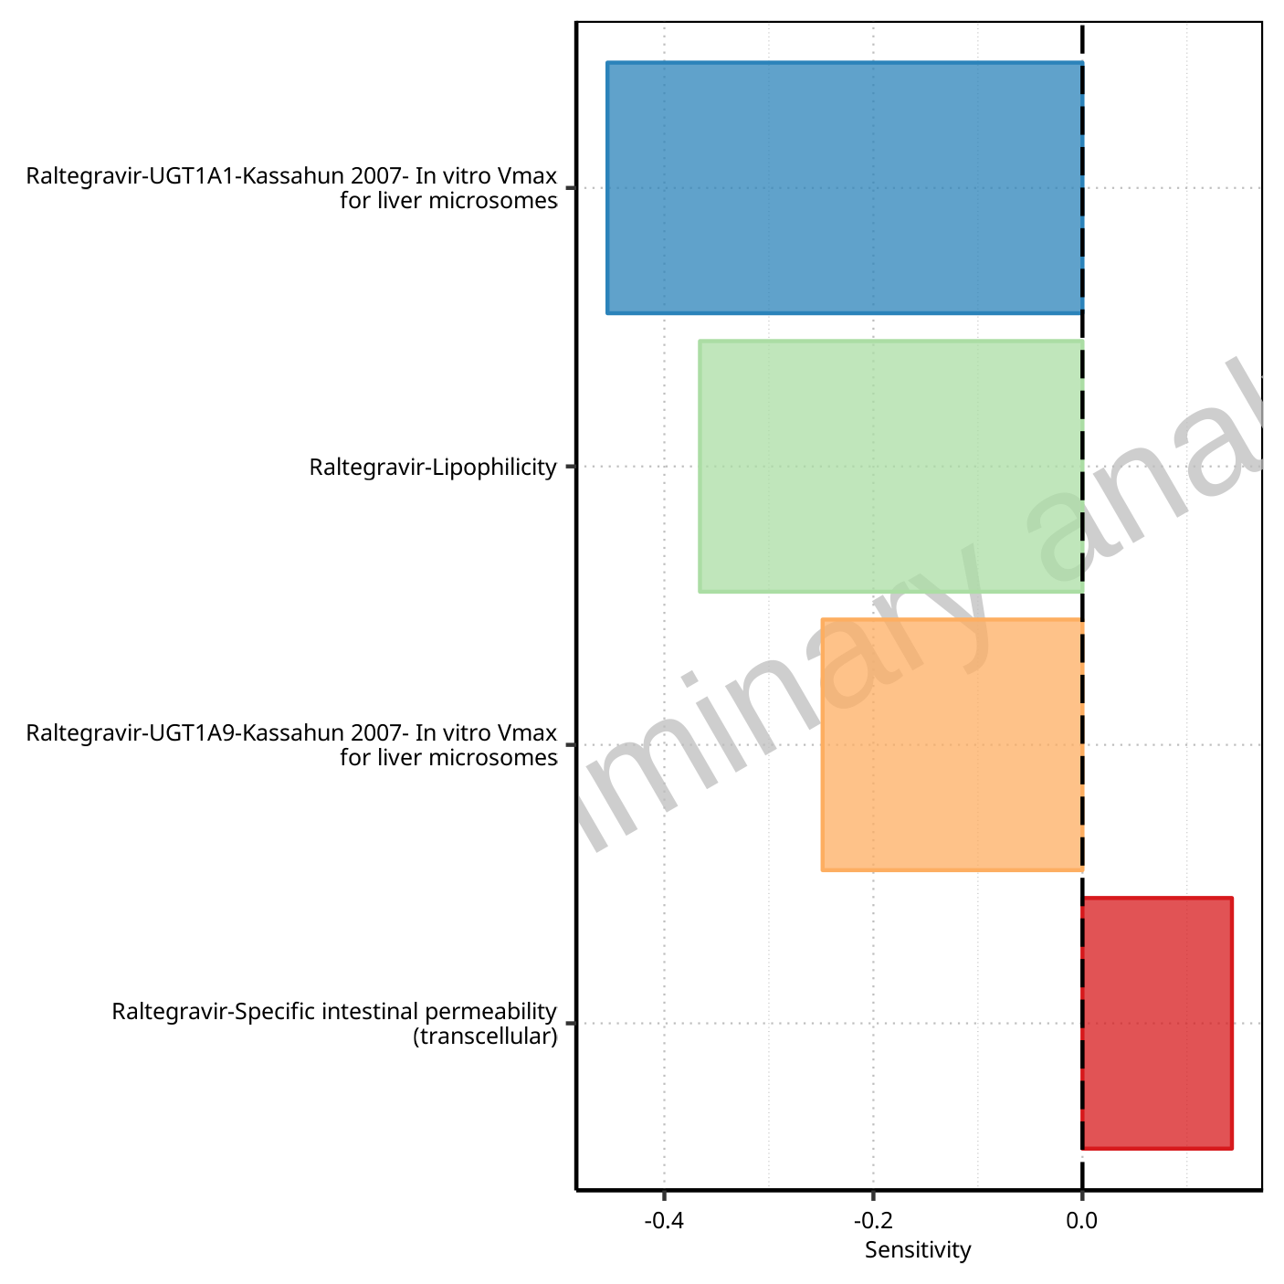

**Figure 1-14: Most sensitive parameters for AUC of Raltegravir.**

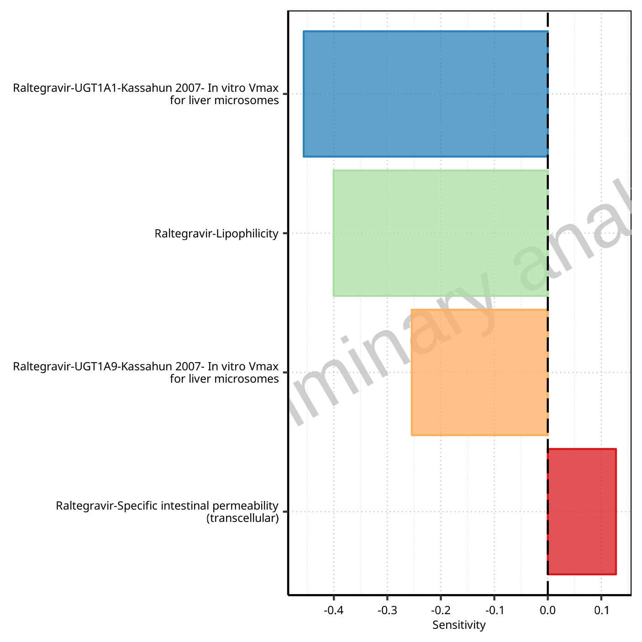

**Figure 1-15: Most sensitive parameters for AUC_inf of Raltegravir.**

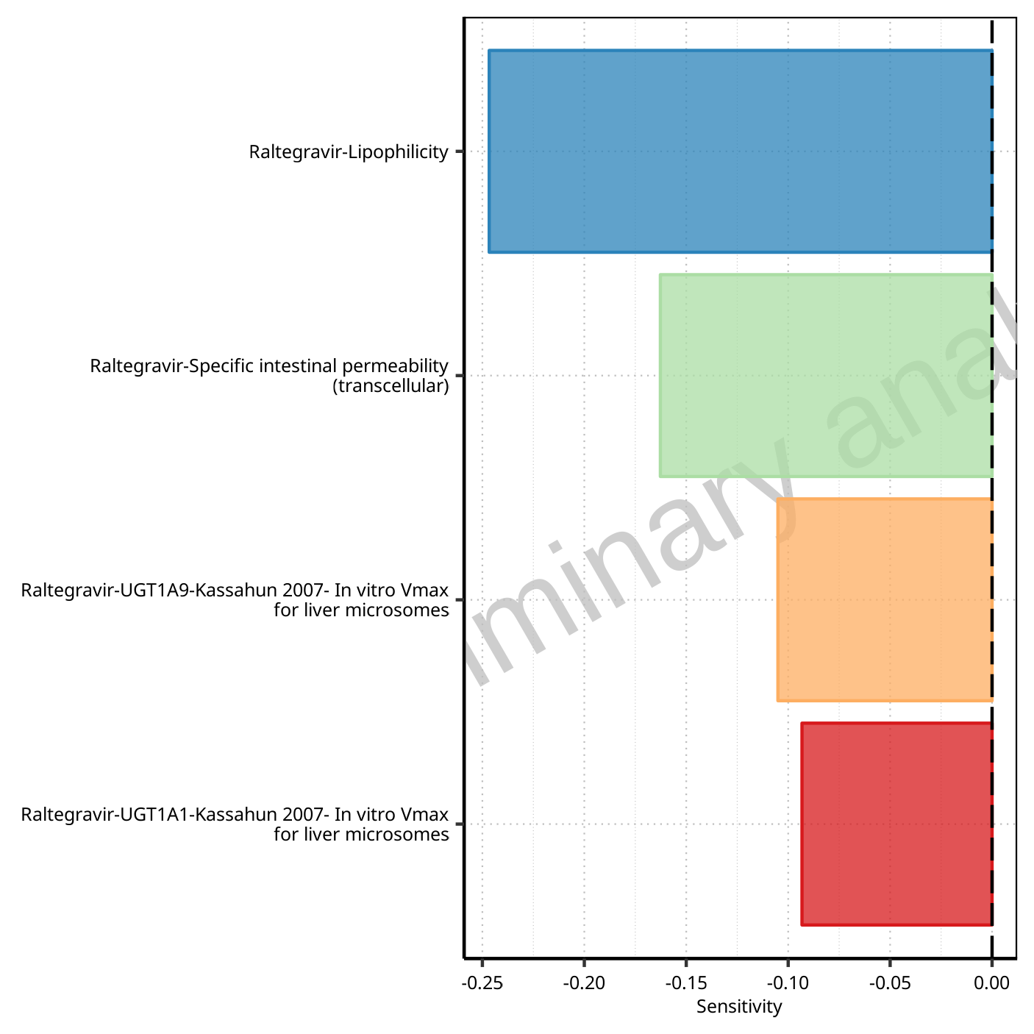

**Figure 1-16: Most sensitive parameters for MRT of Raltegravir.**

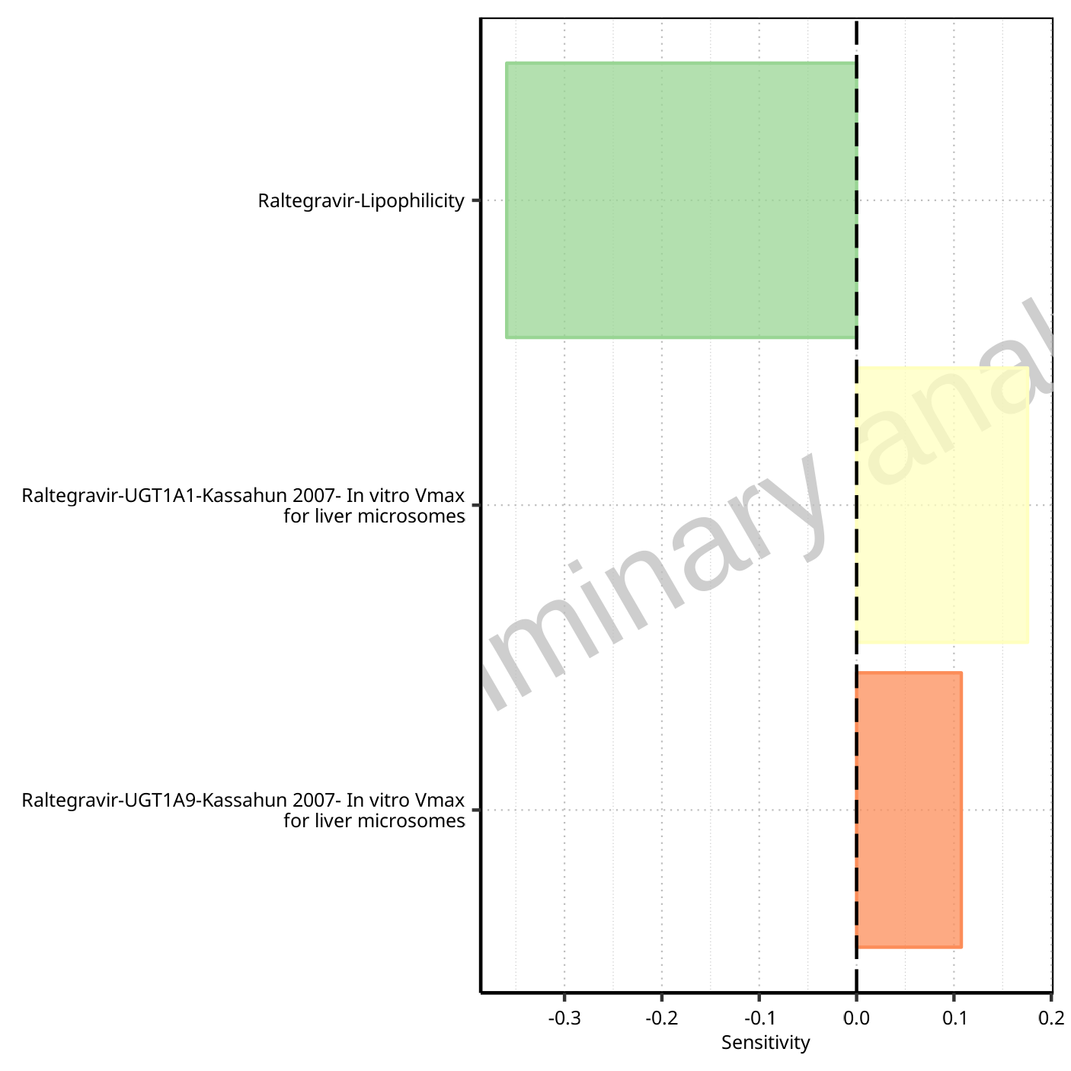

**Figure 1-17: Most sensitive parameters for Thalf of Raltegravir.**

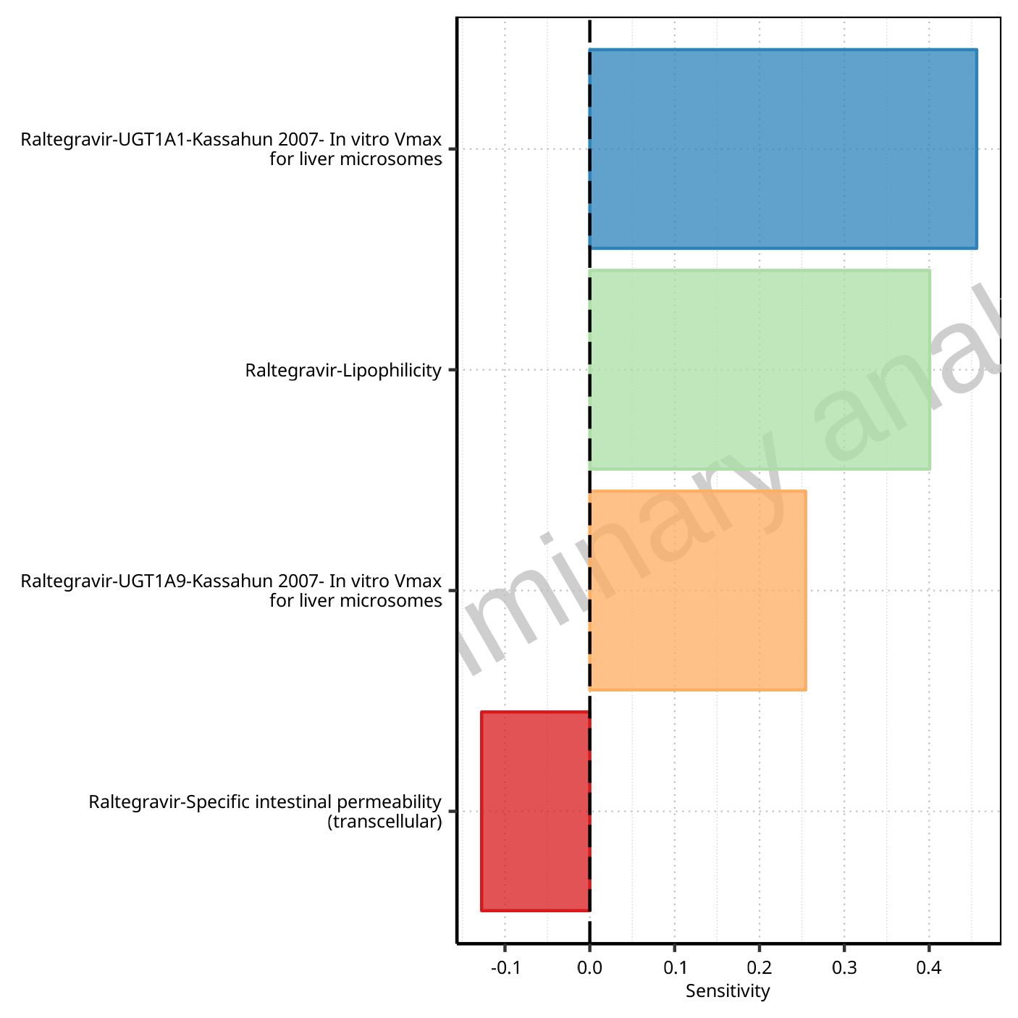

**Figure 1-18: Most sensitive parameters for CL of Raltegravir.**

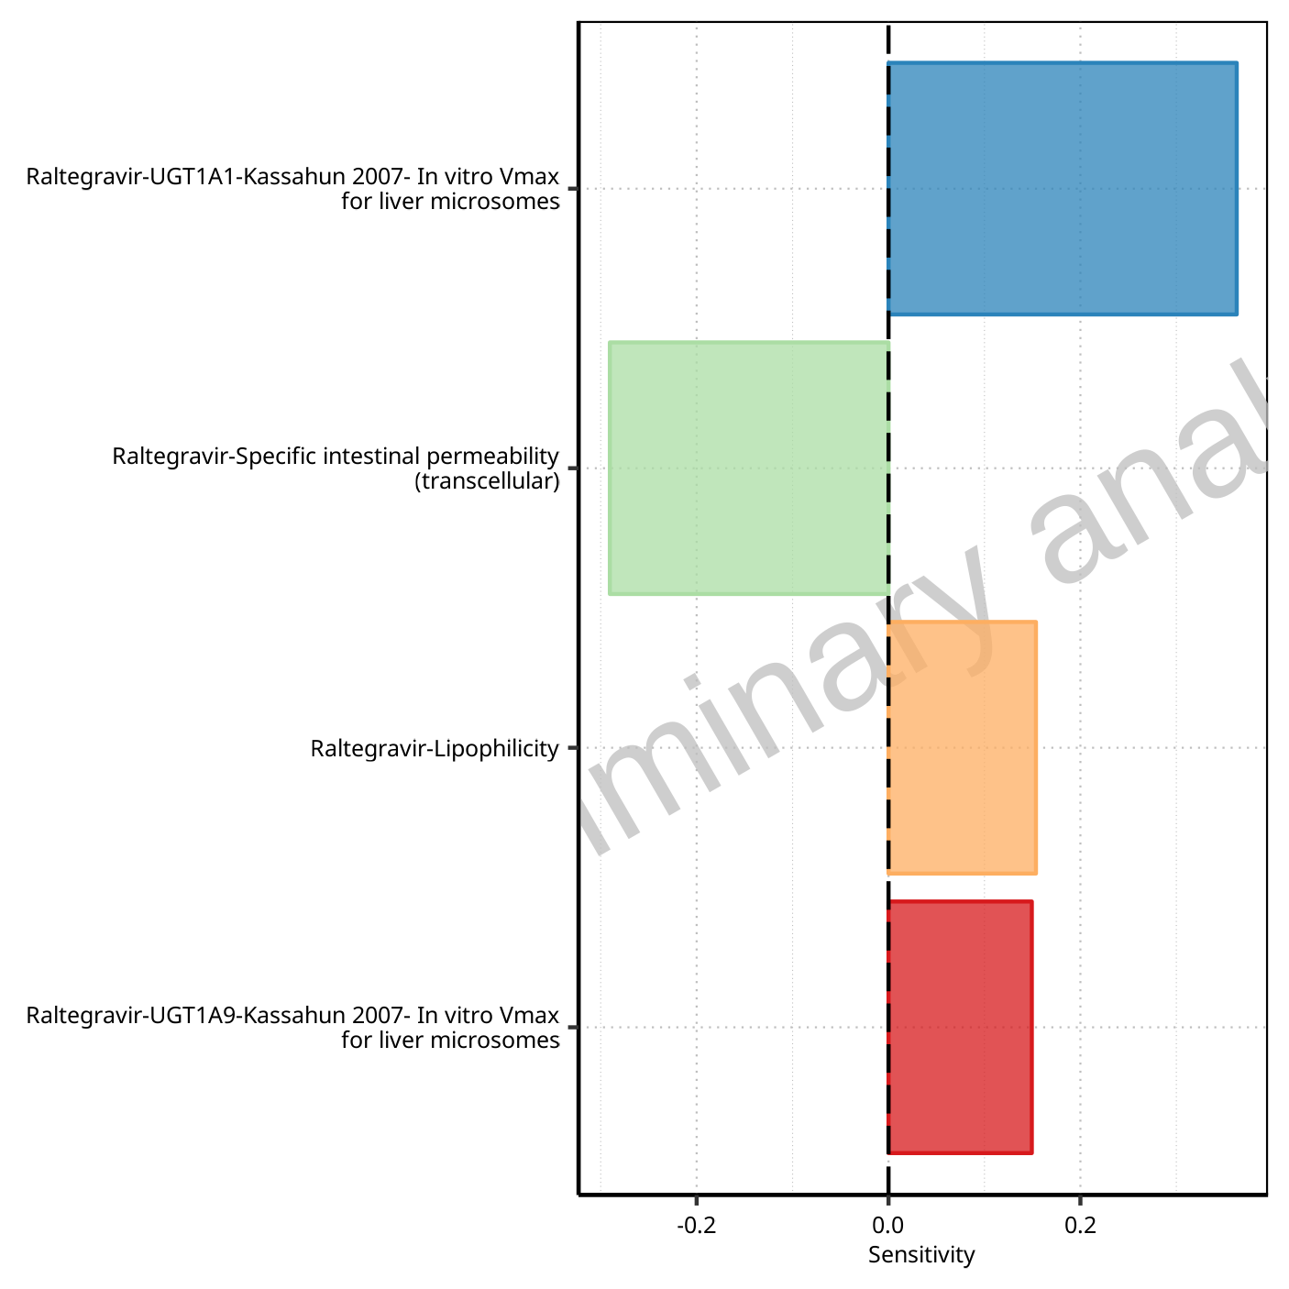

**Figure 1-19: Most sensitive parameters for Vss of Raltegravir.**

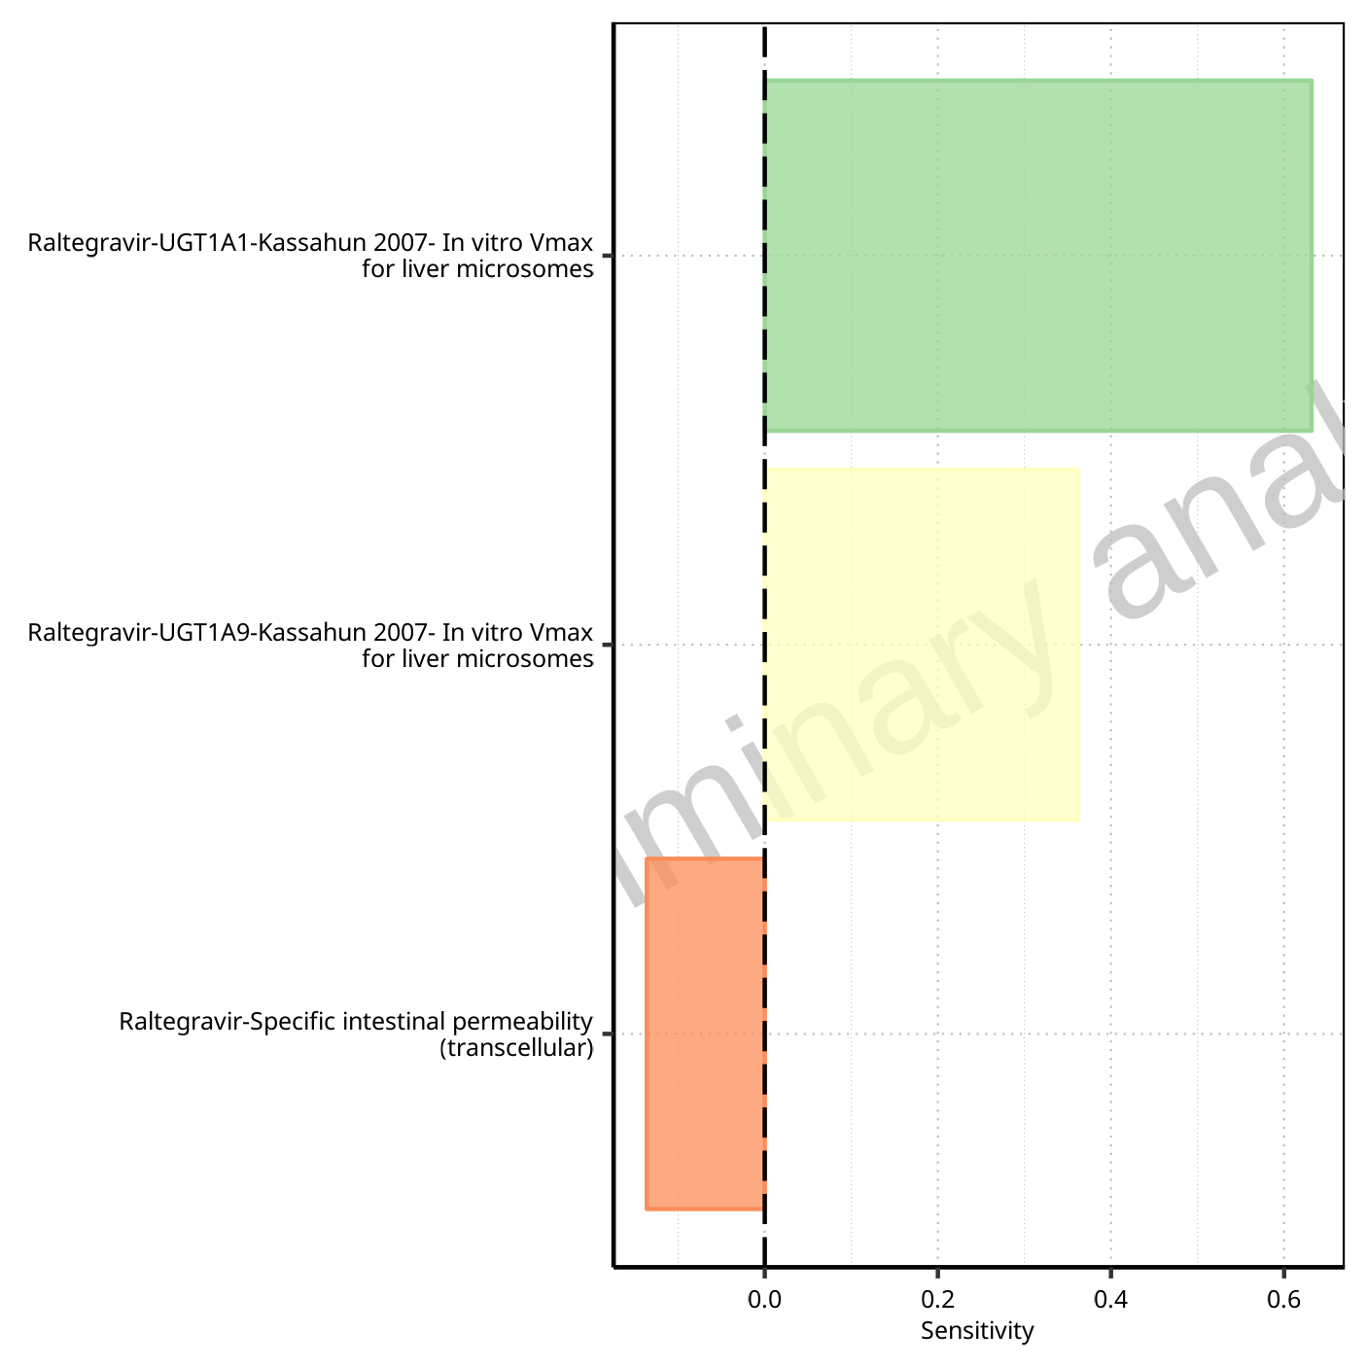

**Figure 1-20: Most sensitive parameters for Vd of Raltegravir.**

## Sensitivity Analysis for Raltegravir 50 mg (lactose formulation)

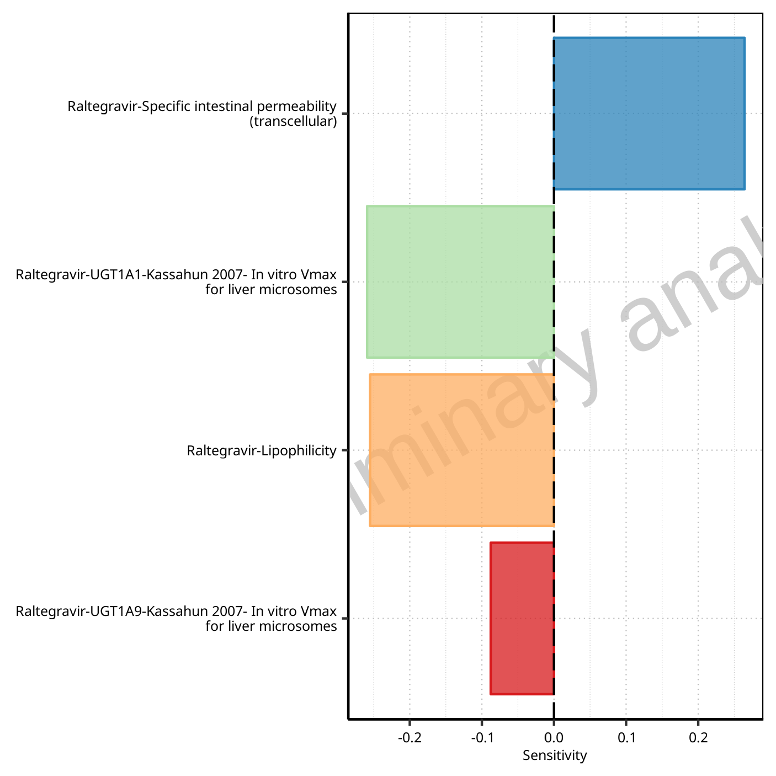

**Figure 1-21: Most sensitive parameters for C_max of Raltegravir.**



**Figure 1-22: Most sensitive parameters for t_max of Raltegravir.**

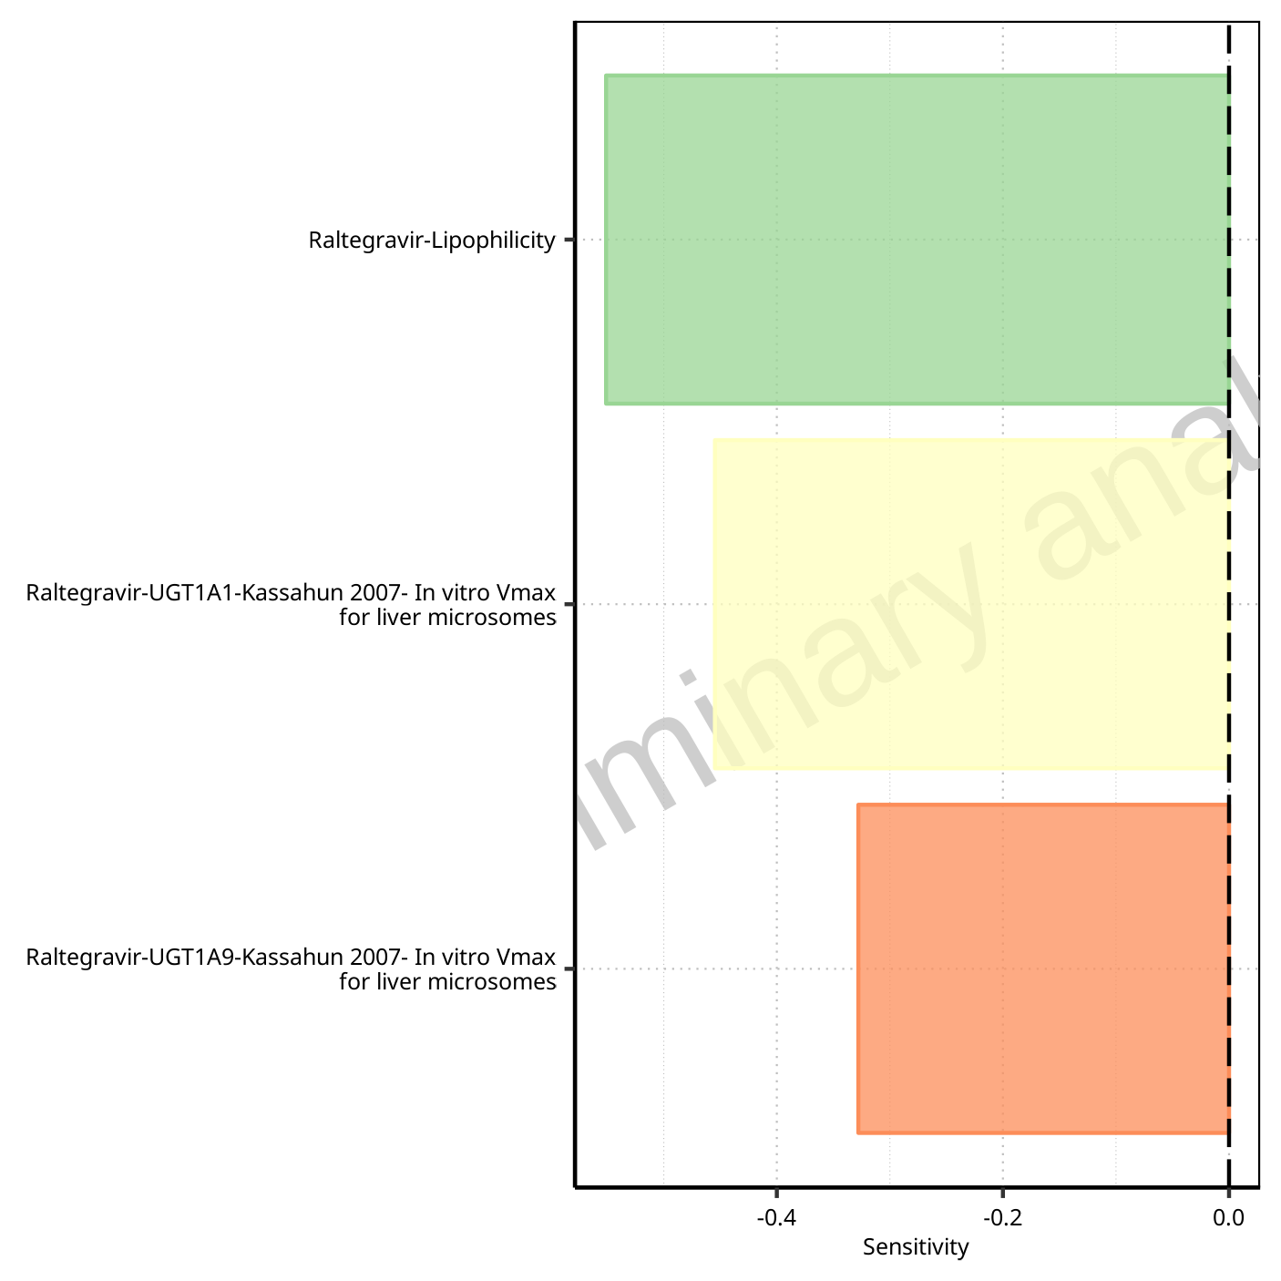

**Figure 1-23: Most sensitive parameters for C_tEnd of Raltegravir.**

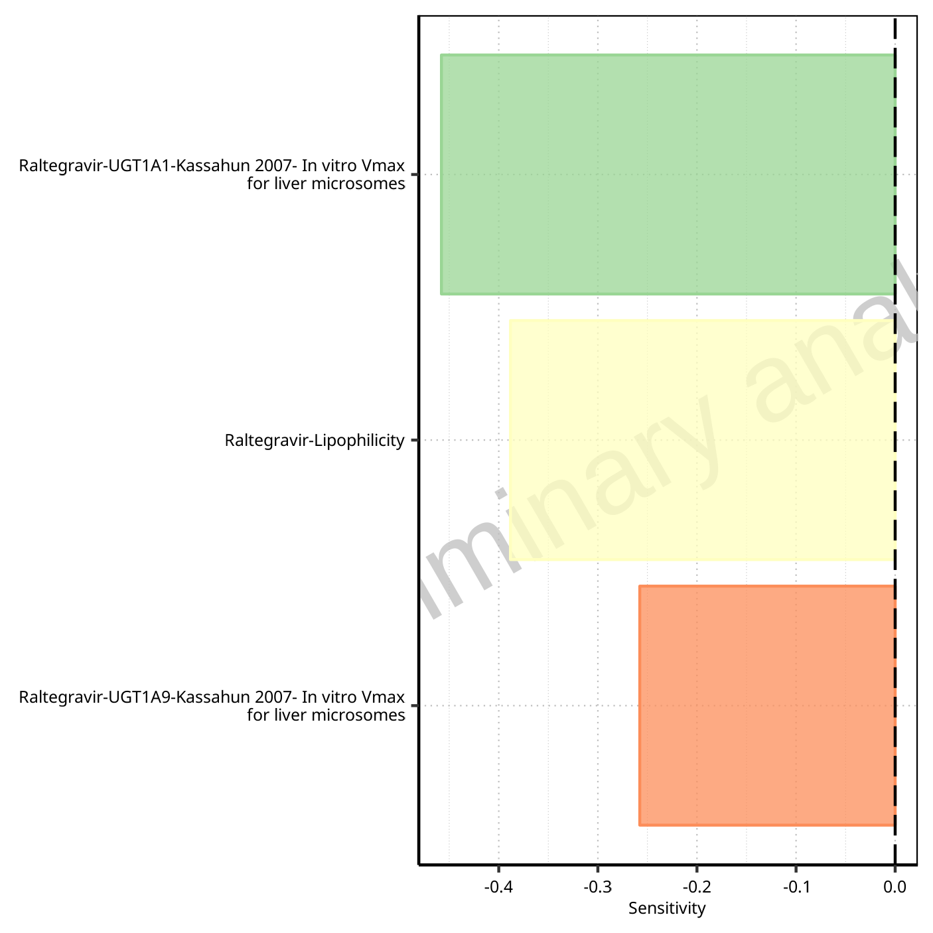

**Figure 1-24: Most sensitive parameters for AUC of Raltegravir.**

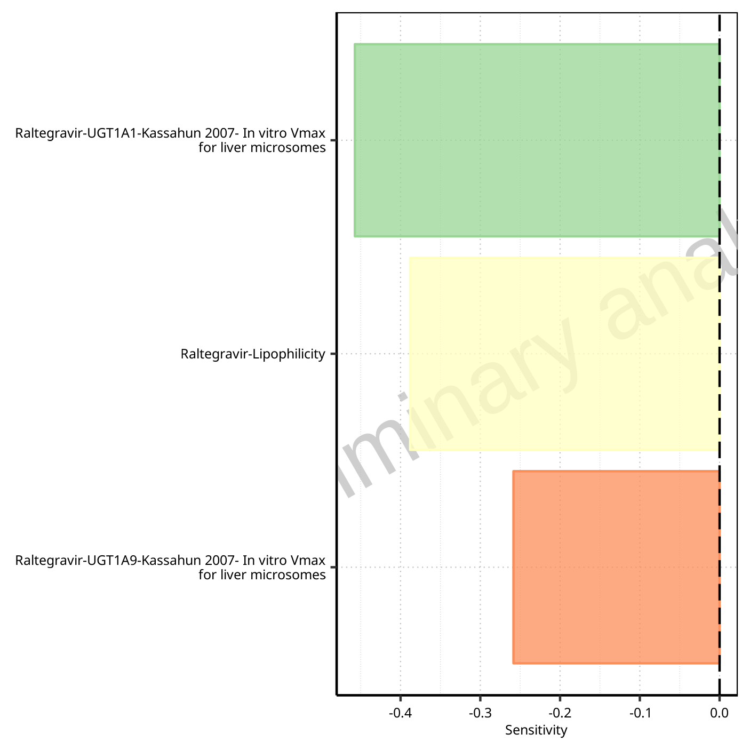

**Figure 1-25: Most sensitive parameters for AUC_inf of Raltegravir.**

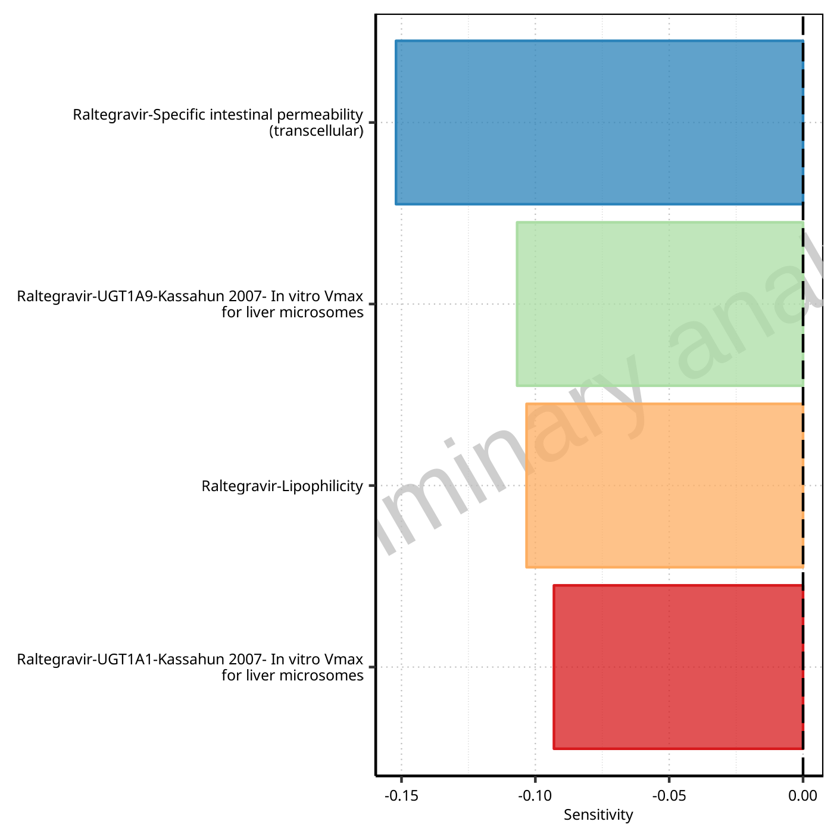

**Figure 1-26: Most sensitive parameters for MRT of Raltegravir.**

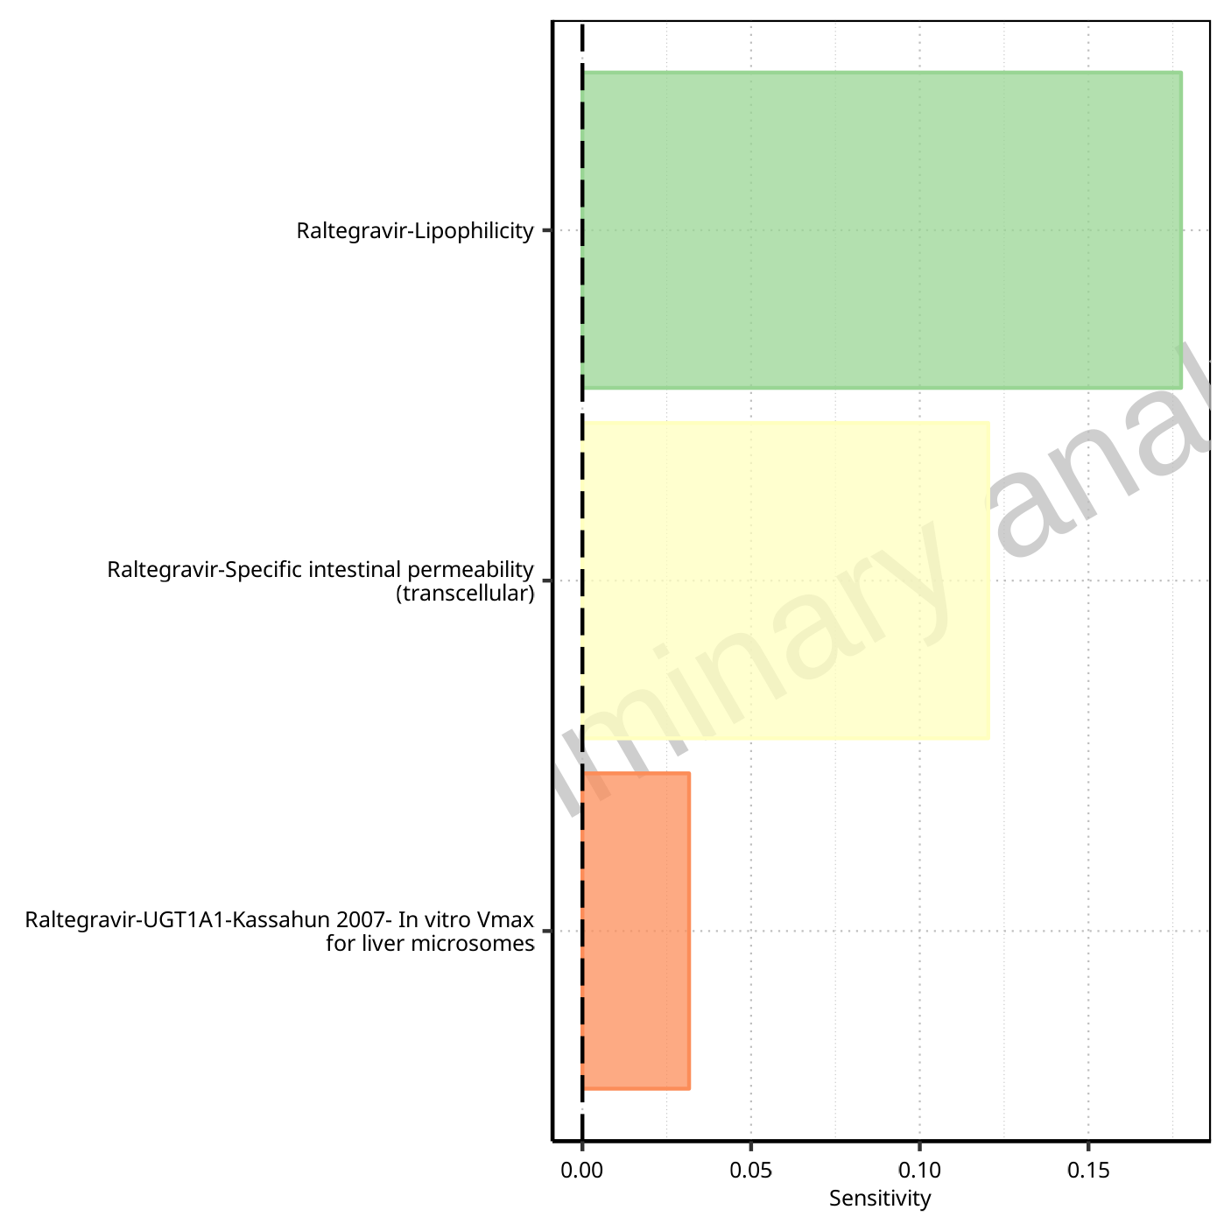

**Figure 1-27: Most sensitive parameters for Thalf of Raltegravir.**

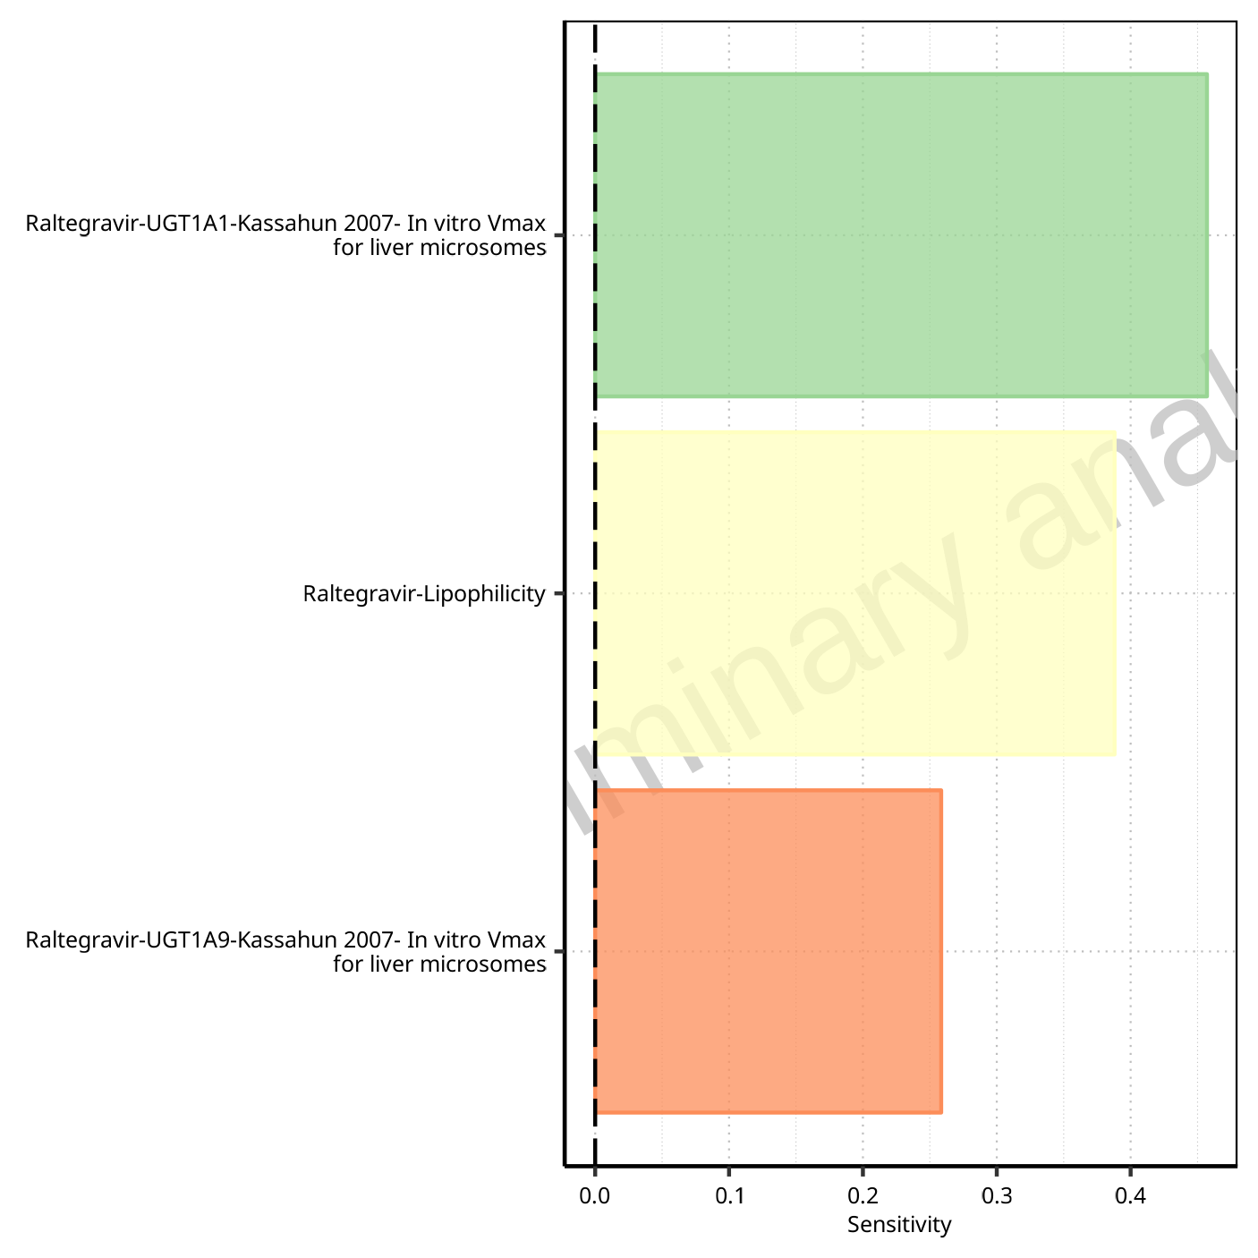

**Figure 1-28: Most sensitive parameters for CL of Raltegravir.**

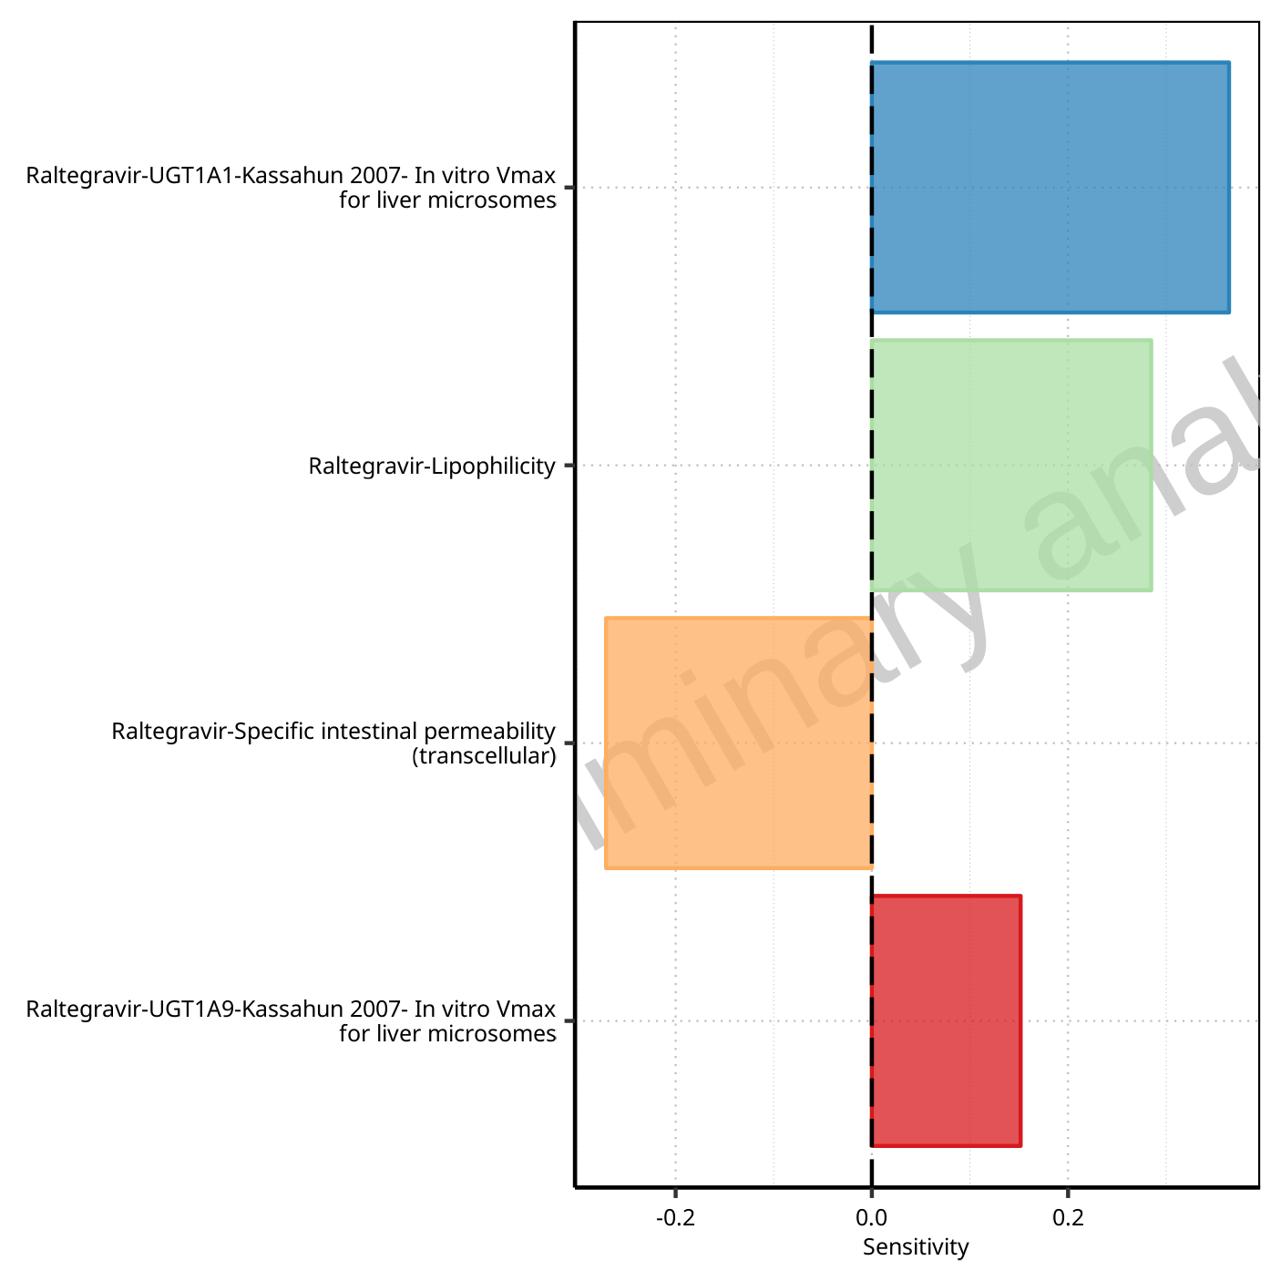

**Figure 1-29: Most sensitive parameters for Vss of Raltegravir.**

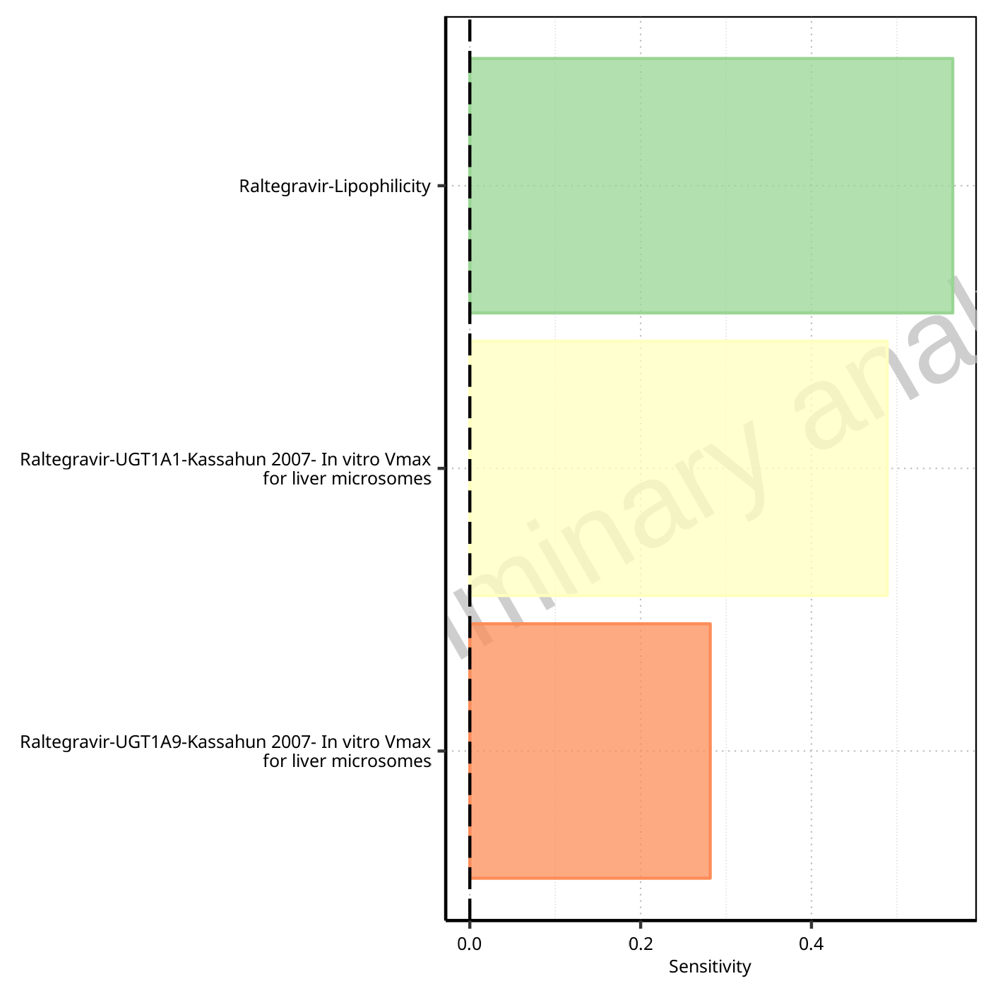

**Figure 1-30: Most sensitive parameters for Vd of Raltegravir.**

## Sensitivity Analysis for Raltegravir 100 mg (lactose formulation)

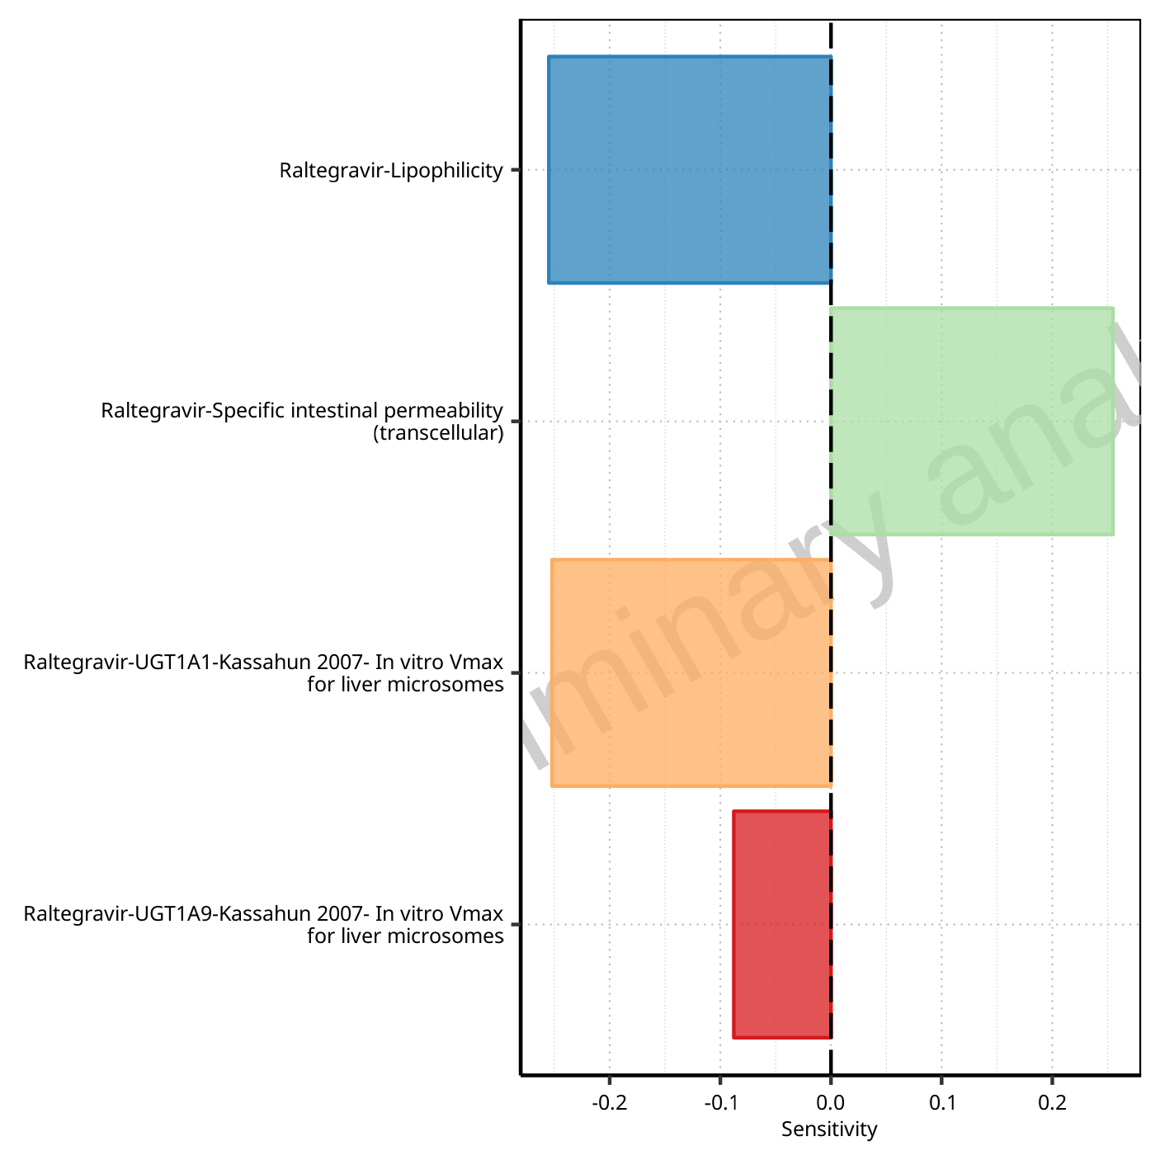

**Figure 1-31: Most sensitive parameters for C_max of Raltegravir.**



**Figure 1-32: Most sensitive parameters for t_max of Raltegravir.**

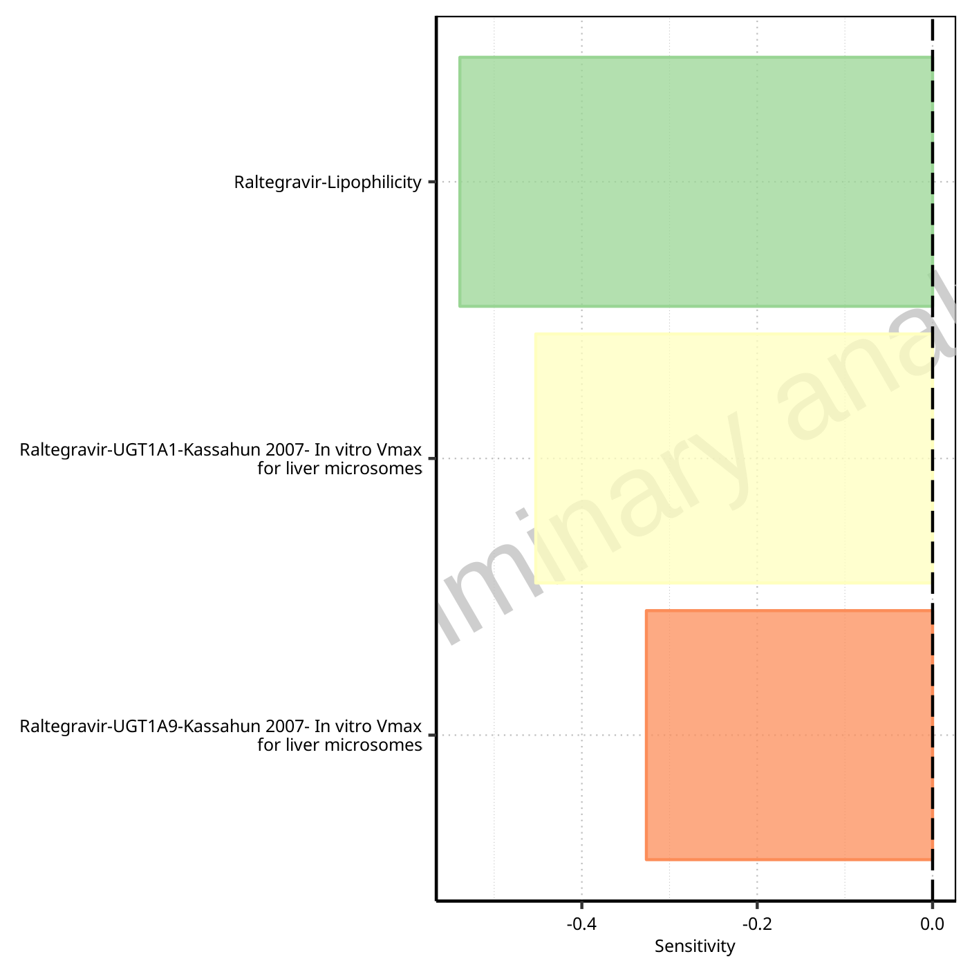

**Figure 1-33: Most sensitive parameters for C_tEnd of Raltegravir.**

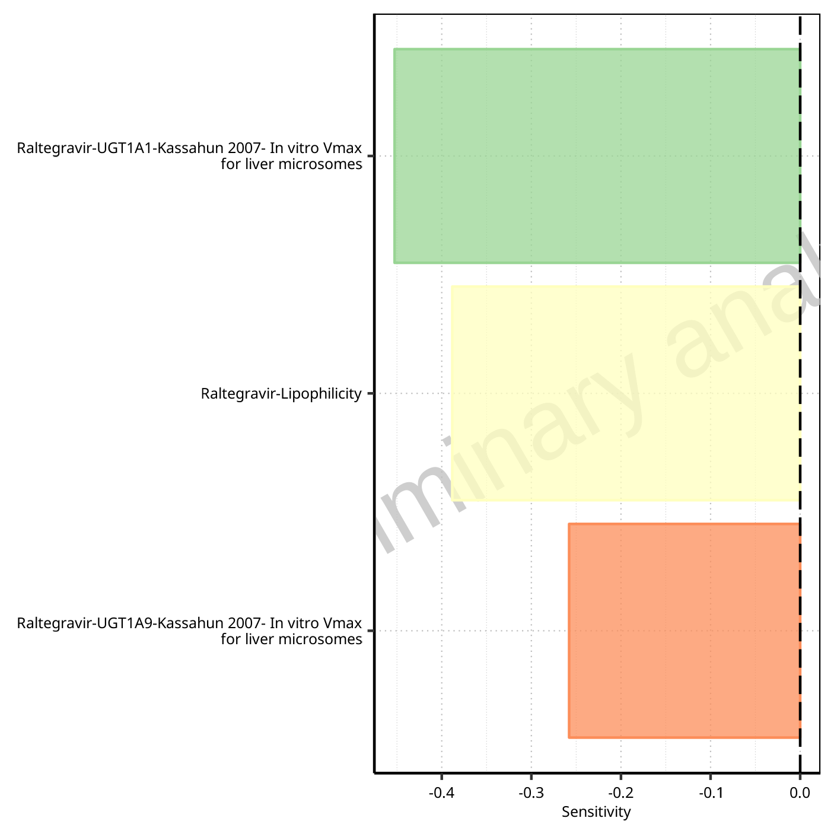

**Figure 1-34: Most sensitive parameters for AUC of Raltegravir.**

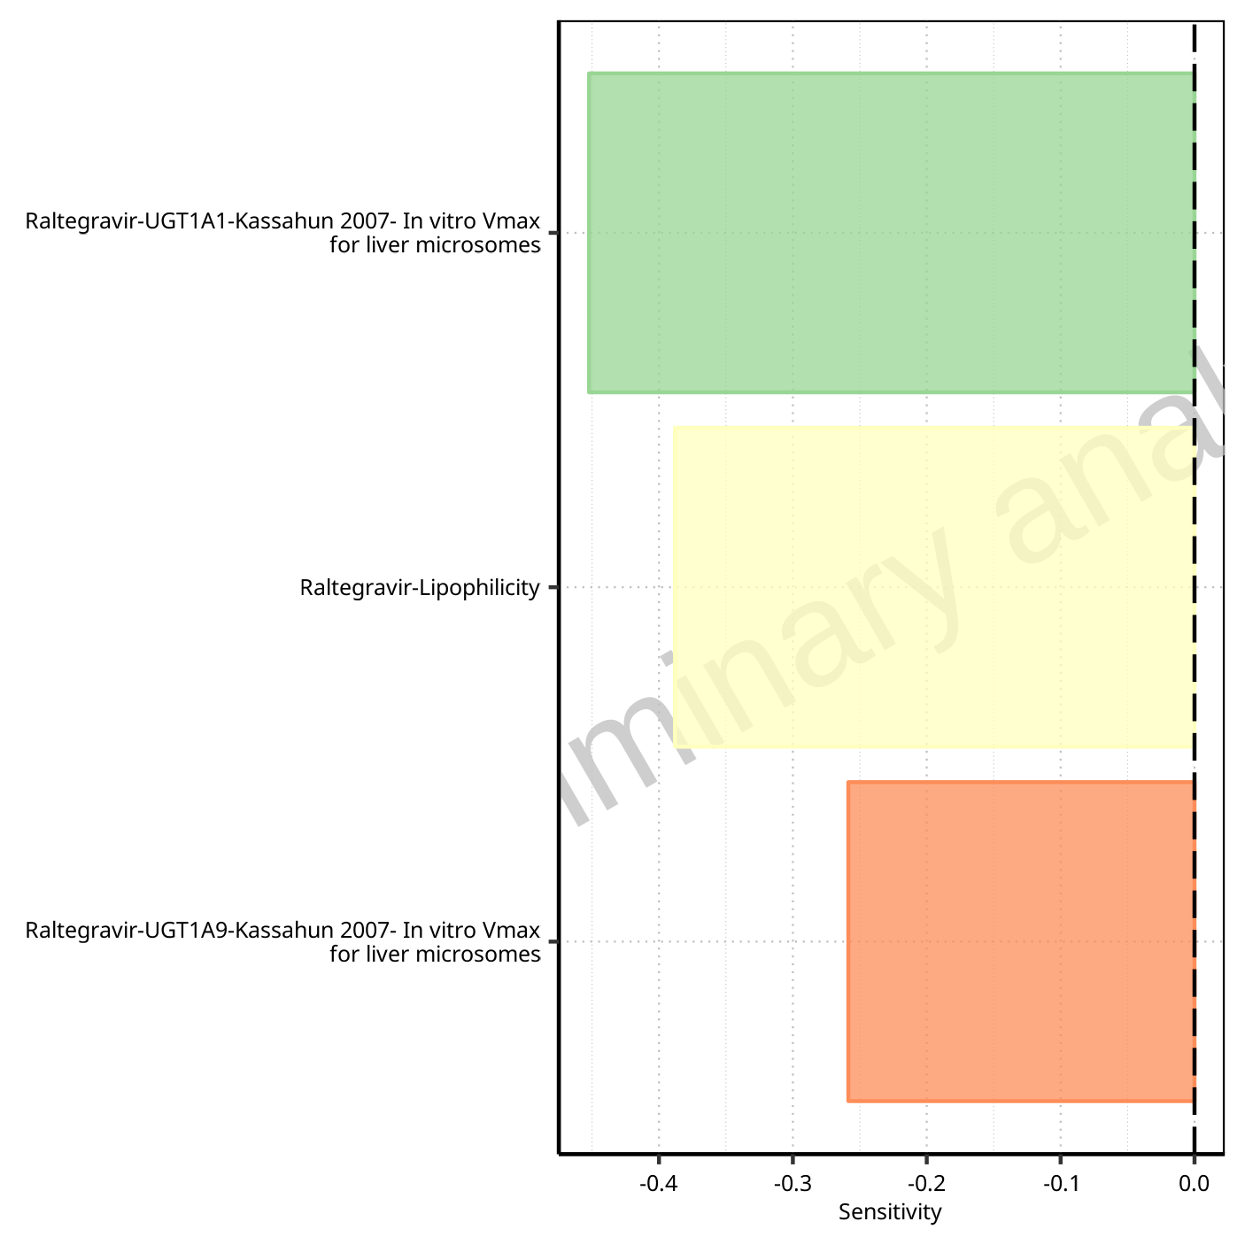

**Figure 1-35: Most sensitive parameters for AUC_inf of Raltegravir.**

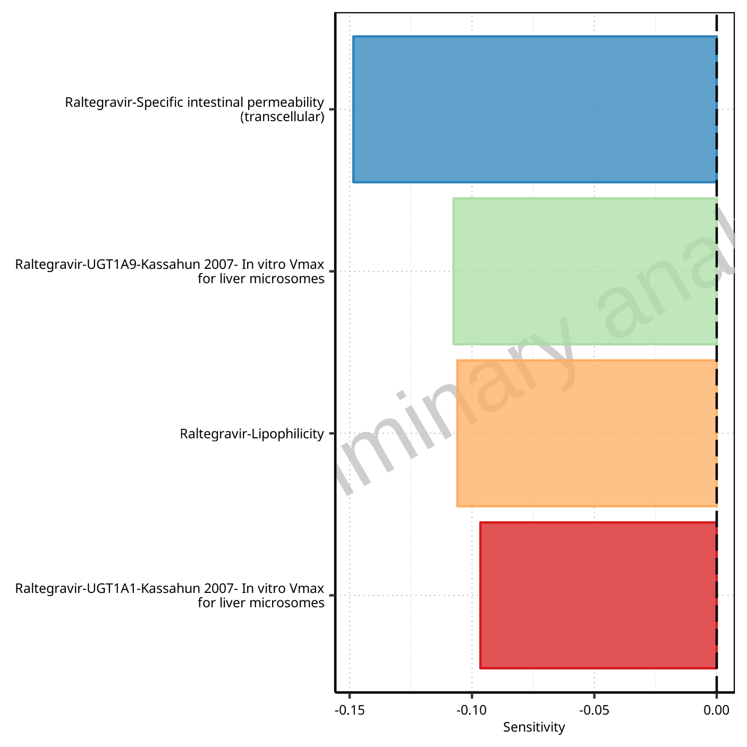

**Figure 1-36: Most sensitive parameters for MRT of Raltegravir.**

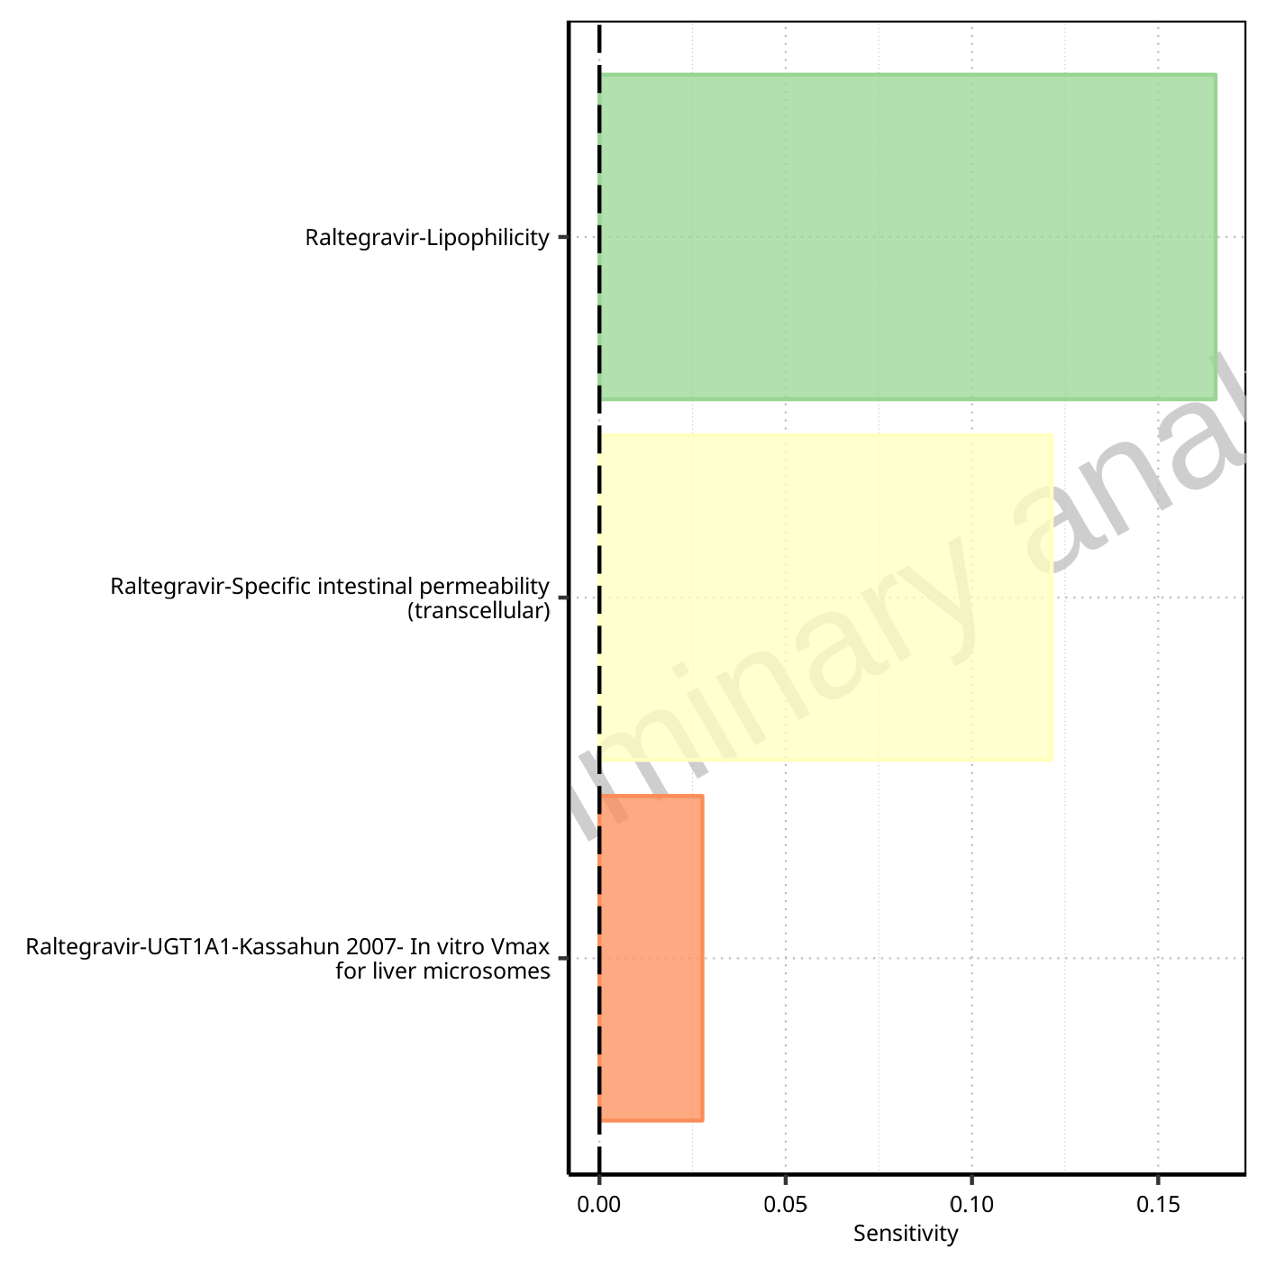

**Figure 1-37: Most sensitive parameters for Thalf of Raltegravir.**

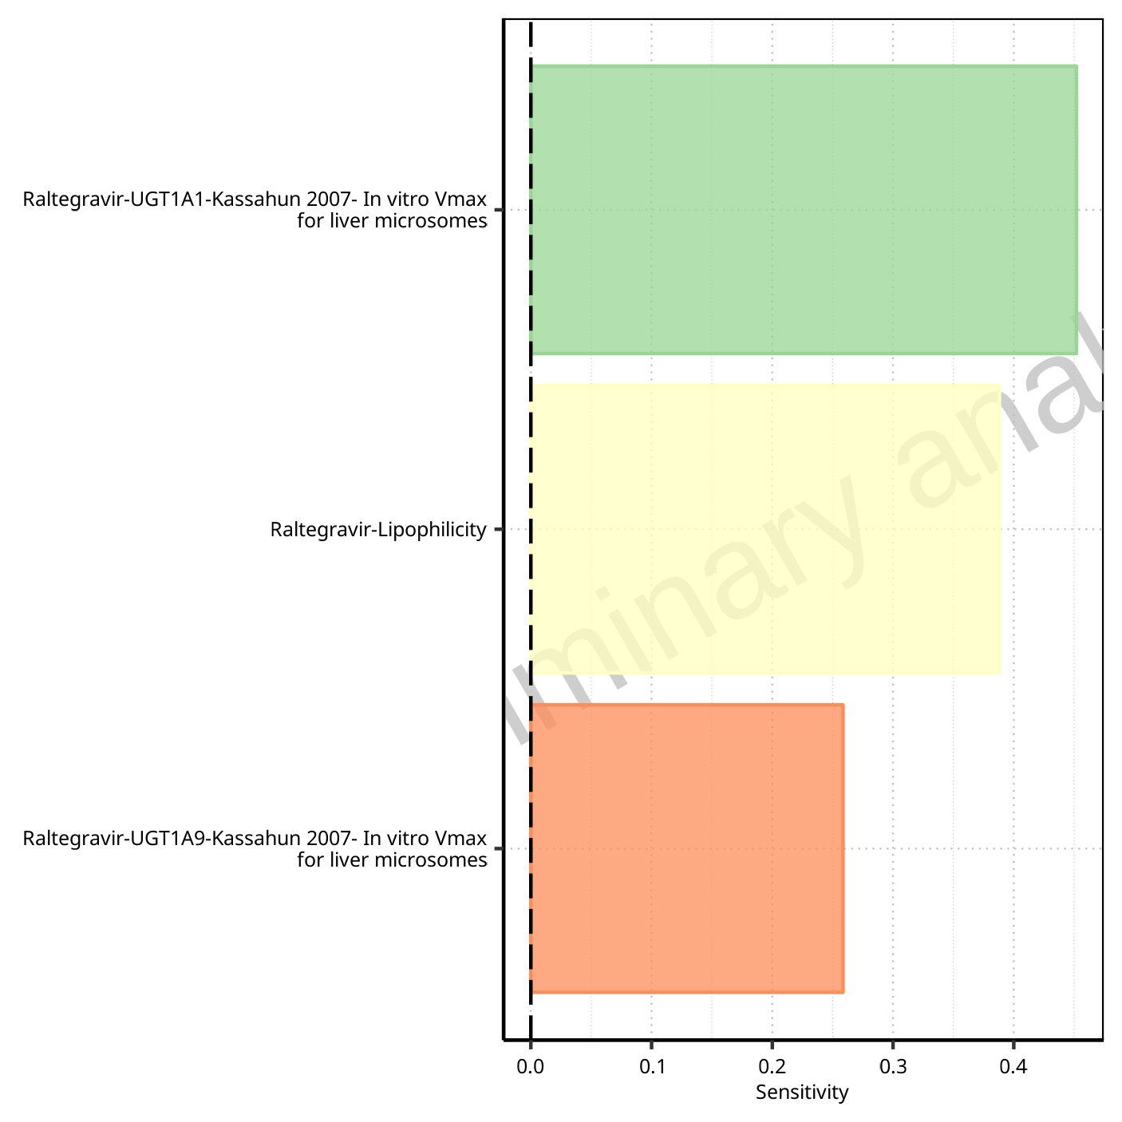

**Figure 1-38: Most sensitive parameters for CL of Raltegravir.**

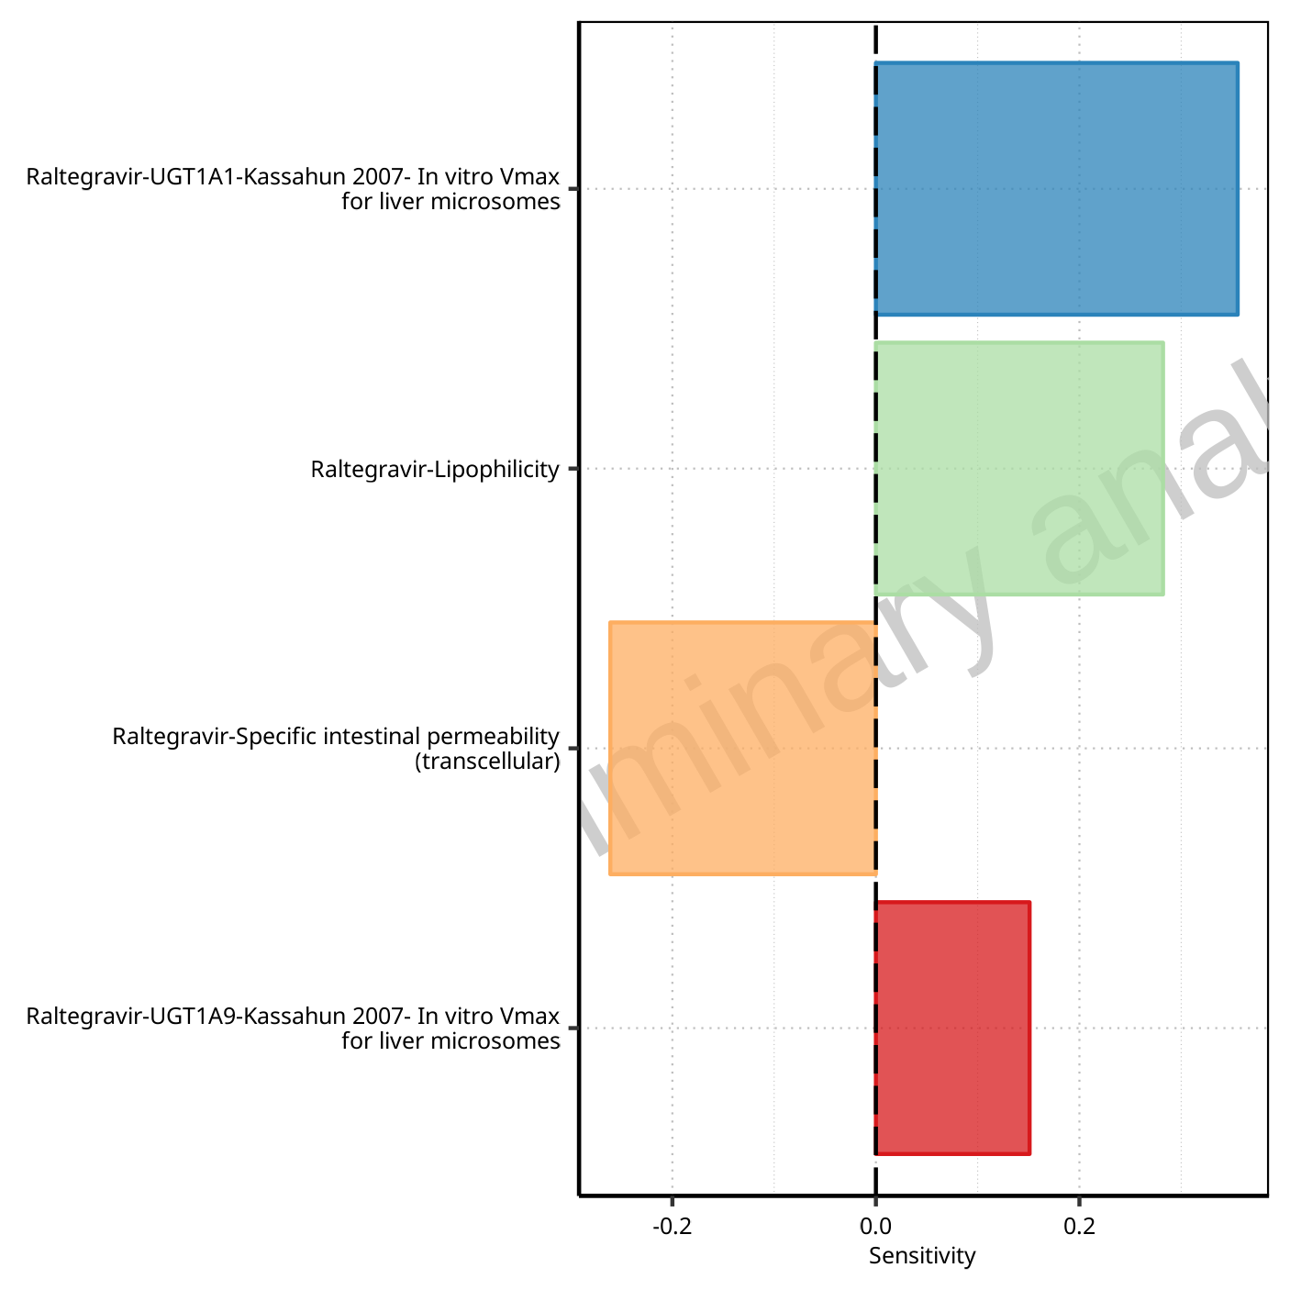

**Figure 1-39: Most sensitive parameters for Vss of Raltegravir.**

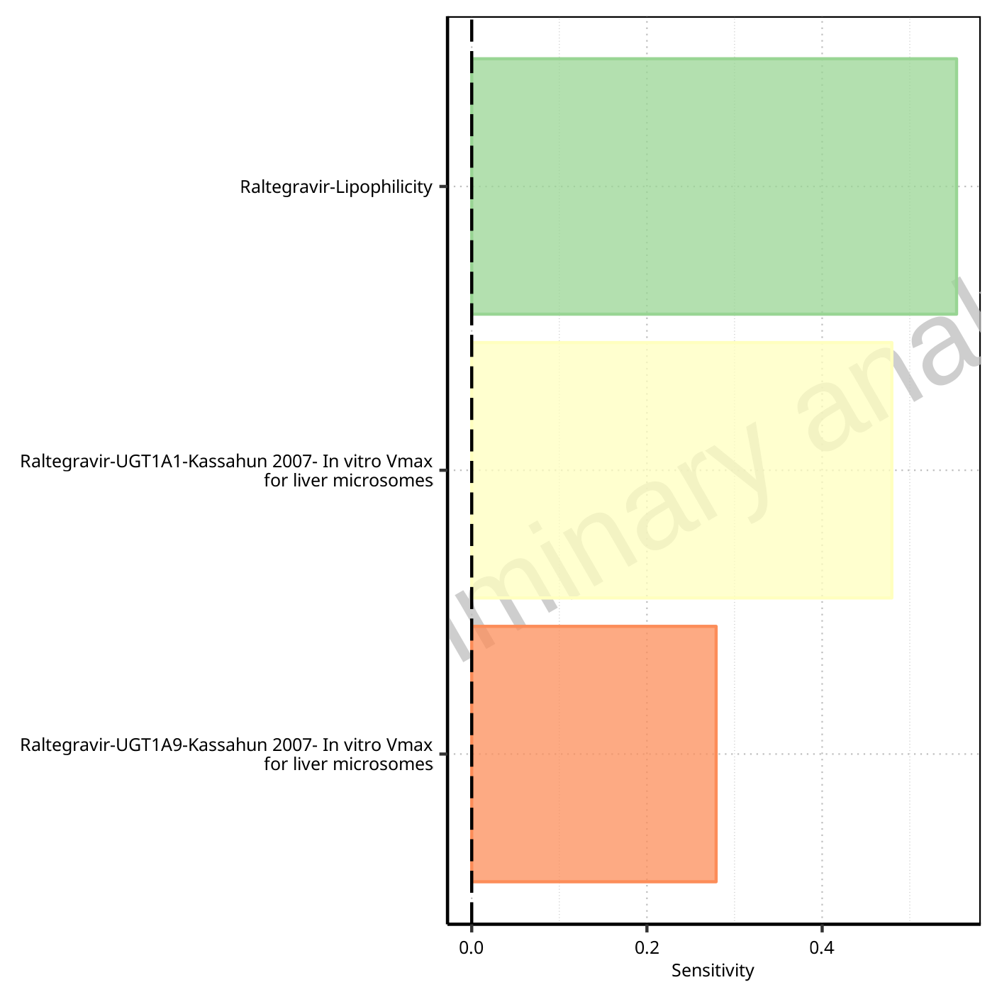

**Figure 1-40: Most sensitive parameters for Vd of Raltegravir.**

## Sensitivity Analysis for Raltegravir 200 mg (lactose formulation)

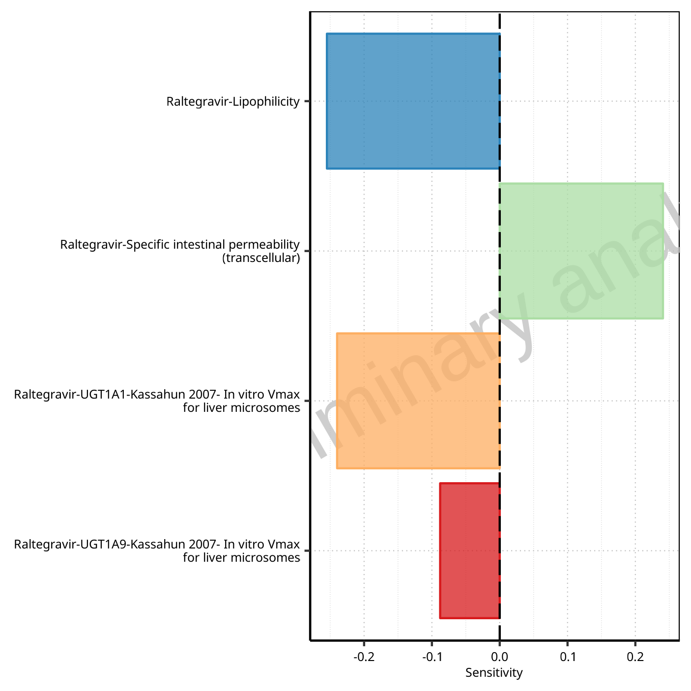

**Figure 1-41: Most sensitive parameters for C_max of Raltegravir.**

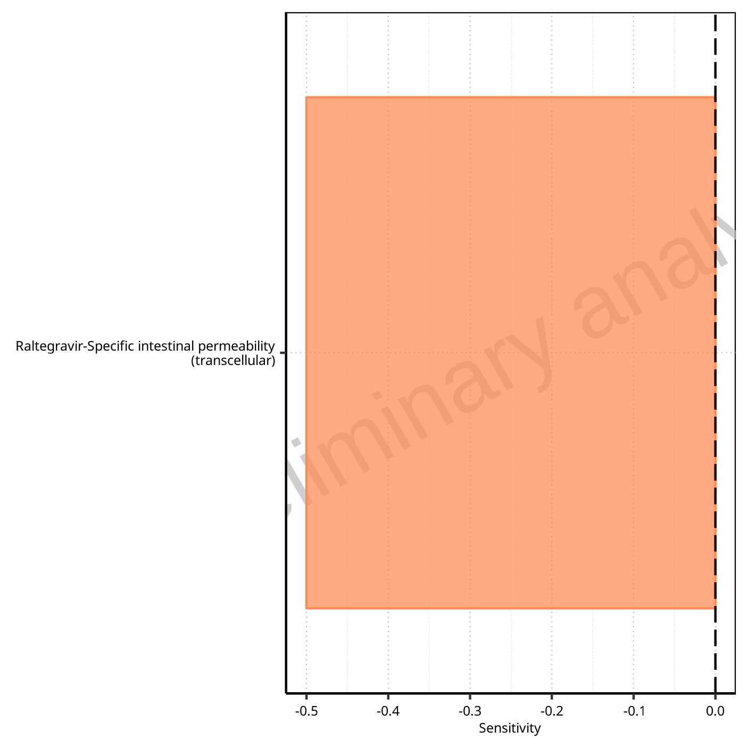

**Figure 1-42: Most sensitive parameters for t_max of Raltegravir.**

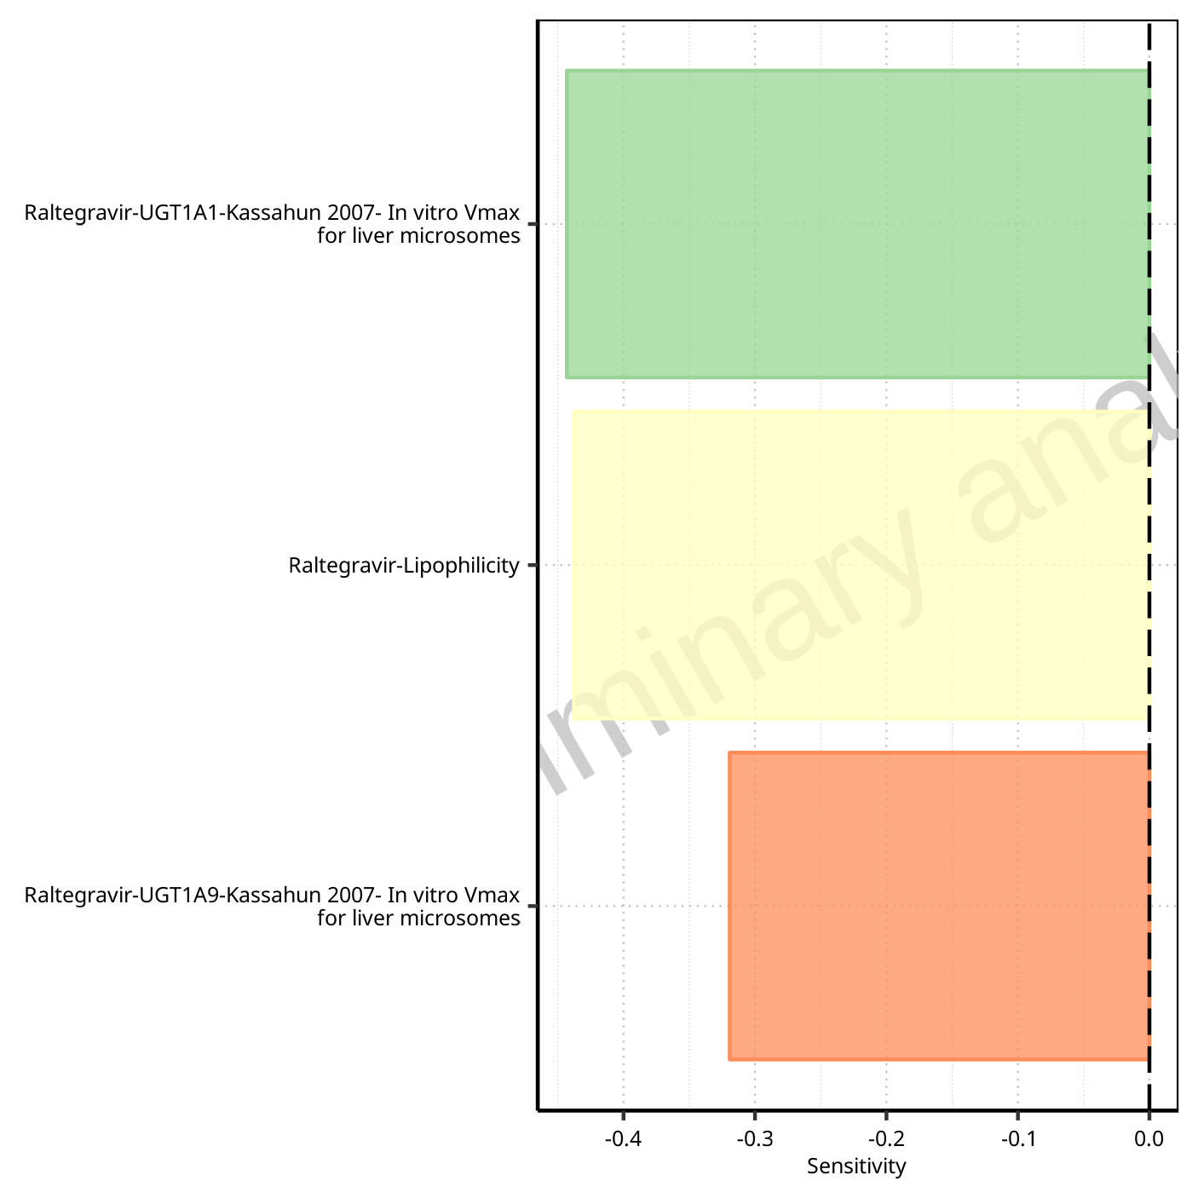

**Figure 1-43: Most sensitive parameters for C_tEnd of Raltegravir.**

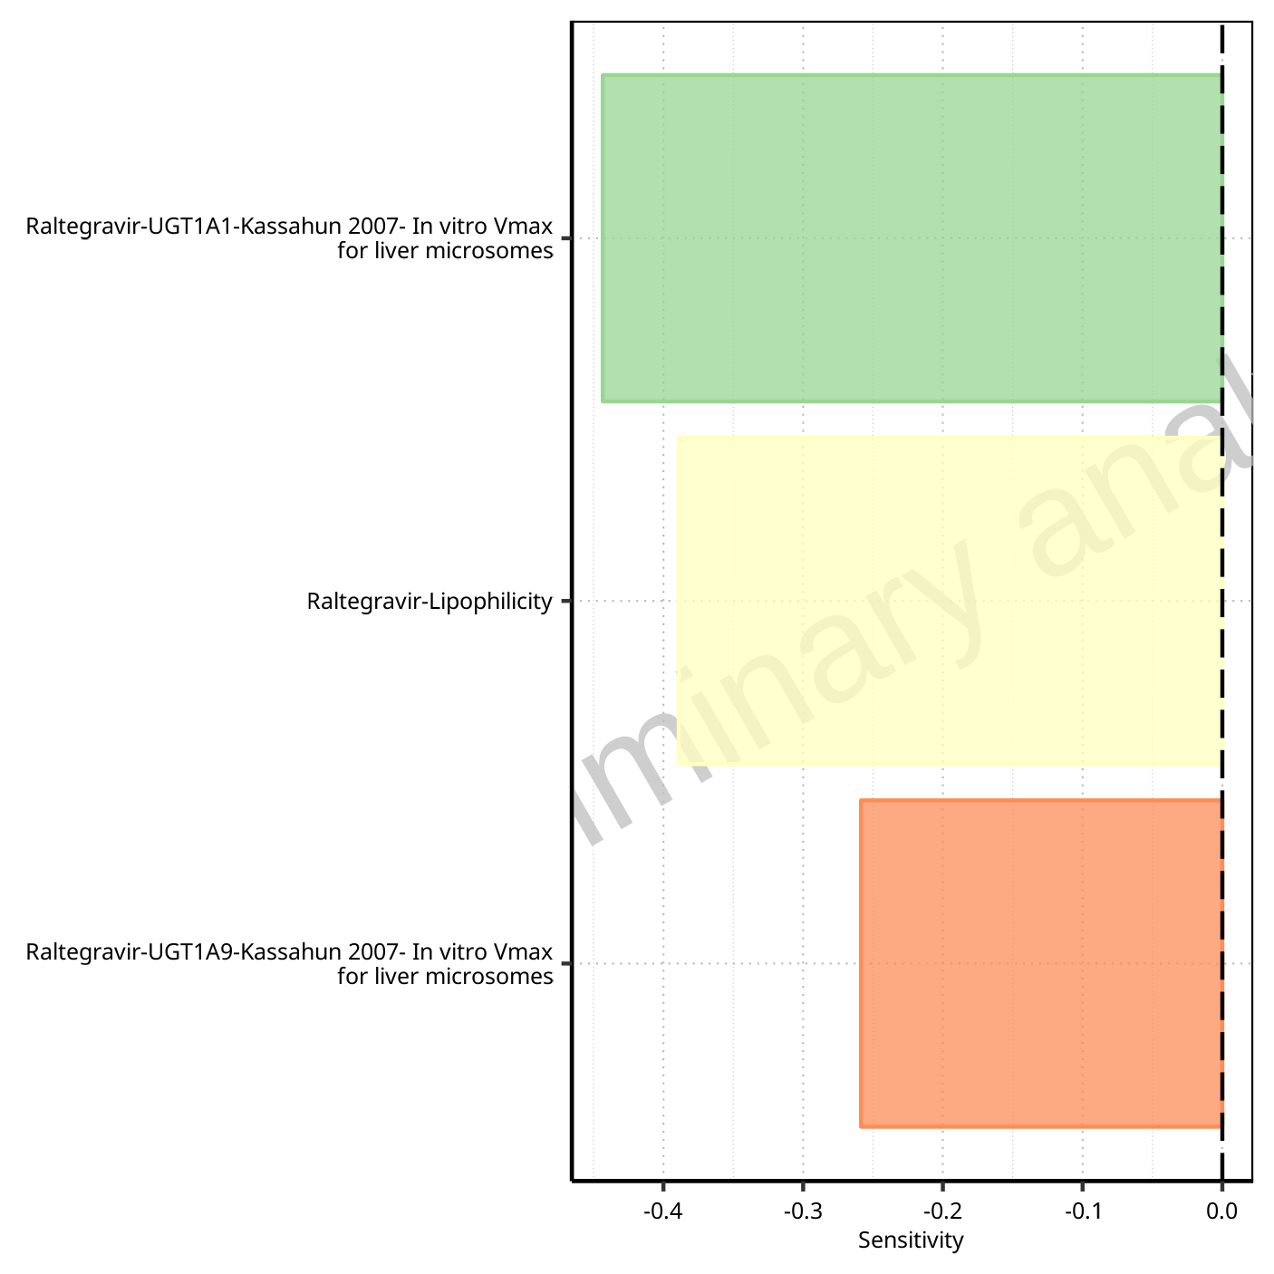

**Figure 1-44: Most sensitive parameters for AUC of Raltegravir.**

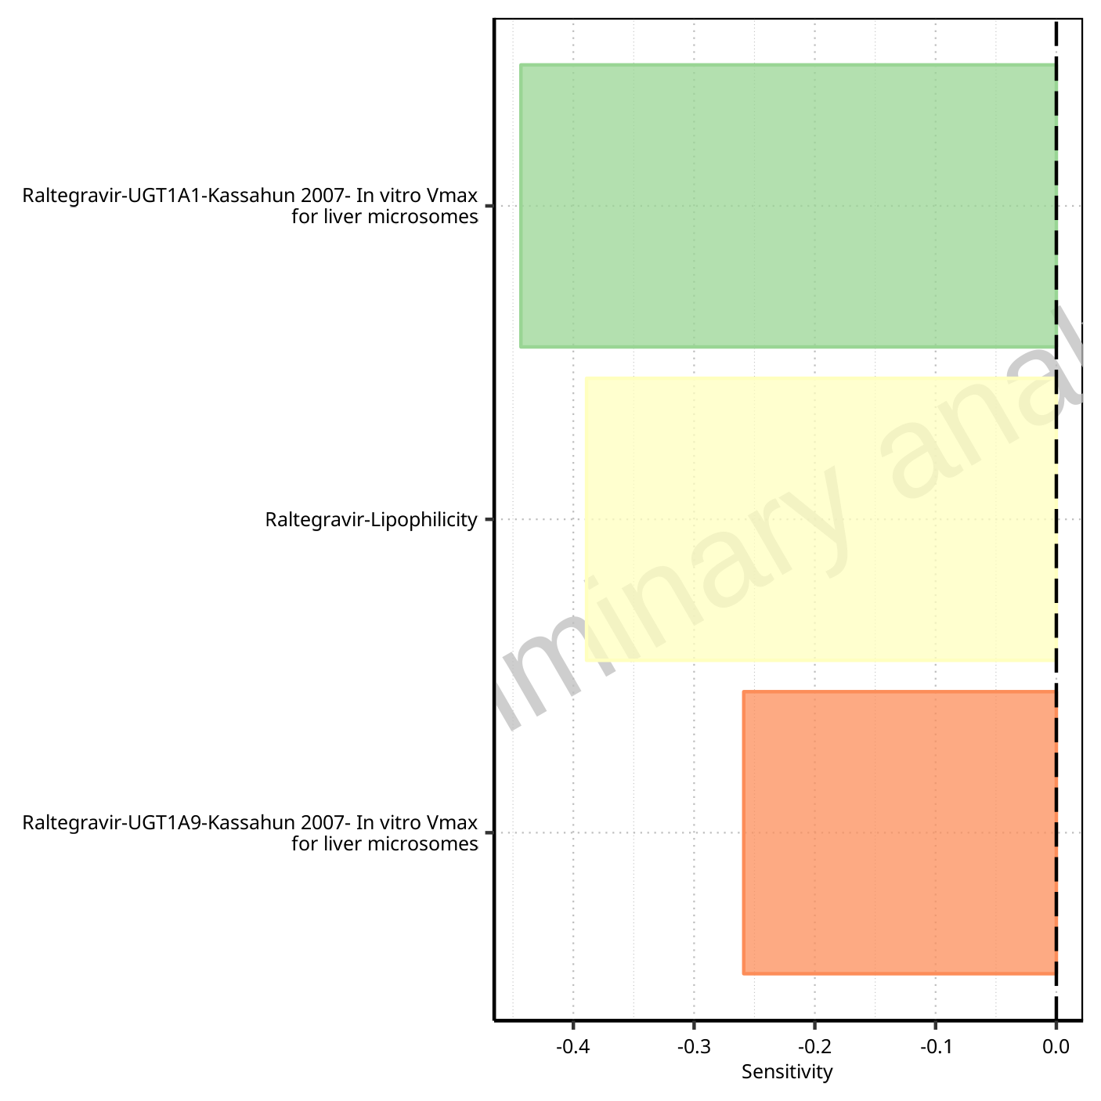

**Figure 1-45: Most sensitive parameters for AUC_inf of Raltegravir.**

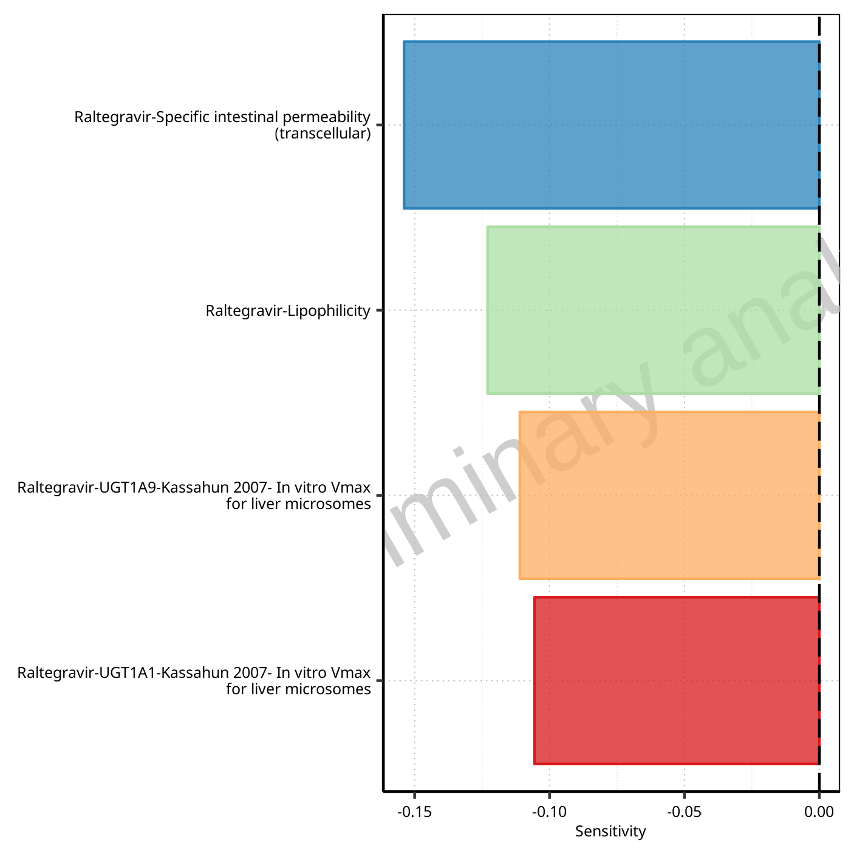

**Figure 1-46: Most sensitive parameters for MRT of Raltegravir.**

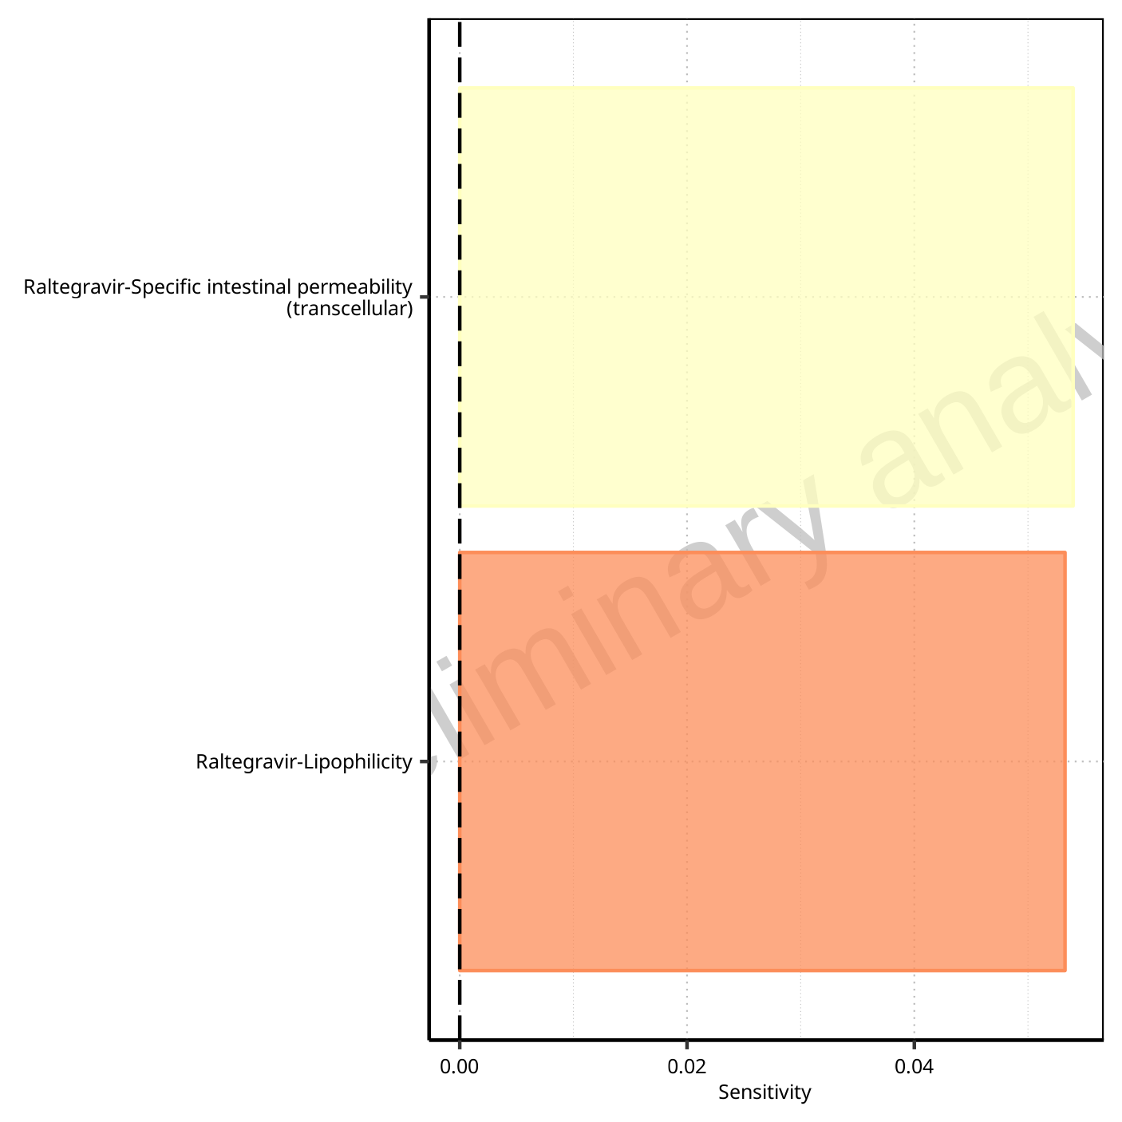

**Figure 1-47: Most sensitive parameters for Thalf of Raltegravir.**

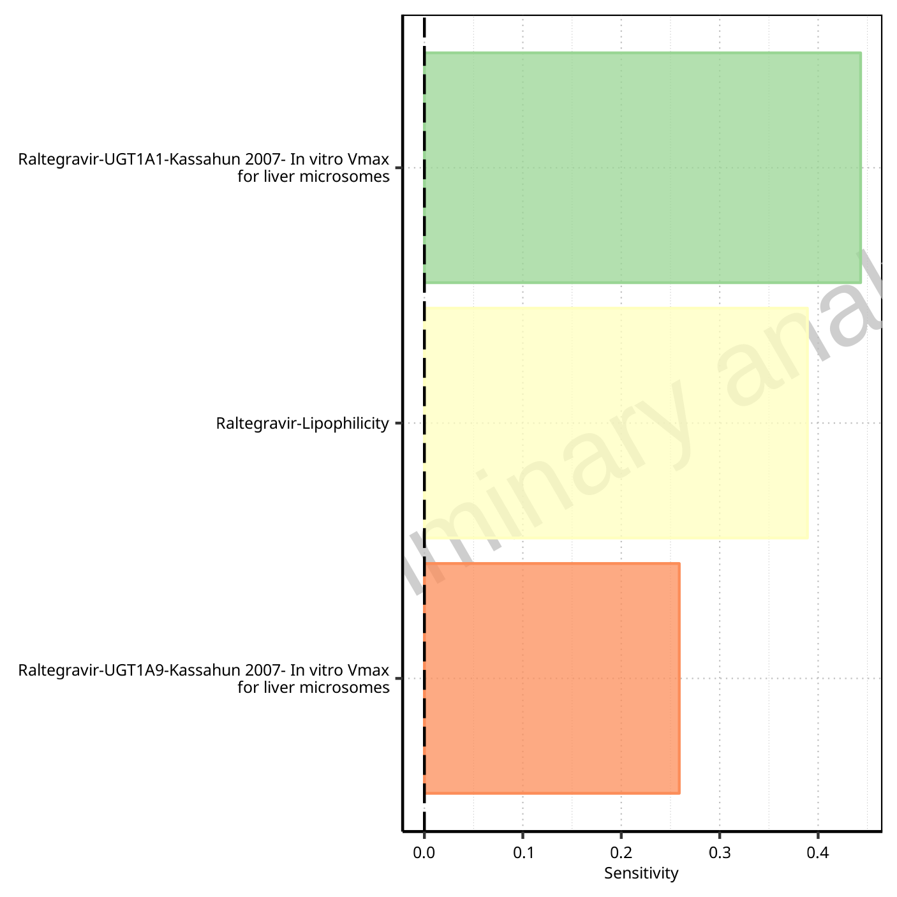

**Figure 1-48: Most sensitive parameters for CL of Raltegravir.**

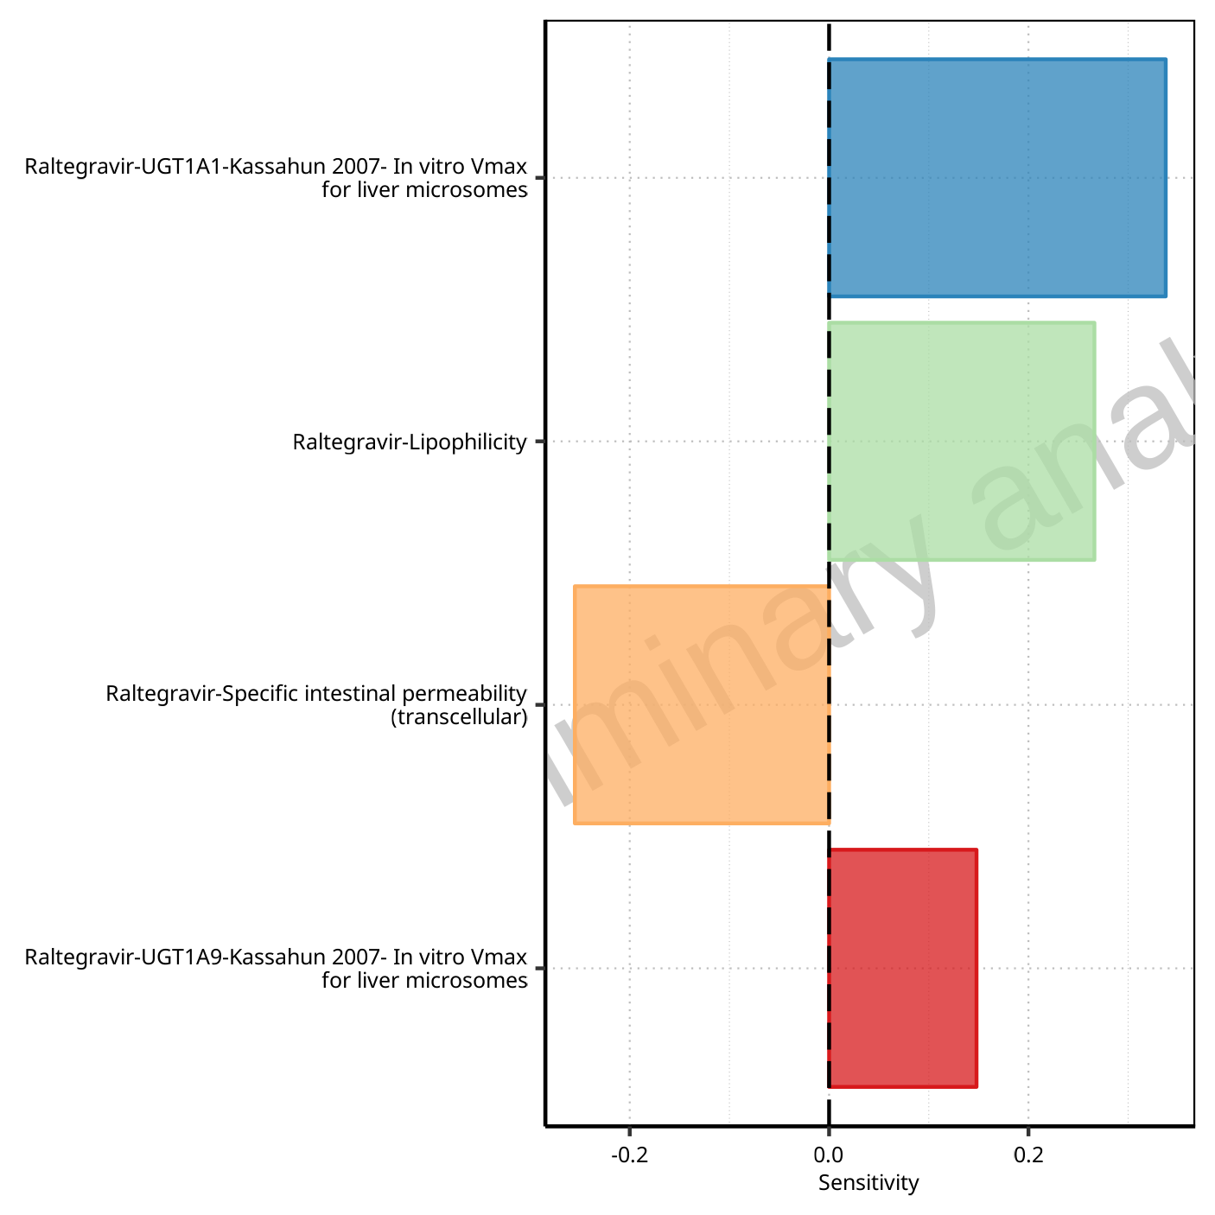

**Figure 1-49: Most sensitive parameters for Vss of Raltegravir.**

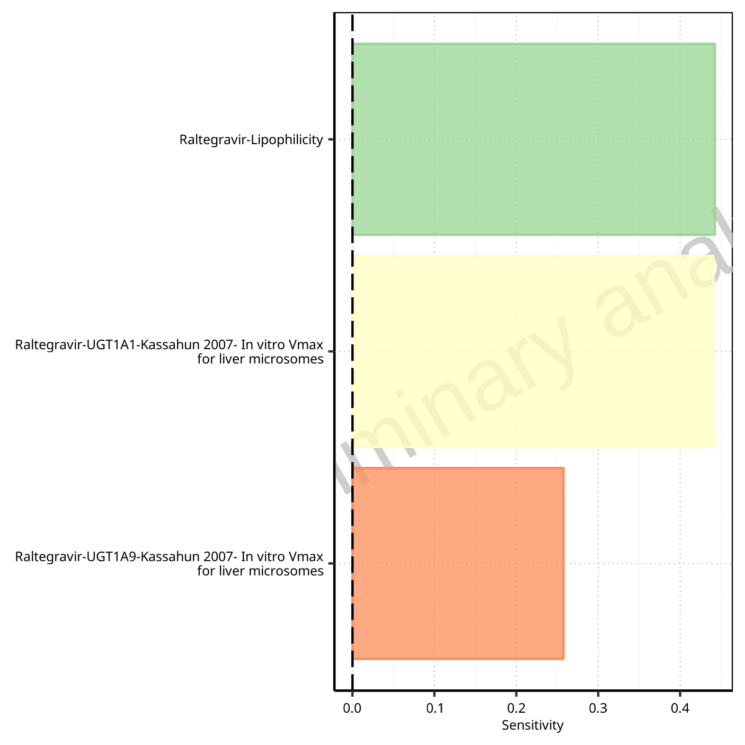

**Figure 1-50: Most sensitive parameters for Vd of Raltegravir.**

## Sensitivity Analysis for Raltegravir 400mg (lactose formulation)

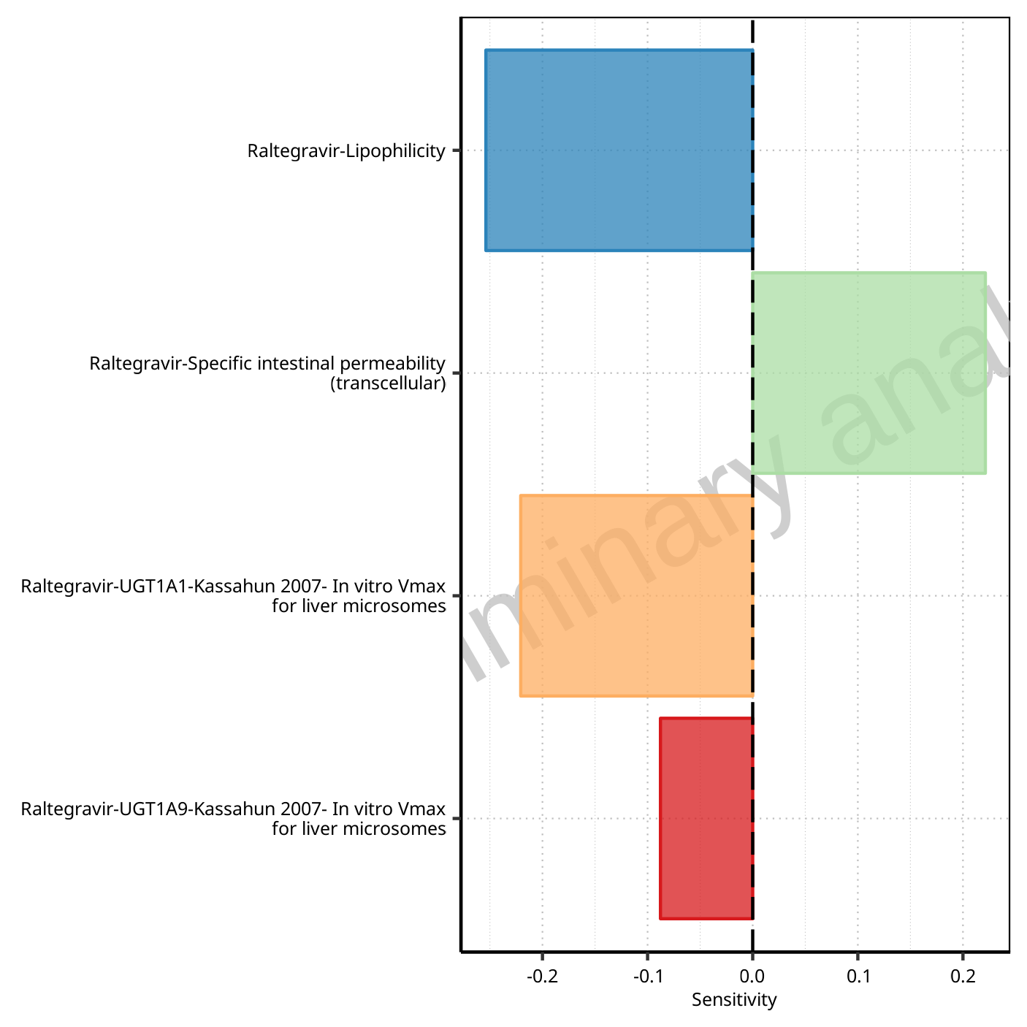

**Figure 1-51: Most sensitive parameters for C_max of Raltegravir.**

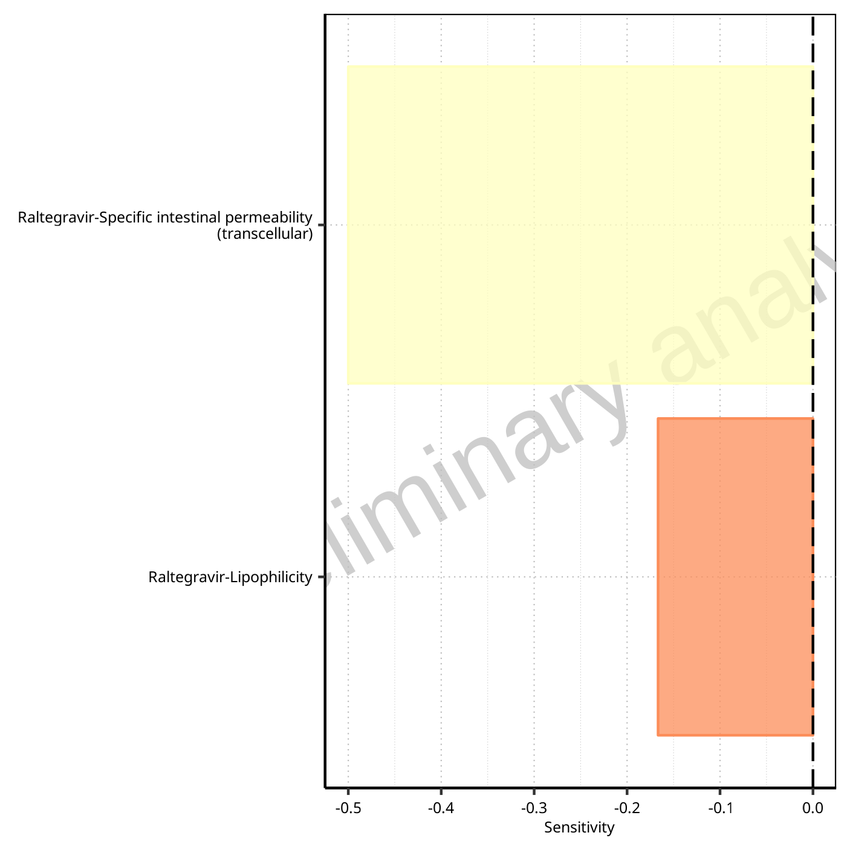

**Figure 1-52: Most sensitive parameters for t_max of Raltegravir.**

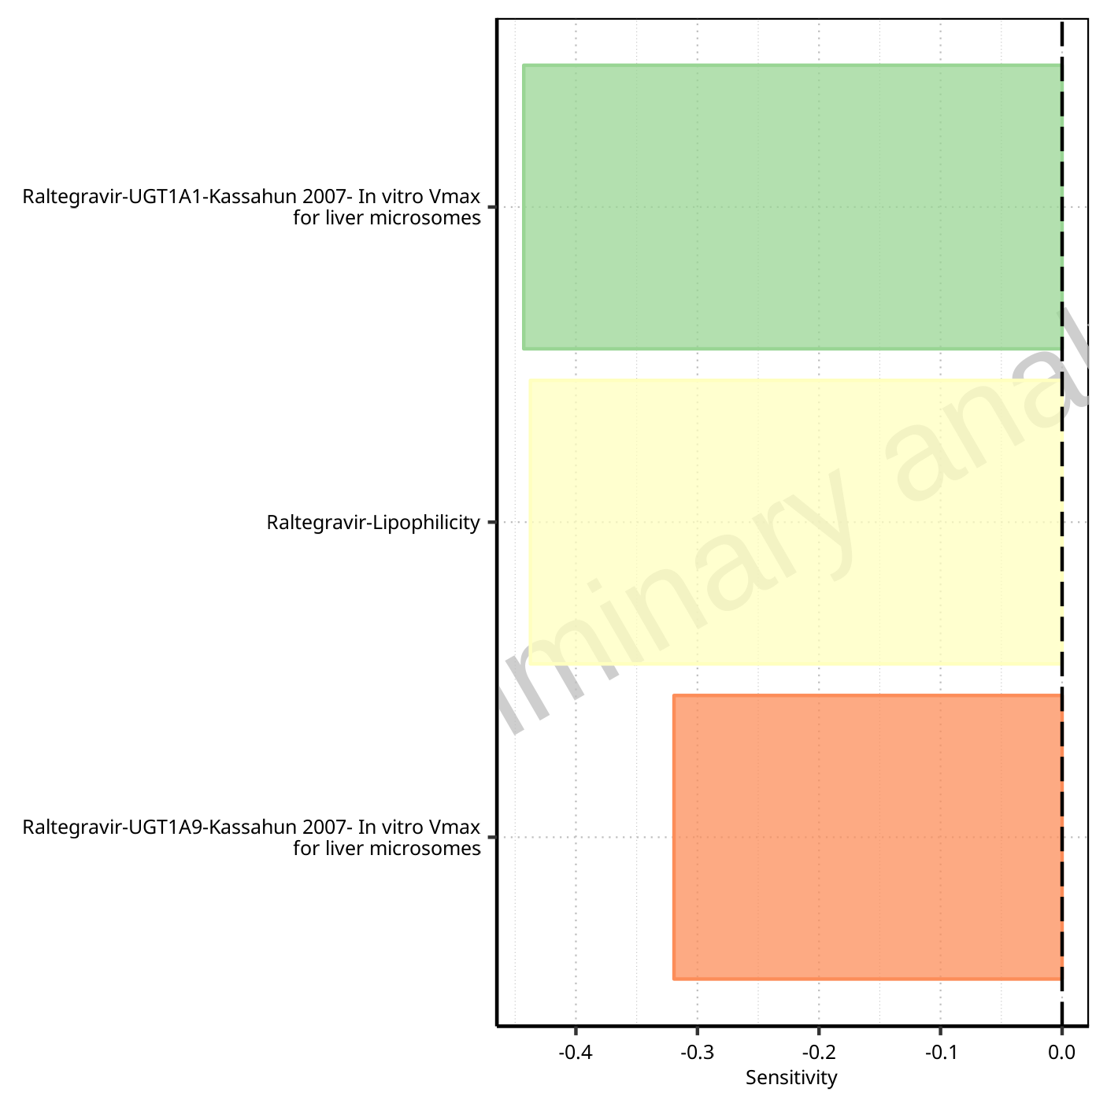

**Figure 1-53: Most sensitive parameters for C_tEnd of Raltegravir.**

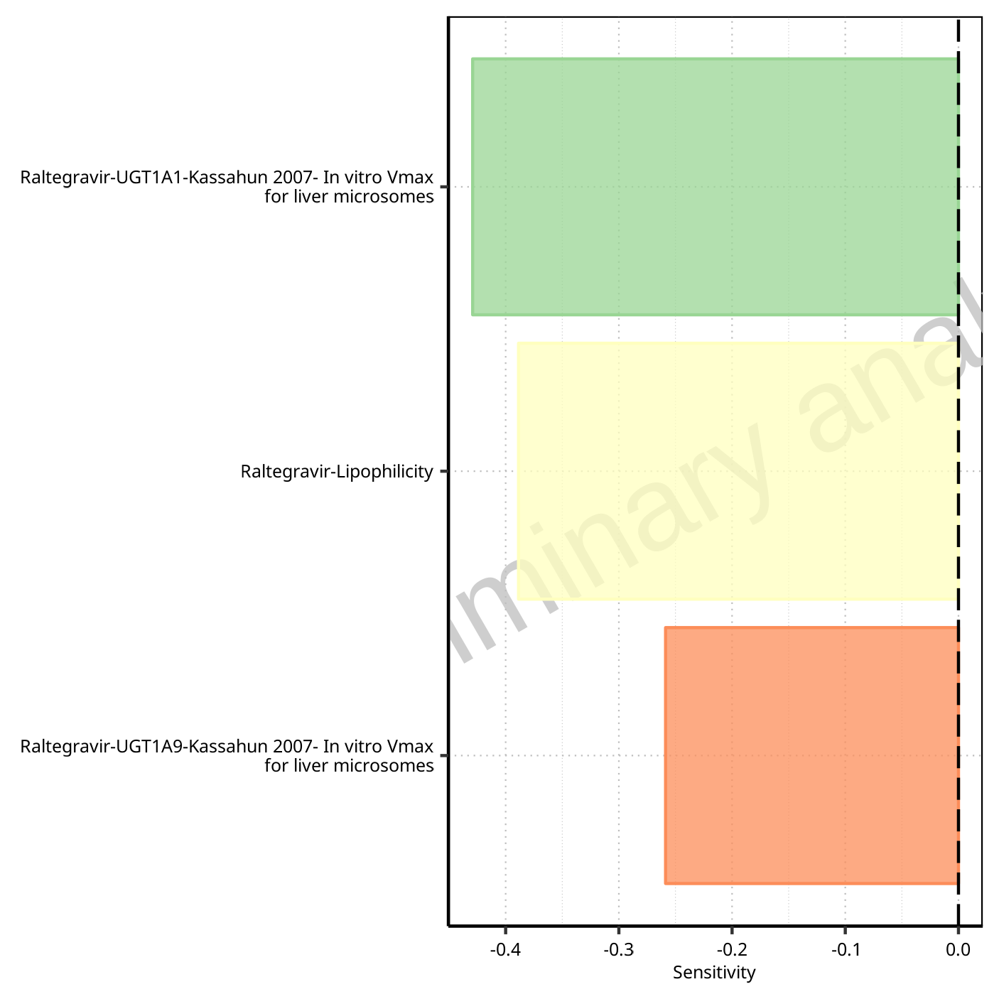

**Figure 1-54: Most sensitive parameters for AUC of Raltegravir.**

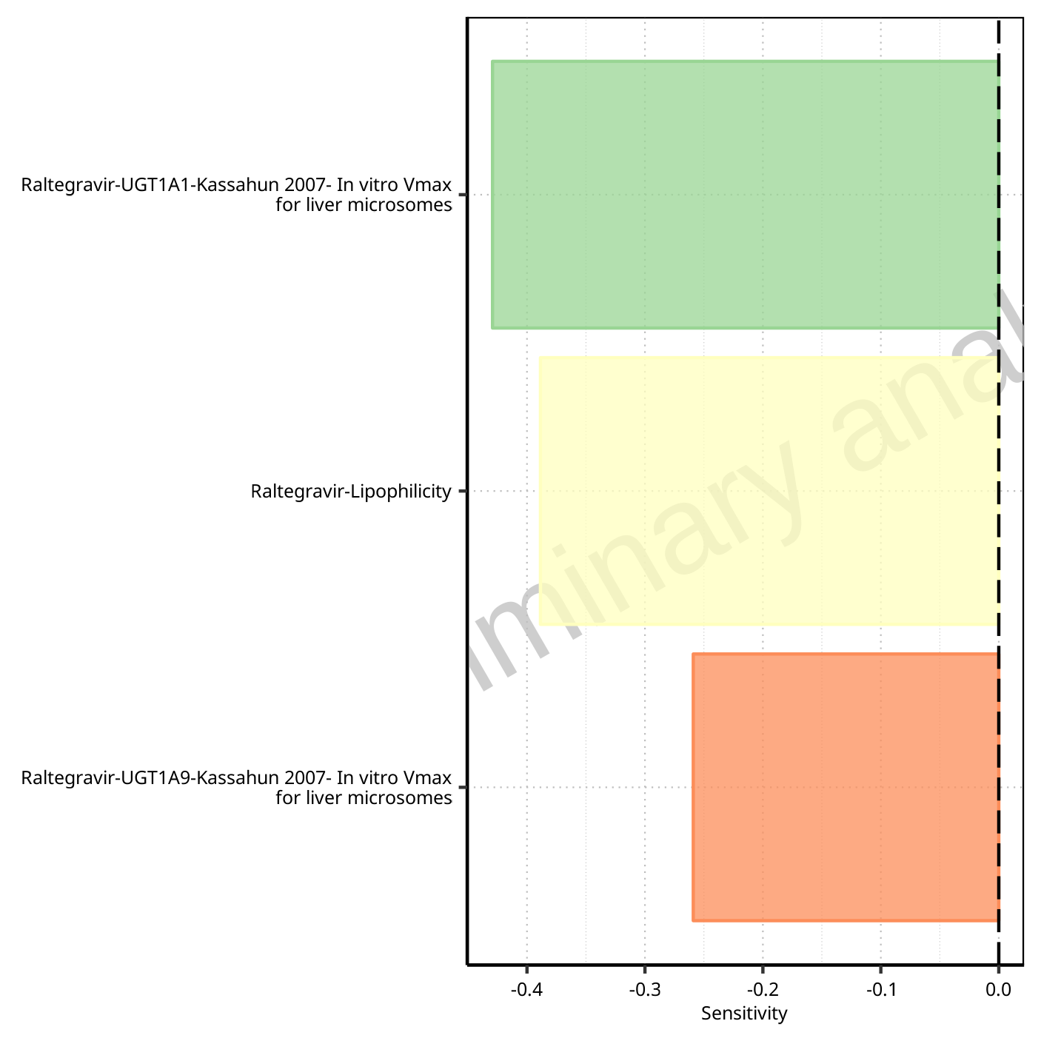

**Figure 1-55: Most sensitive parameters for AUC_inf of Raltegravir.**

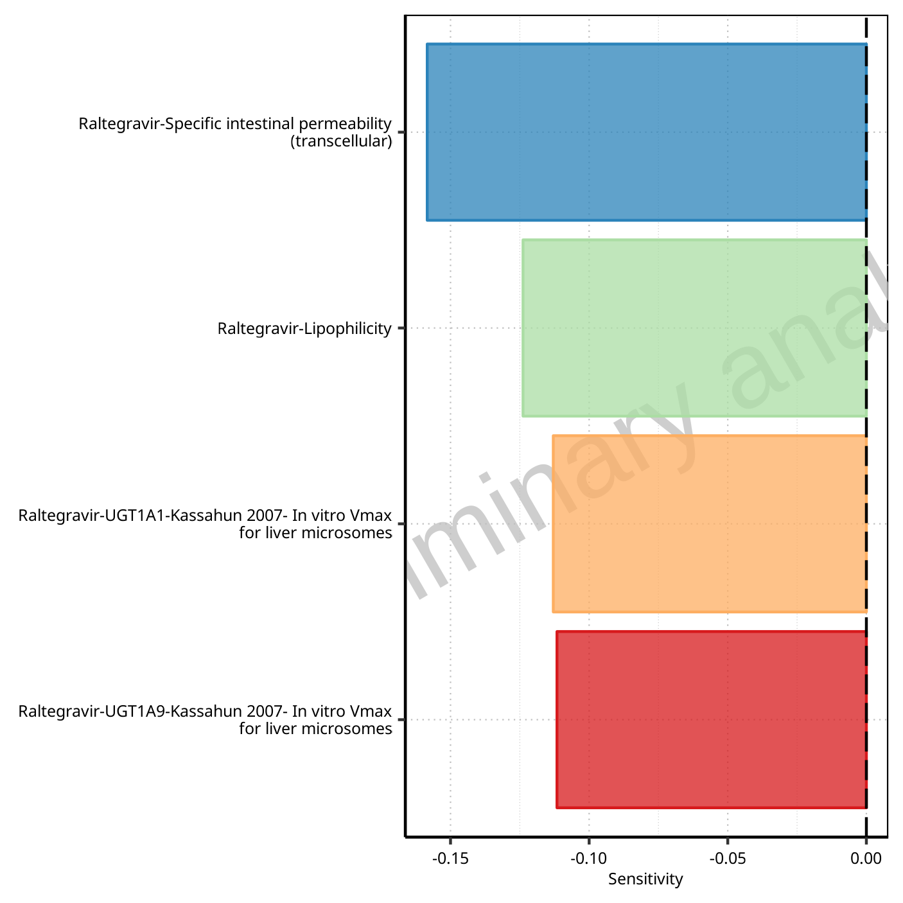

**Figure 1-56: Most sensitive parameters for MRT of Raltegravir.**

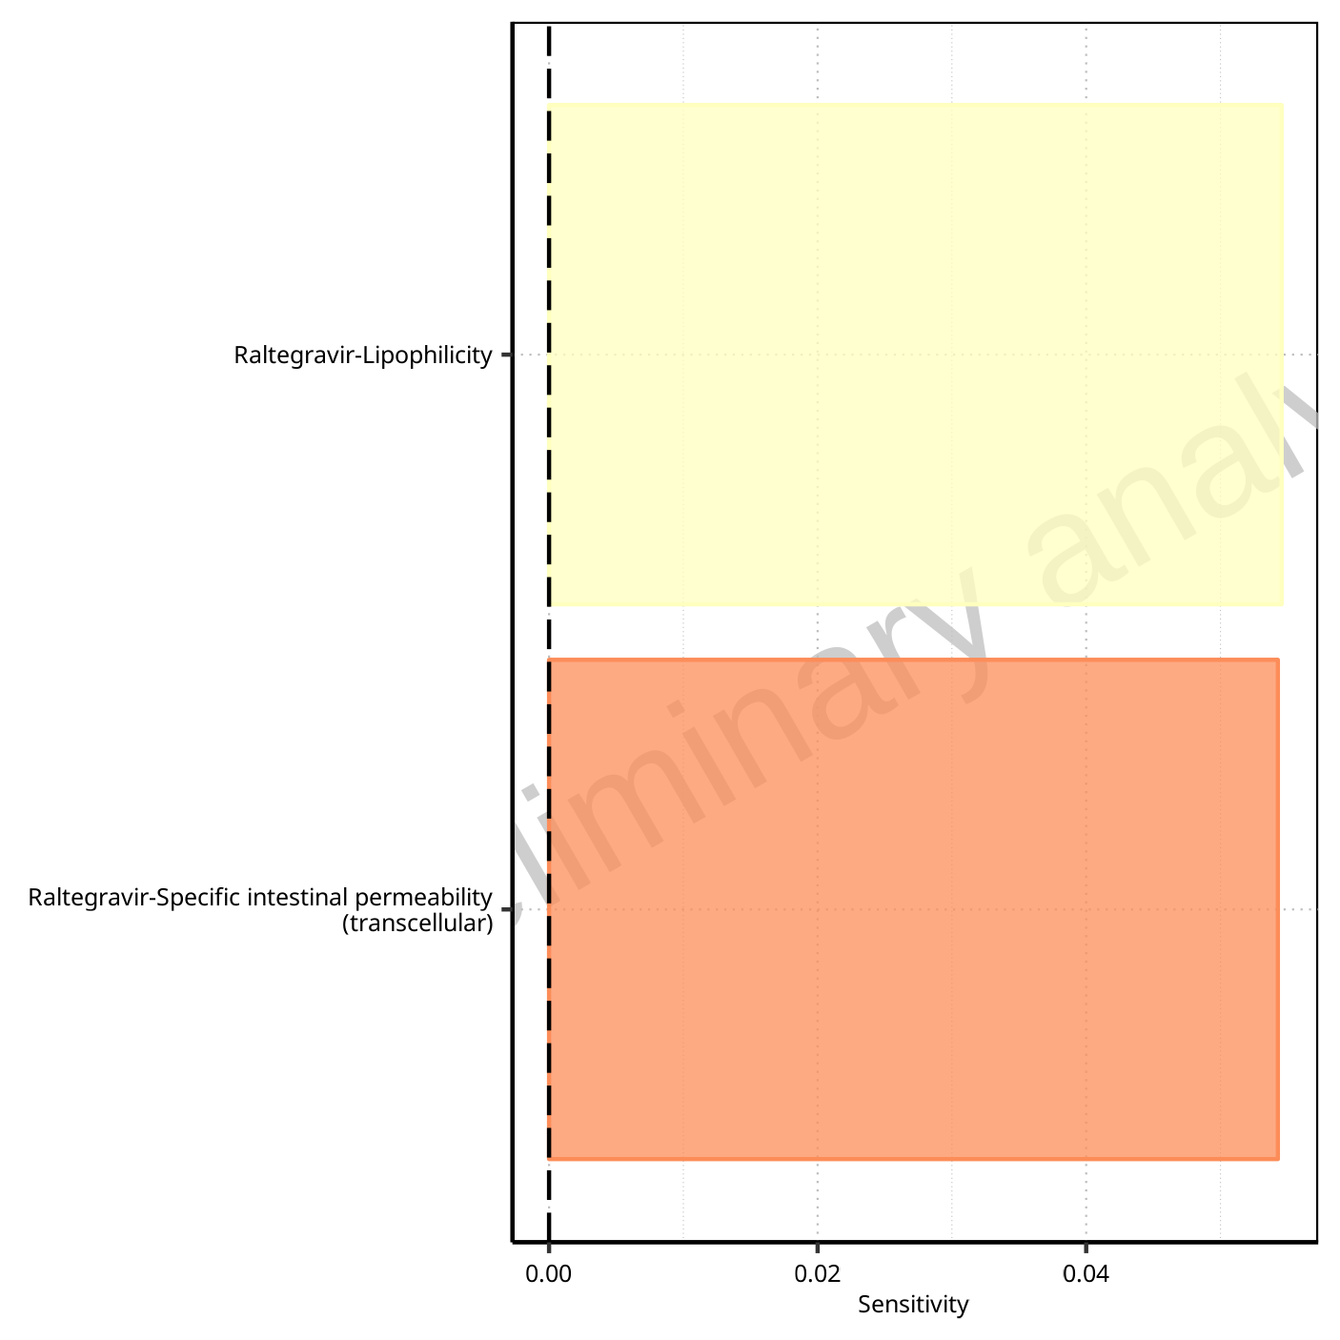

**Figure 1-57: Most sensitive parameters for Thalf of Raltegravir.**

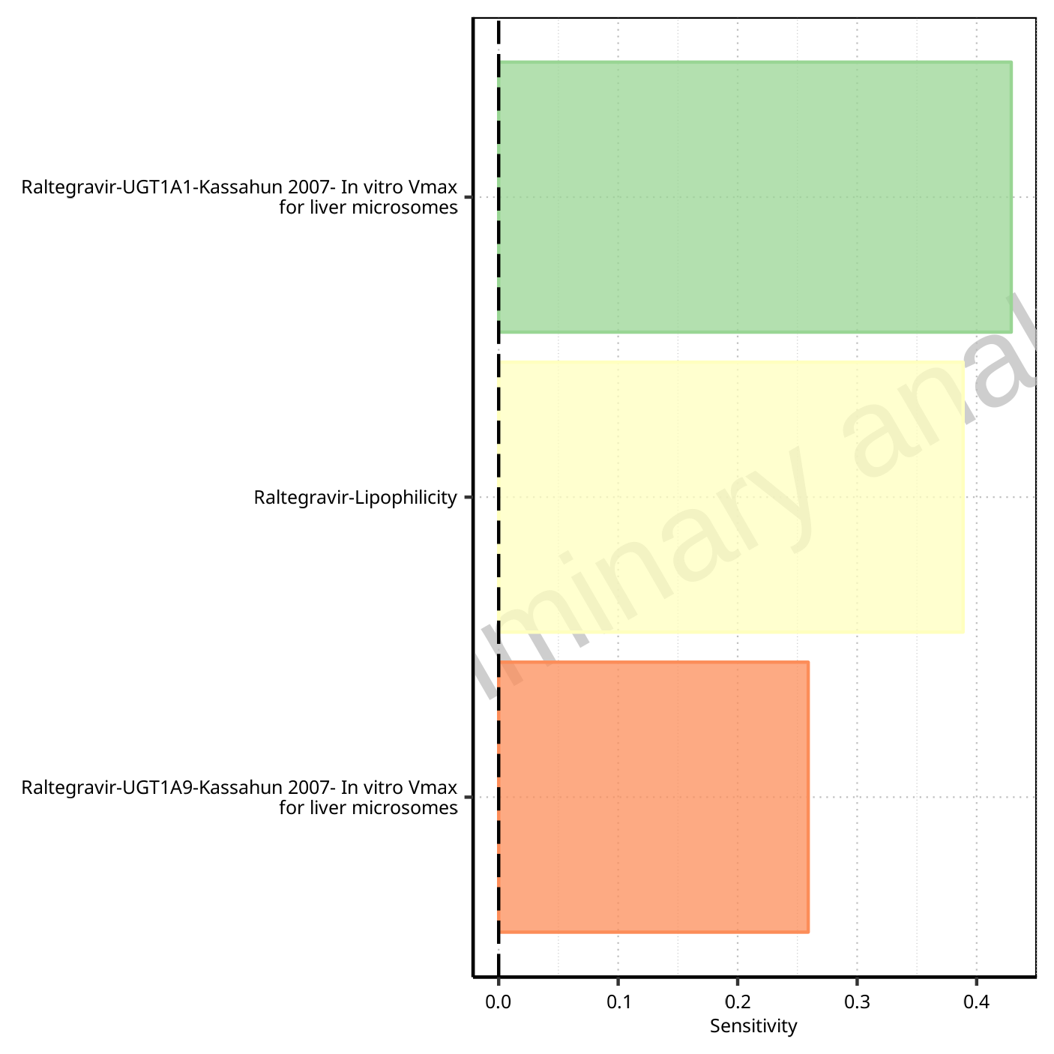

**Figure 1-58: Most sensitive parameters for CL of Raltegravir.**

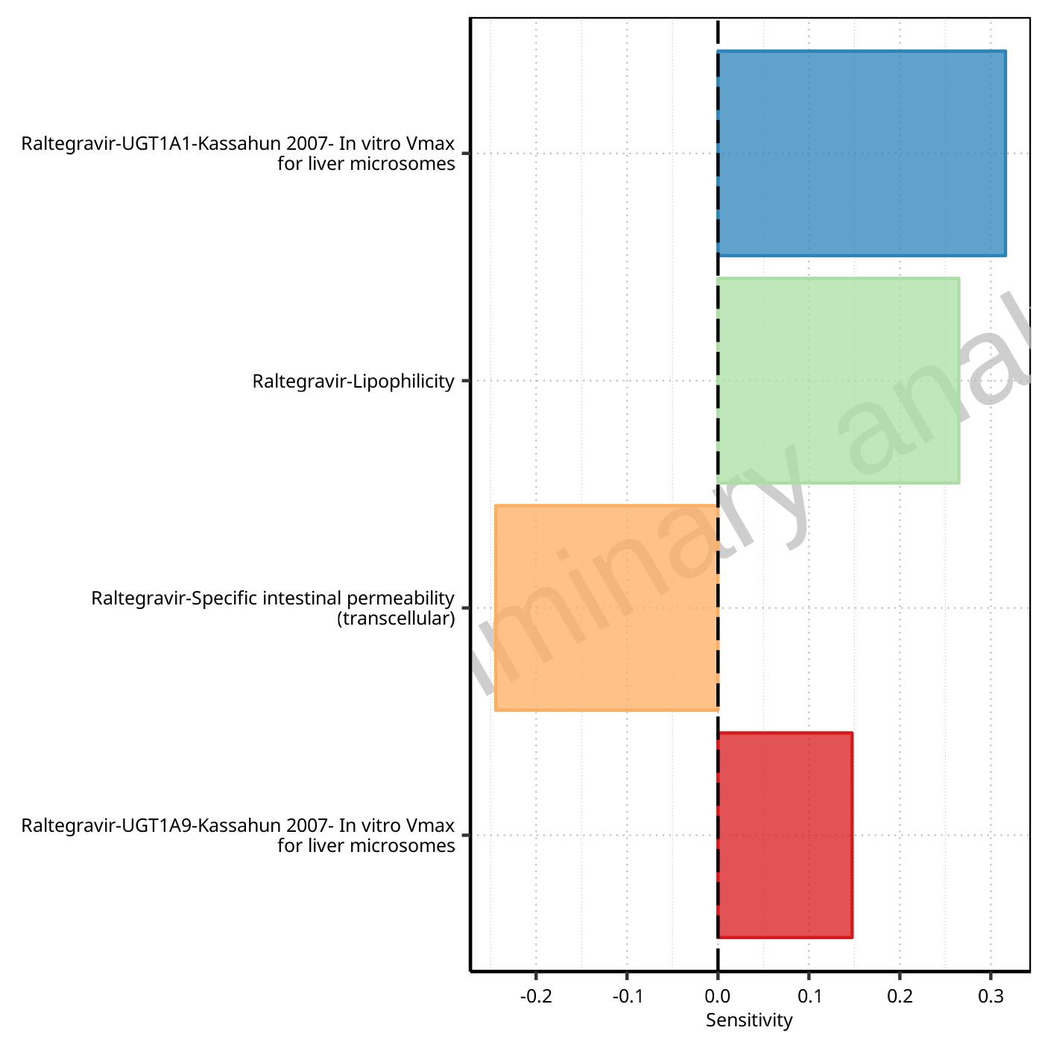

**Figure 1-59: Most sensitive parameters for Vss of Raltegravir.**

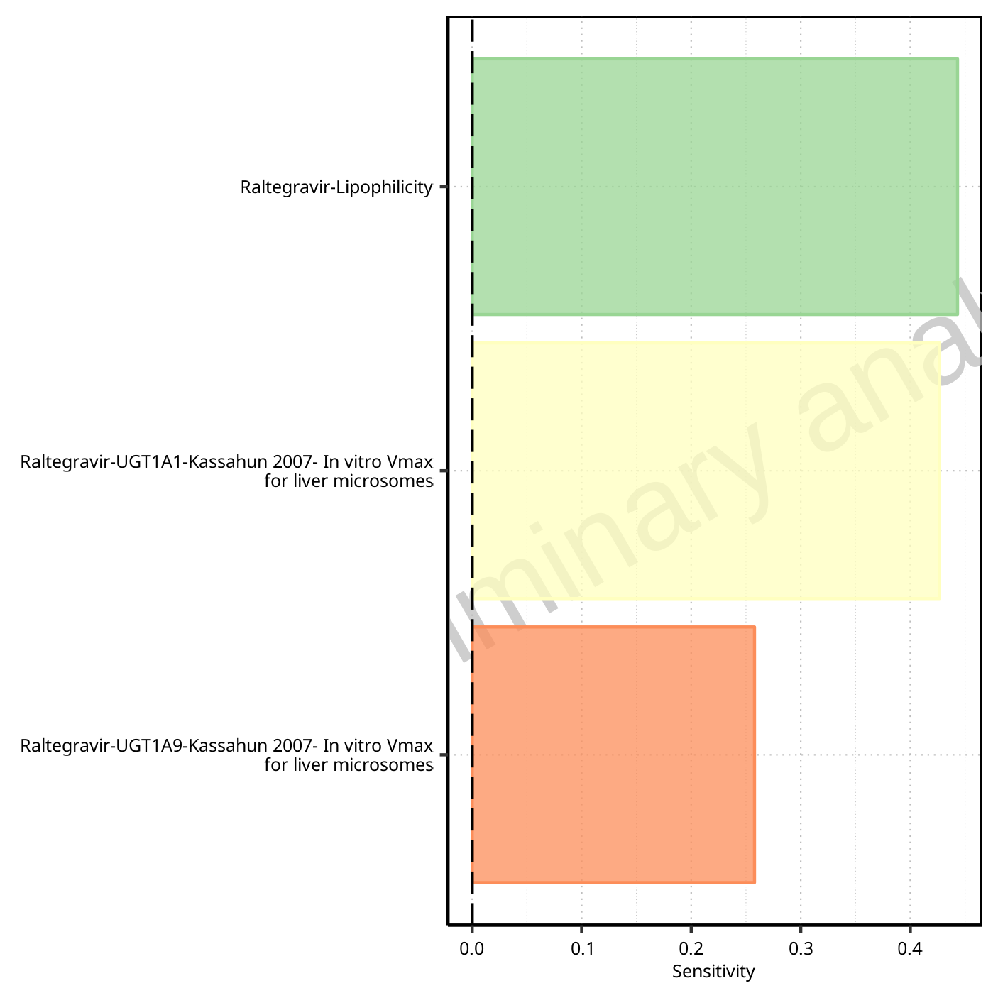

**Figure 1-60: Most sensitive parameters for Vd of Raltegravir.**

## Sensitivity Analysis for Raltegravir 800 mg (lactose formulation)

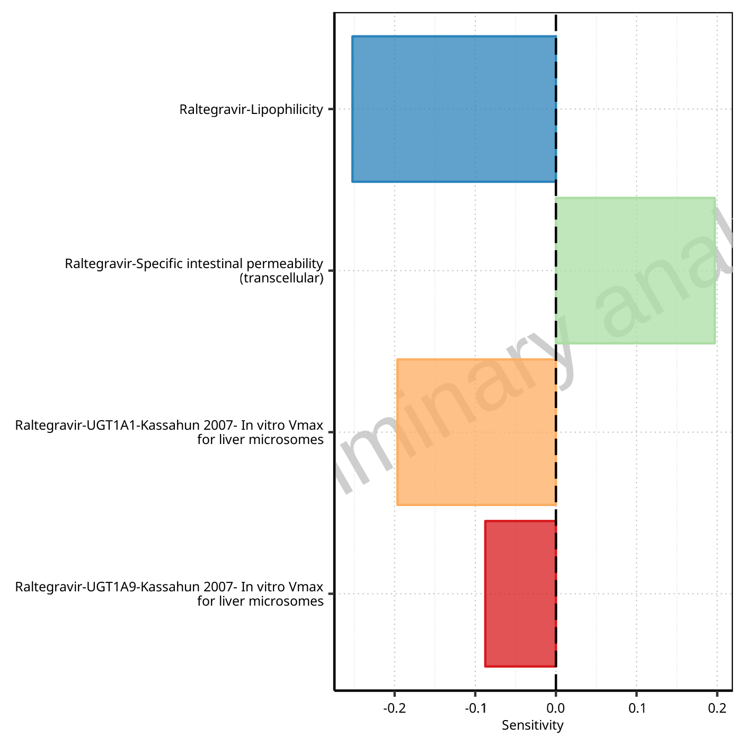

**Figure 1-61: Most sensitive parameters for C_max of Raltegravir.**



**Figure 1-62: Most sensitive parameters for t_max of Raltegravir.**

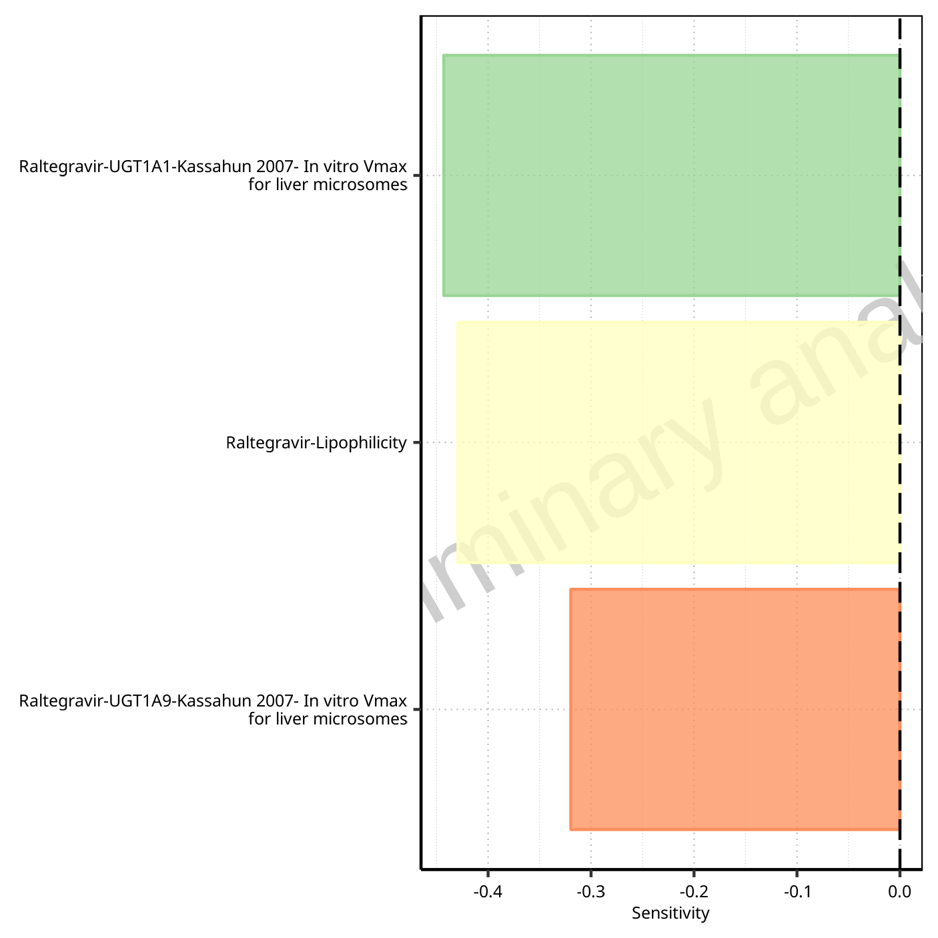

**Figure 1-63: Most sensitive parameters for C_tEnd of Raltegravir.**

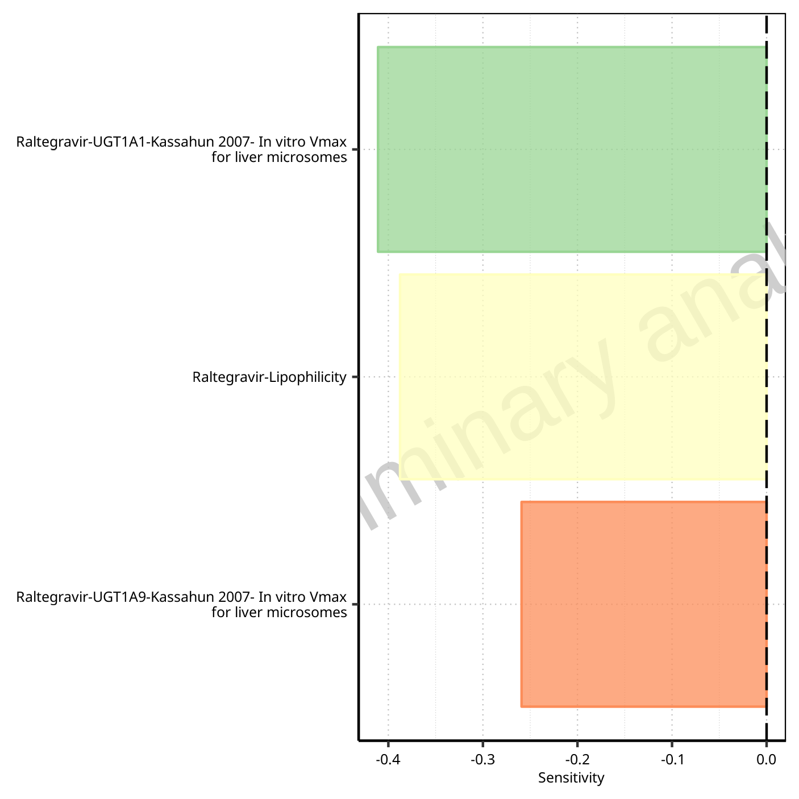

**Figure 1-64: Most sensitive parameters for AUC of Raltegravir.**

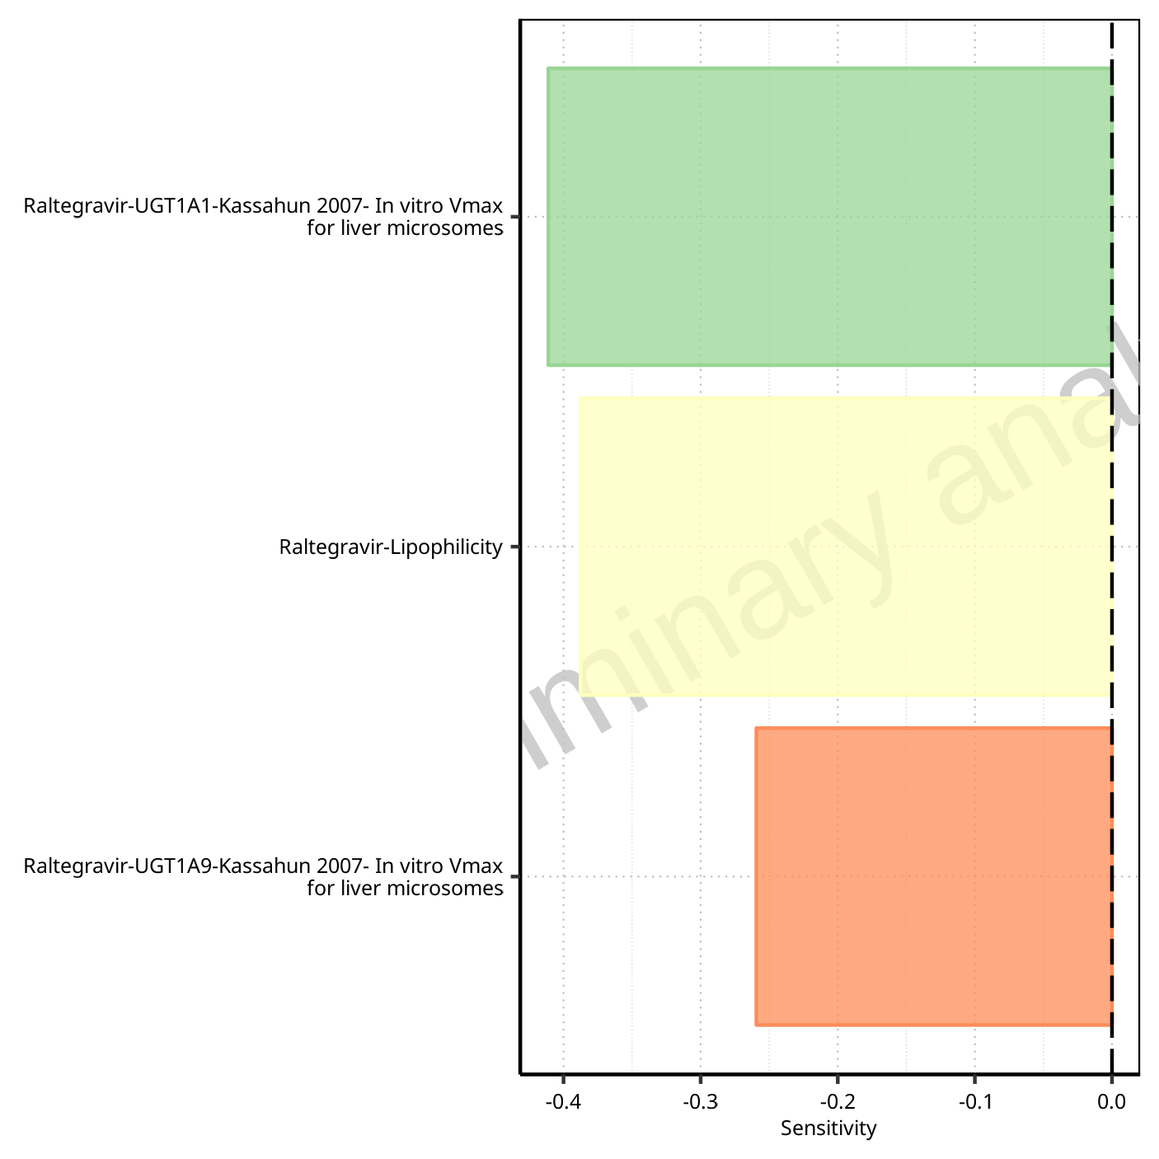

**Figure 1-65: Most sensitive parameters for AUC_inf of Raltegravir.**

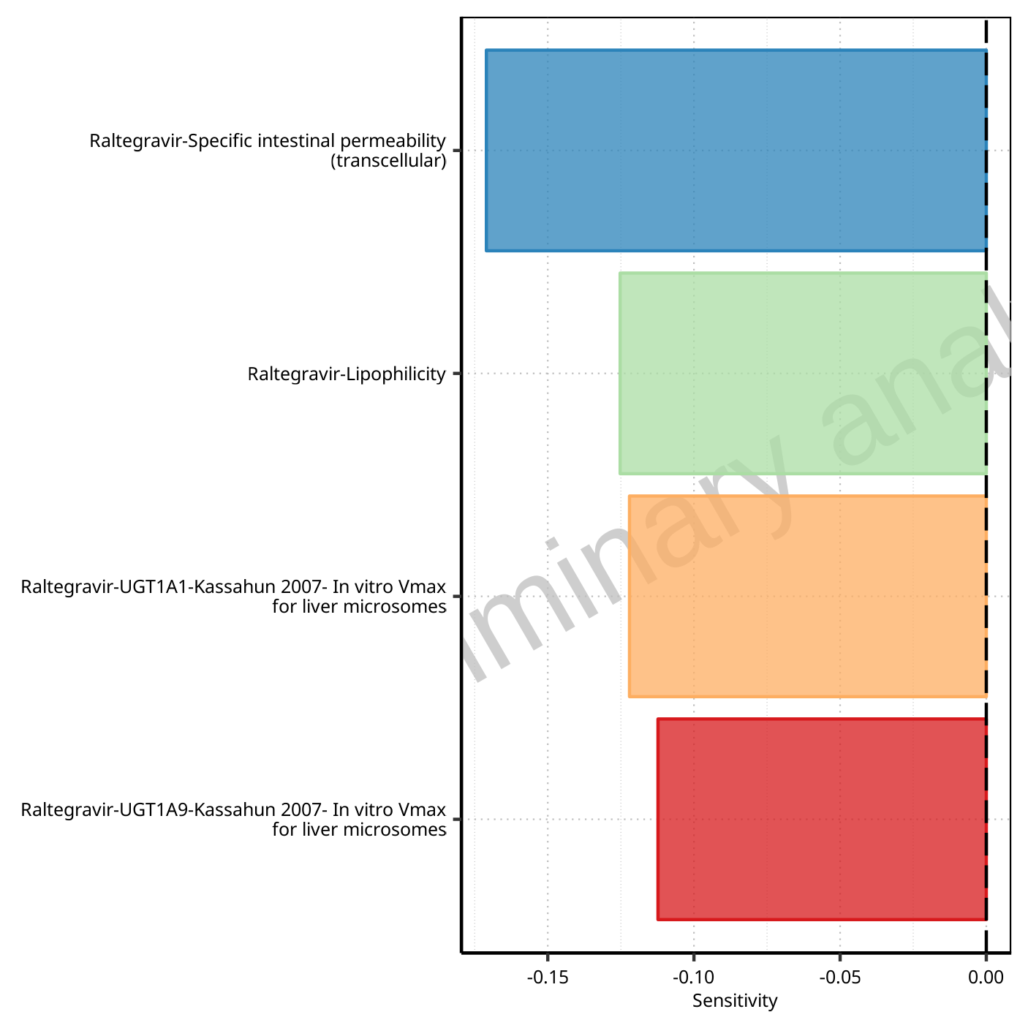

**Figure 1-66: Most sensitive parameters for MRT of Raltegravir.**

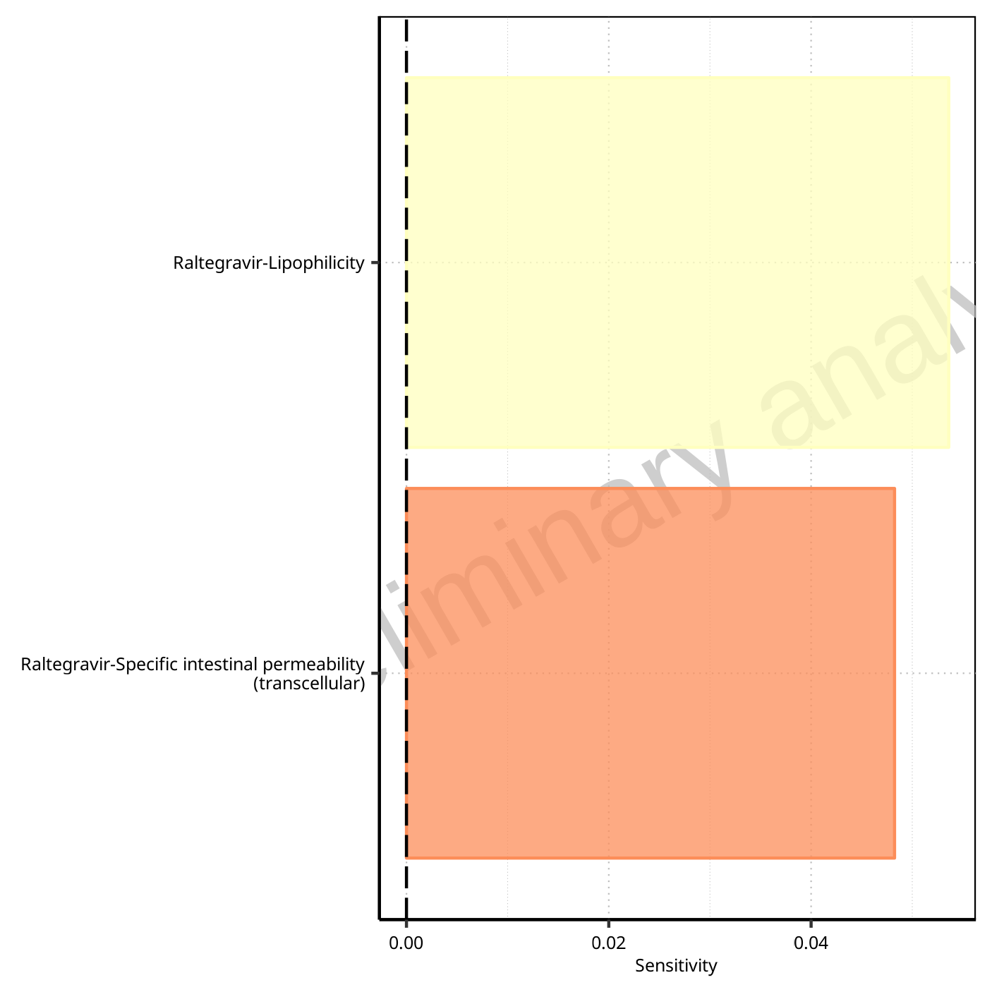

**Figure 1-67: Most sensitive parameters for Thalf of Raltegravir.**

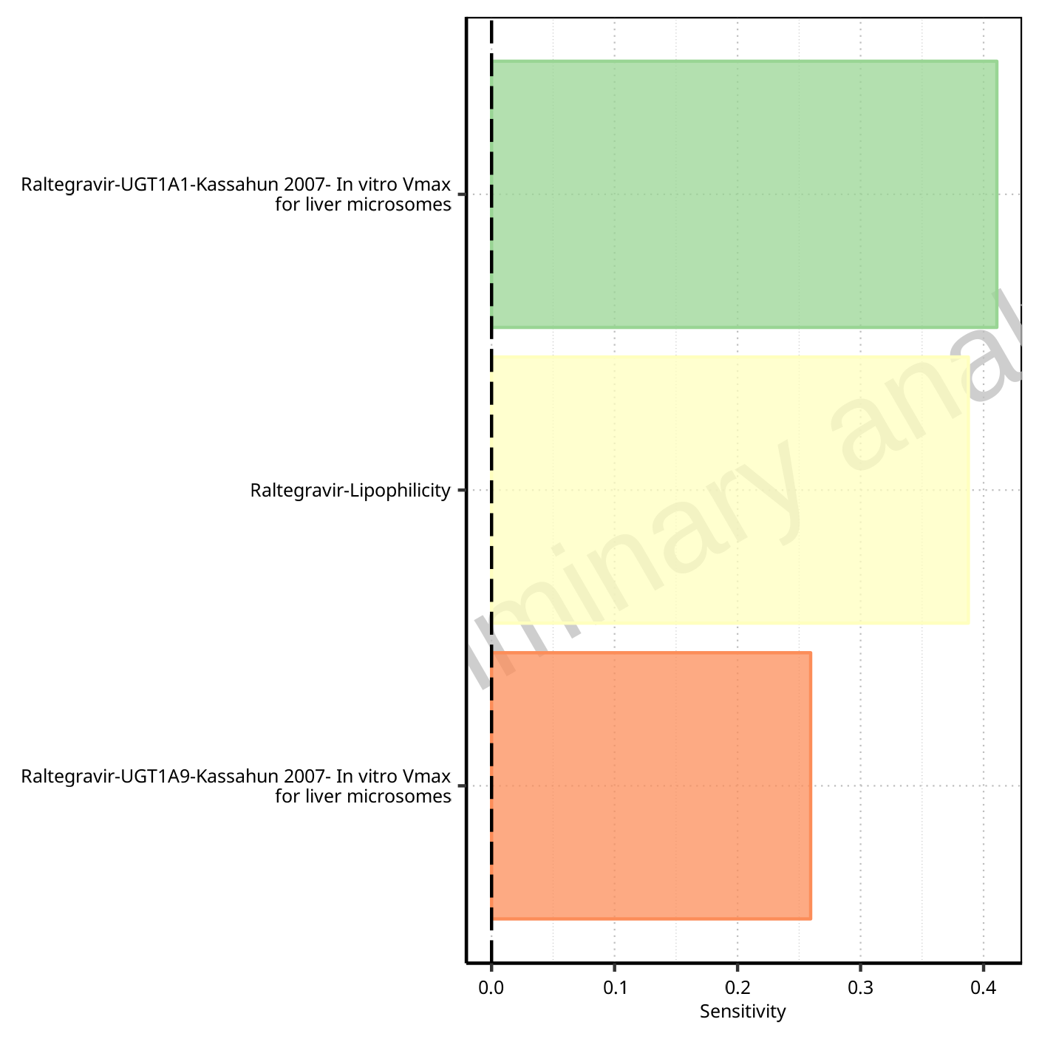

**Figure 1-68: Most sensitive parameters for CL of Raltegravir.**

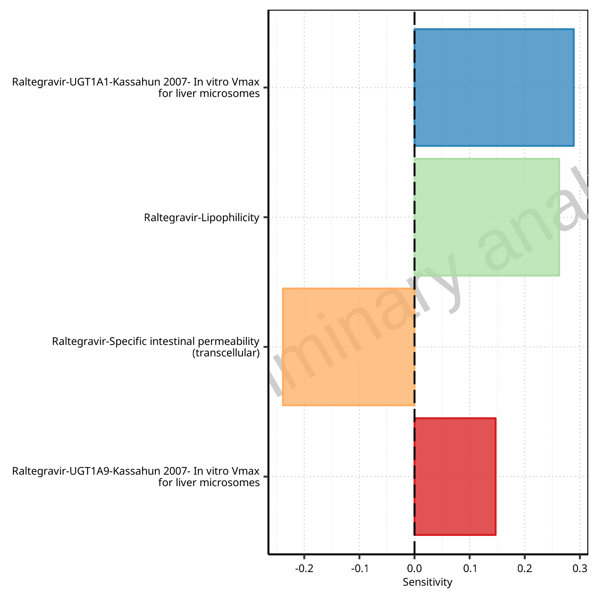

**Figure 1-69: Most sensitive parameters for Vss of Raltegravir.**

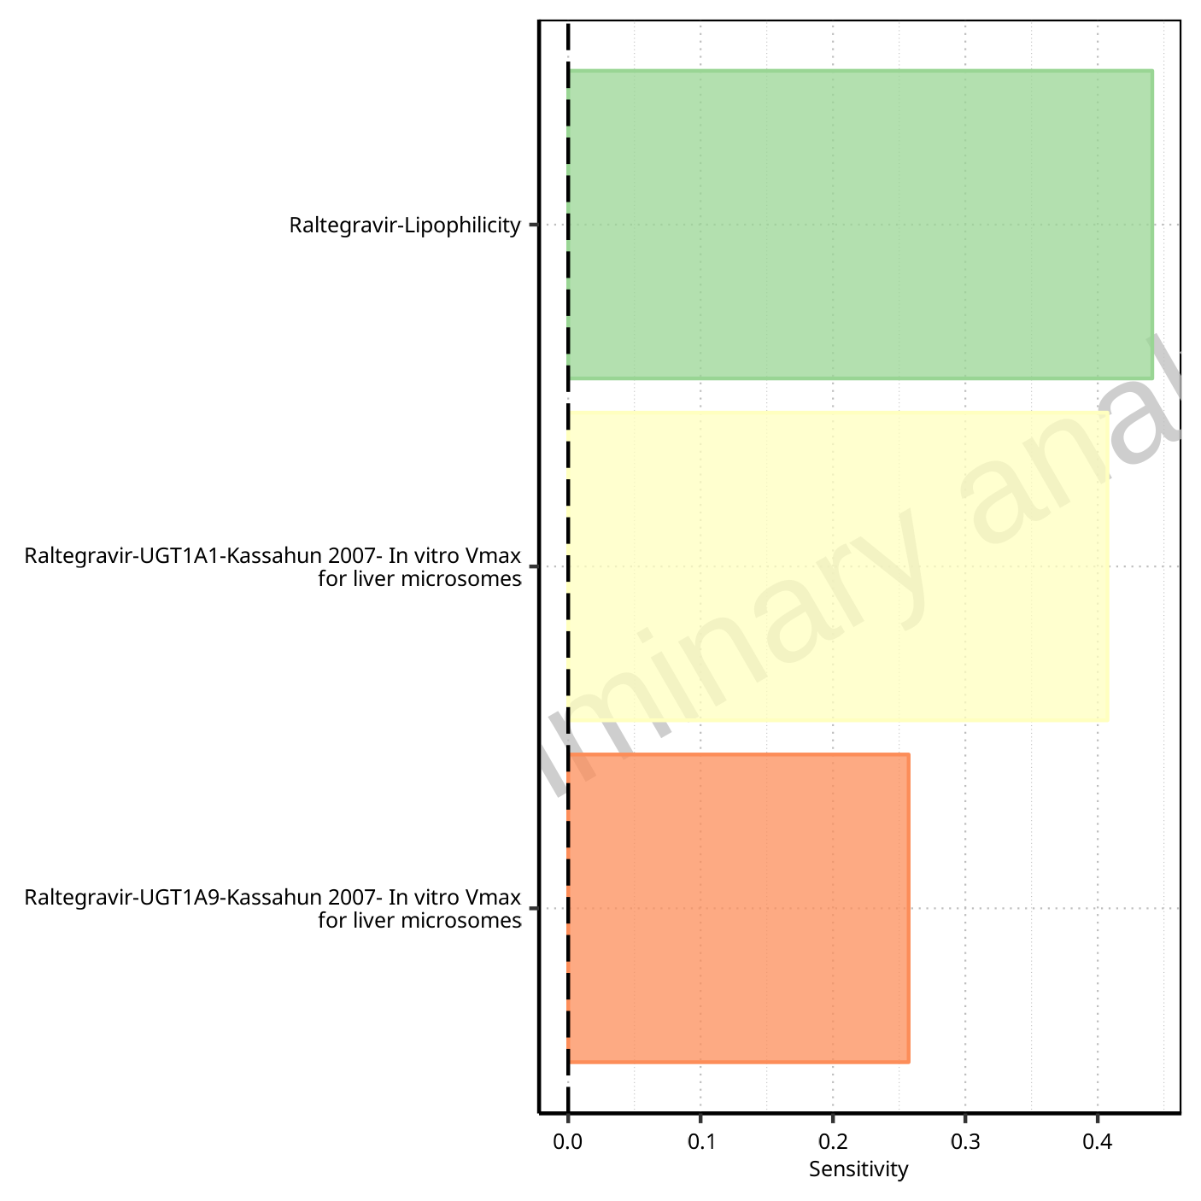

**Figure 1-70: Most sensitive parameters for Vd of Raltegravir.**

## Sensitivity Analysis for Raltegravir 1200 mg (lactose formulation)

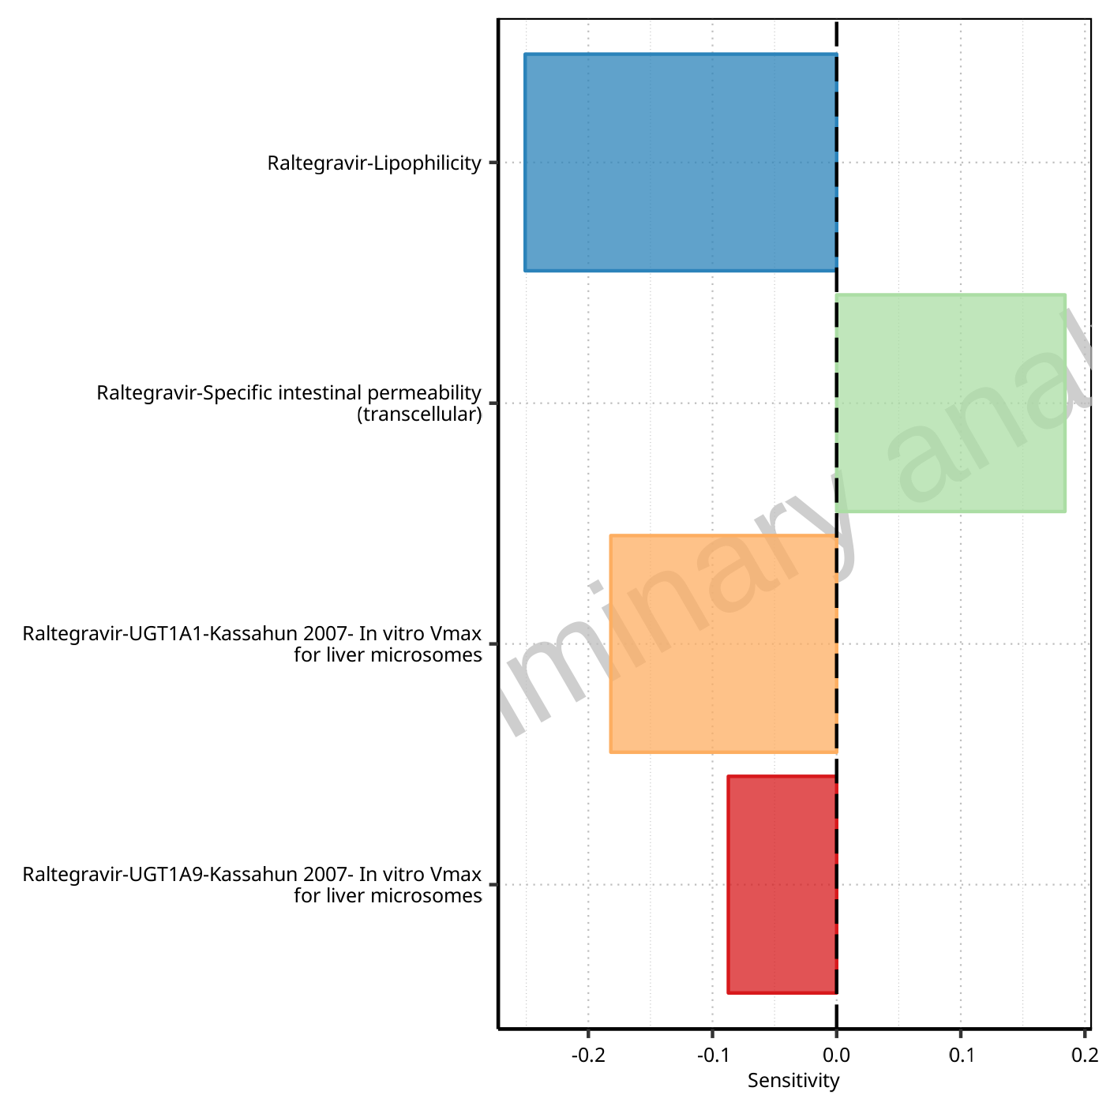

**Figure 1-71: Most sensitive parameters for C_max of Raltegravir.**



**Figure 1-72: Most sensitive parameters for t_max of Raltegravir.**

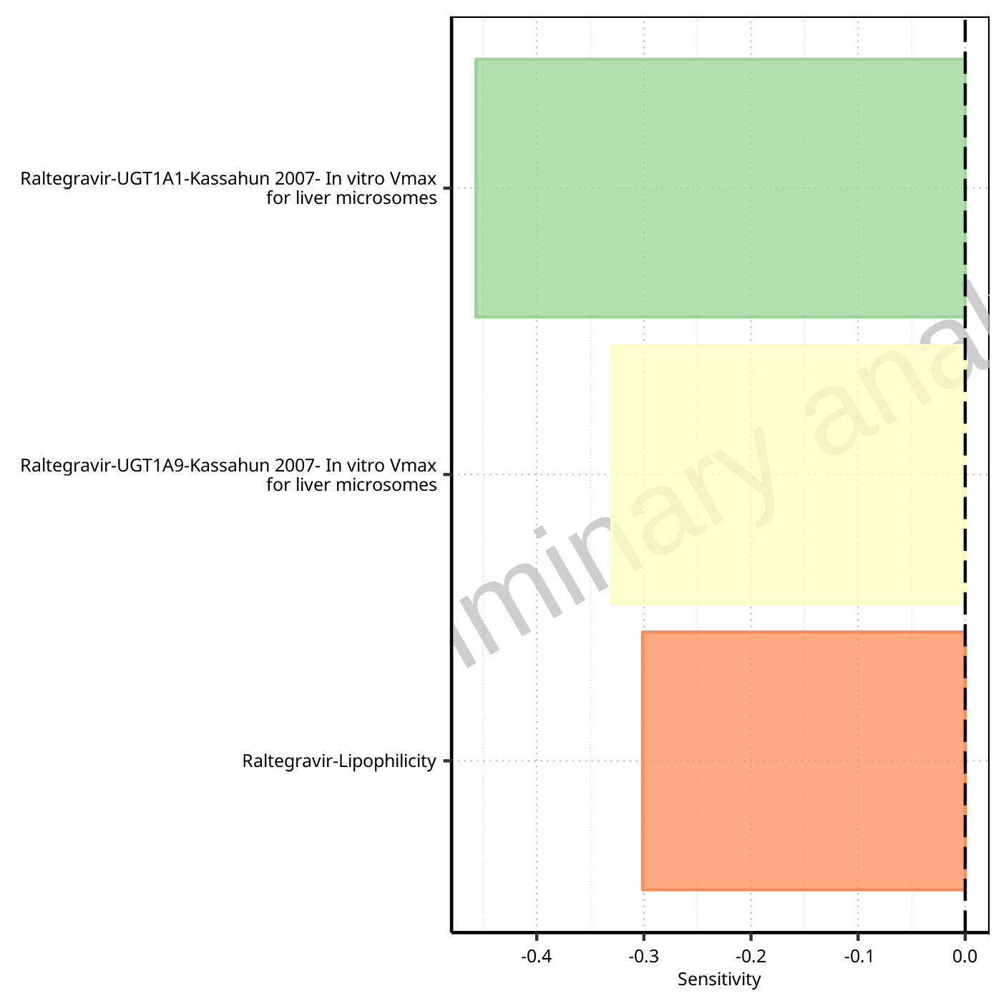

**Figure 1-73: Most sensitive parameters for C_tEnd of Raltegravir.**

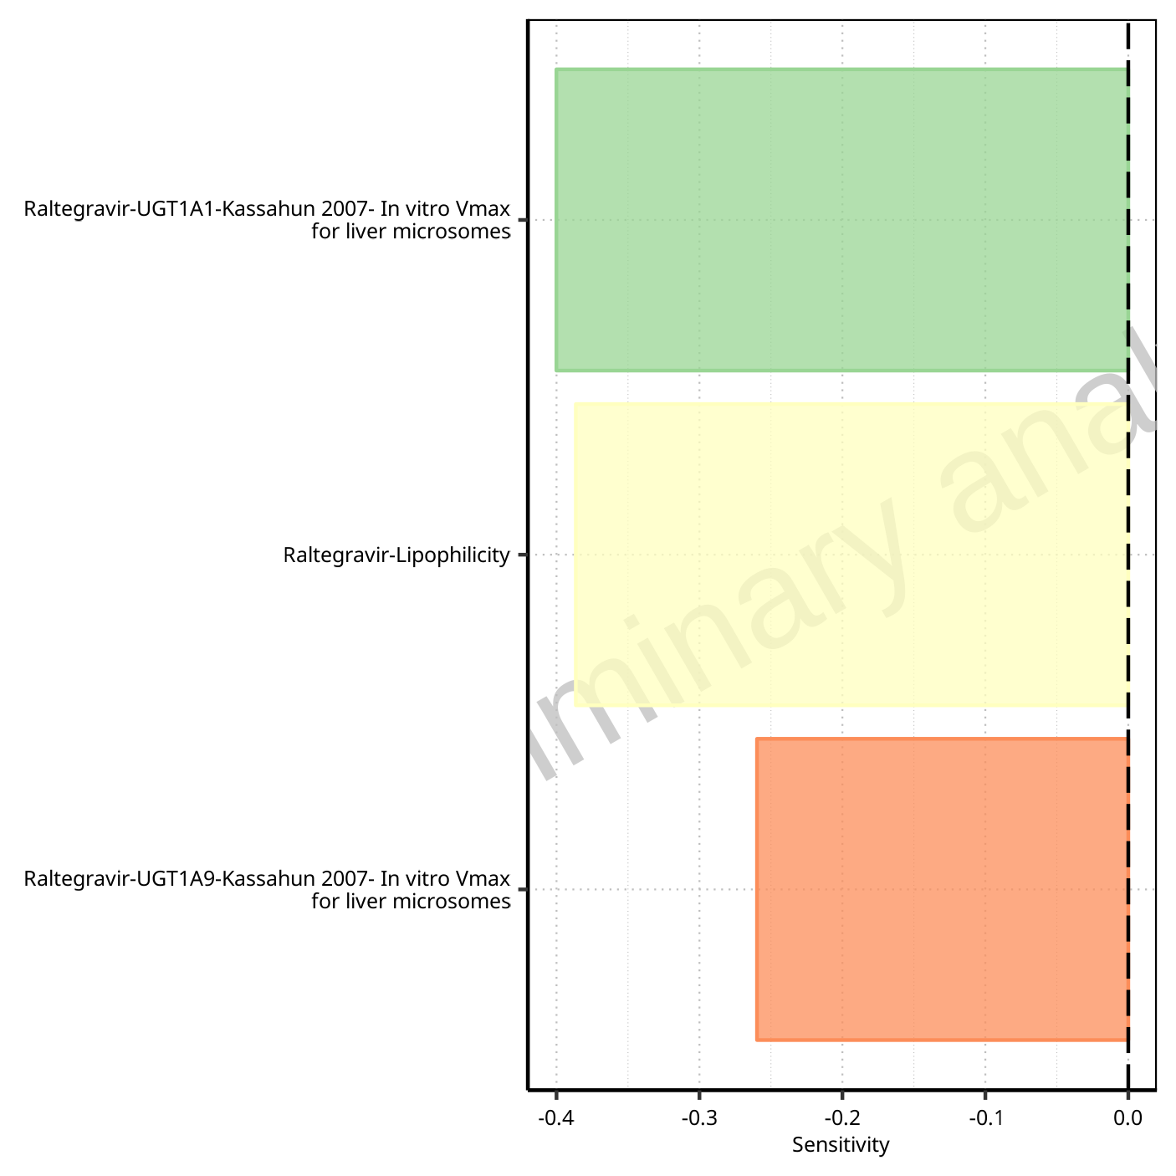

**Figure 1-74: Most sensitive parameters for AUC of Raltegravir.**

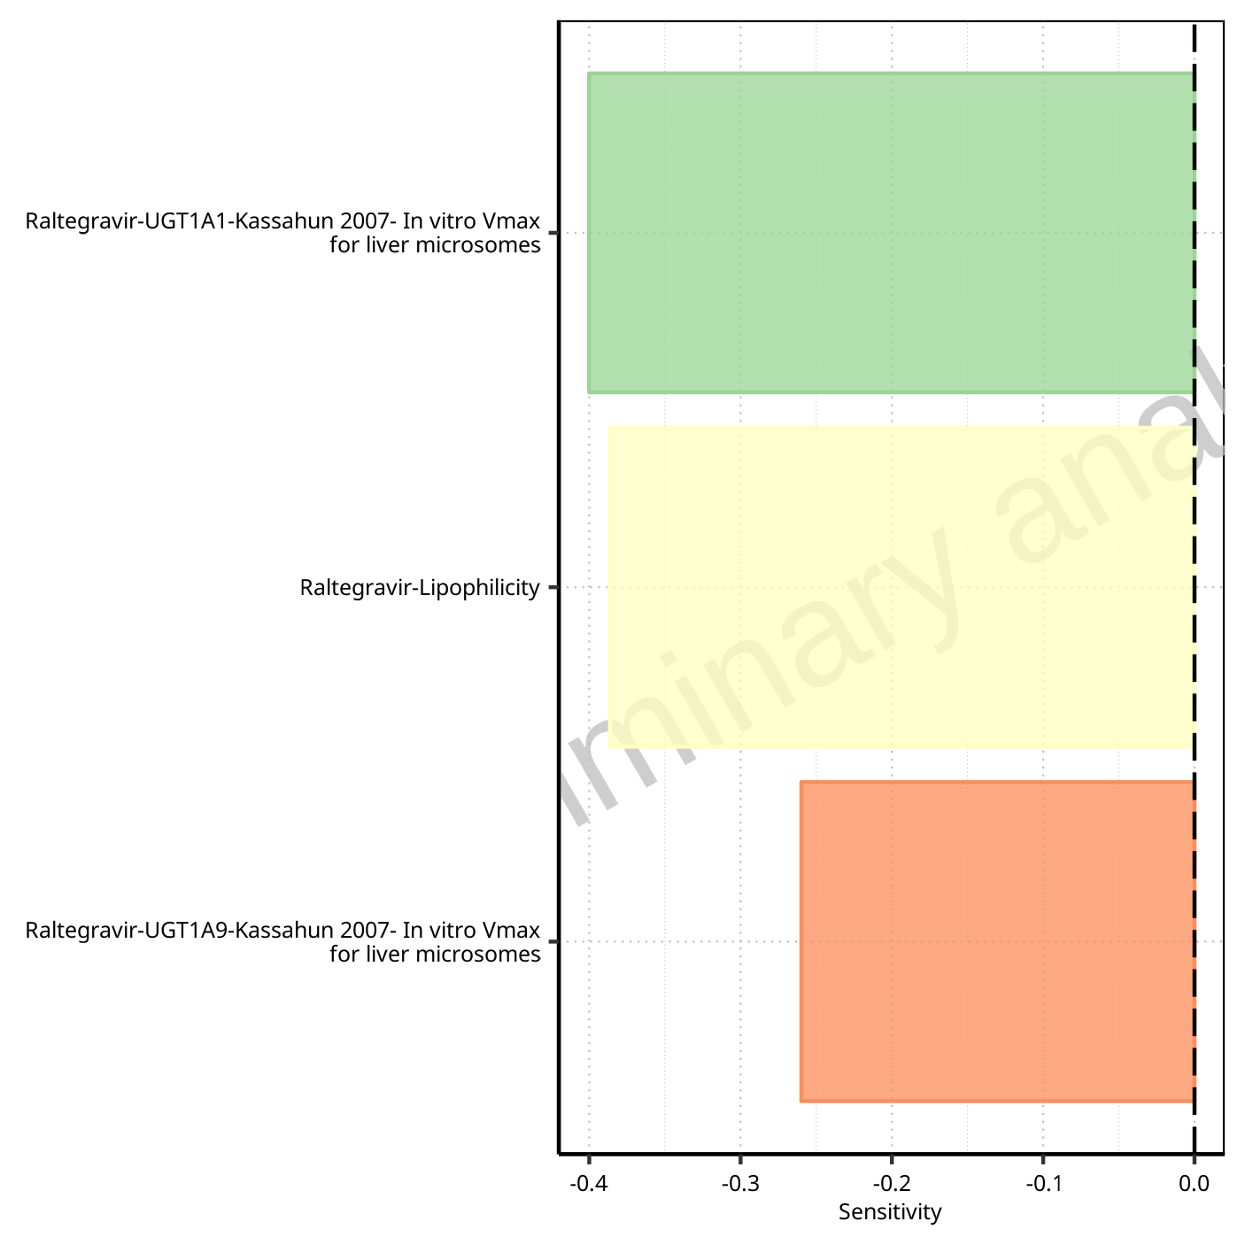

**Figure 1-75: Most sensitive parameters for AUC_inf of Raltegravir.**

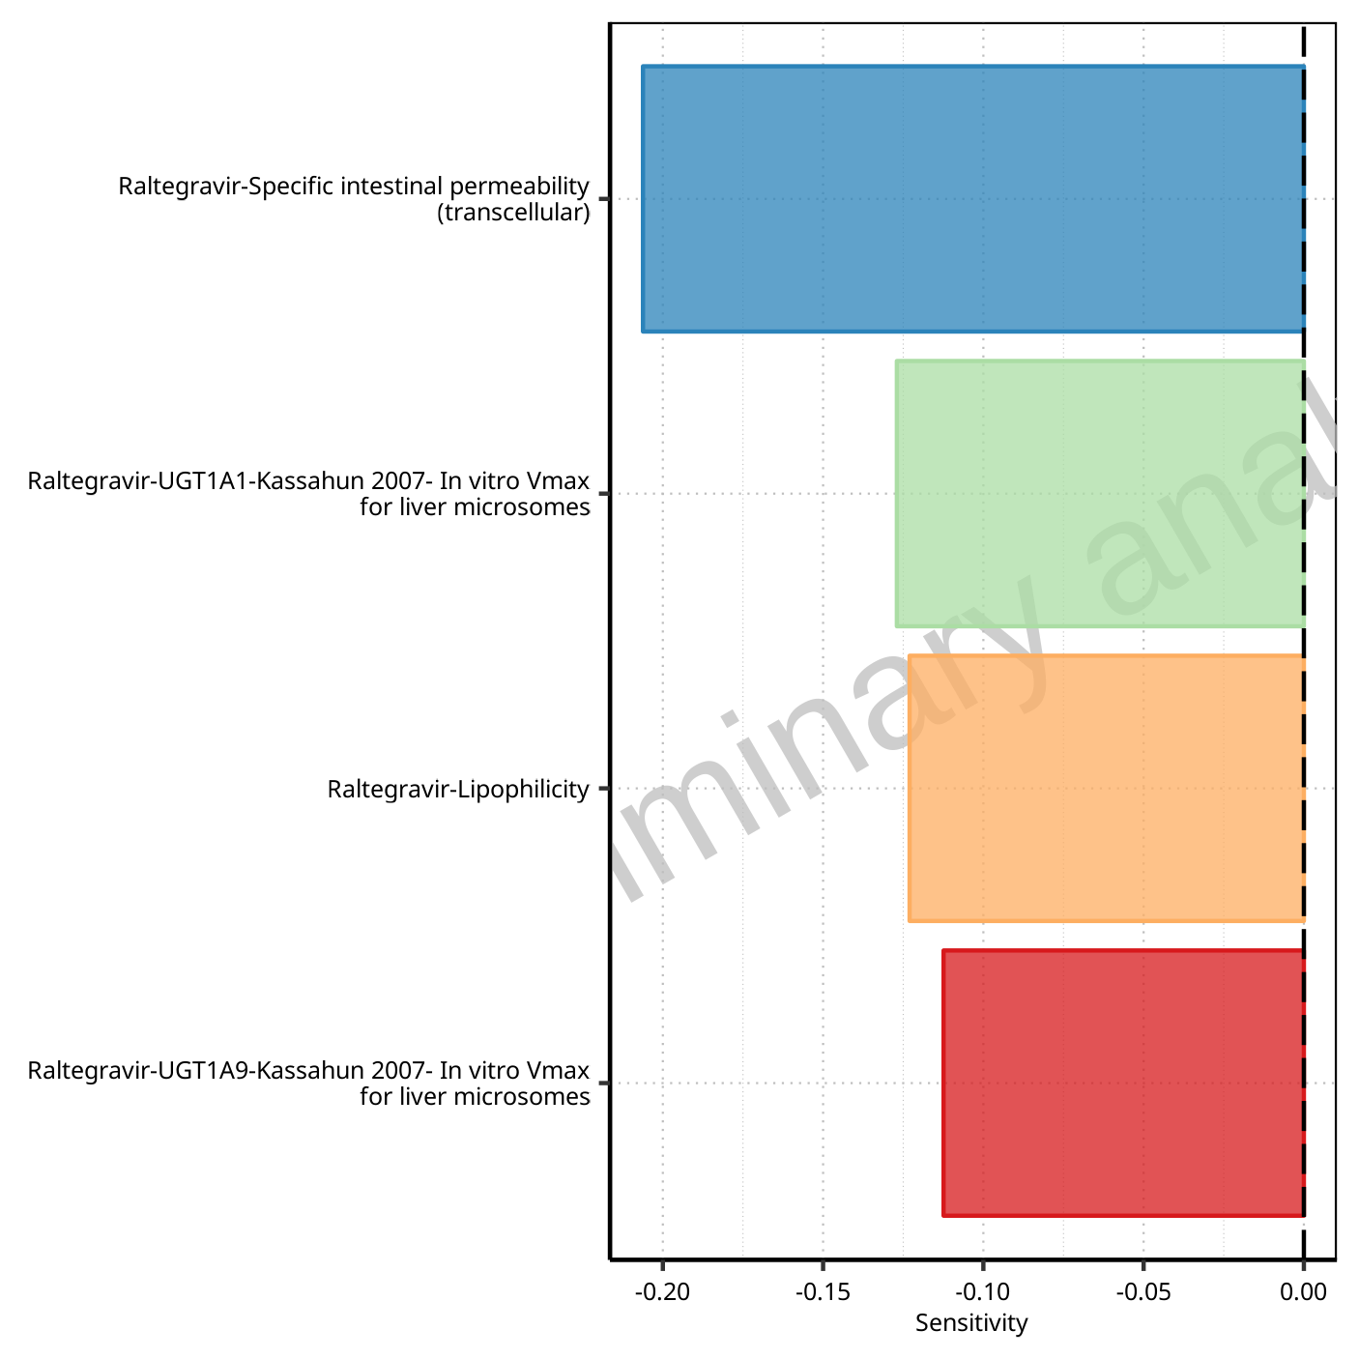

**Figure 1-76: Most sensitive parameters for MRT of Raltegravir.**

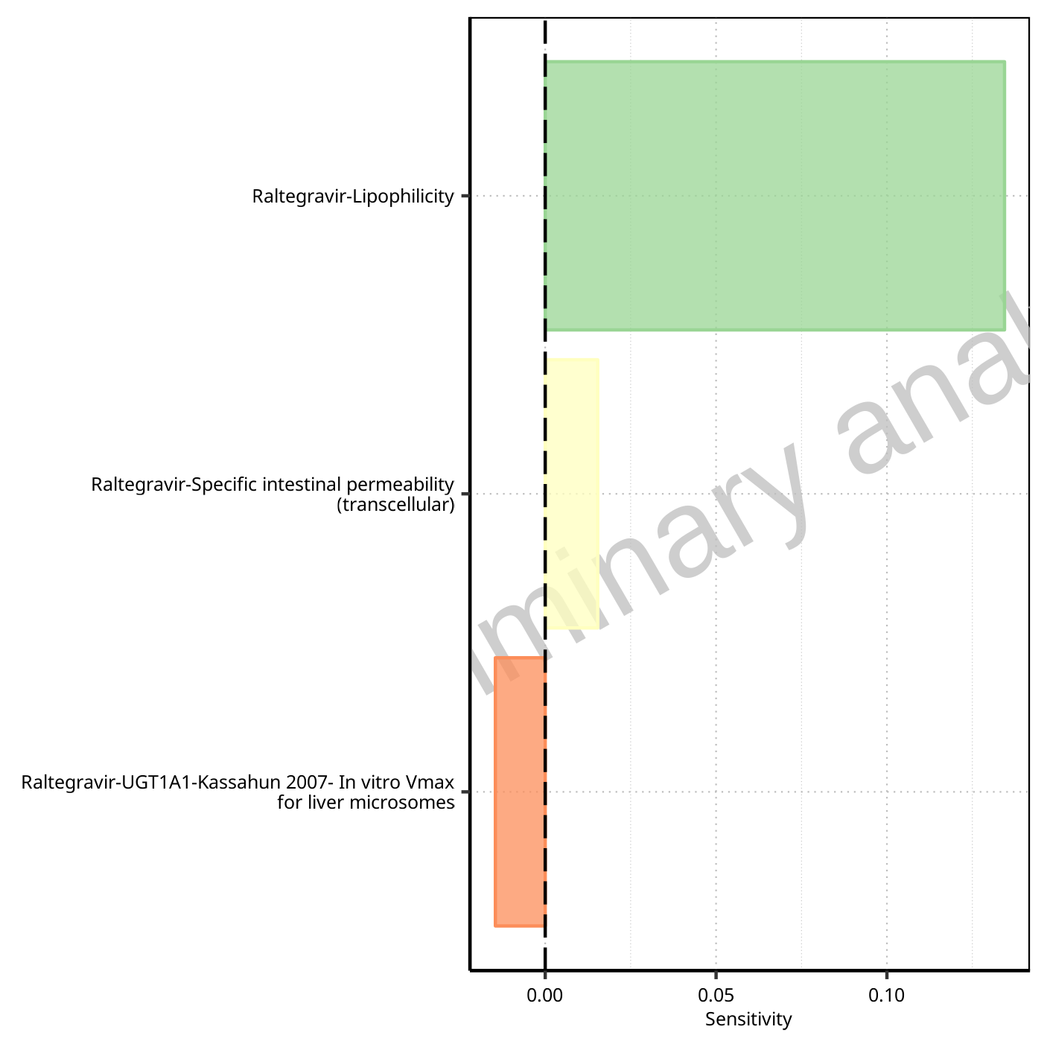

**Figure 1-77: Most sensitive parameters for Thalf of Raltegravir.**

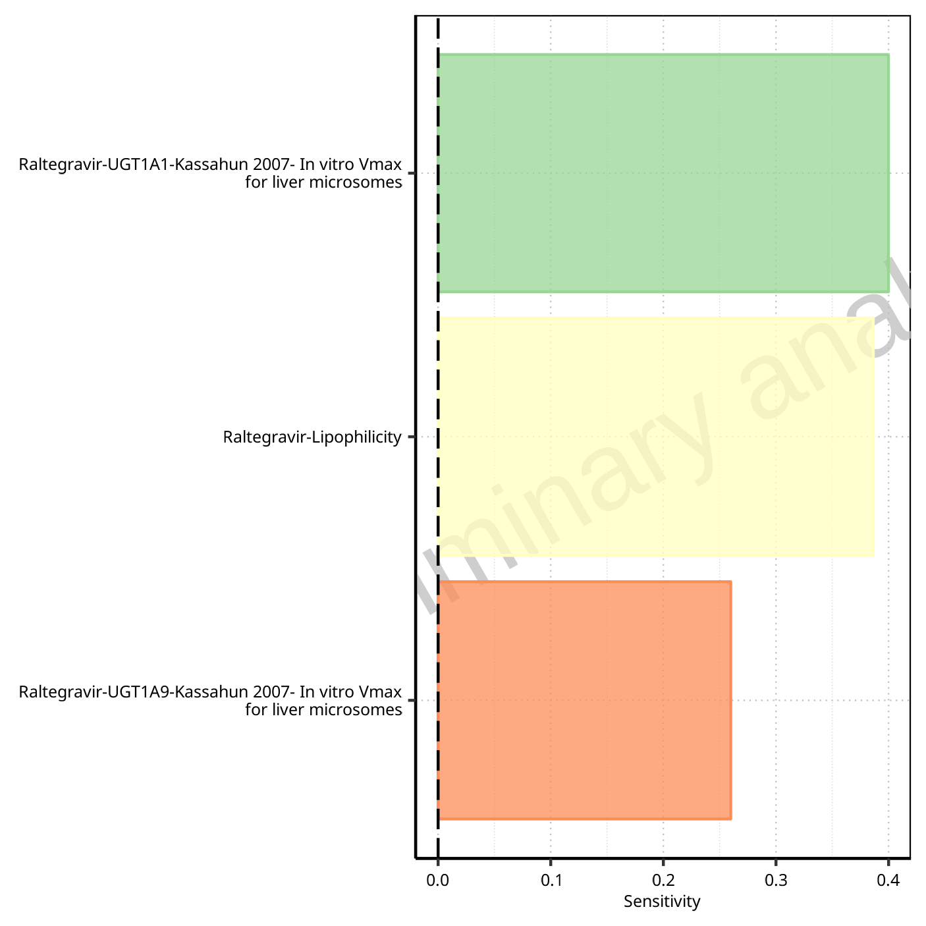

**Figure 1-78: Most sensitive parameters for CL of Raltegravir.**

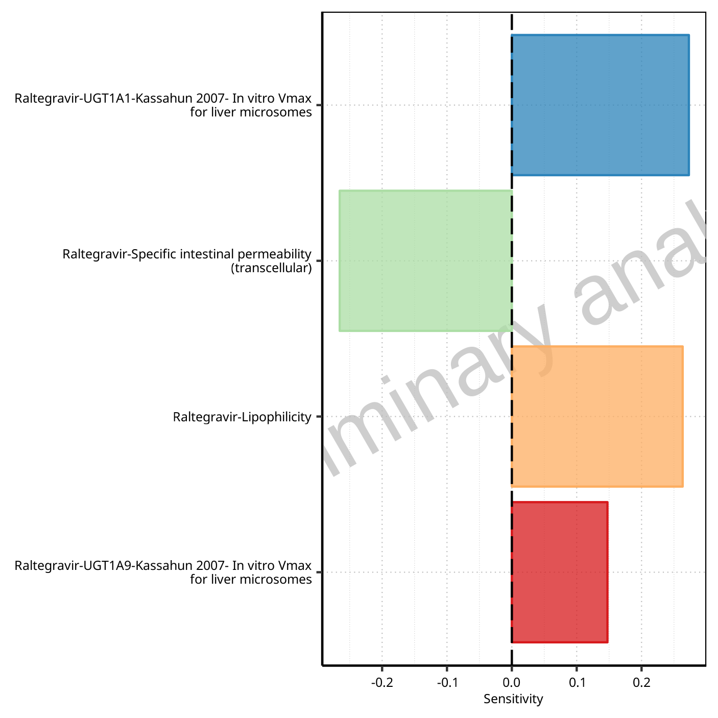

**Figure 1-79: Most sensitive parameters for Vss of Raltegravir.**

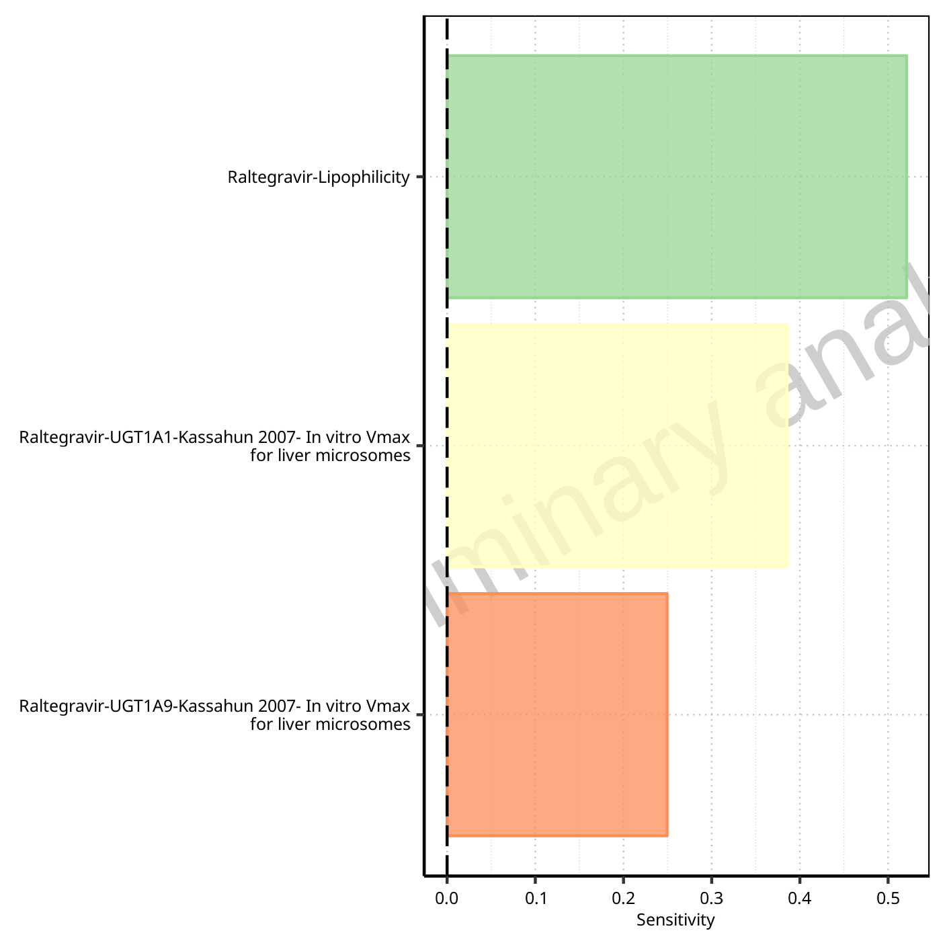

**Figure 1-80: Most sensitive parameters for Vd of Raltegravir.**

## Sensitivity Analysis for Raltegravir 1600 mg (lactose formulation)

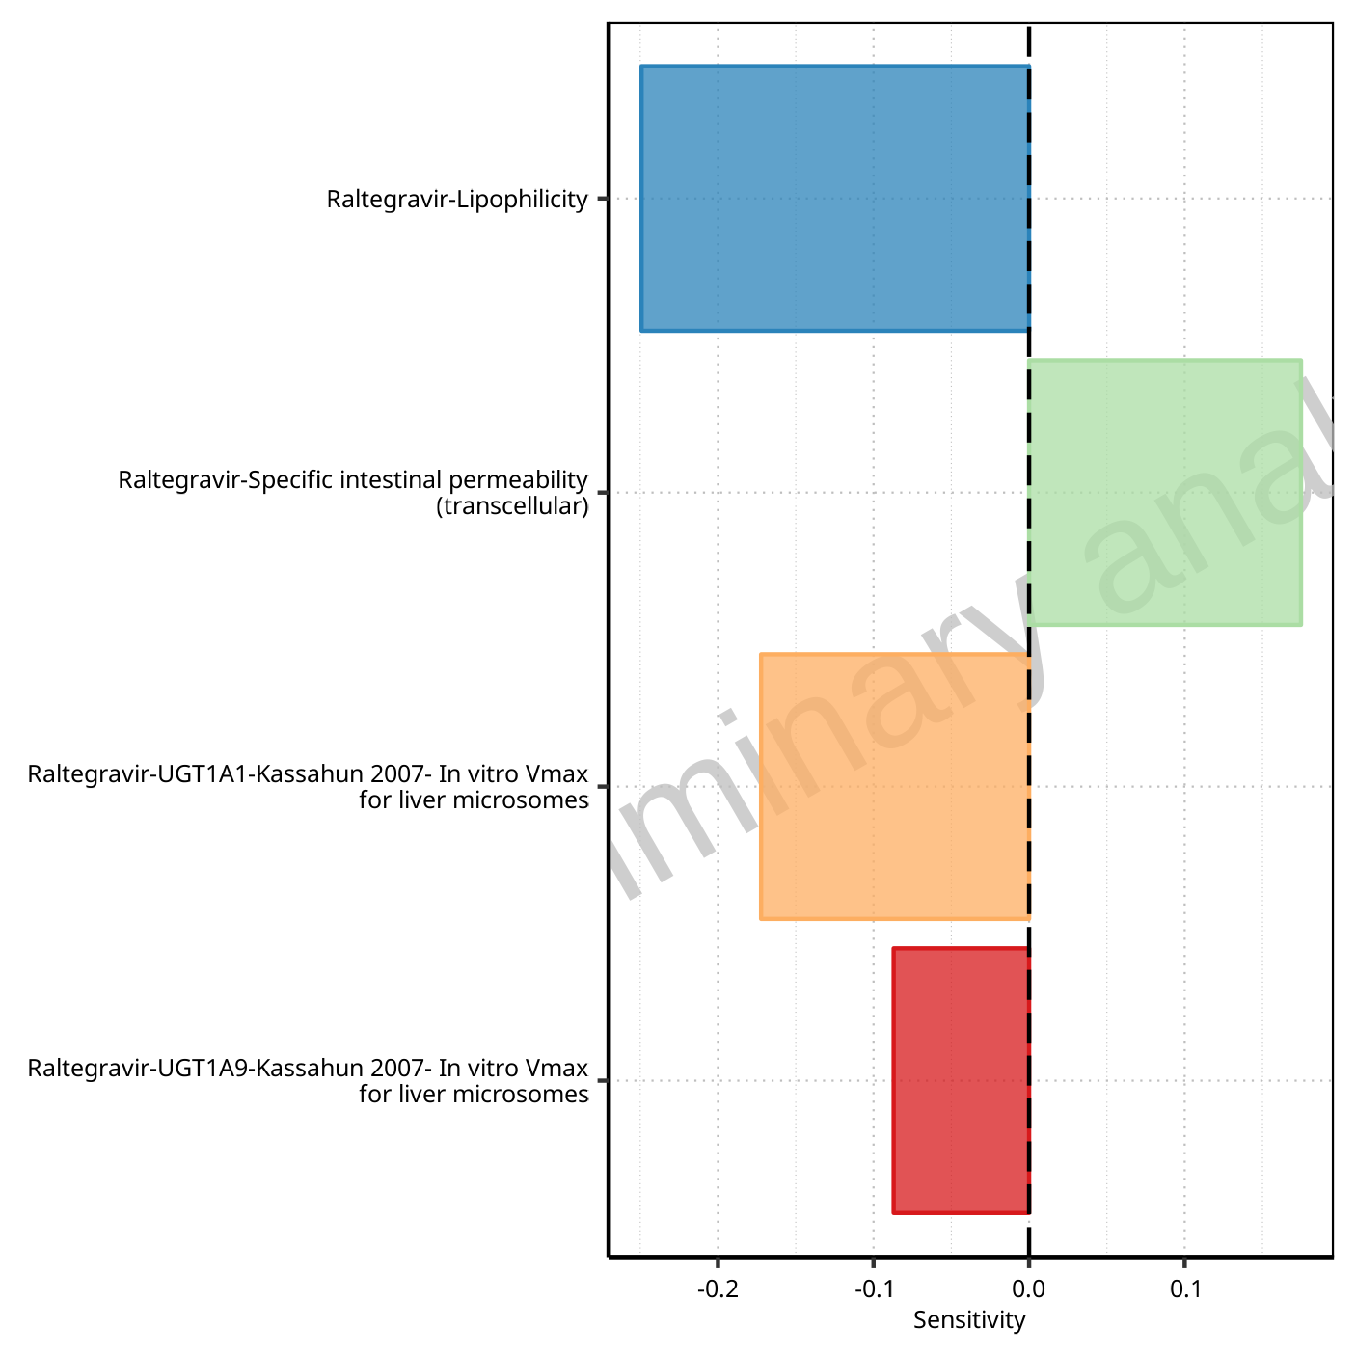

**Figure 1-81: Most sensitive parameters for C_max of Raltegravir.**



**Figure 1-82: Most sensitive parameters for t_max of Raltegravir.**

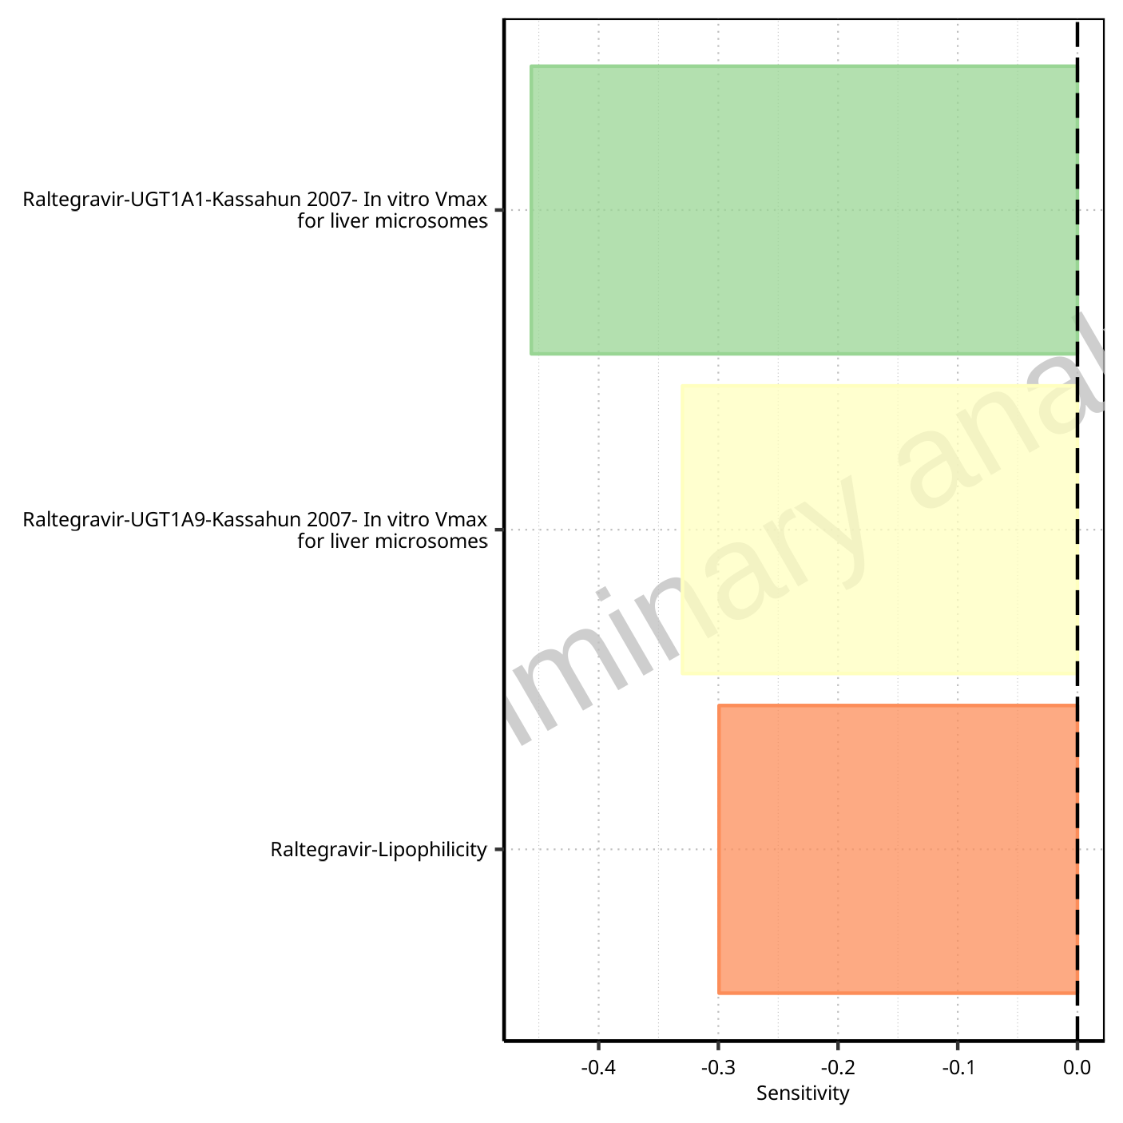

**Figure 1-83: Most sensitive parameters for C_tEnd of Raltegravir.**

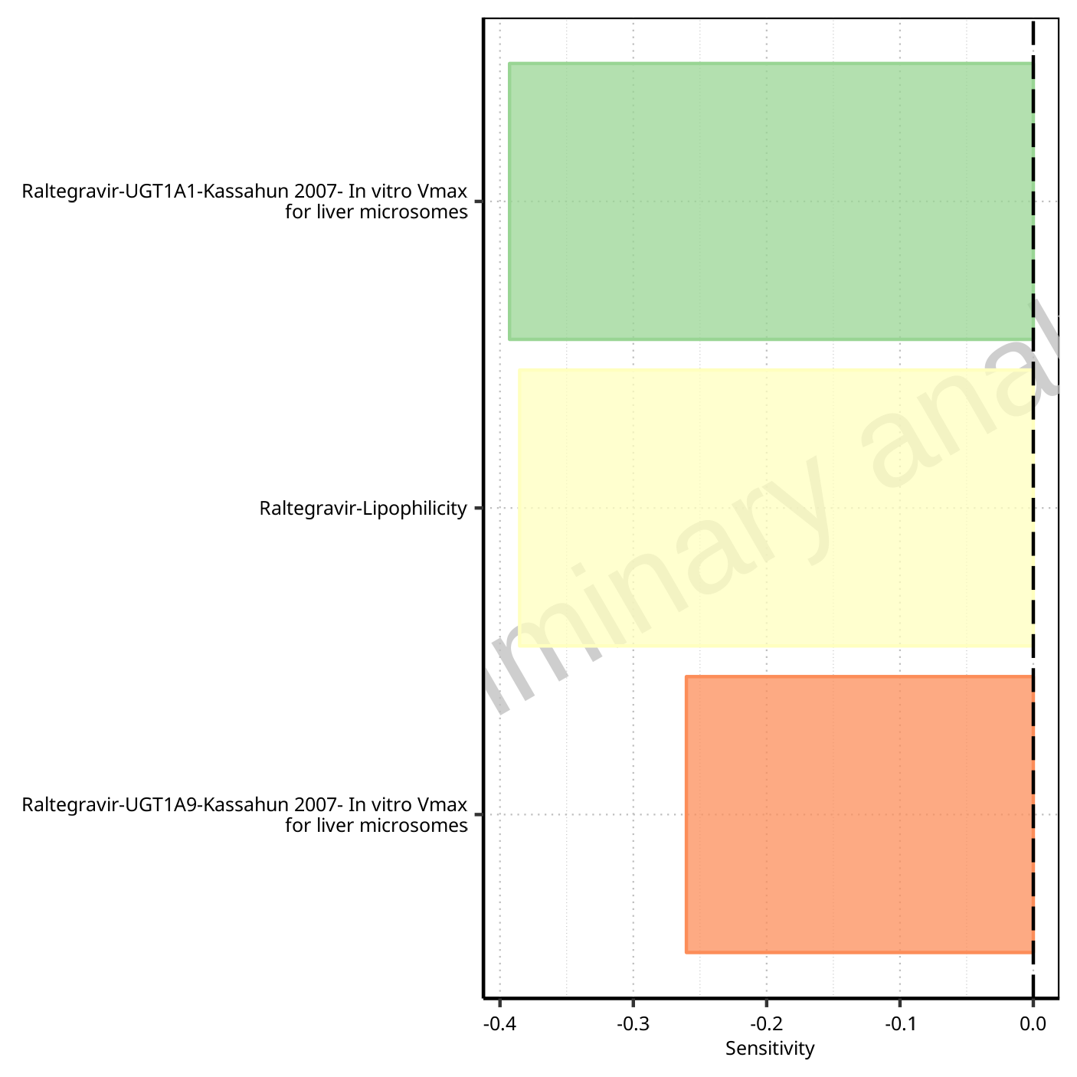

**Figure 1-84: Most sensitive parameters for AUC of Raltegravir.**

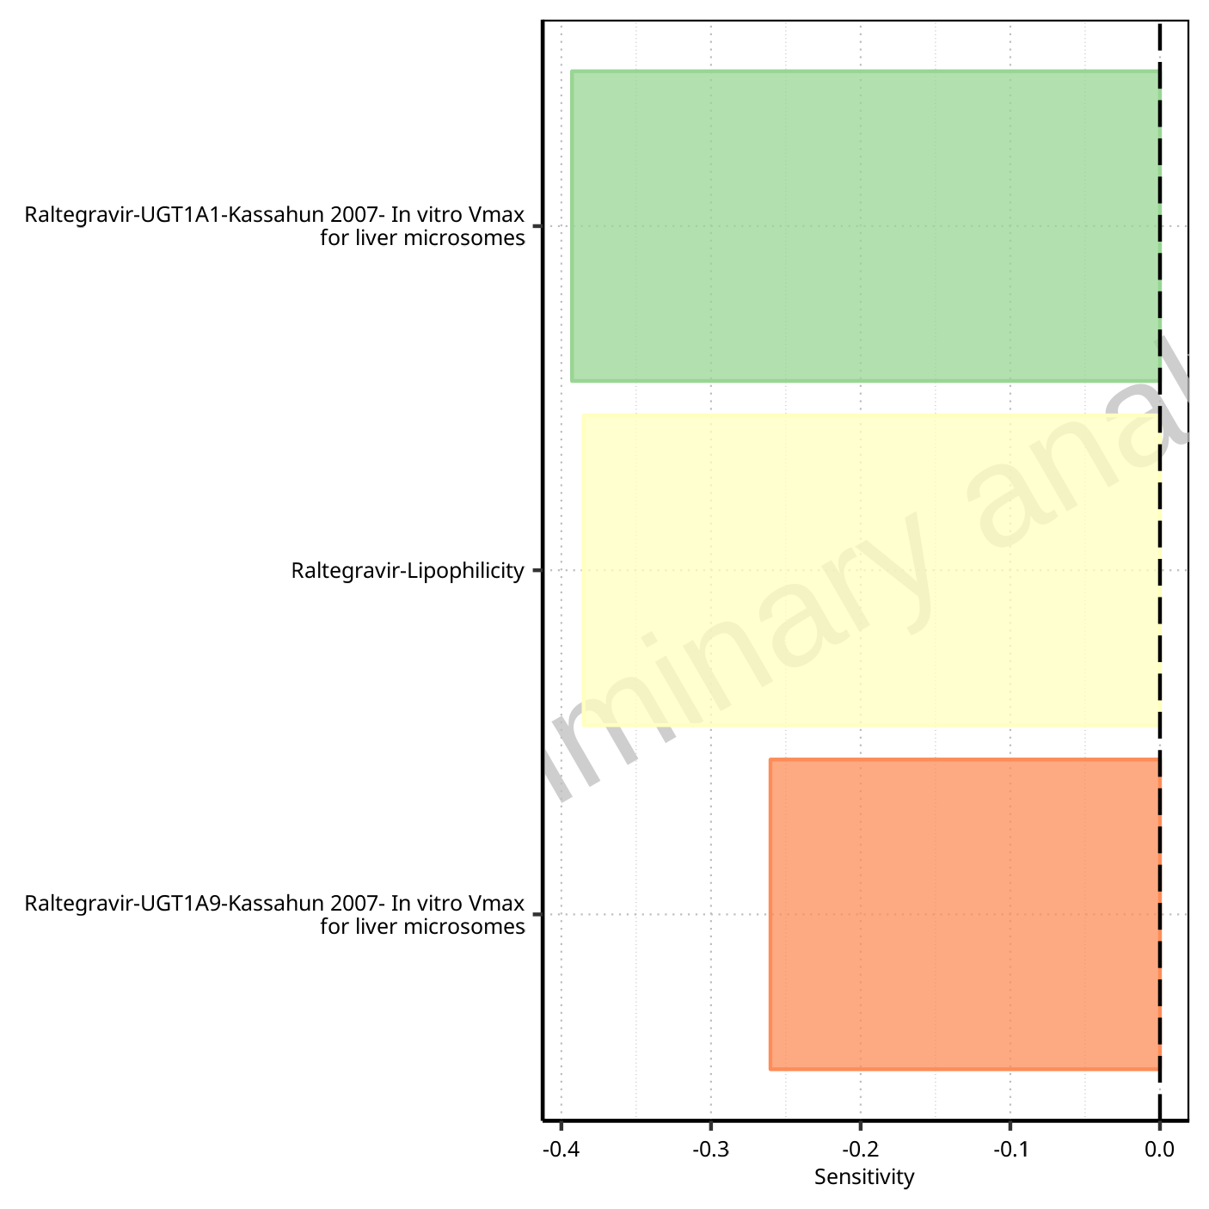

**Figure 1-85: Most sensitive parameters for AUC_inf of Raltegravir.**

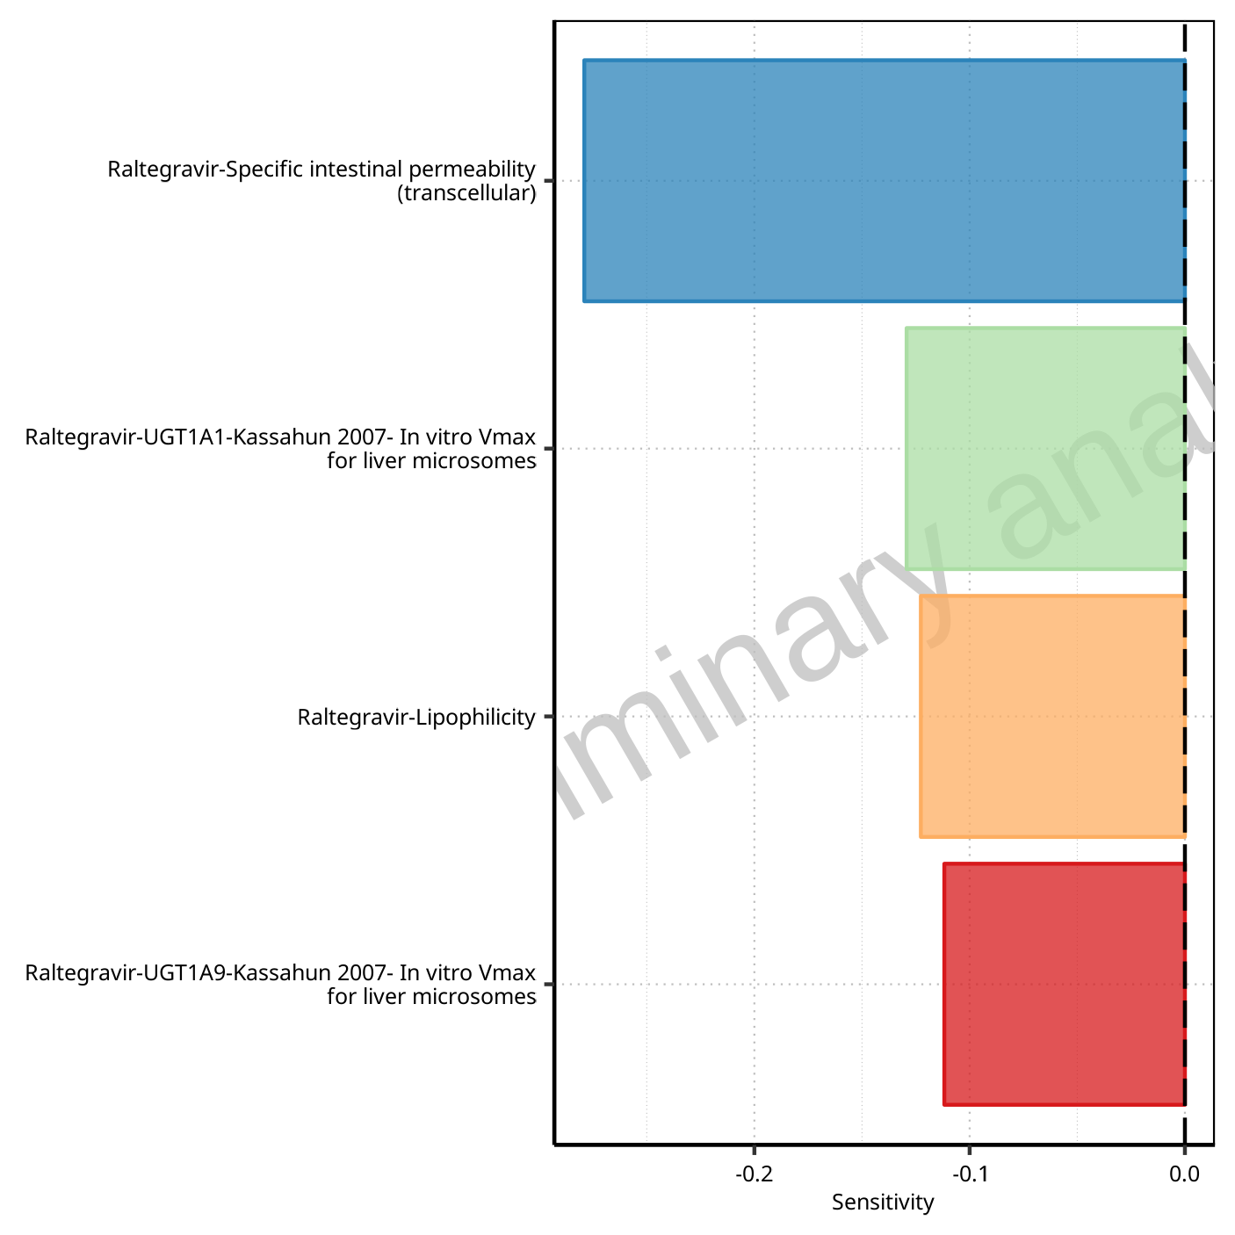

**Figure 1-86: Most sensitive parameters for MRT of Raltegravir.**

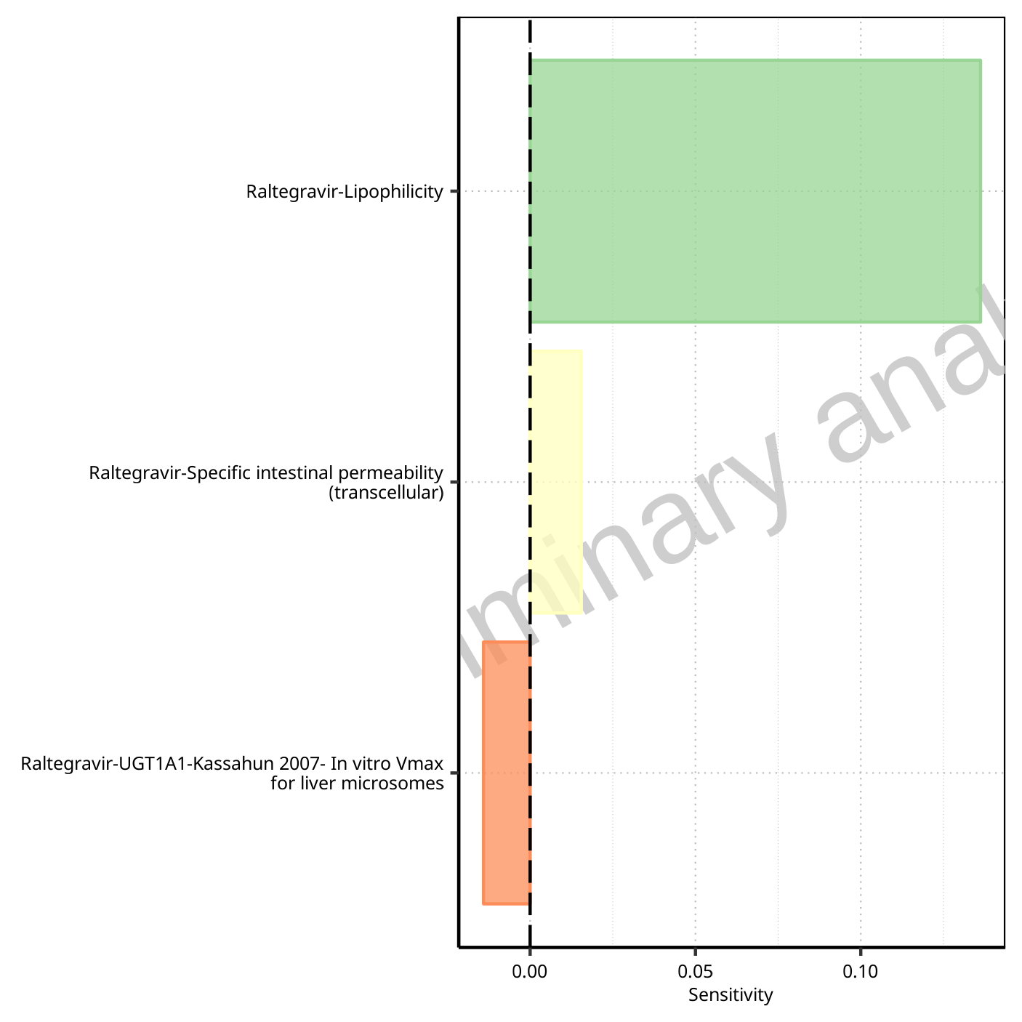

**Figure 1-87: Most sensitive parameters for Thalf of Raltegravir.**

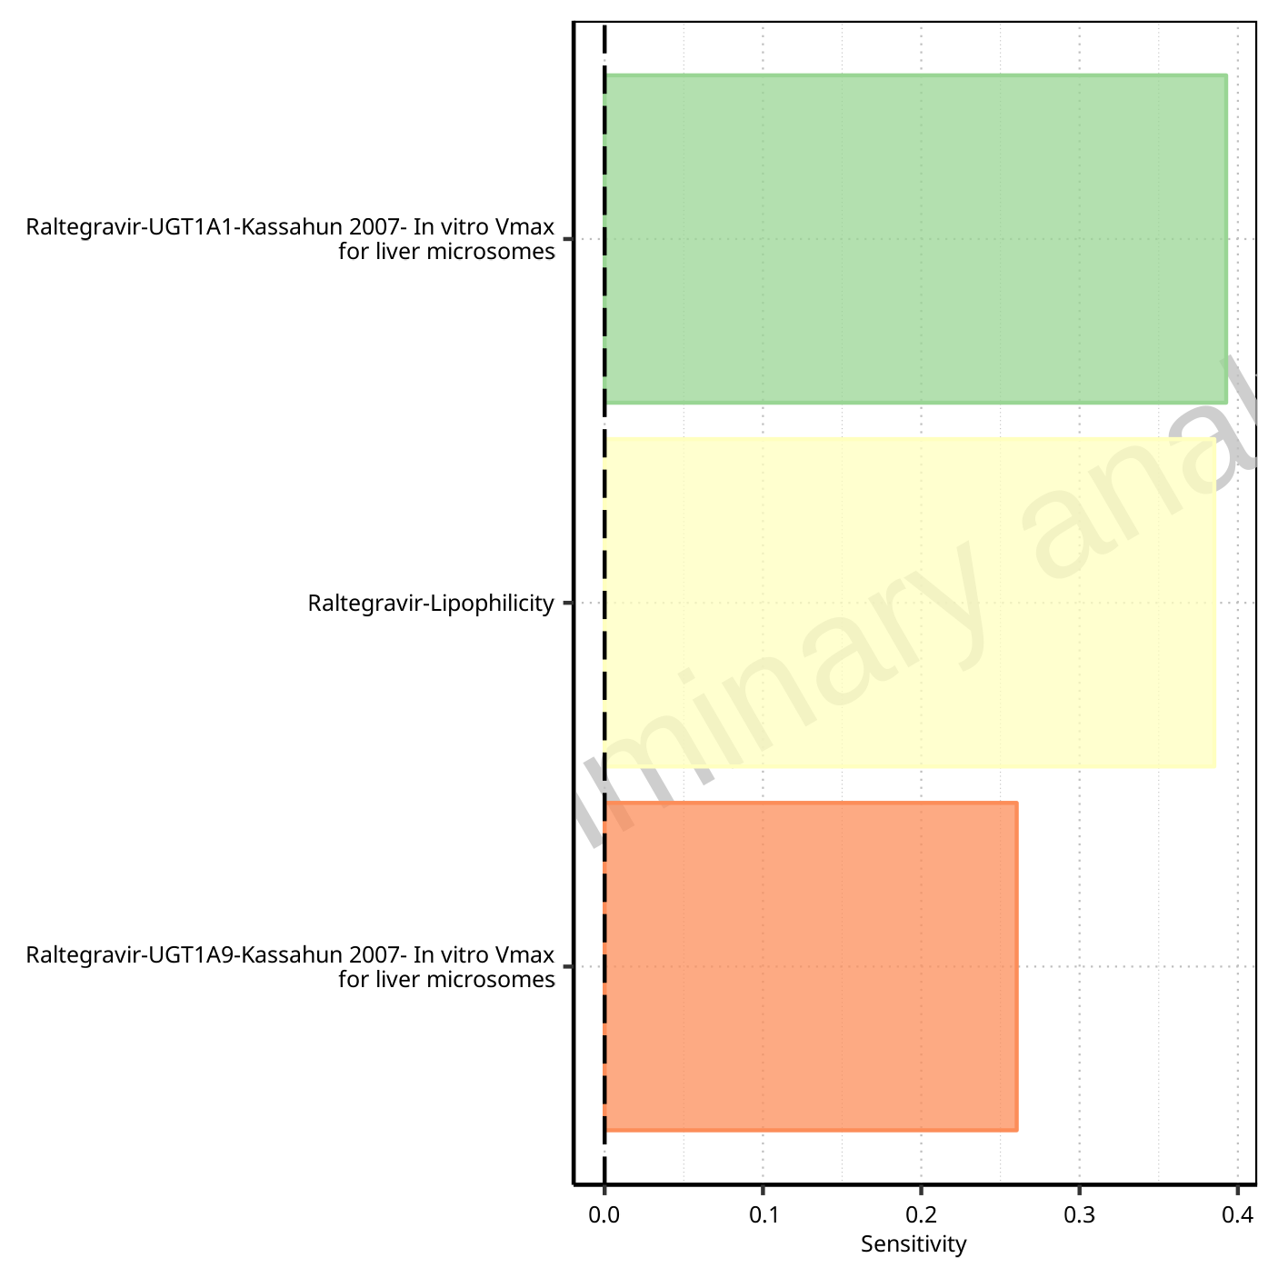

**Figure 1-88: Most sensitive parameters for CL of Raltegravir.**

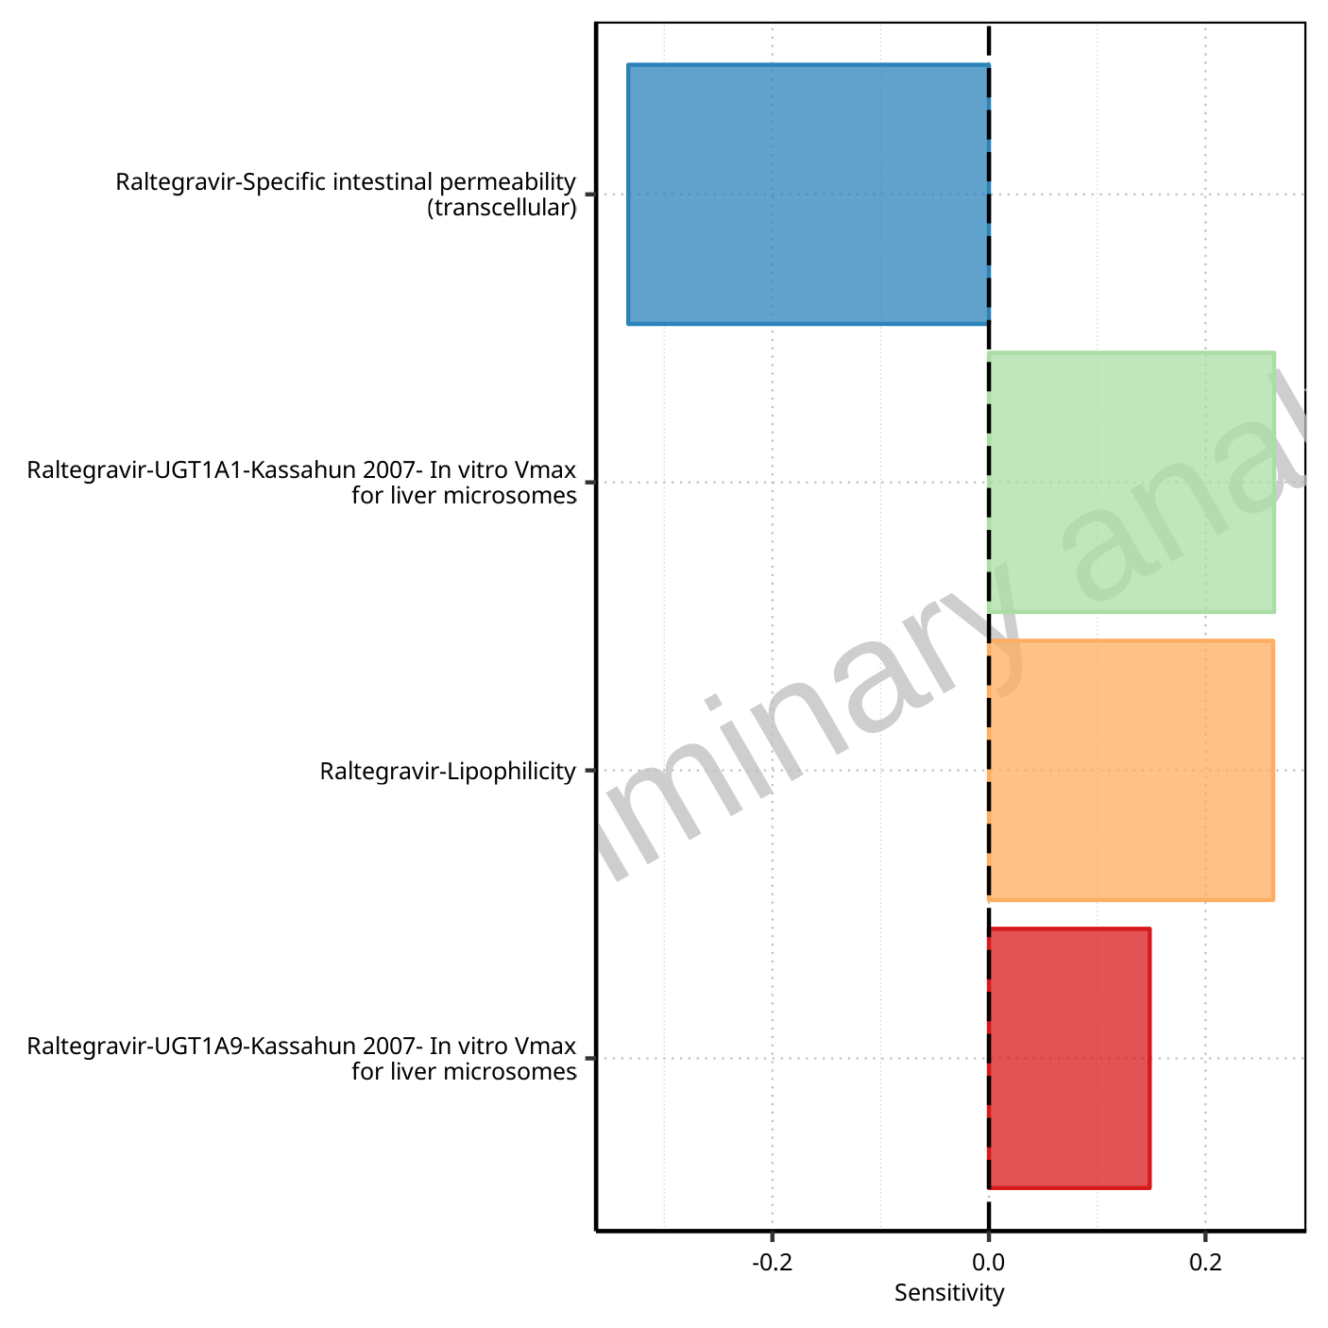

**Figure 1-89: Most sensitive parameters for Vss of Raltegravir.**

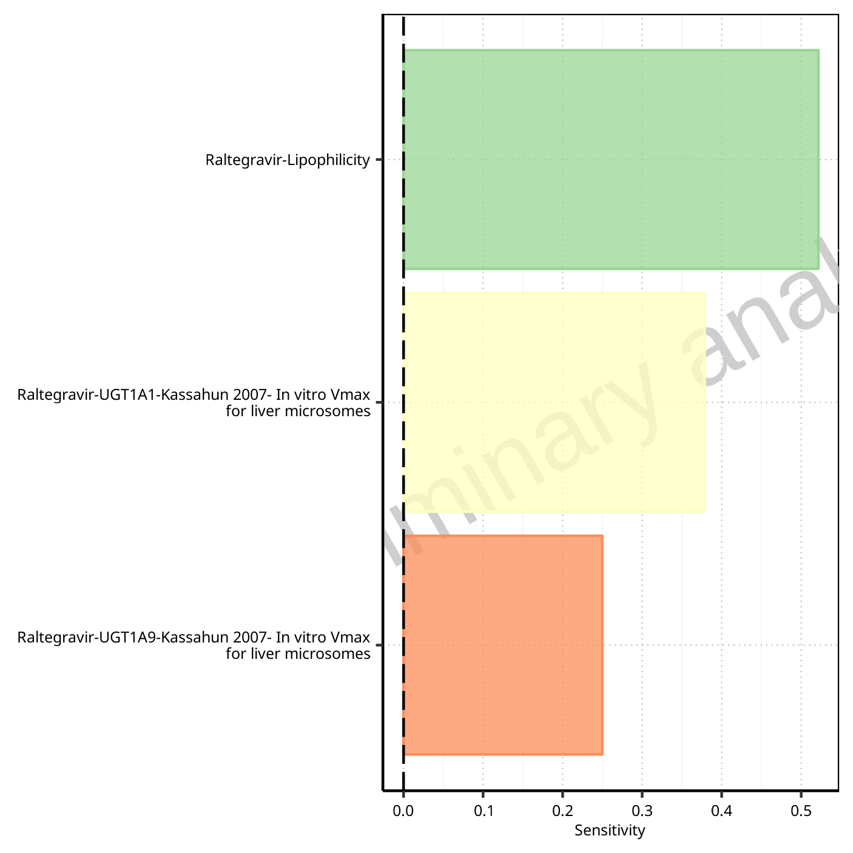

**Figure 1-90: Most sensitive parameters for Vd of Raltegravir.**

## Sensitivity Analysis for Raltegravir 100 mg filmcoated tablet md

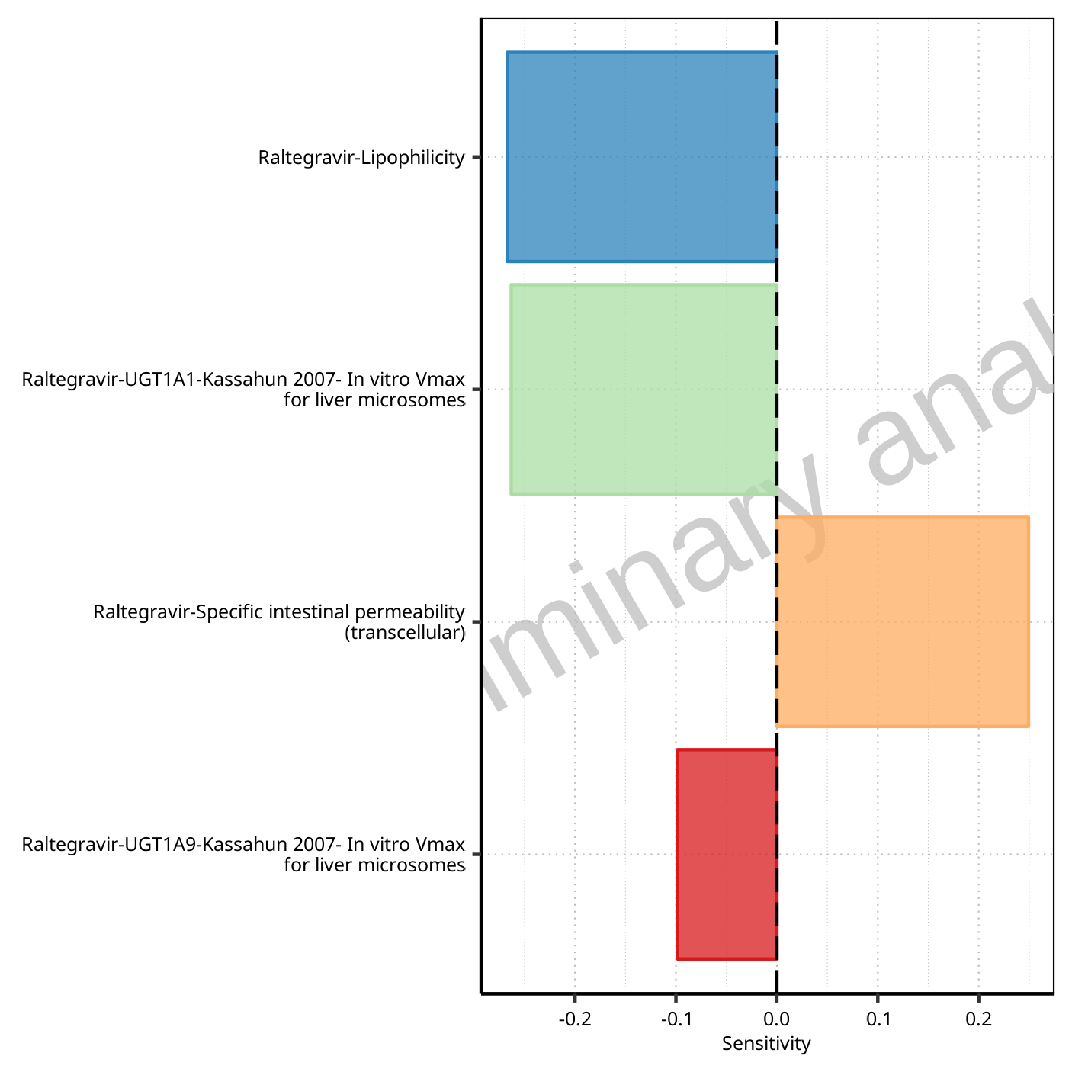

**Figure 1-91: Most sensitive parameters for C_max of Raltegravir.**

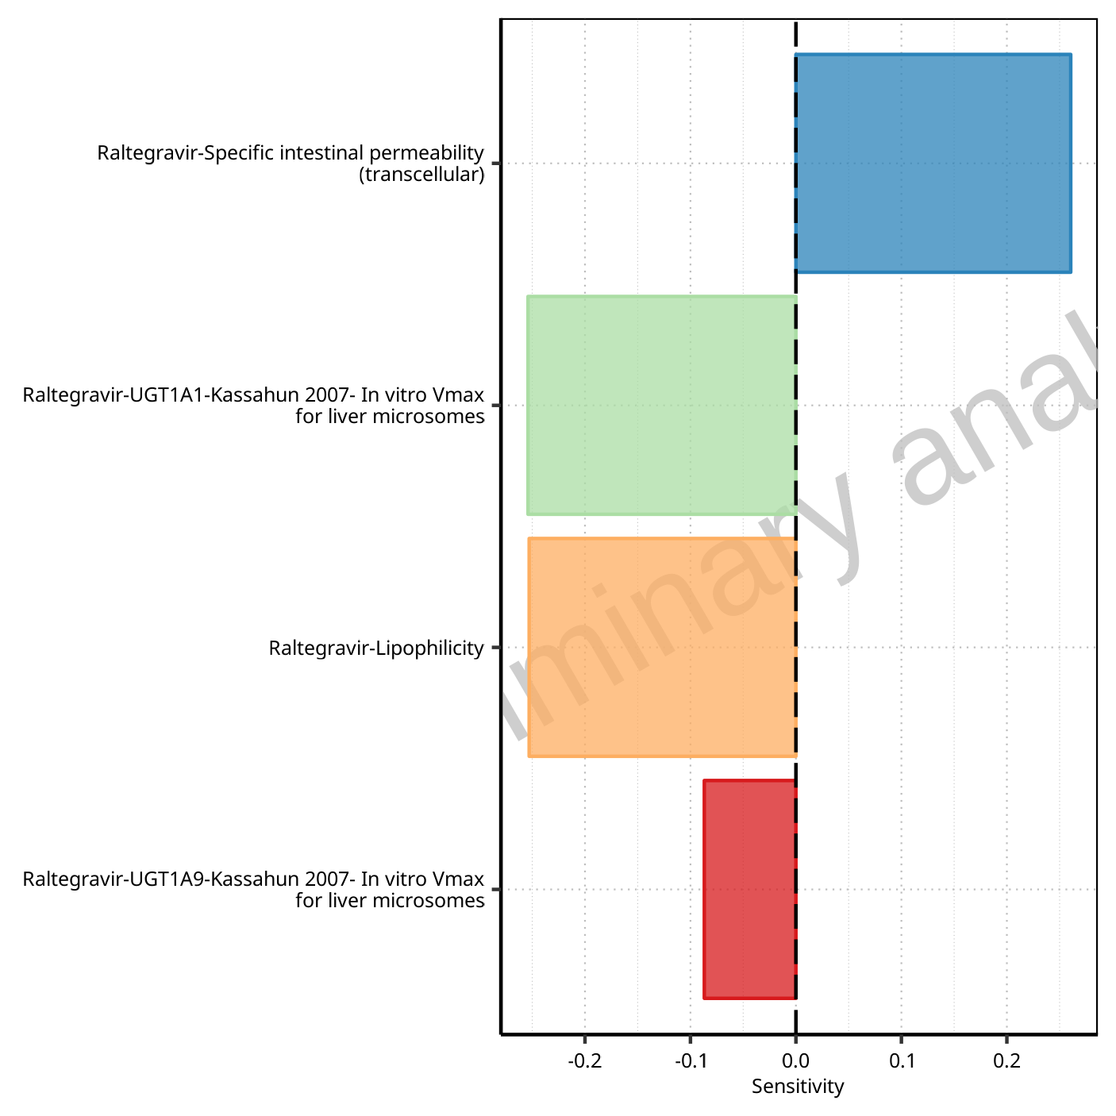

**Figure 1-92: Most sensitive parameters for C_max_t1_t2 of Raltegravir.**

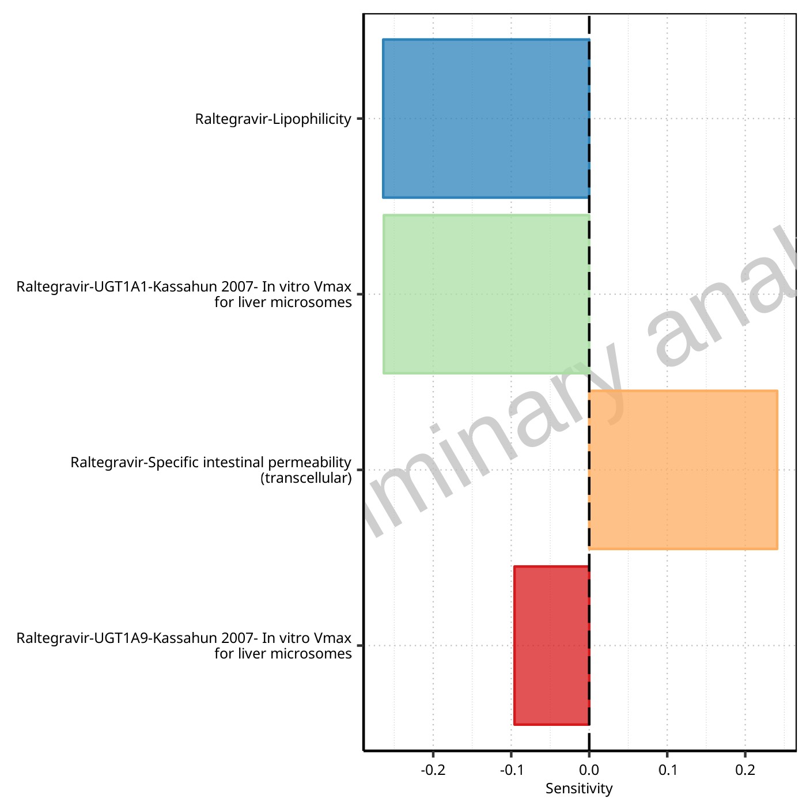

**Figure 1-93: Most sensitive parameters for C_max_tLast_tEnd of Raltegravir.**

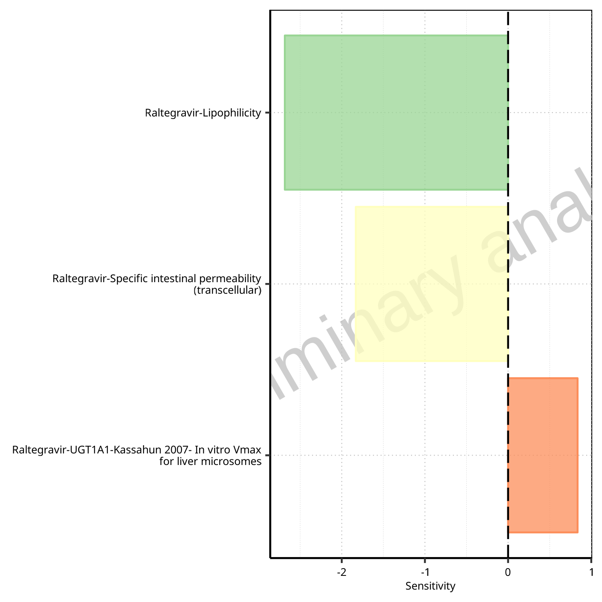

**Figure 1-94: Most sensitive parameters for t_max of Raltegravir.**

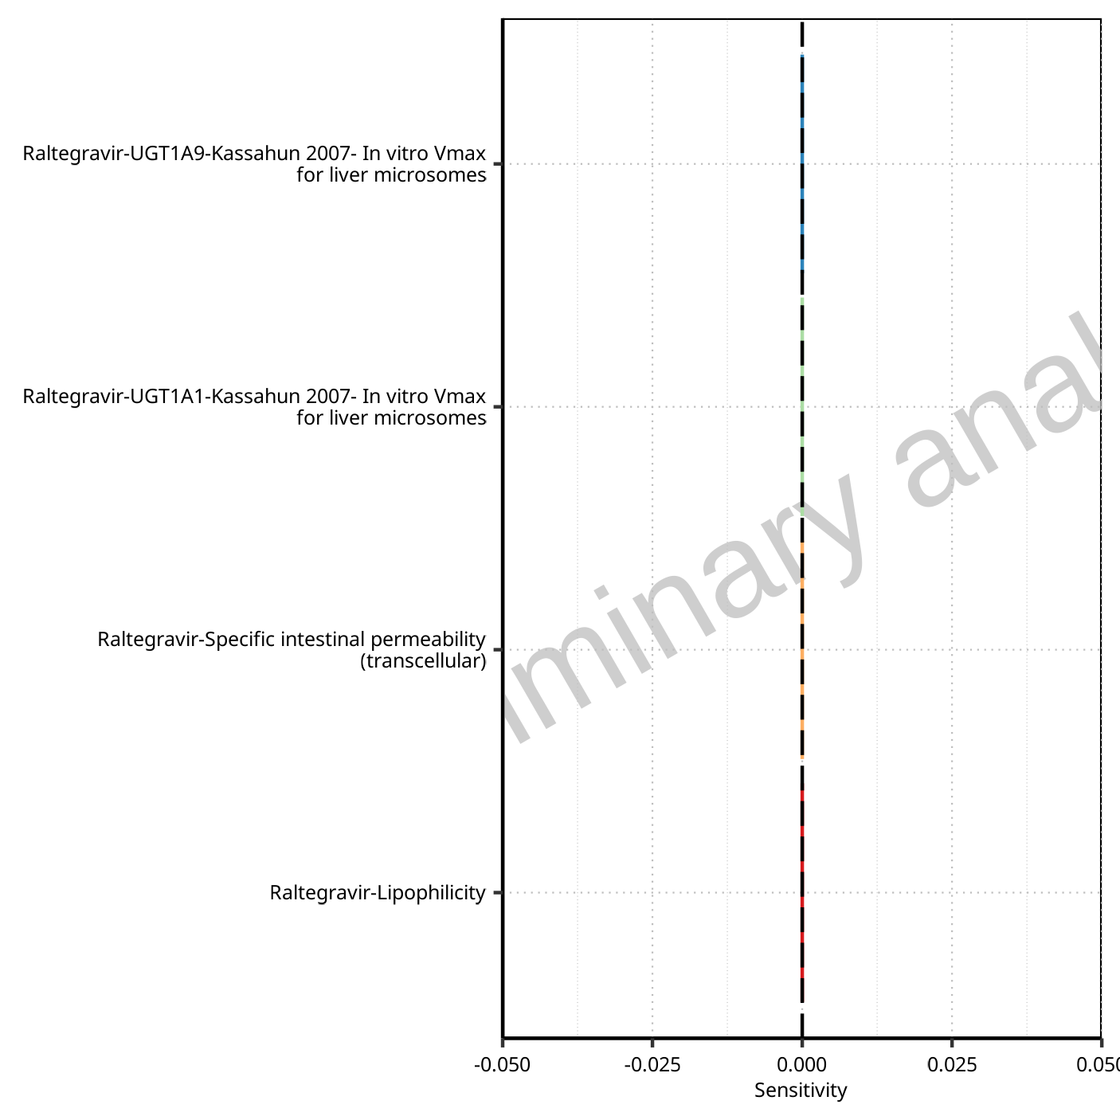

**Figure 1-95: Most sensitive parameters for t_max_t1_t2 of Raltegravir.**



**Figure 1-96: Most sensitive parameters for t_max_tLast_tEnd of Raltegravir.**

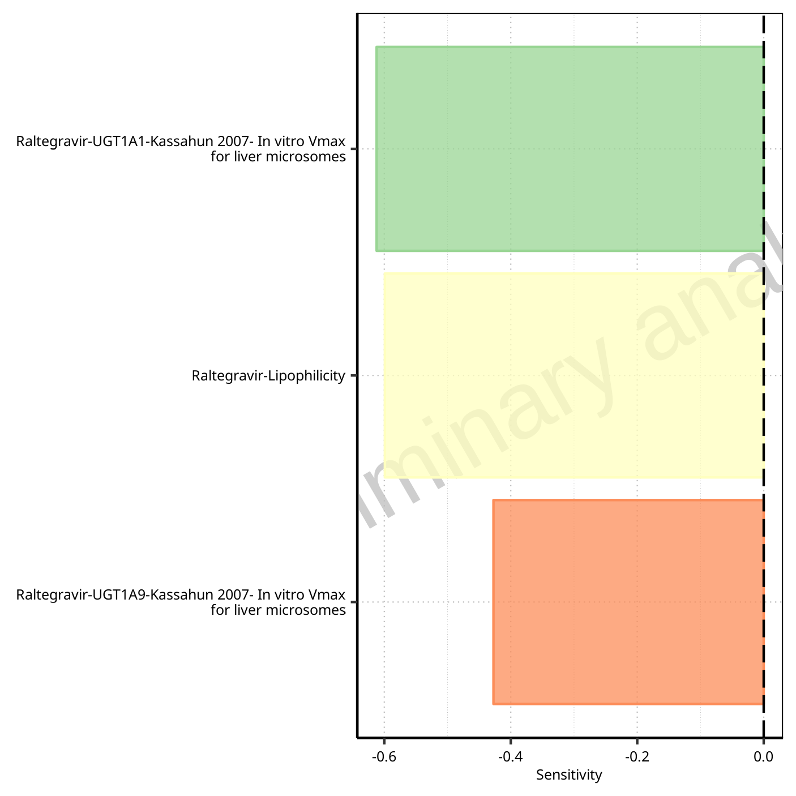

**Figure 1-97: Most sensitive parameters for C_trough_t2 of Raltegravir.**

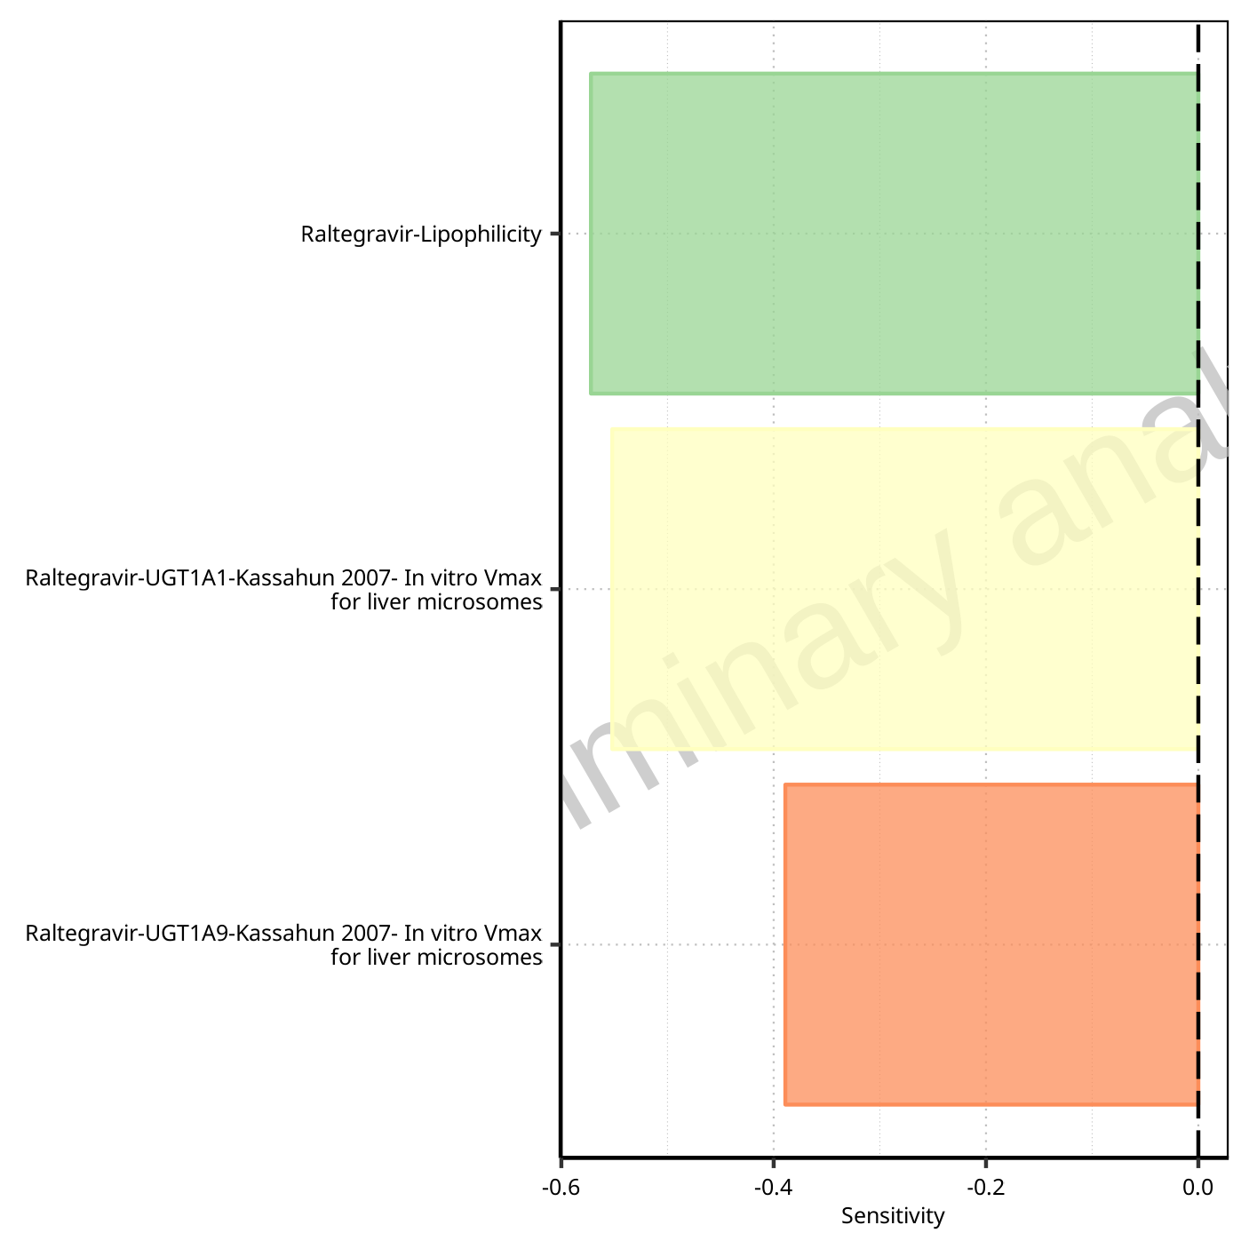

**Figure 1-98: Most sensitive parameters for C_trough_tLast of Raltegravir.**

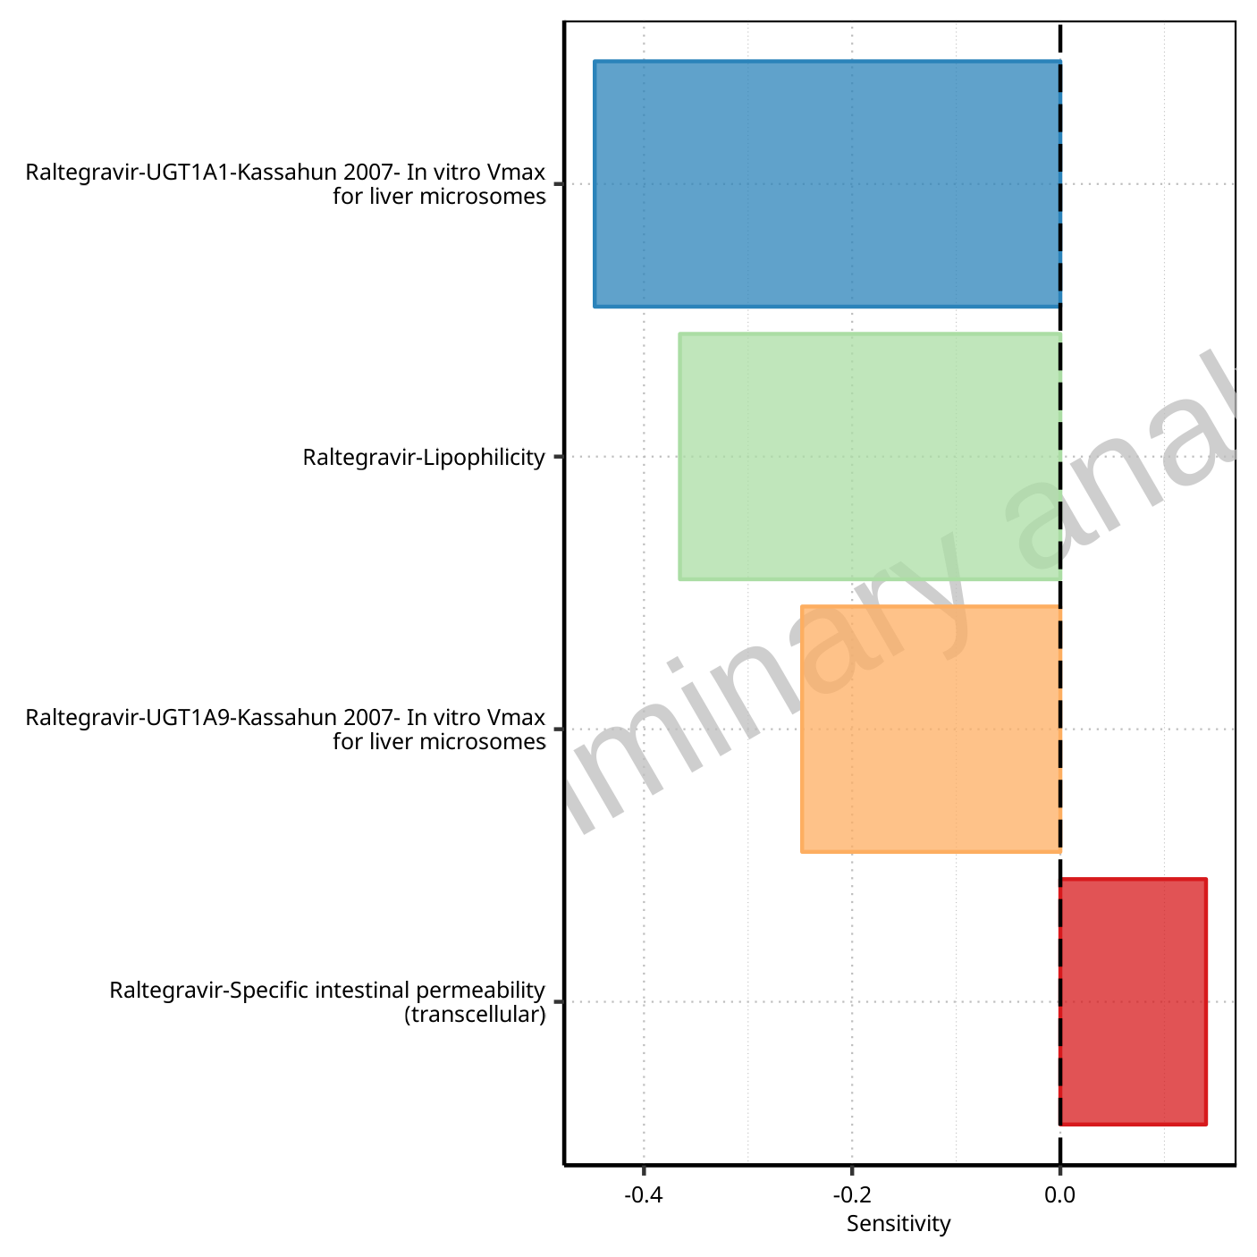

**Figure 1-99: Most sensitive parameters for AUC_t1_t2 of Raltegravir.**

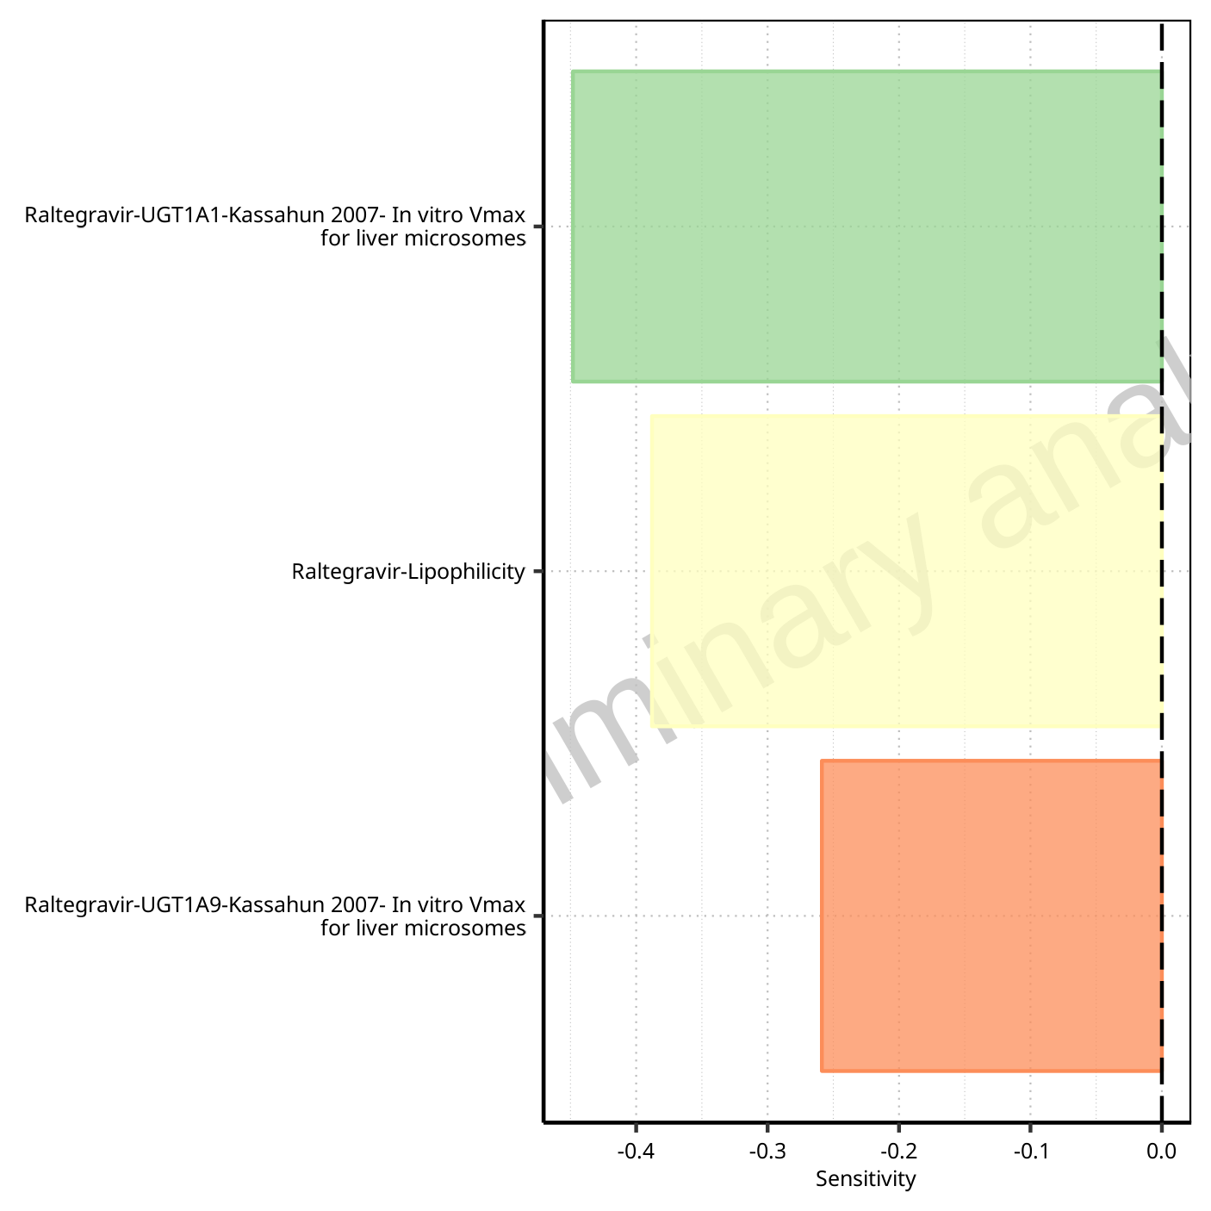

**Figure 1-100: Most sensitive parameters for AUC_tLast_minus_1_tLast of Raltegravir.**

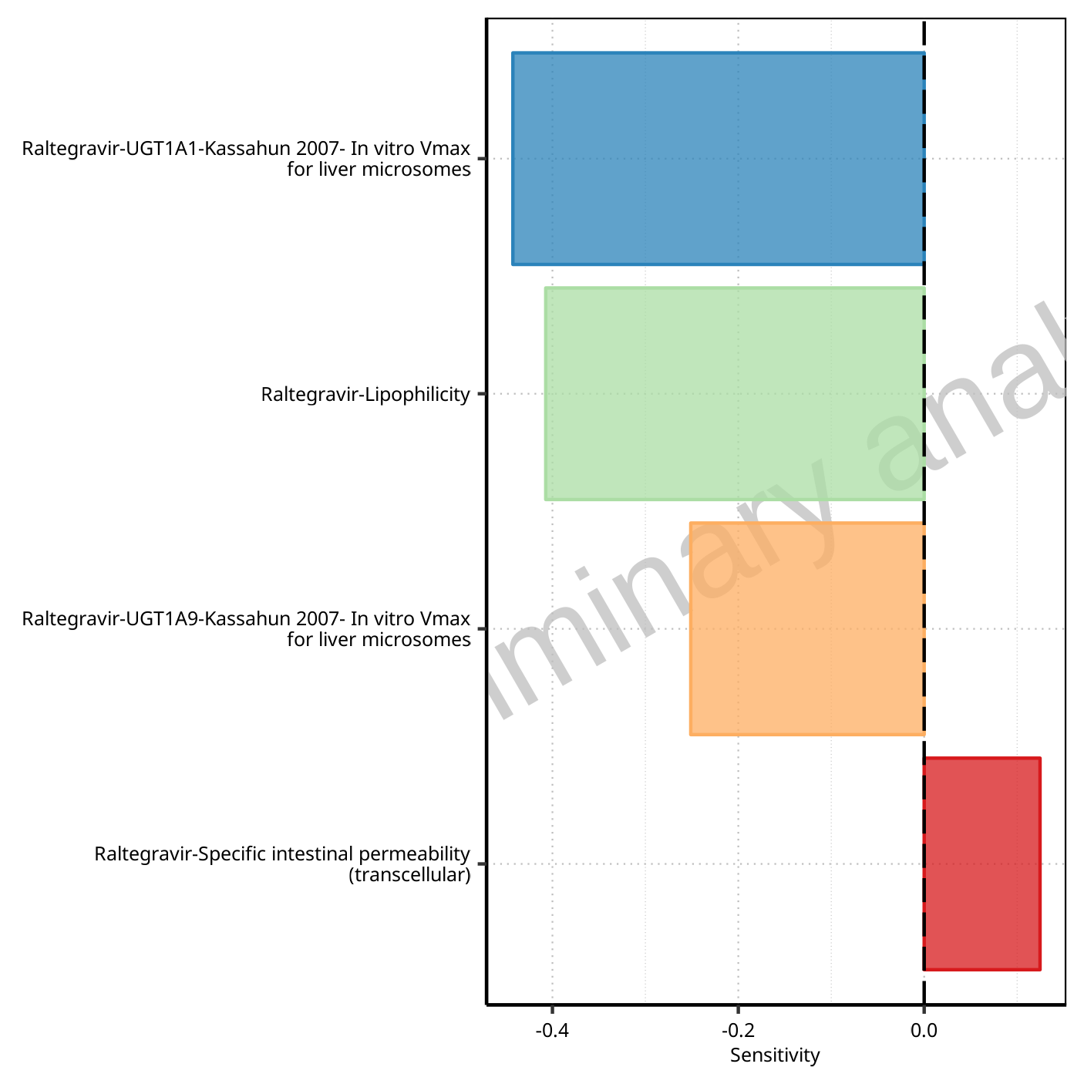

**Figure 1-101: Most sensitive parameters for AUC_inf_t1 of Raltegravir.**

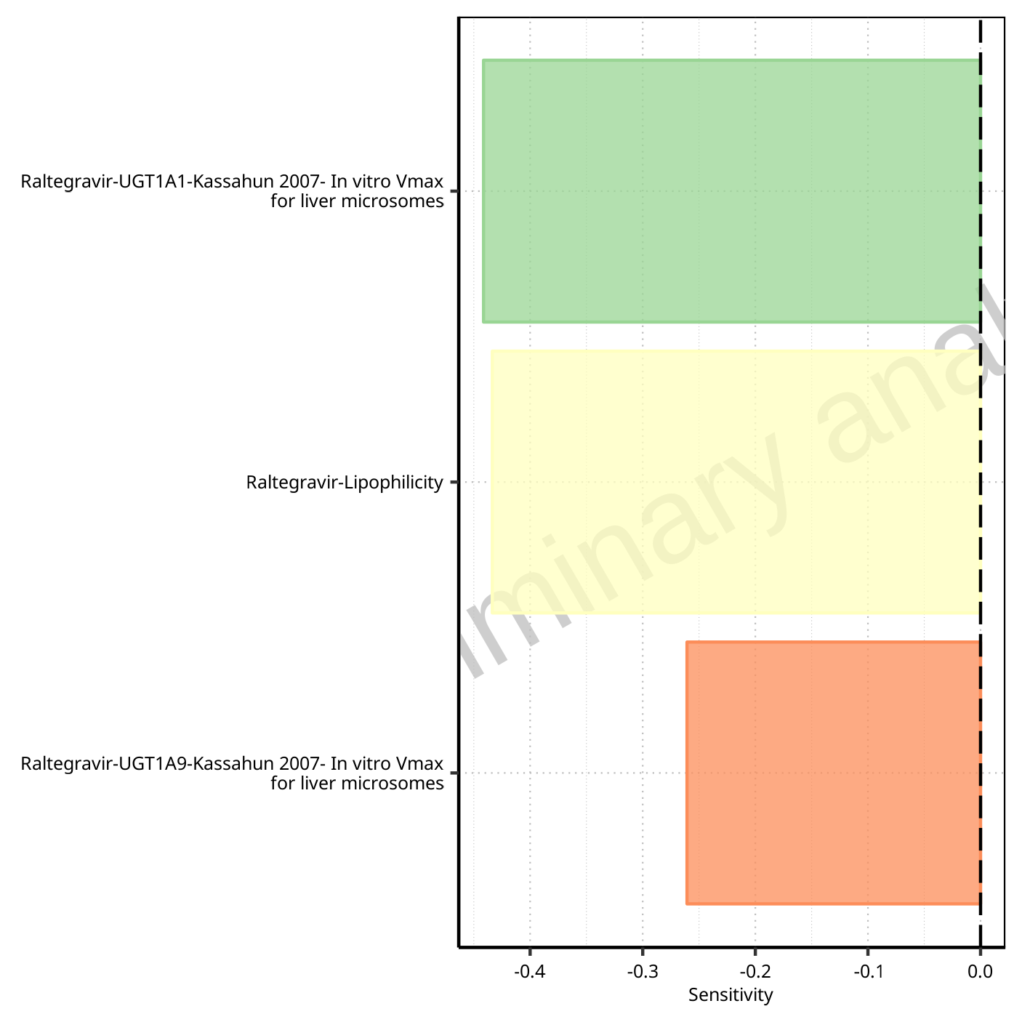

**Figure 1-102: Most sensitive parameters for AUC_inf_tLast of Raltegravir.**

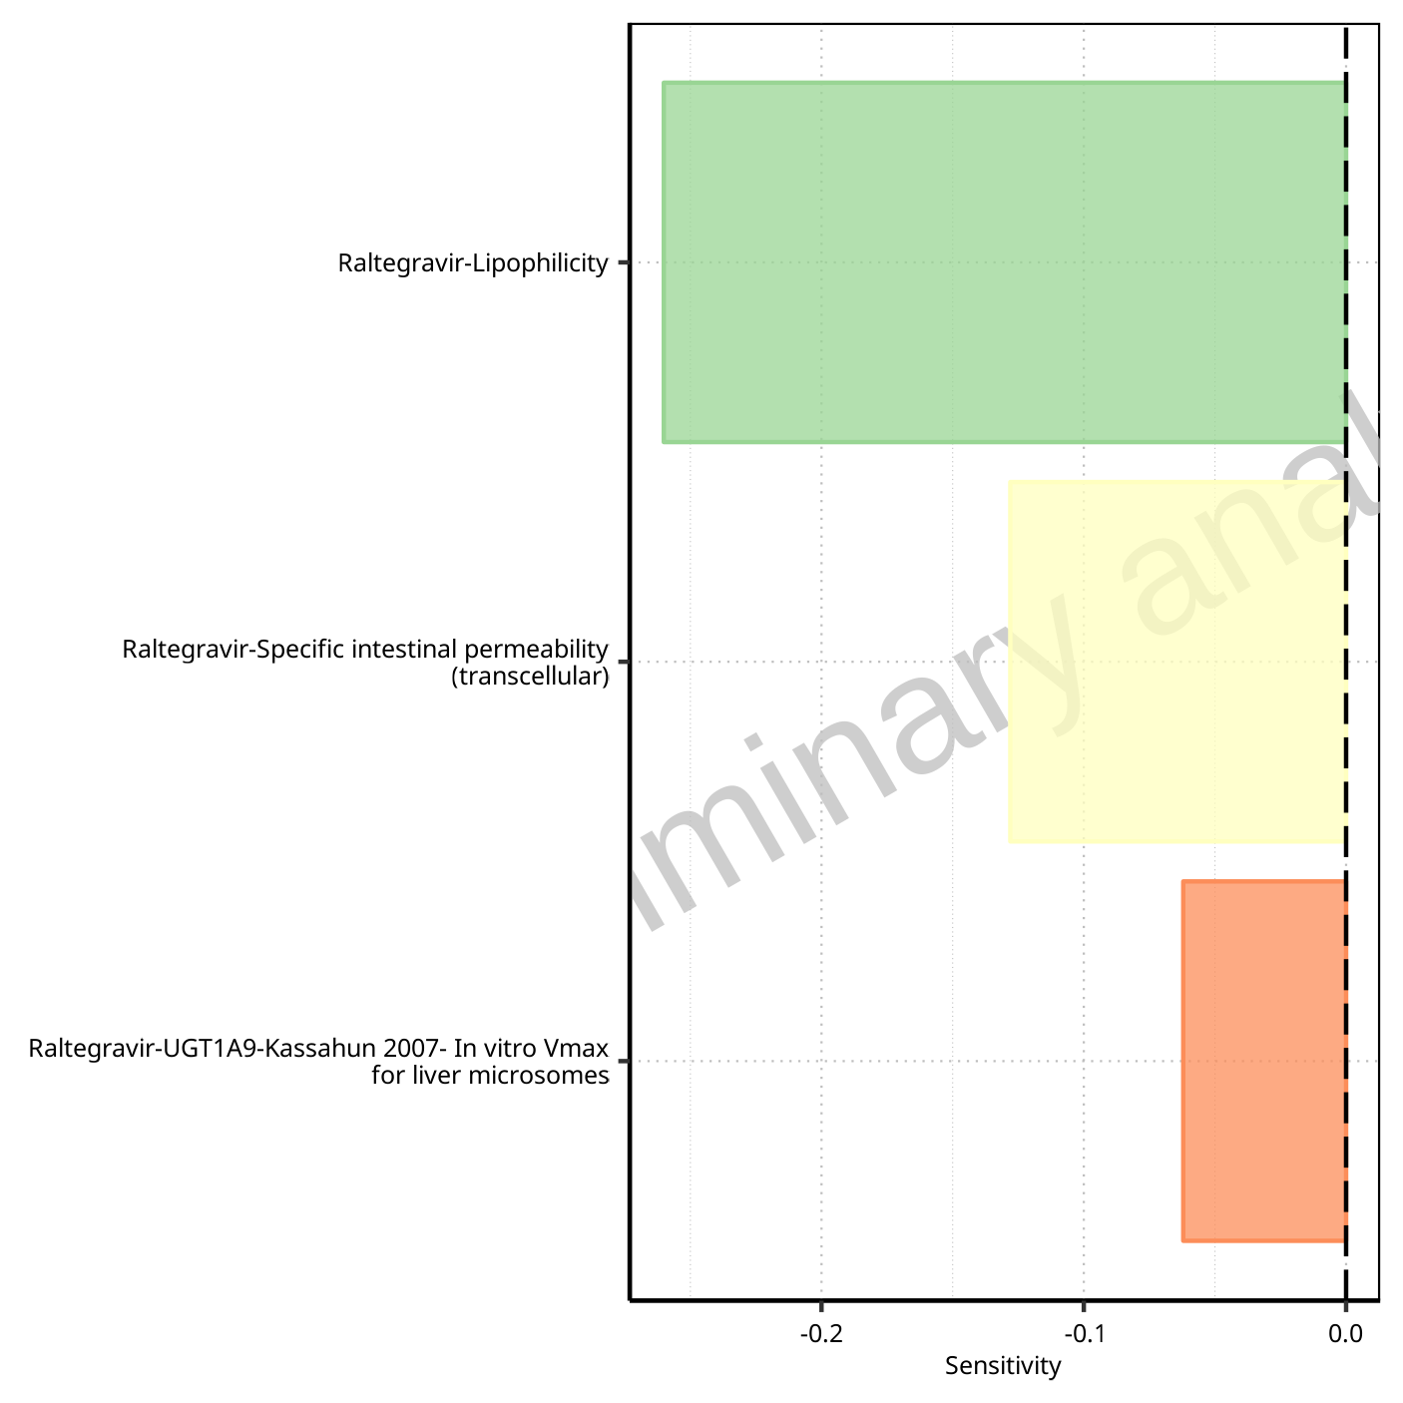

**Figure 1-103: Most sensitive parameters for MRT of Raltegravir.**

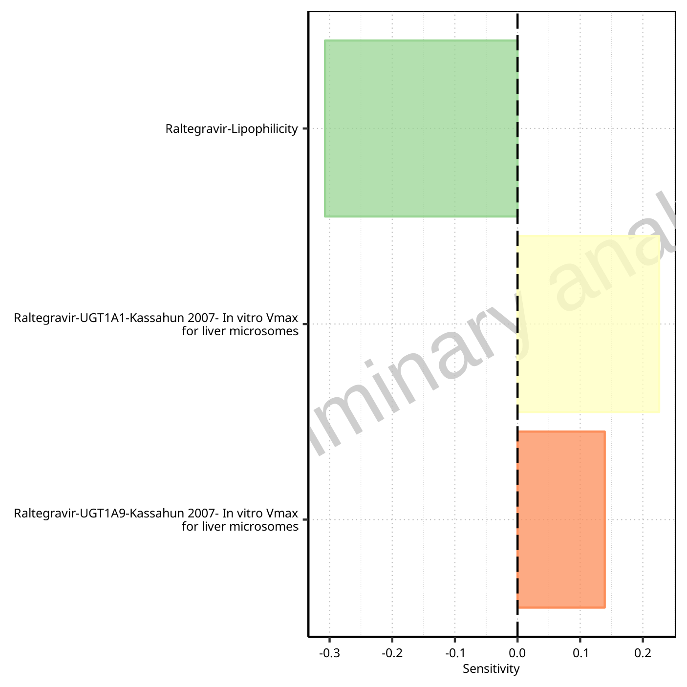

**Figure 1-104: Most sensitive parameters for Thalf of Raltegravir.**

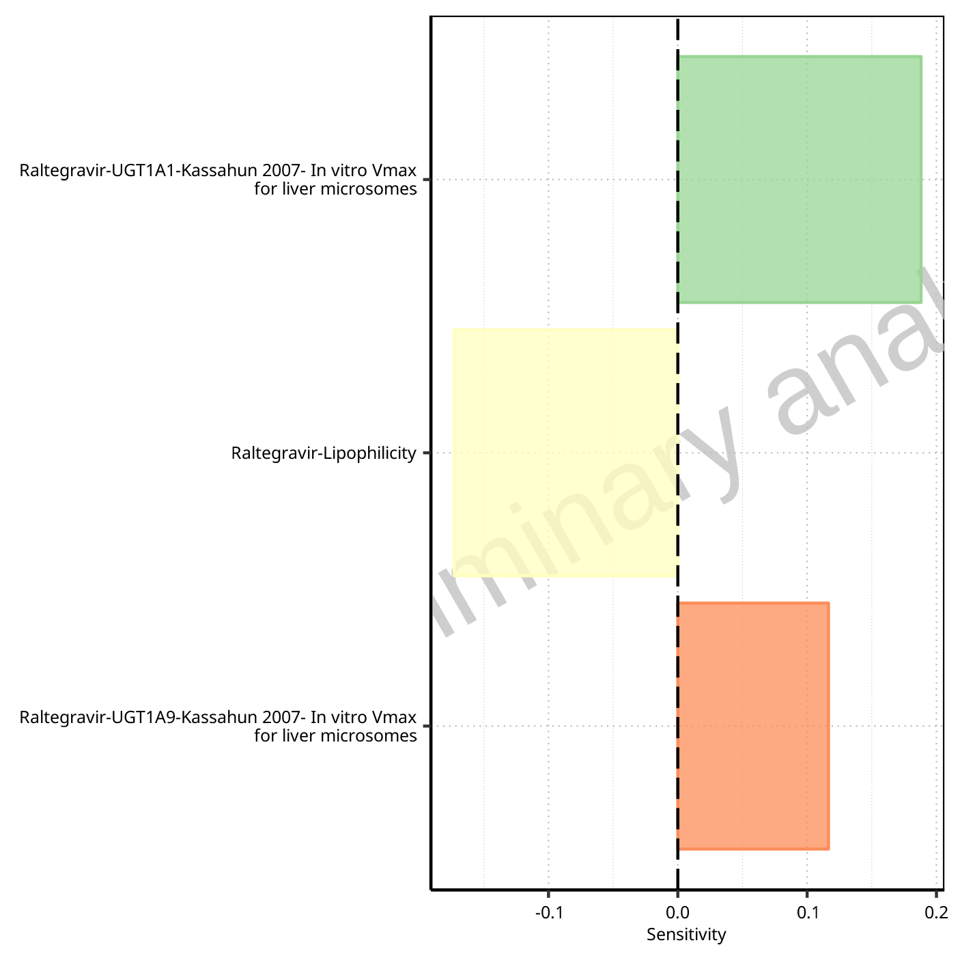

**Figure 1-105: Most sensitive parameters for Thalf_tLast_tEnd of Raltegravir.**

## Sensitivity Analysis for Raltegravir 200 mg filmcoated tablet md

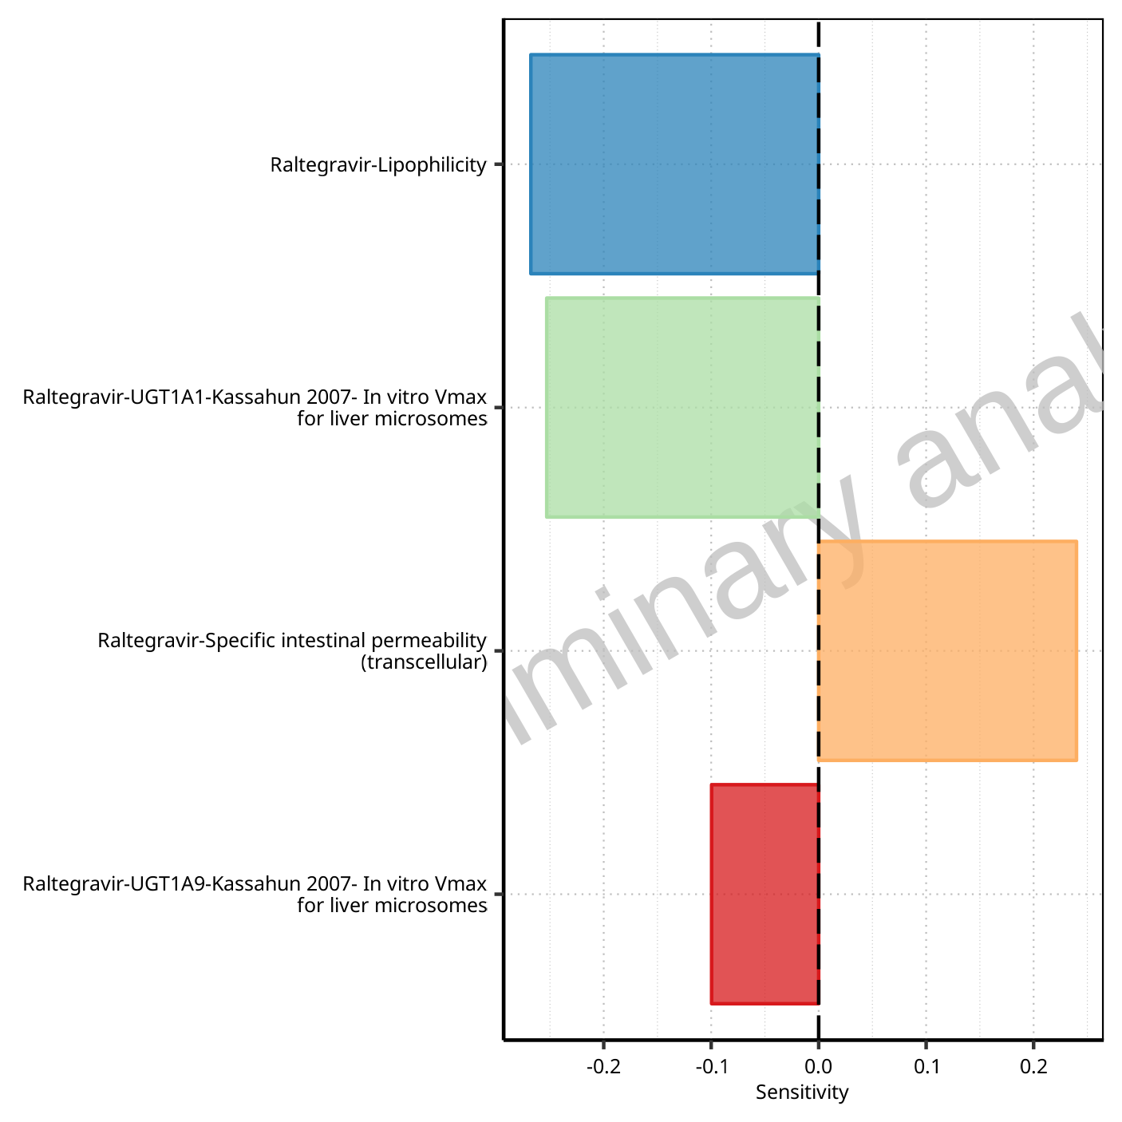

**Figure 1-106: Most sensitive parameters for C_max of Raltegravir.**

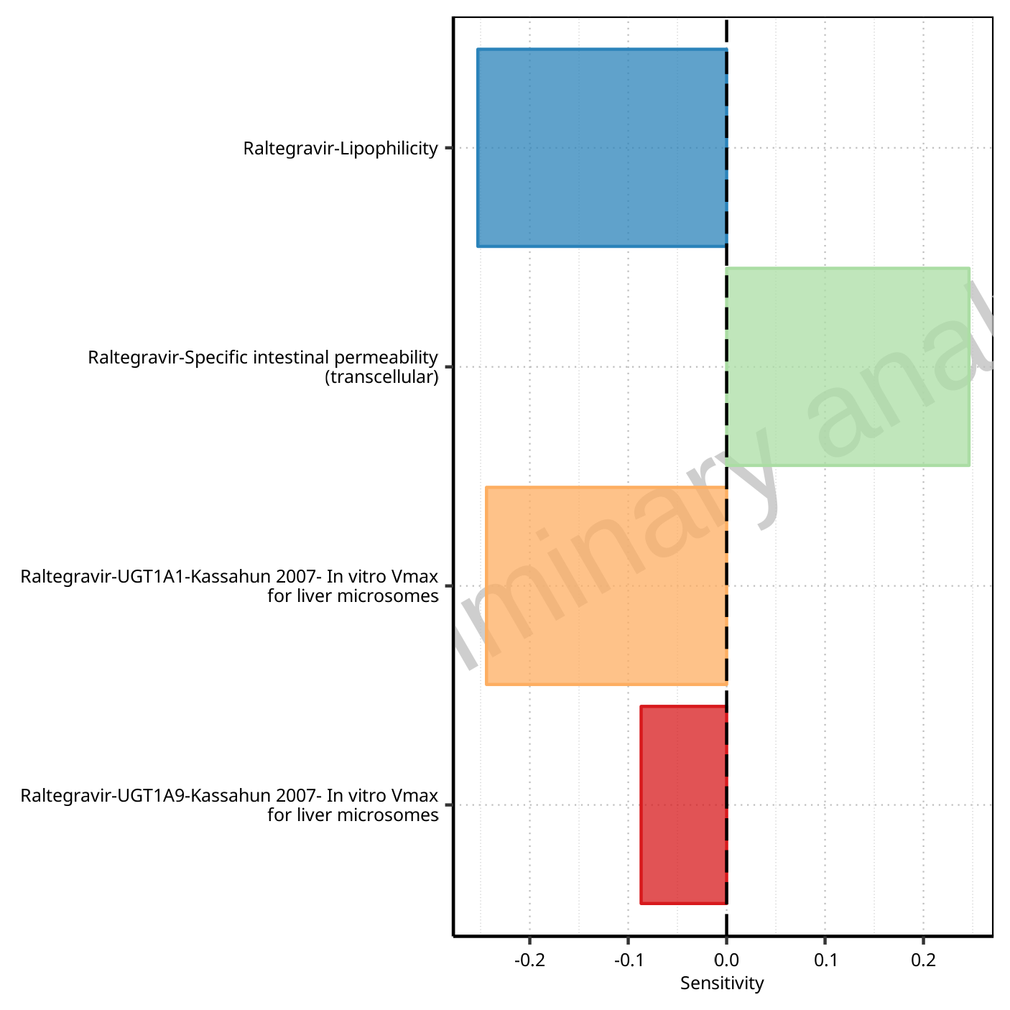

**Figure 1-107: Most sensitive parameters for C_max_t1_t2 of Raltegravir.**

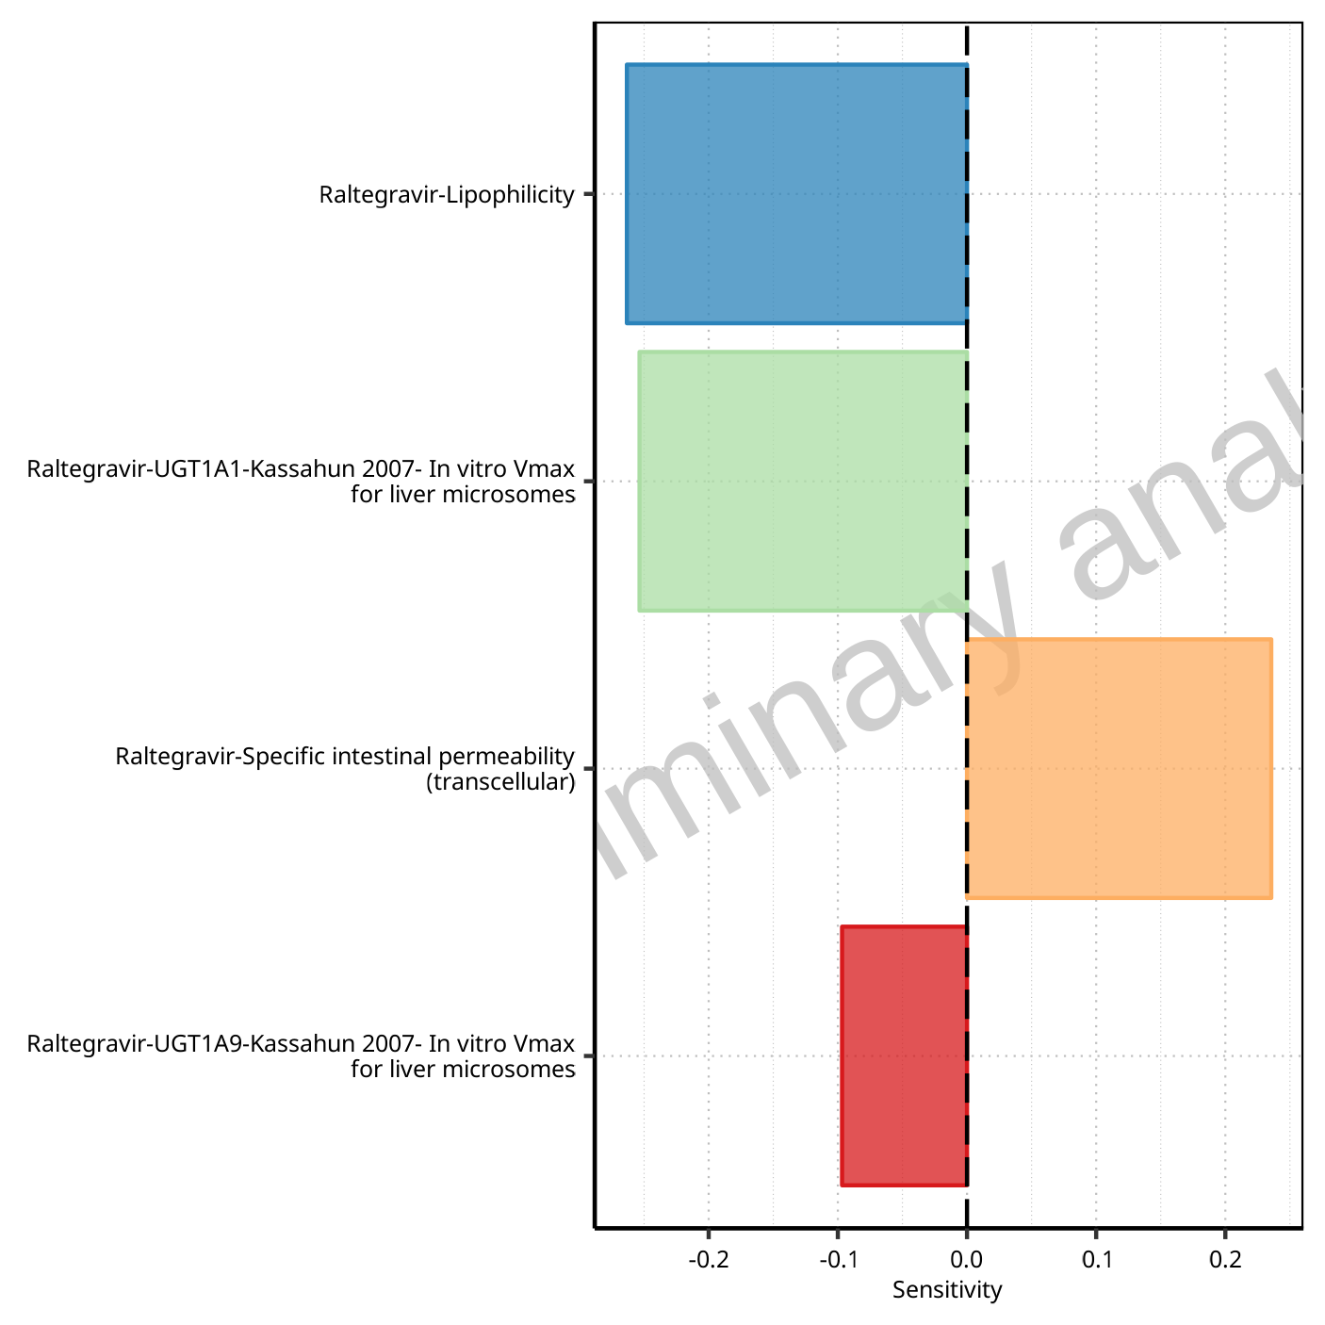

**Figure 1-108: Most sensitive parameters for C_max_tLast_tEnd of Raltegravir.**

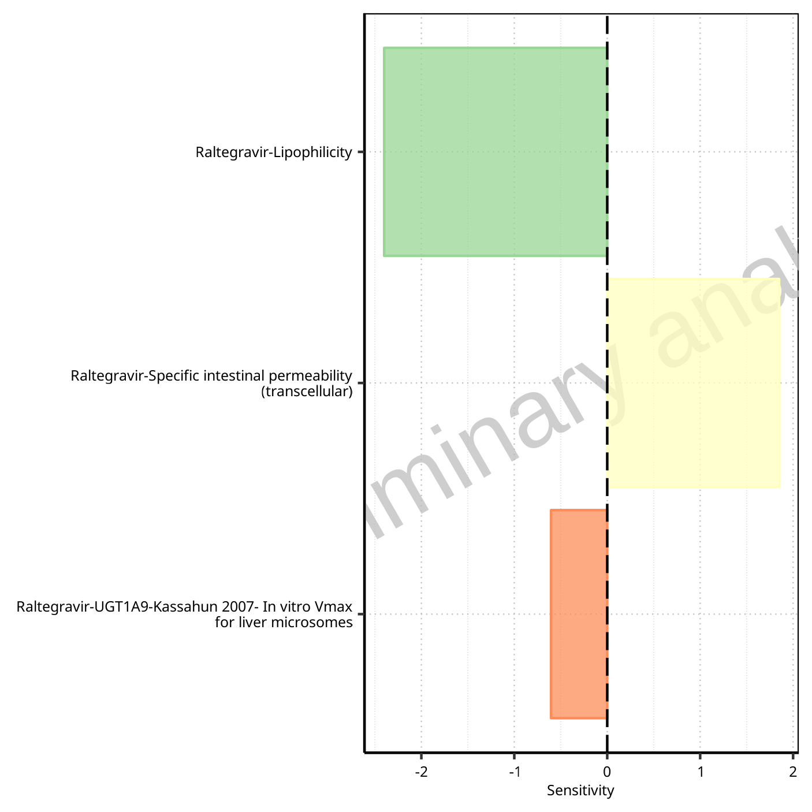

**Figure 1-109: Most sensitive parameters for t_max of Raltegravir.**



**Figure 1-110: Most sensitive parameters for t_max_t1_t2 of Raltegravir.**



**Figure 1-111: Most sensitive parameters for t_max_tLast_tEnd of Raltegravir.**

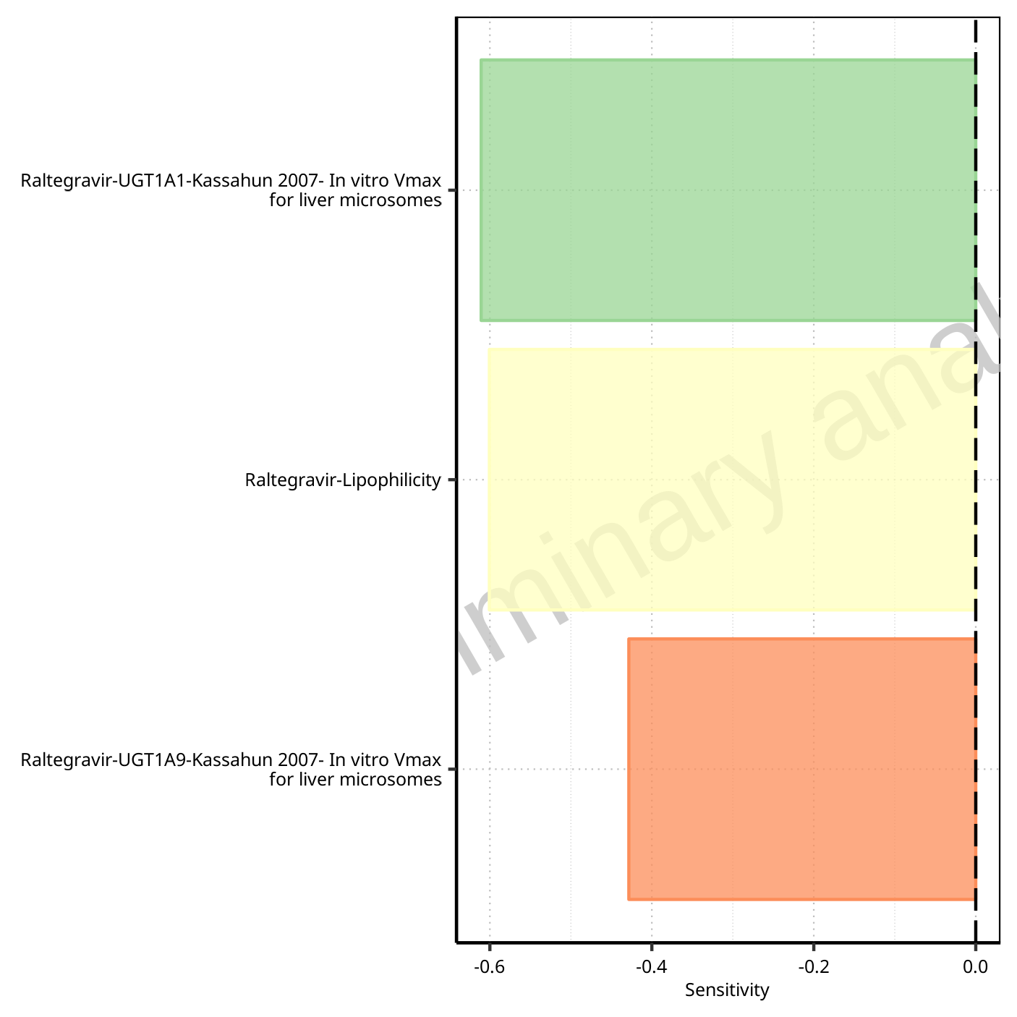

**Figure 1-112: Most sensitive parameters for C_trough_t2 of Raltegravir.**

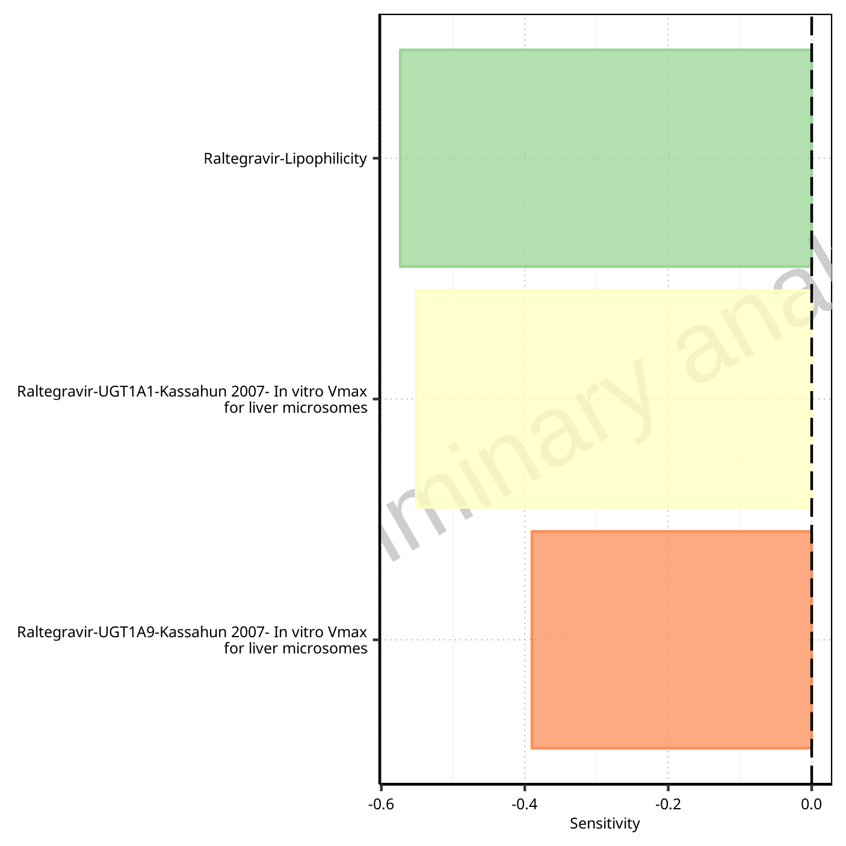

**Figure 1-113: Most sensitive parameters for C_trough_tLast of Raltegravir.**

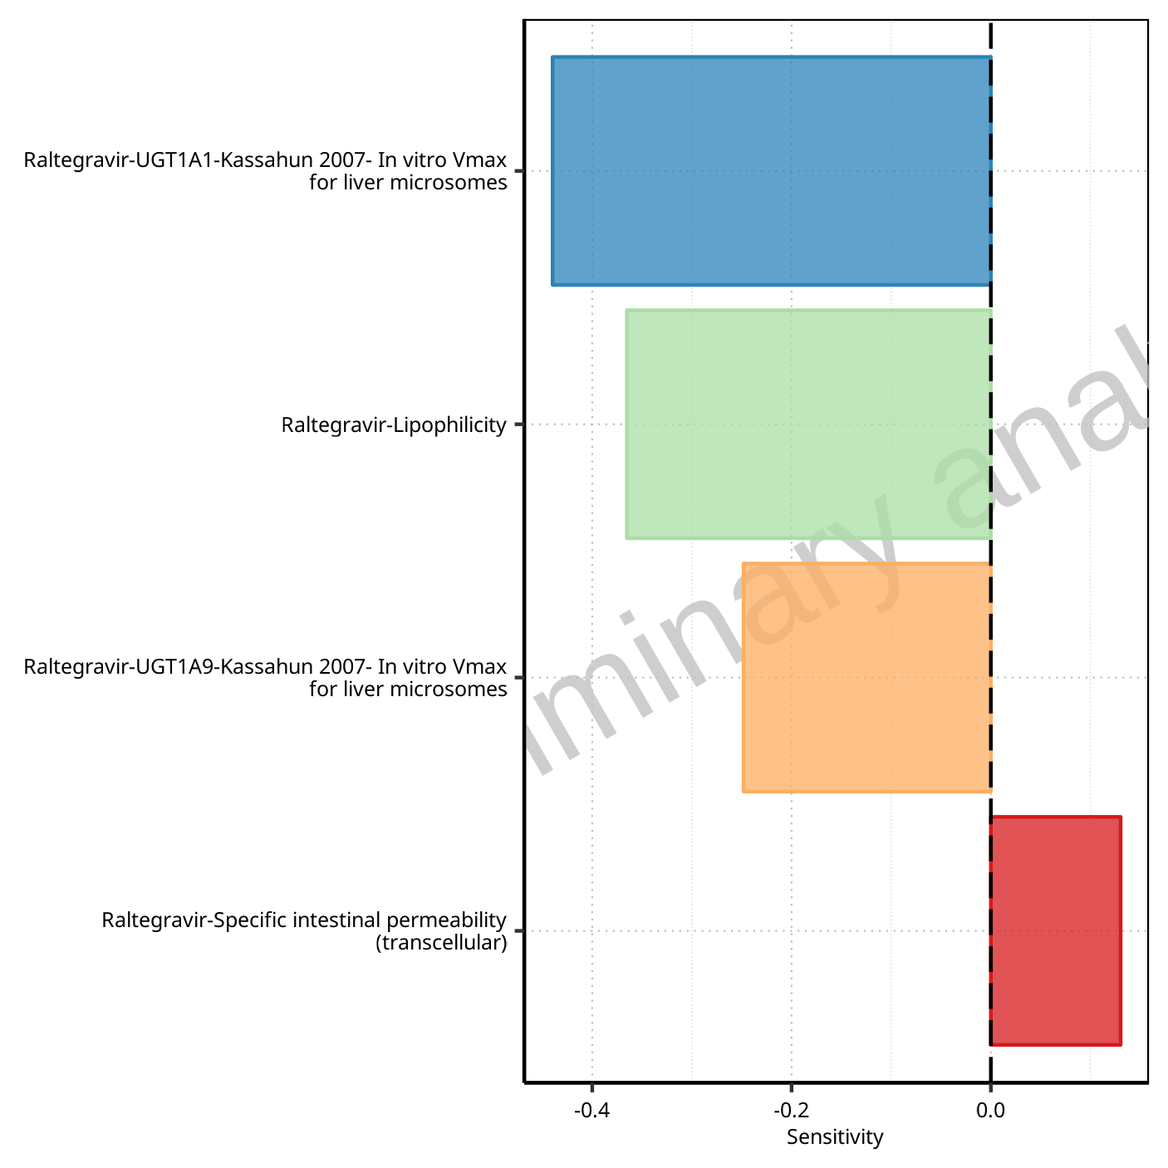

**Figure 1-114: Most sensitive parameters for AUC_t1_t2 of Raltegravir.**

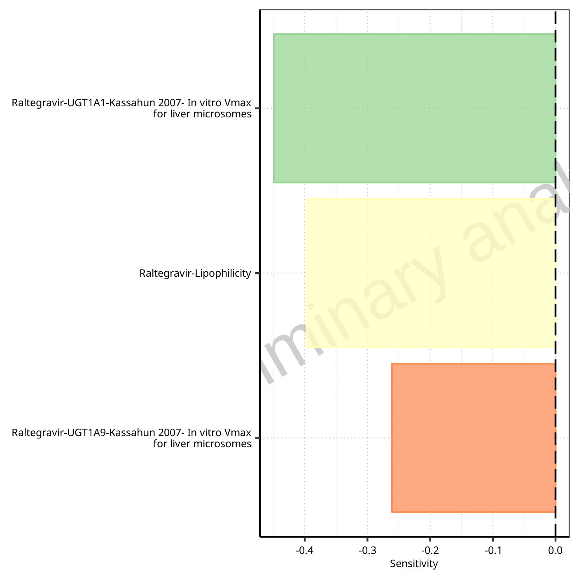

**Figure 1-115: Most sensitive parameters for AUC_tLast_minus_1_tLast of Raltegravir.**

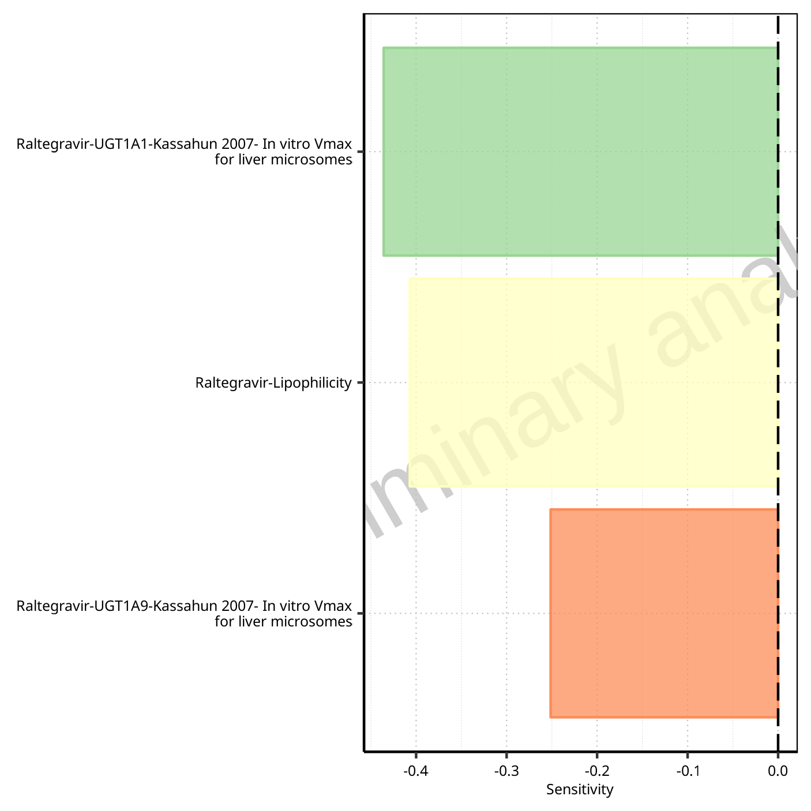

**Figure 1-116: Most sensitive parameters for AUC_inf_t1 of Raltegravir.**

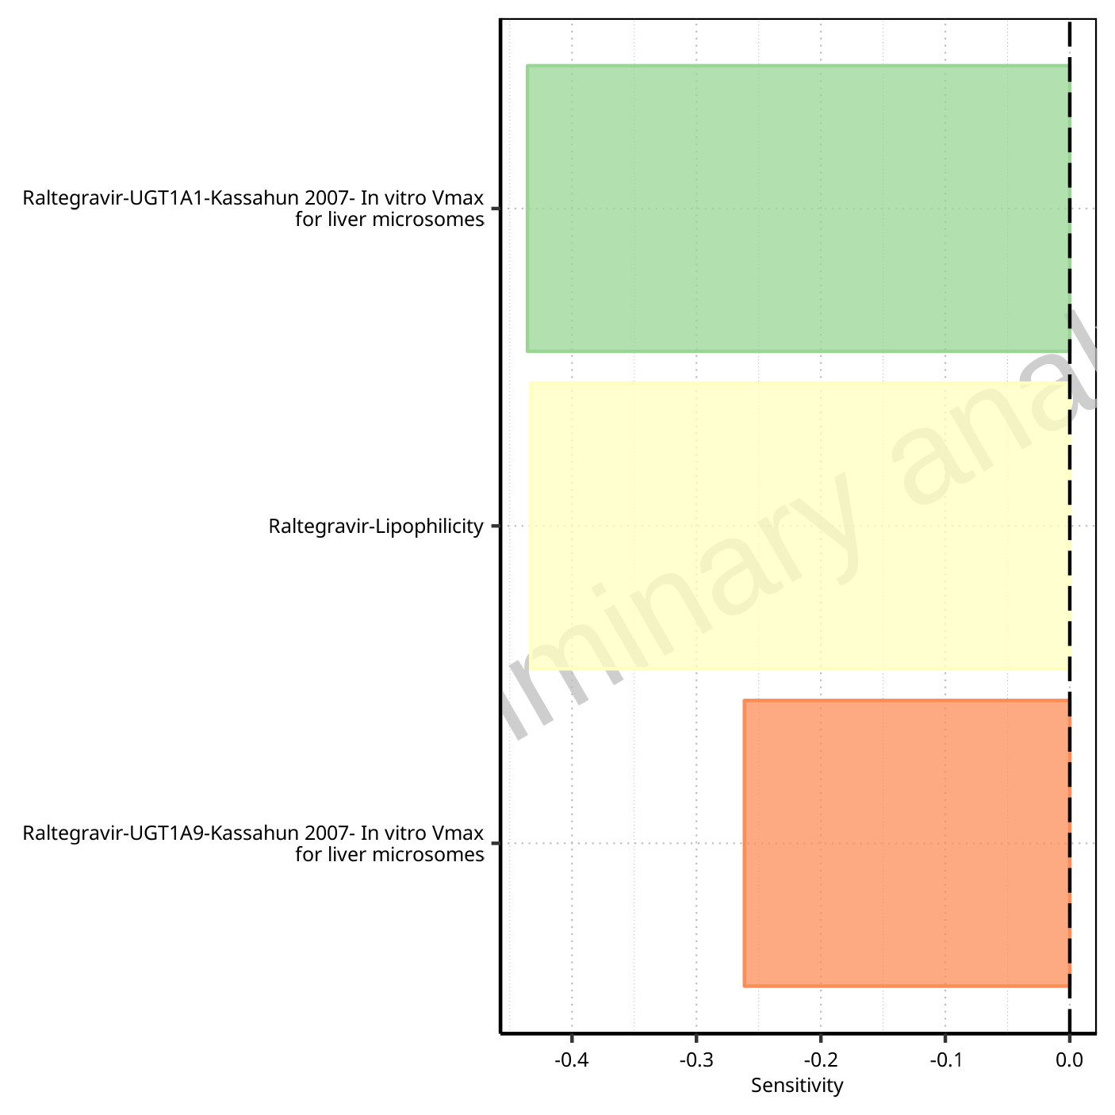

**Figure 1-117: Most sensitive parameters for AUC_inf_tLast of Raltegravir.**

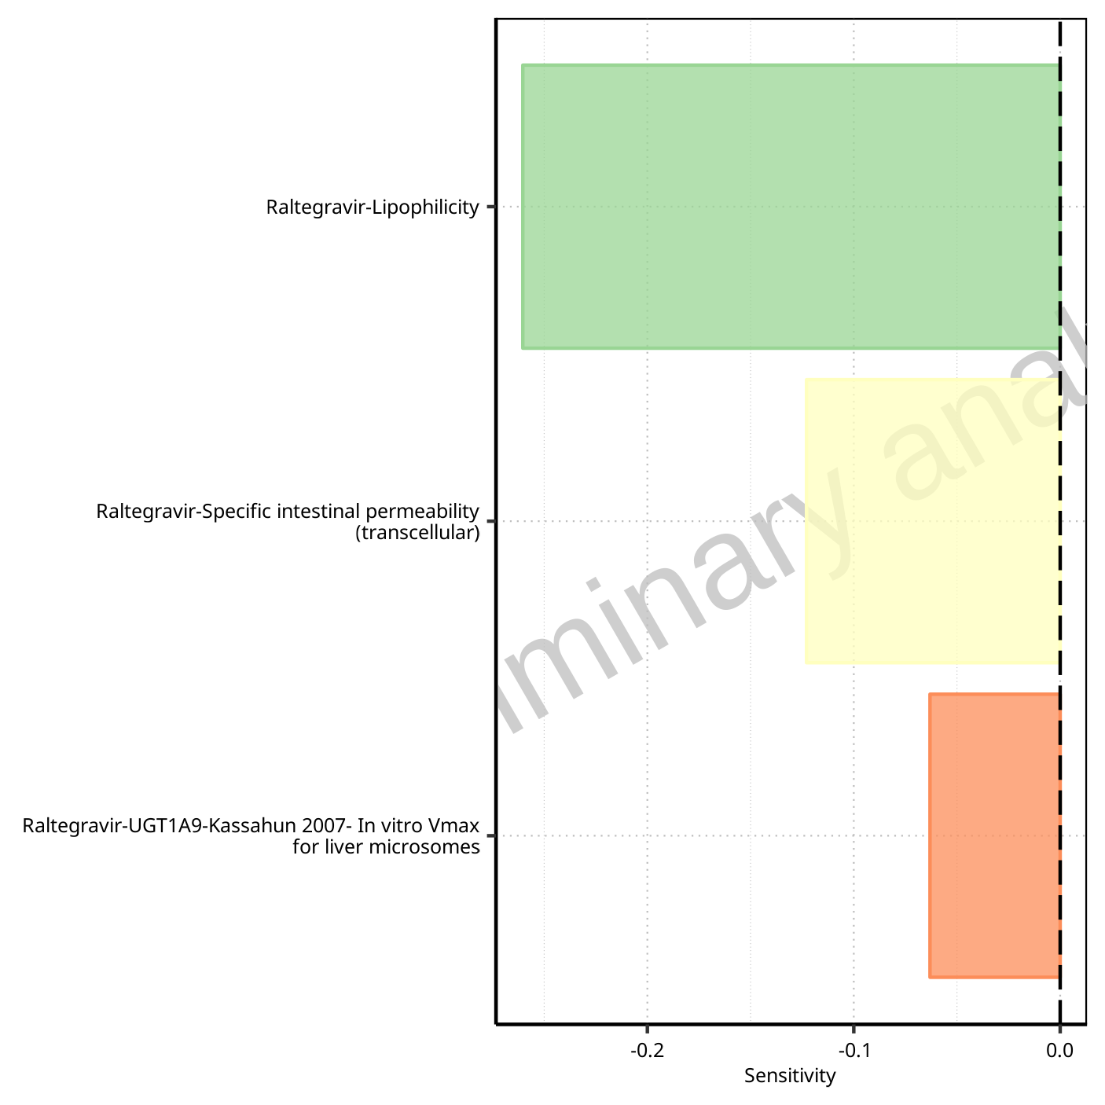

**Figure 1-118: Most sensitive parameters for MRT of Raltegravir.**

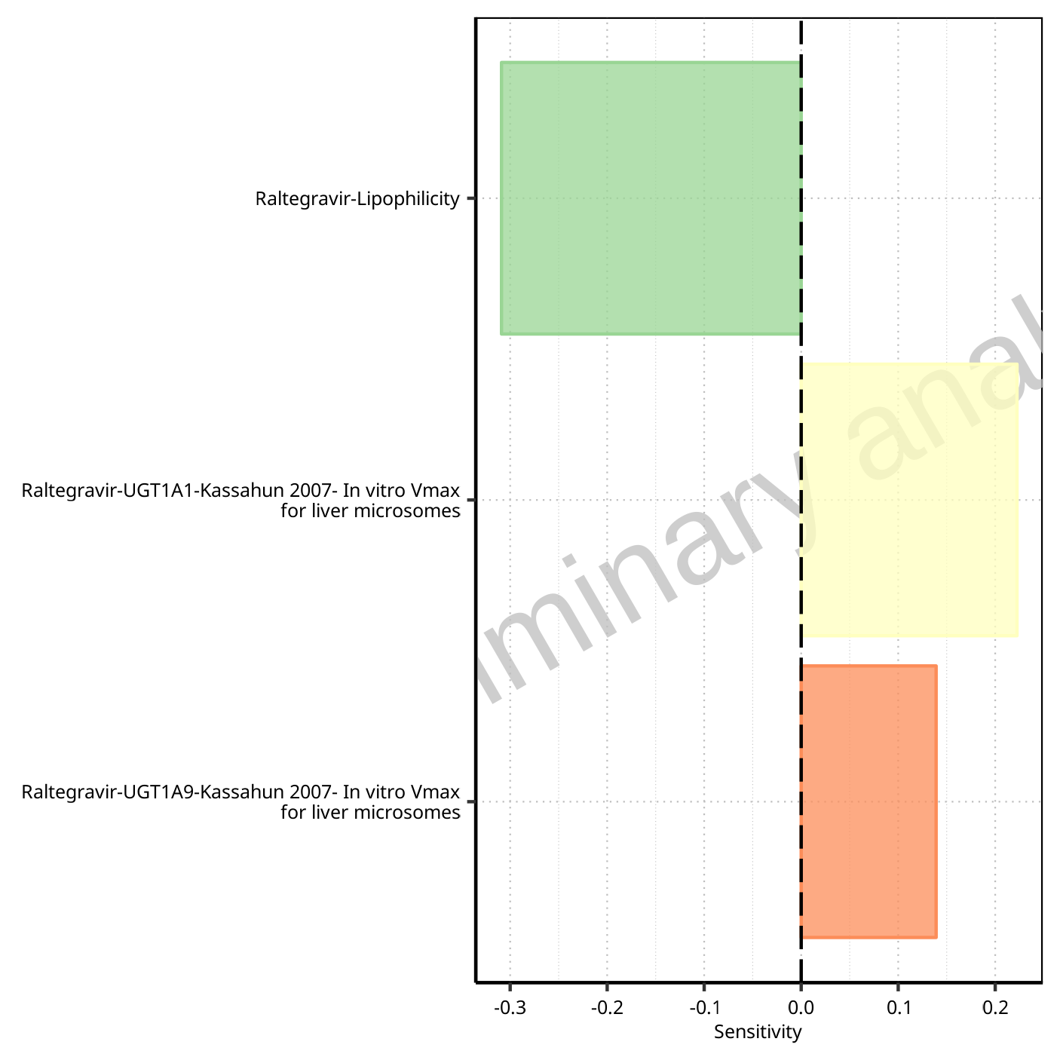

**Figure 1-119: Most sensitive parameters for Thalf of Raltegravir.**

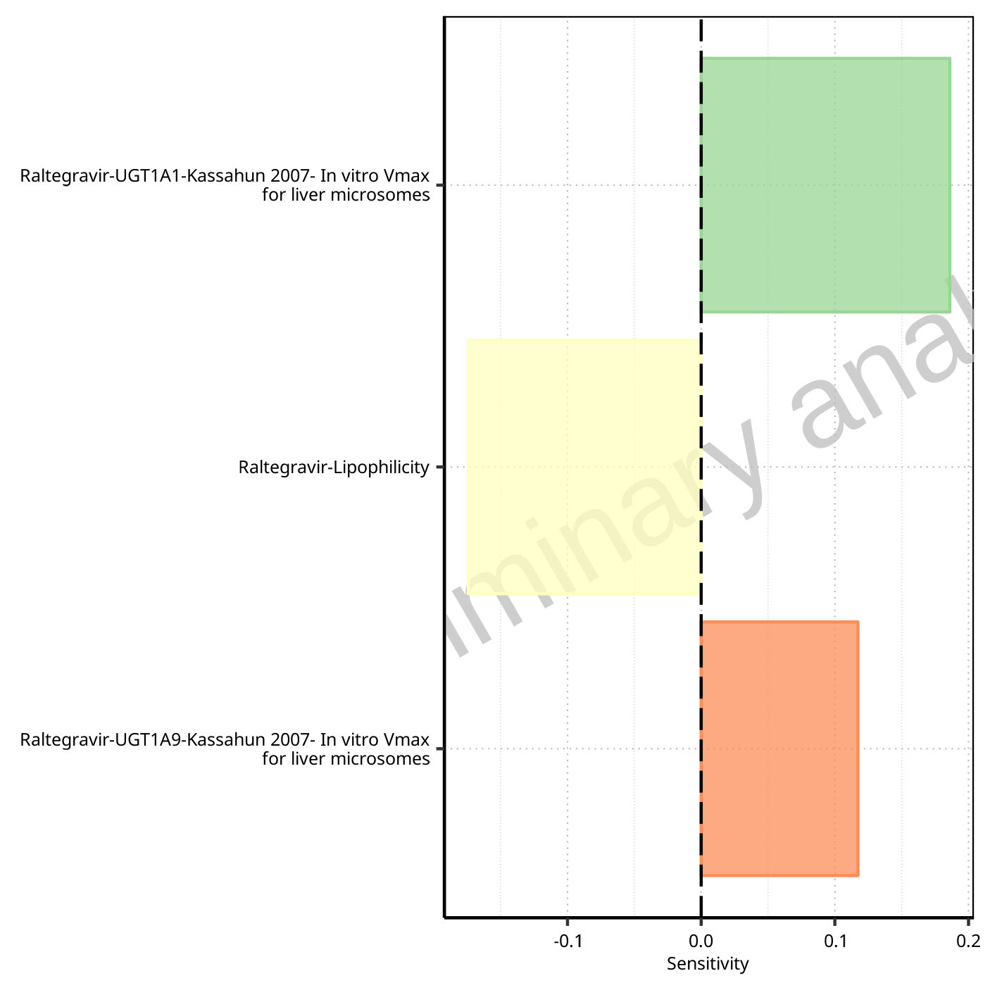

**Figure 1-120: Most sensitive parameters for Thalf_tLast_tEnd of Raltegravir.**

## Sensitivity Analysis for Filmcoated_tablet_400mg_sd

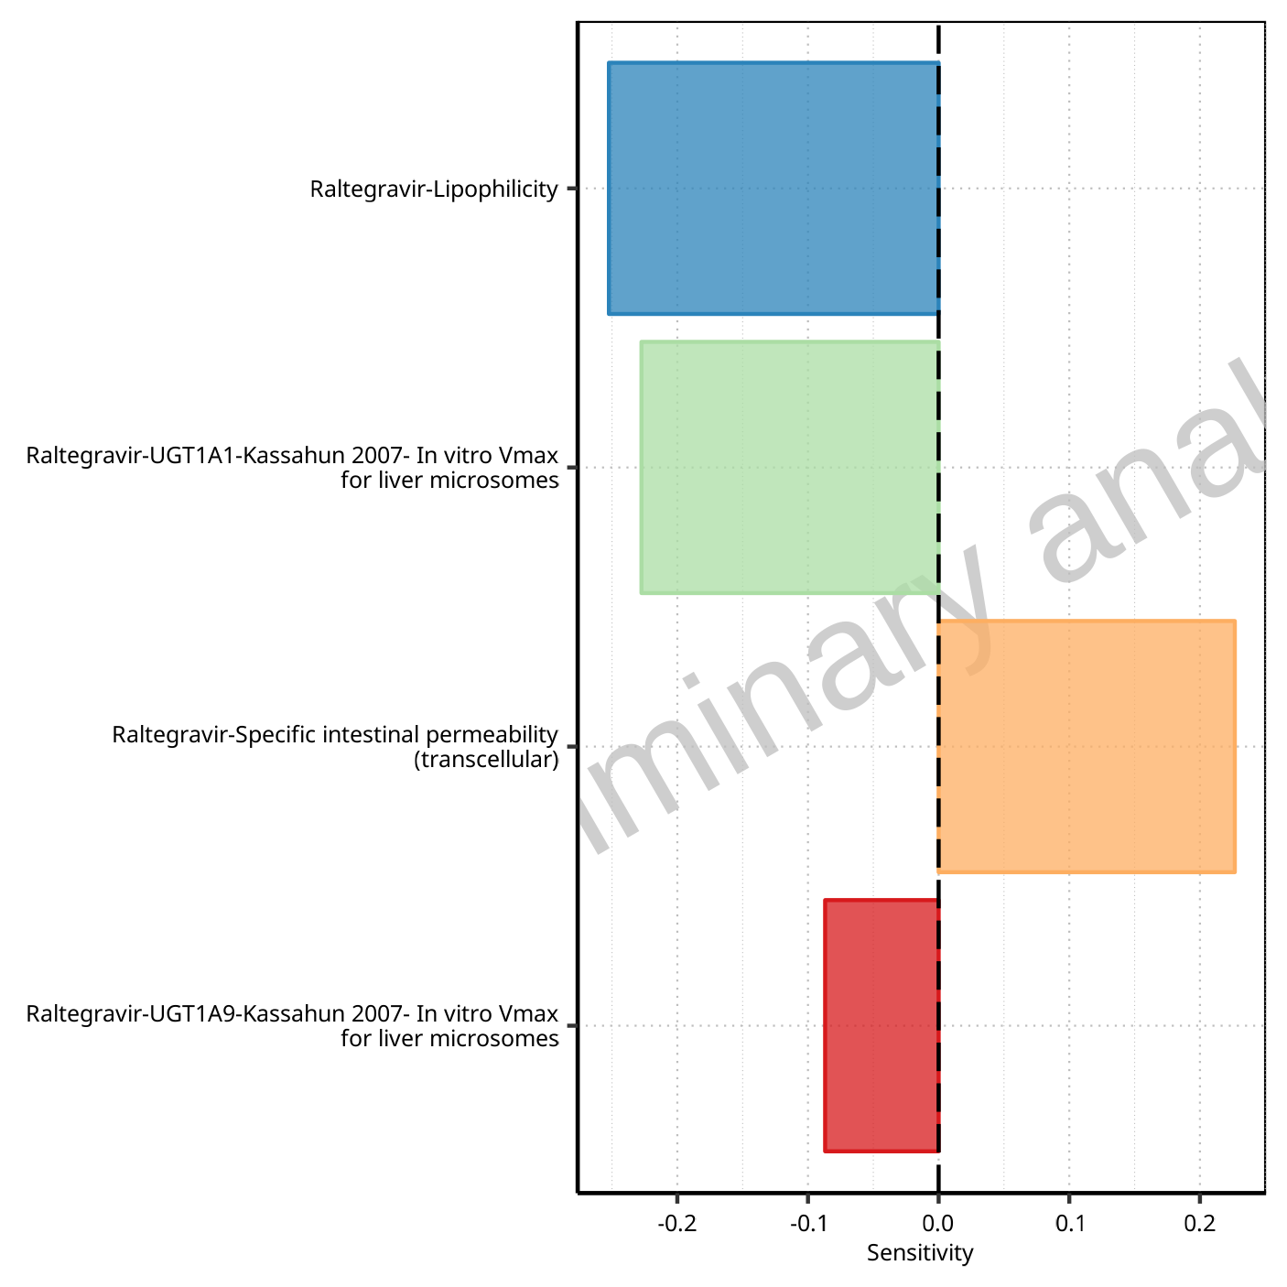

**Figure 1-121: Most sensitive parameters for C_max of Raltegravir.**



**Figure 1-122: Most sensitive parameters for t_max of Raltegravir.**

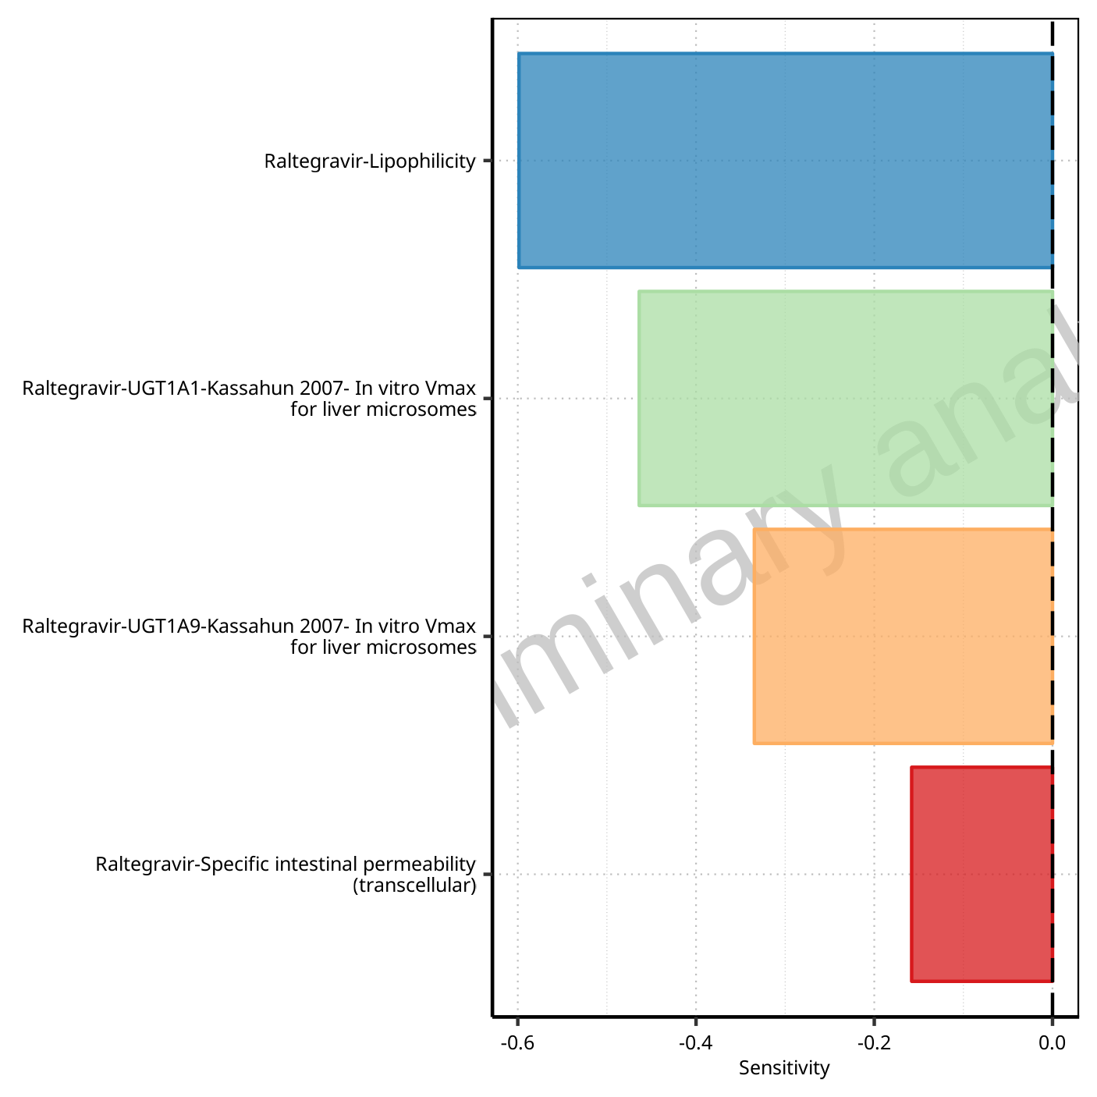

**Figure 1-123: Most sensitive parameters for C_tEnd of Raltegravir.**

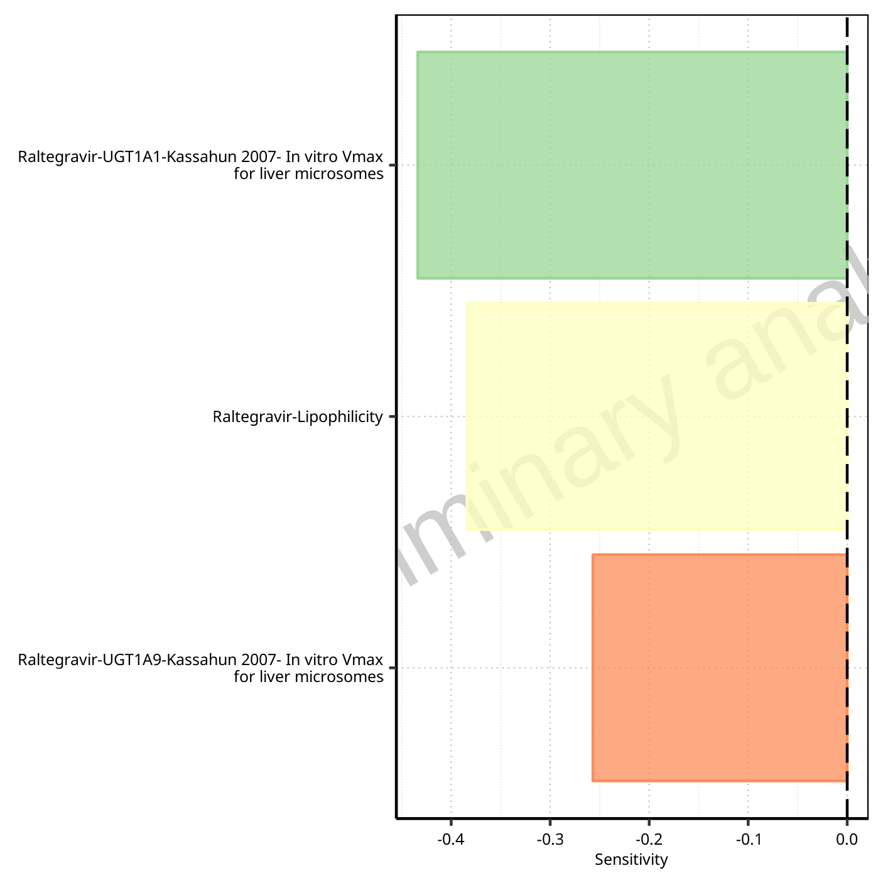

**Figure 1-124: Most sensitive parameters for AUC of Raltegravir.**

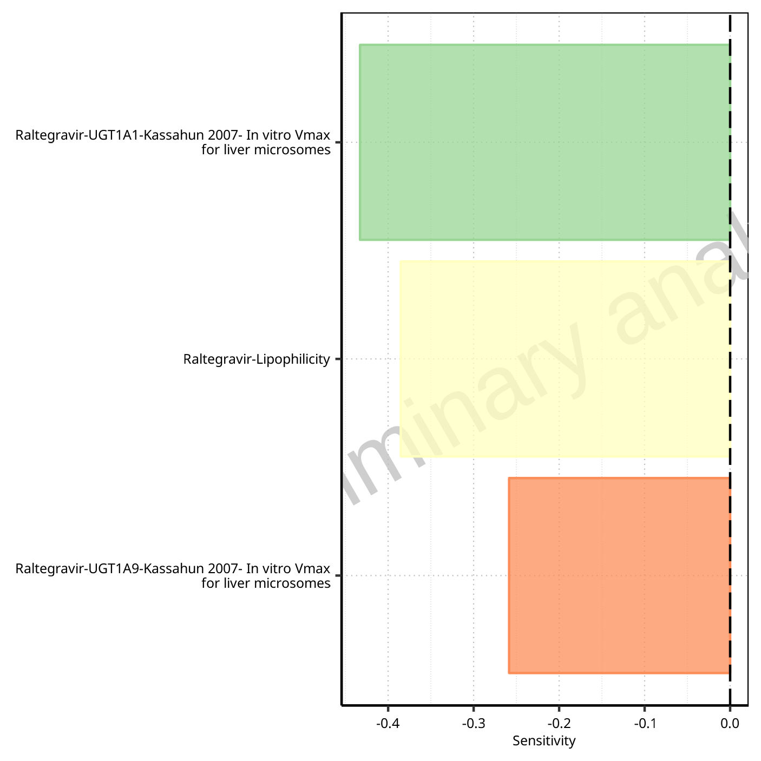

**Figure 1-125: Most sensitive parameters for AUC_inf of Raltegravir.**

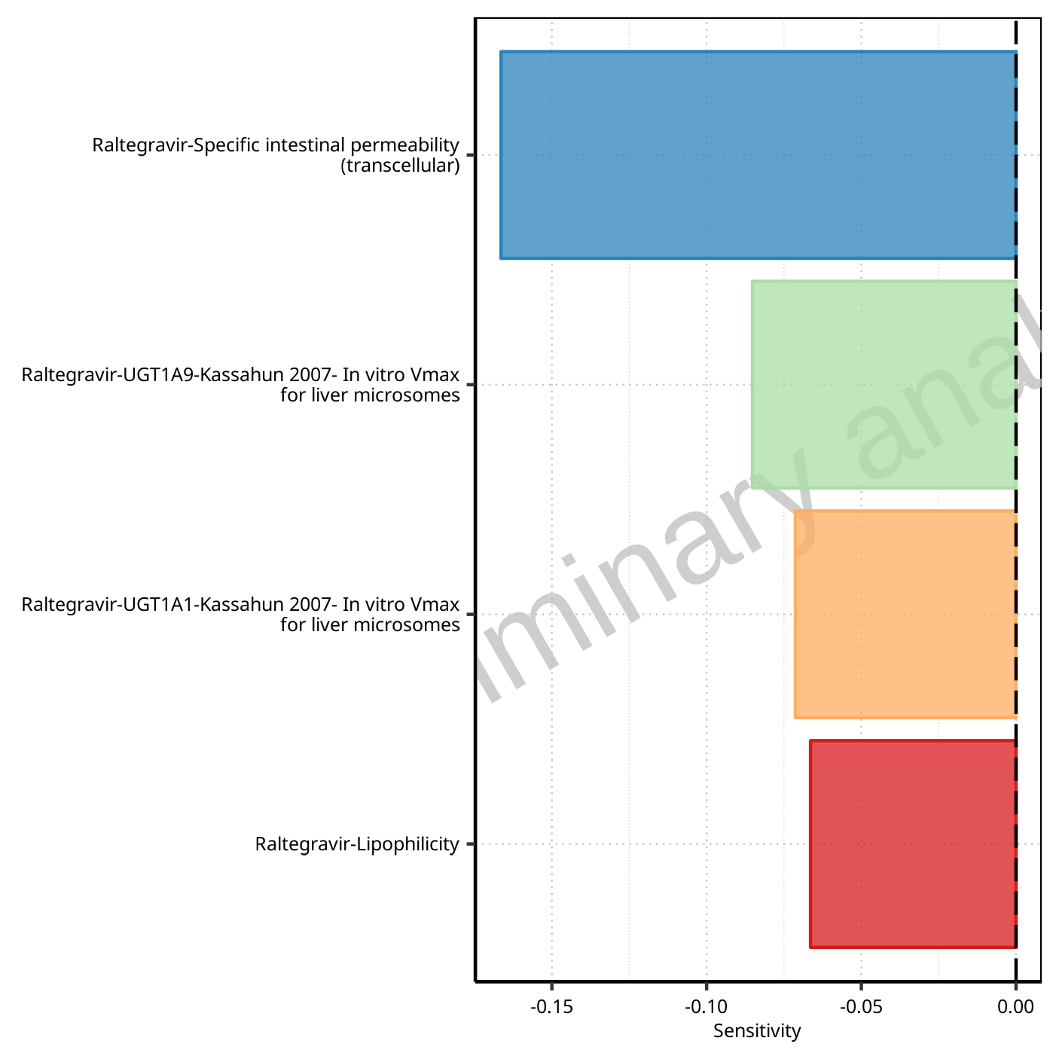

**Figure 1-126: Most sensitive parameters for MRT of Raltegravir.**

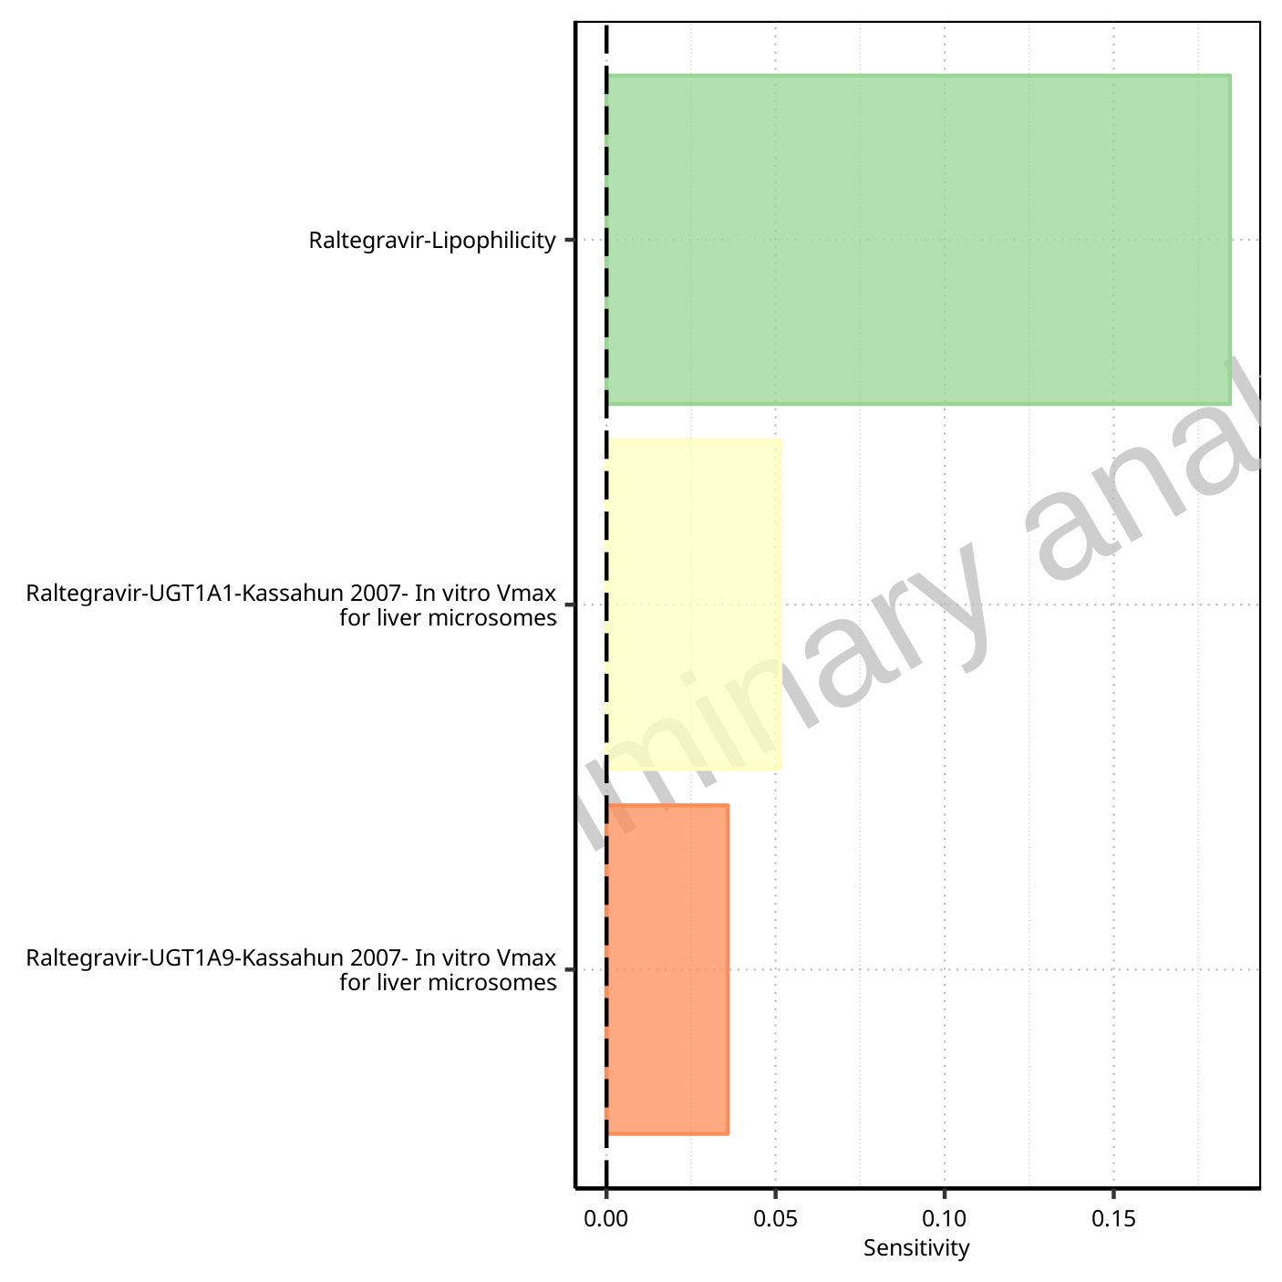

**Figure 1-127: Most sensitive parameters for Thalf of Raltegravir.**

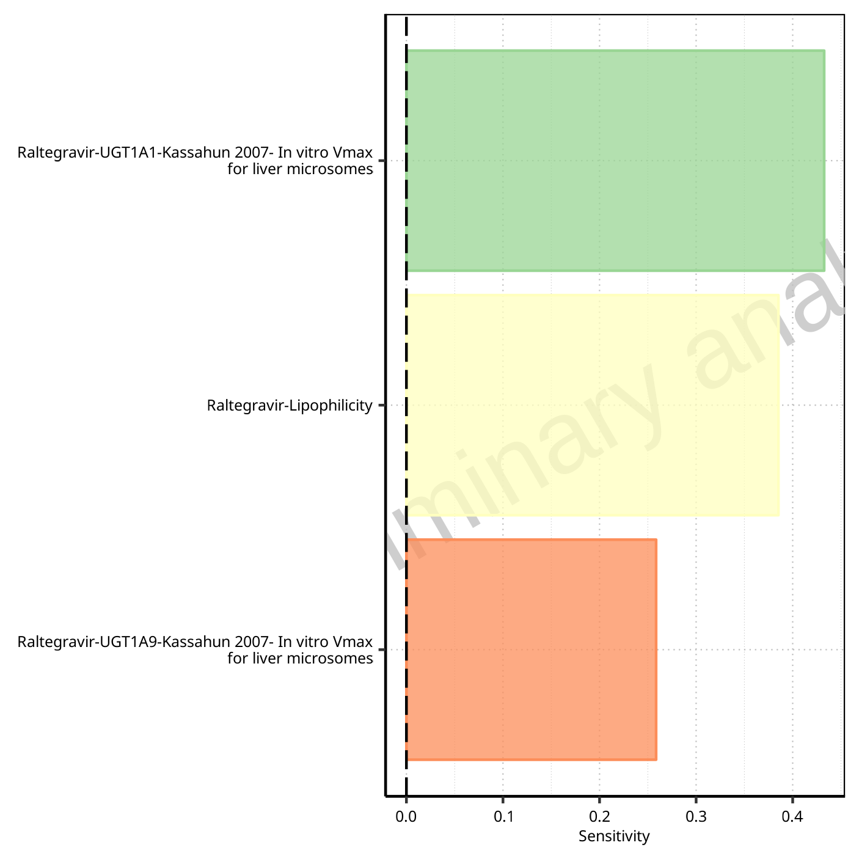

**Figure 1-128: Most sensitive parameters for CL of Raltegravir.**

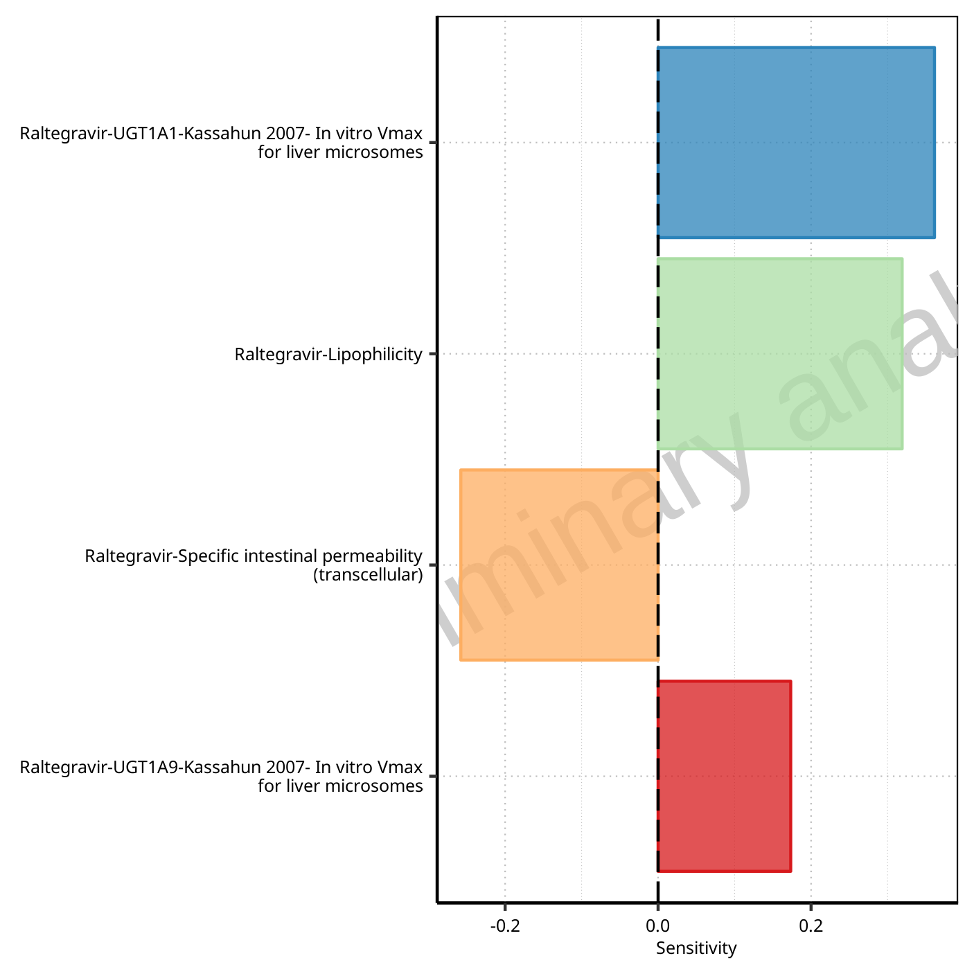

**Figure 1-129: Most sensitive parameters for Vss of Raltegravir.**

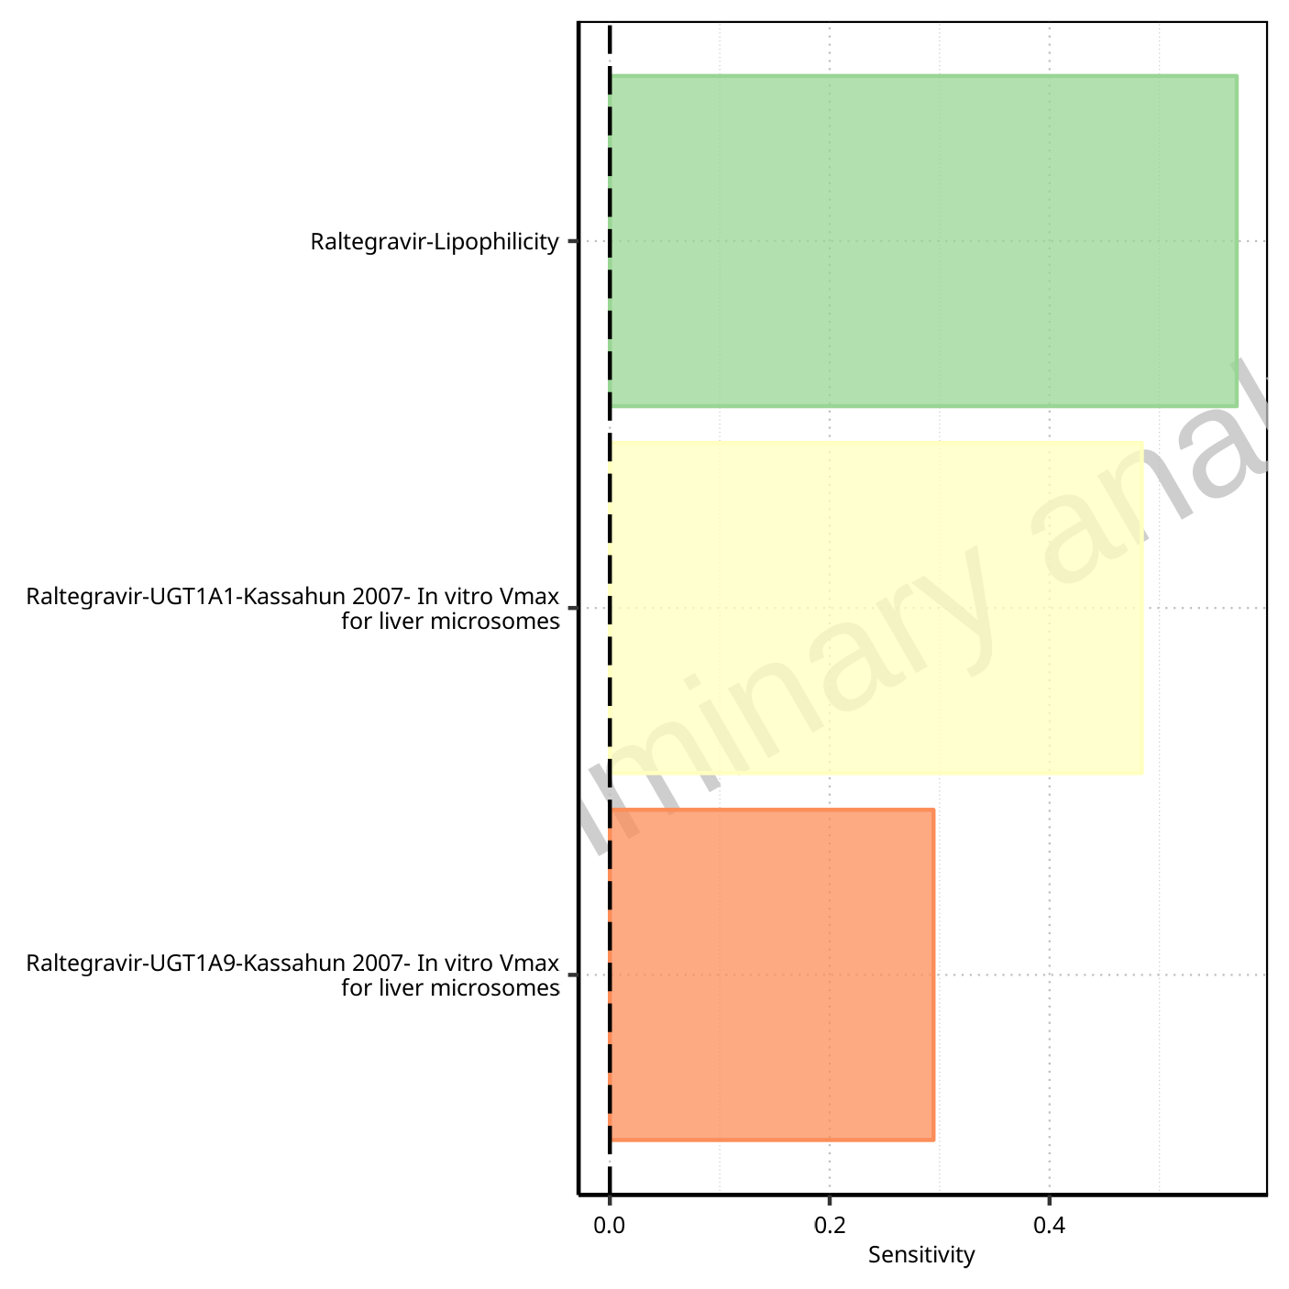

**Figure 1-130: Most sensitive parameters for Vd of Raltegravir.**

## Sensitivity Analysis for Raltegravir 400 mg filmcoated tablet md

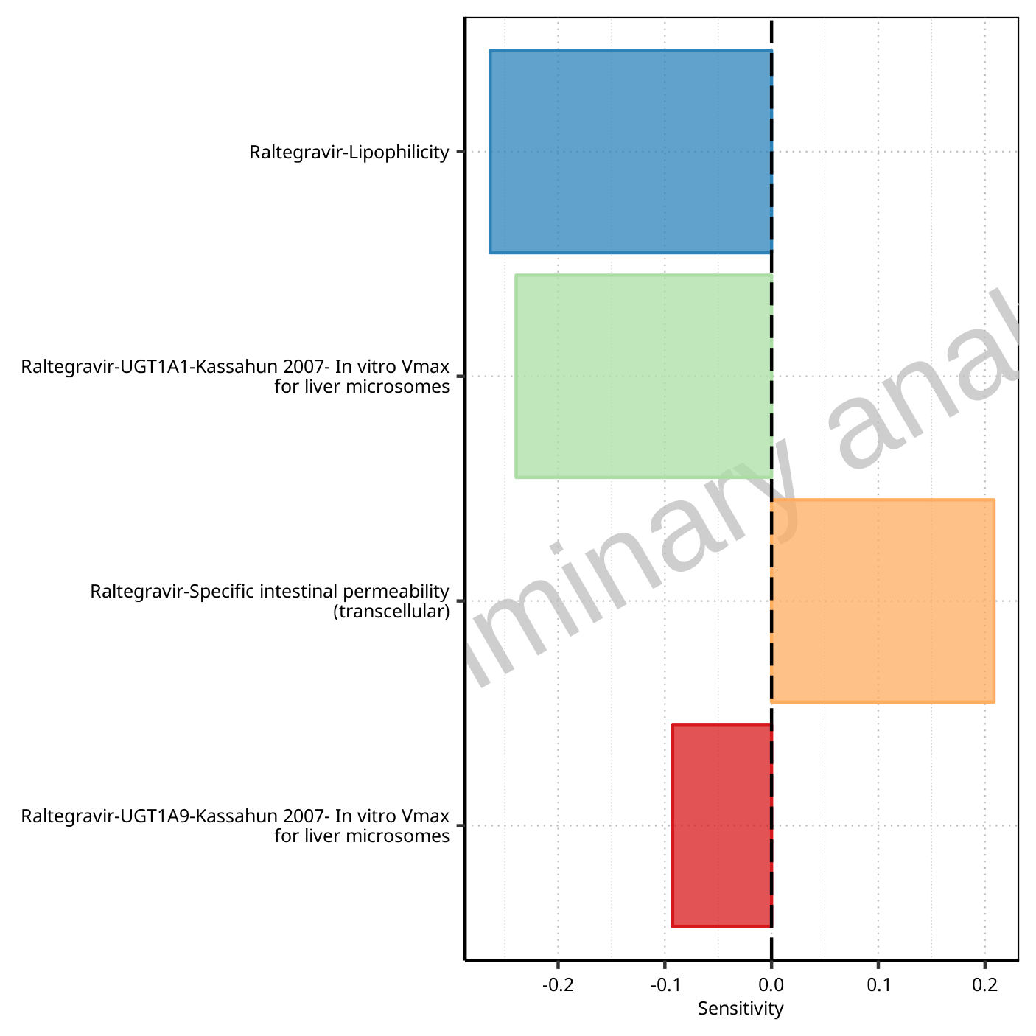

**Figure 1-131: Most sensitive parameters for C_max of Raltegravir.**

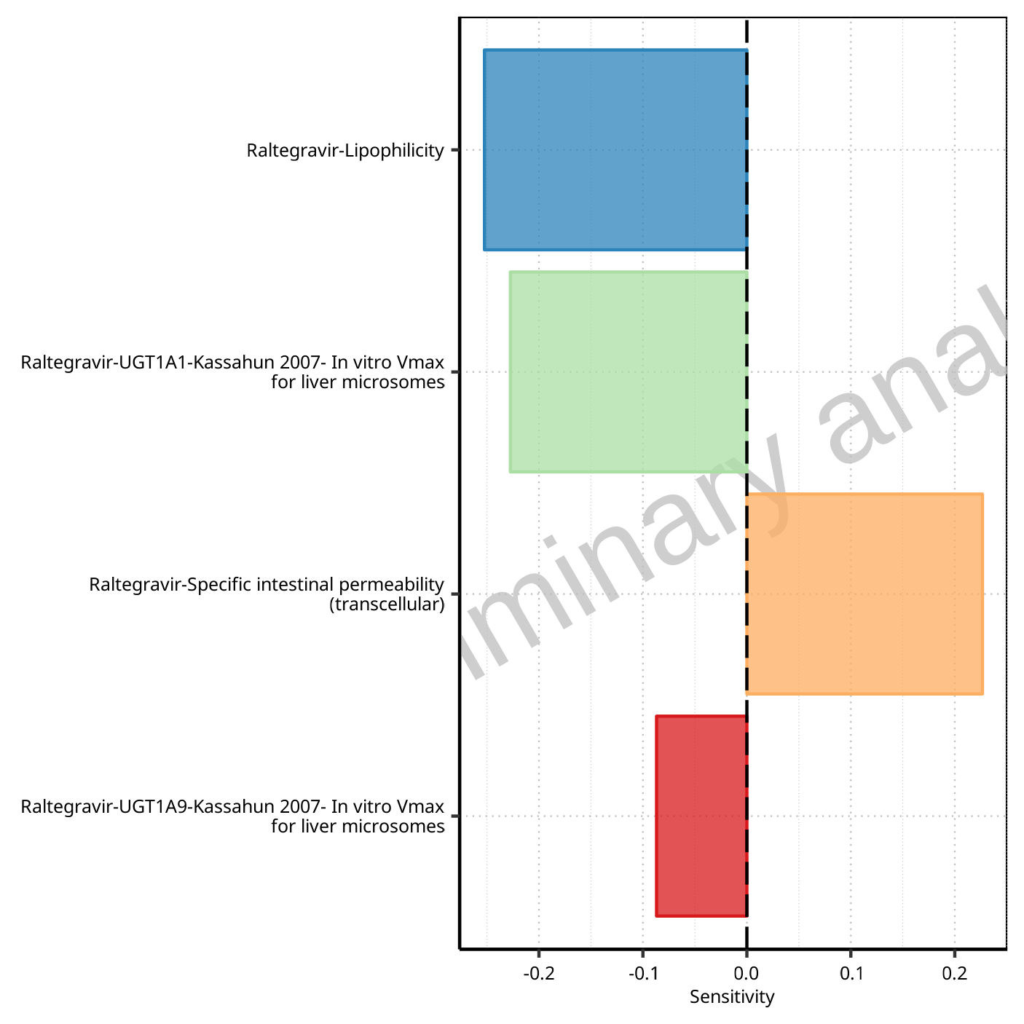

**Figure 1-132: Most sensitive parameters for C_max_t1_t2 of Raltegravir.**

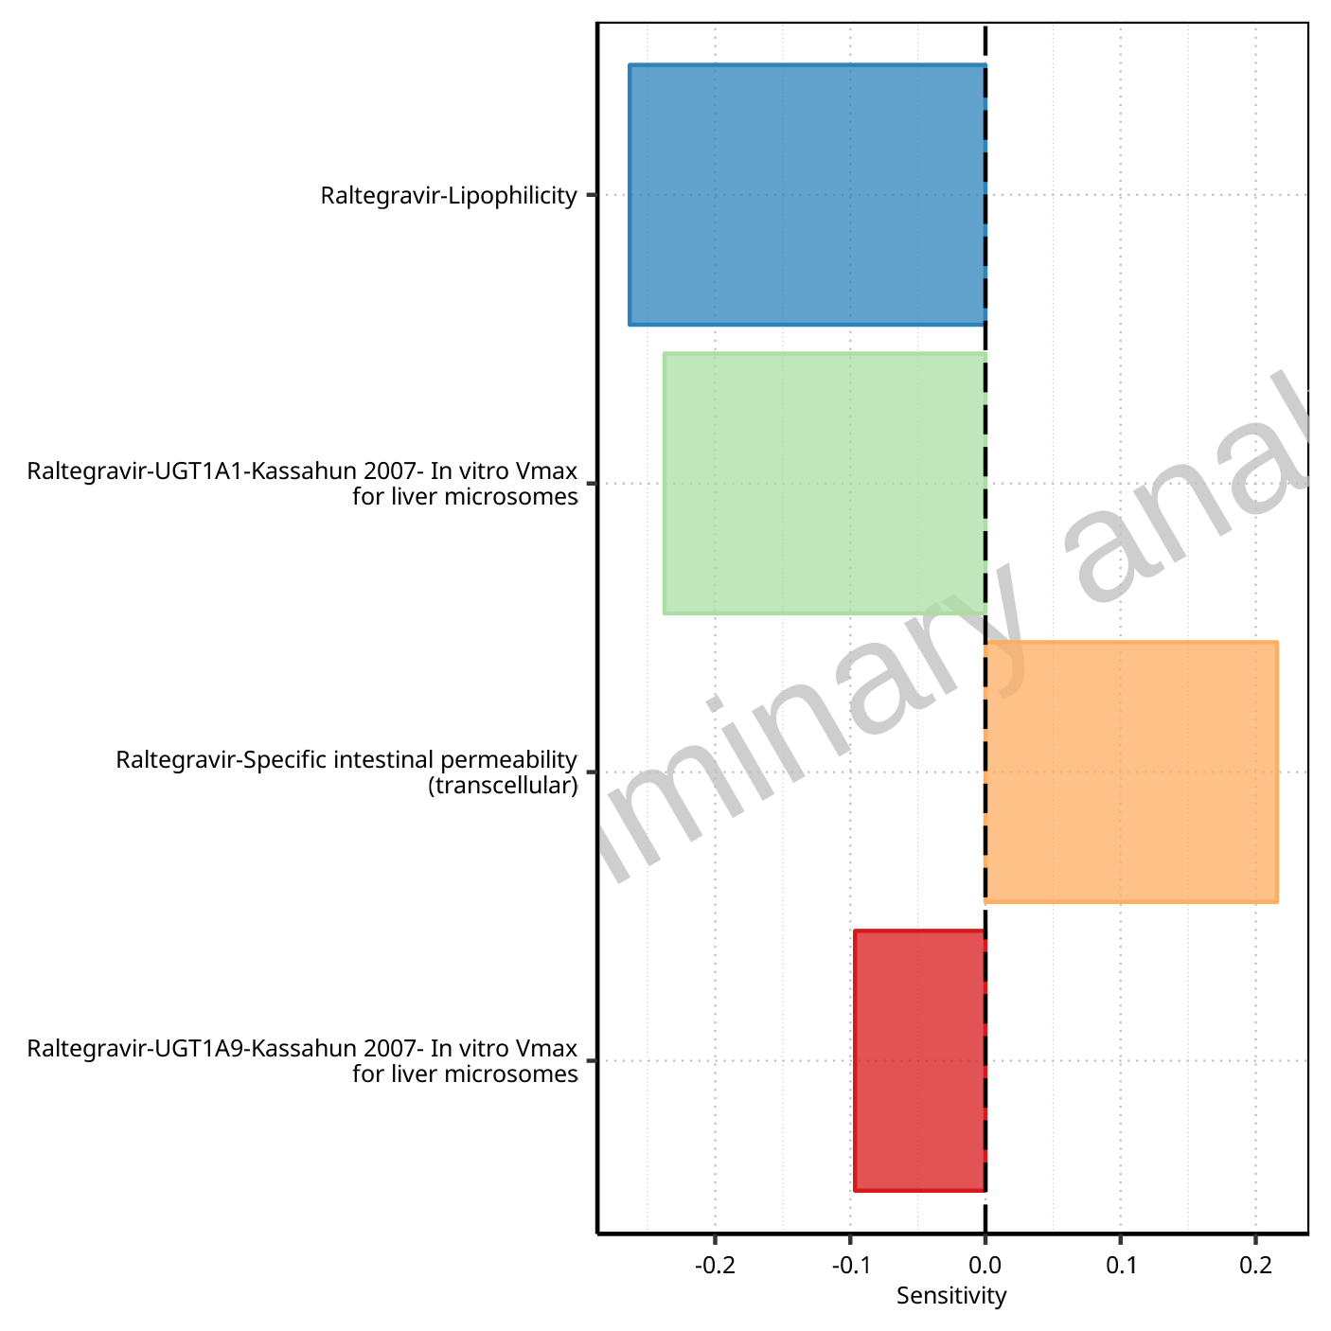

**Figure 1-133: Most sensitive parameters for C_max_tLast_tEnd of Raltegravir.**

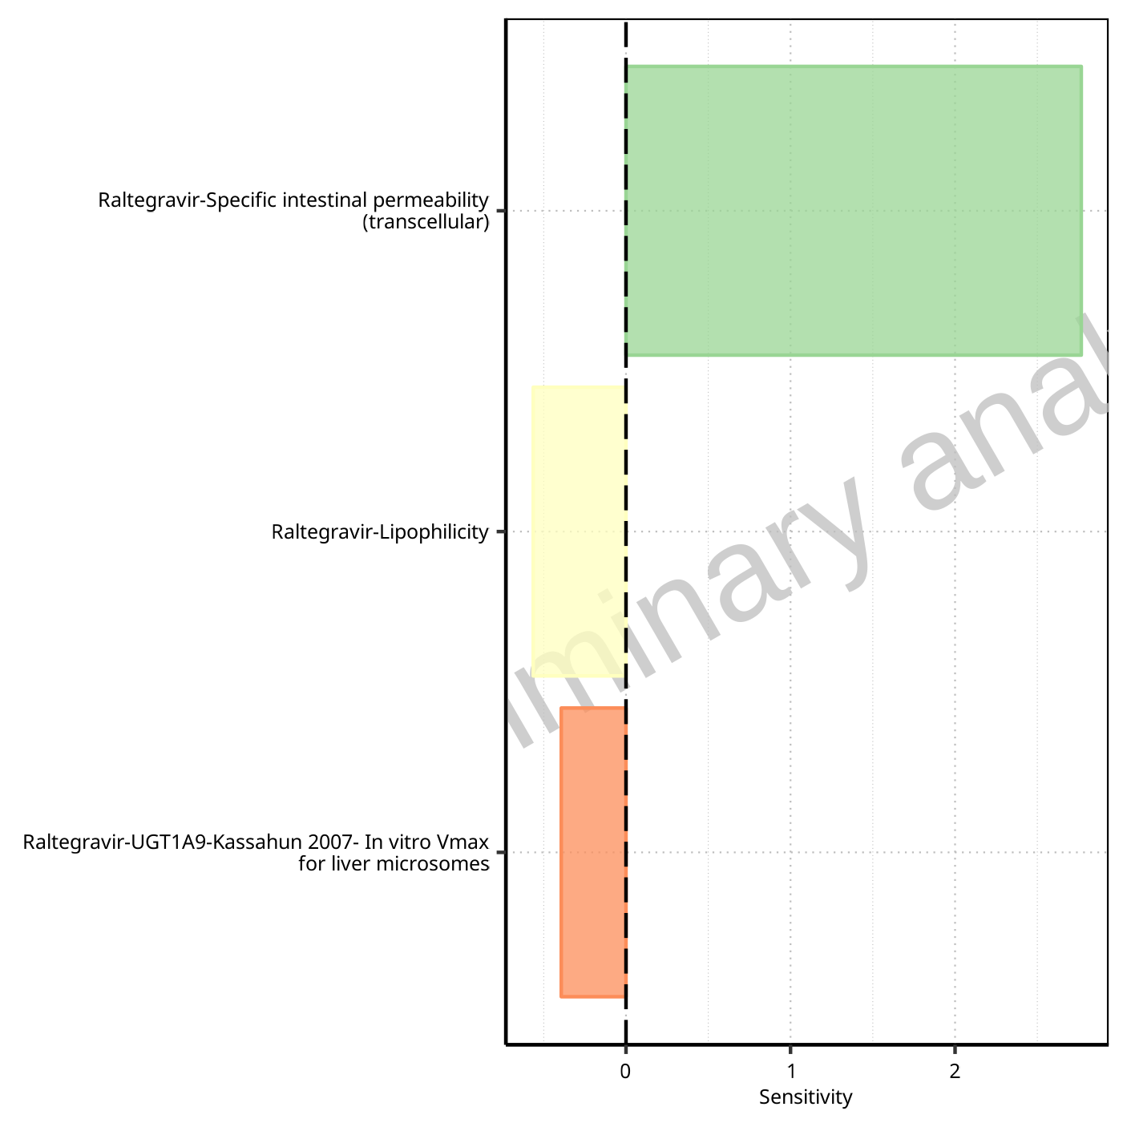

**Figure 1-134: Most sensitive parameters for t_max of Raltegravir.**



**Figure 1-135: Most sensitive parameters for t_max_t1_t2 of Raltegravir.**



**Figure 1-136: Most sensitive parameters for t_max_tLast_tEnd of Raltegravir.**

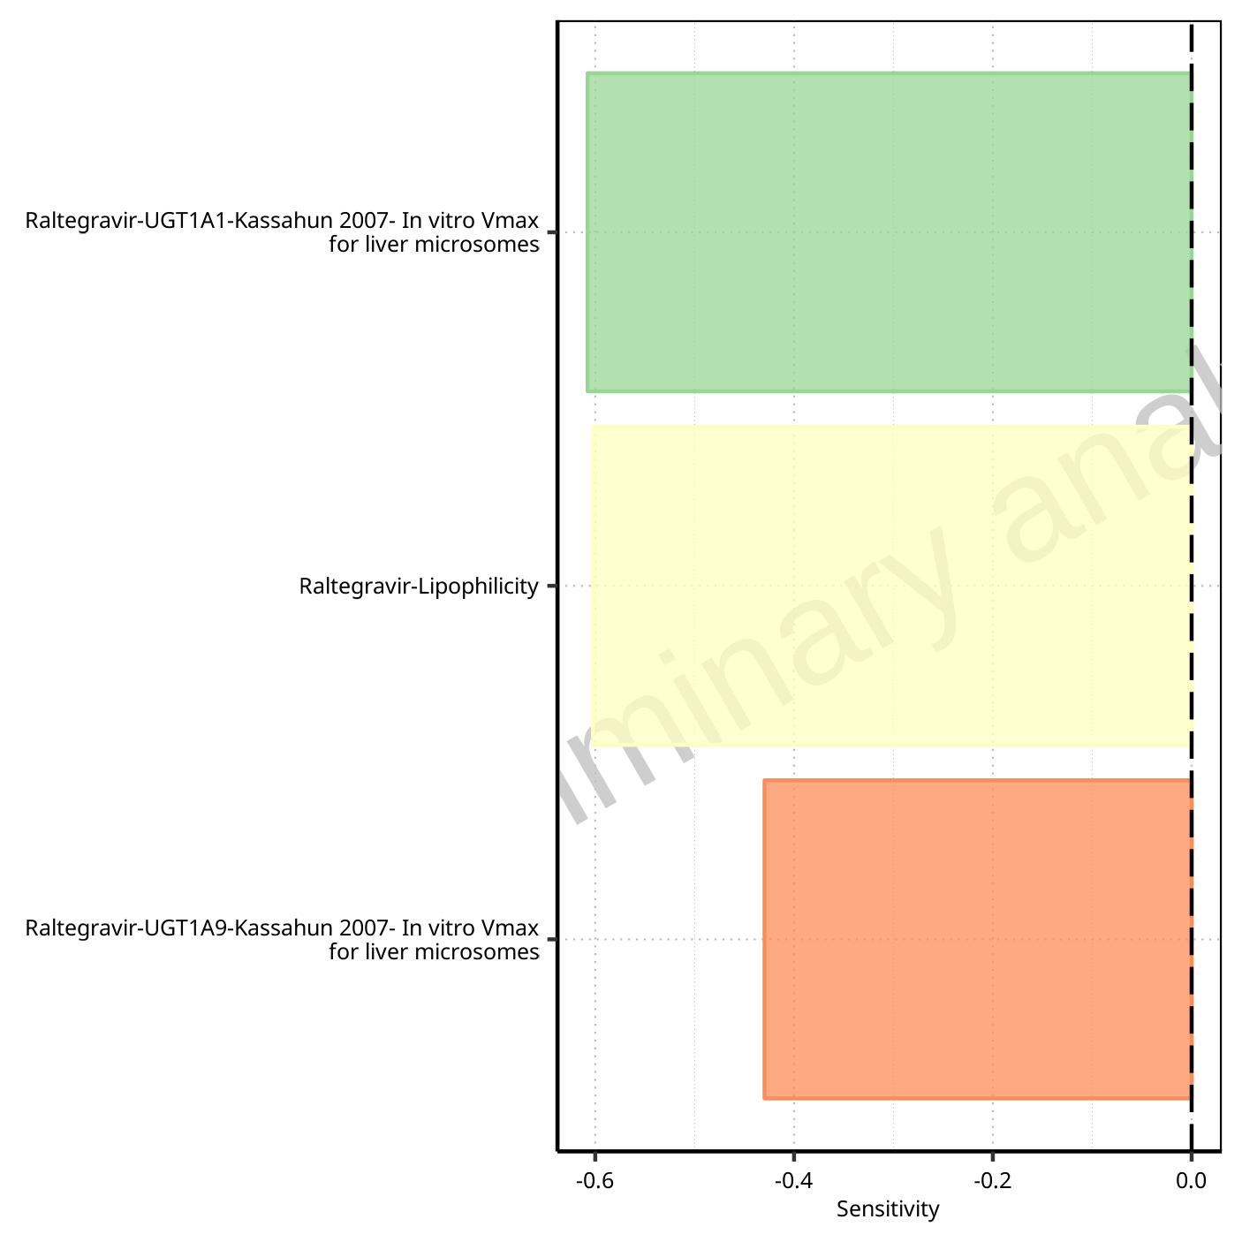

**Figure 1-137: Most sensitive parameters for C_trough_t2 of Raltegravir.**

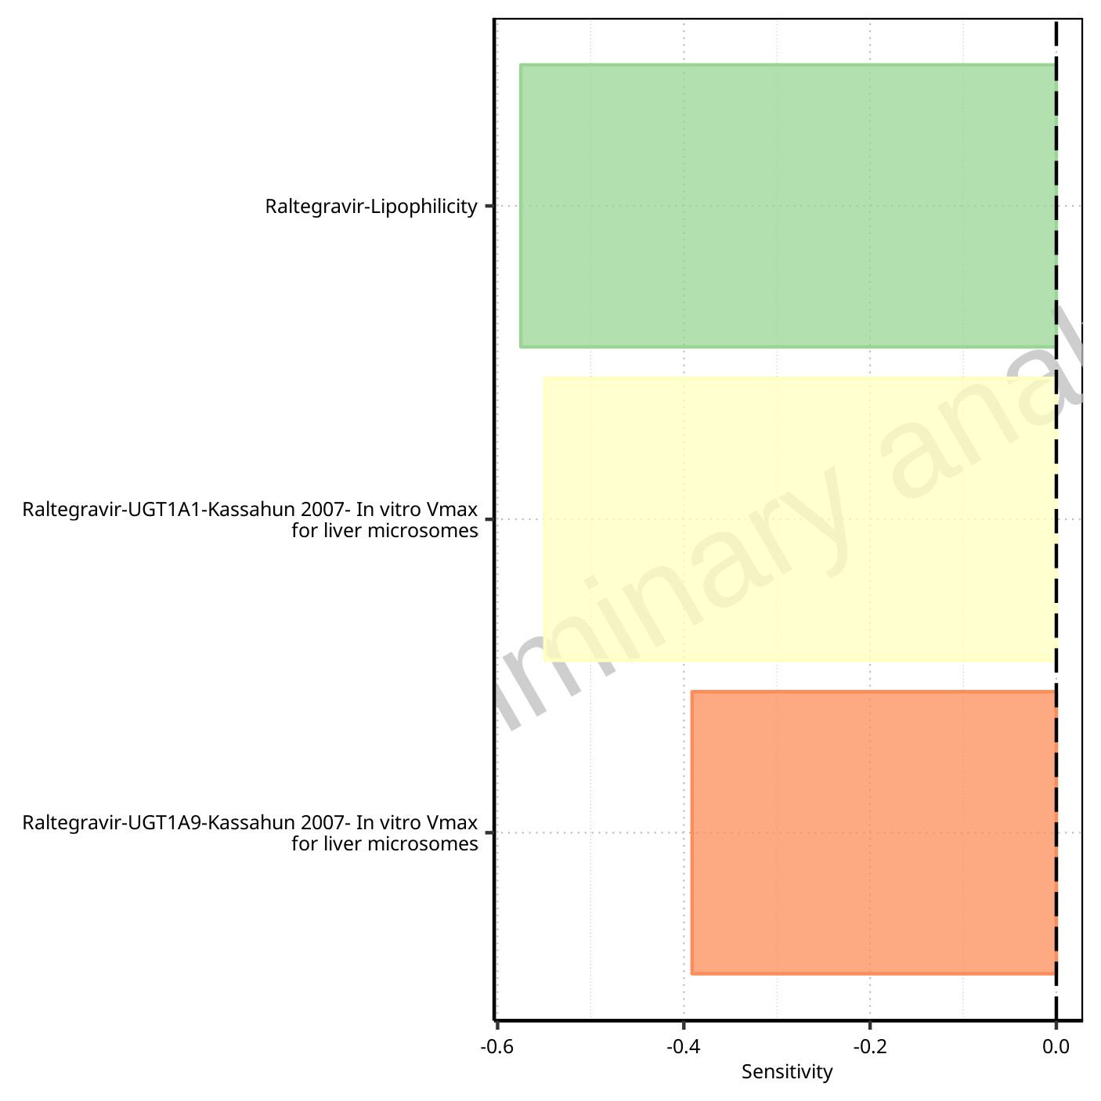

**Figure 1-138: Most sensitive parameters for C_trough_tLast of Raltegravir.**

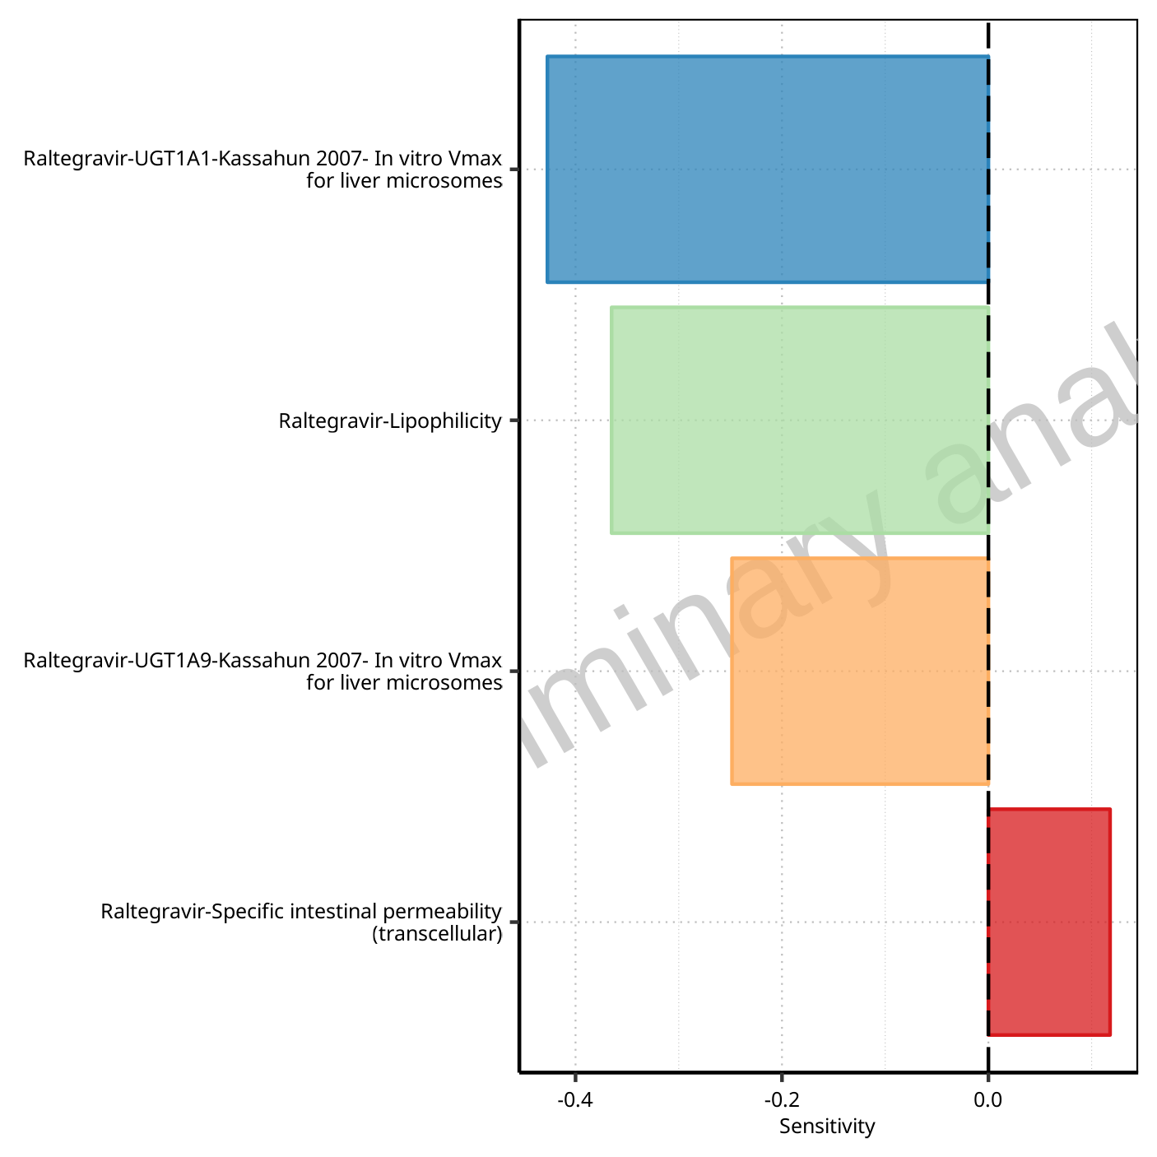

**Figure 1-139: Most sensitive parameters for AUC_t1_t2 of Raltegravir.**

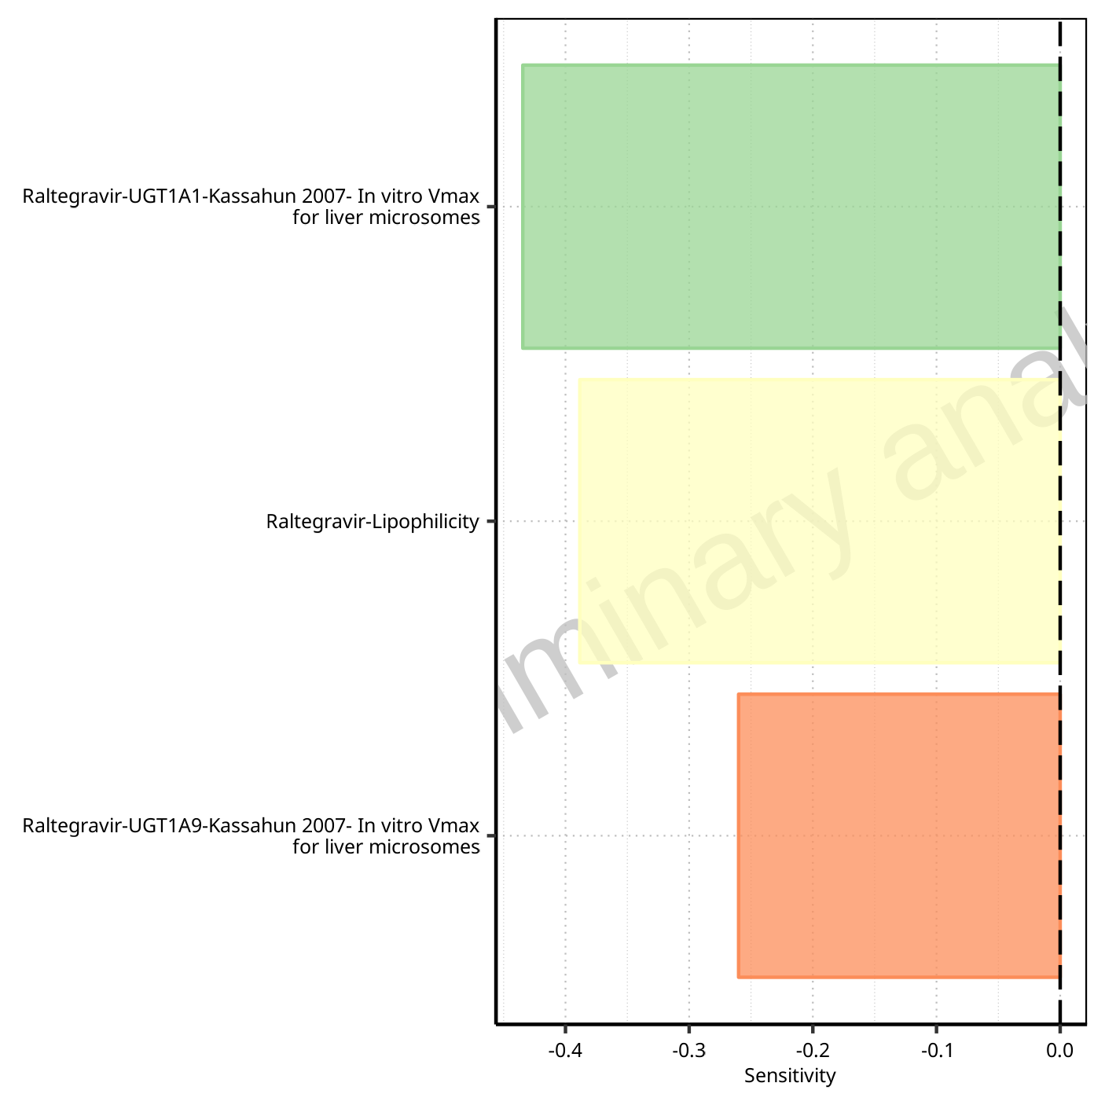

**Figure 1-140: Most sensitive parameters for AUC_tLast_minus_1_tLast of Raltegravir.**

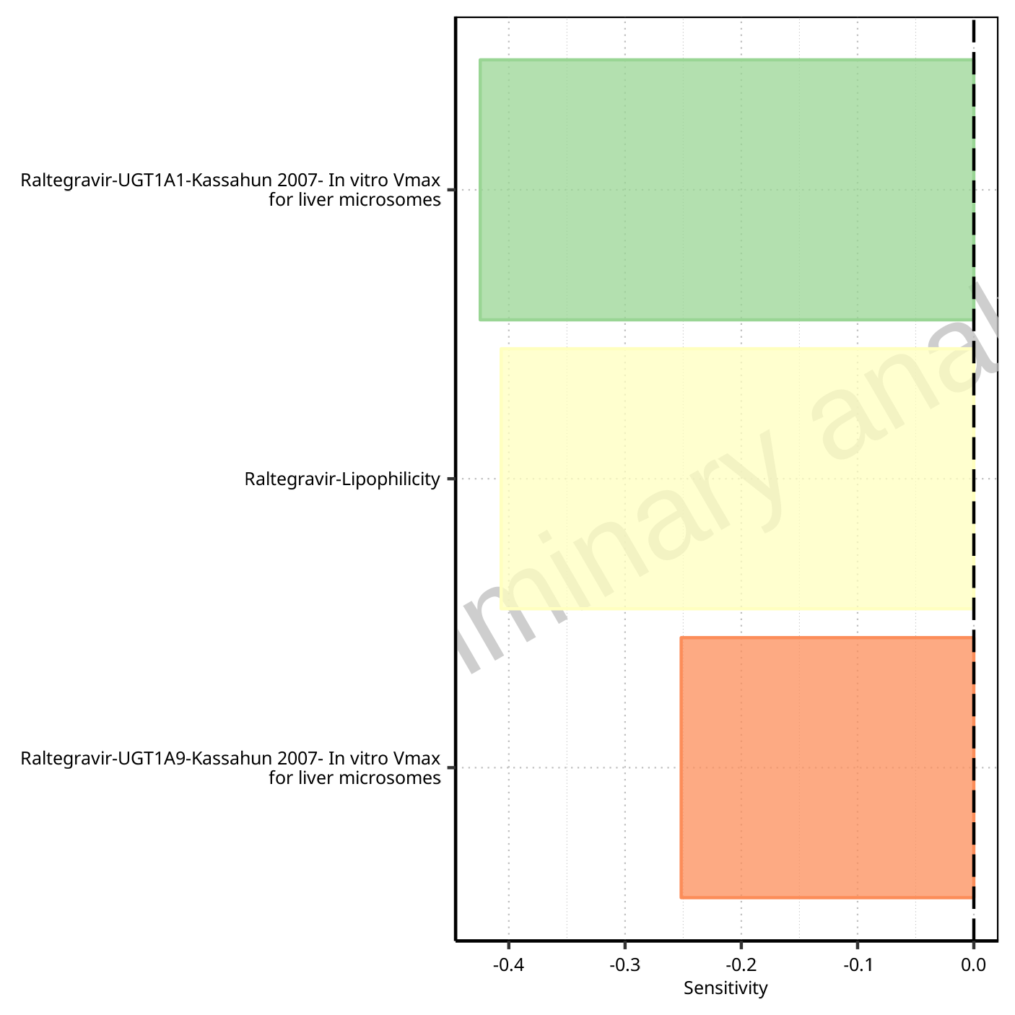

**Figure 1-141: Most sensitive parameters for AUC_inf_t1 of Raltegravir.**

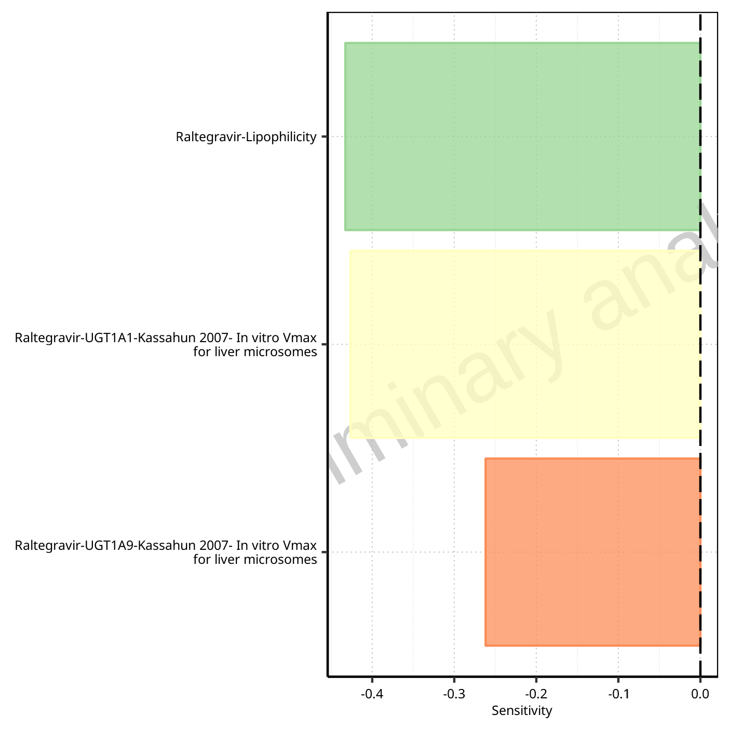

**Figure 1-142: Most sensitive parameters for AUC_inf_tLast of Raltegravir.**

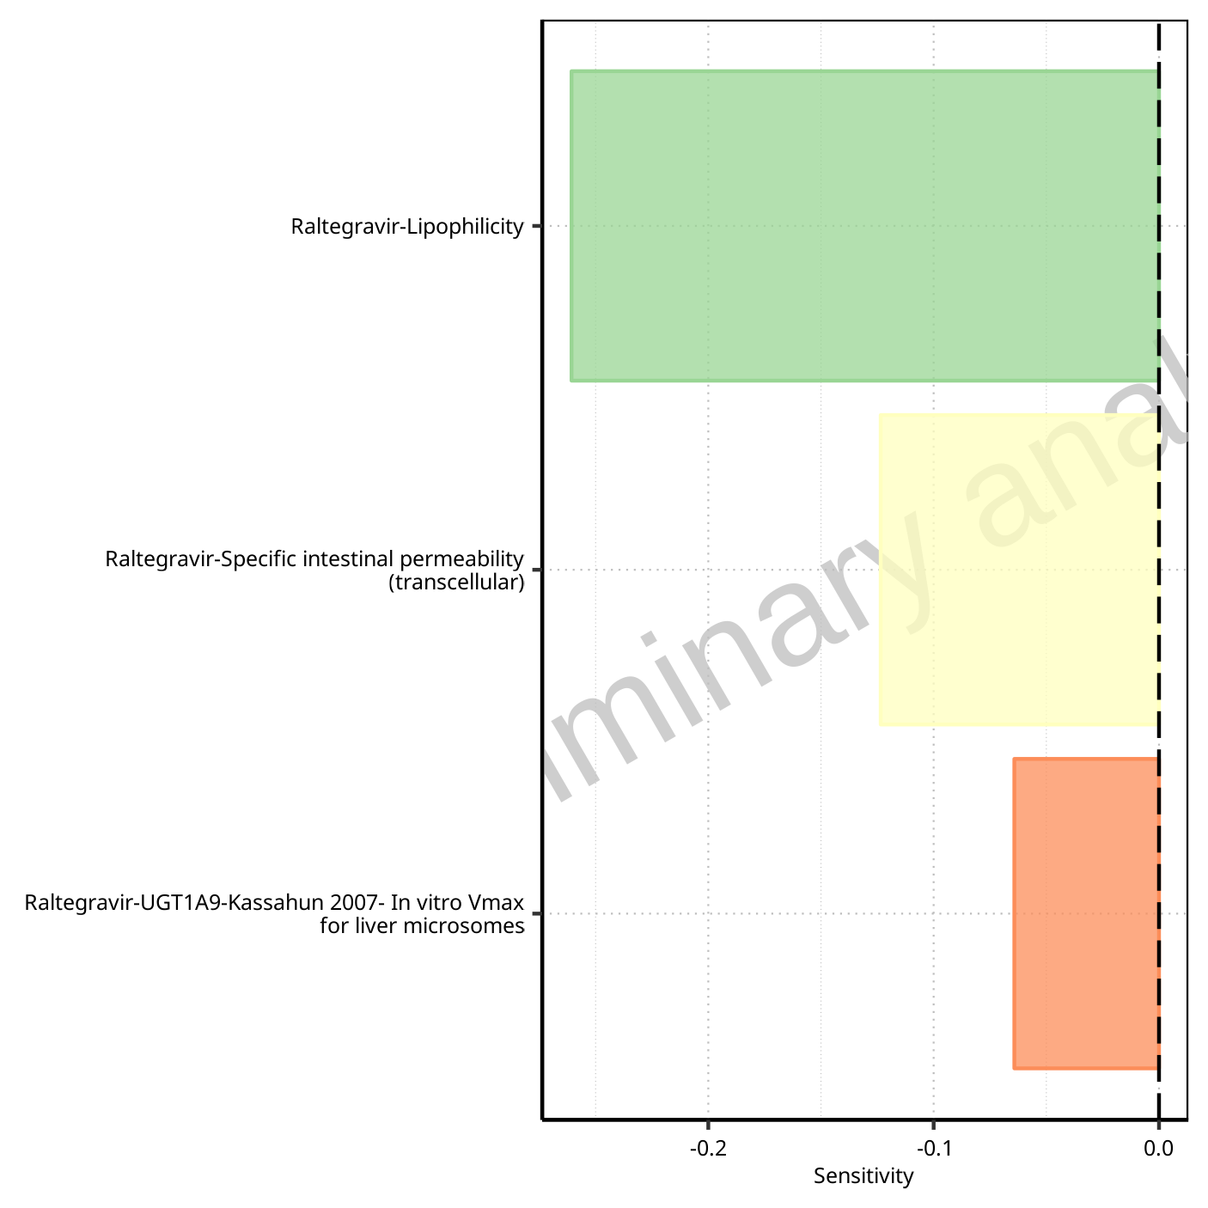

**Figure 1-143: Most sensitive parameters for MRT of Raltegravir.**

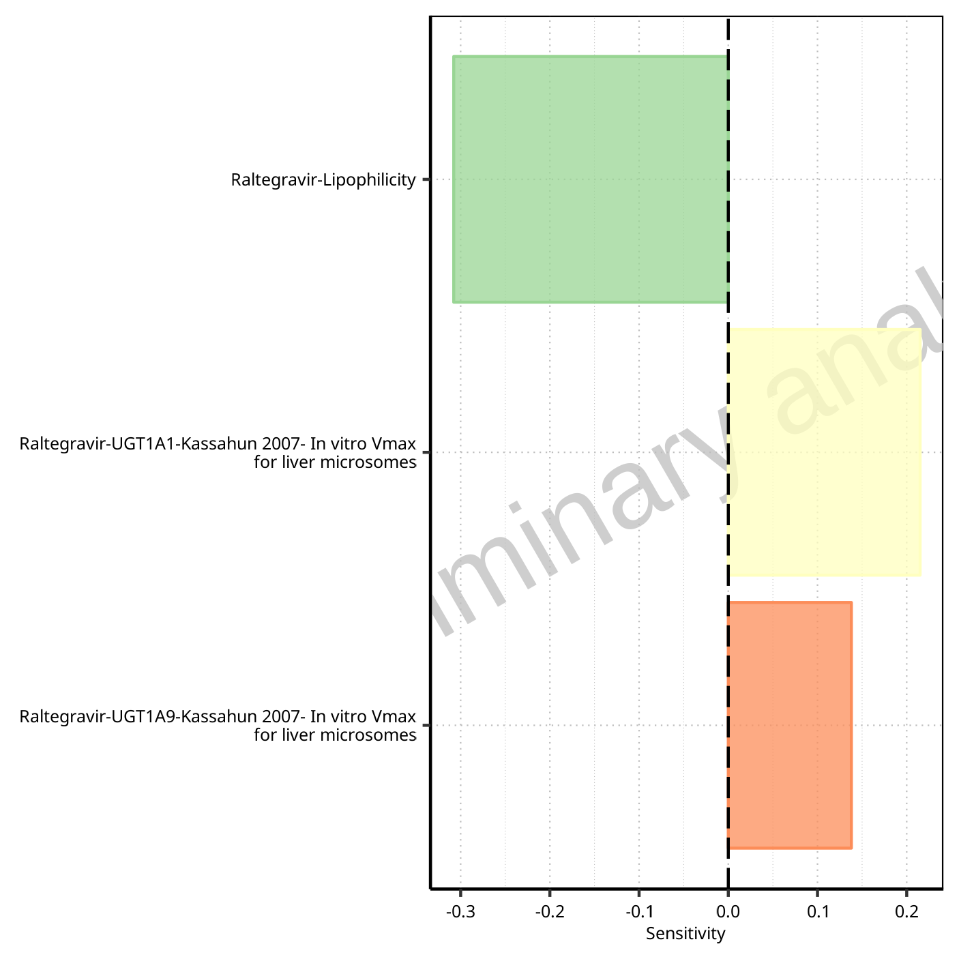

**Figure 1-144: Most sensitive parameters for Thalf of Raltegravir.**

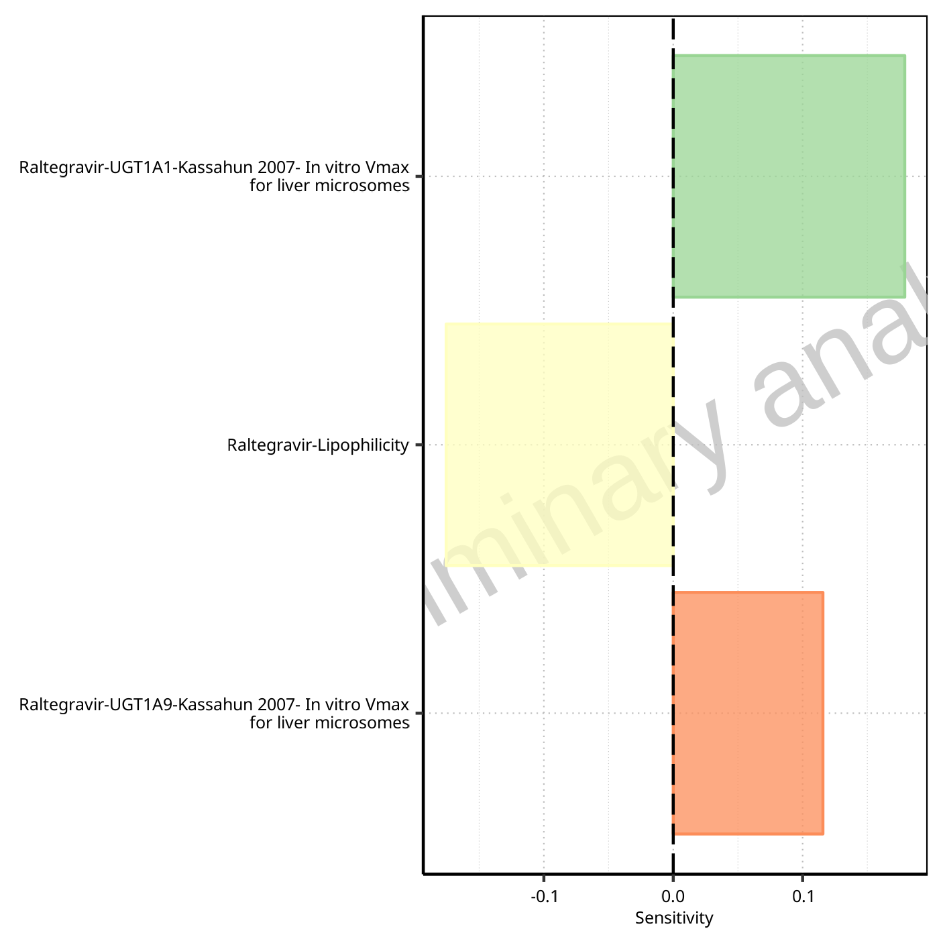

**Figure 1-145: Most sensitive parameters for Thalf_tLast_tEnd of Raltegravir.**

## Sensitivity Analysis for Raltegravir 400mg chewable fasted

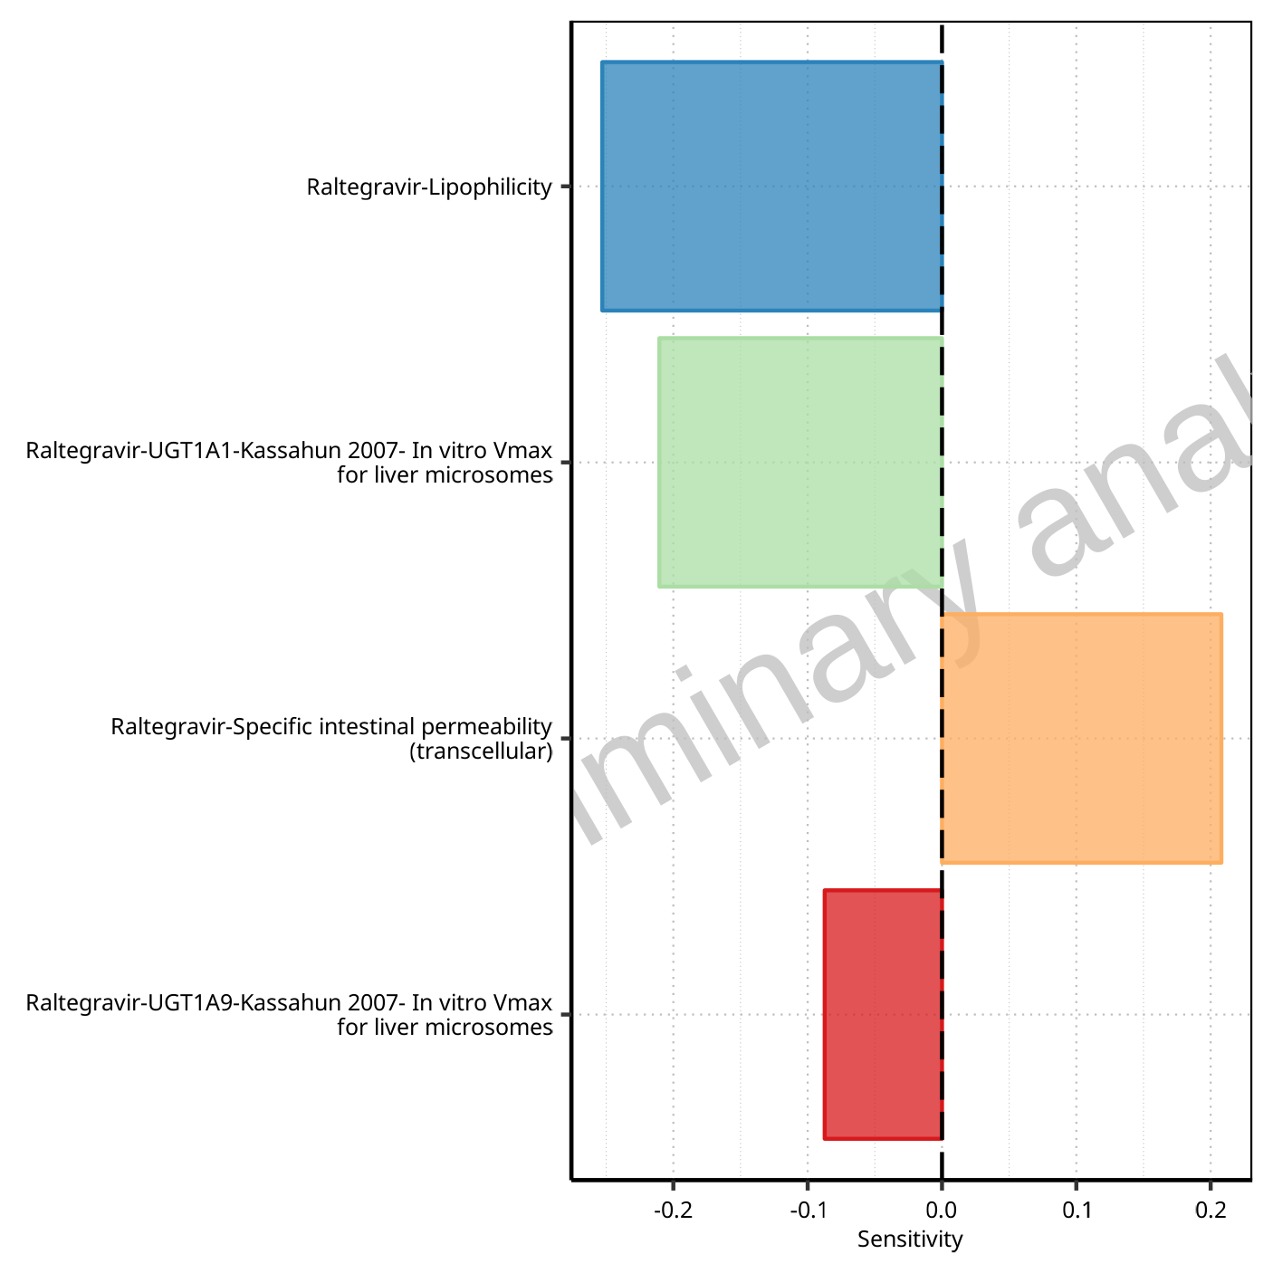

**Figure 1-146: Most sensitive parameters for C_max of Raltegravir.**



**Figure 1-147: Most sensitive parameters for t_max of Raltegravir.**

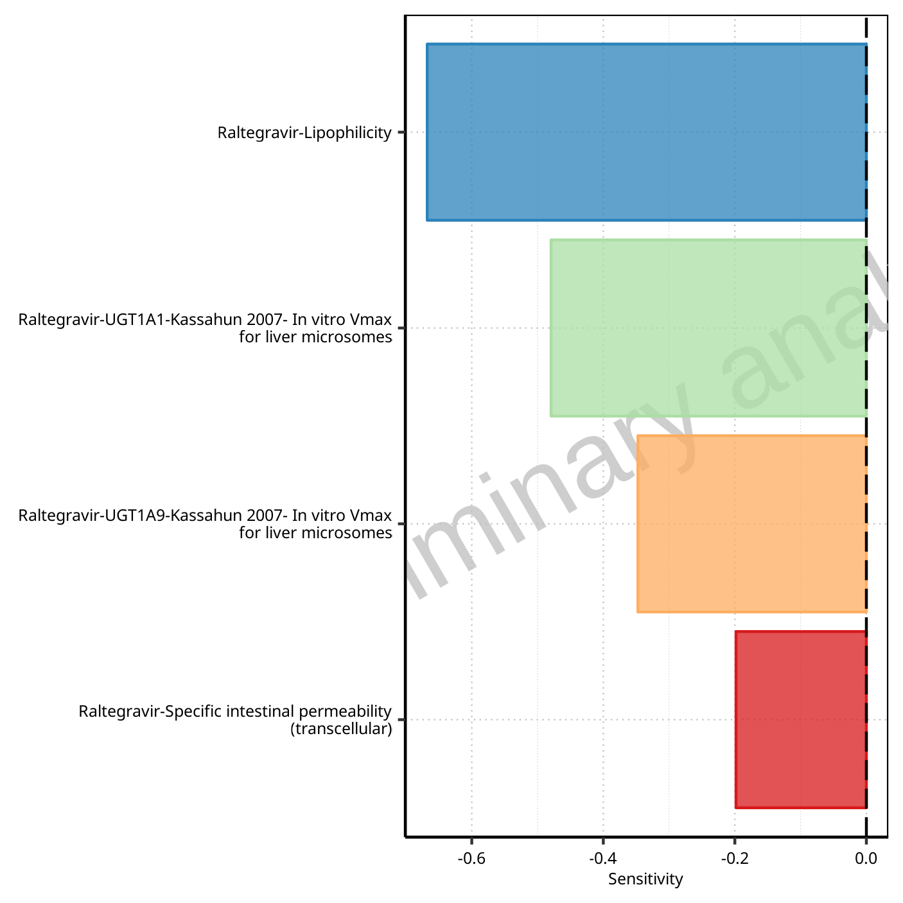

**Figure 1-148: Most sensitive parameters for C_tEnd of Raltegravir.**

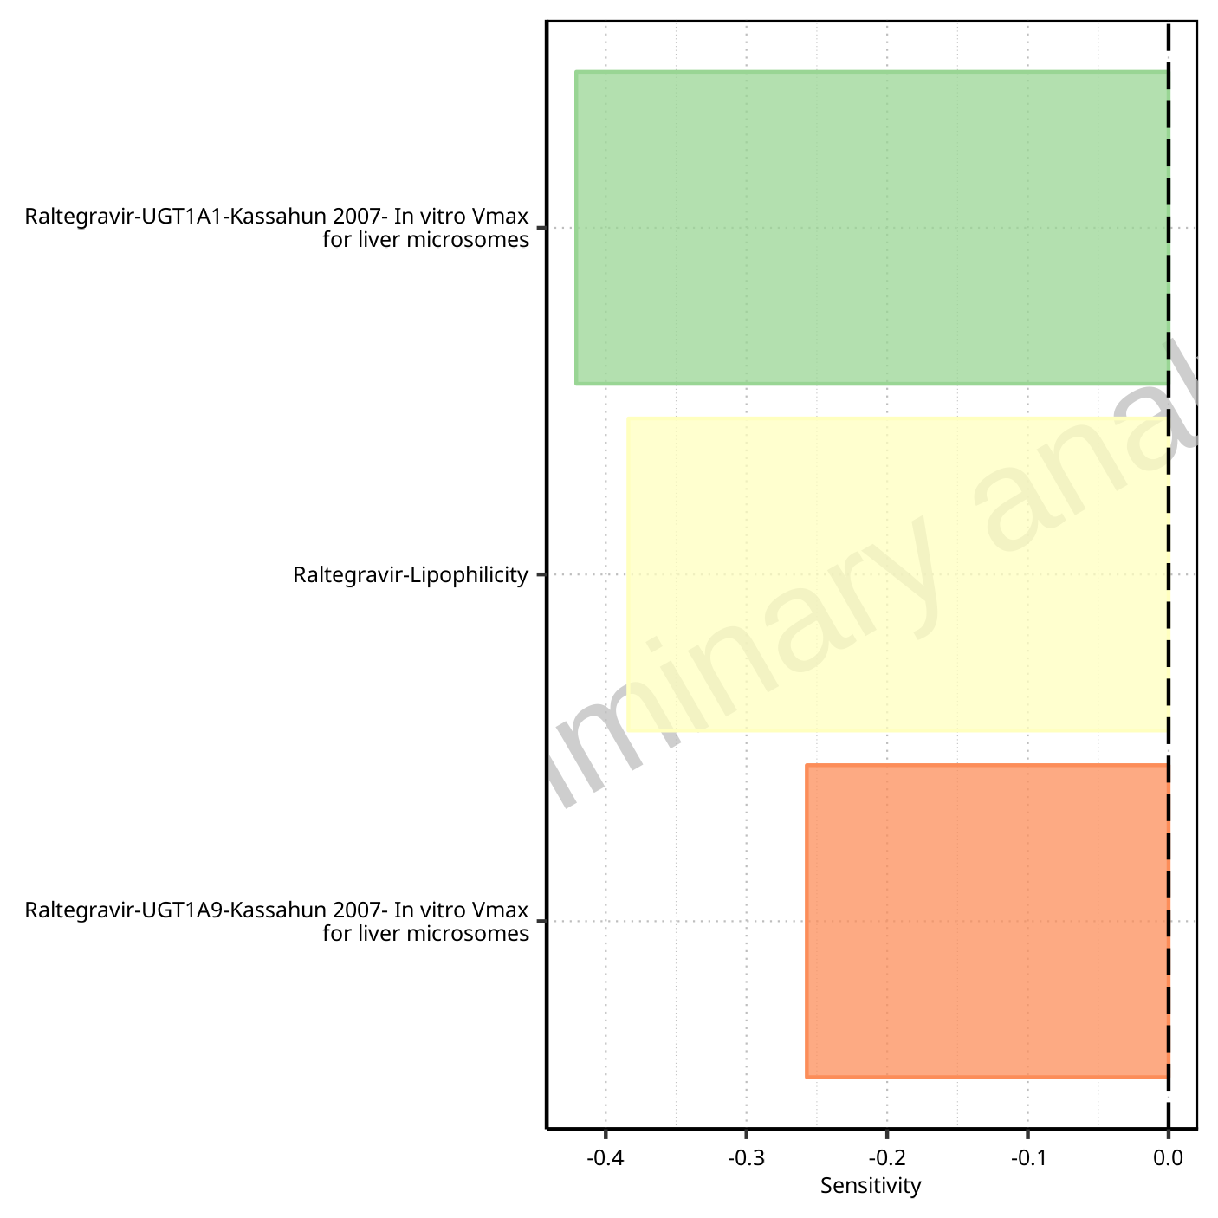

**Figure 1-149: Most sensitive parameters for AUC of Raltegravir.**

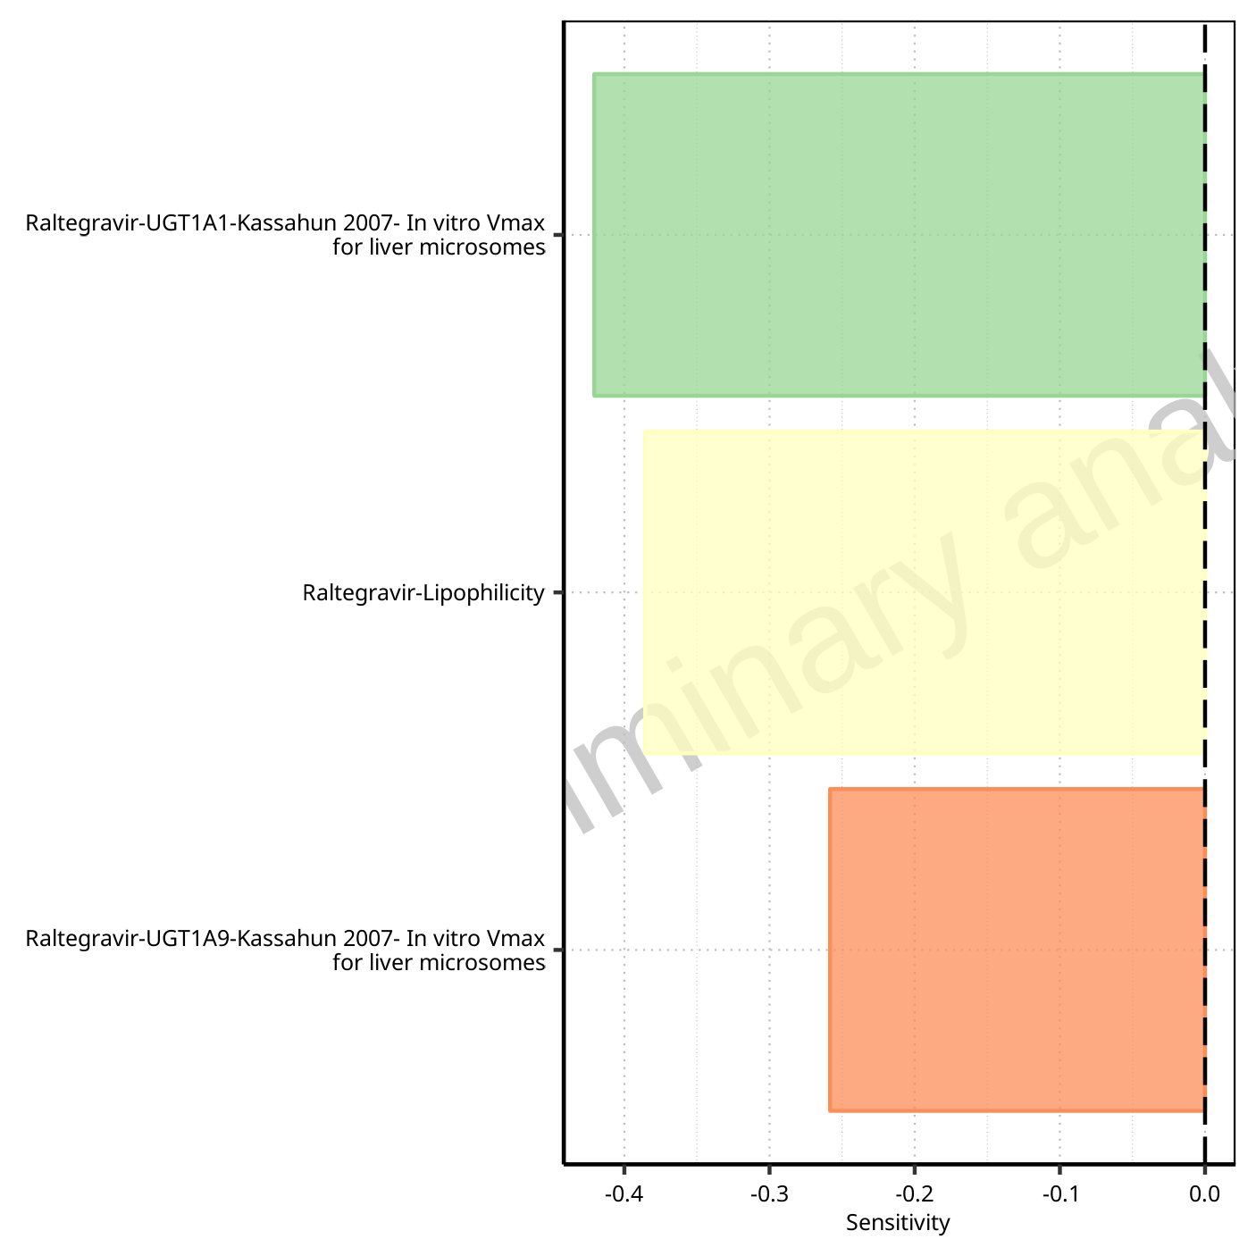

**Figure 1-150: Most sensitive parameters for AUC_inf of Raltegravir.**

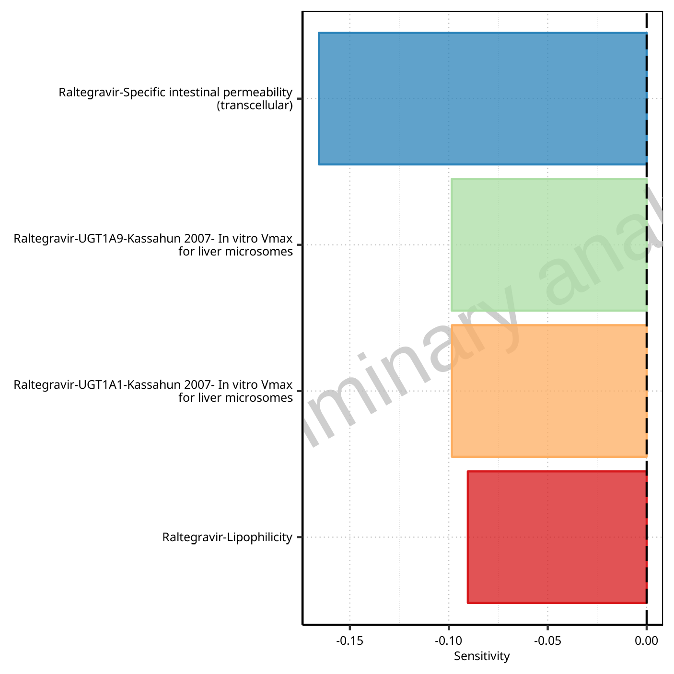

**Figure 1-151: Most sensitive parameters for MRT of Raltegravir.**

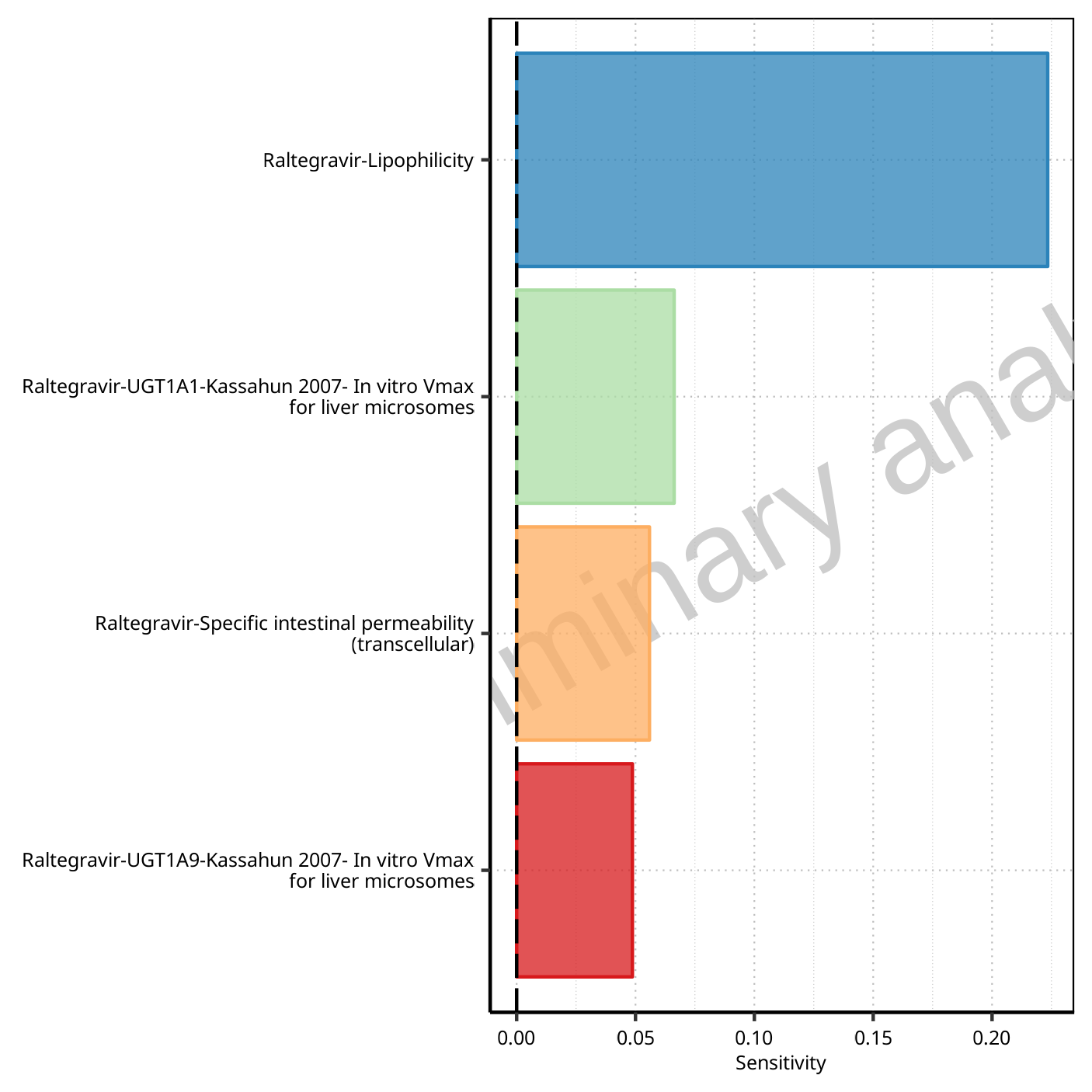

**Figure 1-152: Most sensitive parameters for Thalf of Raltegravir.**

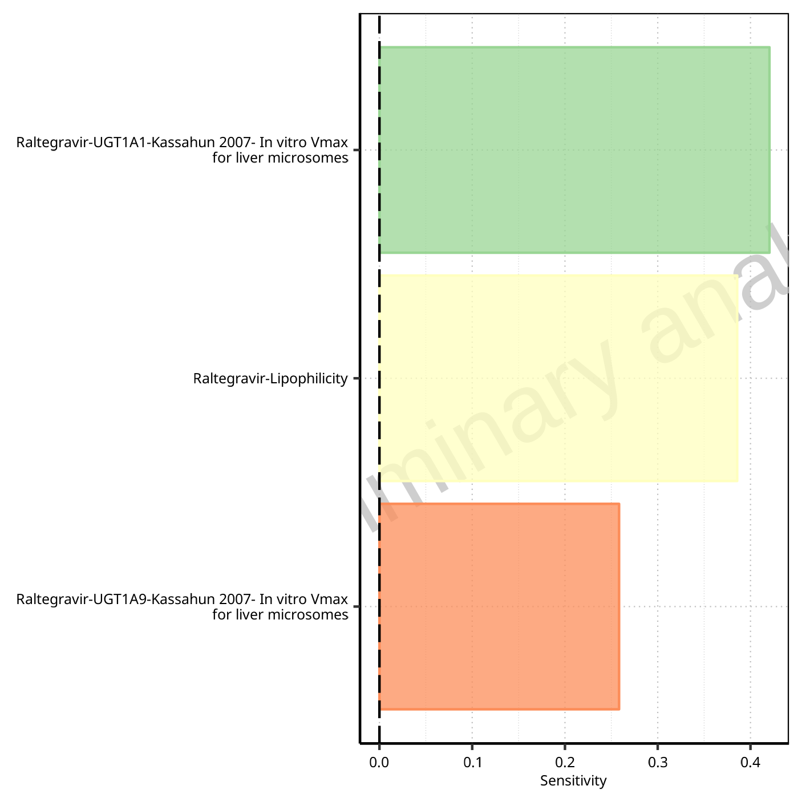

**Figure 1-153: Most sensitive parameters for CL of Raltegravir.**

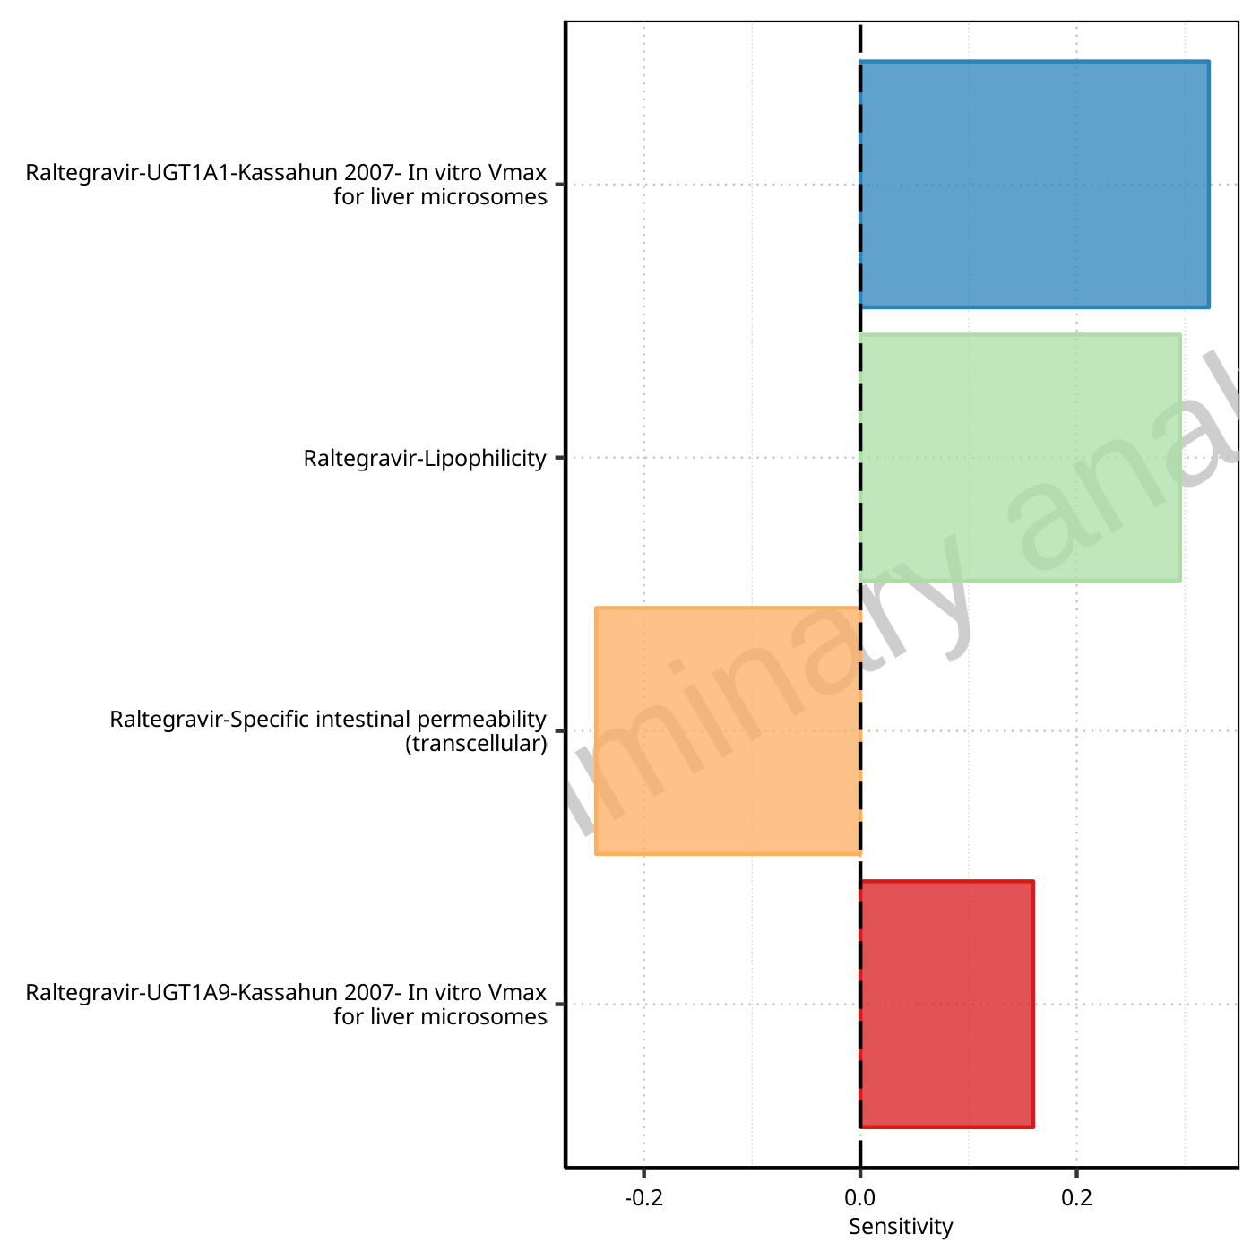

**Figure 1-154: Most sensitive parameters for Vss of Raltegravir.**

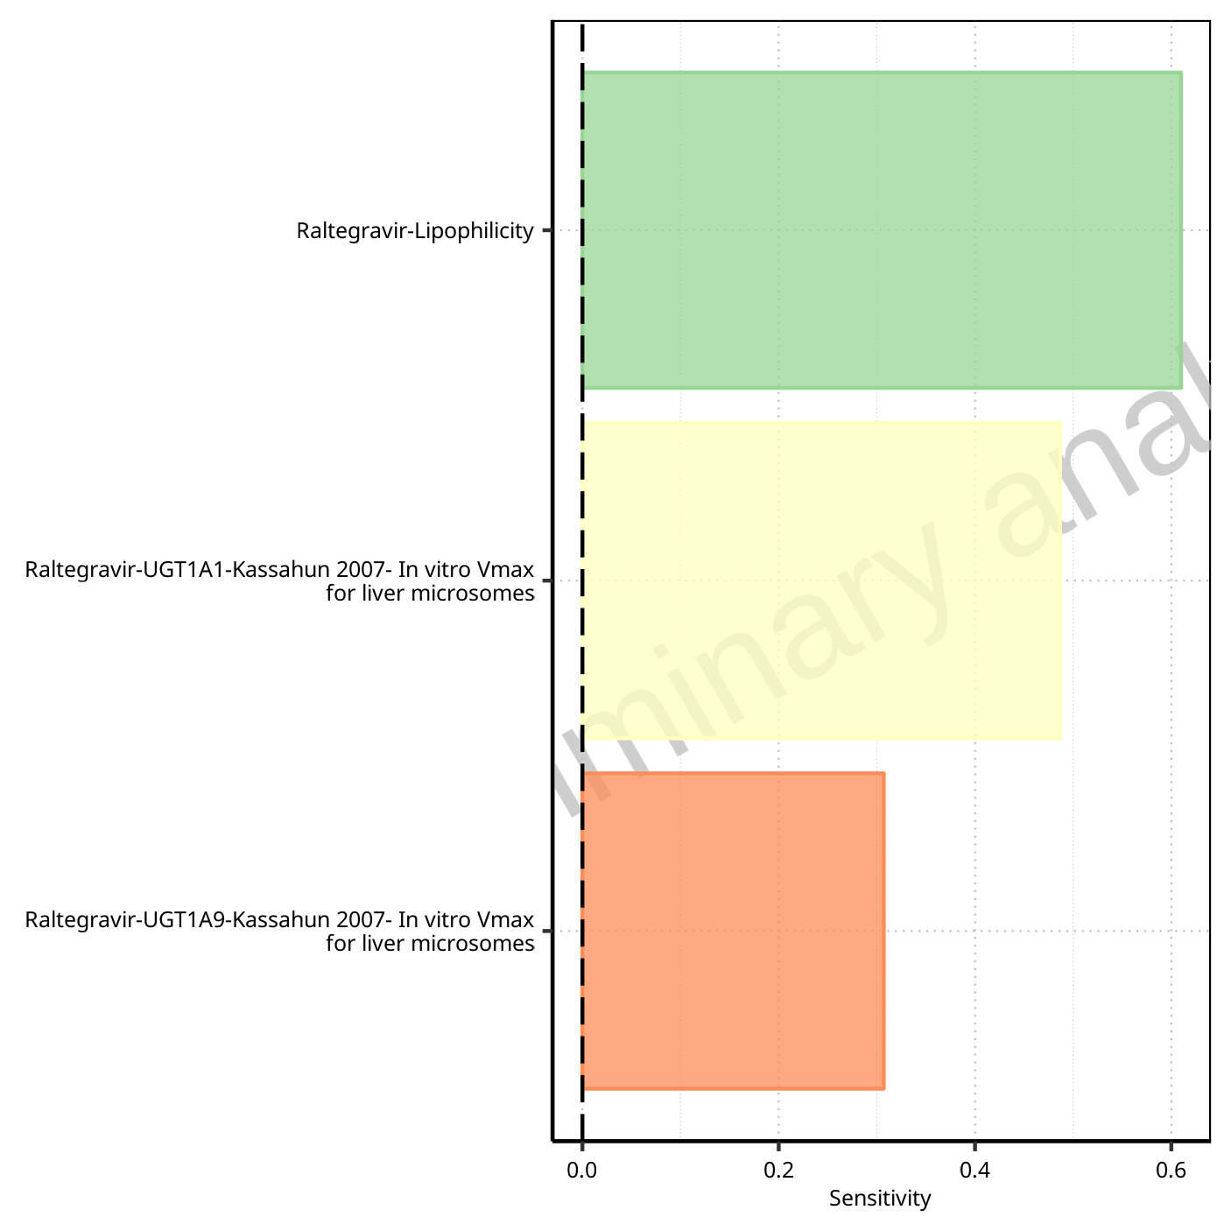

**Figure 1-155: Most sensitive parameters for Vd of Raltegravir.**

## Sensitivity Analysis for Raltegravir 400mg chewable fed

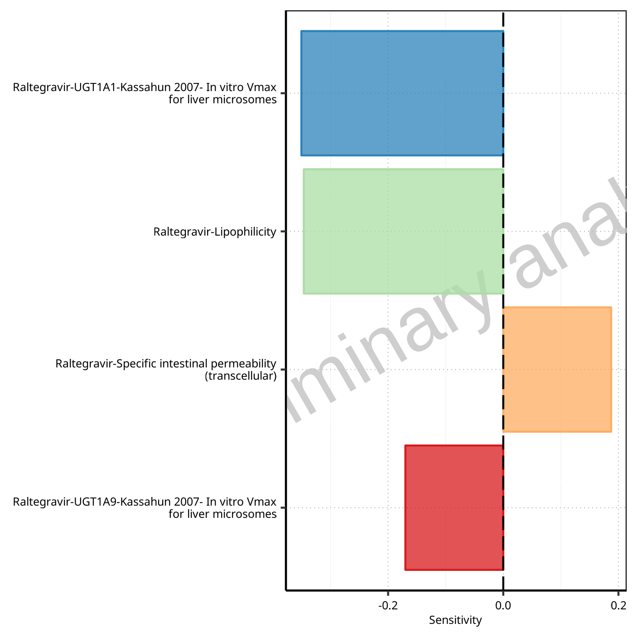

**Figure 1-156: Most sensitive parameters for C_max of Raltegravir.**



**Figure 1-157: Most sensitive parameters for t_max of Raltegravir.**

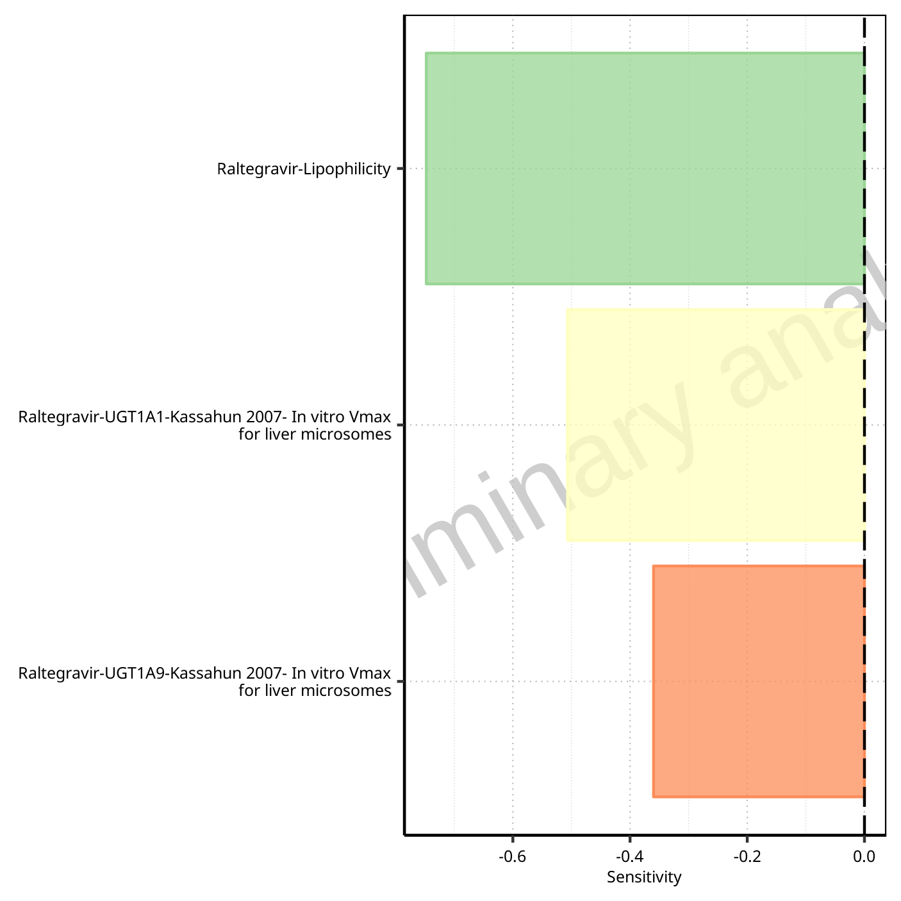

**Figure 1-158: Most sensitive parameters for C_tEnd of Raltegravir.**

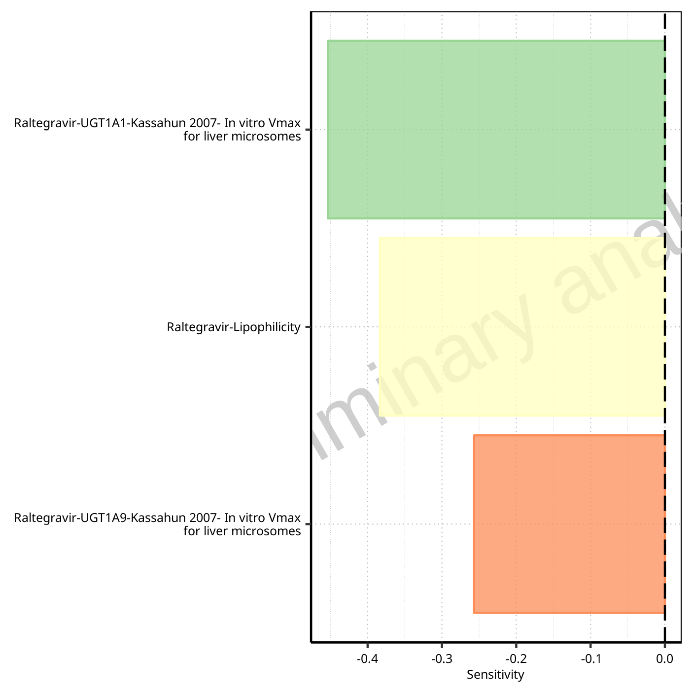

**Figure 1-159: Most sensitive parameters for AUC of Raltegravir.**

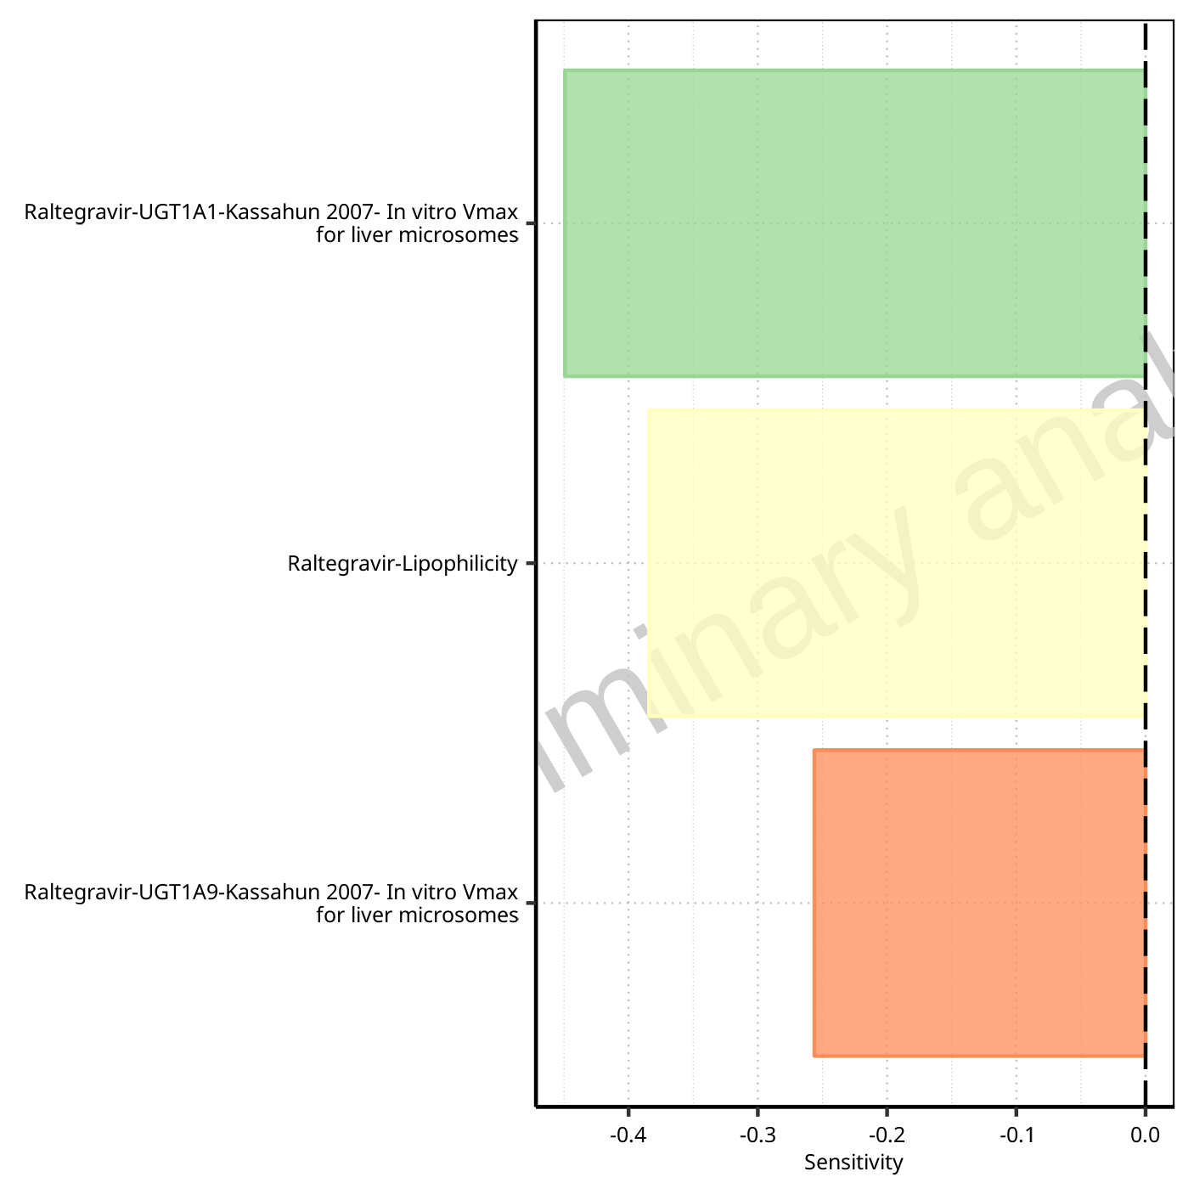

**Figure 1-160: Most sensitive parameters for AUC_inf of Raltegravir.**

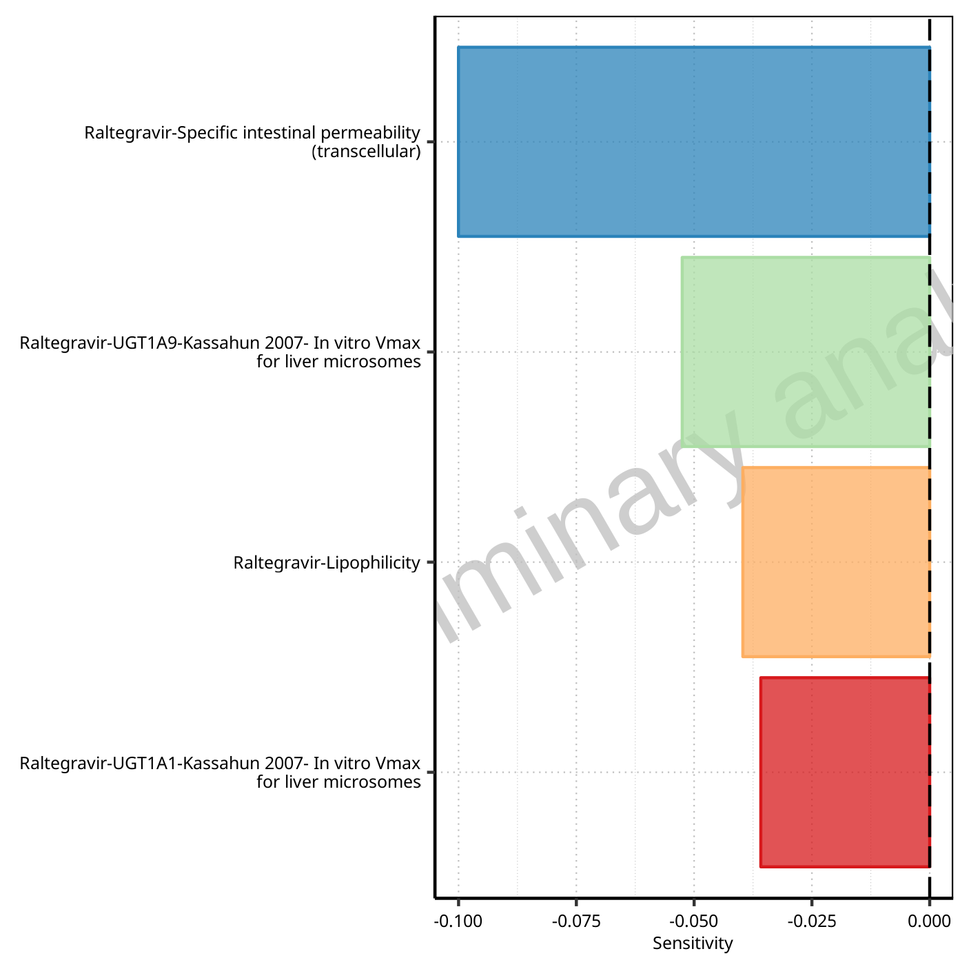

**Figure 1-161: Most sensitive parameters for MRT of Raltegravir.**

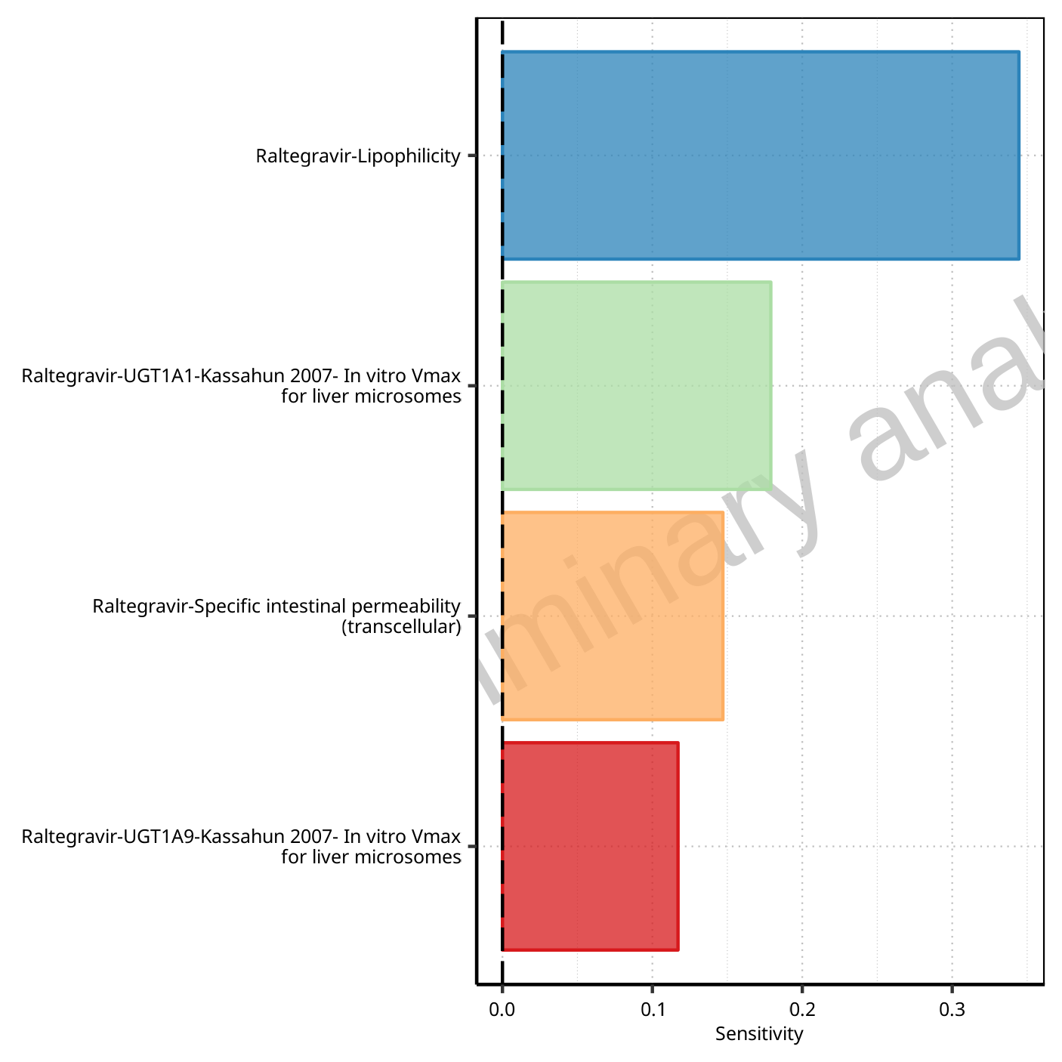

**Figure 1-162: Most sensitive parameters for Thalf of Raltegravir.**

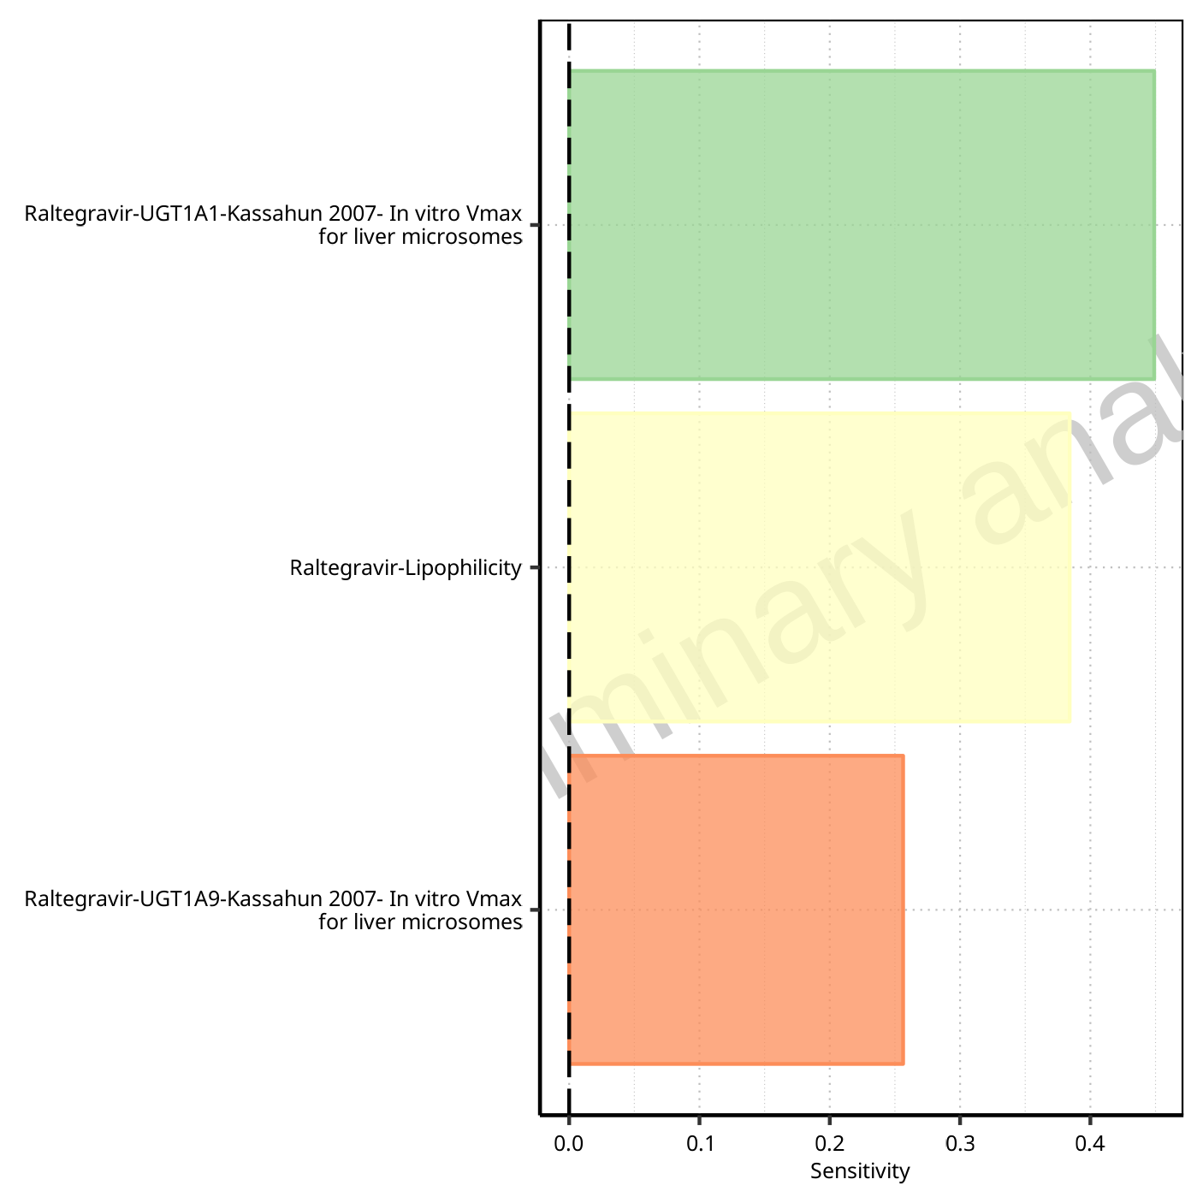

**Figure 1-163: Most sensitive parameters for CL of Raltegravir.**

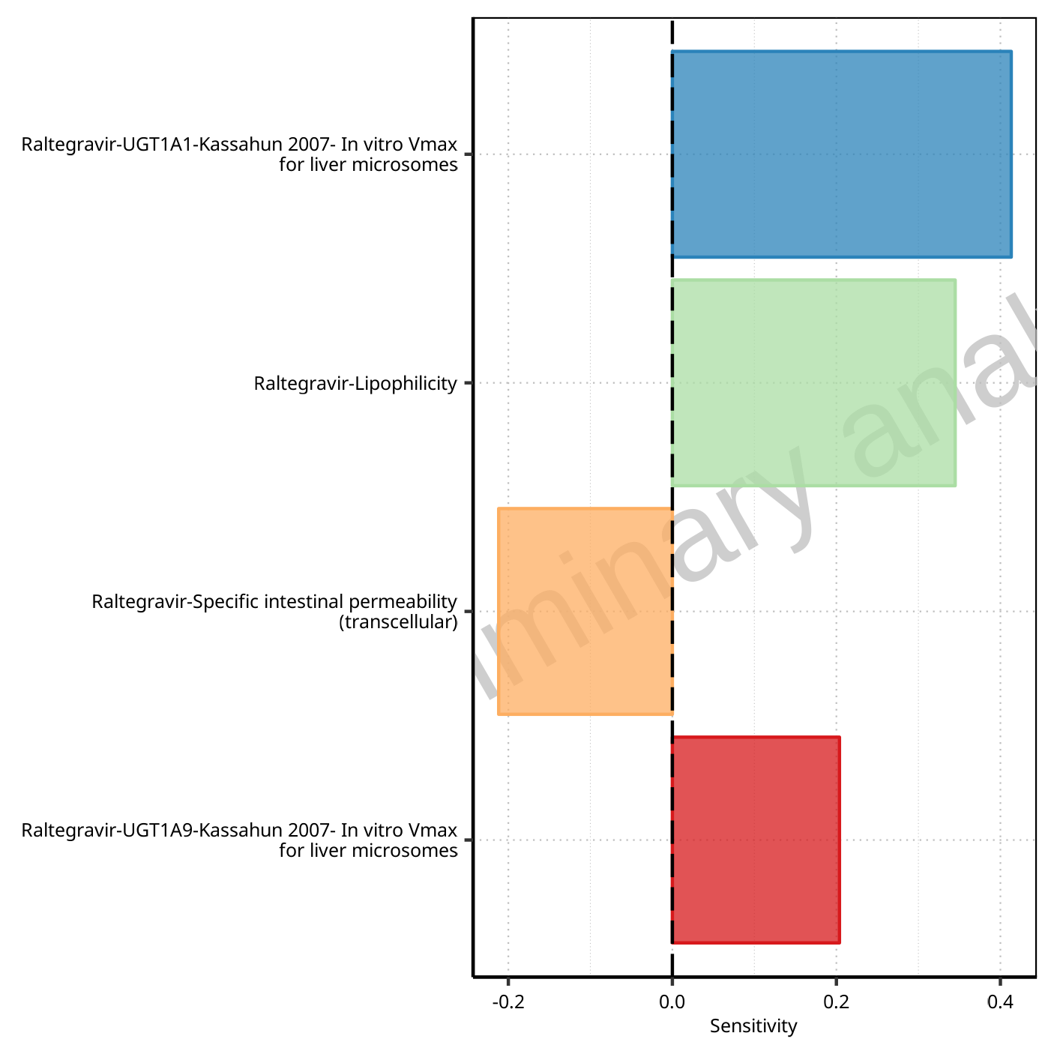

**Figure 1-164: Most sensitive parameters for Vss of Raltegravir.**

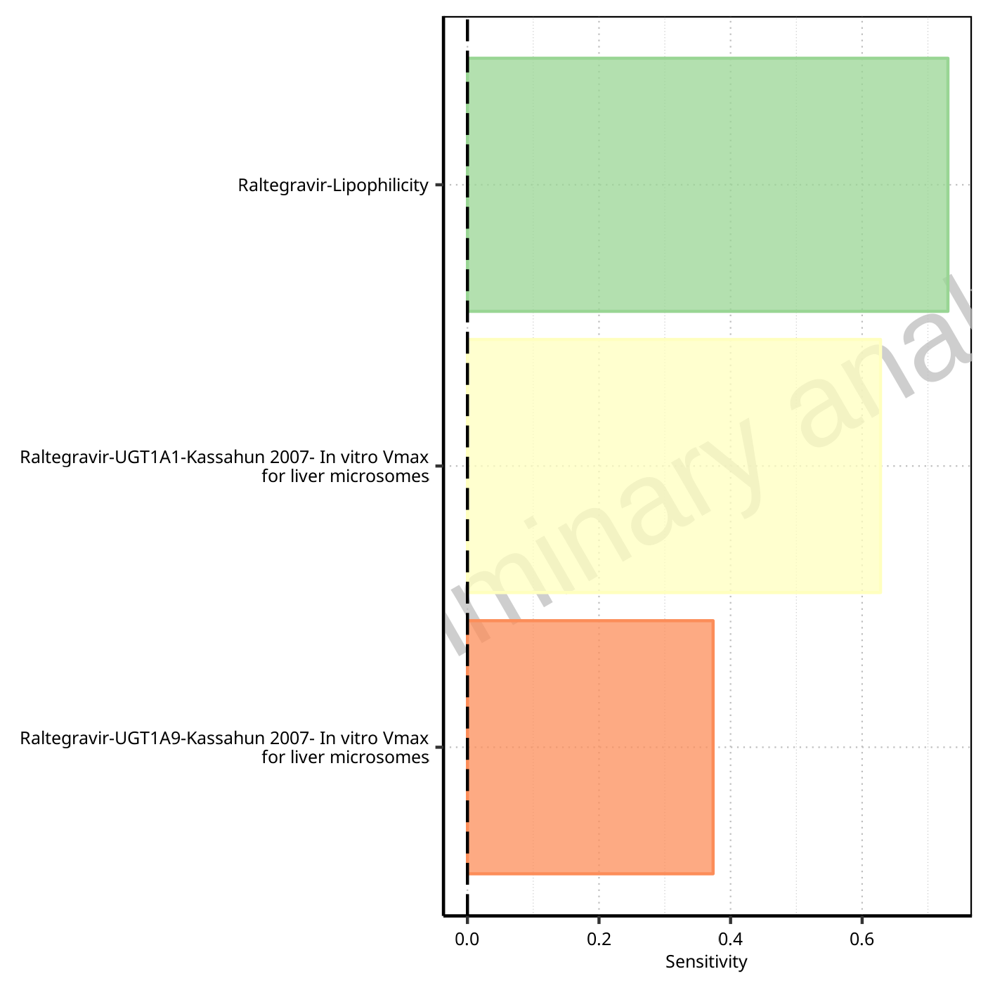

**Figure 1-165: Most sensitive parameters for Vd of Raltegravir.**

## Sensitivity Analysis for Raltegravir 400mg (granules in suspension)

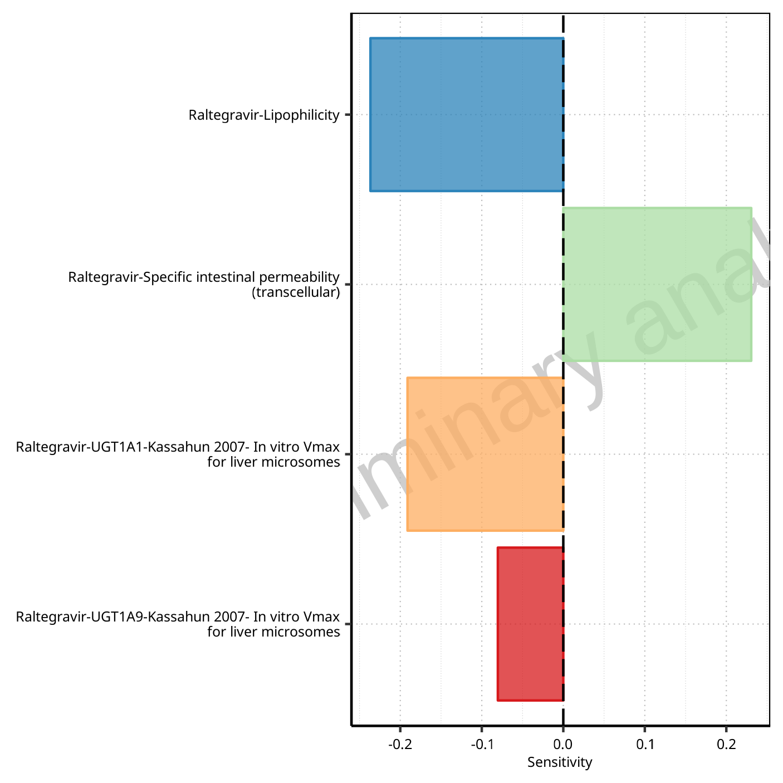

**Figure 1-166: Most sensitive parameters for C_max of Raltegravir.**

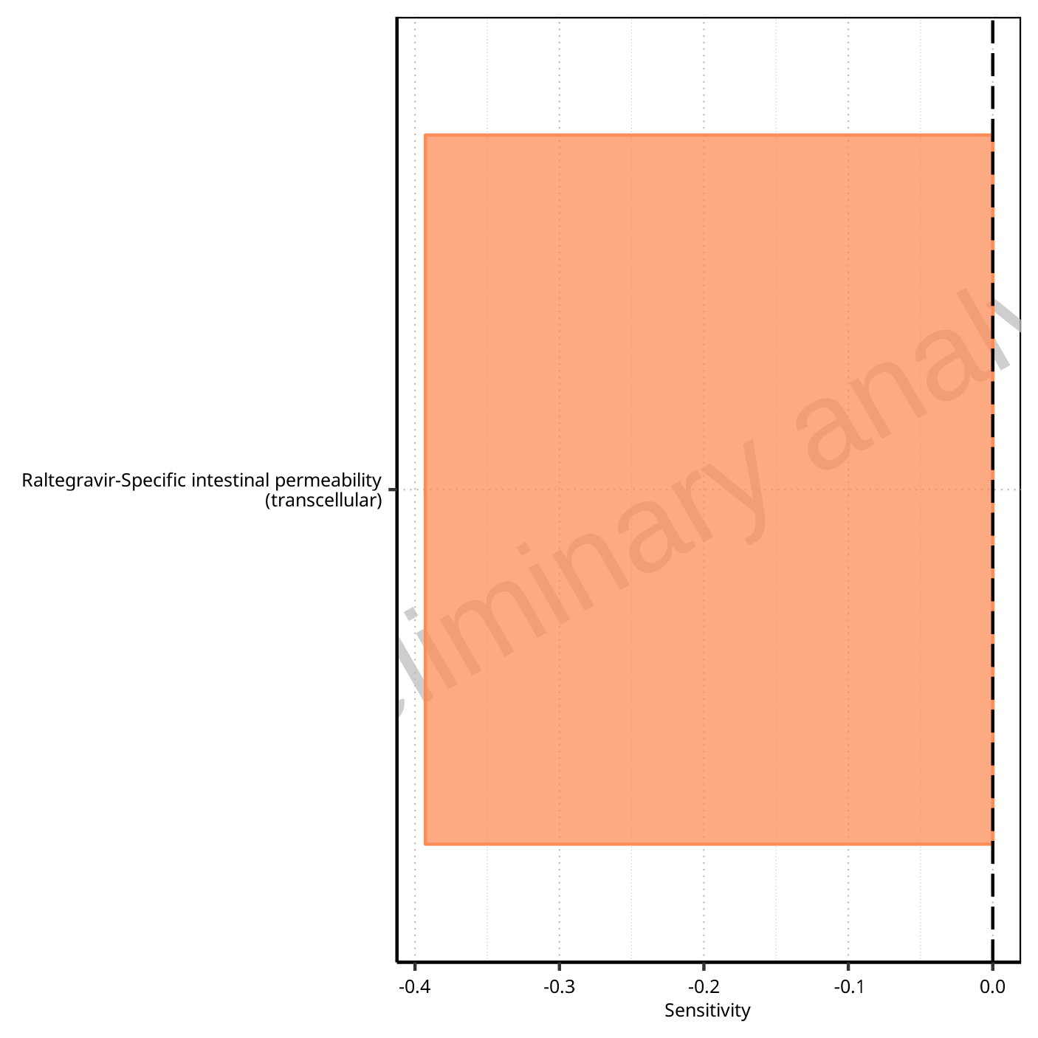

**Figure 1-167: Most sensitive parameters for t_max of Raltegravir.**

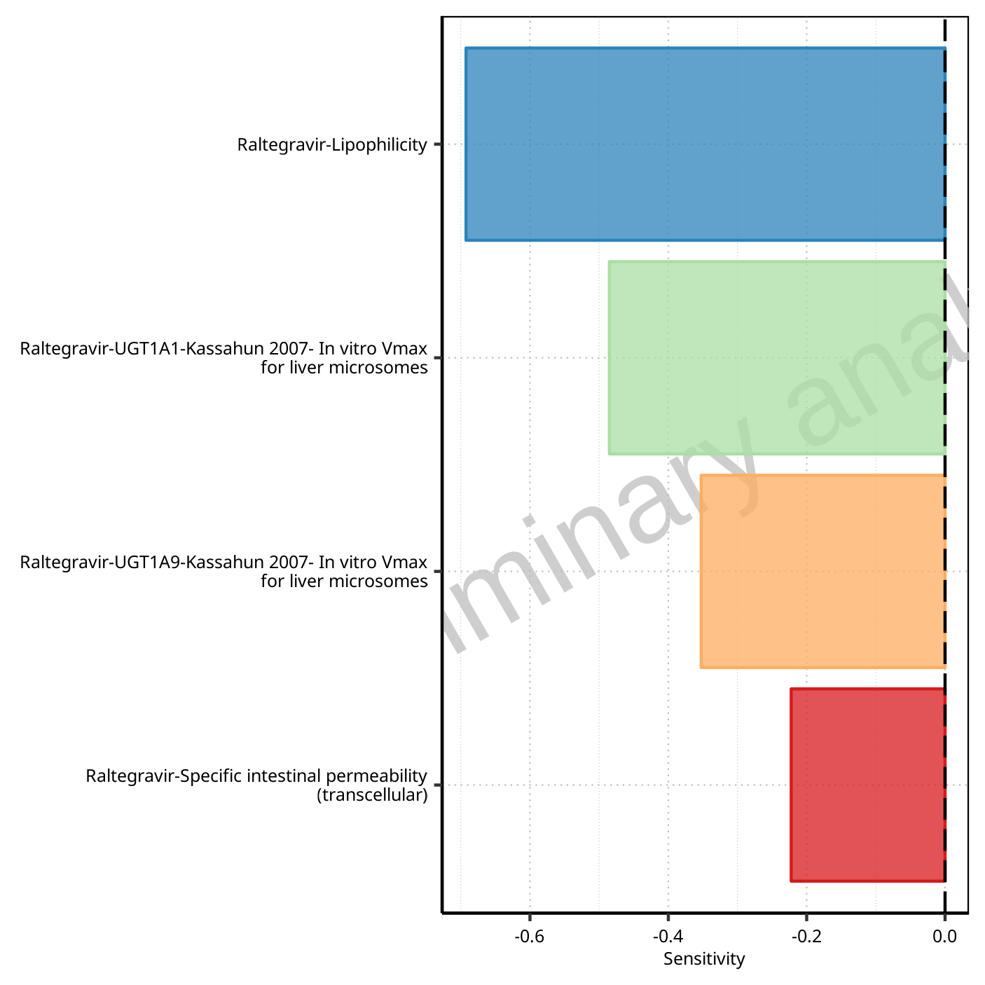

**Figure 1-168: Most sensitive parameters for C_tEnd of Raltegravir.**

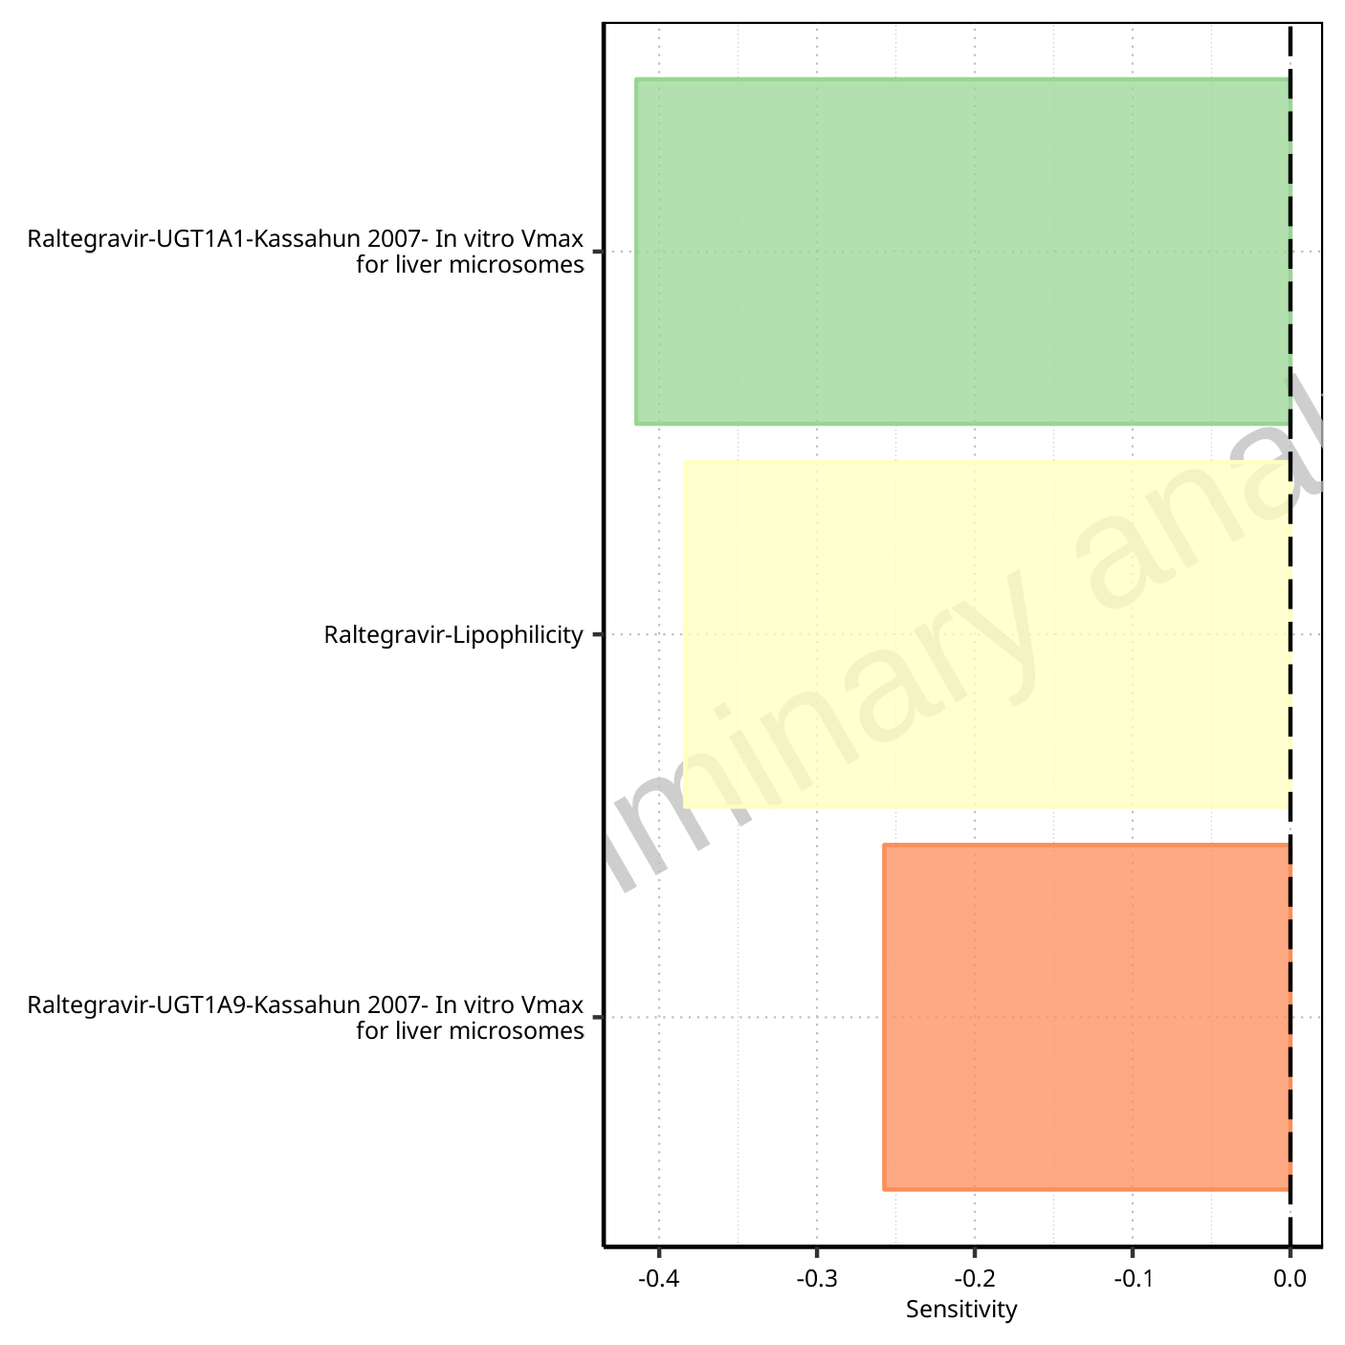

**Figure 1-169: Most sensitive parameters for AUC of Raltegravir.**

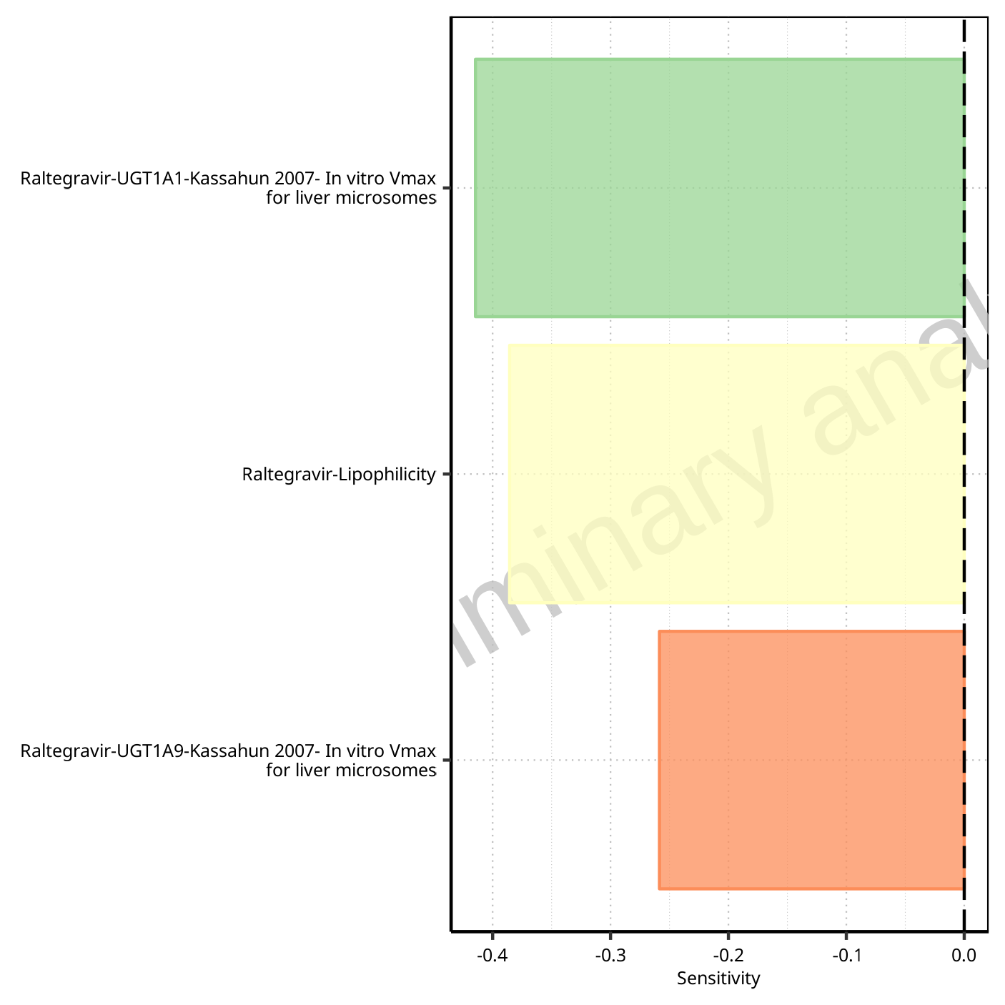

**Figure 1-170: Most sensitive parameters for AUC_inf of Raltegravir.**

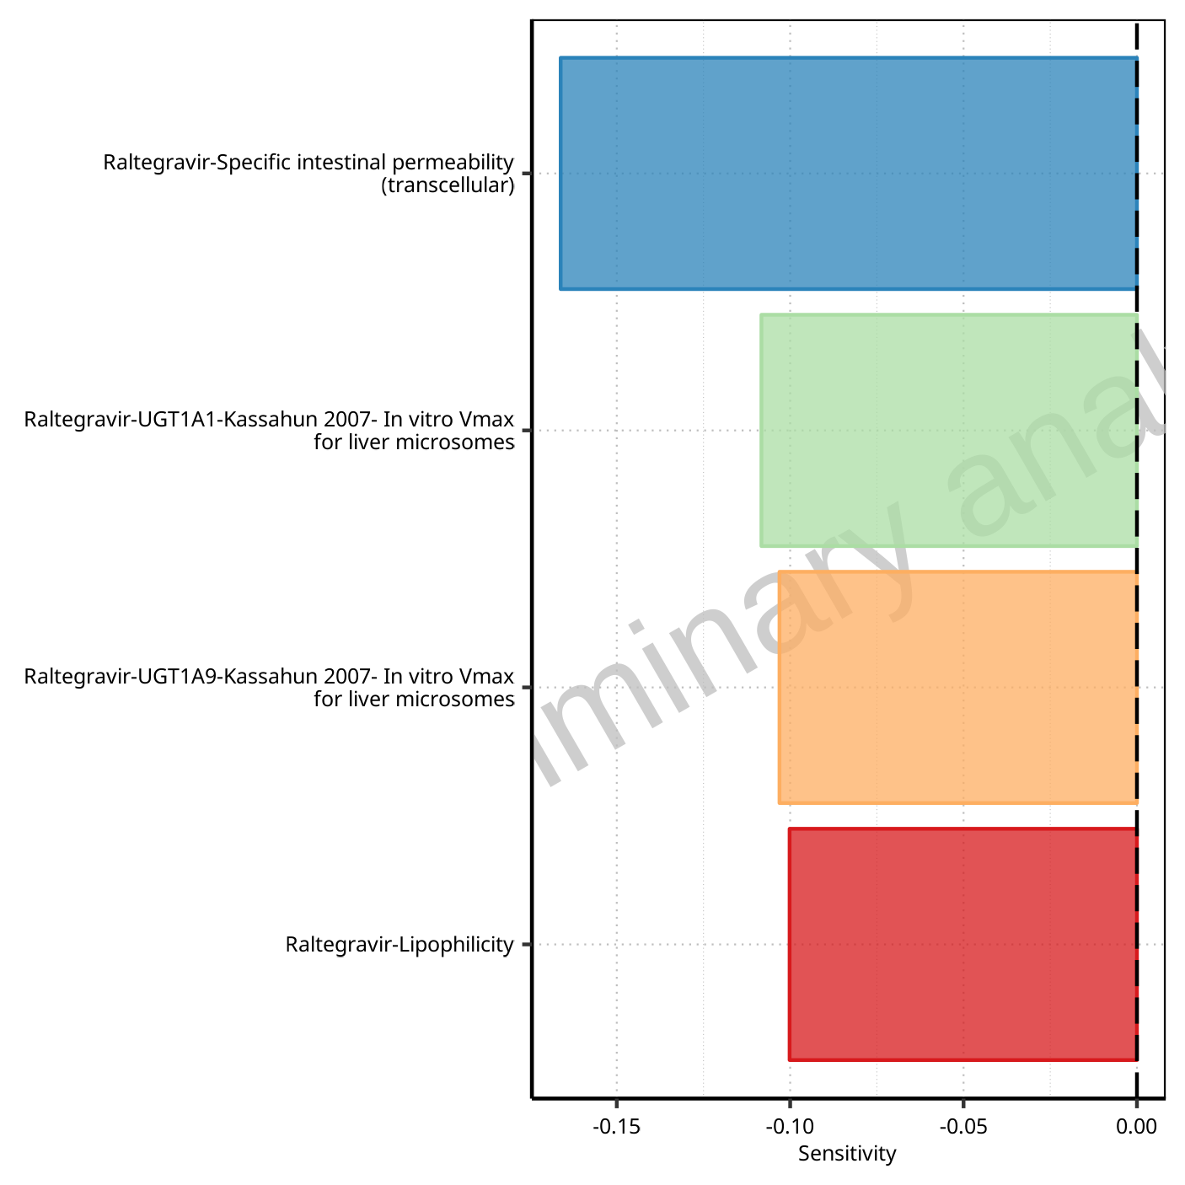

**Figure 1-171: Most sensitive parameters for MRT of Raltegravir.**

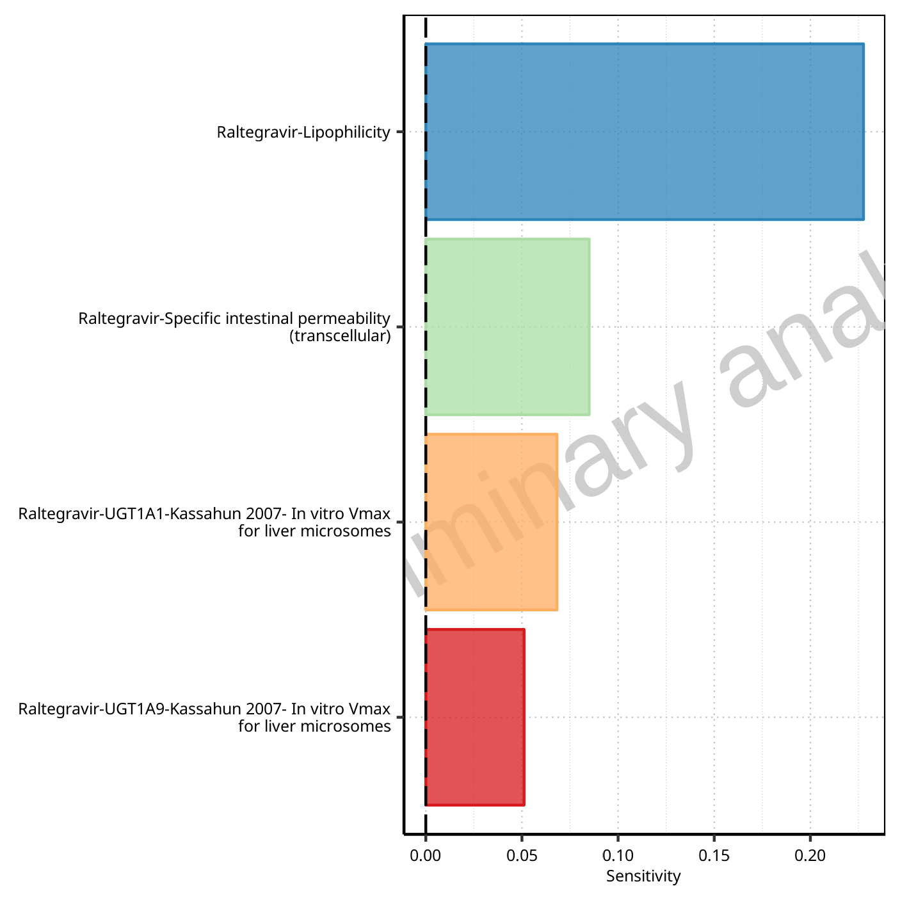

**Figure 1-172: Most sensitive parameters for Thalf of Raltegravir.**

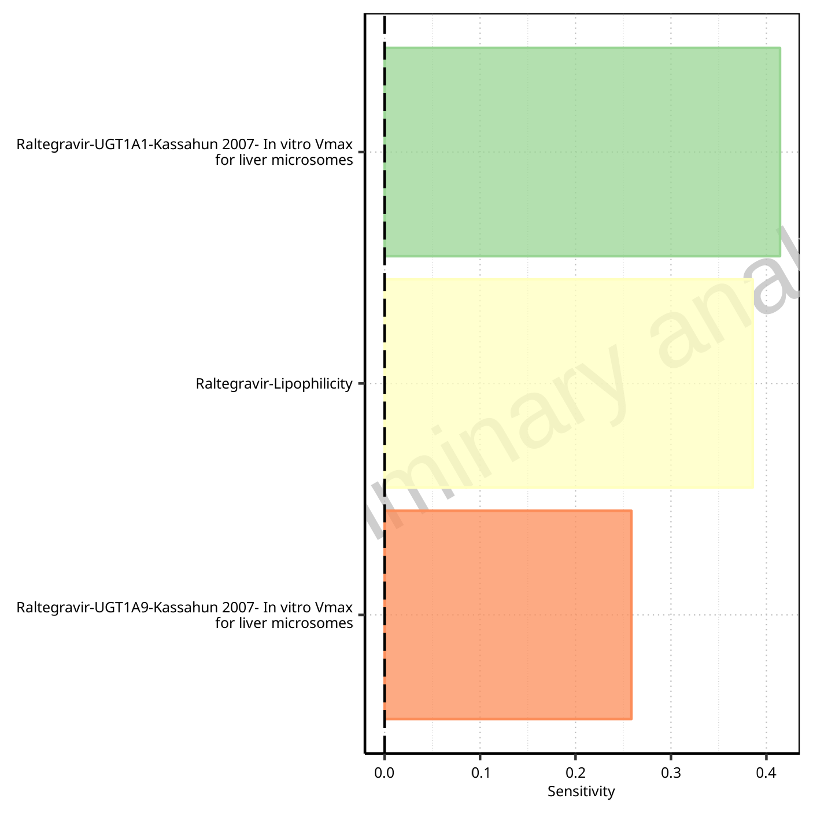

**Figure 1-173: Most sensitive parameters for CL of Raltegravir.**

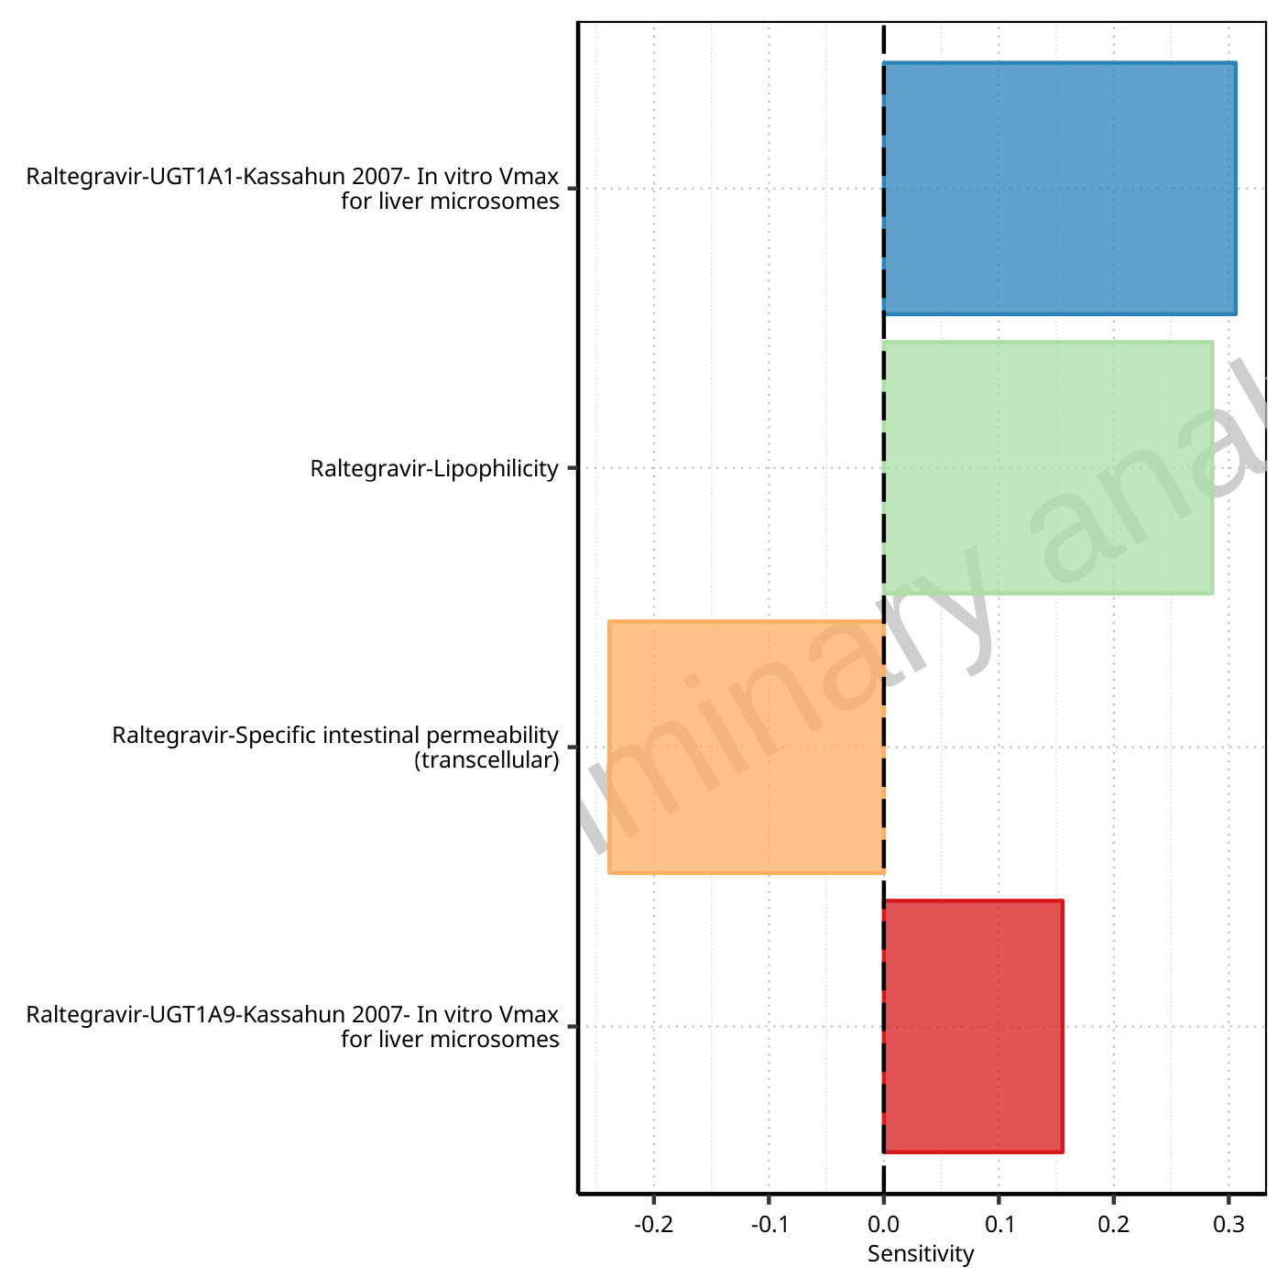

**Figure 1-174: Most sensitive parameters for Vss of Raltegravir.**

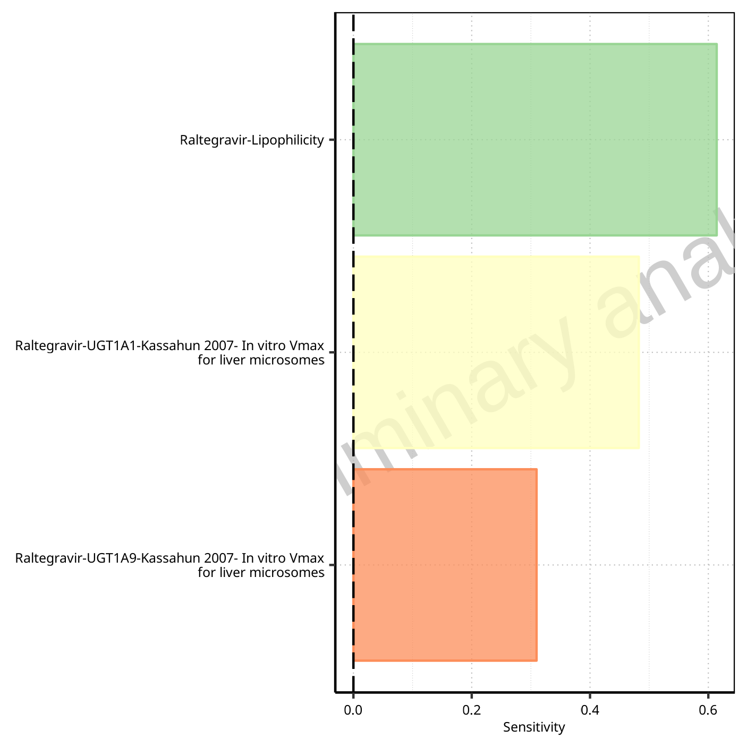

**Figure 1-175: Most sensitive parameters for Vd of Raltegravir.**

# PK parameters

## PK parameters for Raltegravir 10 mg (lactose formulation)

**Table 2-1: PK parameters for Raltegravir 10 mg (lactose formulation)**

| Path | Parameter | Value | Unit |
| --- | --- | --- | --- |
| Raltegravir | C_max | 110.49 | µg/l |
| Raltegravir | C_max_norm | 0.81 | kg/l |
| Raltegravir | t_max | 0.75 | h |
| Raltegravir | C_tEnd | 1.96 | µg/l |
| Raltegravir | AUC | 241.61 | µg*h/l |
| Raltegravir | AUC_norm | 1.76 | kg*h/l |
| Raltegravir | AUC_inf | 255.14 | µg*h/l |
| Raltegravir | AUC_inf_norm | 1.86 | kg*h/l |
| Raltegravir | MRT | 3.33 | h |
| Raltegravir | Thalf | 4.79 | h |
| Raltegravir | CL | 8.95 | ml/min/kg |
| Raltegravir | Vss | 1787.57 | ml/kg |
| Raltegravir | Vd | 3713.90 | ml/kg |

## PK parameters for Raltegravir 25 mg (lactose formulation)

**Table 2-2: PK parameters for Raltegravir 25 mg (lactose formulation)**

| Path | Parameter | Value | Unit |
| --- | --- | --- | --- |
| Raltegravir | C_max | 276.85 | µg/l |
| Raltegravir | C_max_norm | 0.81 | kg/l |
| Raltegravir | t_max | 0.75 | h |
| Raltegravir | C_tEnd | 4.89 | µg/l |
| Raltegravir | AUC | 605.06 | µg*h/l |
| Raltegravir | AUC_norm | 1.77 | kg*h/l |
| Raltegravir | AUC_inf | 638.90 | µg*h/l |
| Raltegravir | AUC_inf_norm | 1.87 | kg*h/l |
| Raltegravir | MRT | 3.33 | h |
| Raltegravir | Thalf | 4.79 | h |
| Raltegravir | CL | 8.93 | ml/min/kg |
| Raltegravir | Vss | 1783.40 | ml/kg |
| Raltegravir | Vd | 3705.77 | ml/kg |

## PK parameters for Raltegravir 50 mg (lactose formulation)

**Table 2-3: PK parameters for Raltegravir 50 mg (lactose formulation)**

| Path | Parameter | Value | Unit |
| --- | --- | --- | --- |
| Raltegravir | C_max | 556.60 | µg/l |
| Raltegravir | C_max_norm | 0.81 | kg/l |
| Raltegravir | t_max | 0.75 | h |
| Raltegravir | C_tEnd | 1.53 | µg/l |
| Raltegravir | AUC | 1296.65 | µg*h/l |
| Raltegravir | AUC_norm | 1.89 | kg*h/l |
| Raltegravir | AUC_inf | 1317.09 | µg*h/l |
| Raltegravir | AUC_inf_norm | 1.92 | kg*h/l |
| Raltegravir | MRT | 4.14 | h |
| Raltegravir | Thalf | 9.27 | h |
| Raltegravir | CL | 8.67 | ml/min/kg |
| Raltegravir | Vss | 2155.21 | ml/kg |
| Raltegravir | Vd | 6957.26 | ml/kg |

## PK parameters for Raltegravir 100 mg (lactose formulation)

**Table 2-4: PK parameters for Raltegravir 100 mg (lactose formulation)**

| Path | Parameter | Value | Unit |
| --- | --- | --- | --- |
| Raltegravir | C_max | 1123.90 | µg/l |
| Raltegravir | C_max_norm | 0.82 | kg/l |
| Raltegravir | t_max | 0.75 | h |
| Raltegravir | C_tEnd | 2.84 | µg/l |
| Raltegravir | AUC | 2615.77 | µg*h/l |
| Raltegravir | AUC_norm | 1.91 | kg*h/l |
| Raltegravir | AUC_inf | 2654.06 | µg*h/l |
| Raltegravir | AUC_inf_norm | 1.94 | kg*h/l |
| Raltegravir | MRT | 4.14 | h |
| Raltegravir | Thalf | 9.36 | h |
| Raltegravir | CL | 8.60 | ml/min/kg |
| Raltegravir | Vss | 2135.84 | ml/kg |
| Raltegravir | Vd | 6967.39 | ml/kg |

## PK parameters for Raltegravir 200 mg (lactose formulation)

**Table 2-5: PK parameters for Raltegravir 200 mg (lactose formulation)**

| Path | Parameter | Value | Unit |
| --- | --- | --- | --- |
| Raltegravir | C_max | 2283.84 | µg/l |
| Raltegravir | C_max_norm | 0.83 | kg/l |
| Raltegravir | t_max | 0.75 | h |
| Raltegravir | C_tEnd | 1.92 | µg/l |
| Raltegravir | AUC | 5349.76 | µg*h/l |
| Raltegravir | AUC_norm | 1.95 | kg*h/l |
| Raltegravir | AUC_inf | 5376.25 | µg*h/l |
| Raltegravir | AUC_inf_norm | 1.96 | kg*h/l |
| Raltegravir | MRT | 4.13 | h |
| Raltegravir | Thalf | 9.57 | h |
| Raltegravir | CL | 8.49 | ml/min/kg |
| Raltegravir | Vss | 2106.69 | ml/kg |
| Raltegravir | Vd | 7038.34 | ml/kg |

## PK parameters for Raltegravir 400mg (lactose formulation)

**Table 2-6: PK parameters for Raltegravir 400mg (lactose formulation)**

| Path | Parameter | Value | Unit |
| --- | --- | --- | --- |
| Raltegravir | C_max | 4673.73 | µg/l |
| Raltegravir | C_max_norm | 0.85 | kg/l |
| Raltegravir | t_max | 0.75 | h |
| Raltegravir | C_tEnd | 3.84 | µg/l |
| Raltegravir | AUC | 10899.61 | µg*h/l |
| Raltegravir | AUC_norm | 1.99 | kg*h/l |
| Raltegravir | AUC_inf | 10952.62 | µg*h/l |
| Raltegravir | AUC_inf_norm | 2.00 | kg*h/l |
| Raltegravir | MRT | 4.11 | h |
| Raltegravir | Thalf | 9.57 | h |
| Raltegravir | CL | 8.34 | ml/min/kg |
| Raltegravir | Vss | 2056.11 | ml/kg |
| Raltegravir | Vd | 6910.68 | ml/kg |

## PK parameters for Raltegravir 800 mg (lactose formulation)

**Table 2-7: PK parameters for Raltegravir 800 mg (lactose formulation)**

| Path | Parameter | Value | Unit |
| --- | --- | --- | --- |
| Raltegravir | C_max | 9613.04 | µg/l |
| Raltegravir | C_max_norm | 0.88 | kg/l |
| Raltegravir | t_max | 0.75 | h |
| Raltegravir | C_tEnd | 6.64 | µg/l |
| Raltegravir | AUC | 22342.32 | µg*h/l |
| Raltegravir | AUC_norm | 2.04 | kg*h/l |
| Raltegravir | AUC_inf | 22433.78 | µg*h/l |
| Raltegravir | AUC_inf_norm | 2.05 | kg*h/l |
| Raltegravir | MRT | 4.08 | h |
| Raltegravir | Thalf | 9.54 | h |
| Raltegravir | CL | 8.14 | ml/min/kg |
| Raltegravir | Vss | 1995.31 | ml/kg |
| Raltegravir | Vd | 6725.32 | ml/kg |

## PK parameters for Raltegravir 1200 mg (lactose formulation)

**Table 2-8: PK parameters for Raltegravir 1200 mg (lactose formulation)**

| Path | Parameter | Value | Unit |
| --- | --- | --- | --- |
| Raltegravir | C_max | 14682.91 | µg/l |
| Raltegravir | C_max_norm | 0.89 | kg/l |
| Raltegravir | t_max | 0.75 | h |
| Raltegravir | C_tEnd | 2.00 | µg/l |
| Raltegravir | AUC | 34176.78 | µg*h/l |
| Raltegravir | AUC_norm | 2.08 | kg*h/l |
| Raltegravir | AUC_inf | 34204.49 | µg*h/l |
| Raltegravir | AUC_inf_norm | 2.08 | kg*h/l |
| Raltegravir | MRT | 4.10 | h |
| Raltegravir | Thalf | 9.62 | h |
| Raltegravir | CL | 8.01 | ml/min/kg |
| Raltegravir | Vss | 1968.21 | ml/kg |
| Raltegravir | Vd | 6668.59 | ml/kg |

## PK parameters for Raltegravir 1600 mg (lactose formulation)

**Table 2-9: PK parameters for Raltegravir 1600 mg (lactose formulation)**

| Path | Parameter | Value | Unit |
| --- | --- | --- | --- |
| Raltegravir | C_max | 19799.54 | µg/l |
| Raltegravir | C_max_norm | 0.90 | kg/l |
| Raltegravir | t_max | 0.75 | h |
| Raltegravir | C_tEnd | 2.67 | µg/l |
| Raltegravir | AUC | 46070.59 | µg*h/l |
| Raltegravir | AUC_norm | 2.10 | kg*h/l |
| Raltegravir | AUC_inf | 46107.61 | µg*h/l |
| Raltegravir | AUC_inf_norm | 2.10 | kg*h/l |
| Raltegravir | MRT | 4.13 | h |
| Raltegravir | Thalf | 9.63 | h |
| Raltegravir | CL | 7.92 | ml/min/kg |
| Raltegravir | Vss | 1961.03 | ml/kg |
| Raltegravir | Vd | 6601.76 | ml/kg |

## PK parameters for Raltegravir 100 mg filmcoated tablet md

**Table 2-10: PK parameters for Raltegravir 100 mg filmcoated tablet md**

| Path | Parameter | Value | Unit |
| --- | --- | --- | --- |
| Raltegravir | C_max | 893.50 | µg/l |
| Raltegravir | C_max_norm | 0.03 | kg/l |
| Raltegravir | C_max_t1_t2 | 863.16 | µg/l |
| Raltegravir | C_max_t1_t2_norm | 0.63 | kg/l |
| Raltegravir | C_max_tLast_tEnd | 892.65 | µg/l |
| Raltegravir | C_max_tLast_tEnd_norm | 0.65 | kg/l |
| Raltegravir | t_max | 168.75 | h |
| Raltegravir | t_max_t1_t2 | 0.75 | h |
| Raltegravir | t_max_tLast_tEnd | 228.75 | h |
| Raltegravir | C_trough_t2 | 19.66 | µg/l |
| Raltegravir | C_trough_tLast | 31.92 | µg/l |
| Raltegravir | AUC_t1_t2 | 1978.76 | µg*h/l |
| Raltegravir | AUC_t1_t2_norm | 1.44 | kg*h/l |
| Raltegravir | AUC_tLast_minus_1_tLast | 2218.73 | µg*h/l |
| Raltegravir | AUC_tLast_minus_1_tLast_norm | 1.62 | kg*h/l |
| Raltegravir | AUC_inf_t1 | 2144.35 | µg*h/l |
| Raltegravir | AUC_inf_t1_norm | 1.57 | kg*h/l |
| Raltegravir | AUC_inf_tLast | 2536.55 | µg*h/l |
| Raltegravir | AUC_inf_tLast_norm | 1.85 | kg*h/l |
| Raltegravir | MRT | 3.96 | h |
| Raltegravir | Thalf | 5.84 | h |
| Raltegravir | Thalf_tLast_tEnd | 6.90 | h |

## PK parameters for Raltegravir 200 mg filmcoated tablet md

**Table 2-11: PK parameters for Raltegravir 200 mg filmcoated tablet md**

| Path | Parameter | Value | Unit |
| --- | --- | --- | --- |
| Raltegravir | C_max | 1811.96 | µg/l |
| Raltegravir | C_max_norm | 0.03 | kg/l |
| Raltegravir | C_max_t1_t2 | 1748.66 | µg/l |
| Raltegravir | C_max_t1_t2_norm | 0.64 | kg/l |
| Raltegravir | C_max_tLast_tEnd | 1808.60 | µg/l |
| Raltegravir | C_max_tLast_tEnd_norm | 0.66 | kg/l |
| Raltegravir | t_max | 204.75 | h |
| Raltegravir | t_max_t1_t2 | 0.75 | h |
| Raltegravir | t_max_tLast_tEnd | 228.75 | h |
| Raltegravir | C_trough_t2 | 39.47 | µg/l |
| Raltegravir | C_trough_tLast | 64.03 | µg/l |
| Raltegravir | AUC_t1_t2 | 3998.12 | µg*h/l |
| Raltegravir | AUC_t1_t2_norm | 1.46 | kg*h/l |
| Raltegravir | AUC_tLast_minus_1_tLast | 4480.74 | µg*h/l |
| Raltegravir | AUC_tLast_minus_1_tLast_norm | 1.64 | kg*h/l |
| Raltegravir | AUC_inf_t1 | 4329.13 | µg*h/l |
| Raltegravir | AUC_inf_t1_norm | 1.58 | kg*h/l |
| Raltegravir | AUC_inf_tLast | 5115.69 | µg*h/l |
| Raltegravir | AUC_inf_tLast_norm | 1.87 | kg*h/l |
| Raltegravir | MRT | 3.94 | h |
| Raltegravir | Thalf | 5.81 | h |
| Raltegravir | Thalf_tLast_tEnd | 6.87 | h |

## PK parameters for Filmcoated_tablet_400mg_sd

**Table 2-12: PK parameters for Filmcoated_tablet_400mg_sd**

| Path | Parameter | Value | Unit |
| --- | --- | --- | --- |
| Raltegravir | C_max | 3568.56 | µg/l |
| Raltegravir | C_max_norm | 0.65 | kg/l |
| Raltegravir | t_max | 0.75 | h |
| Raltegravir | C_tEnd | 28.27 | µg/l |
| Raltegravir | AUC | 8703.65 | µg*h/l |
| Raltegravir | AUC_norm | 1.59 | kg*h/l |
| Raltegravir | AUC_inf | 9072.43 | µg*h/l |
| Raltegravir | AUC_inf_norm | 1.66 | kg*h/l |
| Raltegravir | MRT | 4.89 | h |
| Raltegravir | Thalf | 9.04 | h |
| Raltegravir | CL | 10.07 | ml/min/kg |
| Raltegravir | Vss | 2954.74 | ml/kg |
| Raltegravir | Vd | 7878.98 | ml/kg |

## PK parameters for Raltegravir 400 mg filmcoated tablet md

**Table 2-13: PK parameters for Raltegravir 400 mg filmcoated tablet md**

| Path | Parameter | Value | Unit |
| --- | --- | --- | --- |
| Raltegravir | C_max | 3691.84 | µg/l |
| Raltegravir | C_max_norm | 0.03 | kg/l |
| Raltegravir | C_max_t1_t2 | 3569.01 | µg/l |
| Raltegravir | C_max_t1_t2_norm | 0.65 | kg/l |
| Raltegravir | C_max_tLast_tEnd | 3689.99 | µg/l |
| Raltegravir | C_max_tLast_tEnd_norm | 0.67 | kg/l |
| Raltegravir | t_max | 72.75 | h |
| Raltegravir | t_max_t1_t2 | 0.75 | h |
| Raltegravir | t_max_tLast_tEnd | 228.75 | h |
| Raltegravir | C_trough_t2 | 79.75 | µg/l |
| Raltegravir | C_trough_tLast | 129.19 | µg/l |
| Raltegravir | AUC_t1_t2 | 8128.05 | µg*h/l |
| Raltegravir | AUC_t1_t2_norm | 1.48 | kg*h/l |
| Raltegravir | AUC_tLast_minus_1_tLast | 9098.53 | µg*h/l |
| Raltegravir | AUC_tLast_minus_1_tLast_norm | 1.66 | kg*h/l |
| Raltegravir | AUC_inf_t1 | 8798.72 | µg*h/l |
| Raltegravir | AUC_inf_t1_norm | 1.61 | kg*h/l |
| Raltegravir | AUC_inf_tLast | 10365.92 | µg*h/l |
| Raltegravir | AUC_inf_tLast_norm | 1.89 | kg*h/l |
| Raltegravir | MRT | 3.93 | h |
| Raltegravir | Thalf | 5.83 | h |
| Raltegravir | Thalf_tLast_tEnd | 6.80 | h |

## PK parameters for Raltegravir 400mg chewable fasted

**Table 2-14: PK parameters for Raltegravir 400mg chewable fasted**

| Path | Parameter | Value | Unit |
| --- | --- | --- | --- |
| Raltegravir | C_max | 6330.52 | µg/l |
| Raltegravir | C_max_norm | 1.16 | kg/l |
| Raltegravir | t_max | 0.75 | h |
| Raltegravir | C_tEnd | 35.84 | µg/l |
| Raltegravir | AUC | 14694.82 | µg*h/l |
| Raltegravir | AUC_norm | 2.68 | kg*h/l |
| Raltegravir | AUC_inf | 15124.21 | µg*h/l |
| Raltegravir | AUC_inf_norm | 2.76 | kg*h/l |
| Raltegravir | MRT | 4.19 | h |
| Raltegravir | Thalf | 8.31 | h |
| Raltegravir | CL | 6.04 | ml/min/kg |
| Raltegravir | Vss | 1516.69 | ml/kg |
| Raltegravir | Vd | 4340.96 | ml/kg |

## PK parameters for Raltegravir 400mg chewable fed

**Table 2-15: PK parameters for Raltegravir 400mg chewable fed**

| Path | Parameter | Value | Unit |
| --- | --- | --- | --- |
| Raltegravir | C_max | 2580.44 | µg/l |
| Raltegravir | C_max_norm | 0.47 | kg/l |
| Raltegravir | t_max | 2.50 | h |
| Raltegravir | C_tEnd | 35.93 | µg/l |
| Raltegravir | AUC | 14119.09 | µg*h/l |
| Raltegravir | AUC_norm | 2.58 | kg*h/l |
| Raltegravir | AUC_inf | 14606.36 | µg*h/l |
| Raltegravir | AUC_inf_norm | 2.67 | kg*h/l |
| Raltegravir | MRT | 5.99 | h |
| Raltegravir | Thalf | 9.40 | h |
| Raltegravir | CL | 6.25 | ml/min/kg |
| Raltegravir | Vss | 2246.85 | ml/kg |
| Raltegravir | Vd | 5087.80 | ml/kg |

## PK parameters for Raltegravir 400mg (granules in suspension)

**Table 2-16: PK parameters for Raltegravir 400mg (granules in suspension)**

| Path | Parameter | Value | Unit |
| --- | --- | --- | --- |
| Raltegravir | C_max | 8156.79 | µg/l |
| Raltegravir | C_max_norm | 1.49 | kg/l |
| Raltegravir | t_max | 0.70 | h |
| Raltegravir | C_tEnd | 42.19 | µg/l |
| Raltegravir | AUC | 18791.01 | µg*h/l |
| Raltegravir | AUC_norm | 3.43 | kg*h/l |
| Raltegravir | AUC_inf | 19278.71 | µg*h/l |
| Raltegravir | AUC_inf_norm | 3.52 | kg*h/l |
| Raltegravir | MRT | 4.02 | h |
| Raltegravir | Thalf | 8.01 | h |
| Raltegravir | CL | 4.74 | ml/min/kg |
| Raltegravir | Vss | 1142.66 | ml/kg |
| Raltegravir | Vd | 3285.73 | ml/kg |

# Absorption

## Absorption for Raltegravir 10 mg (lactose formulation)

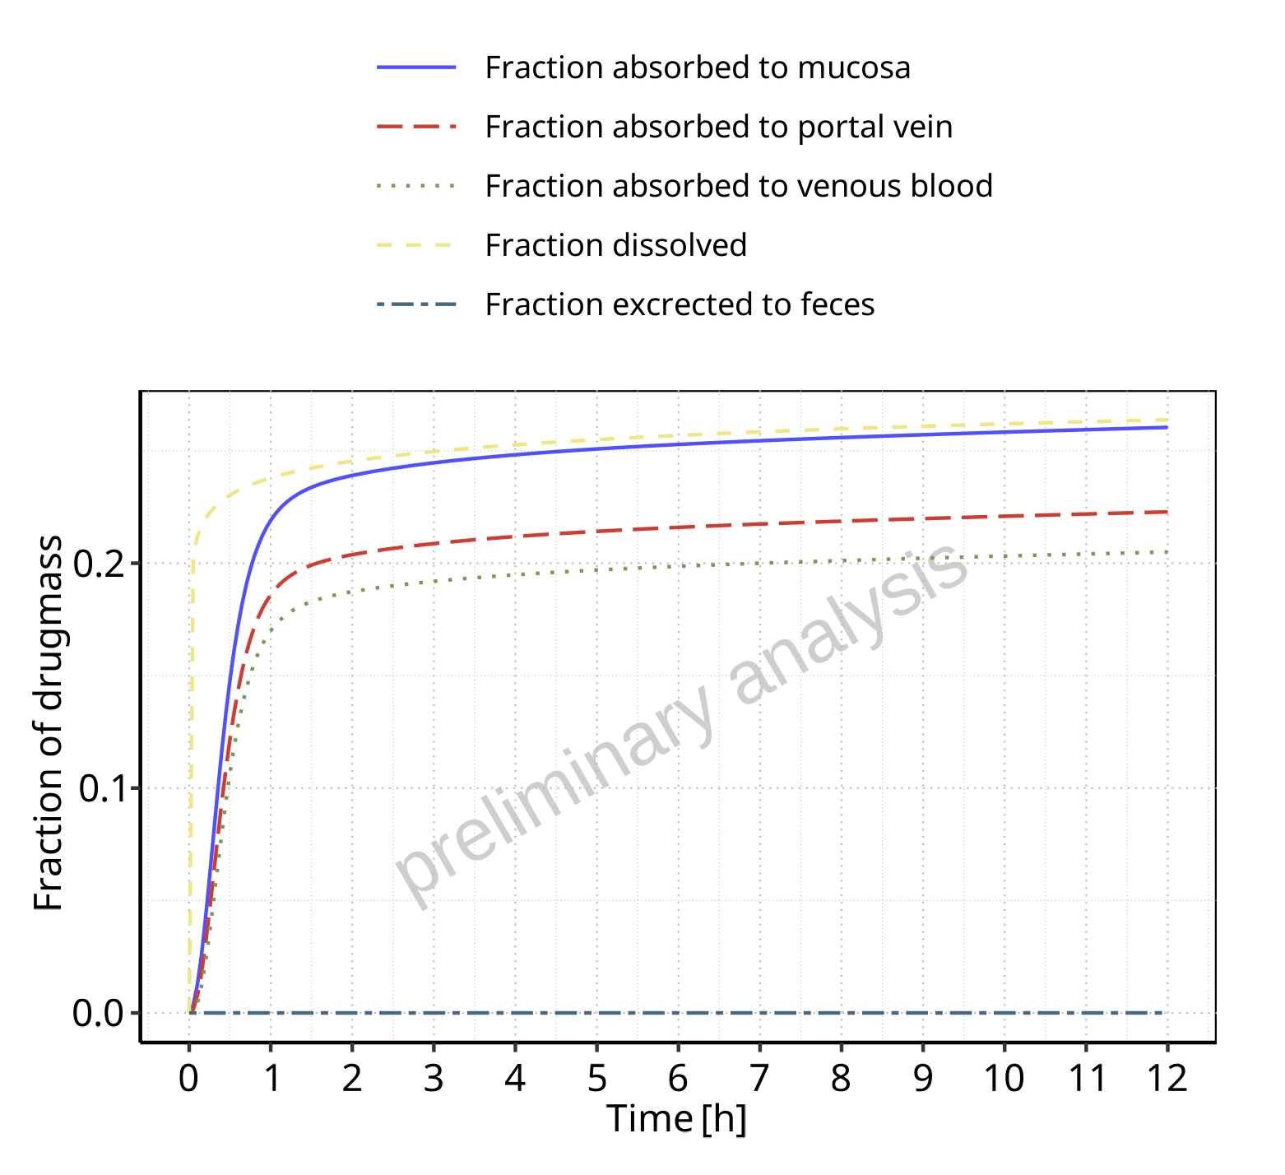

**Figure 3-1: Absorption of Raltegravir**

## Absorption for Raltegravir 25 mg (lactose formulation)

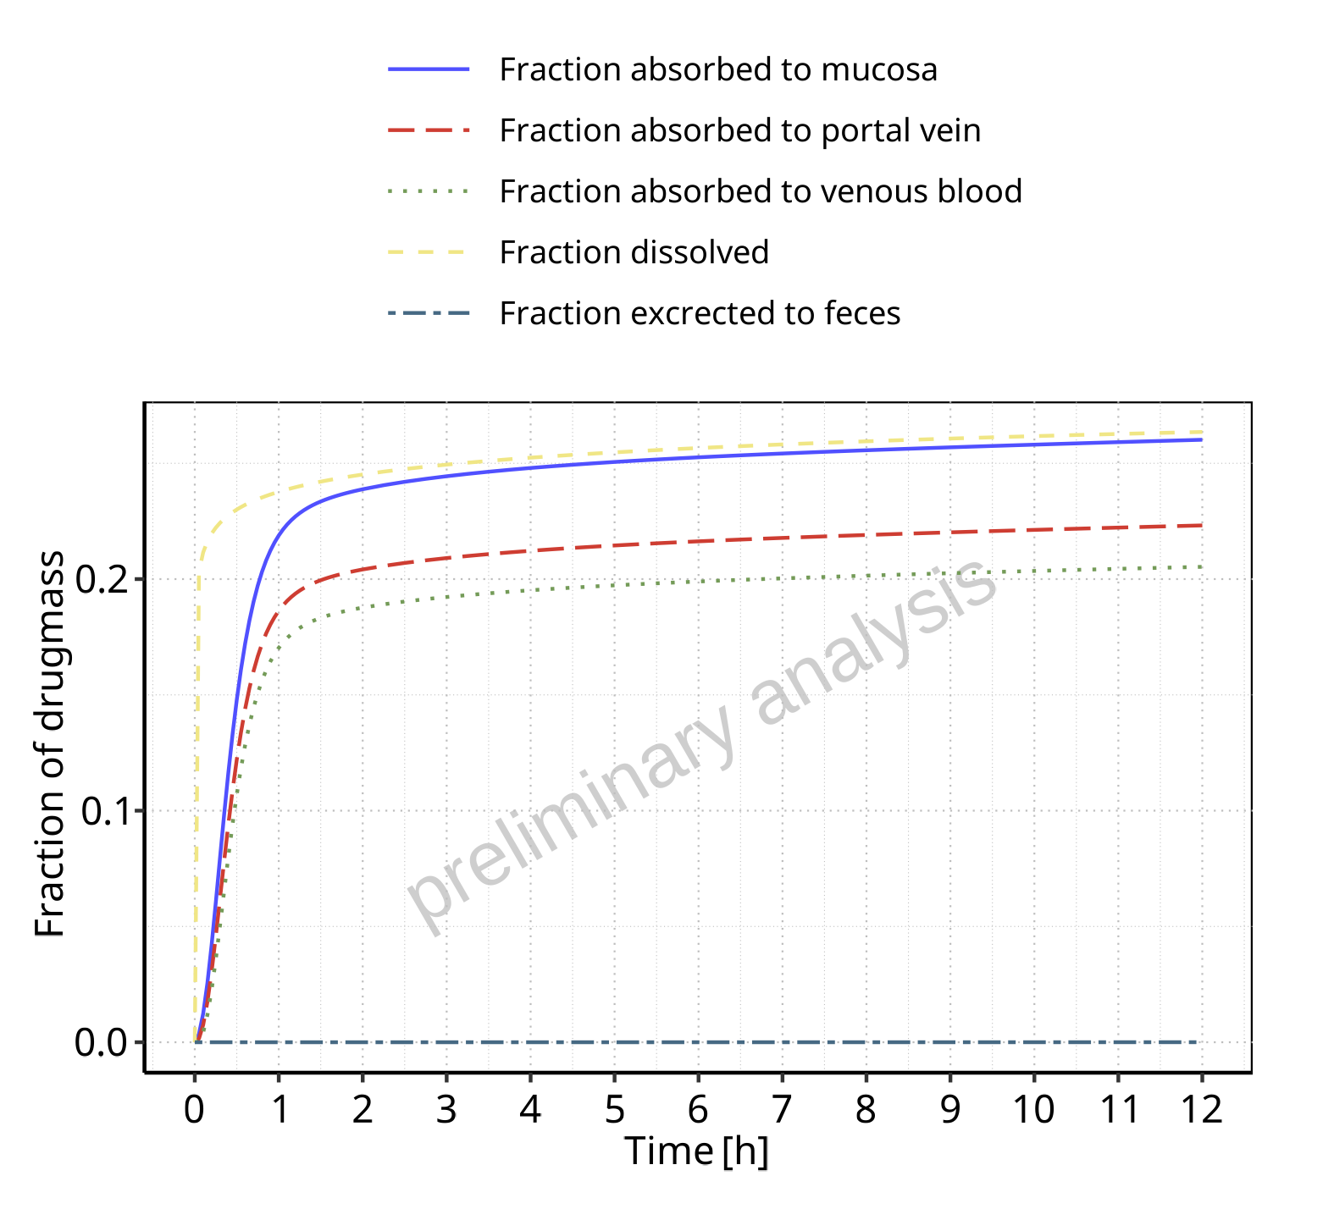

**Figure 3-2: Absorption of Raltegravir**

## Absorption for Raltegravir 50 mg (lactose formulation)

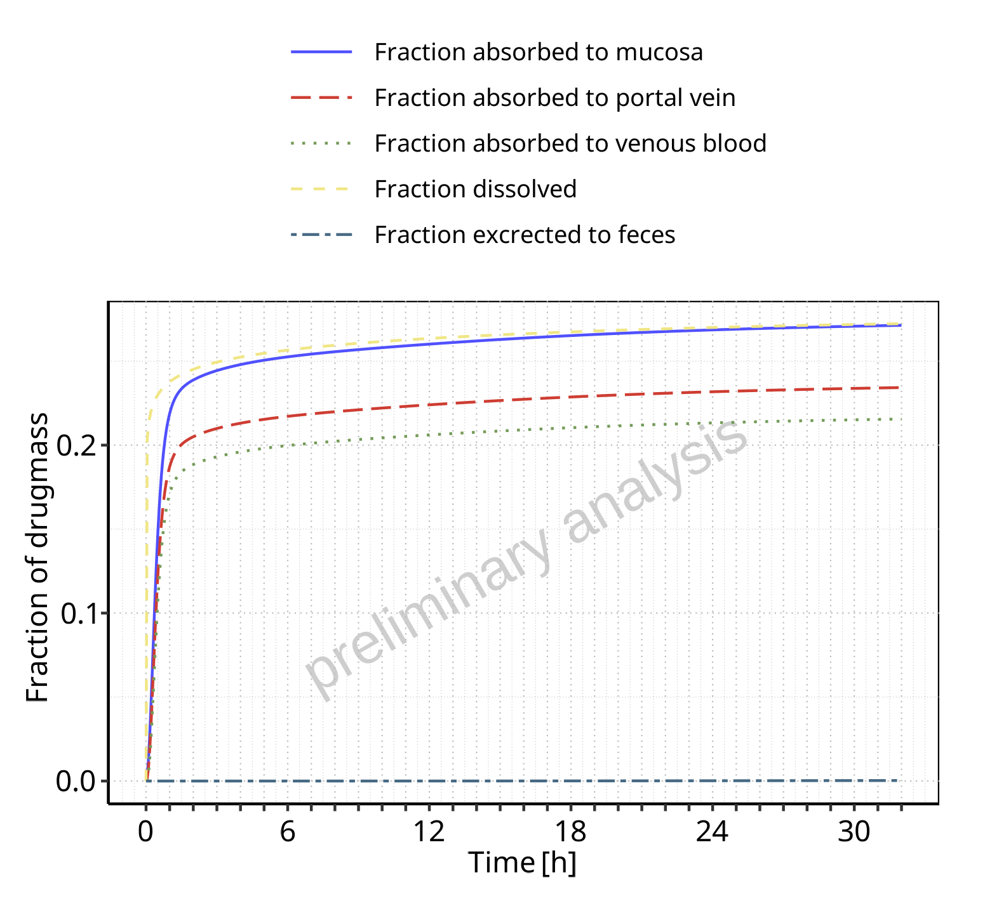

**Figure 3-3: Absorption of Raltegravir**

## Absorption for Raltegravir 100 mg (lactose formulation)

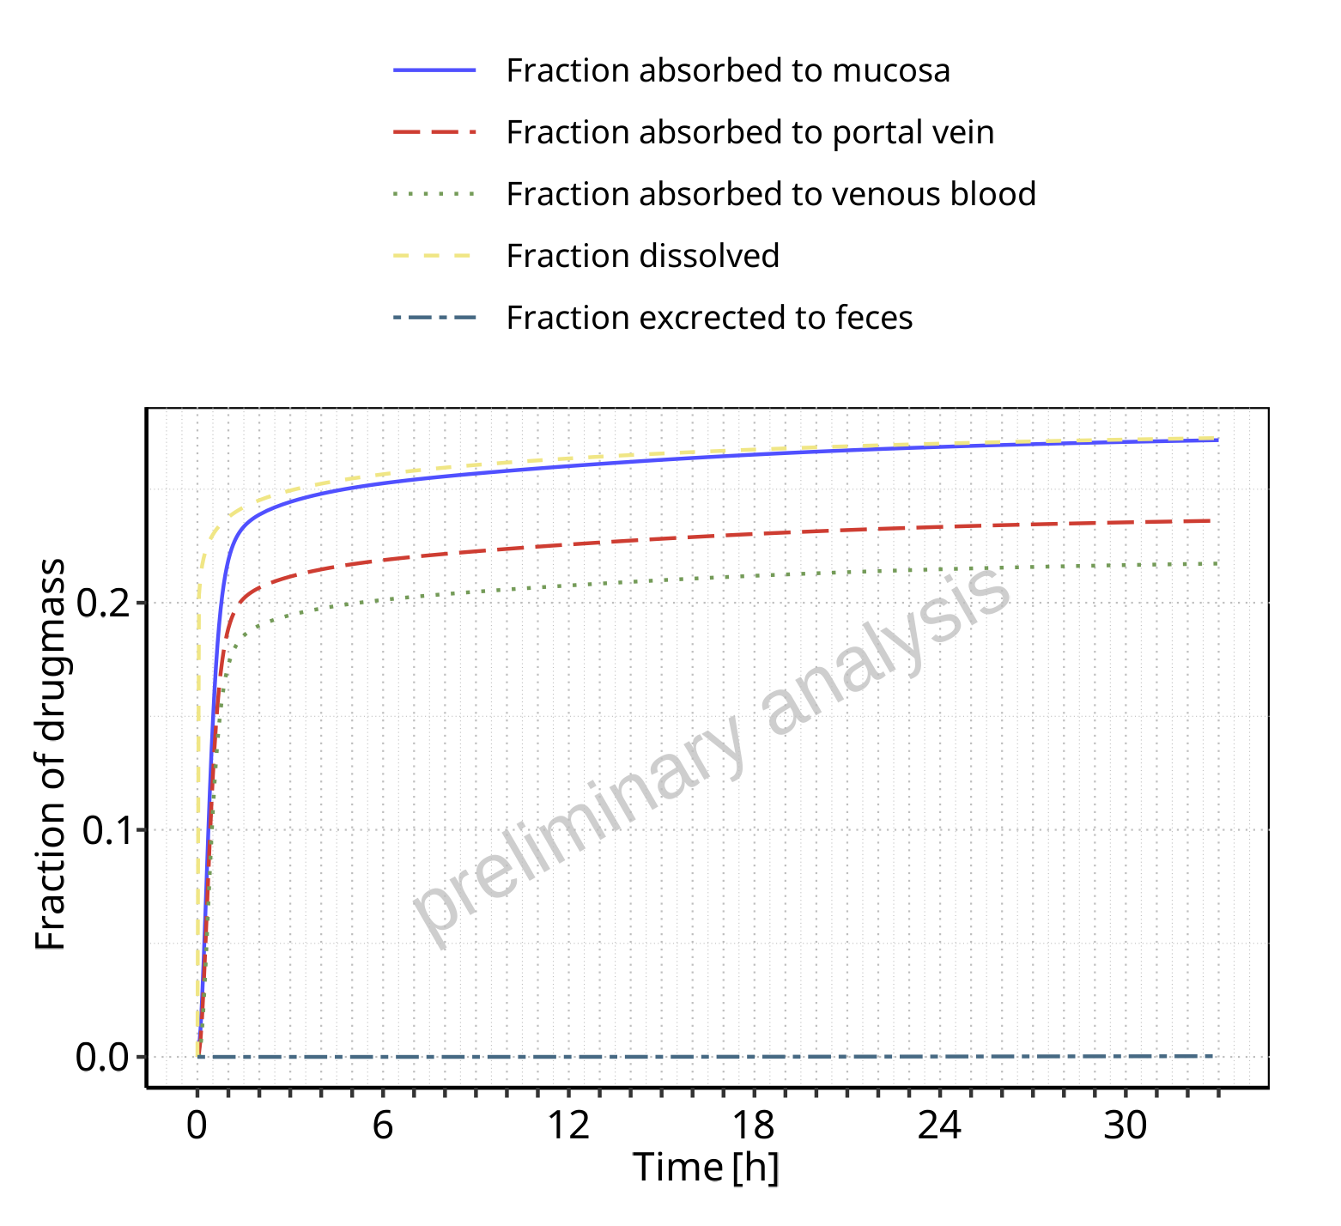

**Figure 3-4: Absorption of Raltegravir**

## Absorption for Raltegravir 200 mg (lactose formulation)

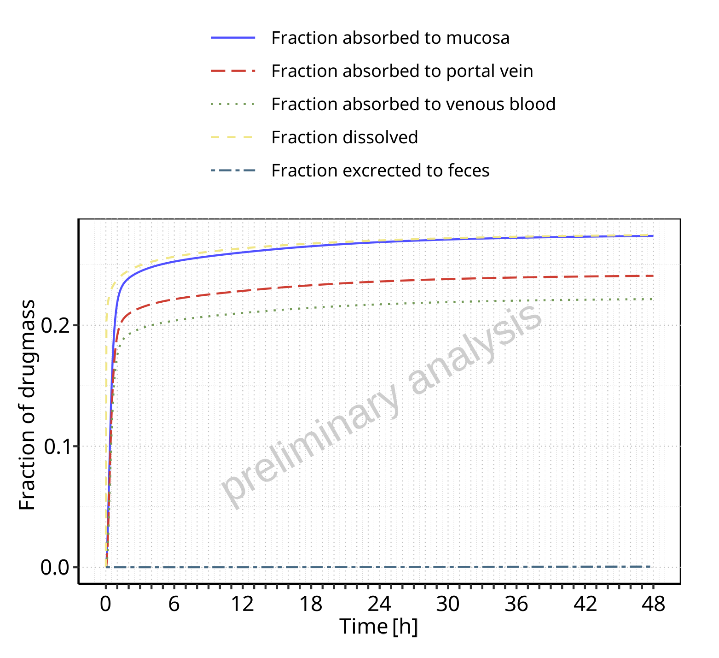

**Figure 3-5: Absorption of Raltegravir**

## Absorption for Raltegravir 400mg (lactose formulation)

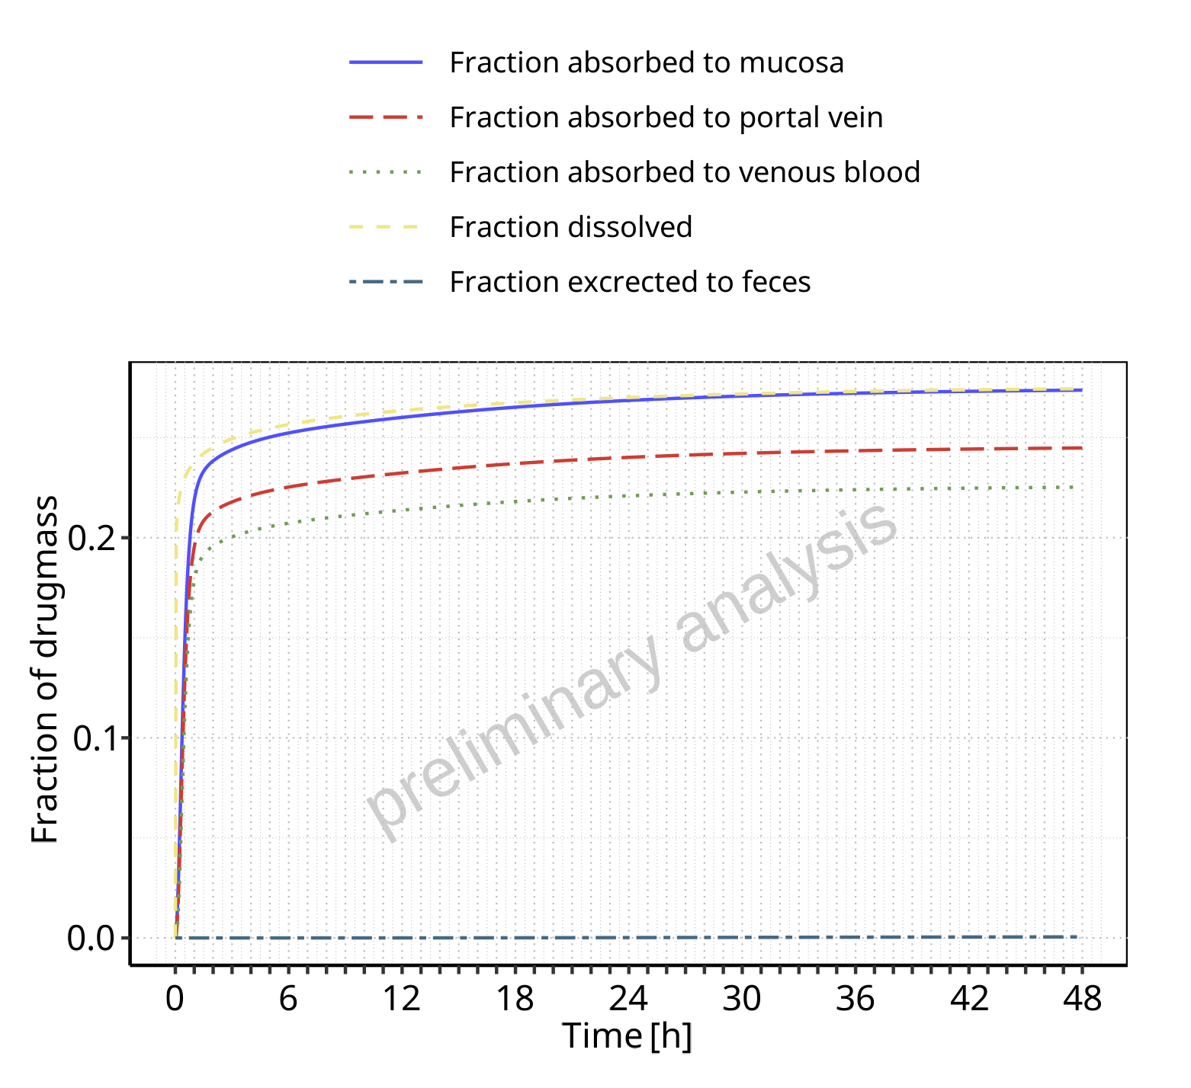

**Figure 3-6: Absorption of Raltegravir**

## Absorption for Raltegravir 800 mg (lactose formulation)

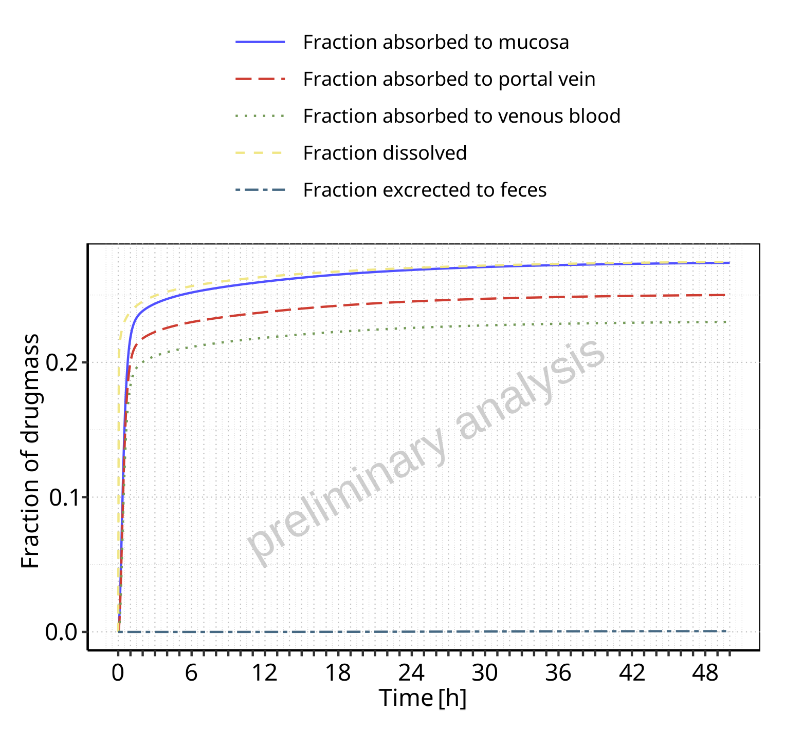

**Figure 3-7: Absorption of Raltegravir**

## Absorption for Raltegravir 1200 mg (lactose formulation)

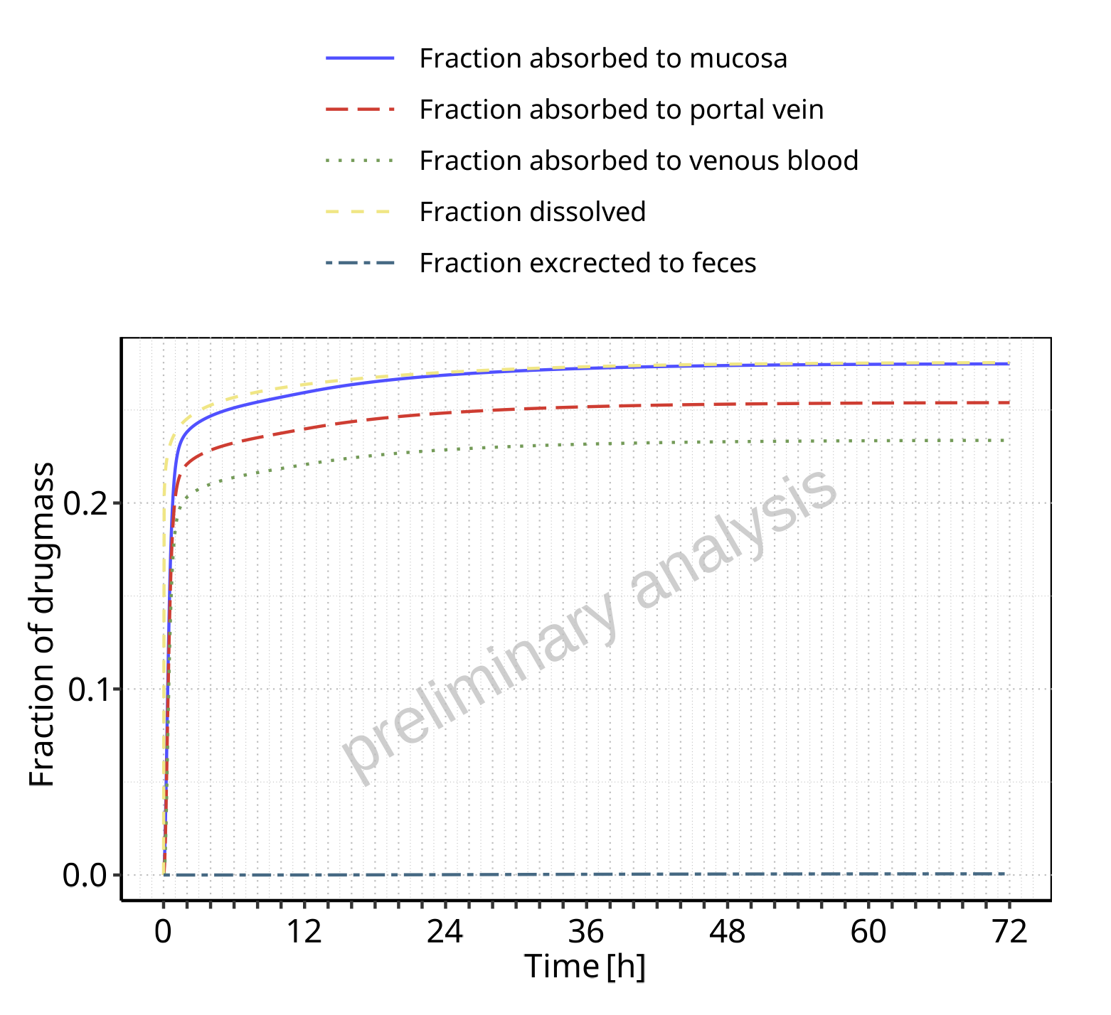

**Figure 3-8: Absorption of Raltegravir**

## Absorption for Raltegravir 1600 mg (lactose formulation)

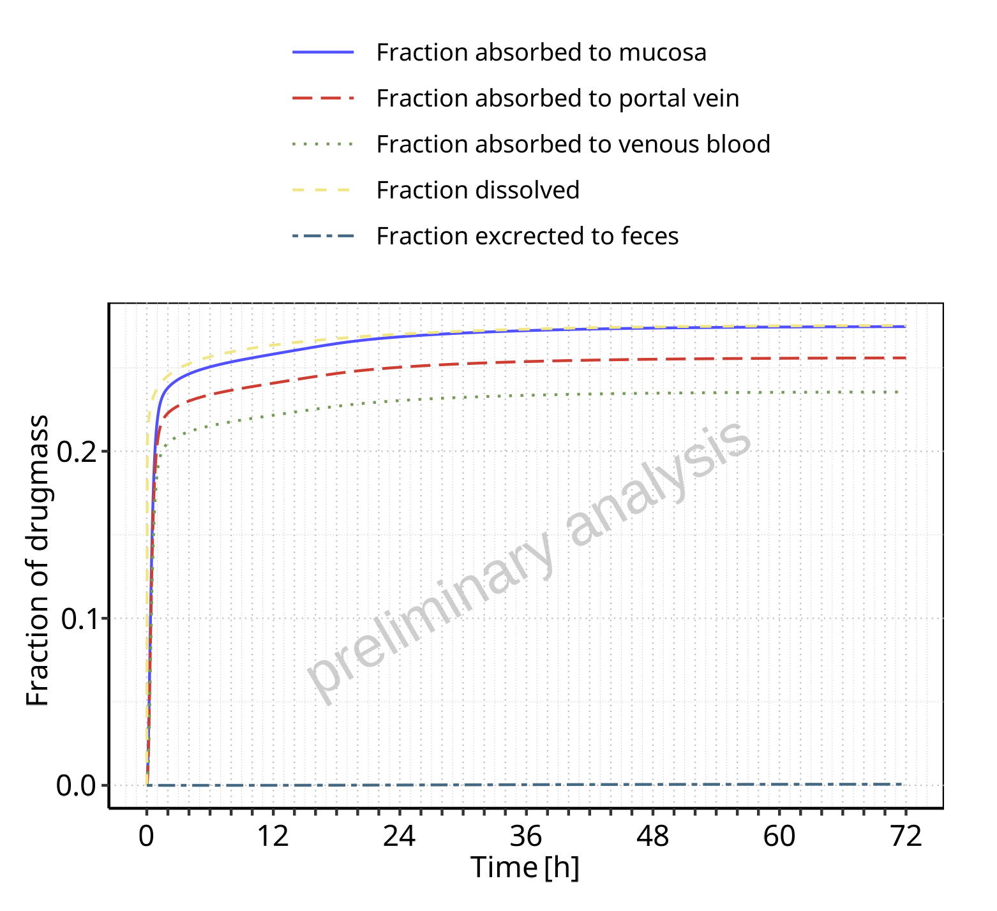

**Figure 3-9: Absorption of Raltegravir**

## Absorption for Raltegravir 100 mg filmcoated tablet md

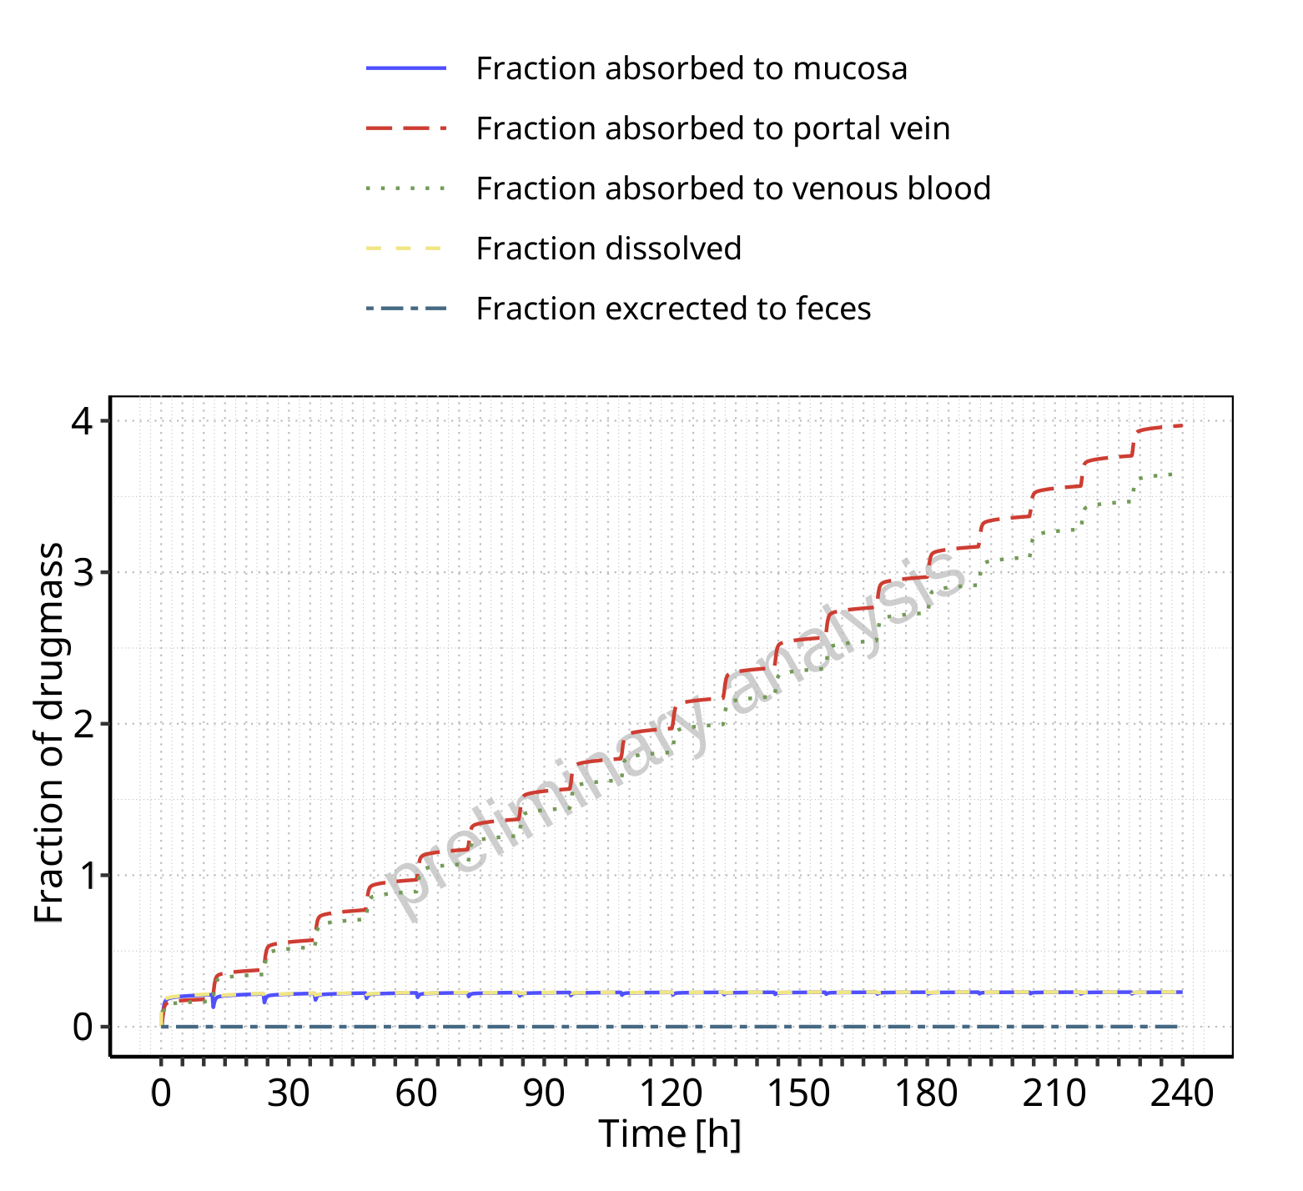

**Figure 3-10: Absorption of Raltegravir**

## Absorption for Raltegravir 200 mg filmcoated tablet md

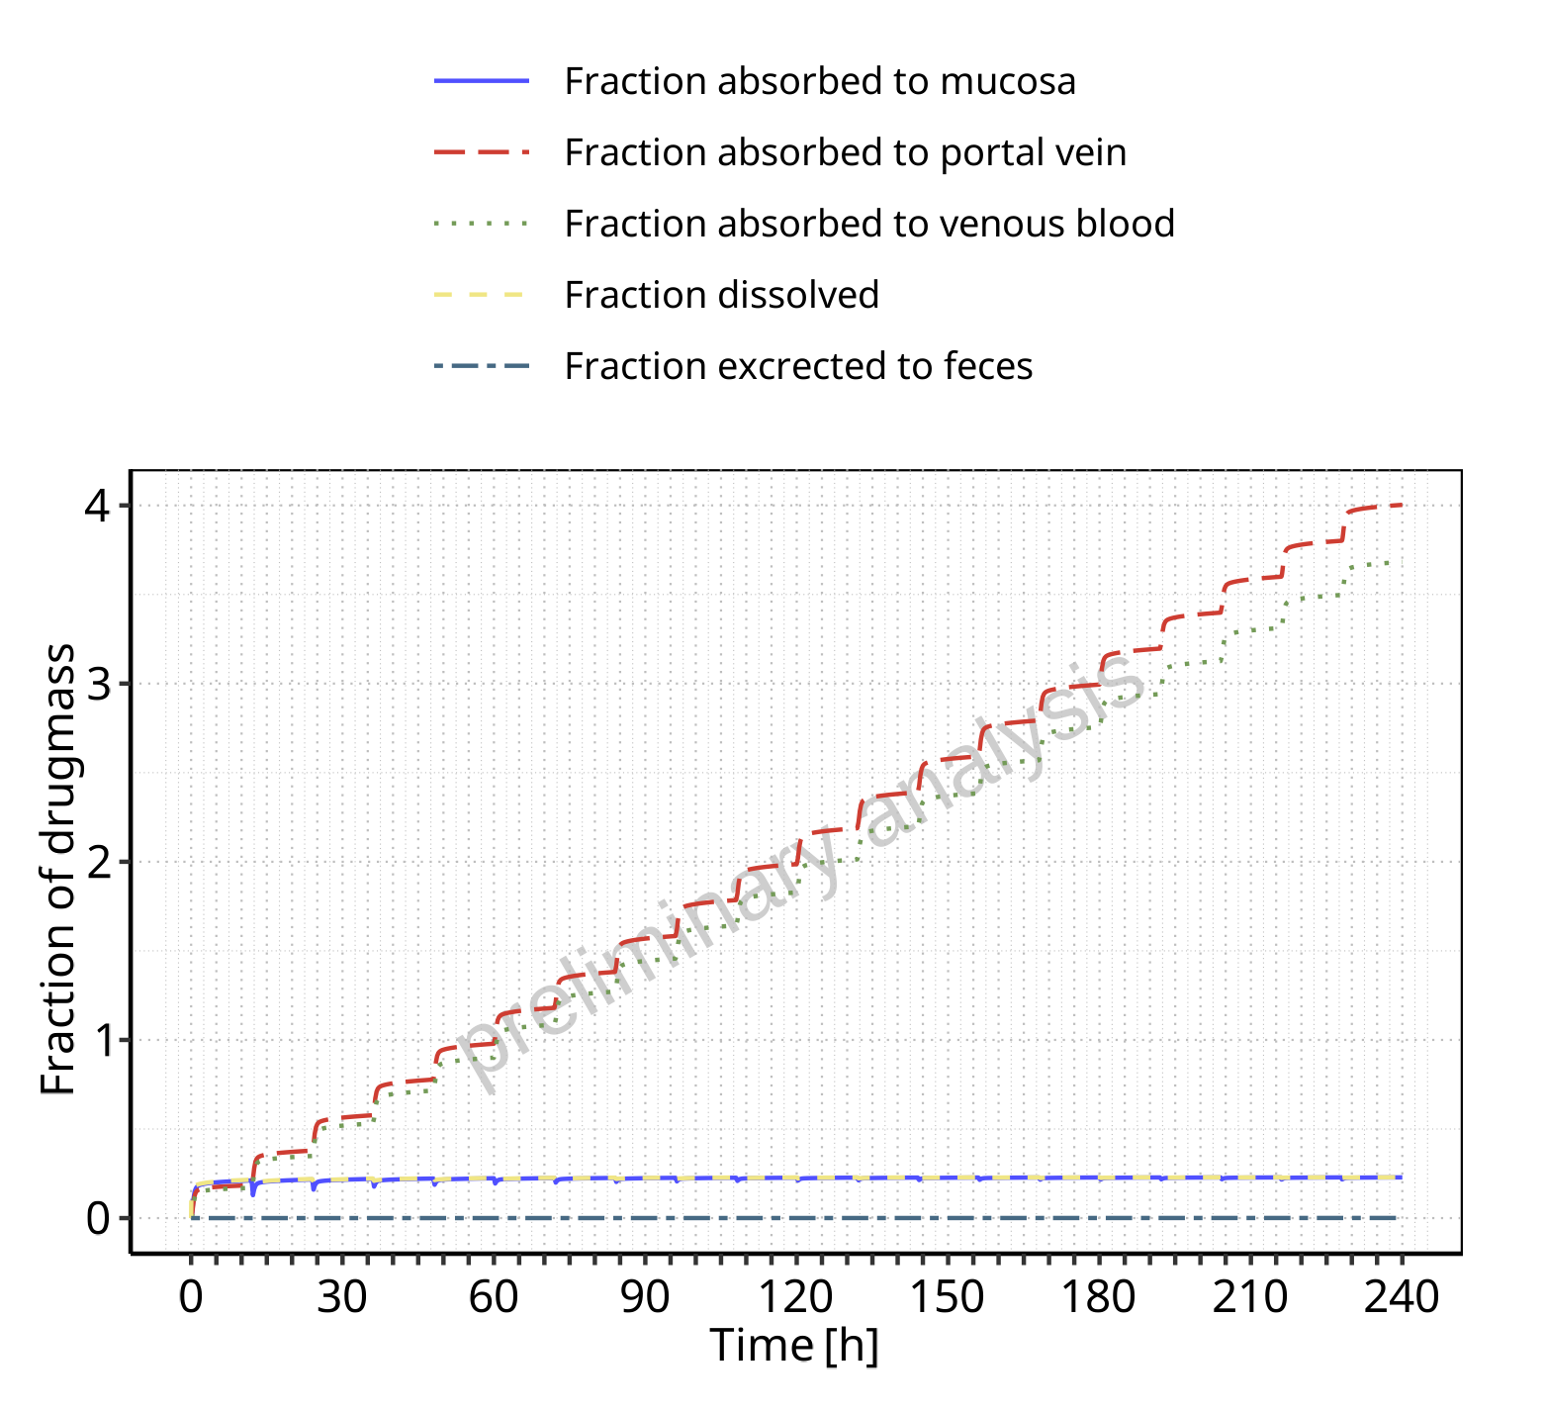

**Figure 3-11: Absorption of Raltegravir**

## Absorption for Filmcoated_tablet_400mg_sd

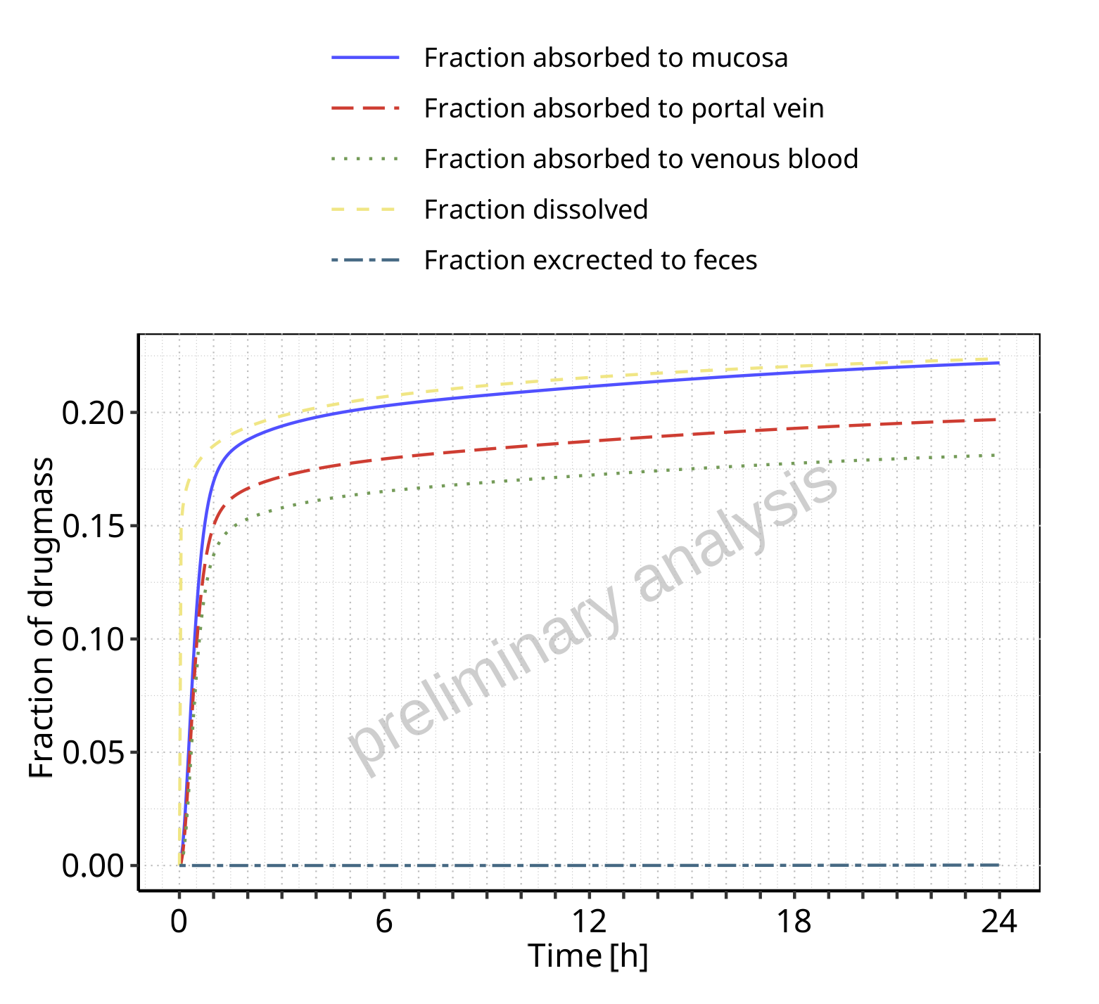

**Figure 3-12: Absorption of Raltegravir**

## Absorption for Raltegravir 400 mg filmcoated tablet md

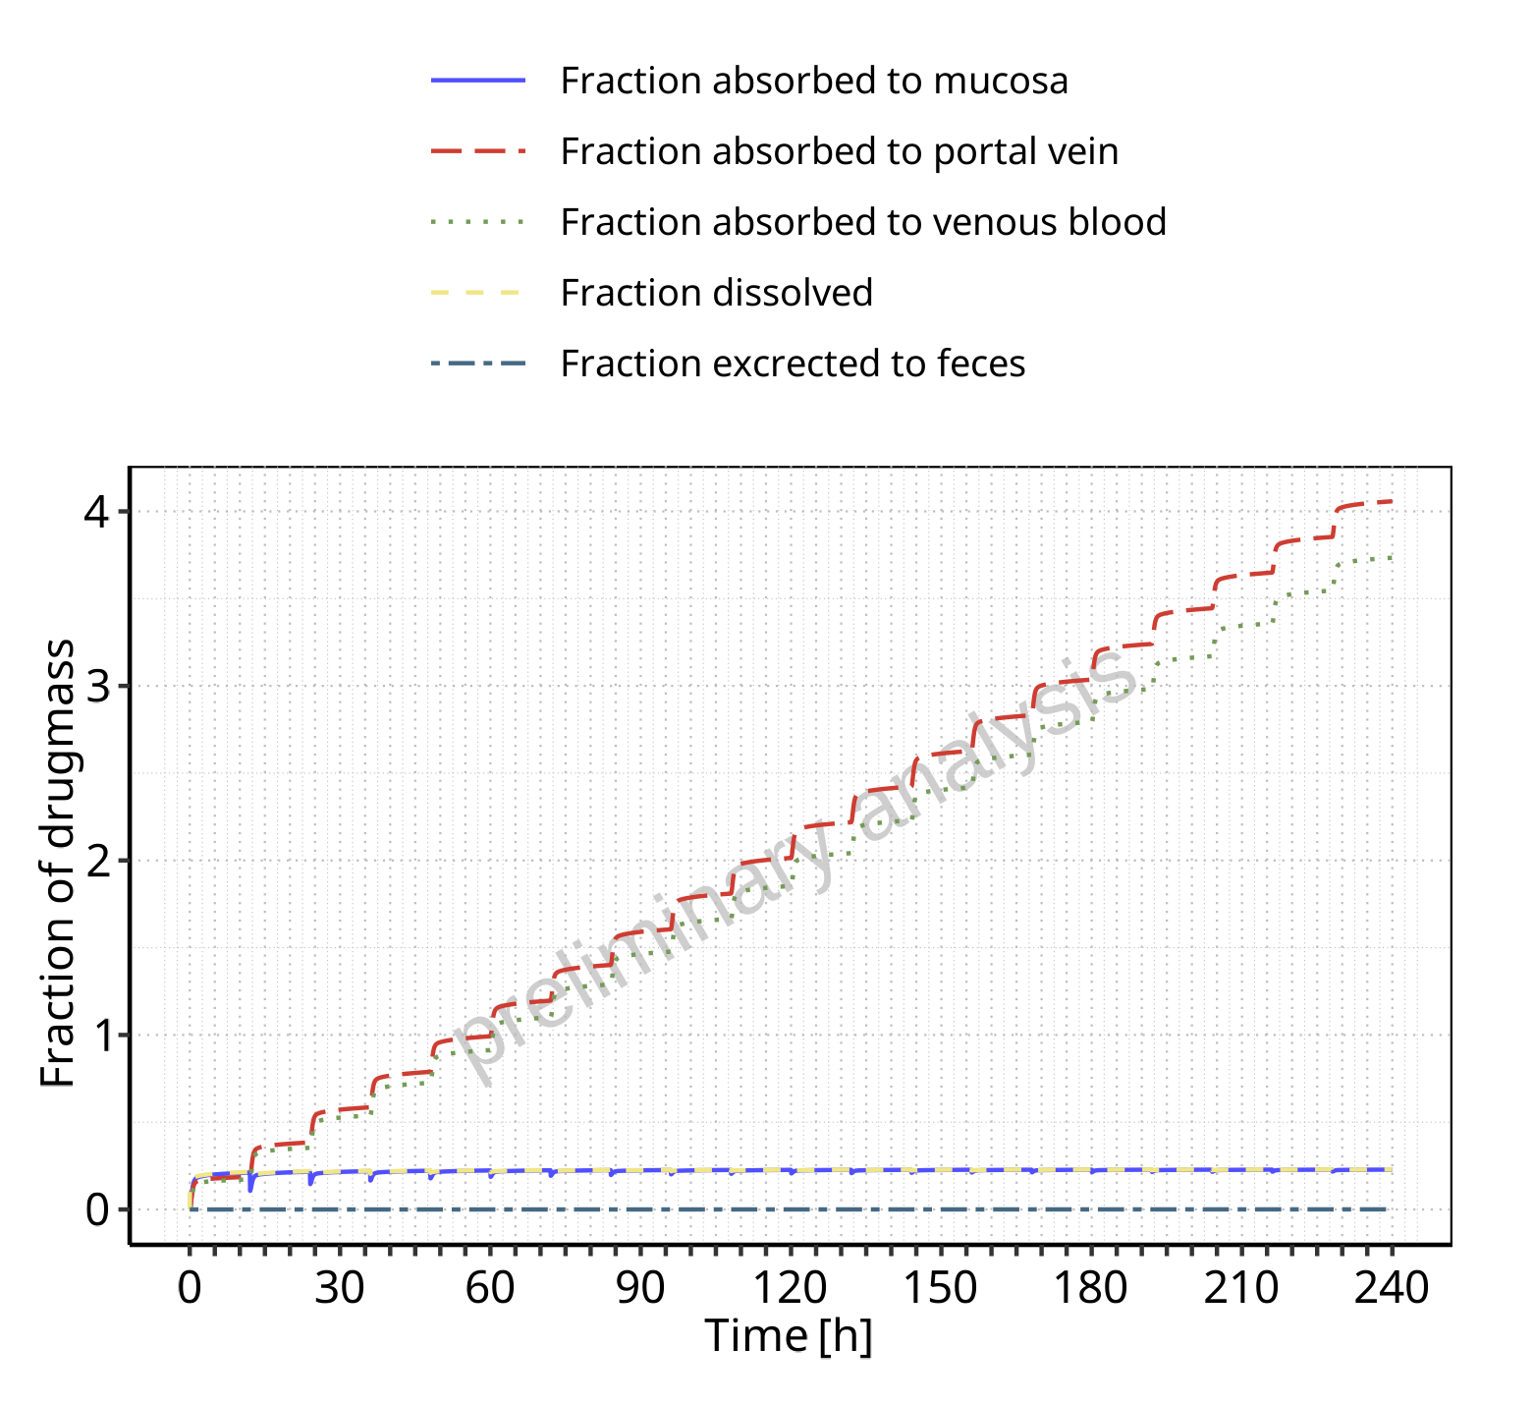

**Figure 3-13: Absorption of Raltegravir**

## Absorption for Raltegravir 400mg chewable fasted

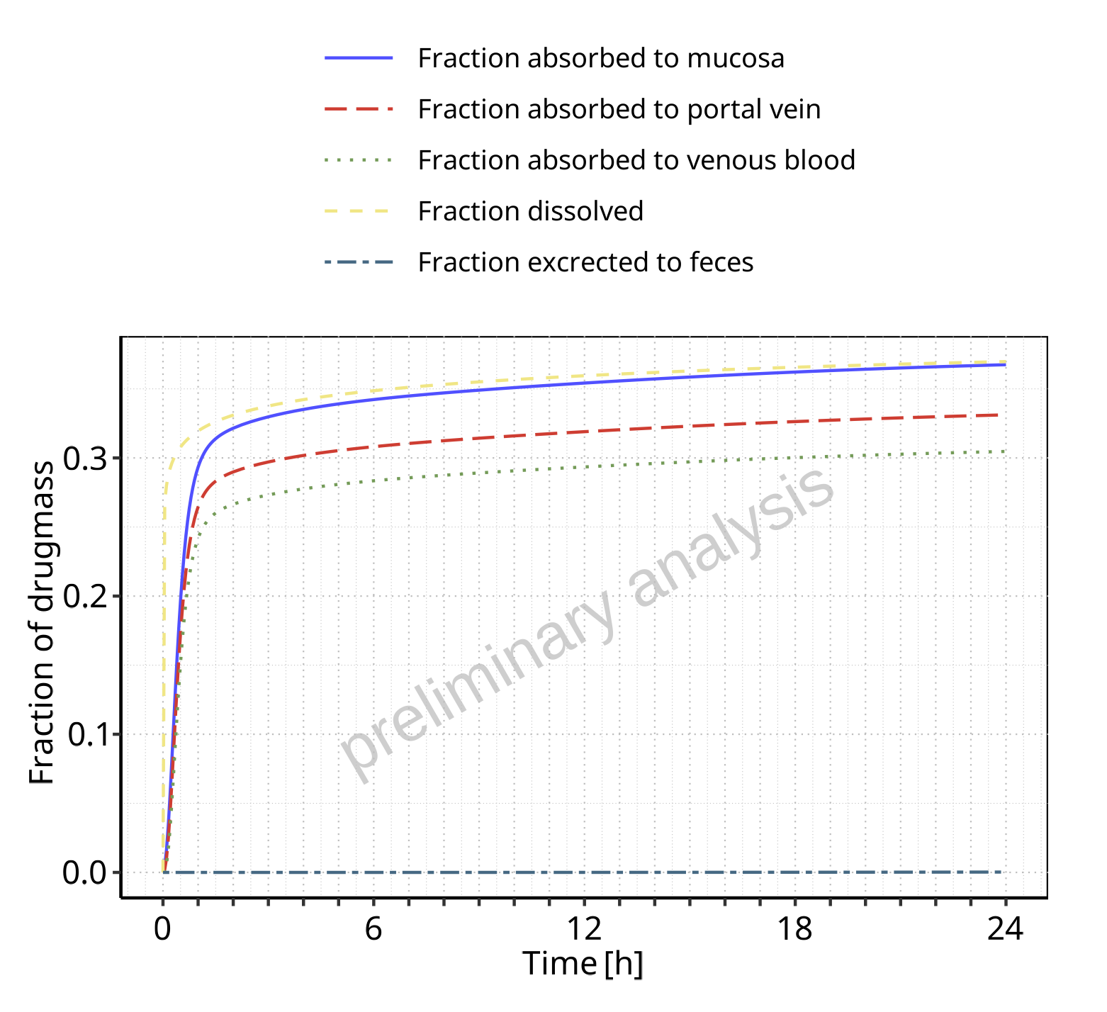

**Figure 3-14: Absorption of Raltegravir**

## Absorption for Raltegravir 400mg chewable fed

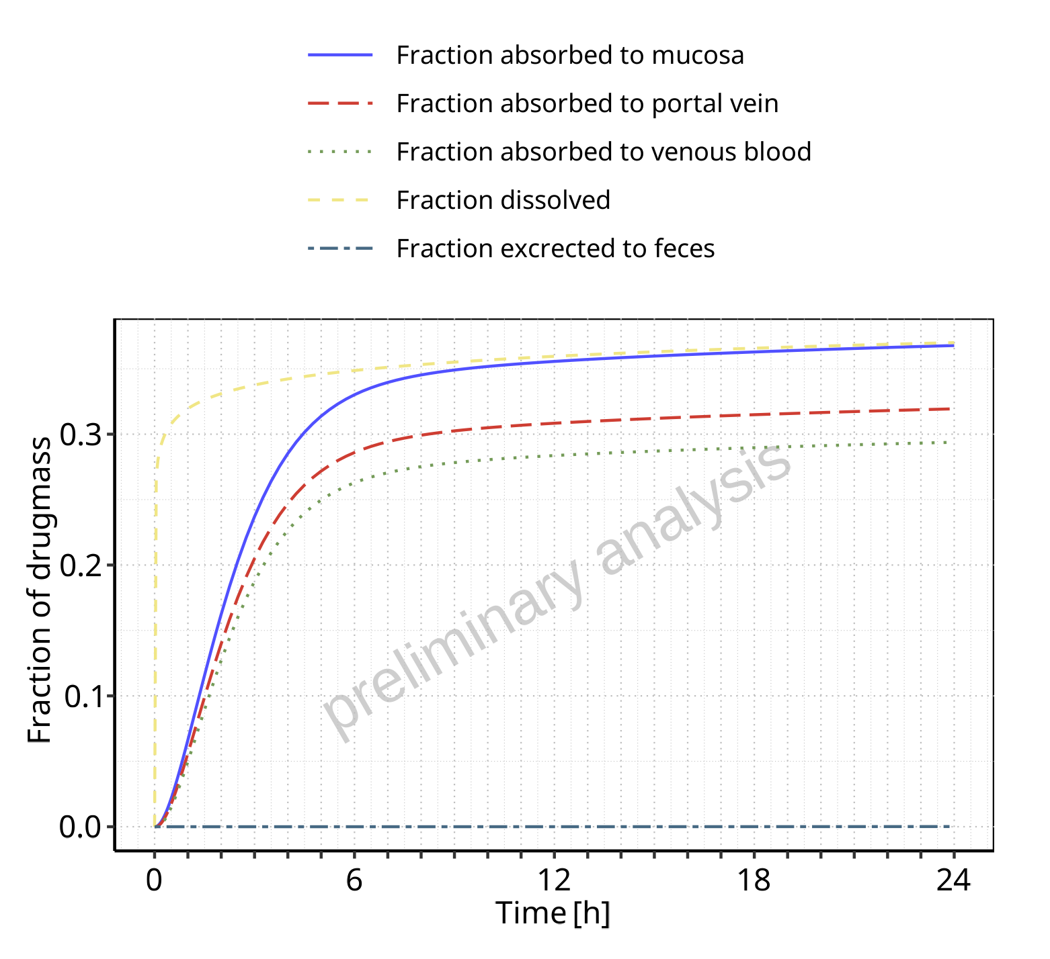

**Figure 3-15: Absorption of Raltegravir**

## Absorption for Raltegravir 400mg (granules in suspension)

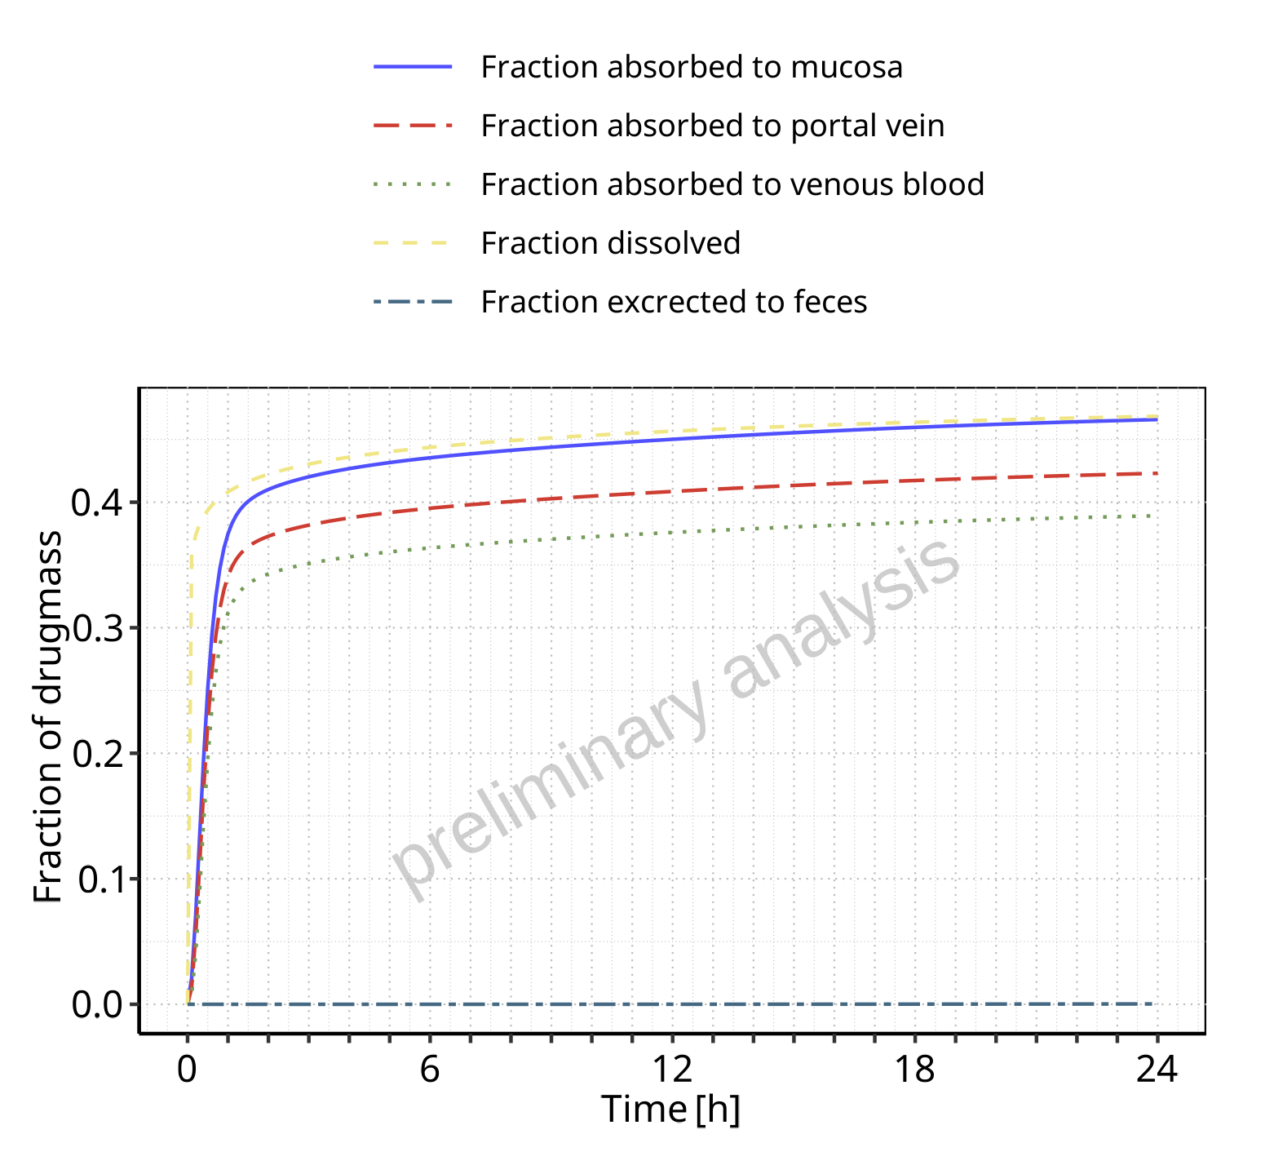

**Figure 3-16: Absorption of Raltegravir**

# Mass Balance

## Mass Balance for Raltegravir 10 mg (lactose formulation)

### Mass Balance for Raltegravir

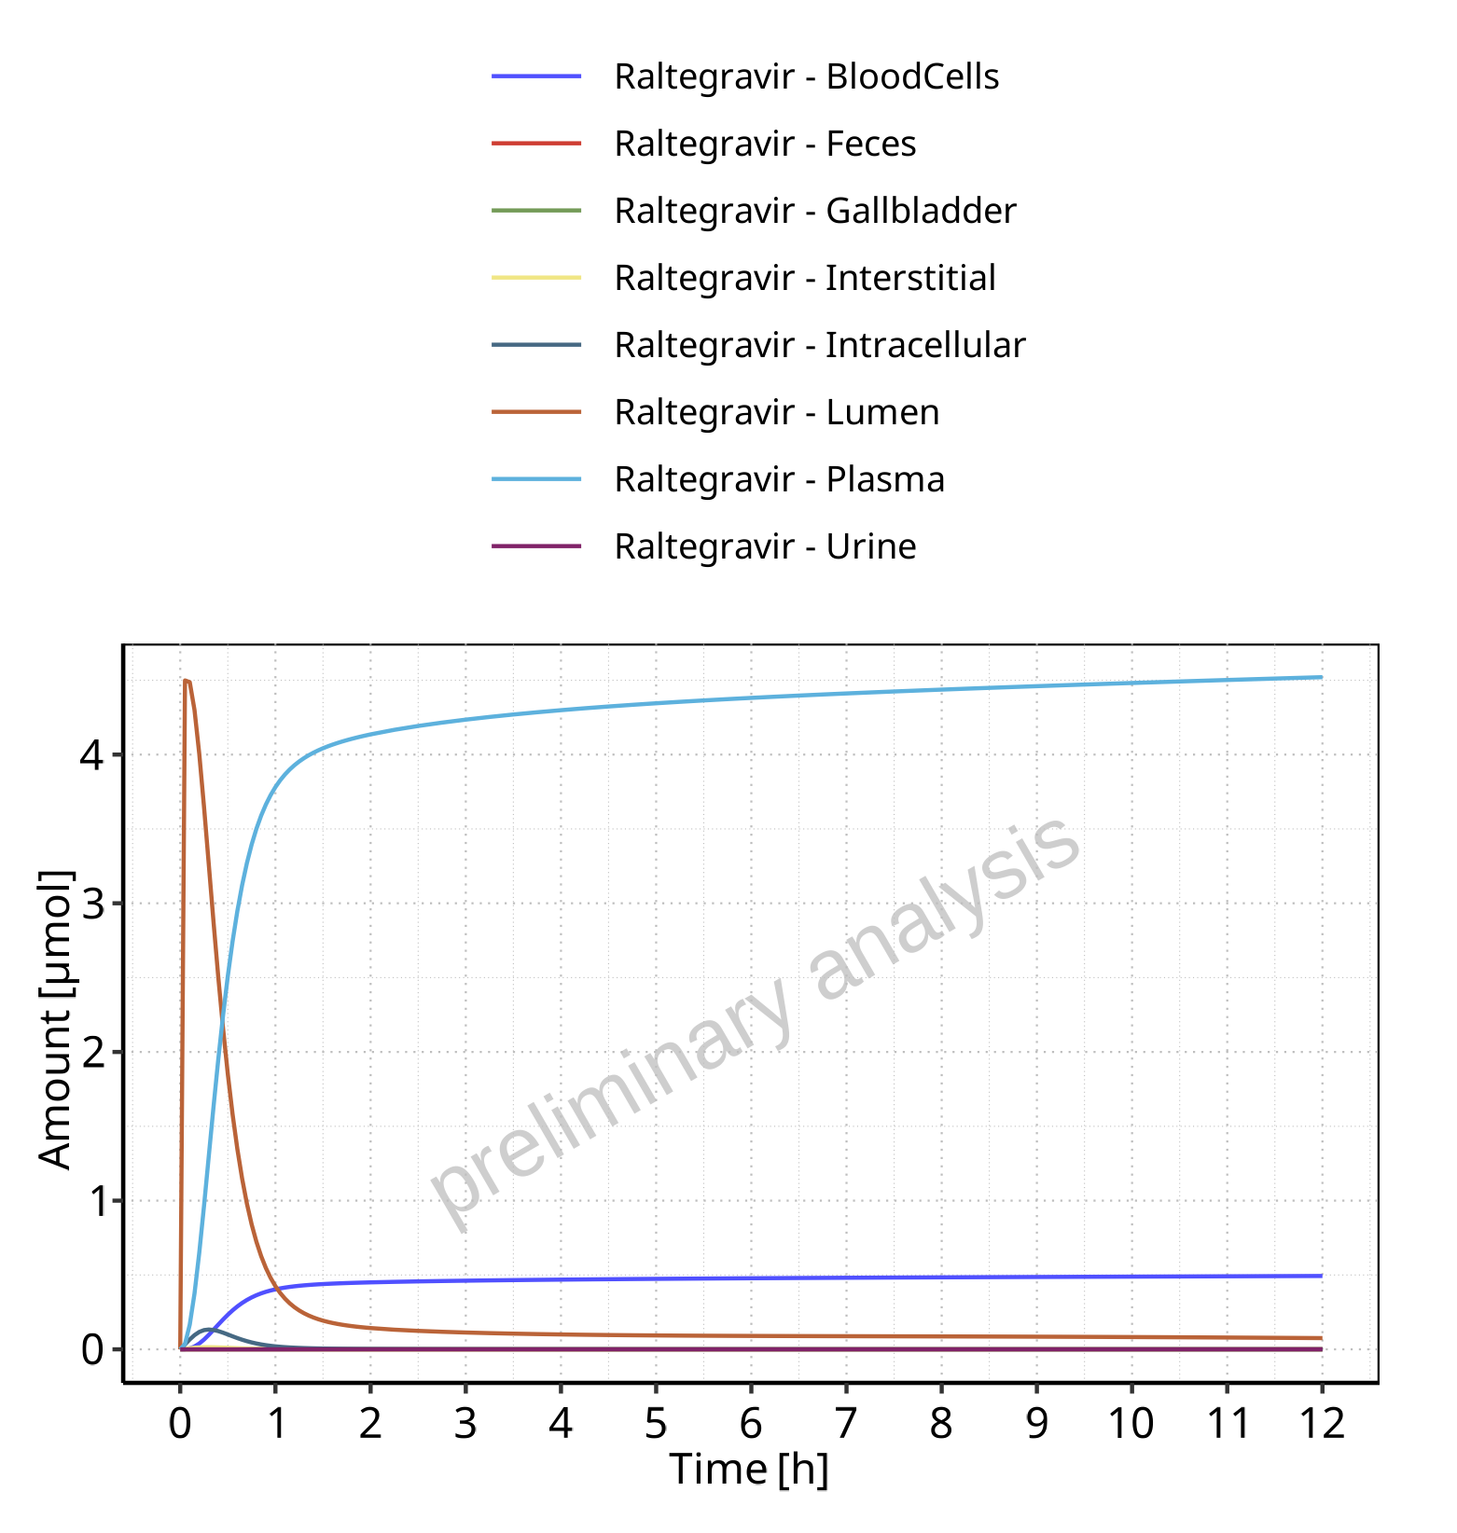

**Figure 4-1: Amount of drug vs time within the different compartments for Raltegravir**

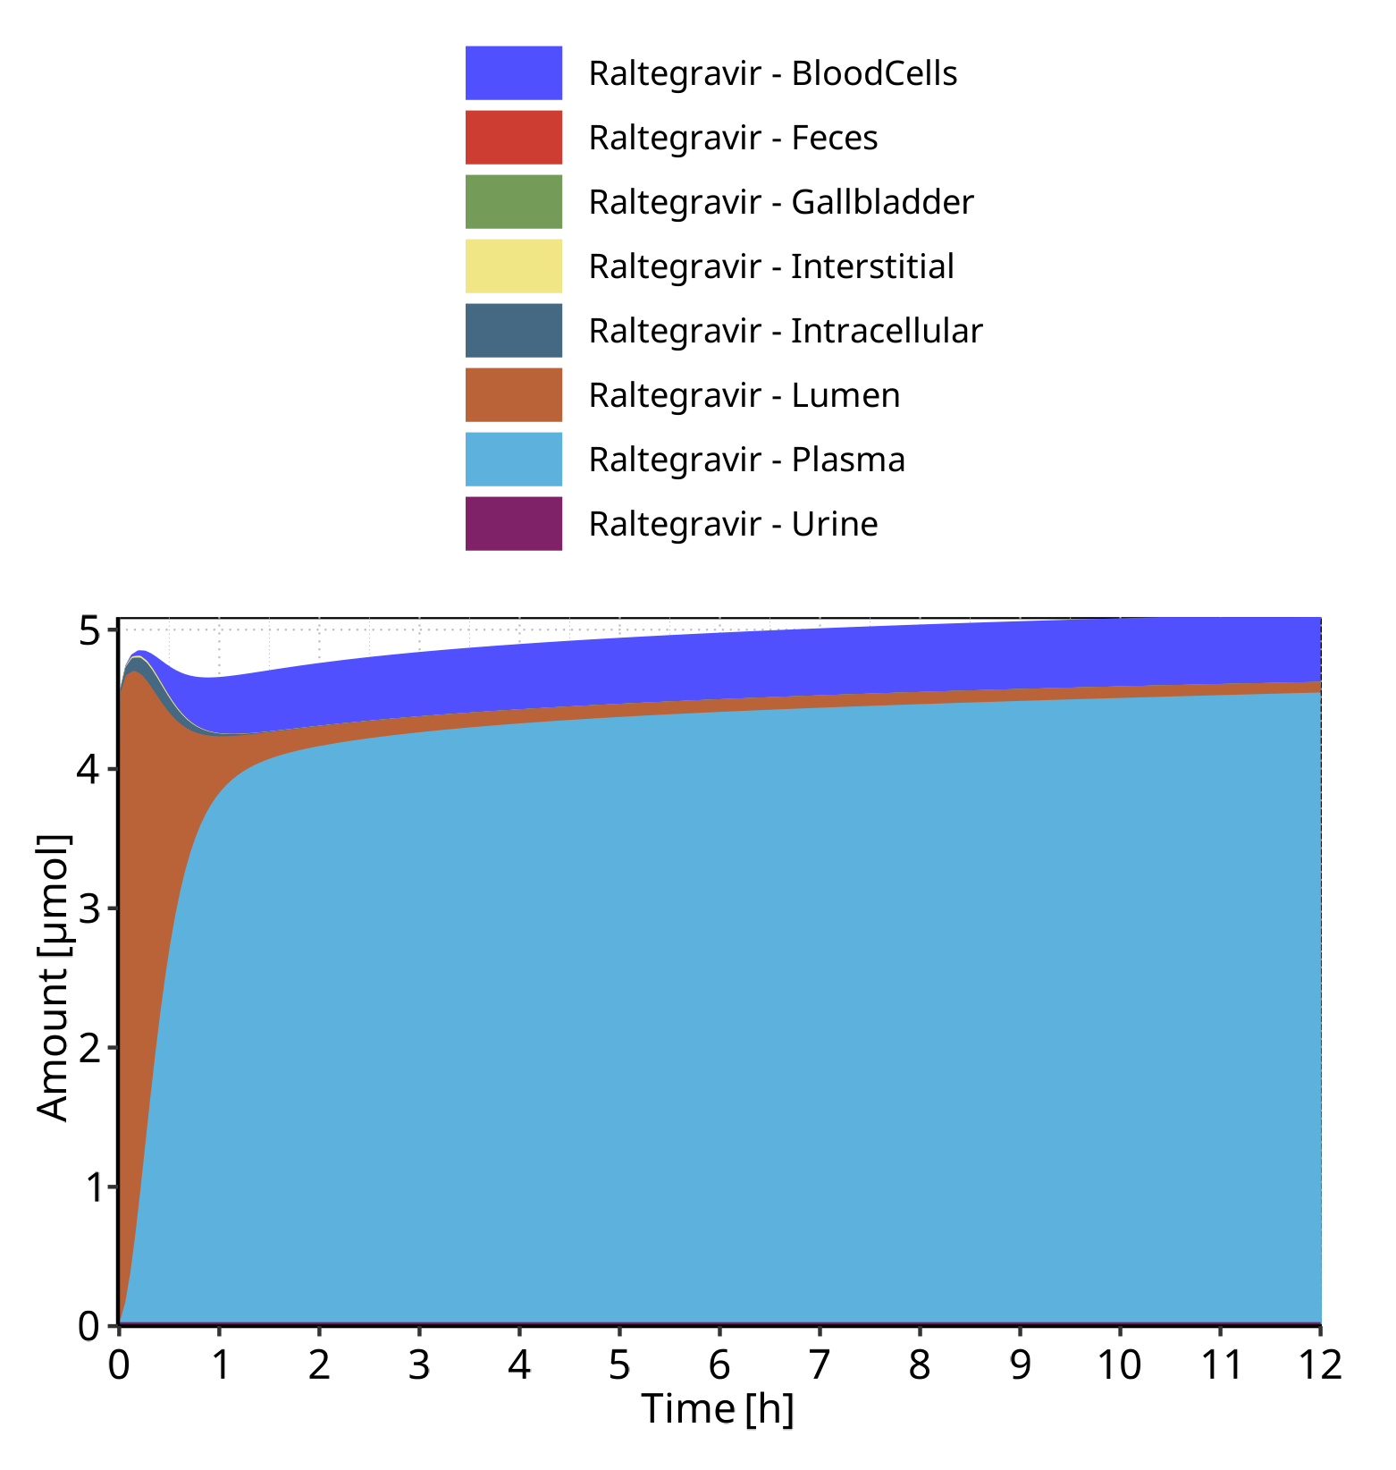

**Figure 4-2: Cumulated amount of drug vs time within the different compartments for Raltegravir**

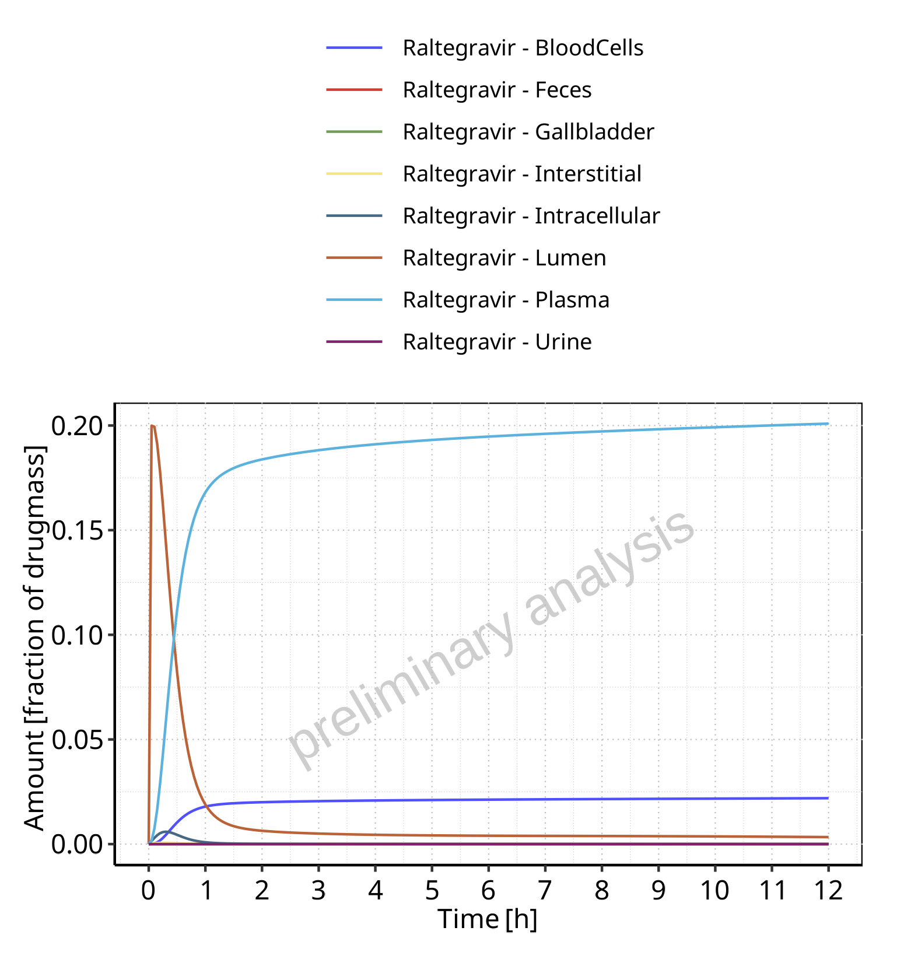

**Figure 4-3: Amount of drug vs time within the different compartments normalized to applicated drugmass for Raltegravir**

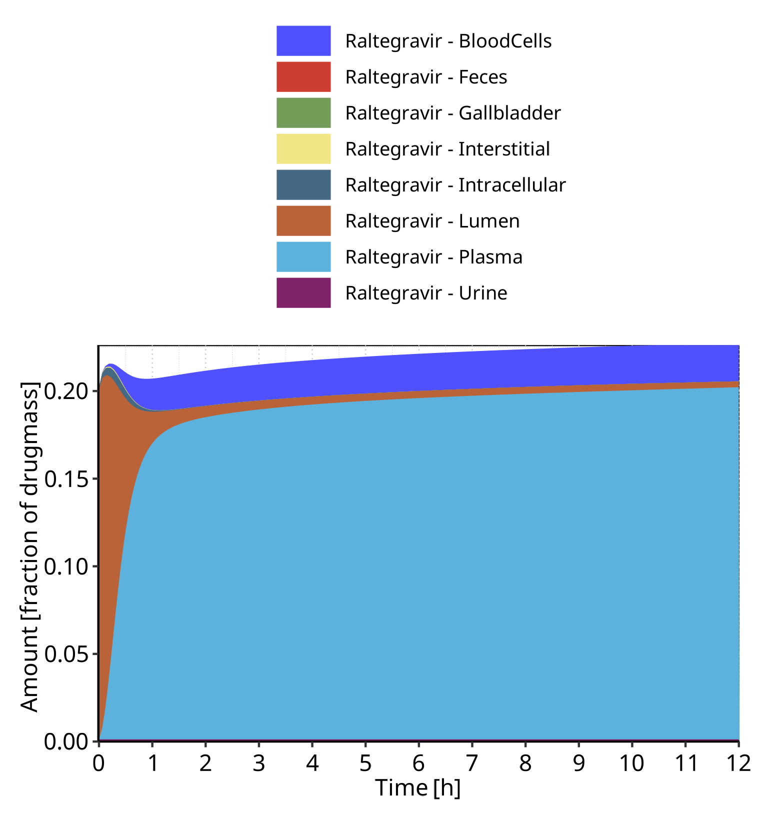

**Figure 4-4: Cumulated amount of drug vs time within the different compartments normalized to applicated drugmass for Raltegravir**

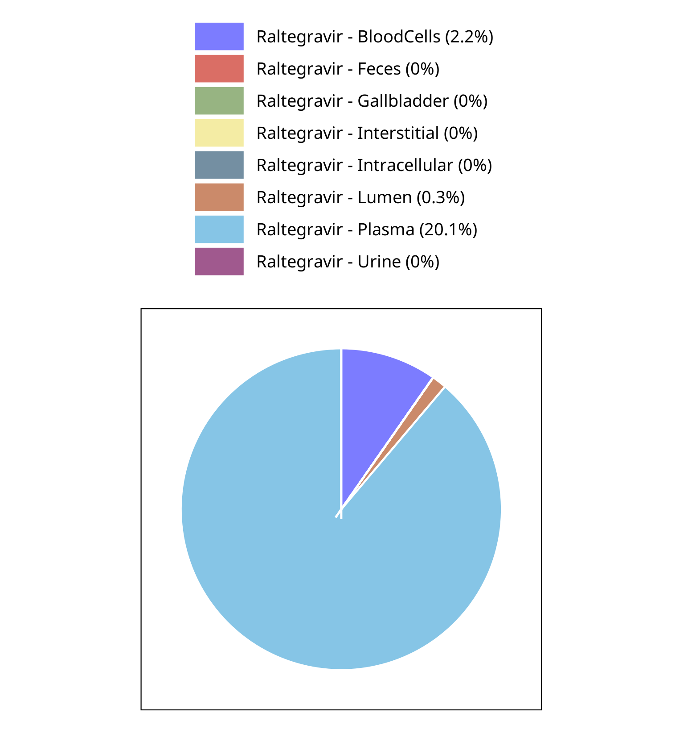

**Figure 4-5: Fraction of drug within the different compartments at 12.00h for Raltegravir**

## Mass Balance for Raltegravir 25 mg (lactose formulation)

### Mass Balance for Raltegravir

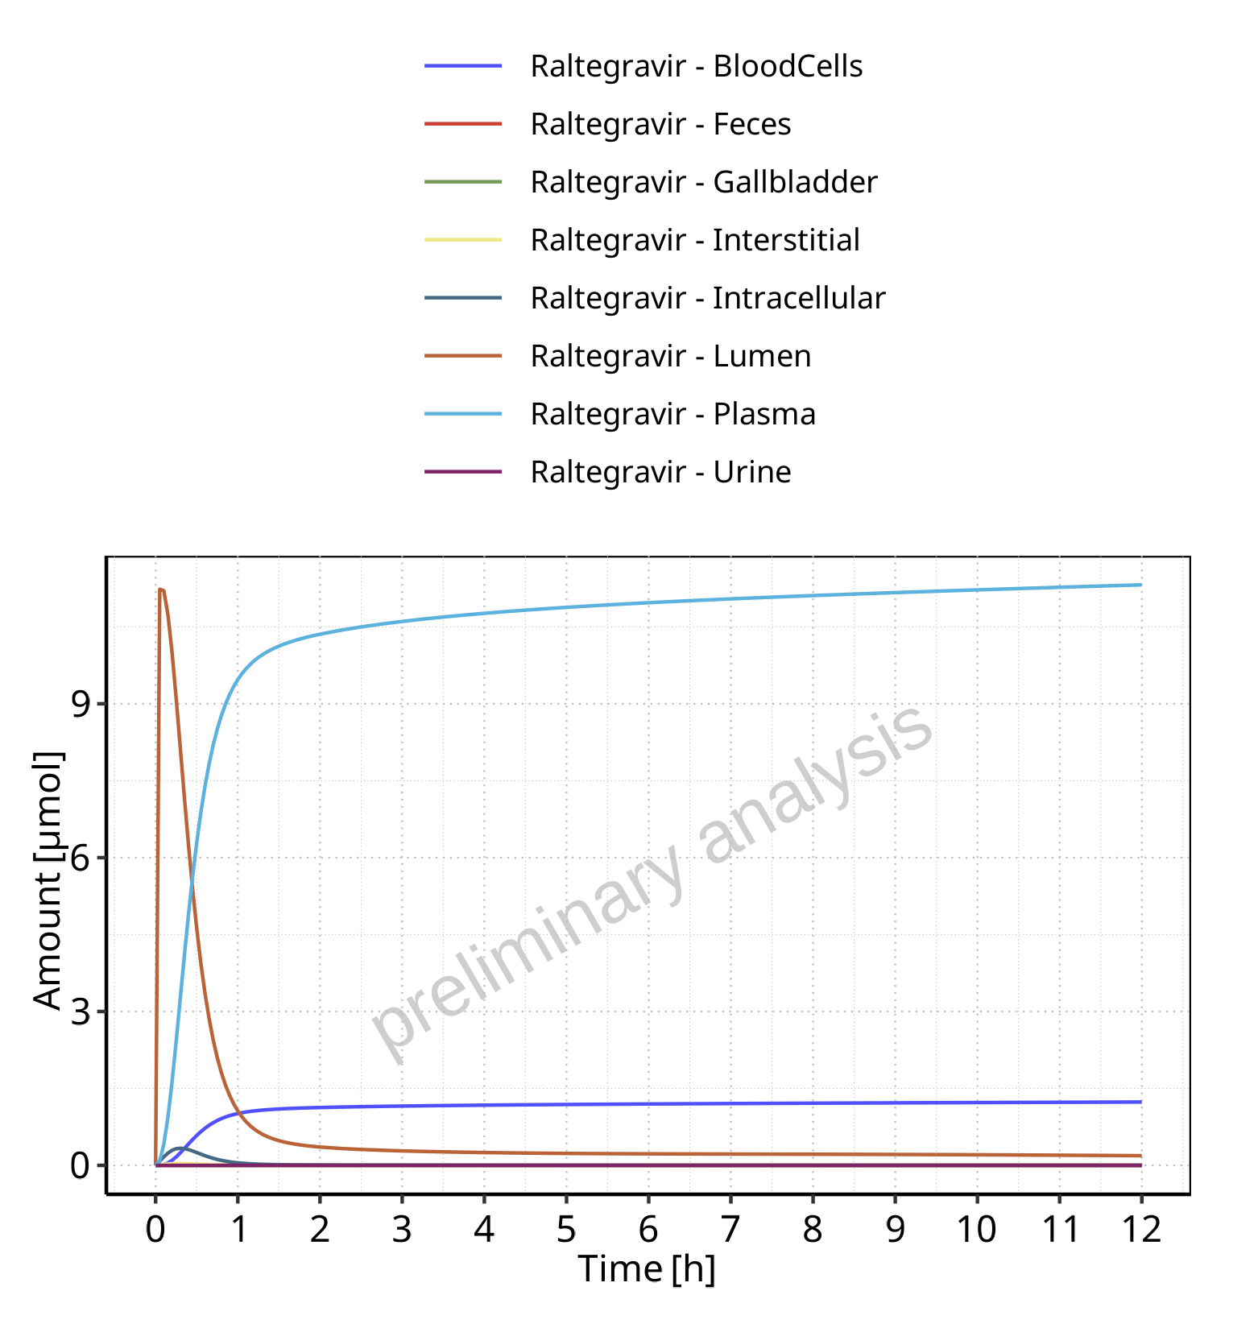

**Figure 4-6: Amount of drug vs time within the different compartments for Raltegravir**

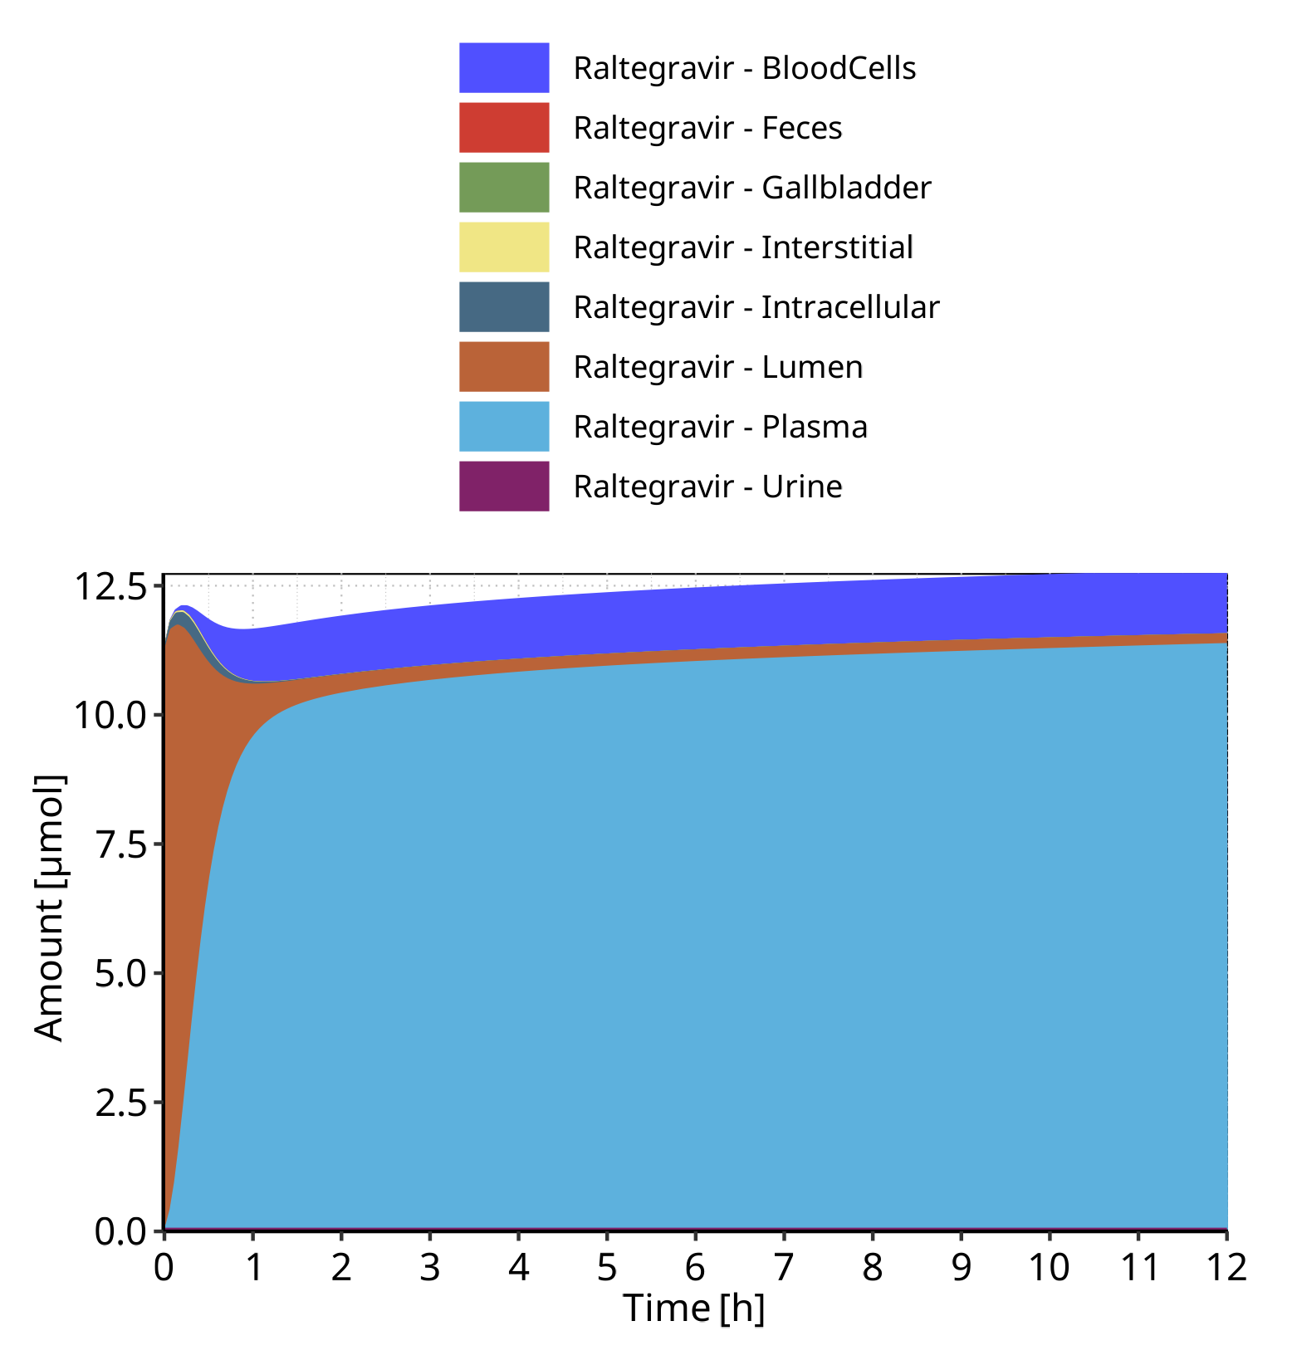

**Figure 4-7: Cumulated amount of drug vs time within the different compartments for Raltegravir**

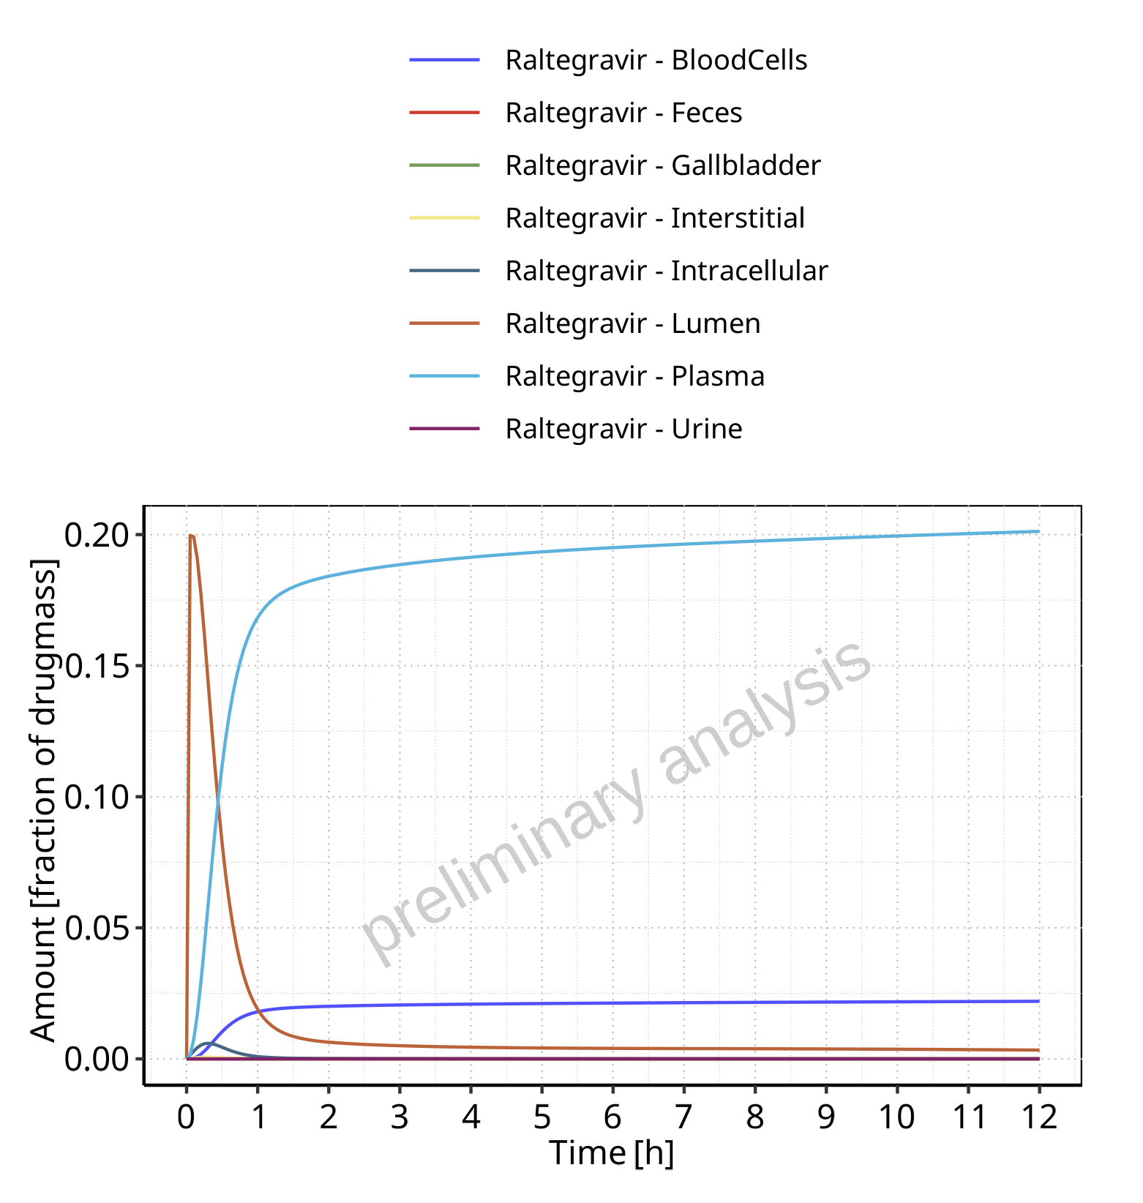

**Figure 4-8: Amount of drug vs time within the different compartments normalized to applicated drugmass for Raltegravir**

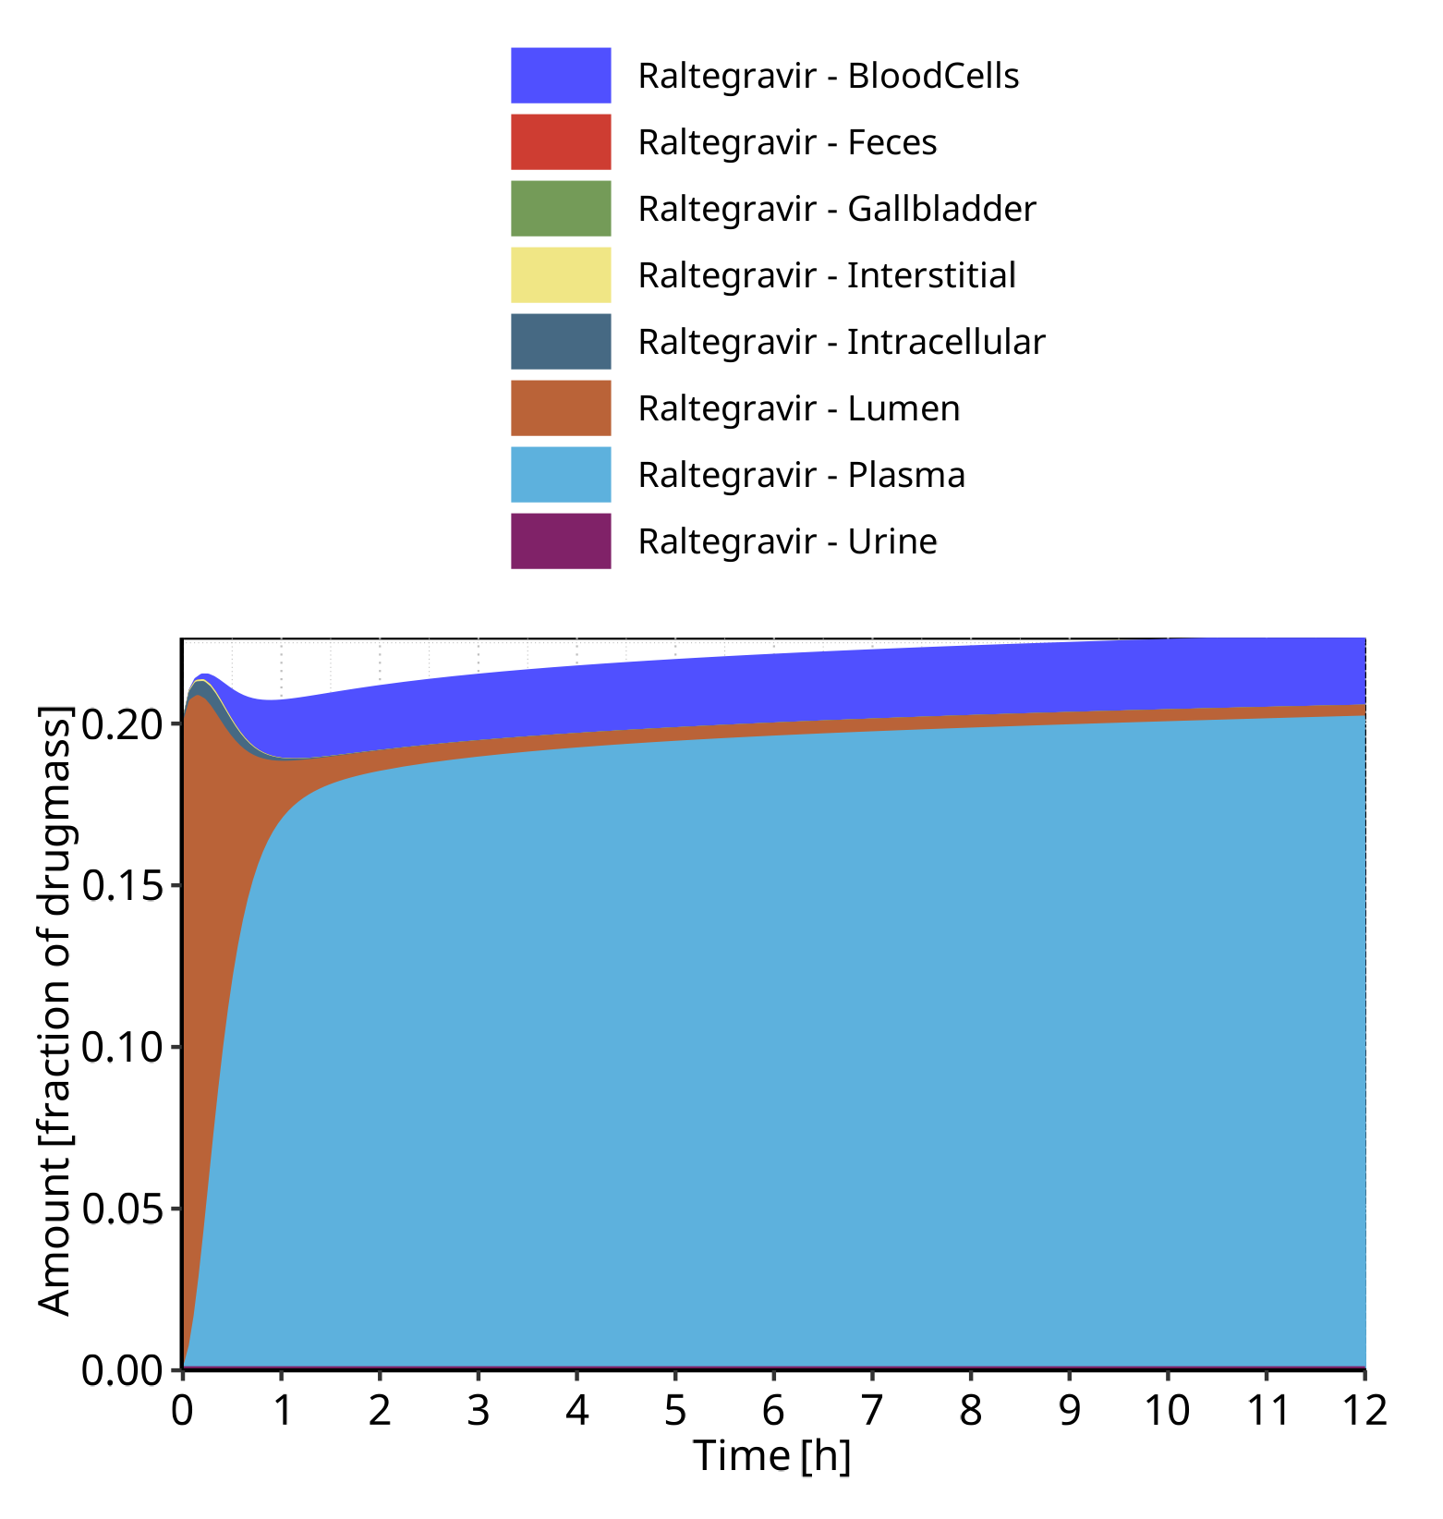

**Figure 4-9: Cumulated amount of drug vs time within the different compartments normalized to applicated drugmass for Raltegravir**

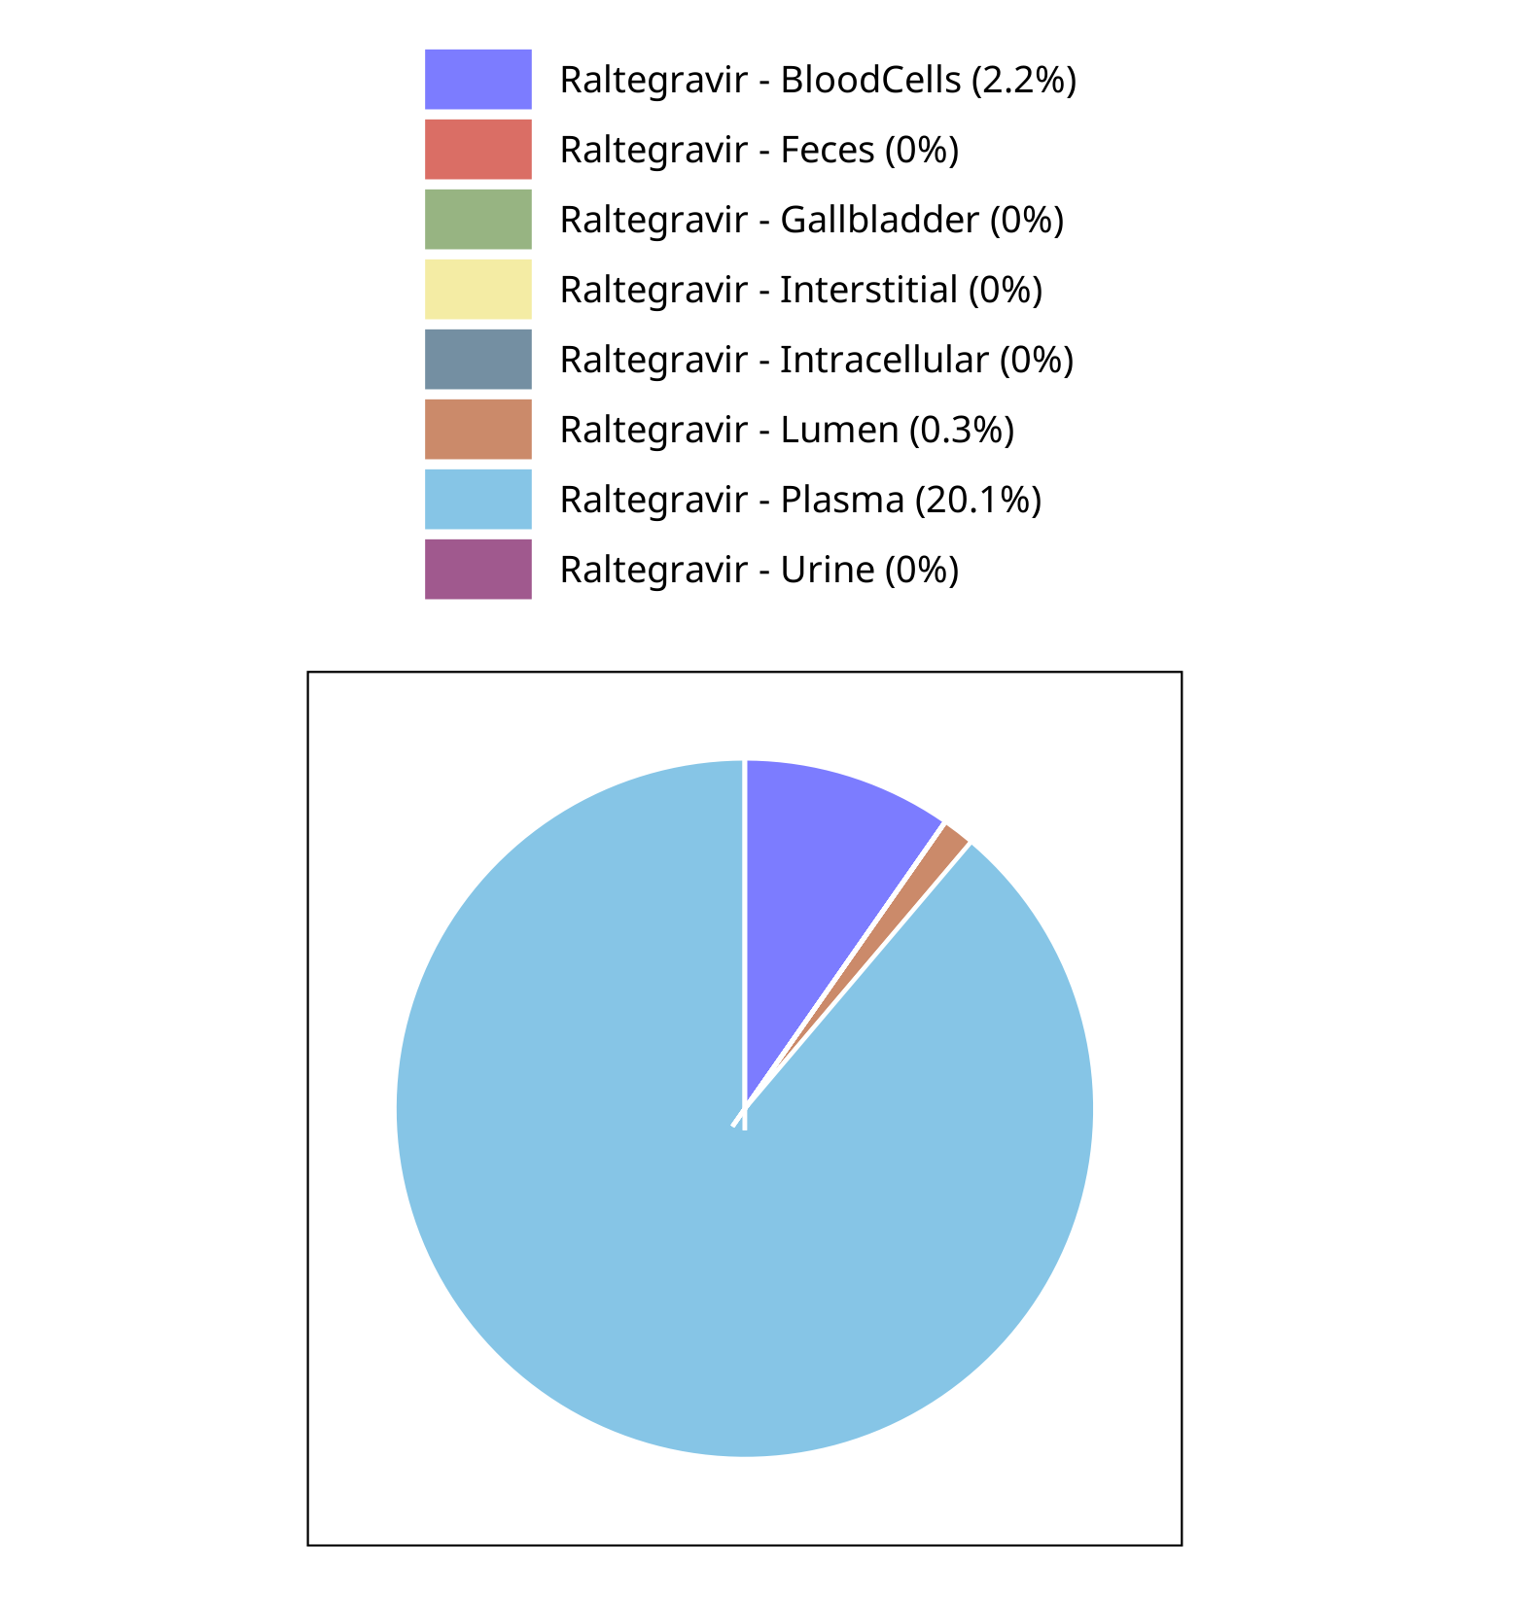

**Figure 4-10: Fraction of drug within the different compartments at 12.00h for Raltegravir**

## Mass Balance for Raltegravir 50 mg (lactose formulation)

### Mass Balance for Raltegravir

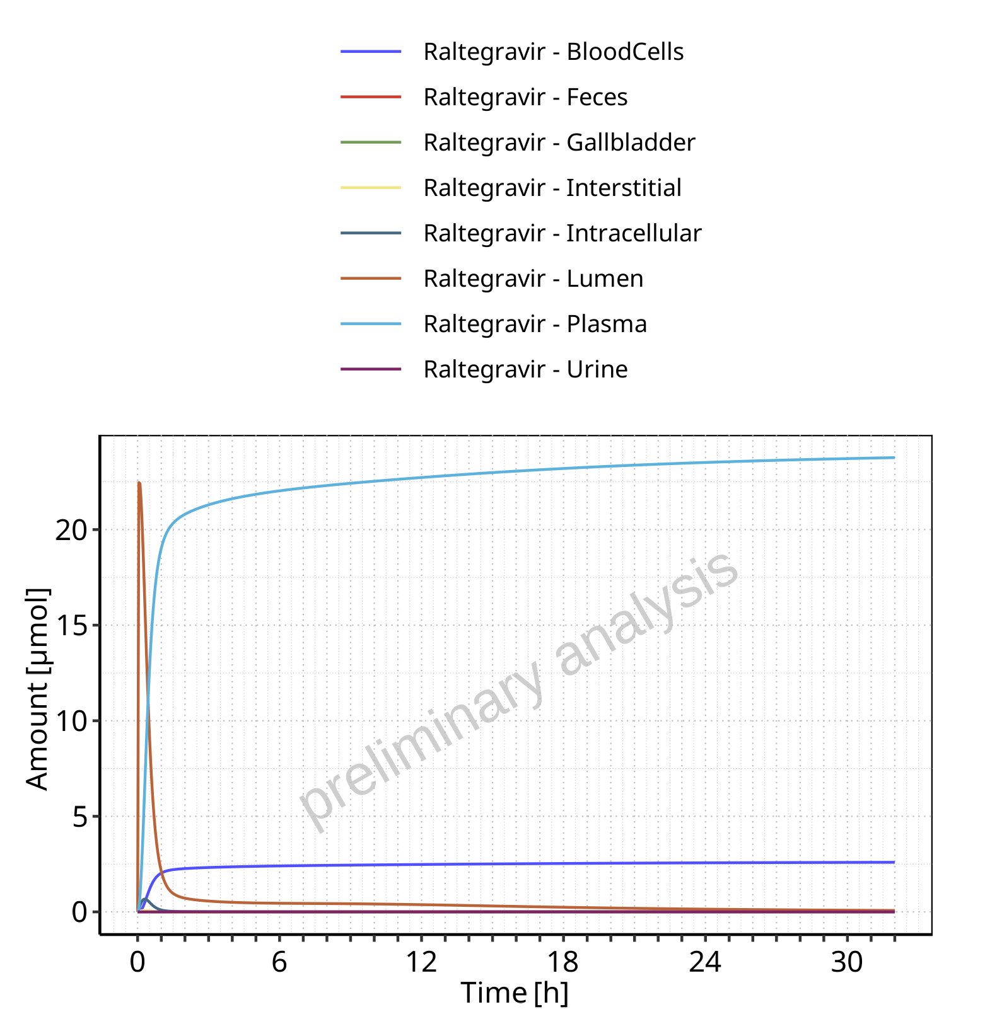

**Figure 4-11: Amount of drug vs time within the different compartments for Raltegravir**

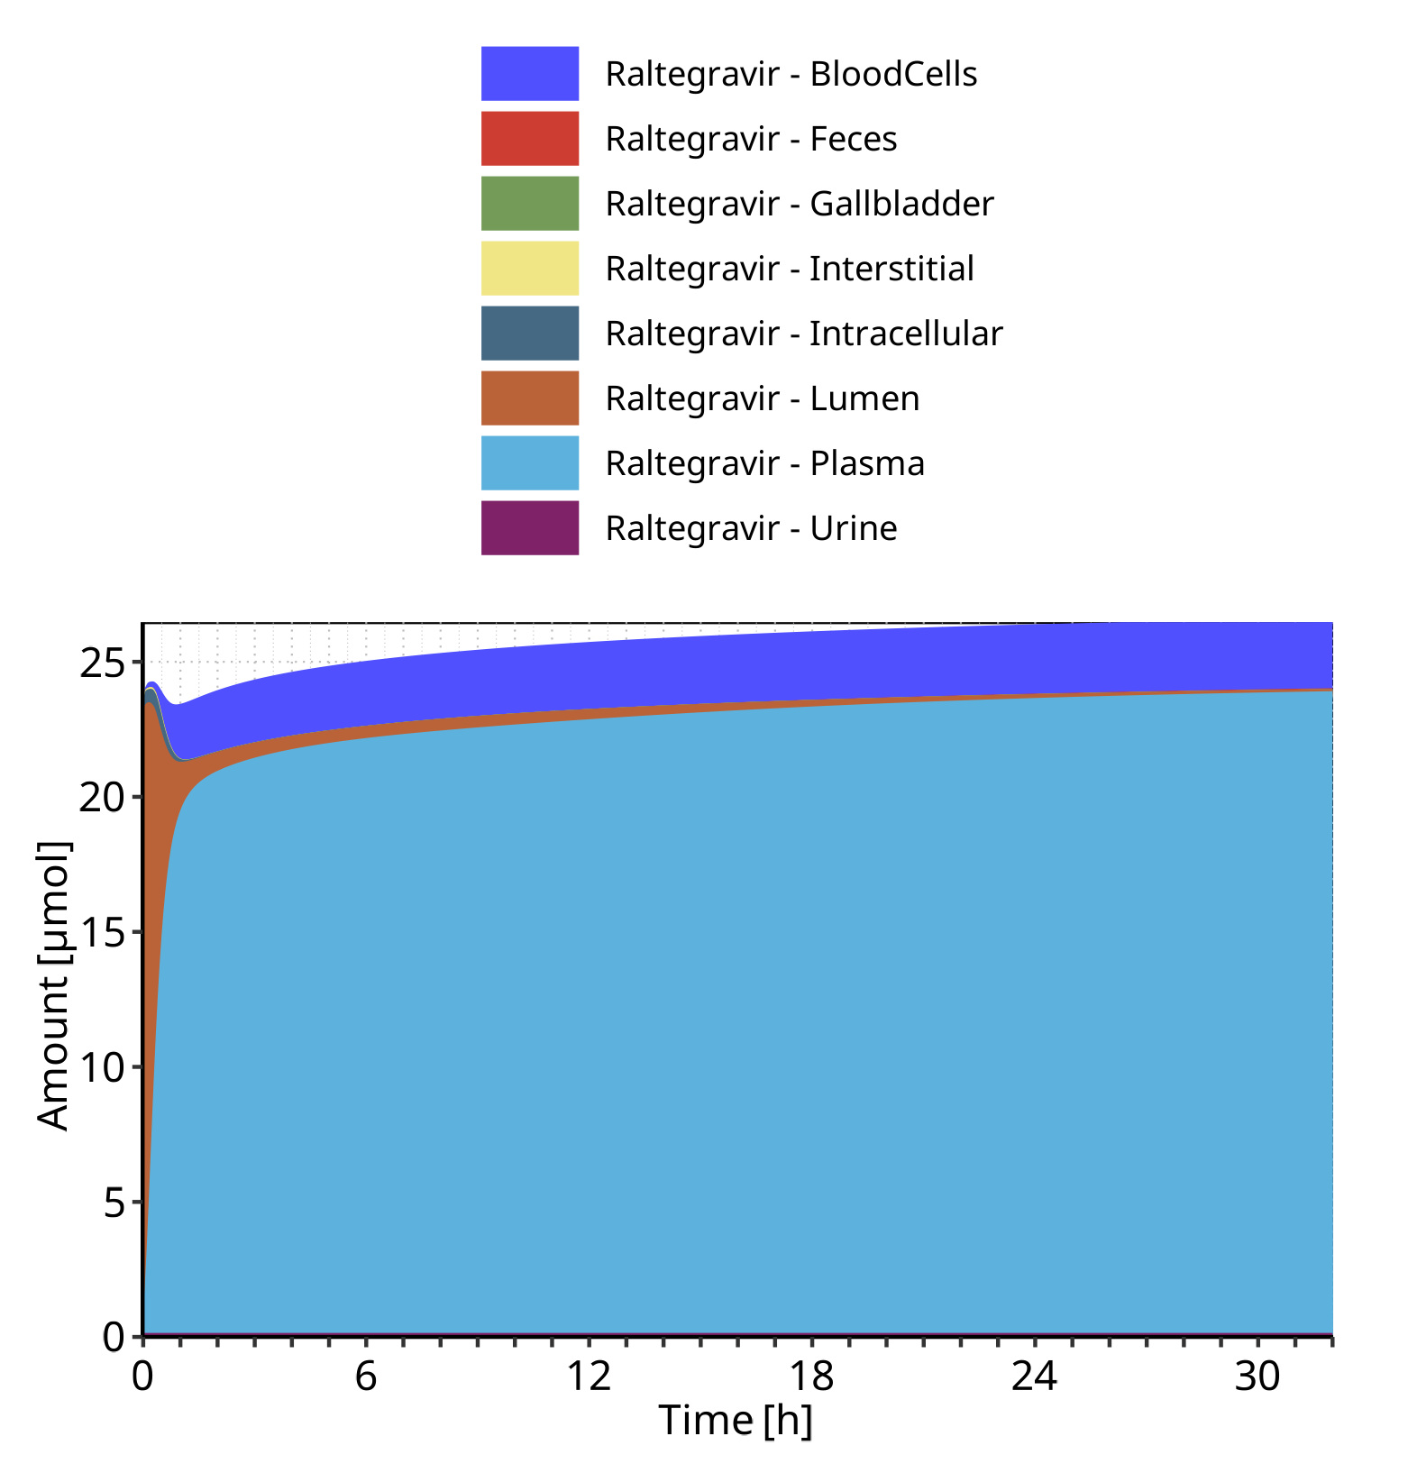

**Figure 4-12: Cumulated amount of drug vs time within the different compartments for Raltegravir**

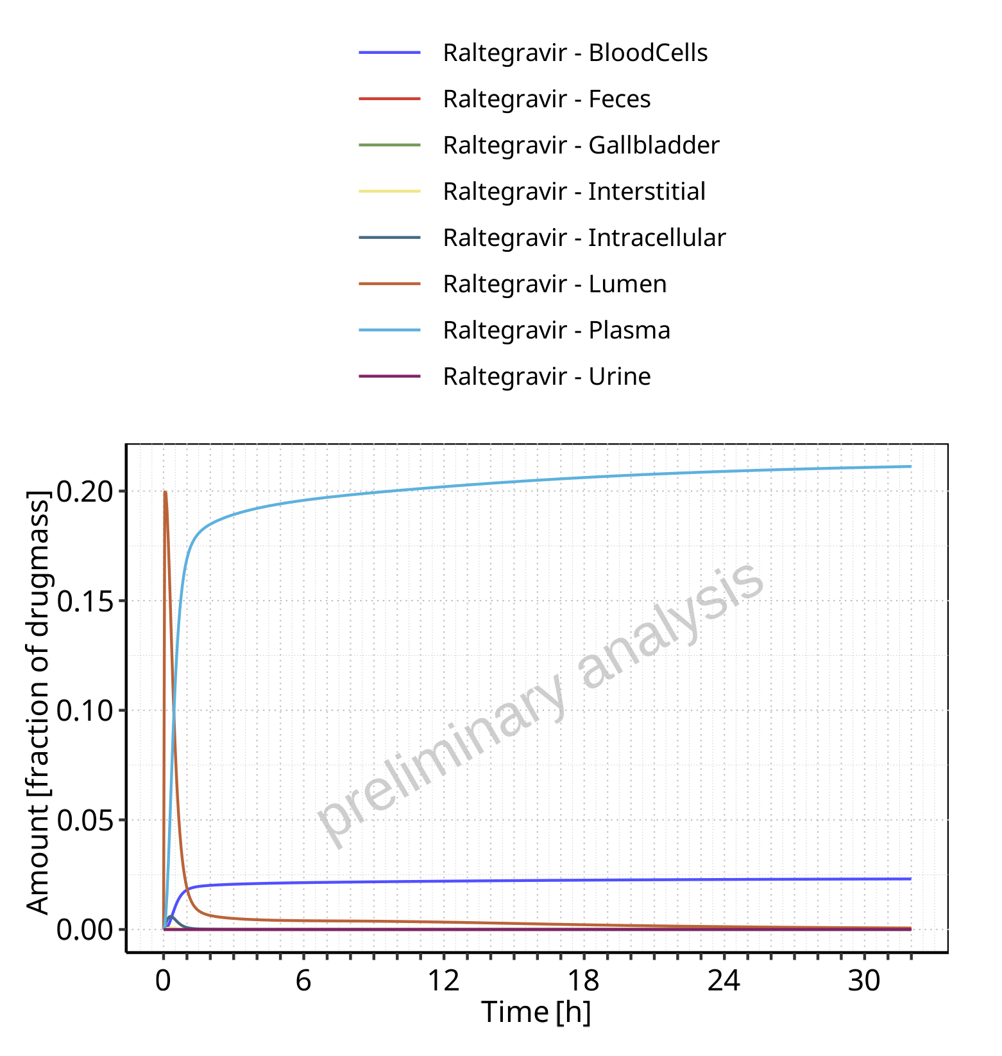

**Figure 4-13: Amount of drug vs time within the different compartments normalized to applicated drugmass for Raltegravir**

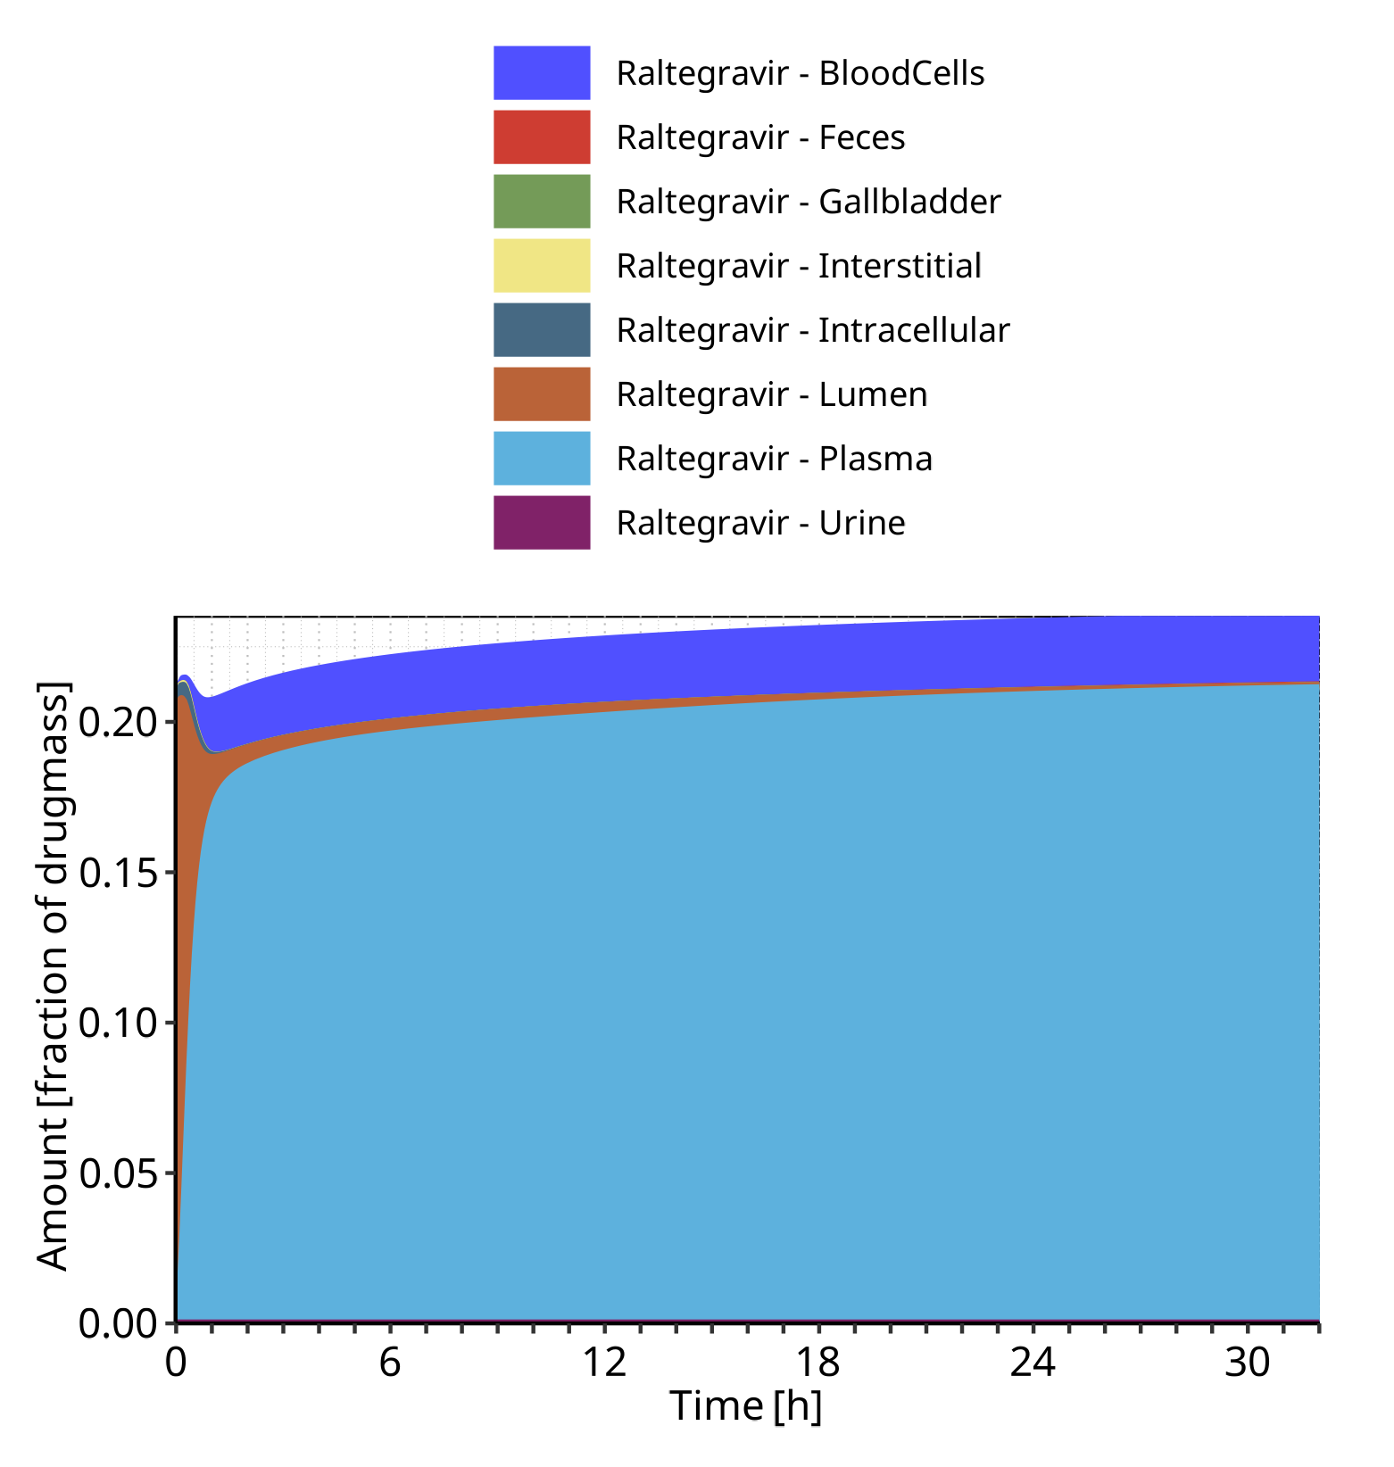

**Figure 4-14: Cumulated amount of drug vs time within the different compartments normalized to applicated drugmass for Raltegravir**

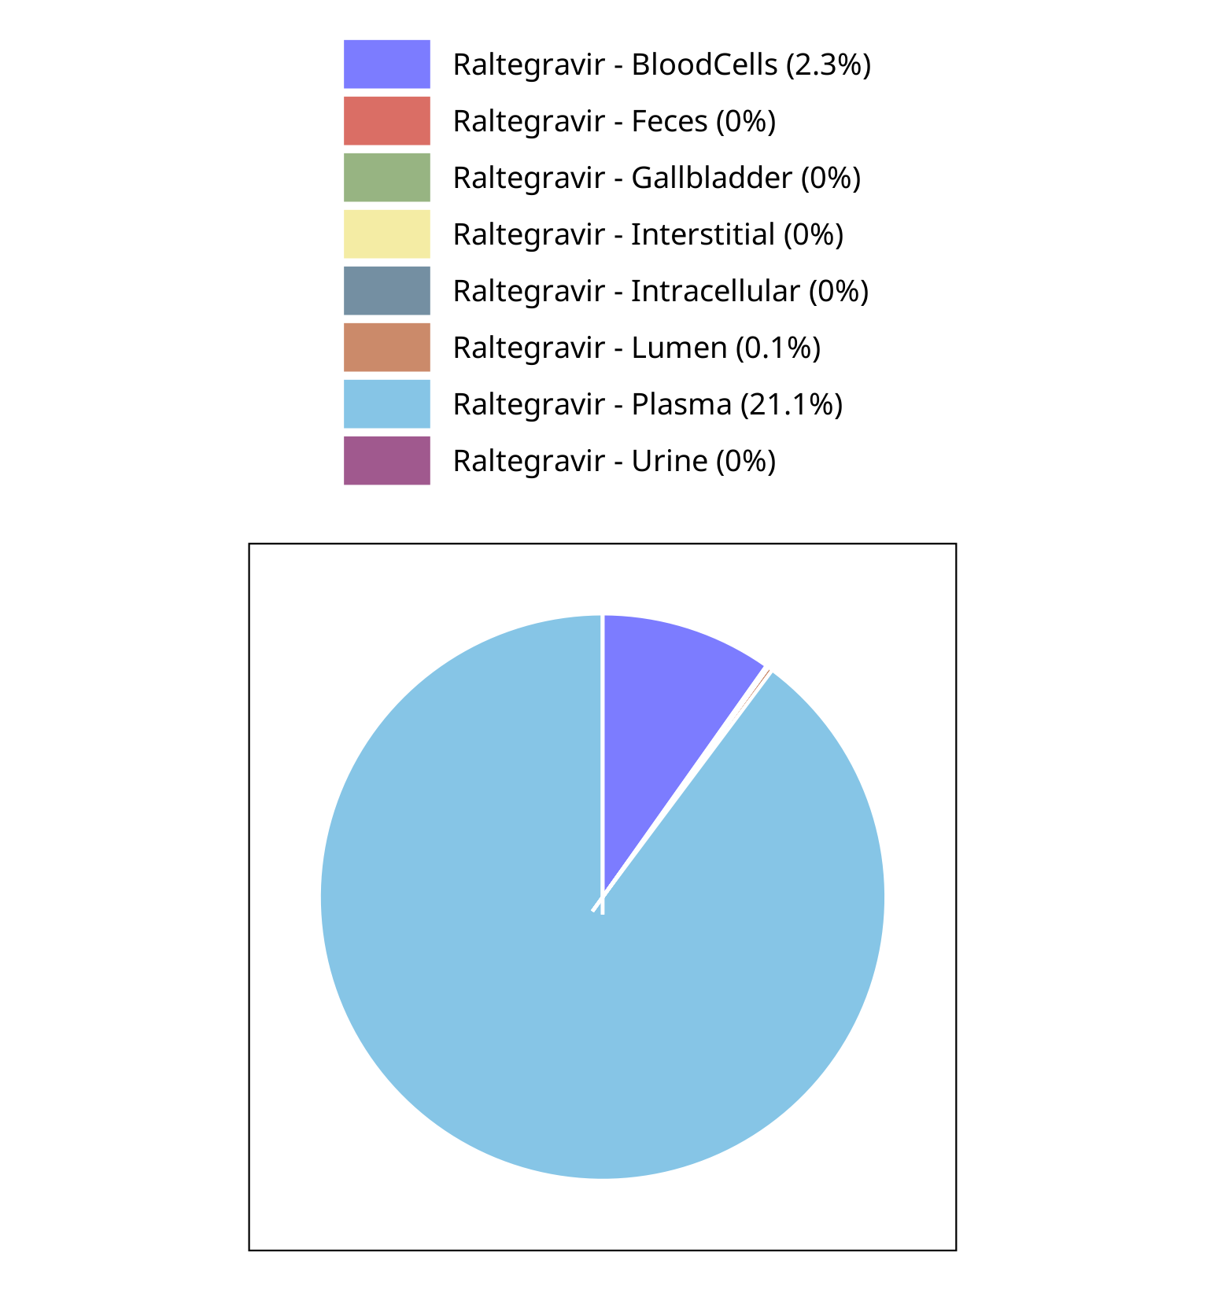

**Figure 4-15: Fraction of drug within the different compartments at 32.00h for Raltegravir**

## Mass Balance for Raltegravir 100 mg (lactose formulation)

### Mass Balance for Raltegravir

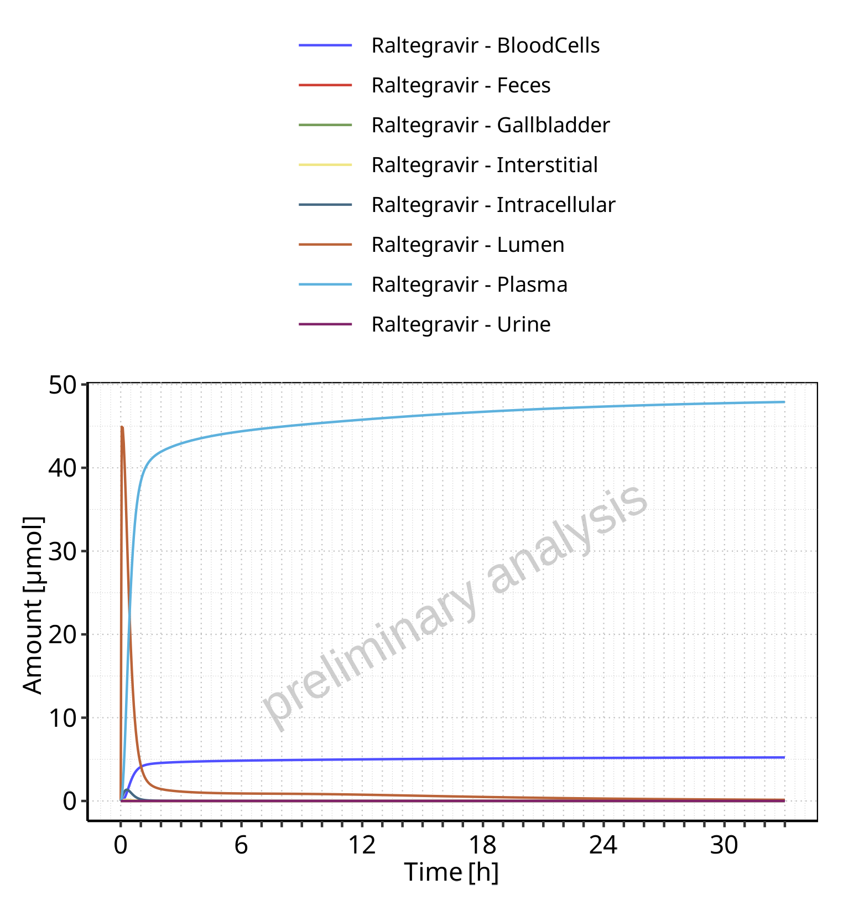

**Figure 4-16: Amount of drug vs time within the different compartments for Raltegravir**

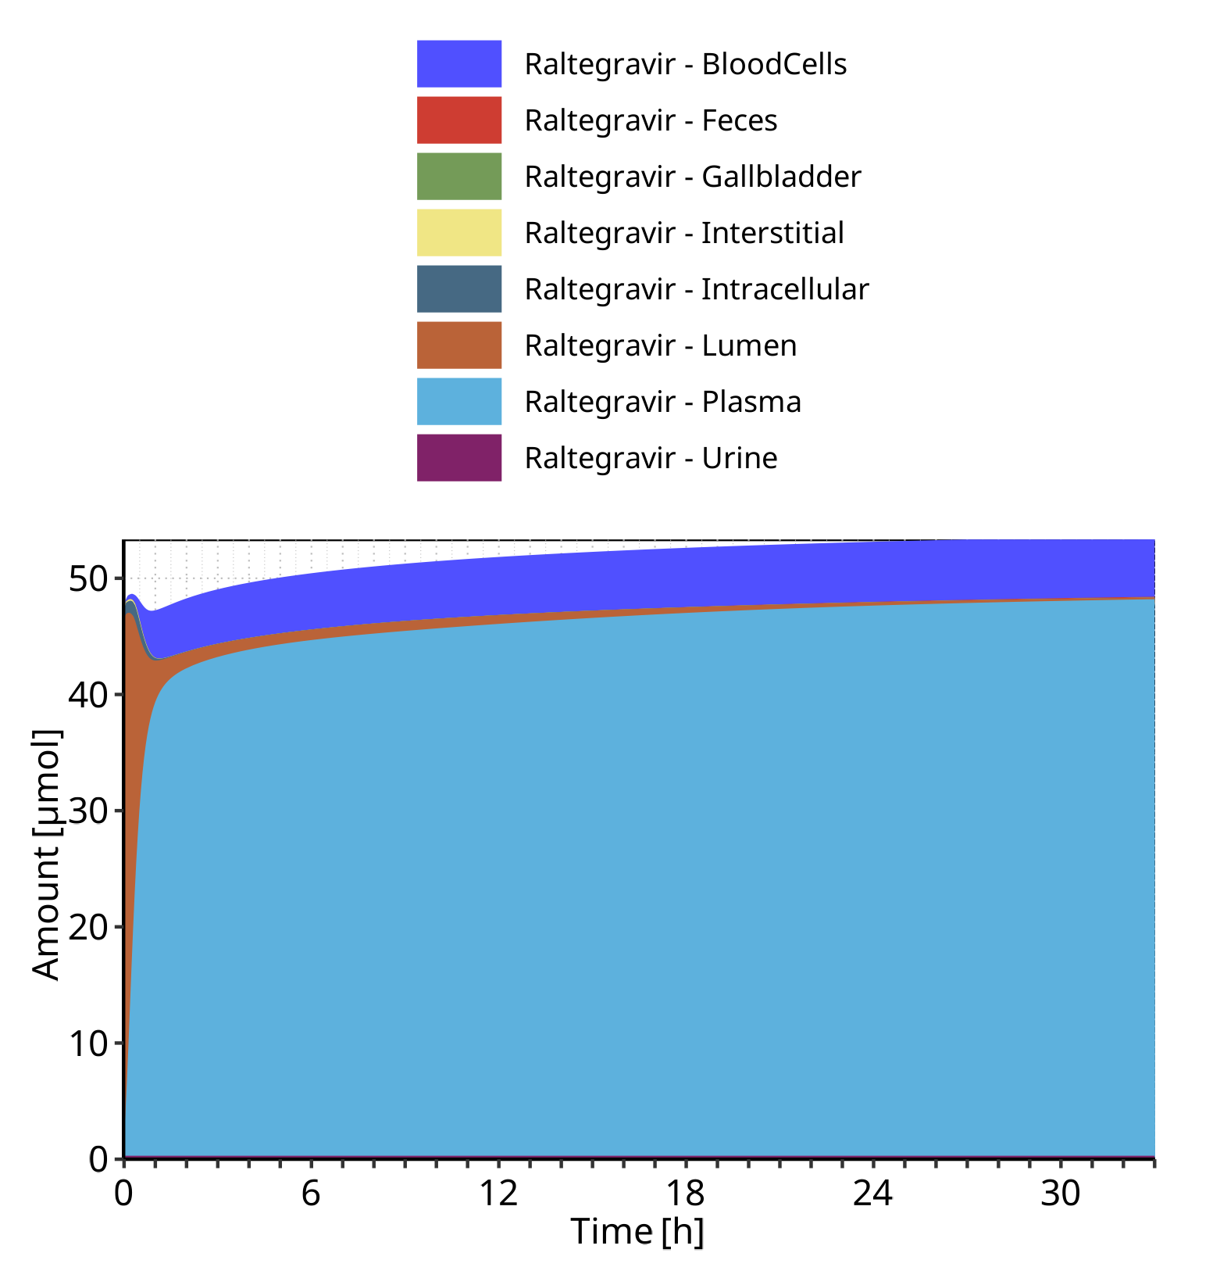

**Figure 4-17: Cumulated amount of drug vs time within the different compartments for Raltegravir**

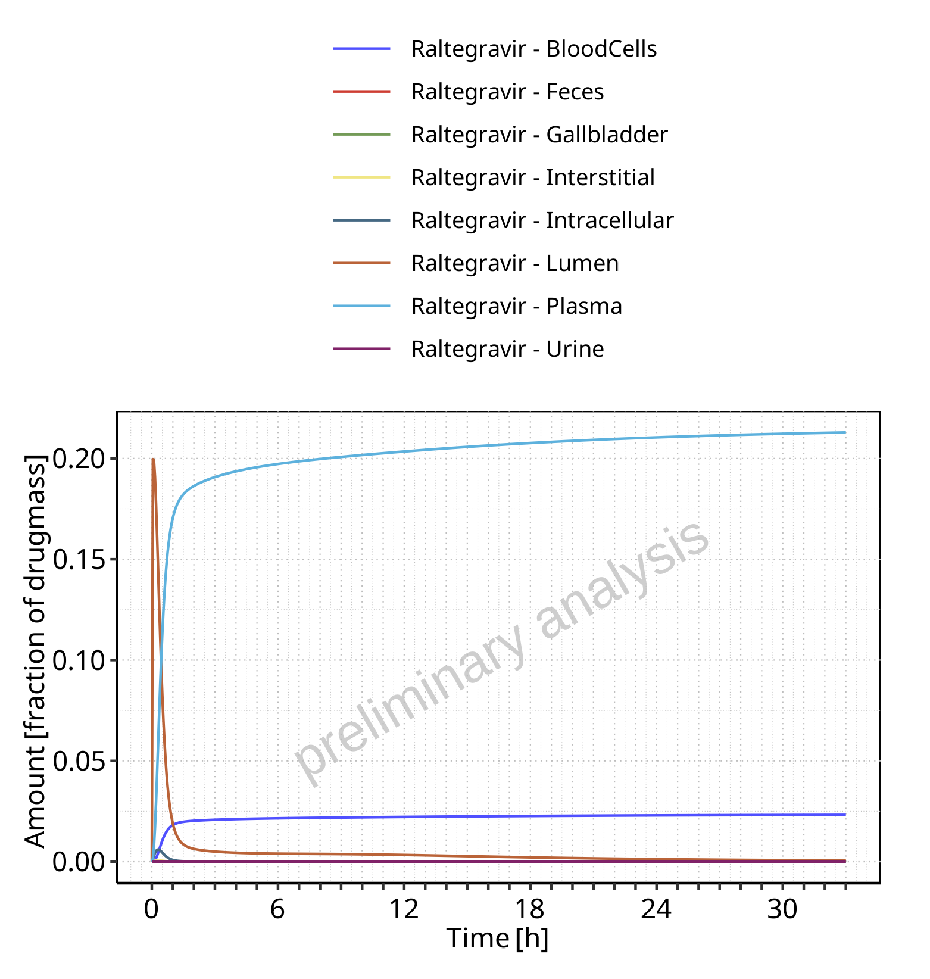

**Figure 4-18: Amount of drug vs time within the different compartments normalized to applicated drugmass for Raltegravir**

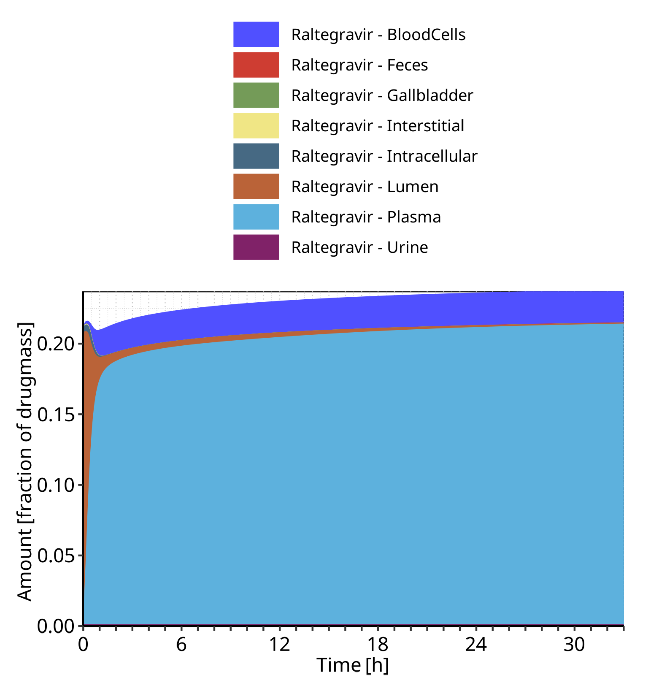

**Figure 4-19: Cumulated amount of drug vs time within the different compartments normalized to applicated drugmass for Raltegravir**

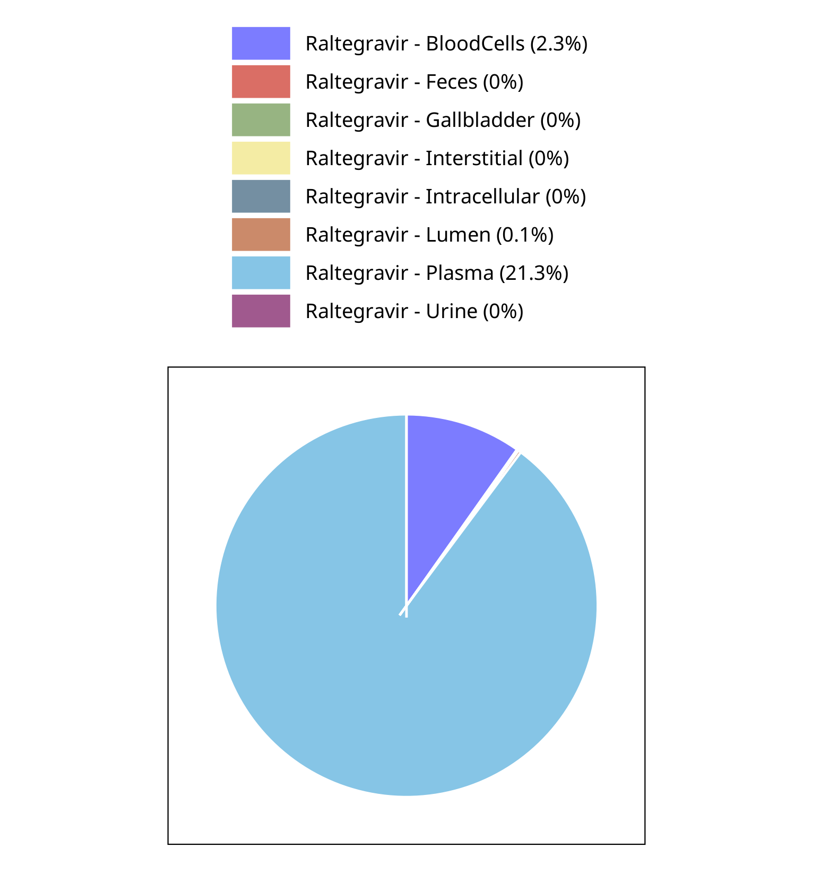

**Figure 4-20: Fraction of drug within the different compartments at 33.00h for Raltegravir**

## Mass Balance for Raltegravir 200 mg (lactose formulation)

### Mass Balance for Raltegravir

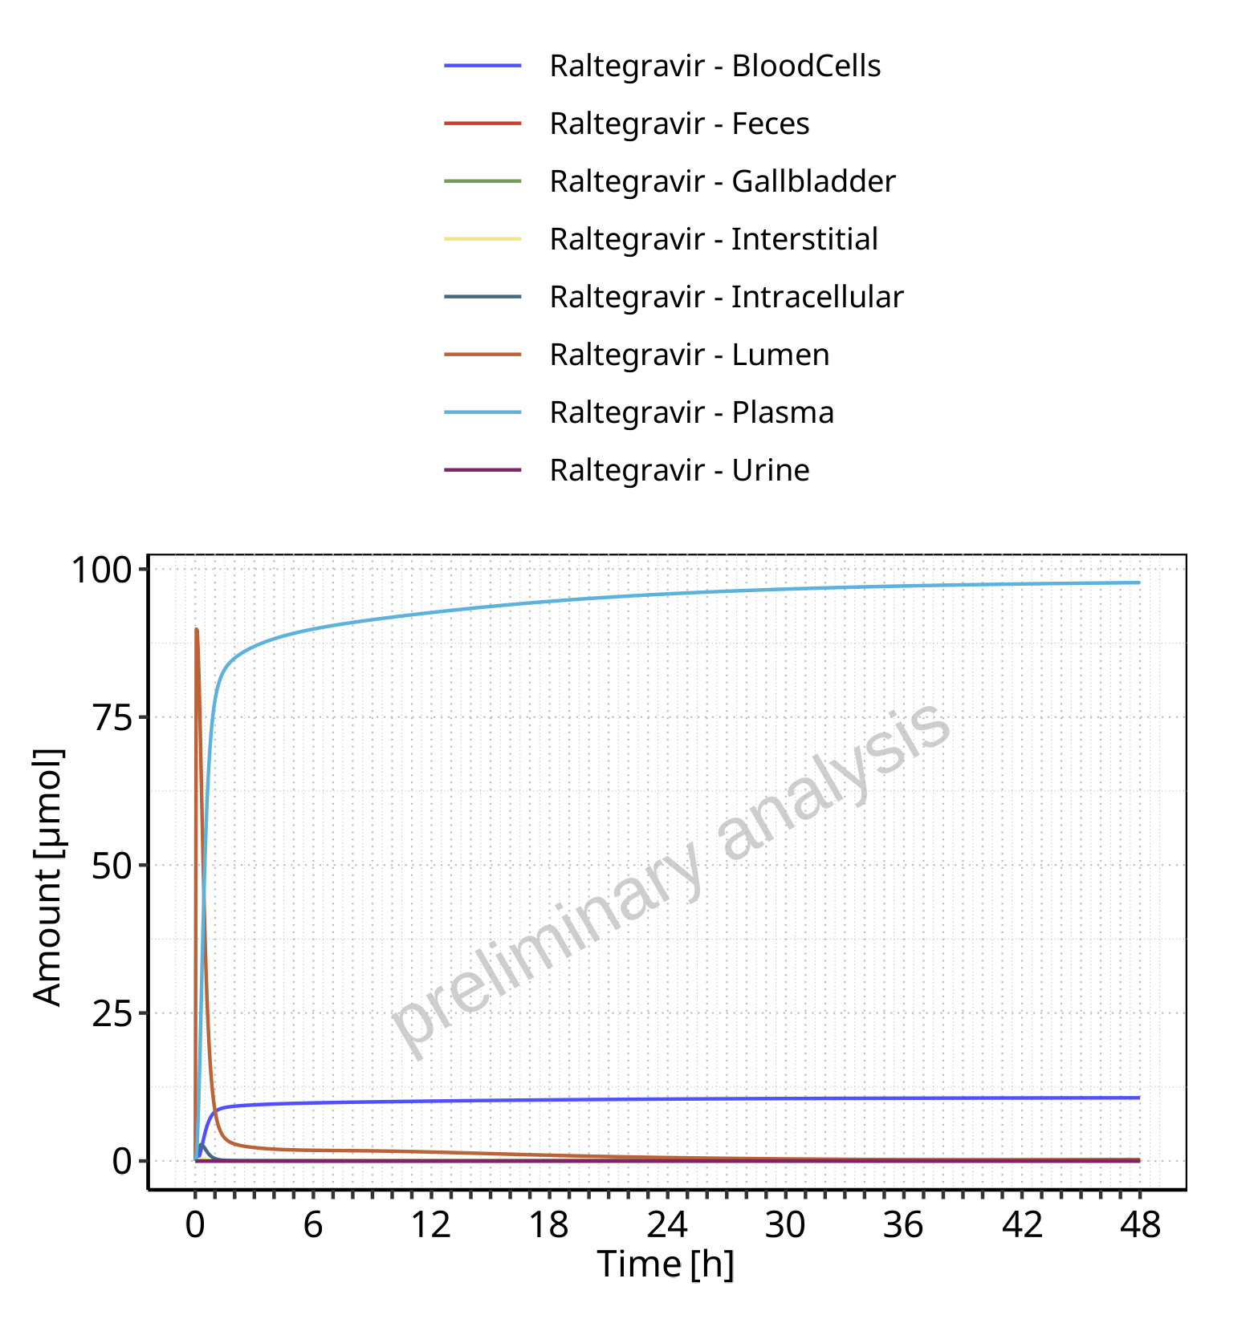

**Figure 4-21: Amount of drug vs time within the different compartments for Raltegravir**

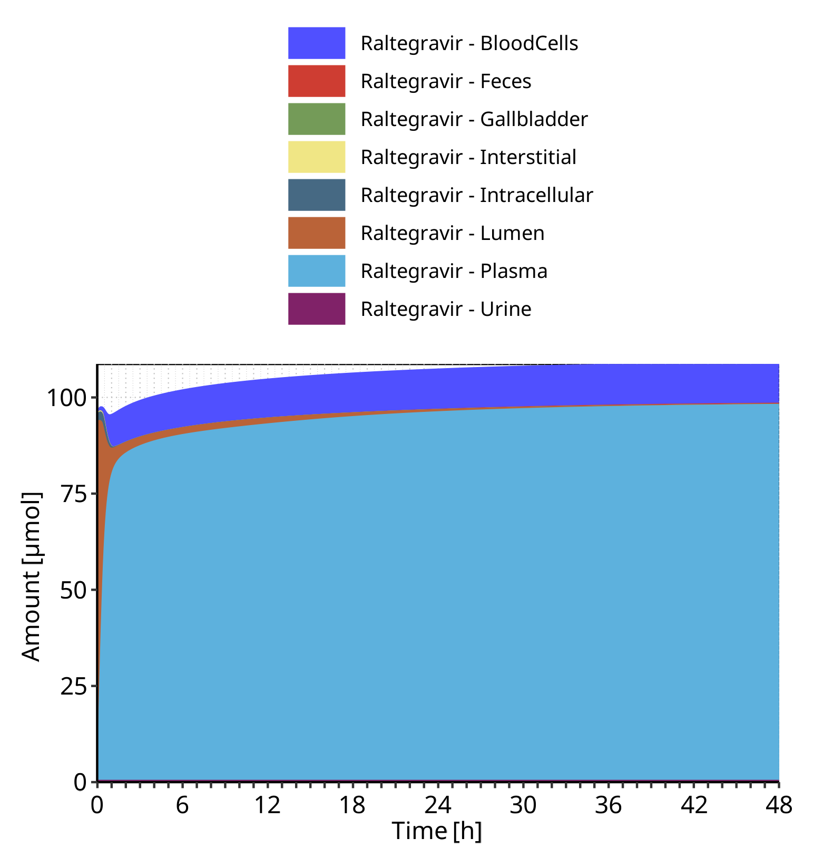

**Figure 4-22: Cumulated amount of drug vs time within the different compartments for Raltegravir**

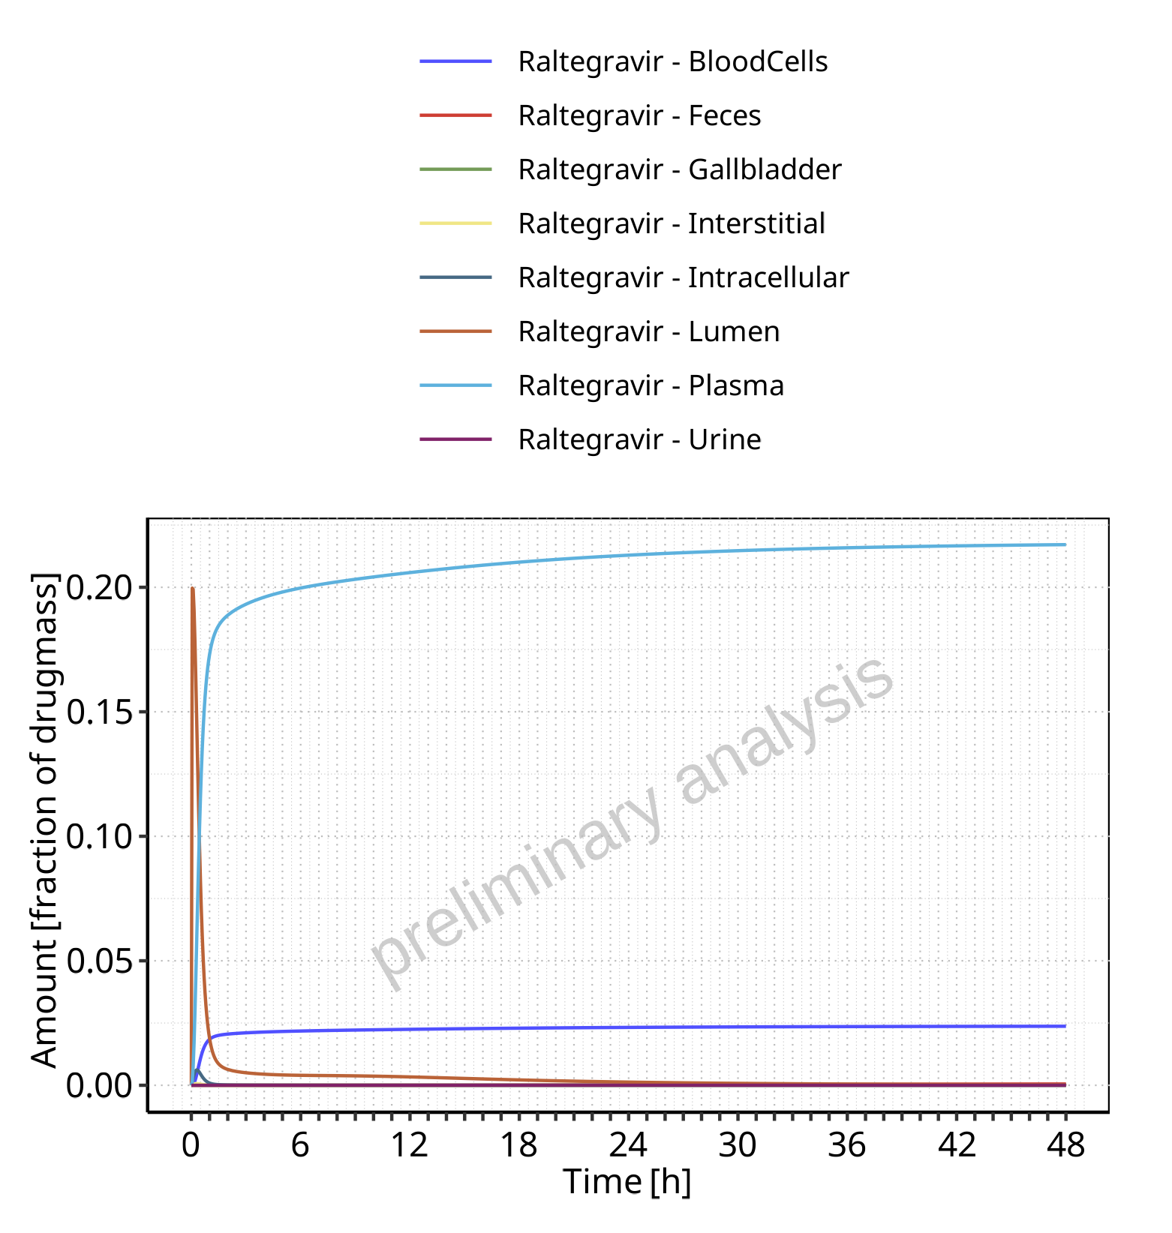

**Figure 4-23: Amount of drug vs time within the different compartments normalized to applicated drugmass for Raltegravir**

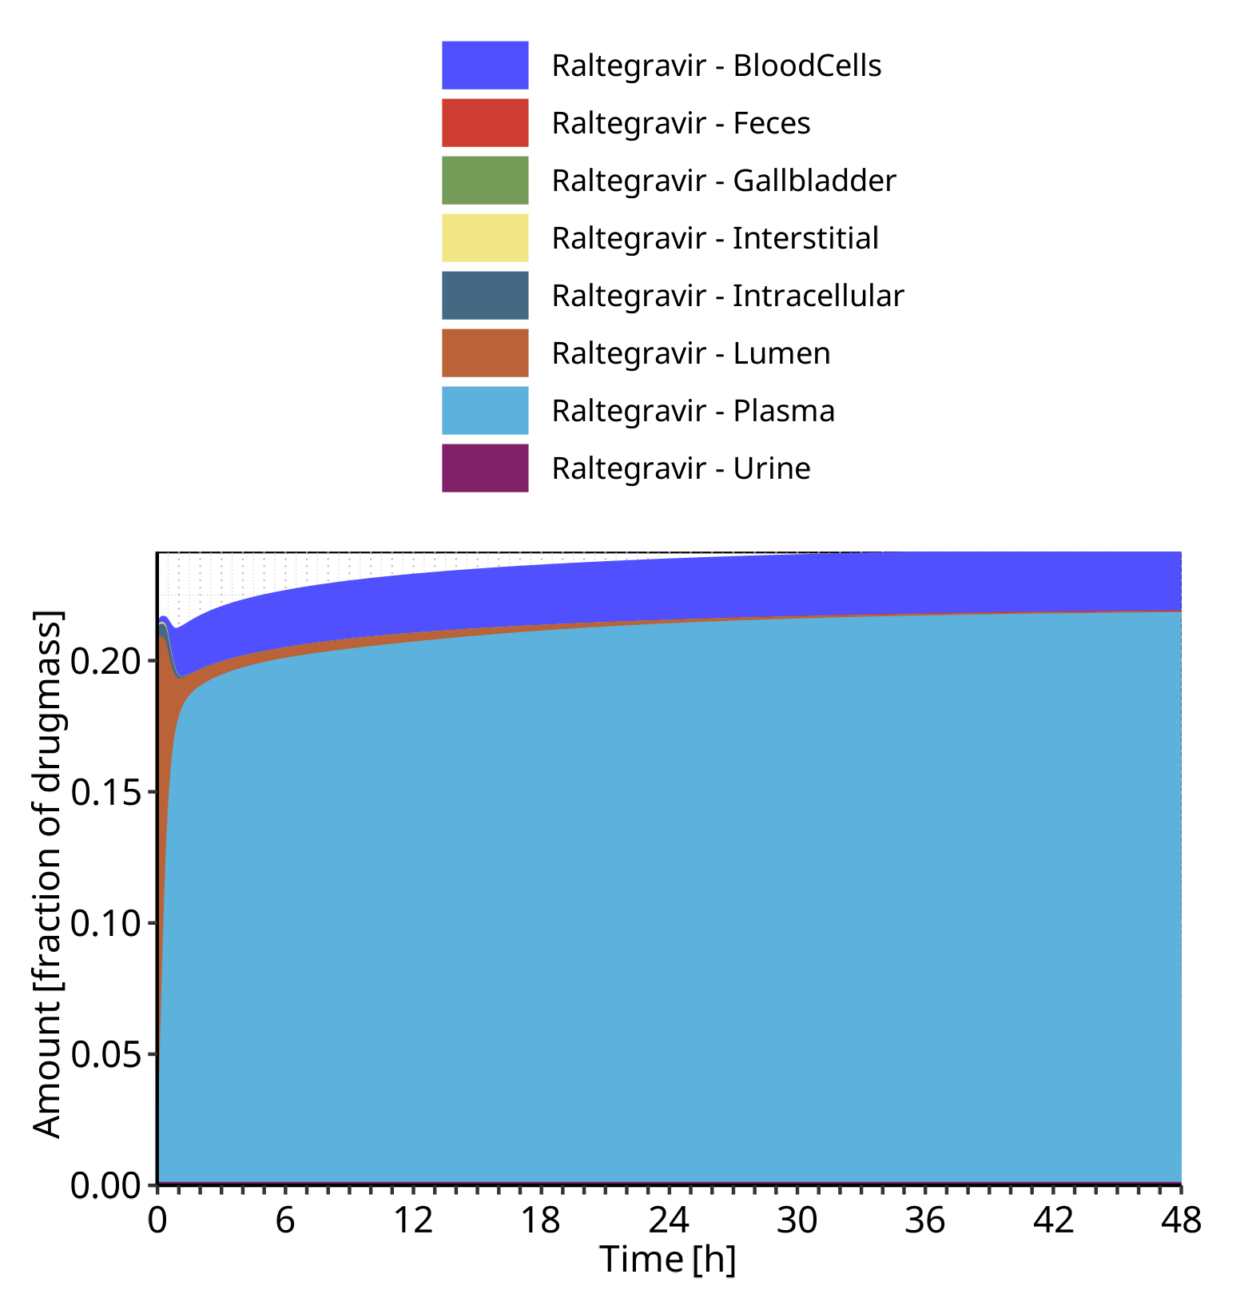

**Figure 4-24: Cumulated amount of drug vs time within the different compartments normalized to applicated drugmass for Raltegravir**

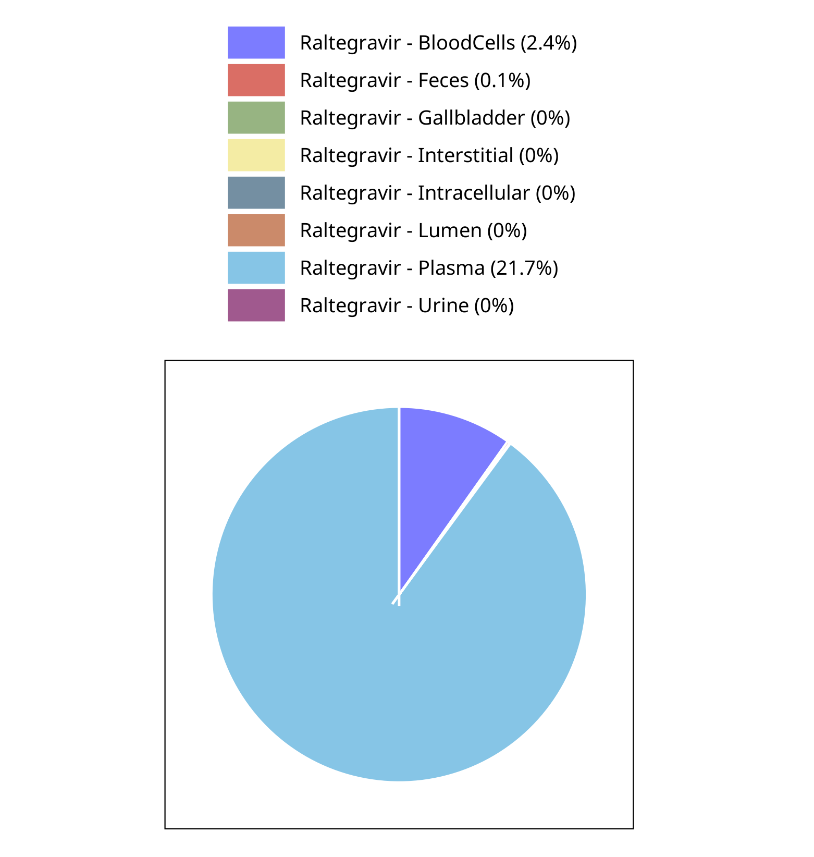

**Figure 4-25: Fraction of drug within the different compartments at 48.00h for Raltegravir**

## Mass Balance for Raltegravir 400mg (lactose formulation)

### Mass Balance for Raltegravir

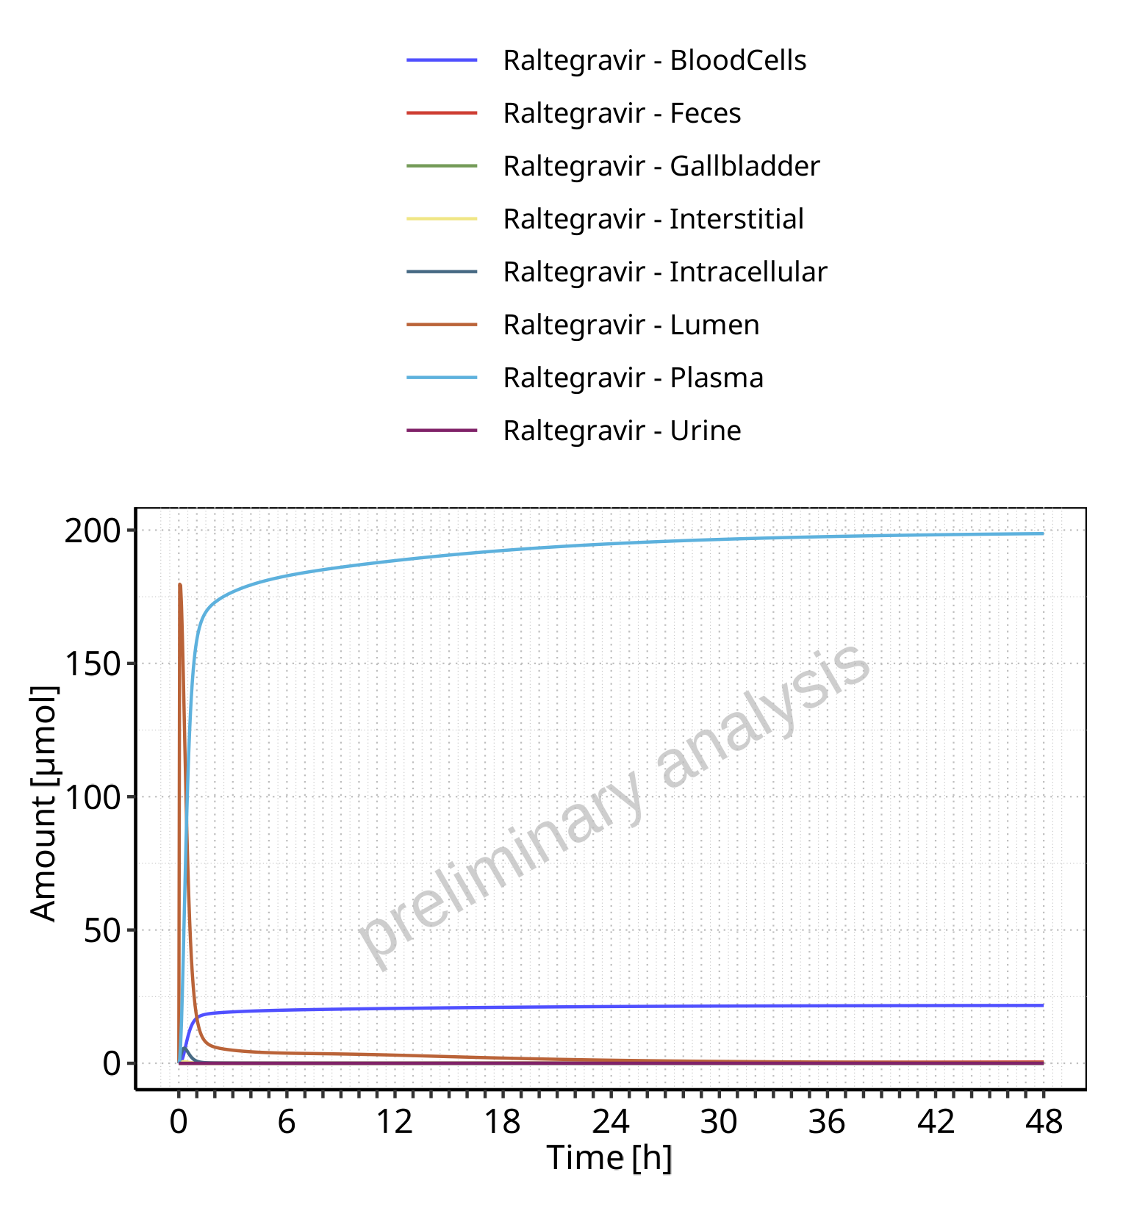

**Figure 4-26: Amount of drug vs time within the different compartments for Raltegravir**

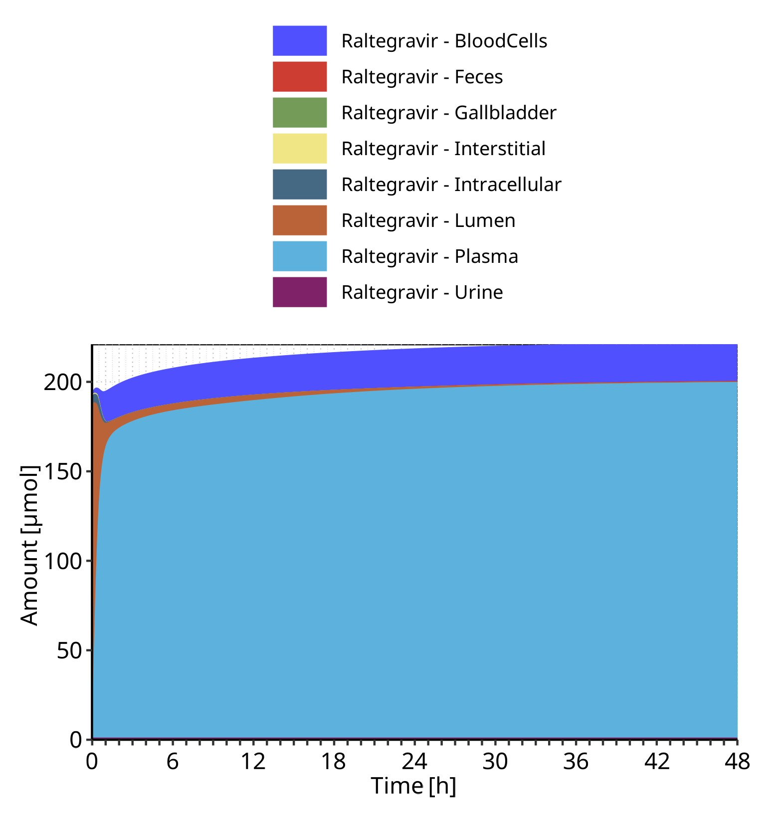

**Figure 4-27: Cumulated amount of drug vs time within the different compartments for Raltegravir**

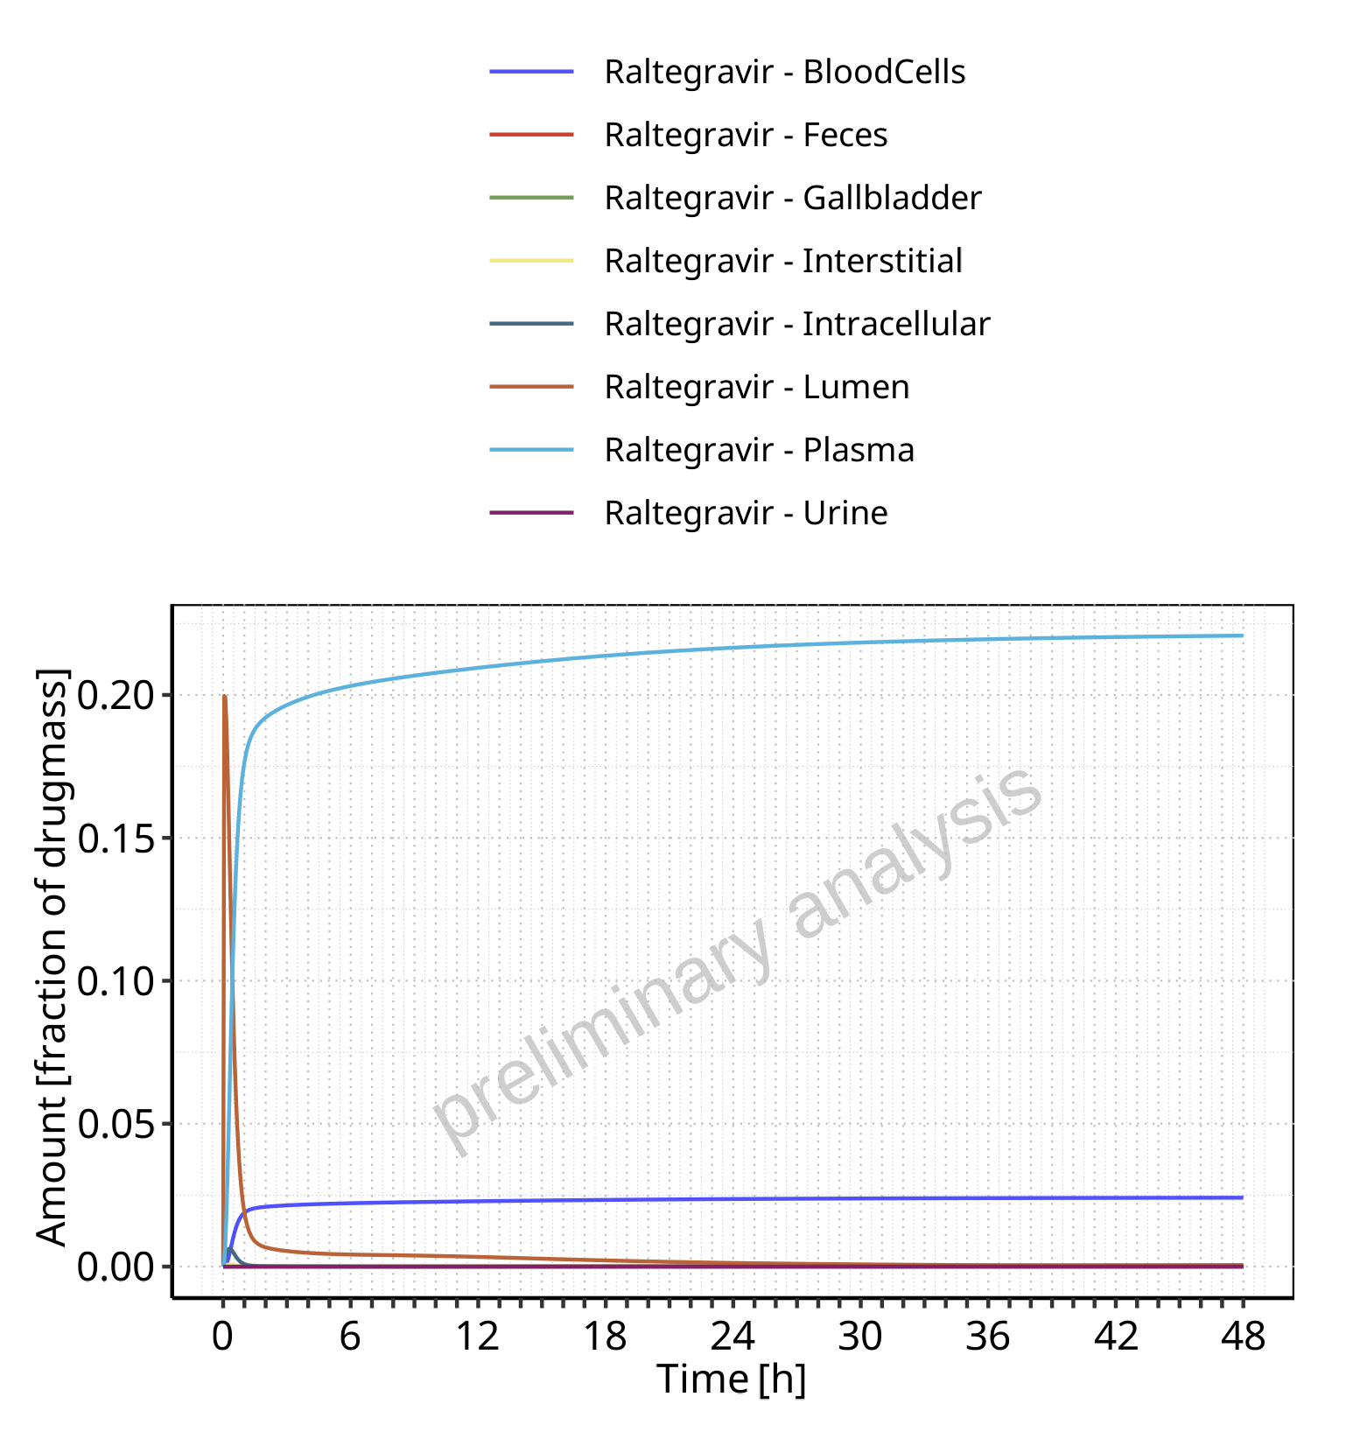

**Figure 4-28: Amount of drug vs time within the different compartments normalized to applicated drugmass for Raltegravir**

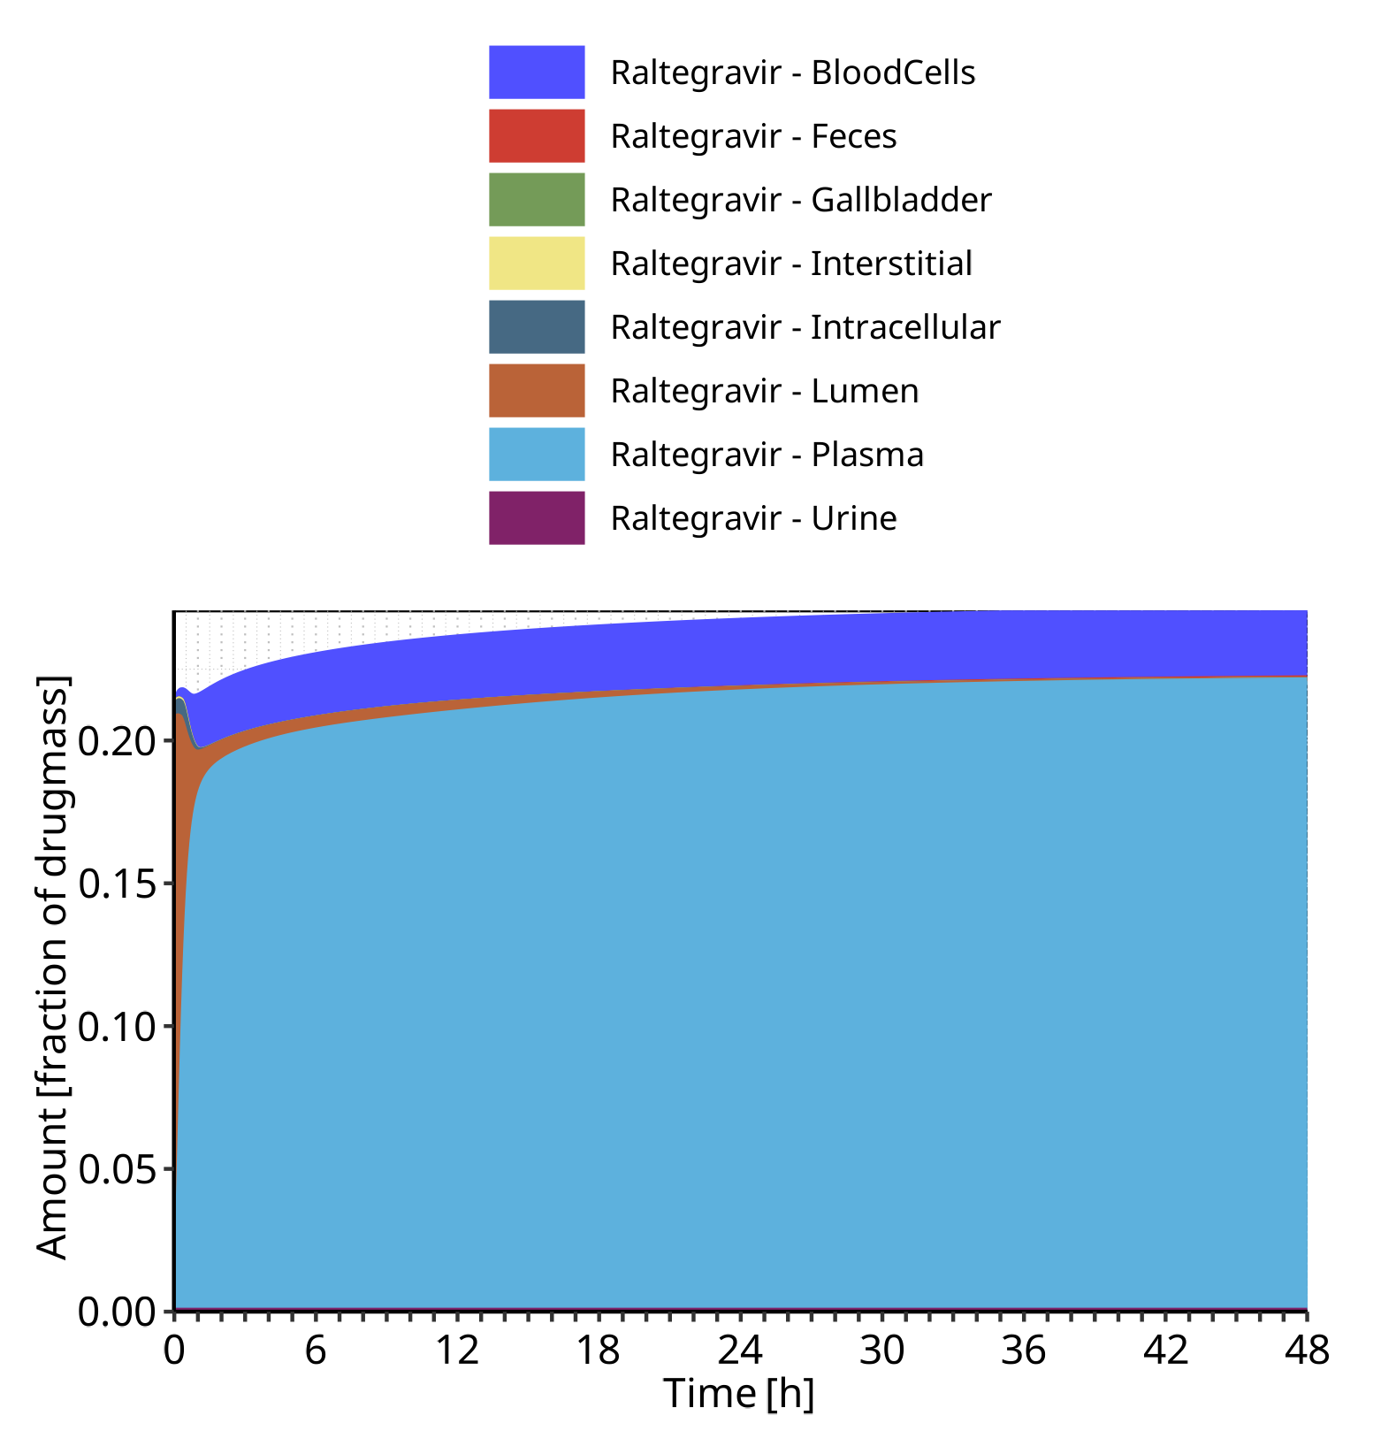

**Figure 4-29: Cumulated amount of drug vs time within the different compartments normalized to applicated drugmass for Raltegravir**

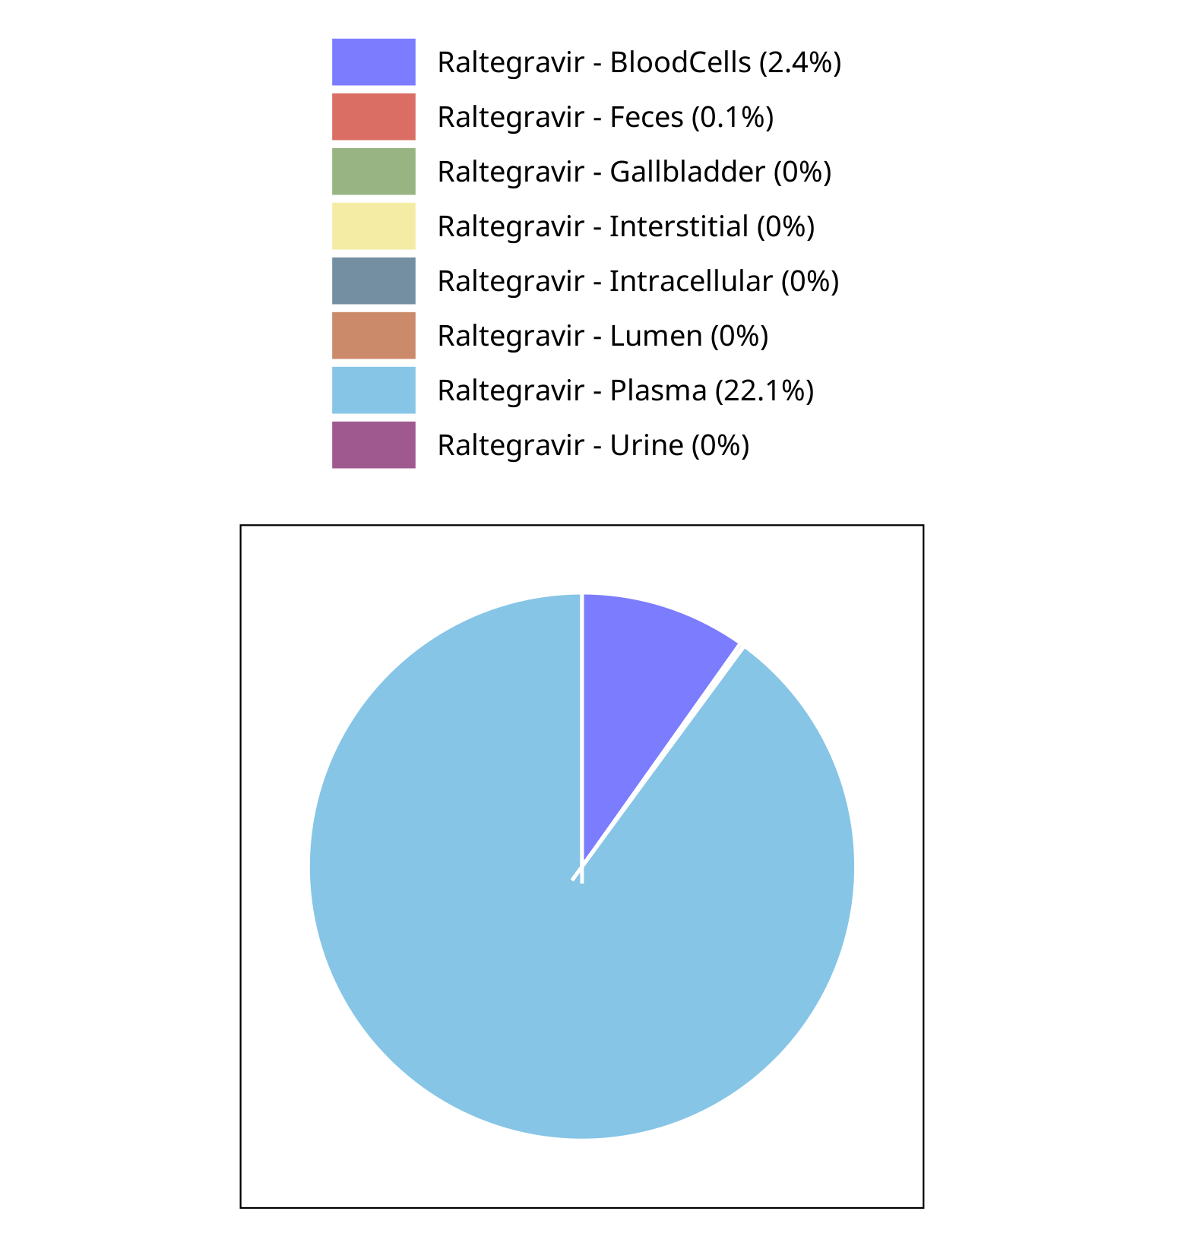

**Figure 4-30: Fraction of drug within the different compartments at 48.00h for Raltegravir**

## Mass Balance for Raltegravir 800 mg (lactose formulation)

### Mass Balance for Raltegravir

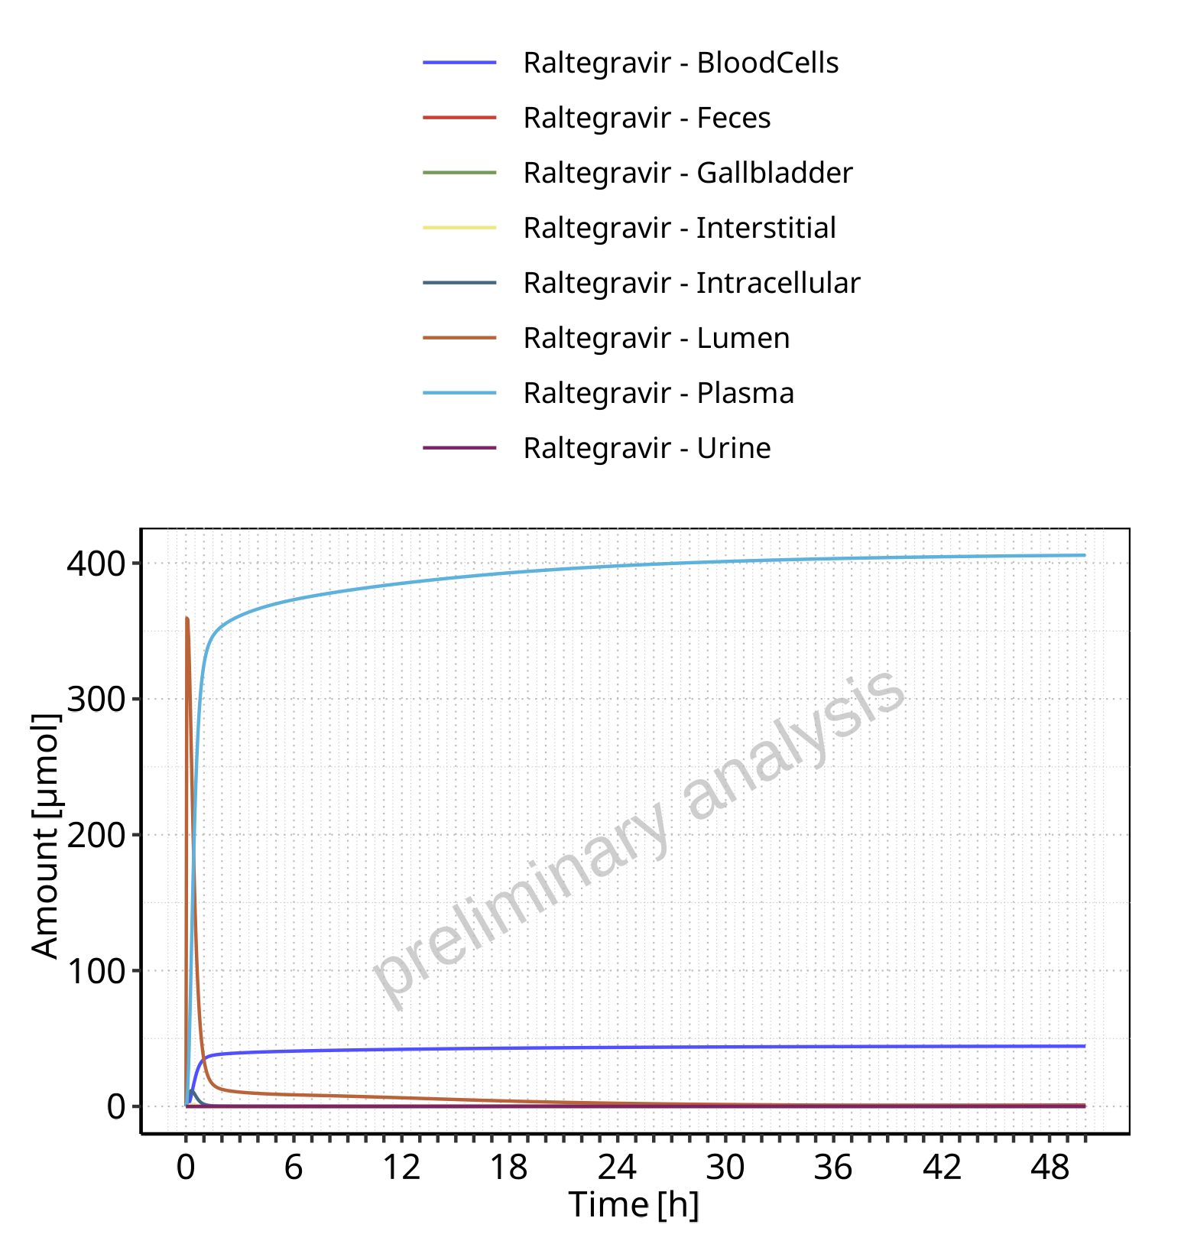

**Figure 4-31: Amount of drug vs time within the different compartments for Raltegravir**

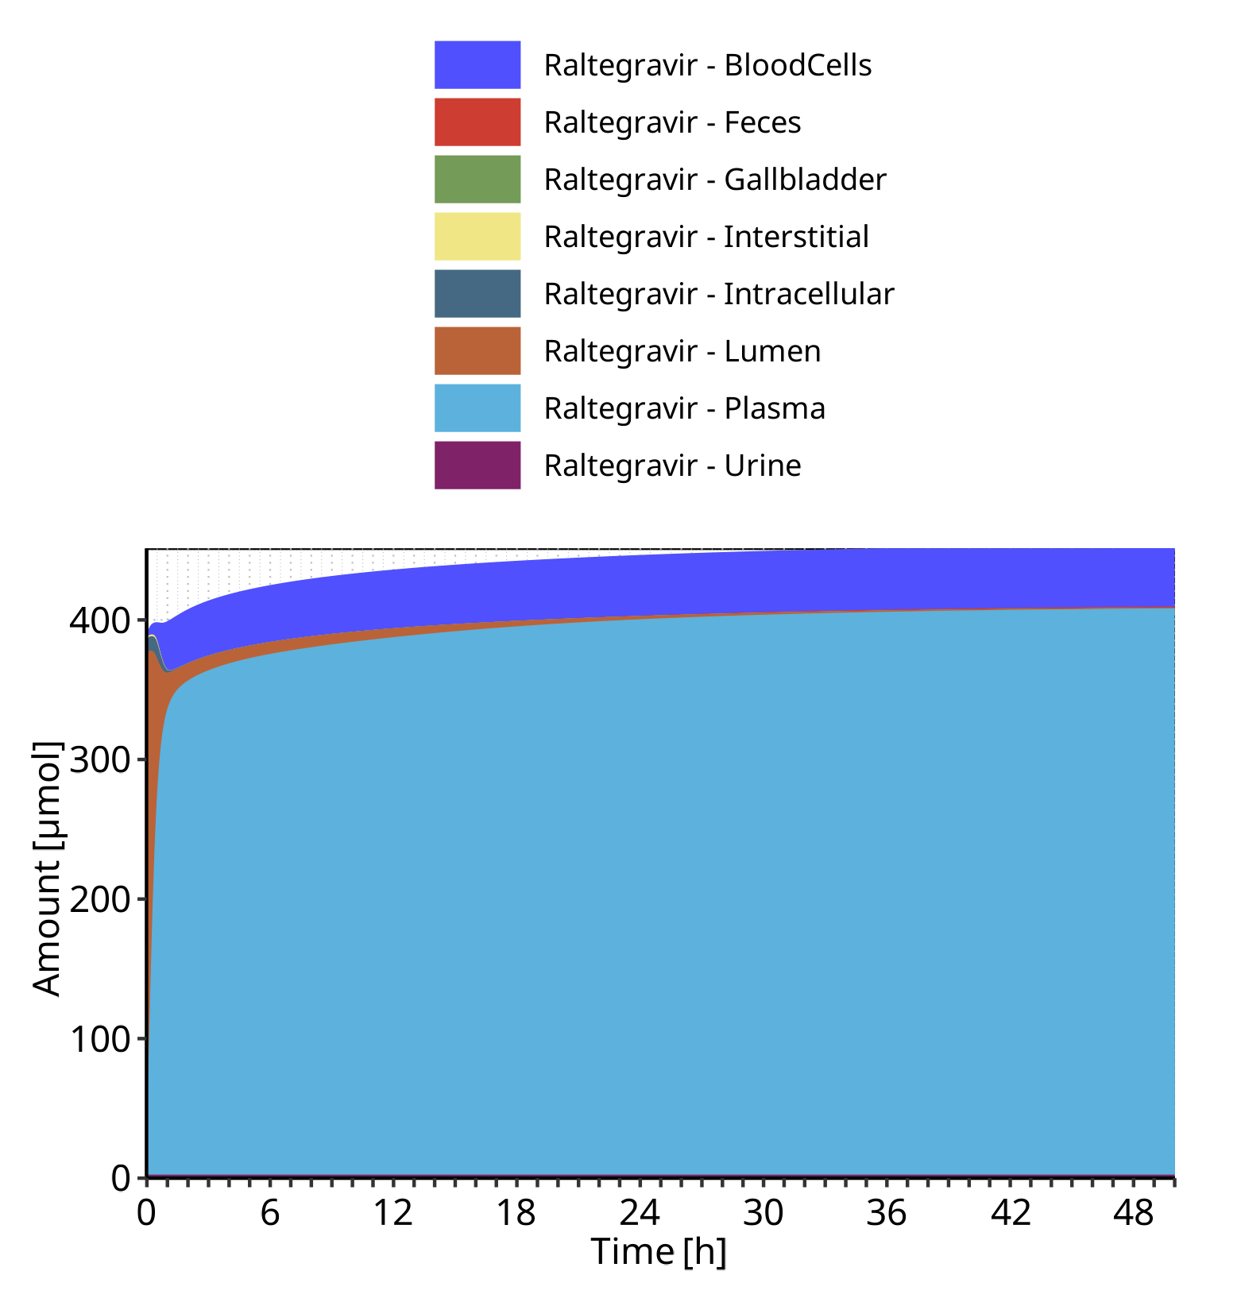

**Figure 4-32: Cumulated amount of drug vs time within the different compartments for Raltegravir**

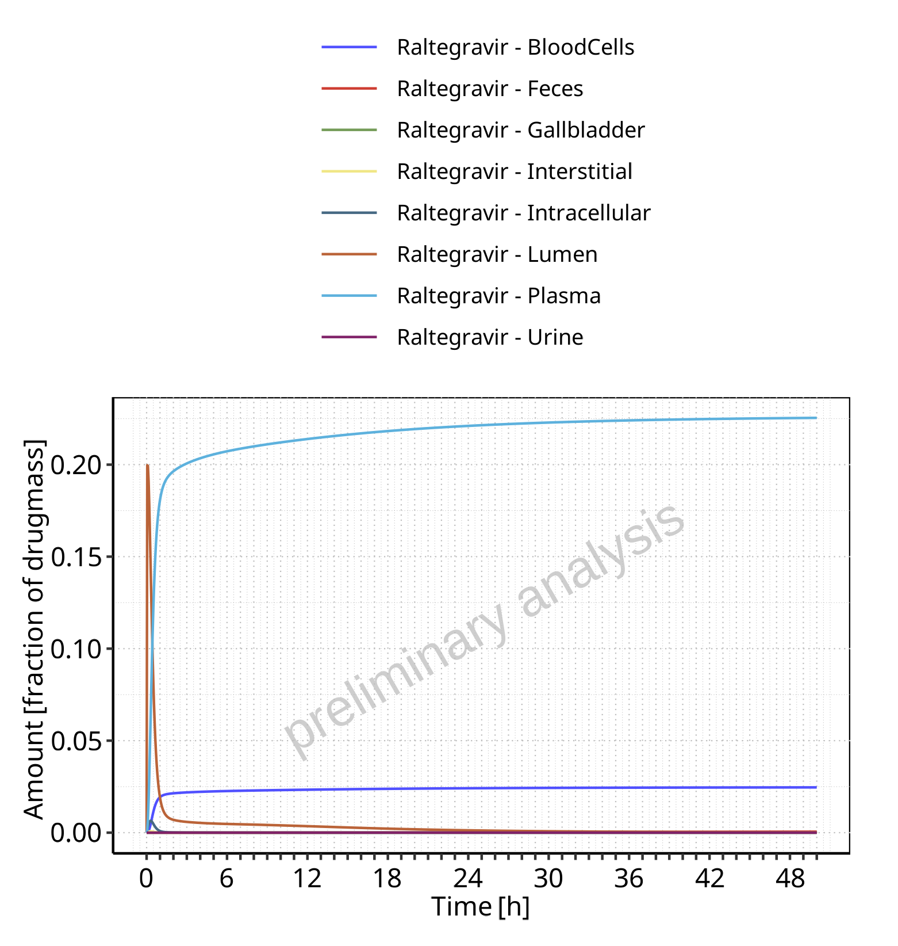

**Figure 4-33: Amount of drug vs time within the different compartments normalized to applicated drugmass for Raltegravir**

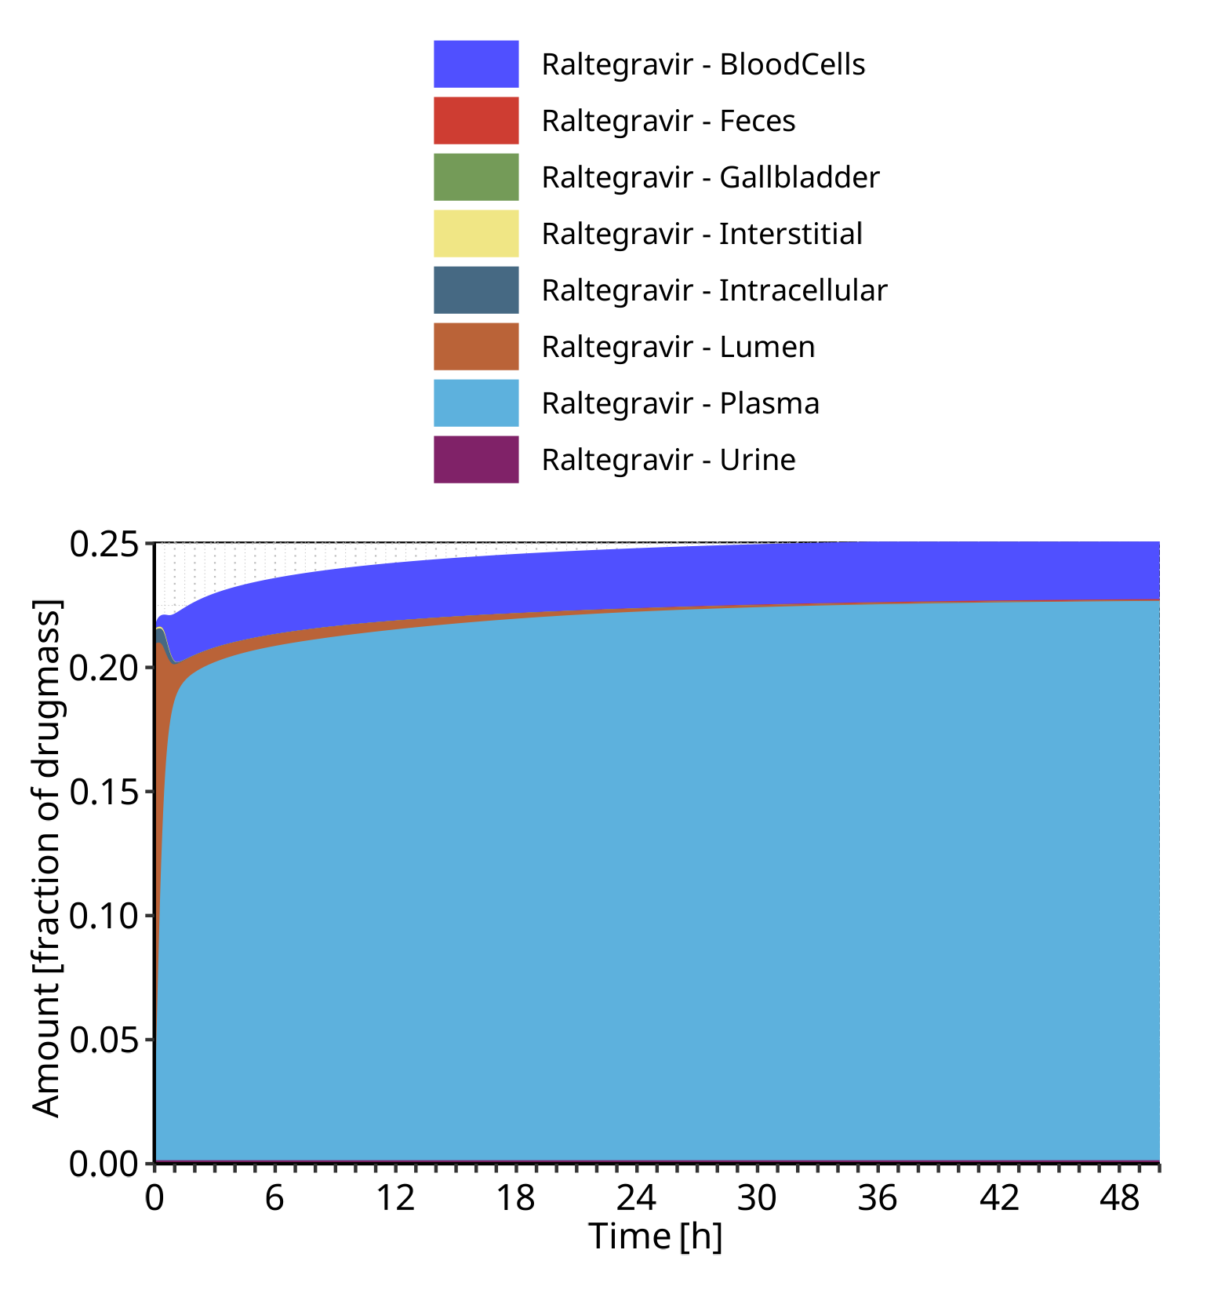

**Figure 4-34: Cumulated amount of drug vs time within the different compartments normalized to applicated drugmass for Raltegravir**

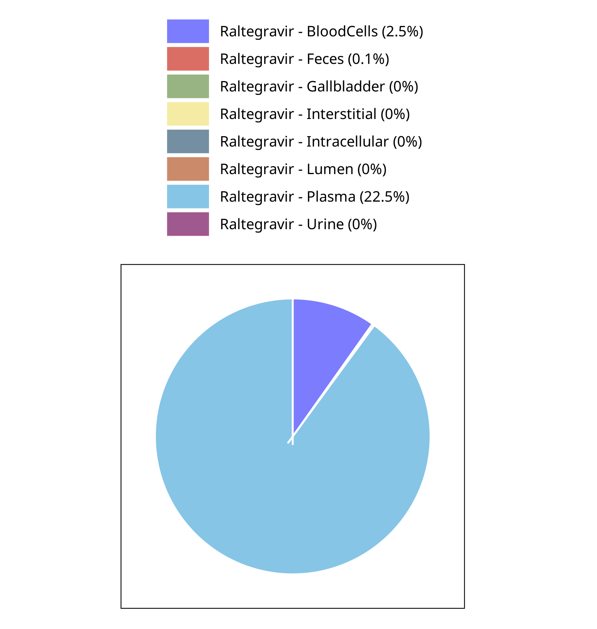

**Figure 4-35: Fraction of drug within the different compartments at 50.00h for Raltegravir**

## Mass Balance for Raltegravir 1200 mg (lactose formulation)

### Mass Balance for Raltegravir

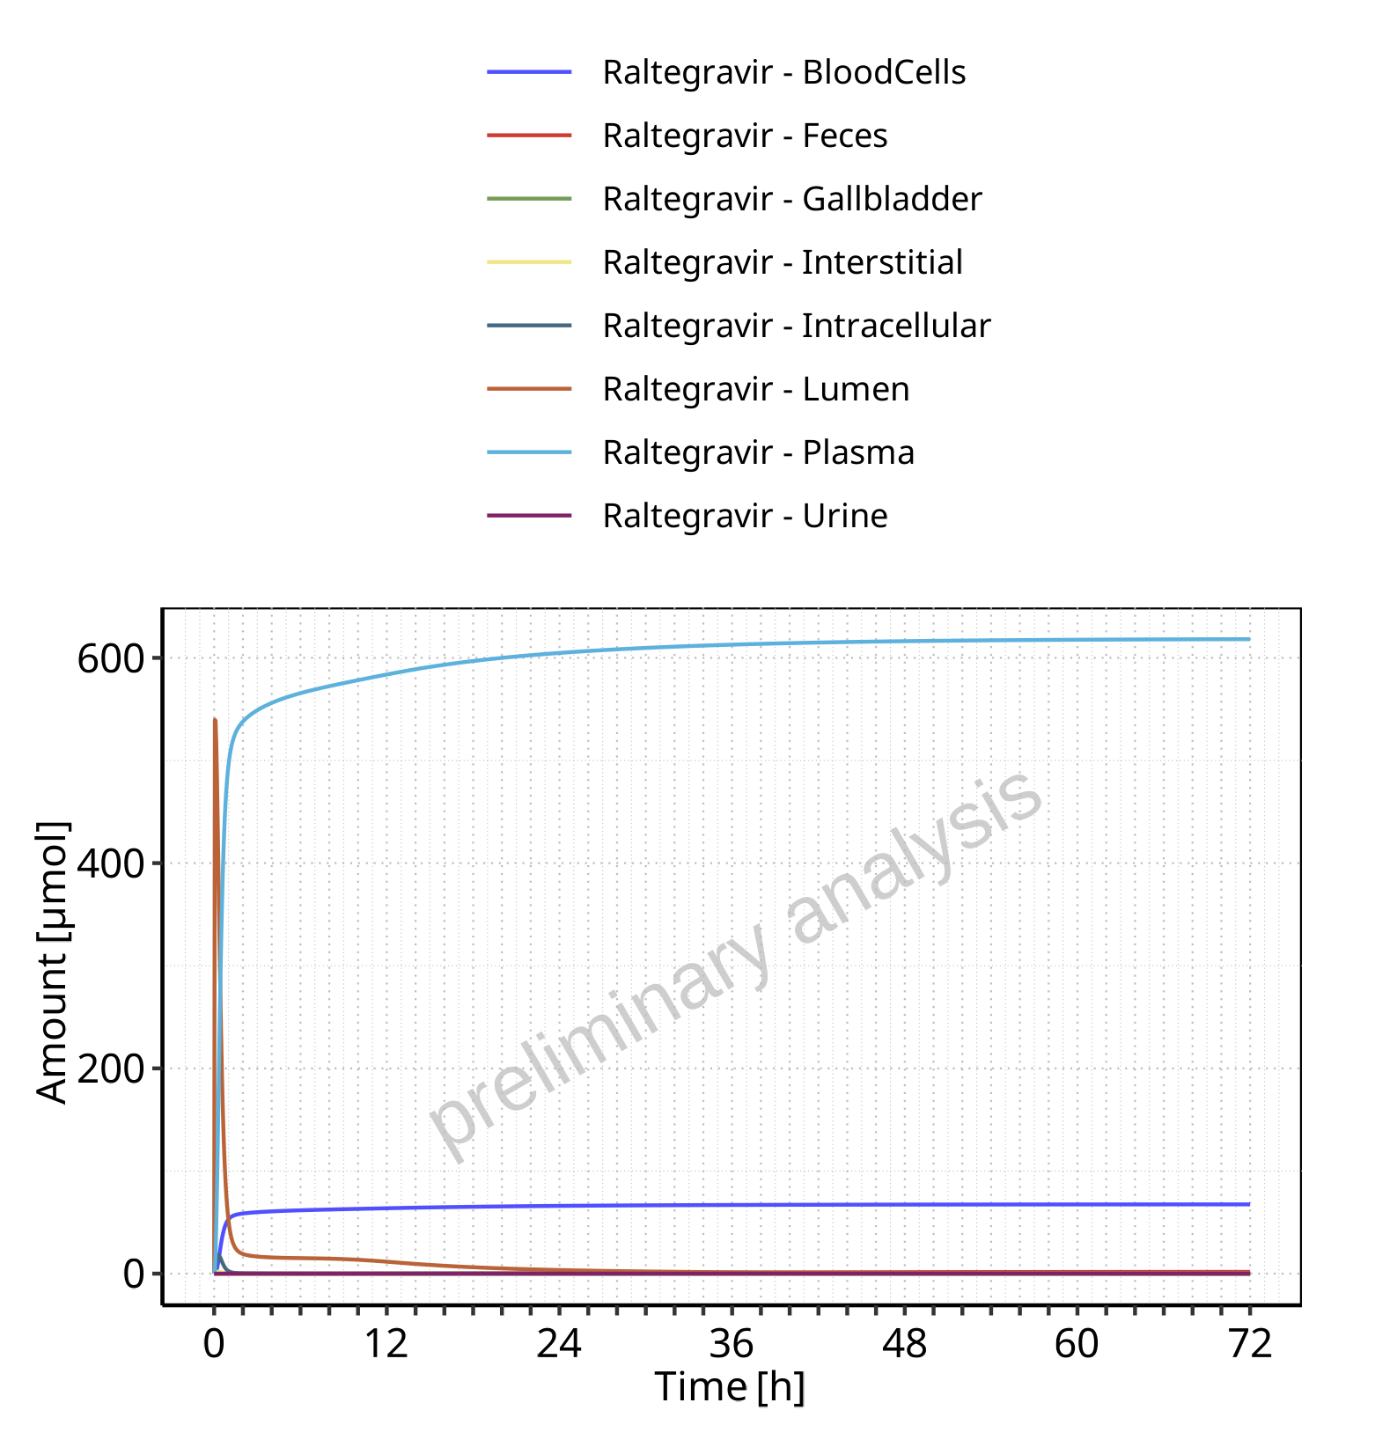

**Figure 4-36: Amount of drug vs time within the different compartments for Raltegravir**

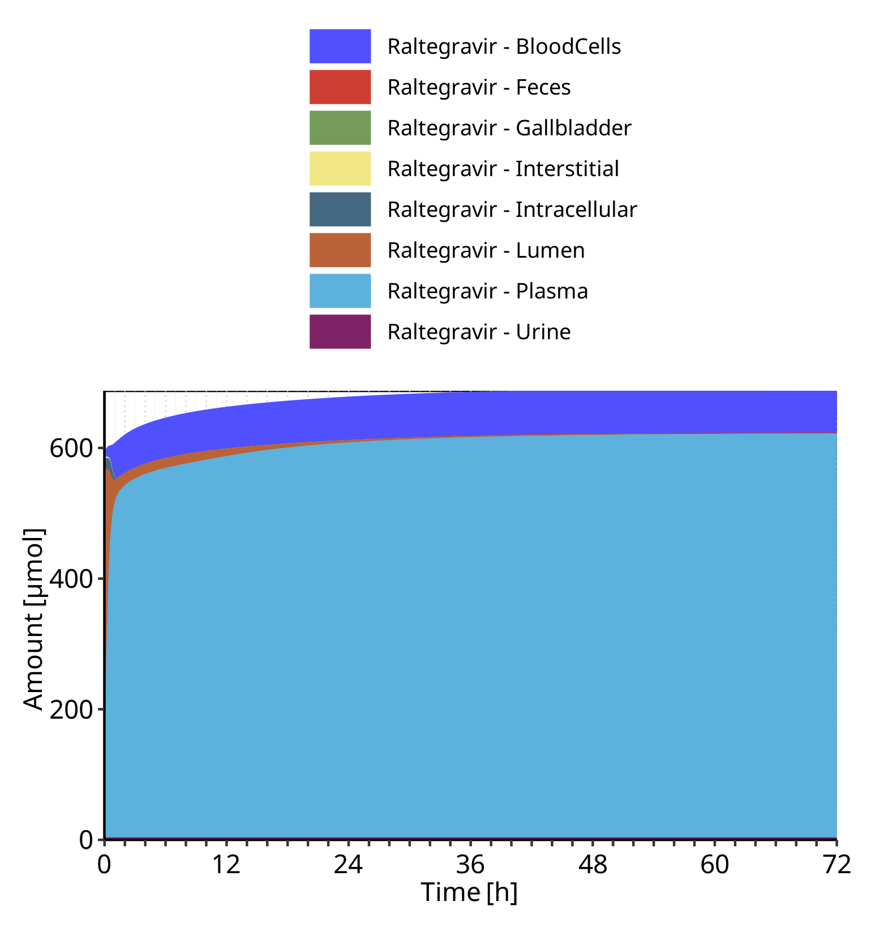

**Figure 4-37: Cumulated amount of drug vs time within the different compartments for Raltegravir**

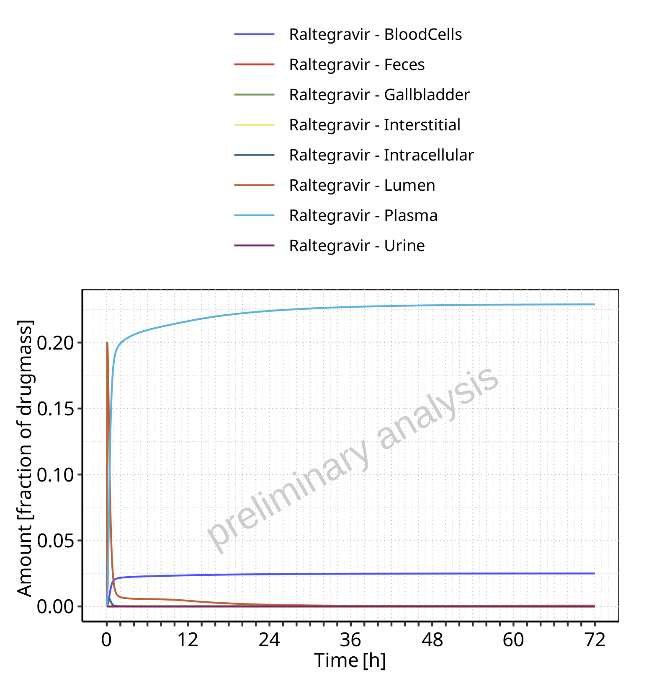

**Figure 4-38: Amount of drug vs time within the different compartments normalized to applicated drugmass for Raltegravir**

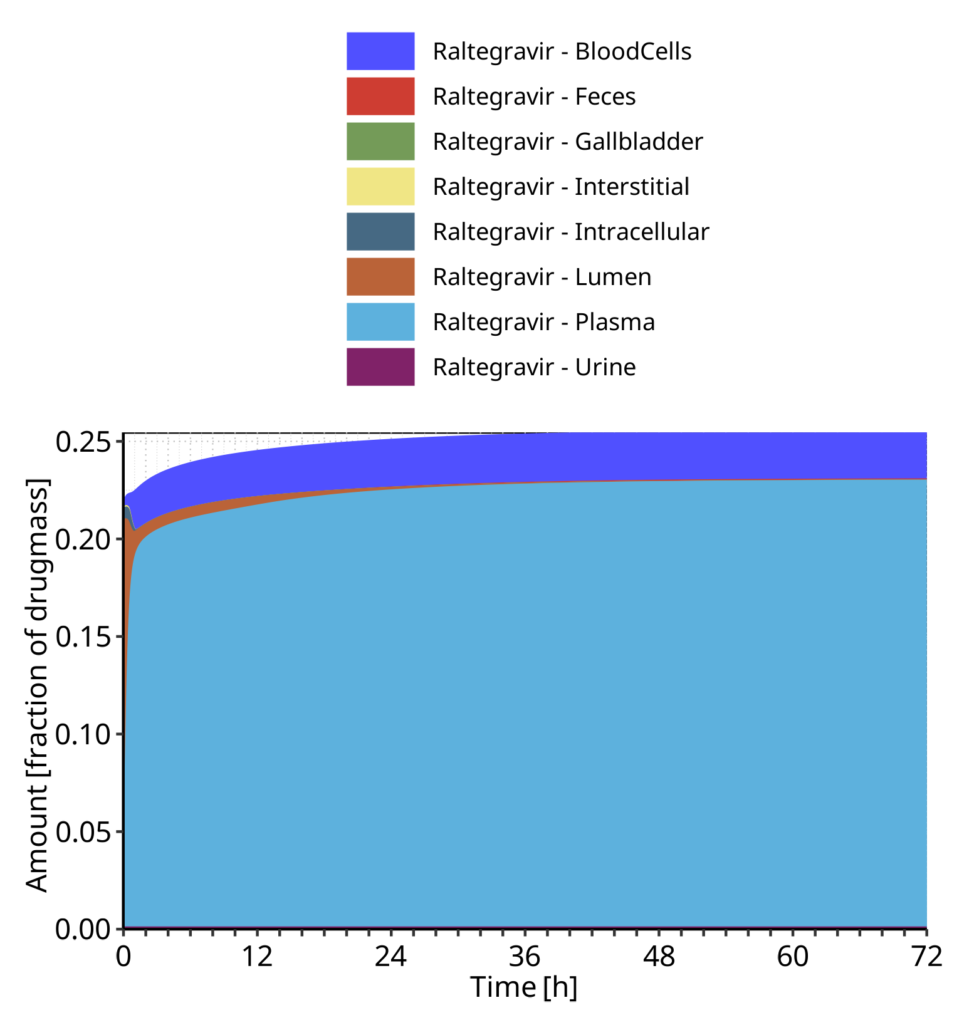

**Figure 4-39: Cumulated amount of drug vs time within the different compartments normalized to applicated drugmass for Raltegravir**

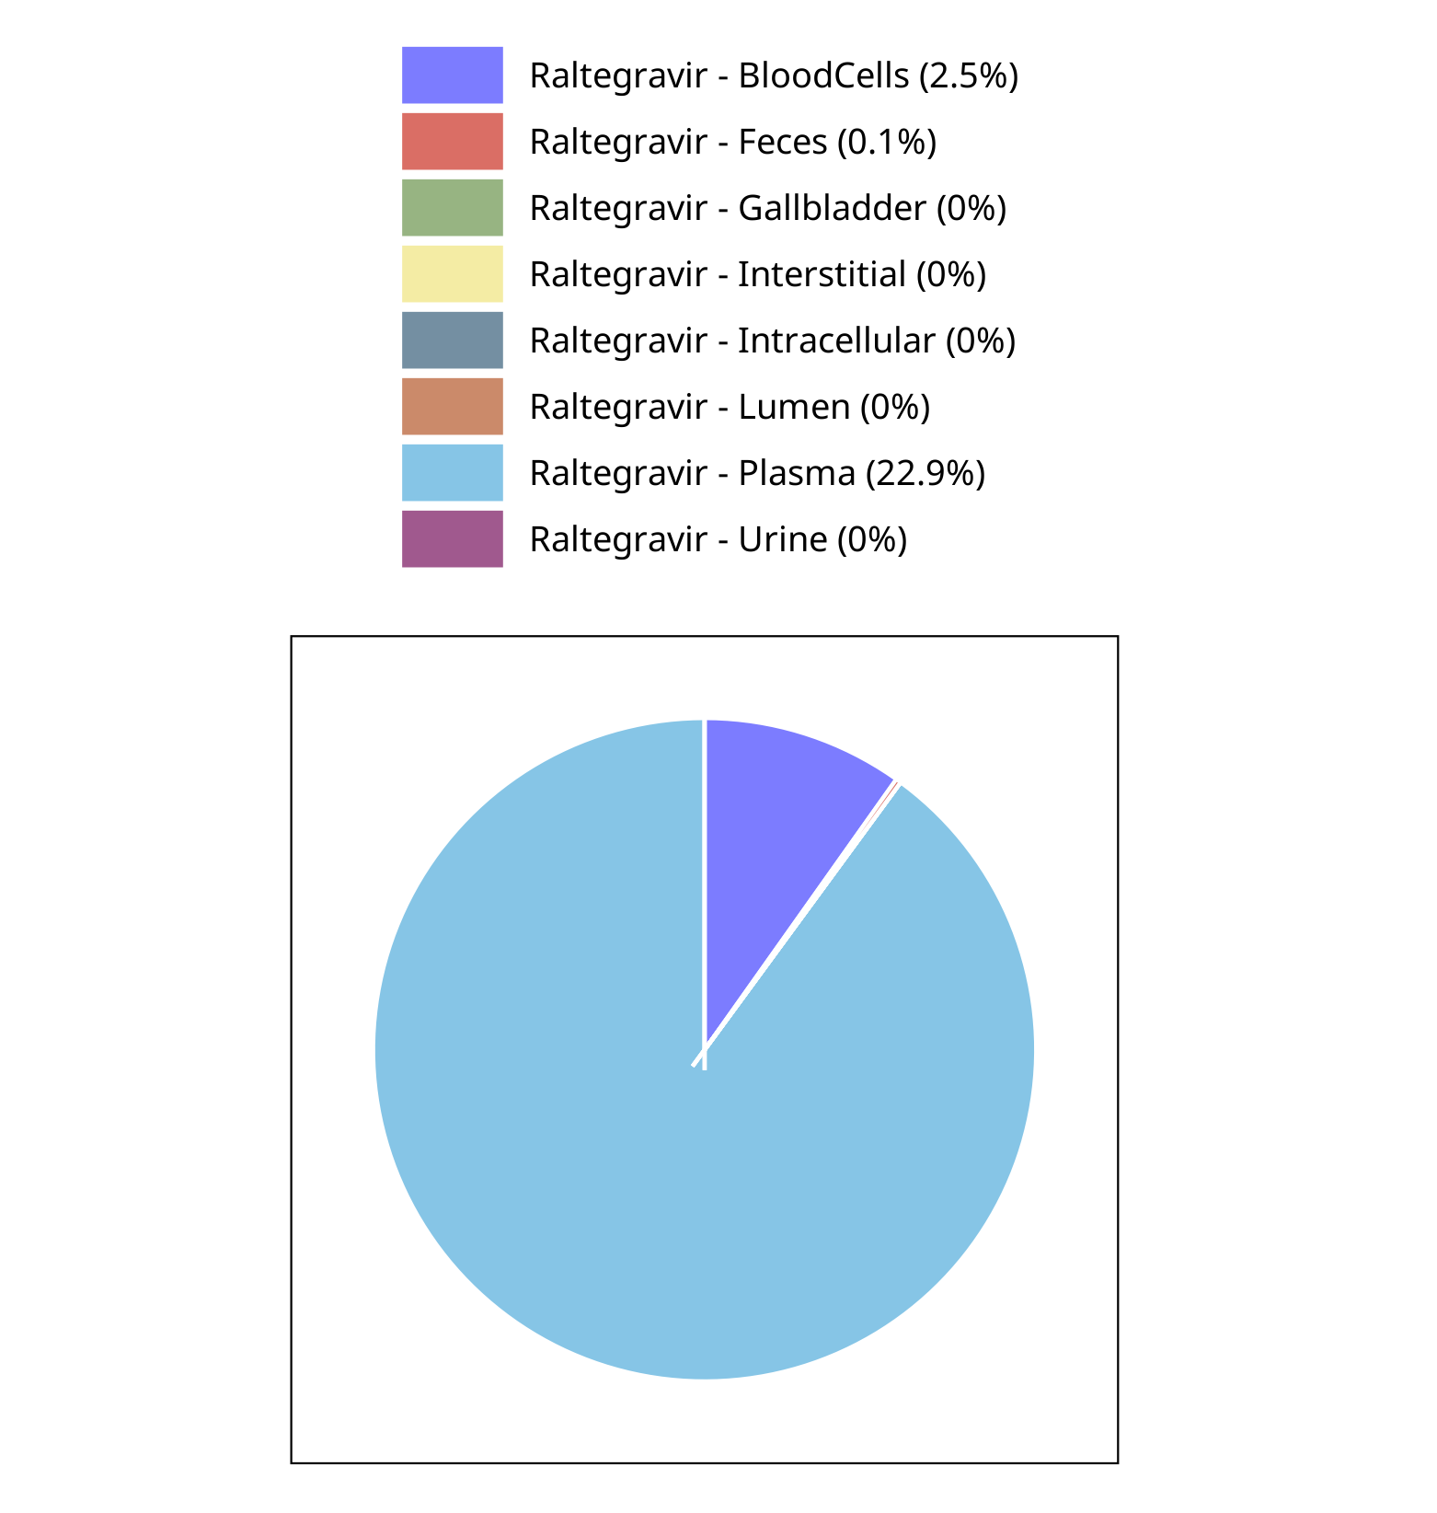

**Figure 4-40: Fraction of drug within the different compartments at 72.00h for Raltegravir**

## Mass Balance for Raltegravir 1600 mg (lactose formulation)

### Mass Balance for Raltegravir

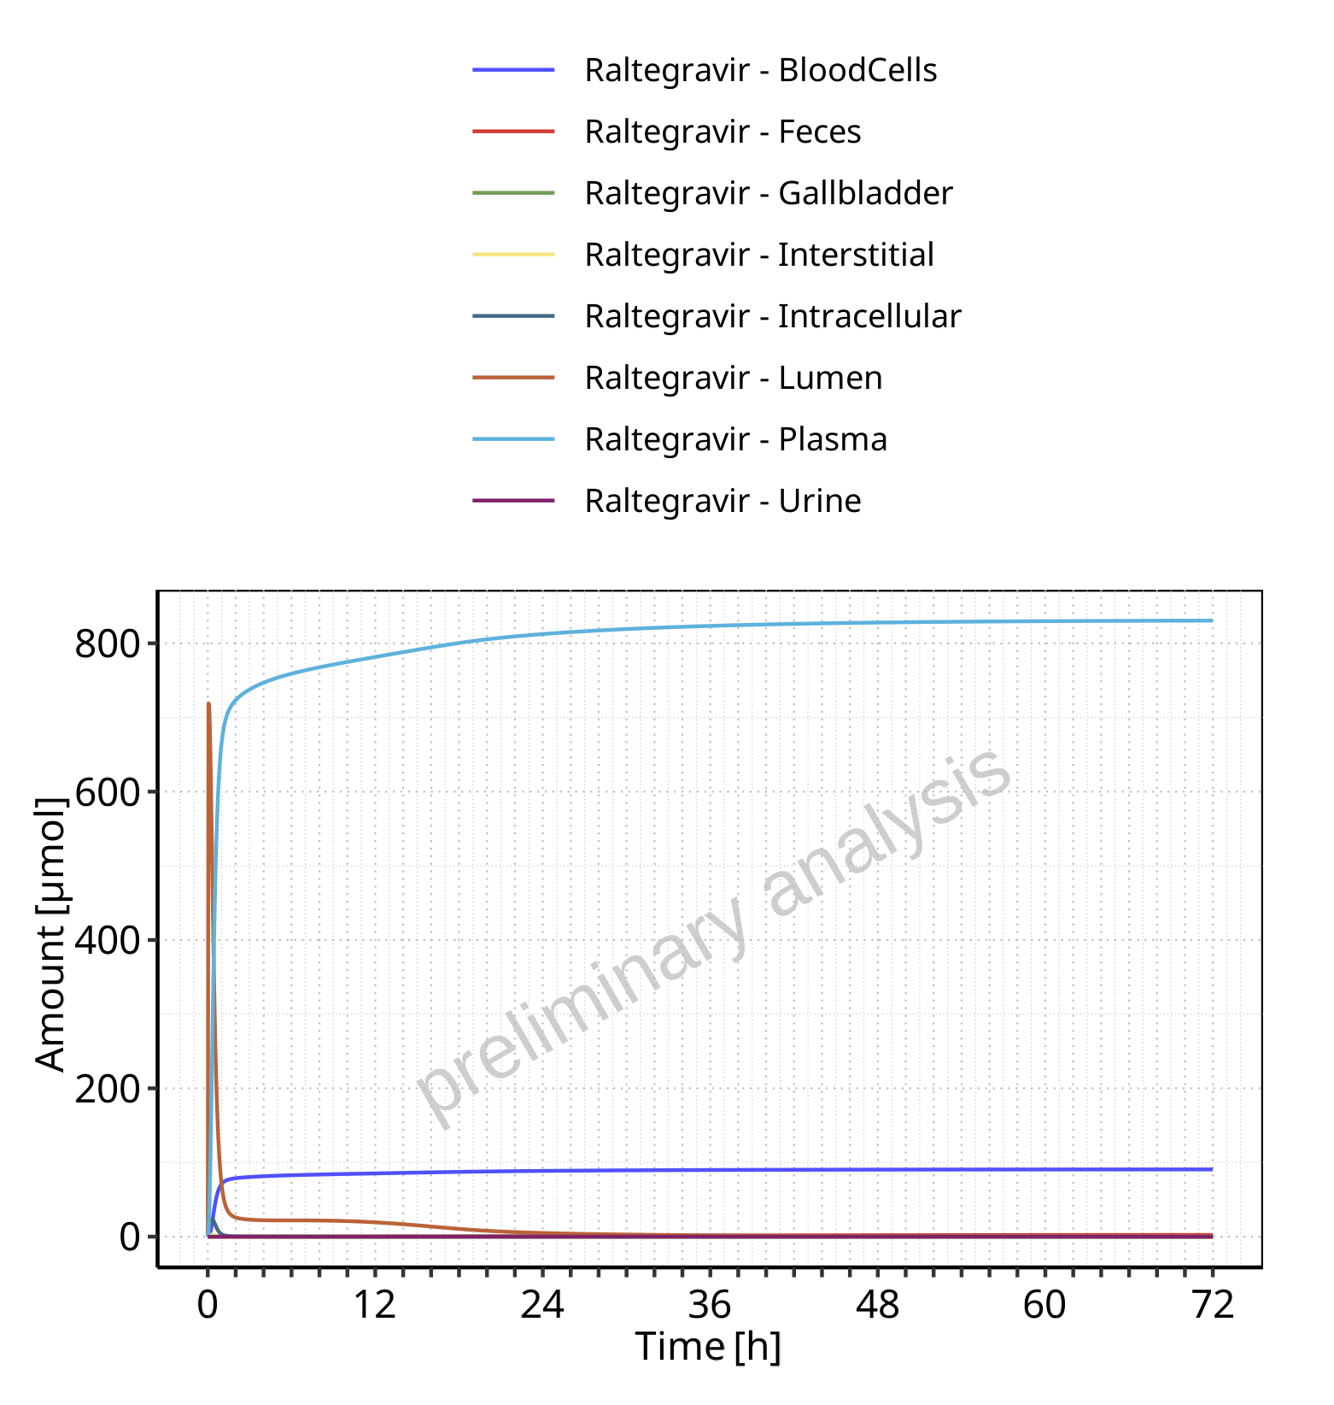

**Figure 4-41: Amount of drug vs time within the different compartments for Raltegravir**

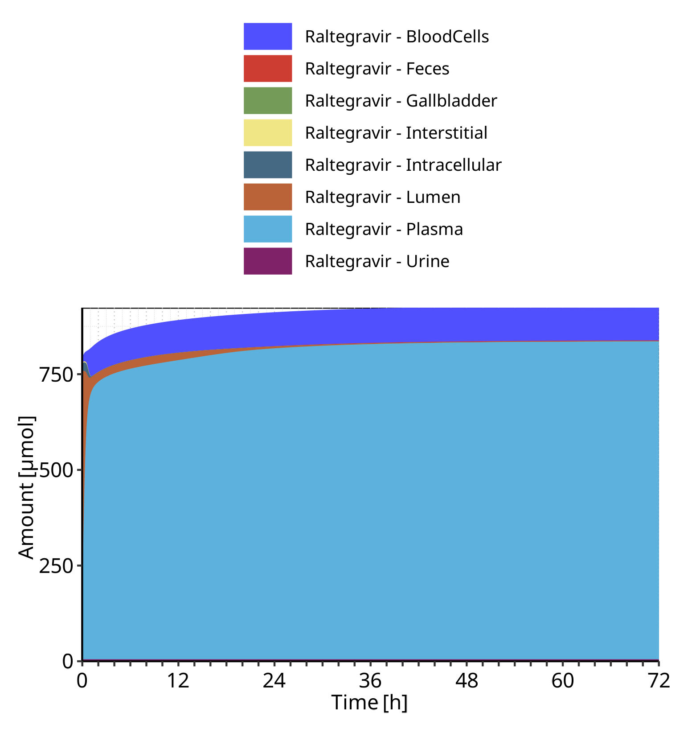

**Figure 4-42: Cumulated amount of drug vs time within the different compartments for Raltegravir**

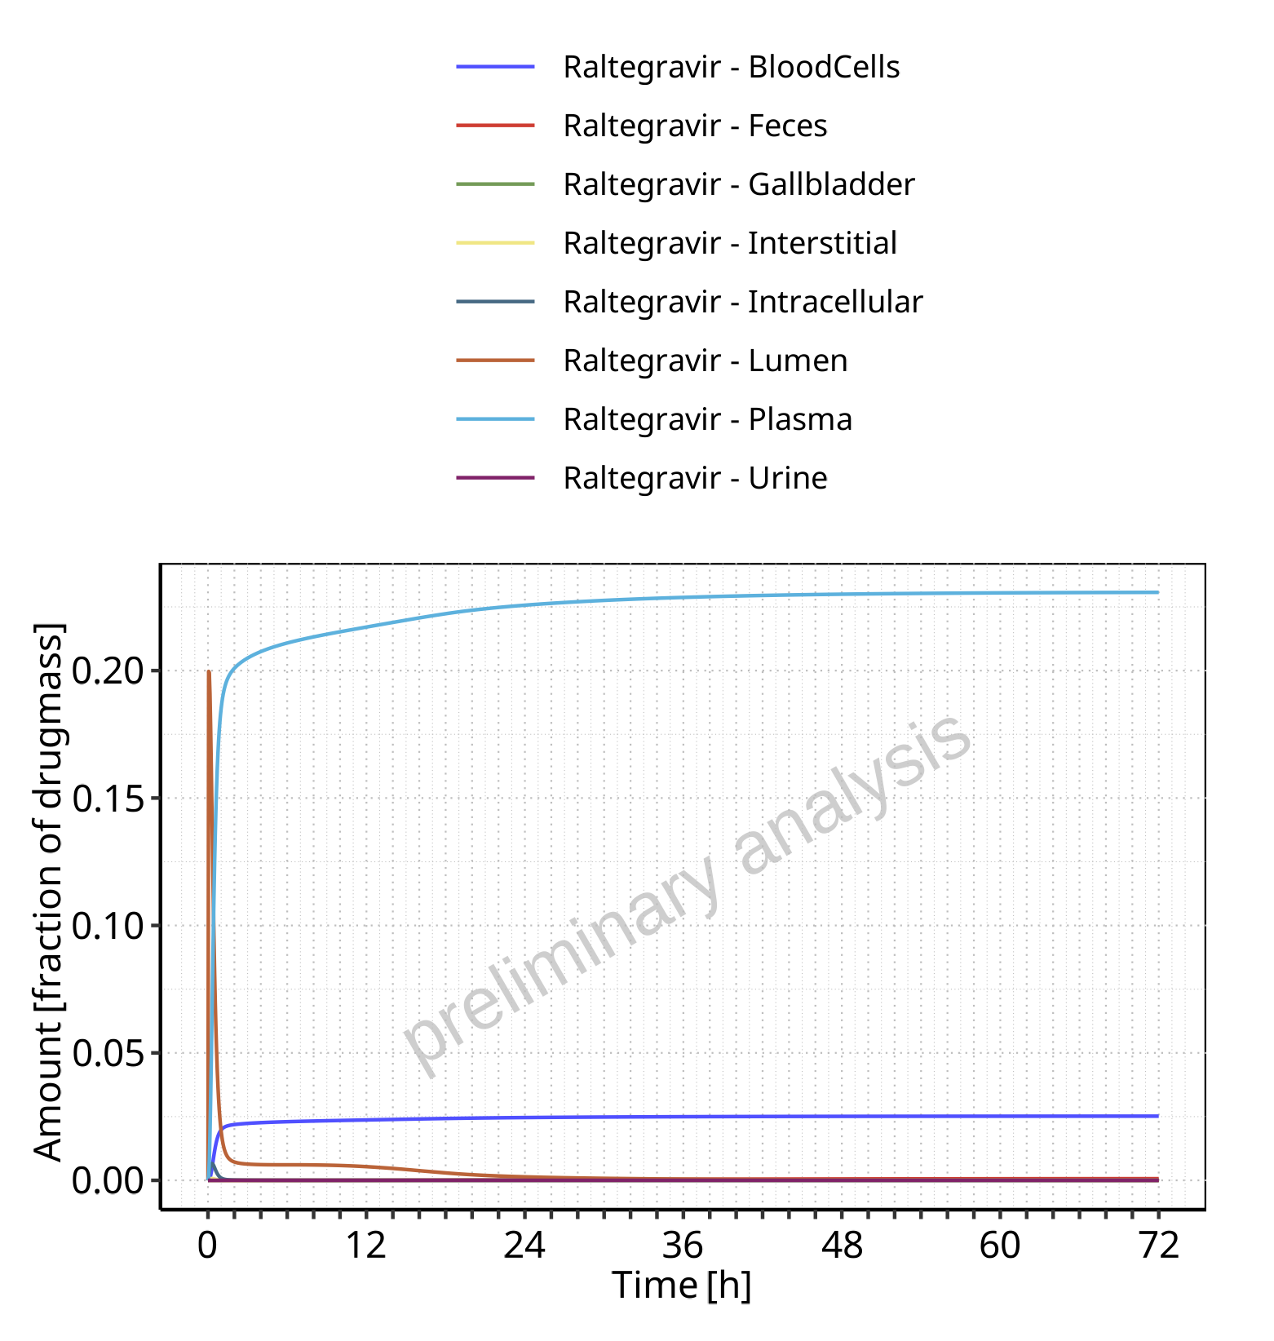

**Figure 4-43: Amount of drug vs time within the different compartments normalized to applicated drugmass for Raltegravir**

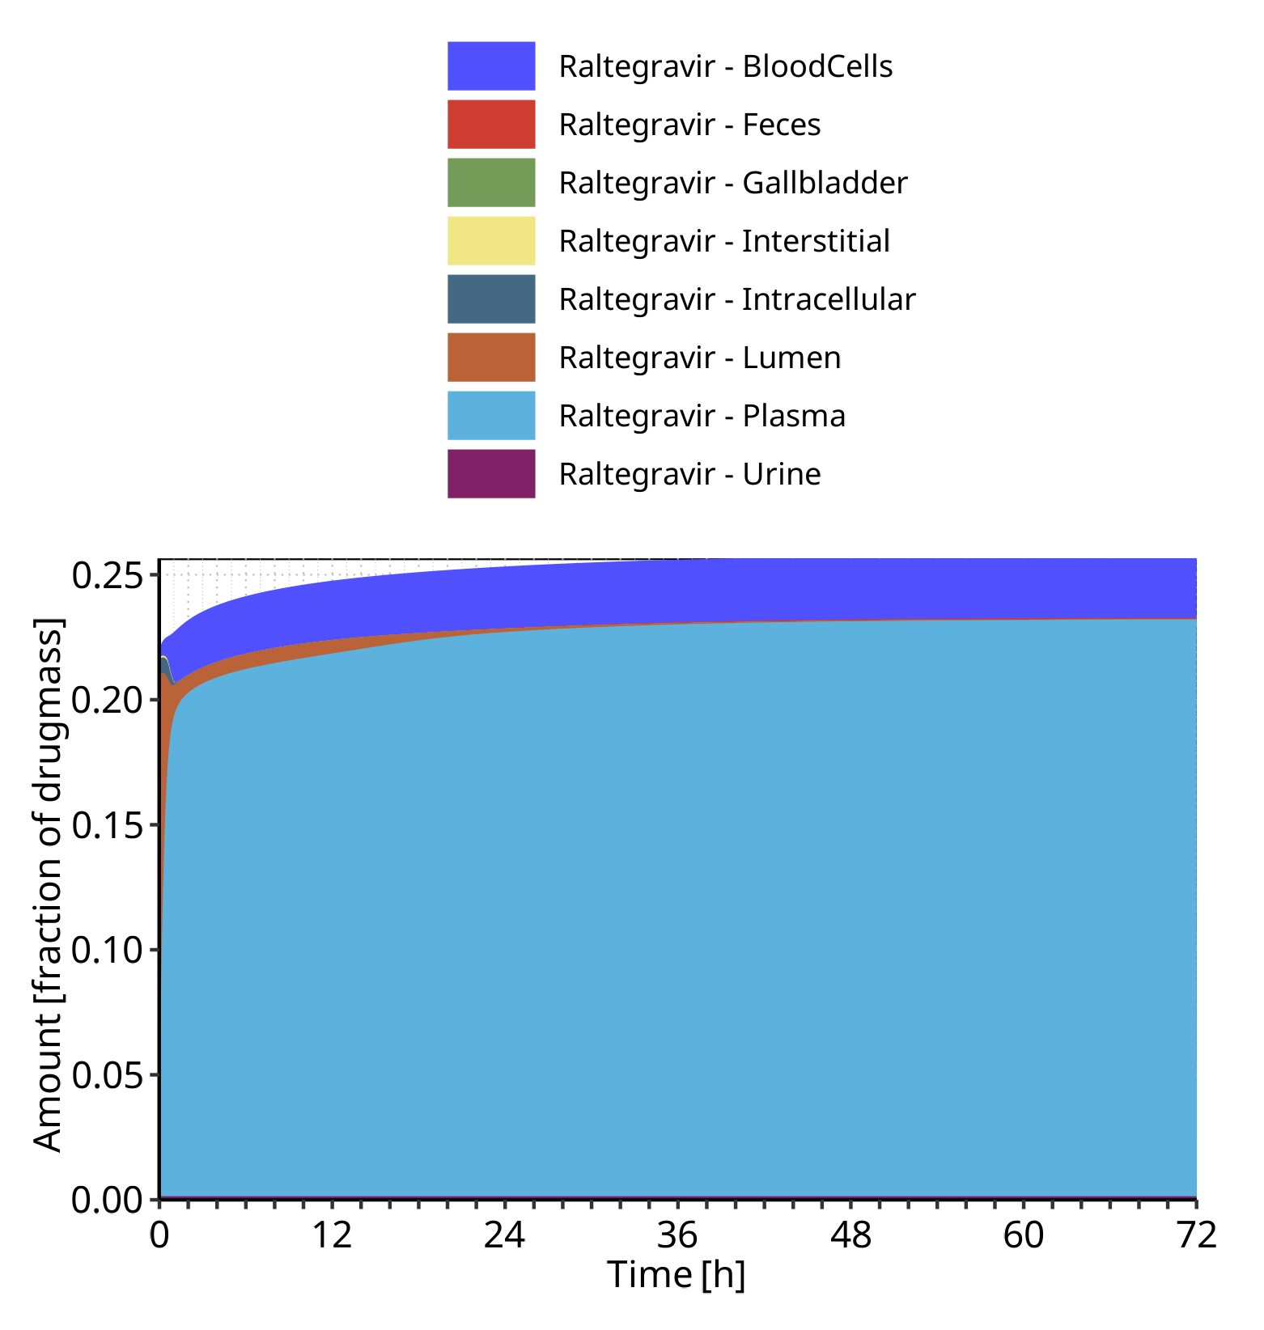

**Figure 4-44: Cumulated amount of drug vs time within the different compartments normalized to applicated drugmass for Raltegravir**

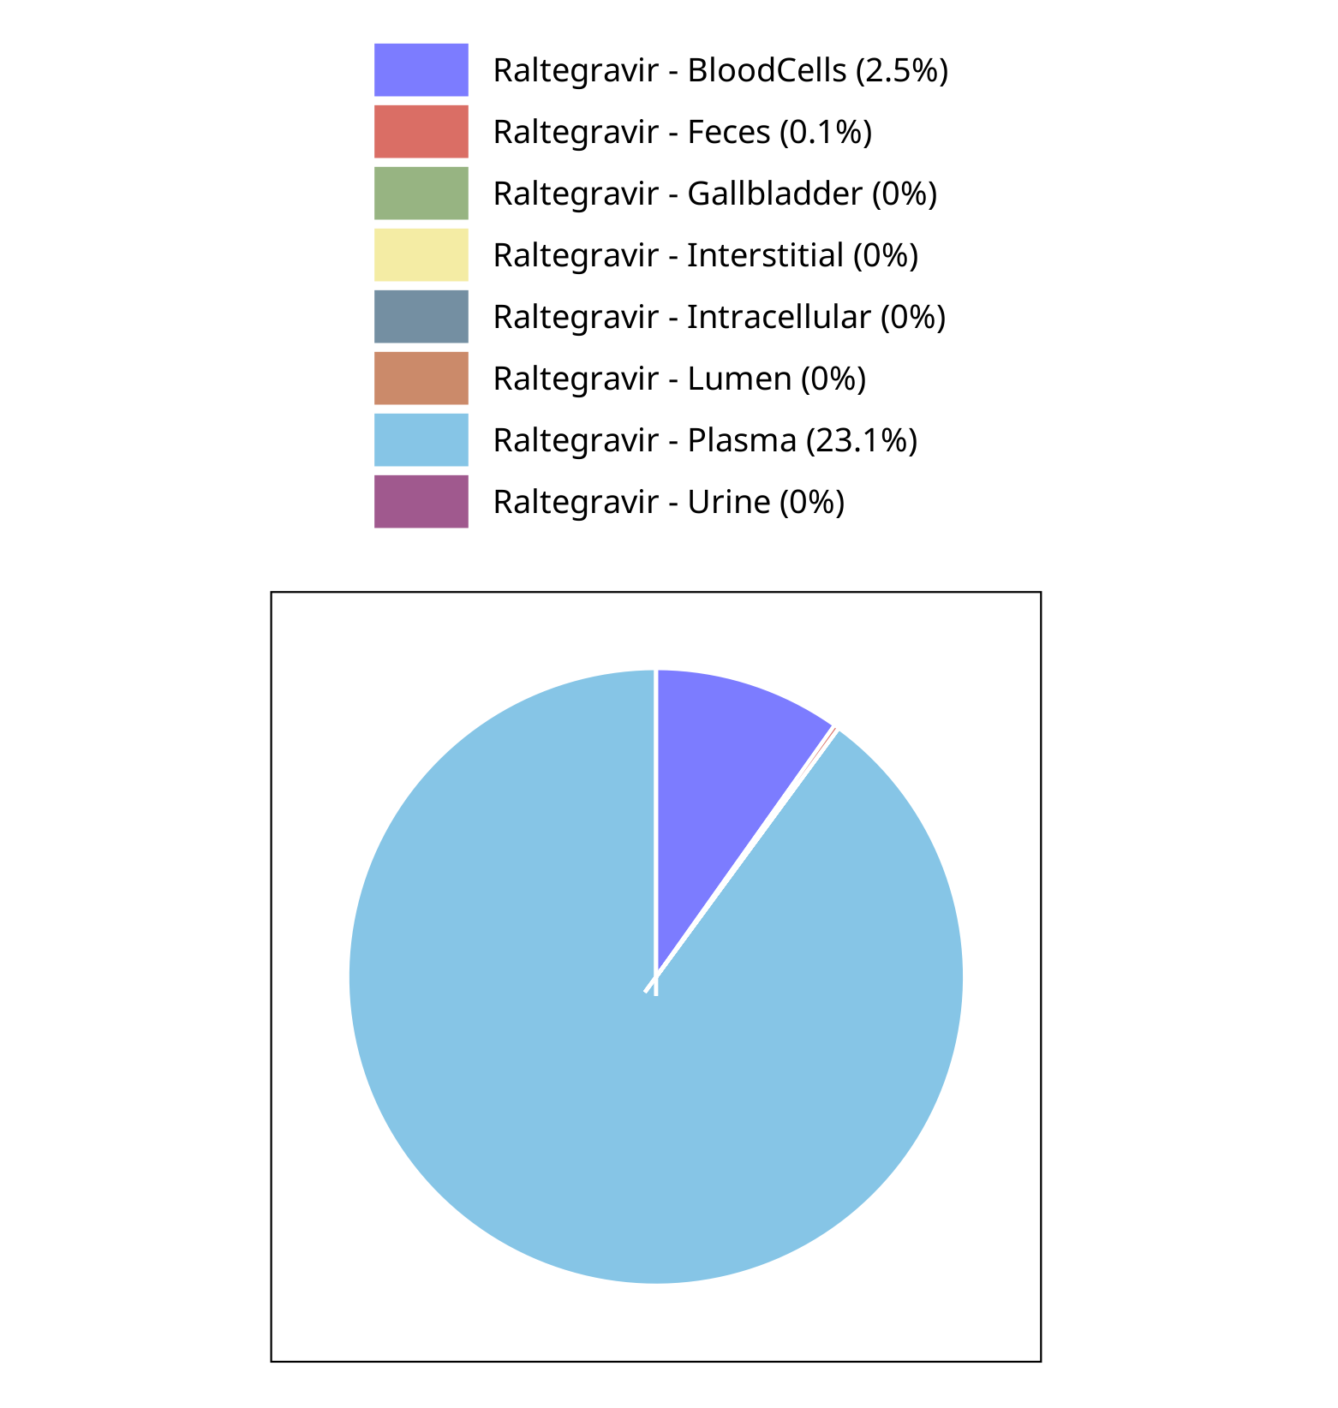

**Figure 4-45: Fraction of drug within the different compartments at 72.00h for Raltegravir**

## Mass Balance for Raltegravir 100 mg filmcoated tablet md

### Mass Balance for Raltegravir

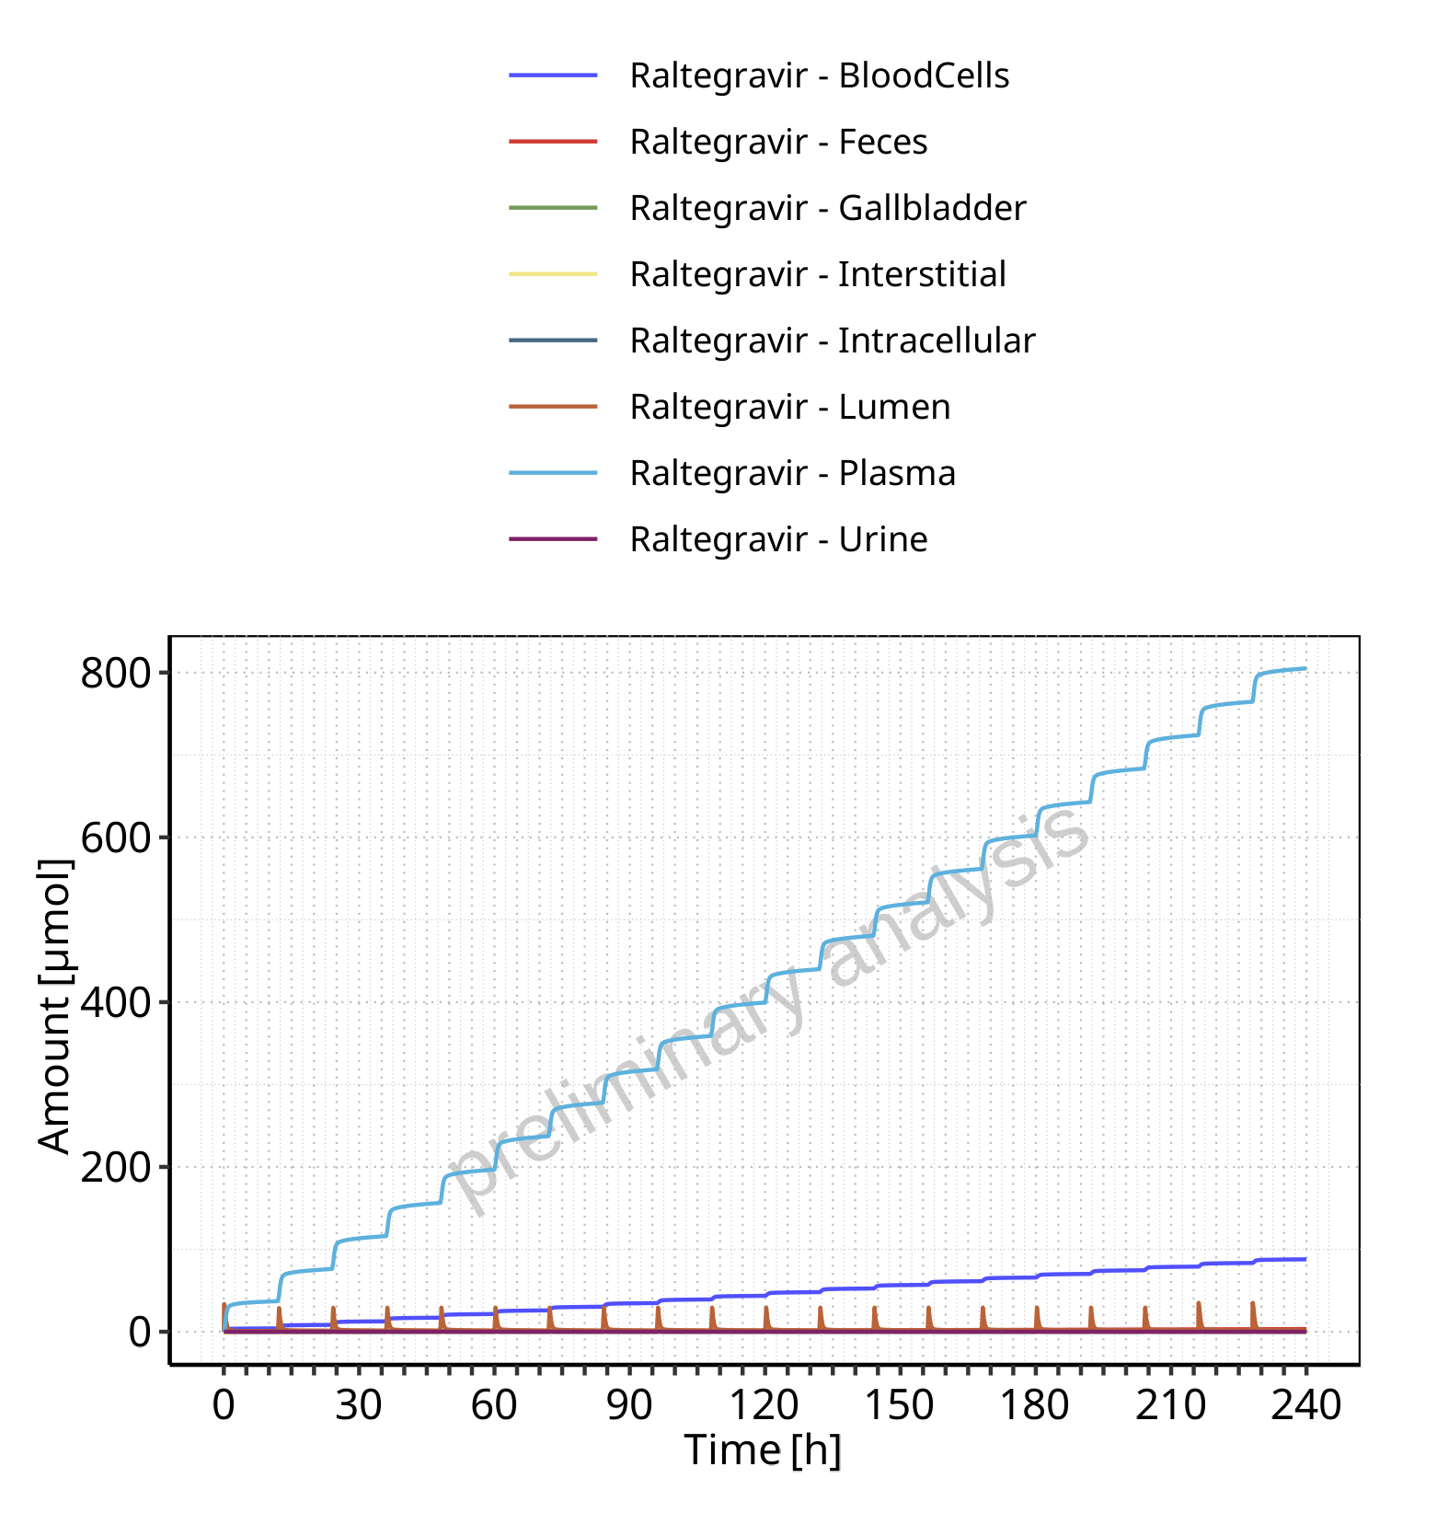

**Figure 4-46: Amount of drug vs time within the different compartments for Raltegravir**

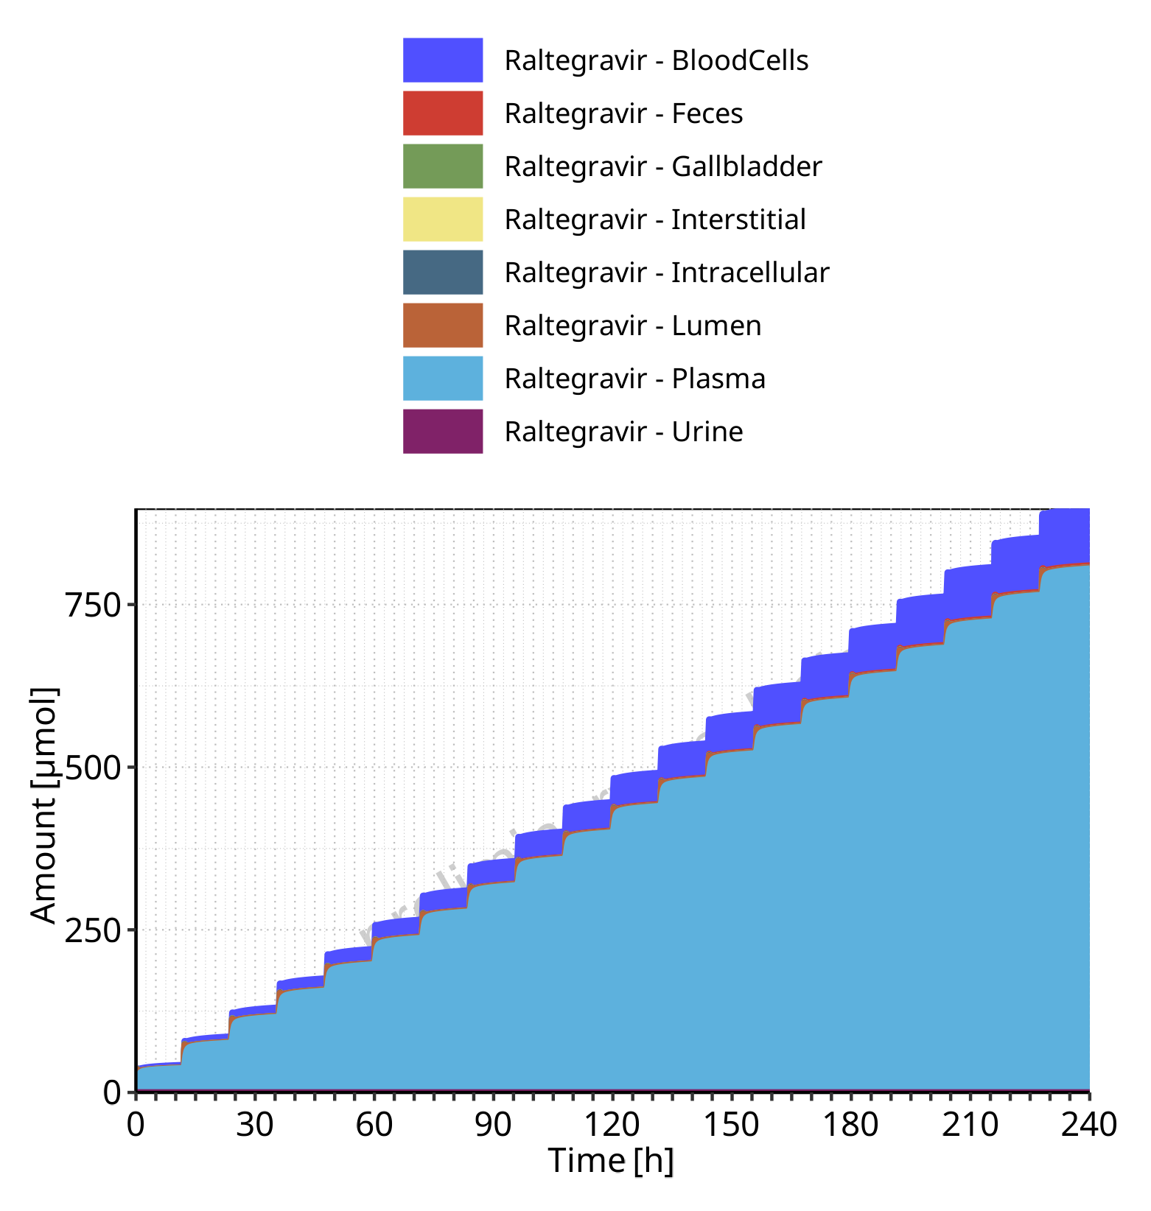

**Figure 4-47: Cumulated amount of drug vs time within the different compartments for Raltegravir**

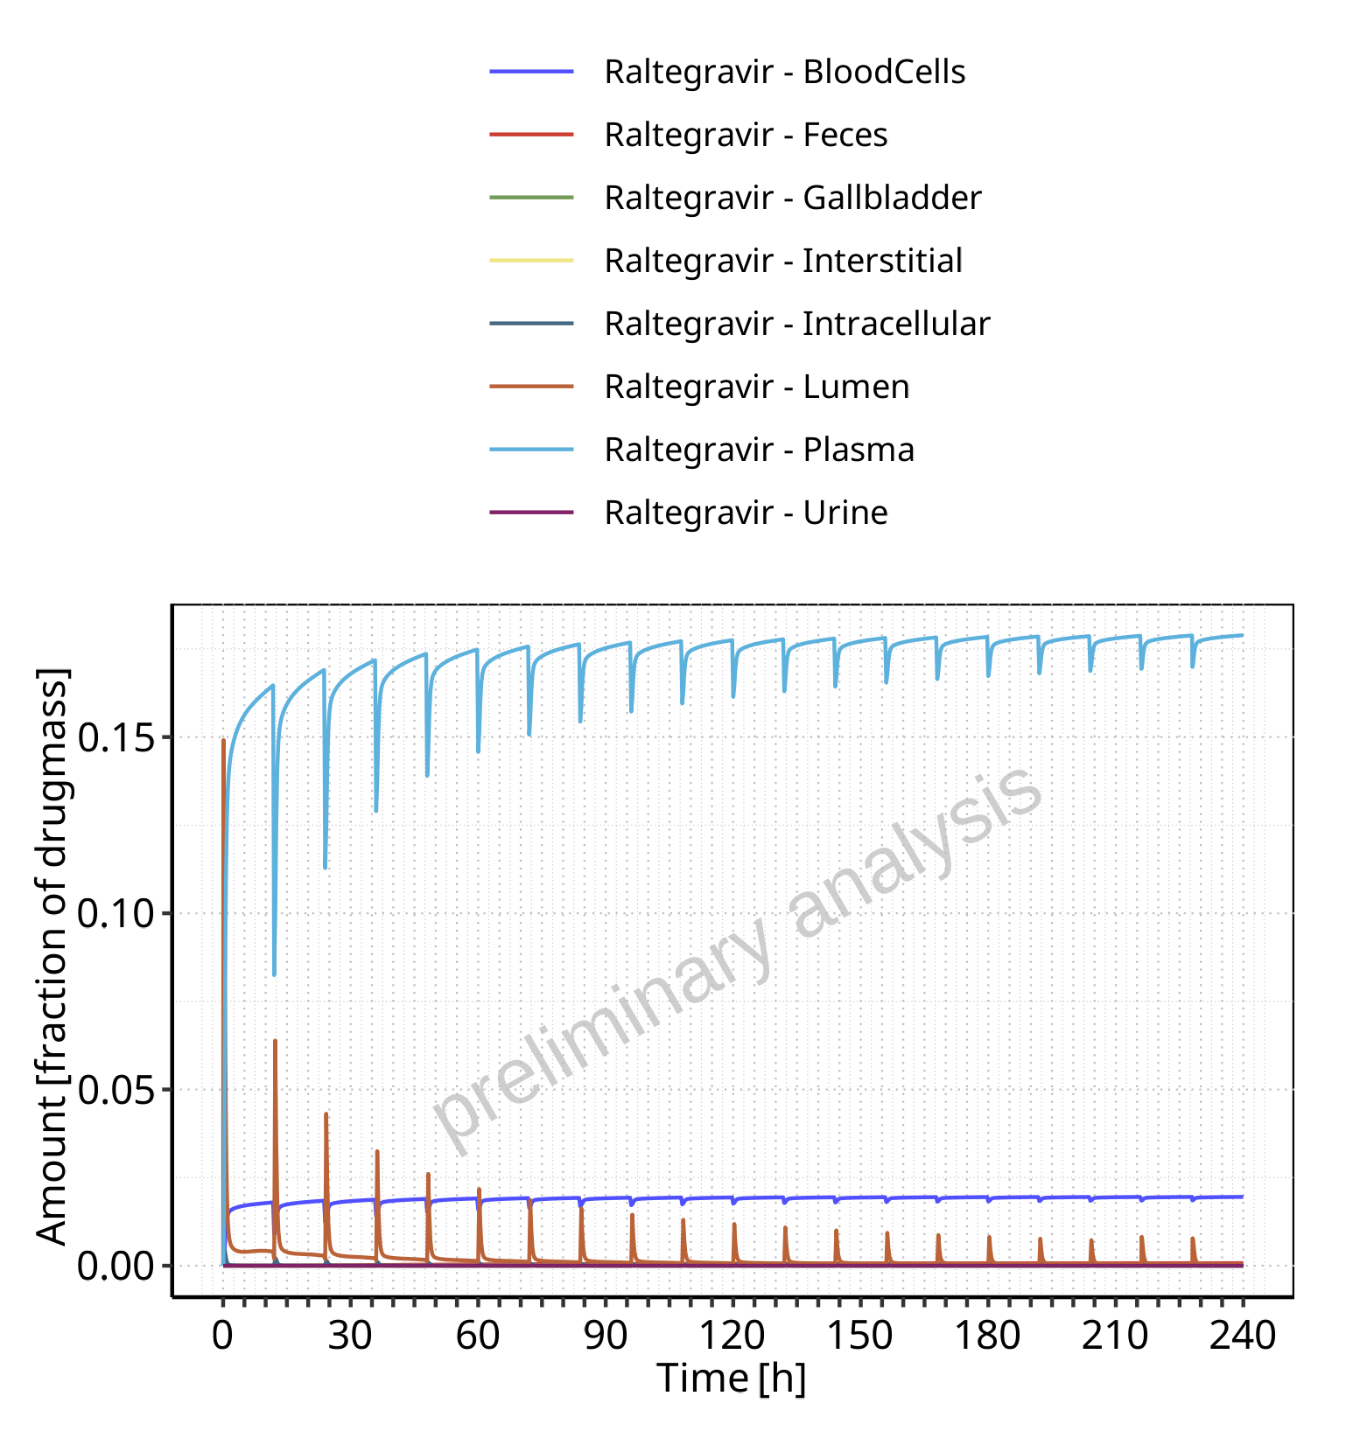

**Figure 4-48: Amount of drug vs time within the different compartments normalized to applicated drugmass for Raltegravir**

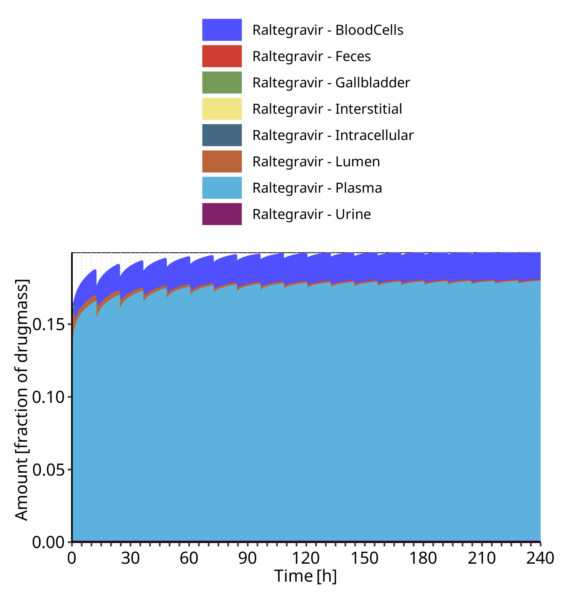

**Figure 4-49: Cumulated amount of drug vs time within the different compartments normalized to applicated drugmass for Raltegravir**

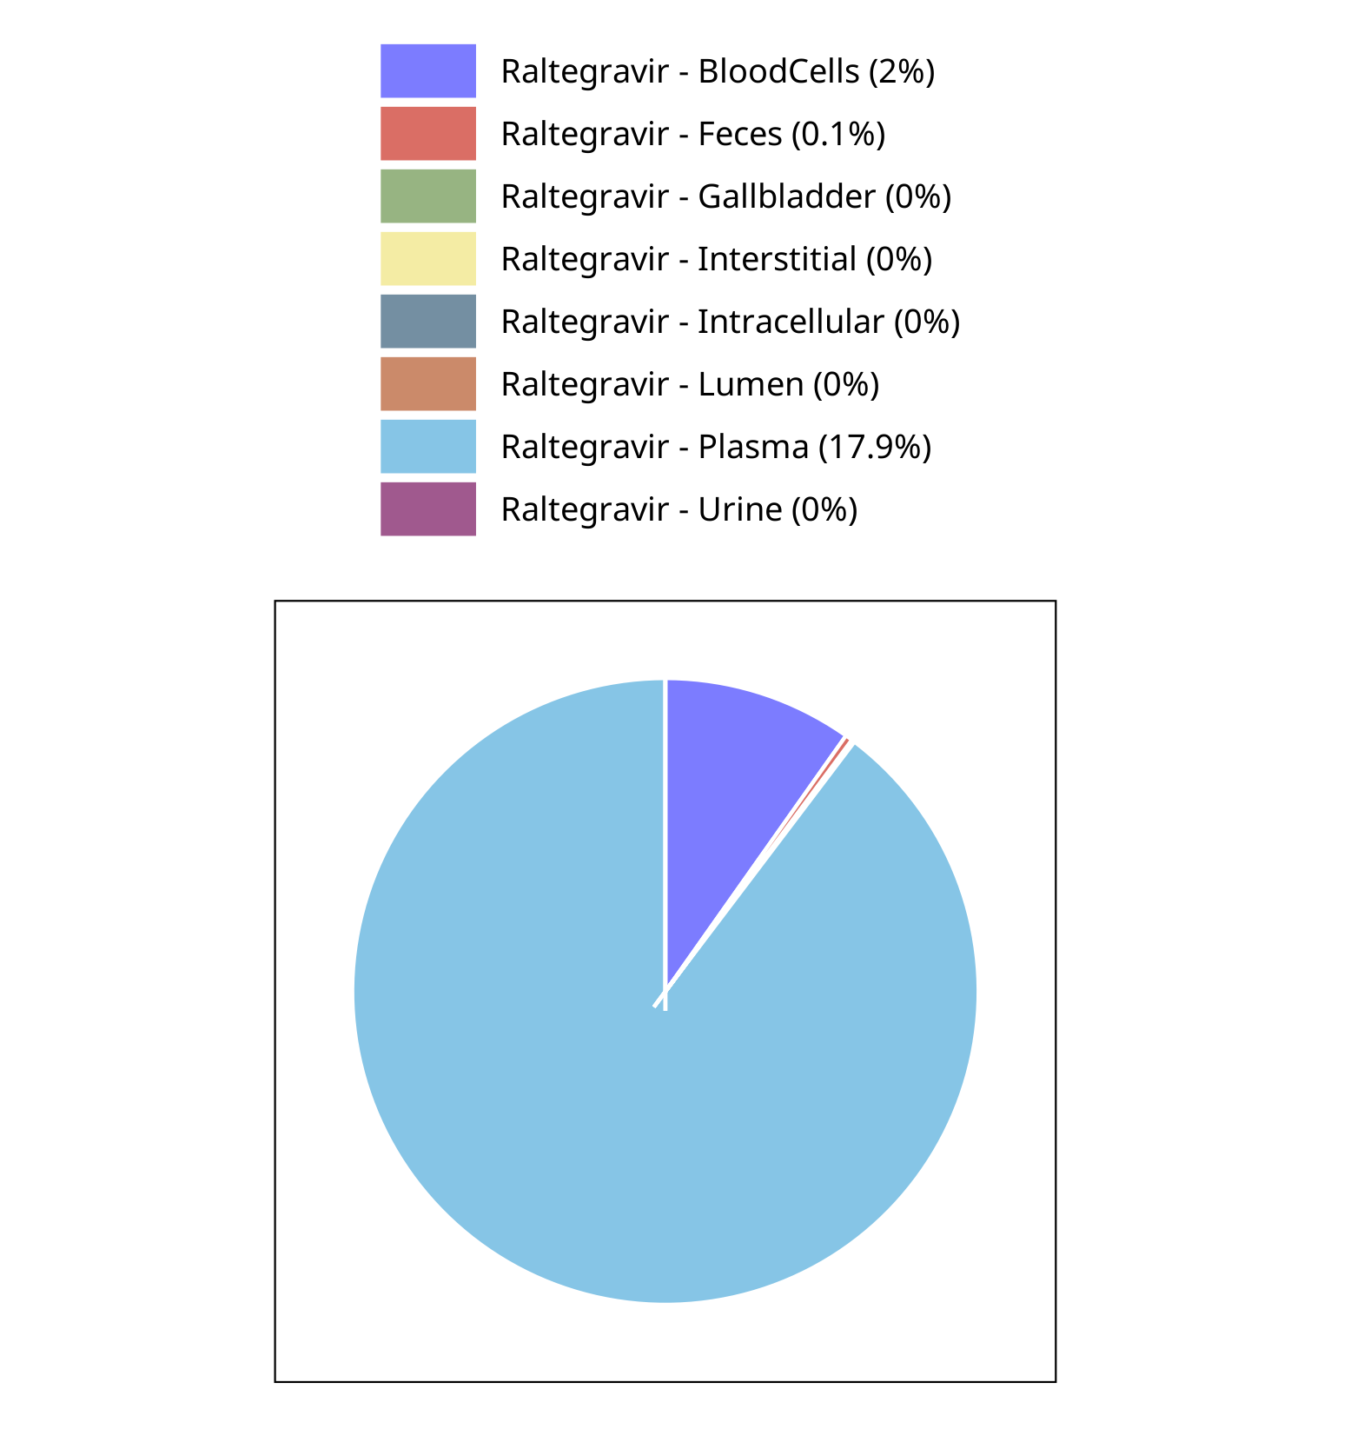

**Figure 4-50: Fraction of drug within the different compartments at 240.00h for Raltegravir**

## Mass Balance for Raltegravir 200 mg filmcoated tablet md

### Mass Balance for Raltegravir

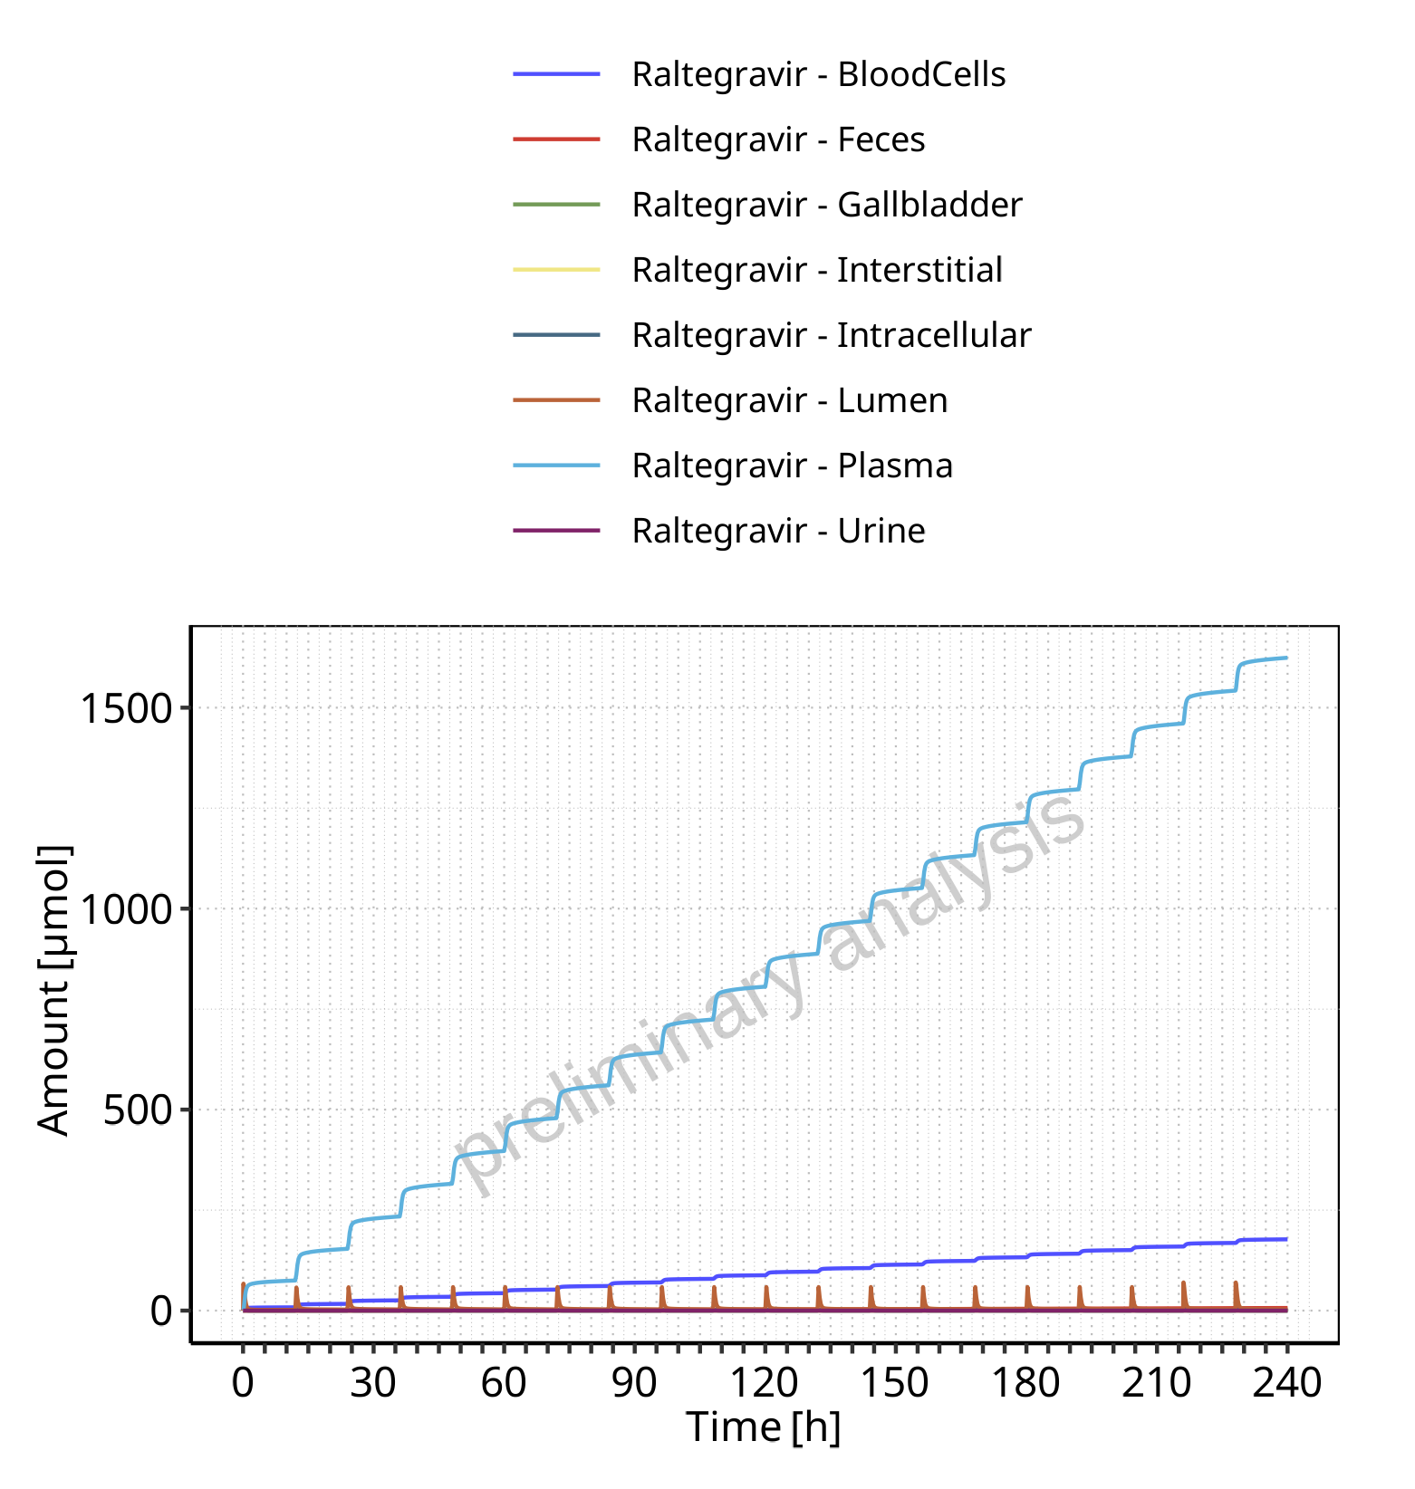

**Figure 4-51: Amount of drug vs time within the different compartments for Raltegravir**

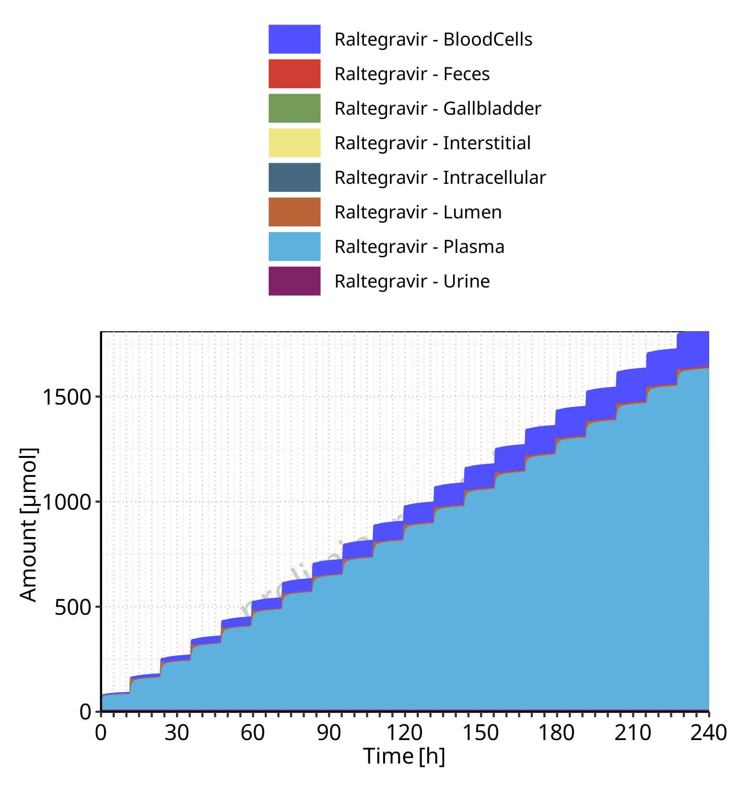

**Figure 4-52: Cumulated amount of drug vs time within the different compartments for Raltegravir**

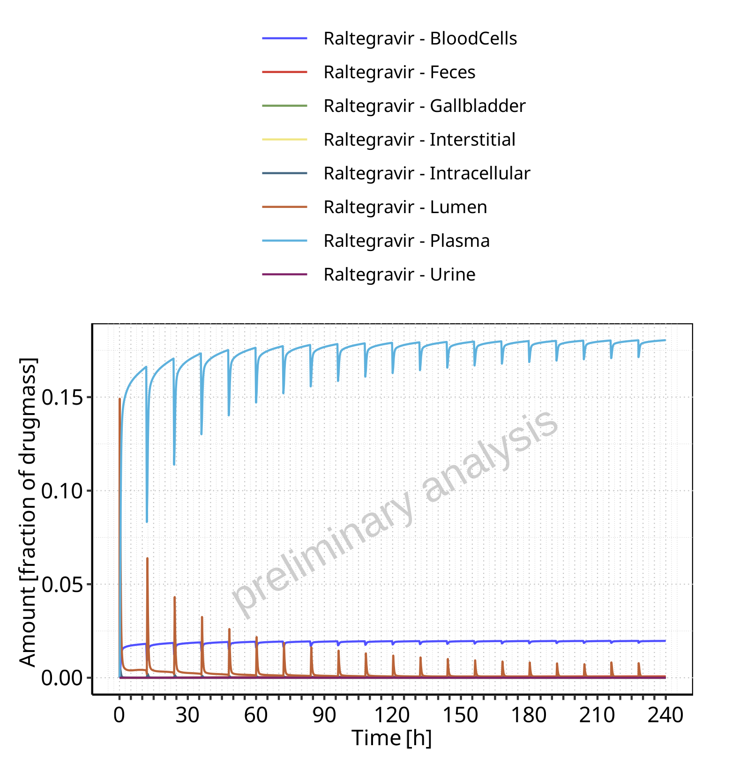

**Figure 4-53: Amount of drug vs time within the different compartments normalized to applicated drugmass for Raltegravir**

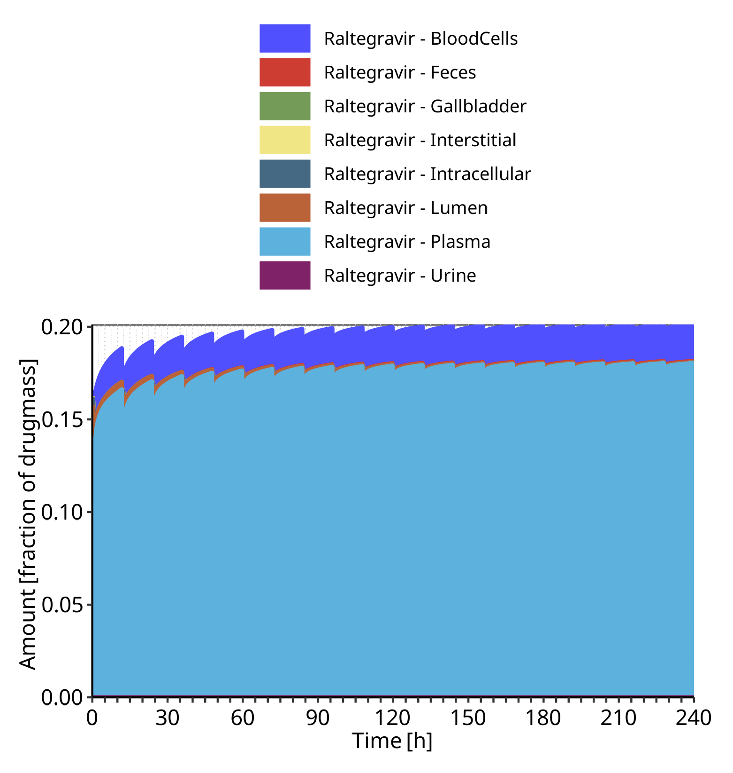

**Figure 4-54: Cumulated amount of drug vs time within the different compartments normalized to applicated drugmass for Raltegravir**

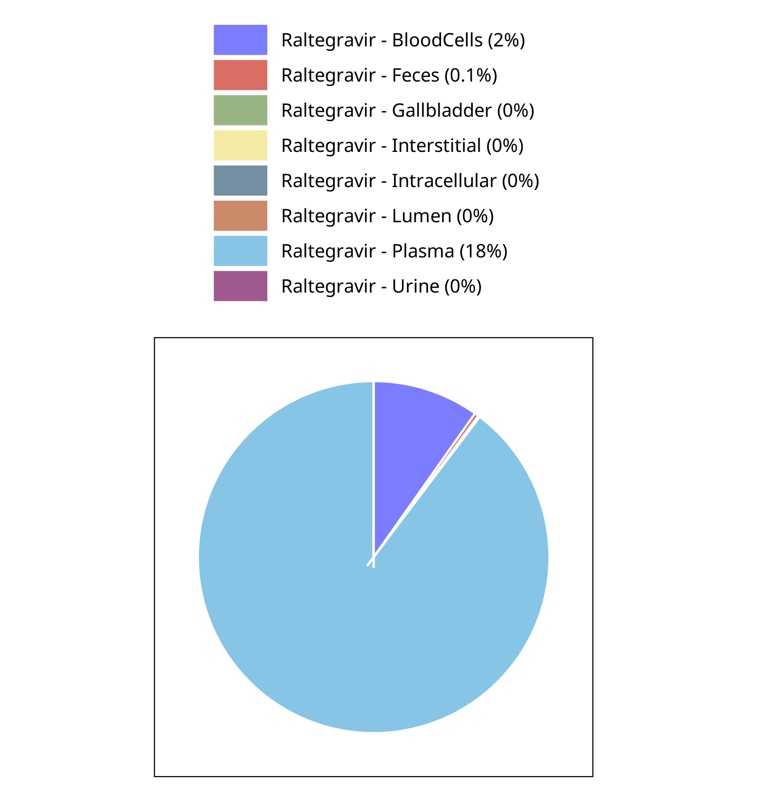

**Figure 4-55: Fraction of drug within the different compartments at 240.00h for Raltegravir**

## Mass Balance for Filmcoated_tablet_400mg_sd

### Mass Balance for Raltegravir

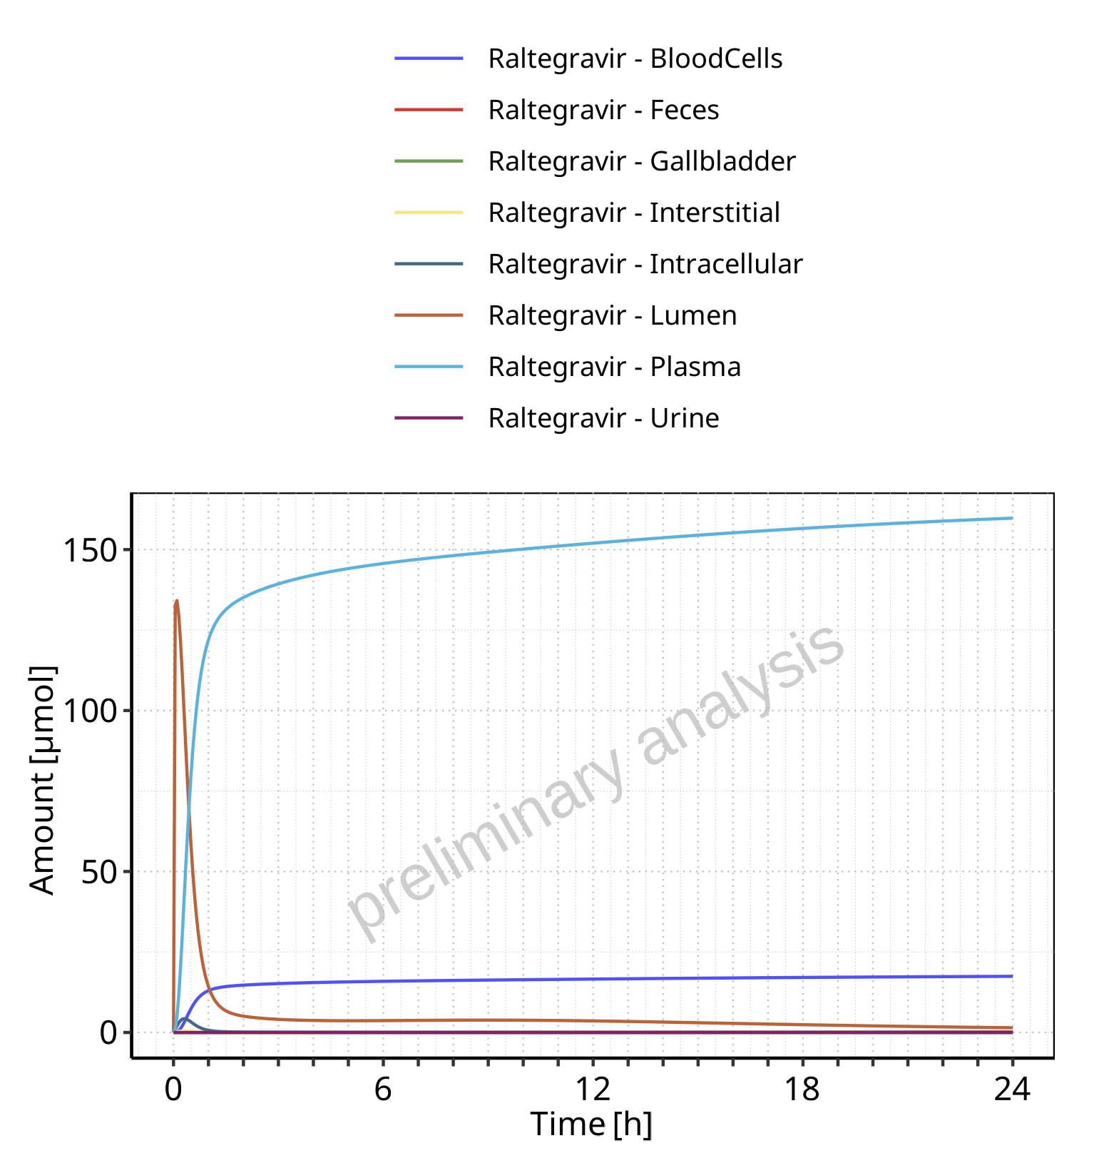

**Figure 4-56: Amount of drug vs time within the different compartments for Raltegravir**

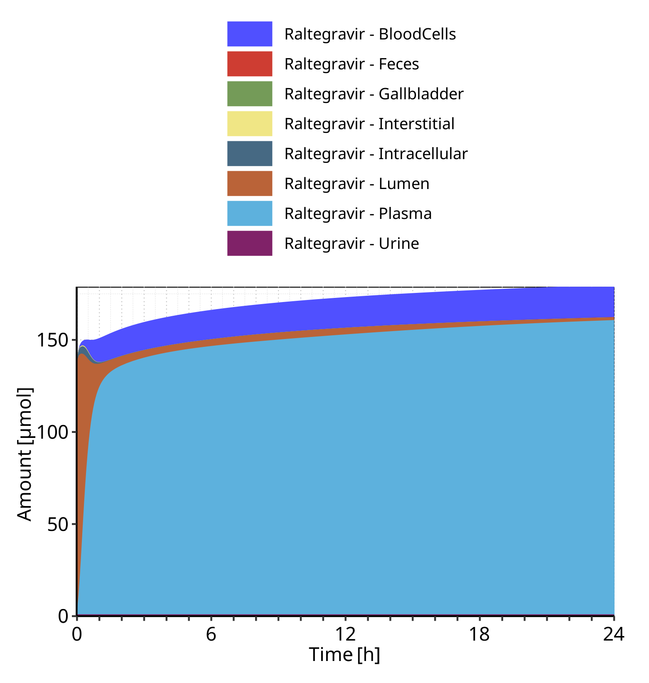

**Figure 4-57: Cumulated amount of drug vs time within the different compartments for Raltegravir**

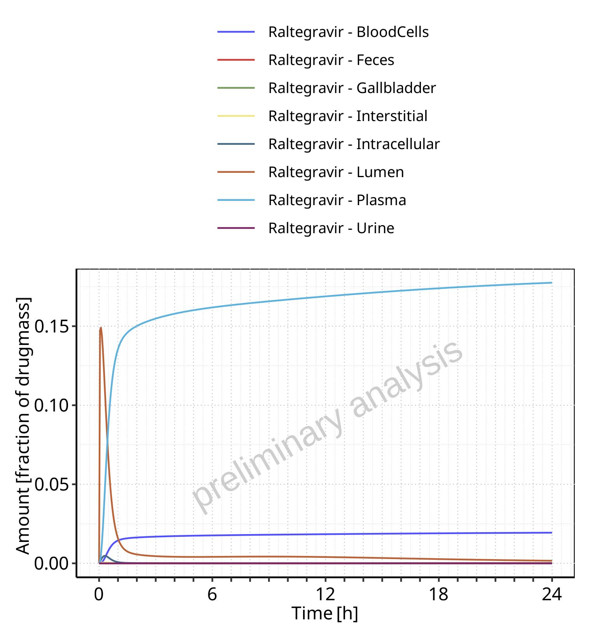

**Figure 4-58: Amount of drug vs time within the different compartments normalized to applicated drugmass for Raltegravir**

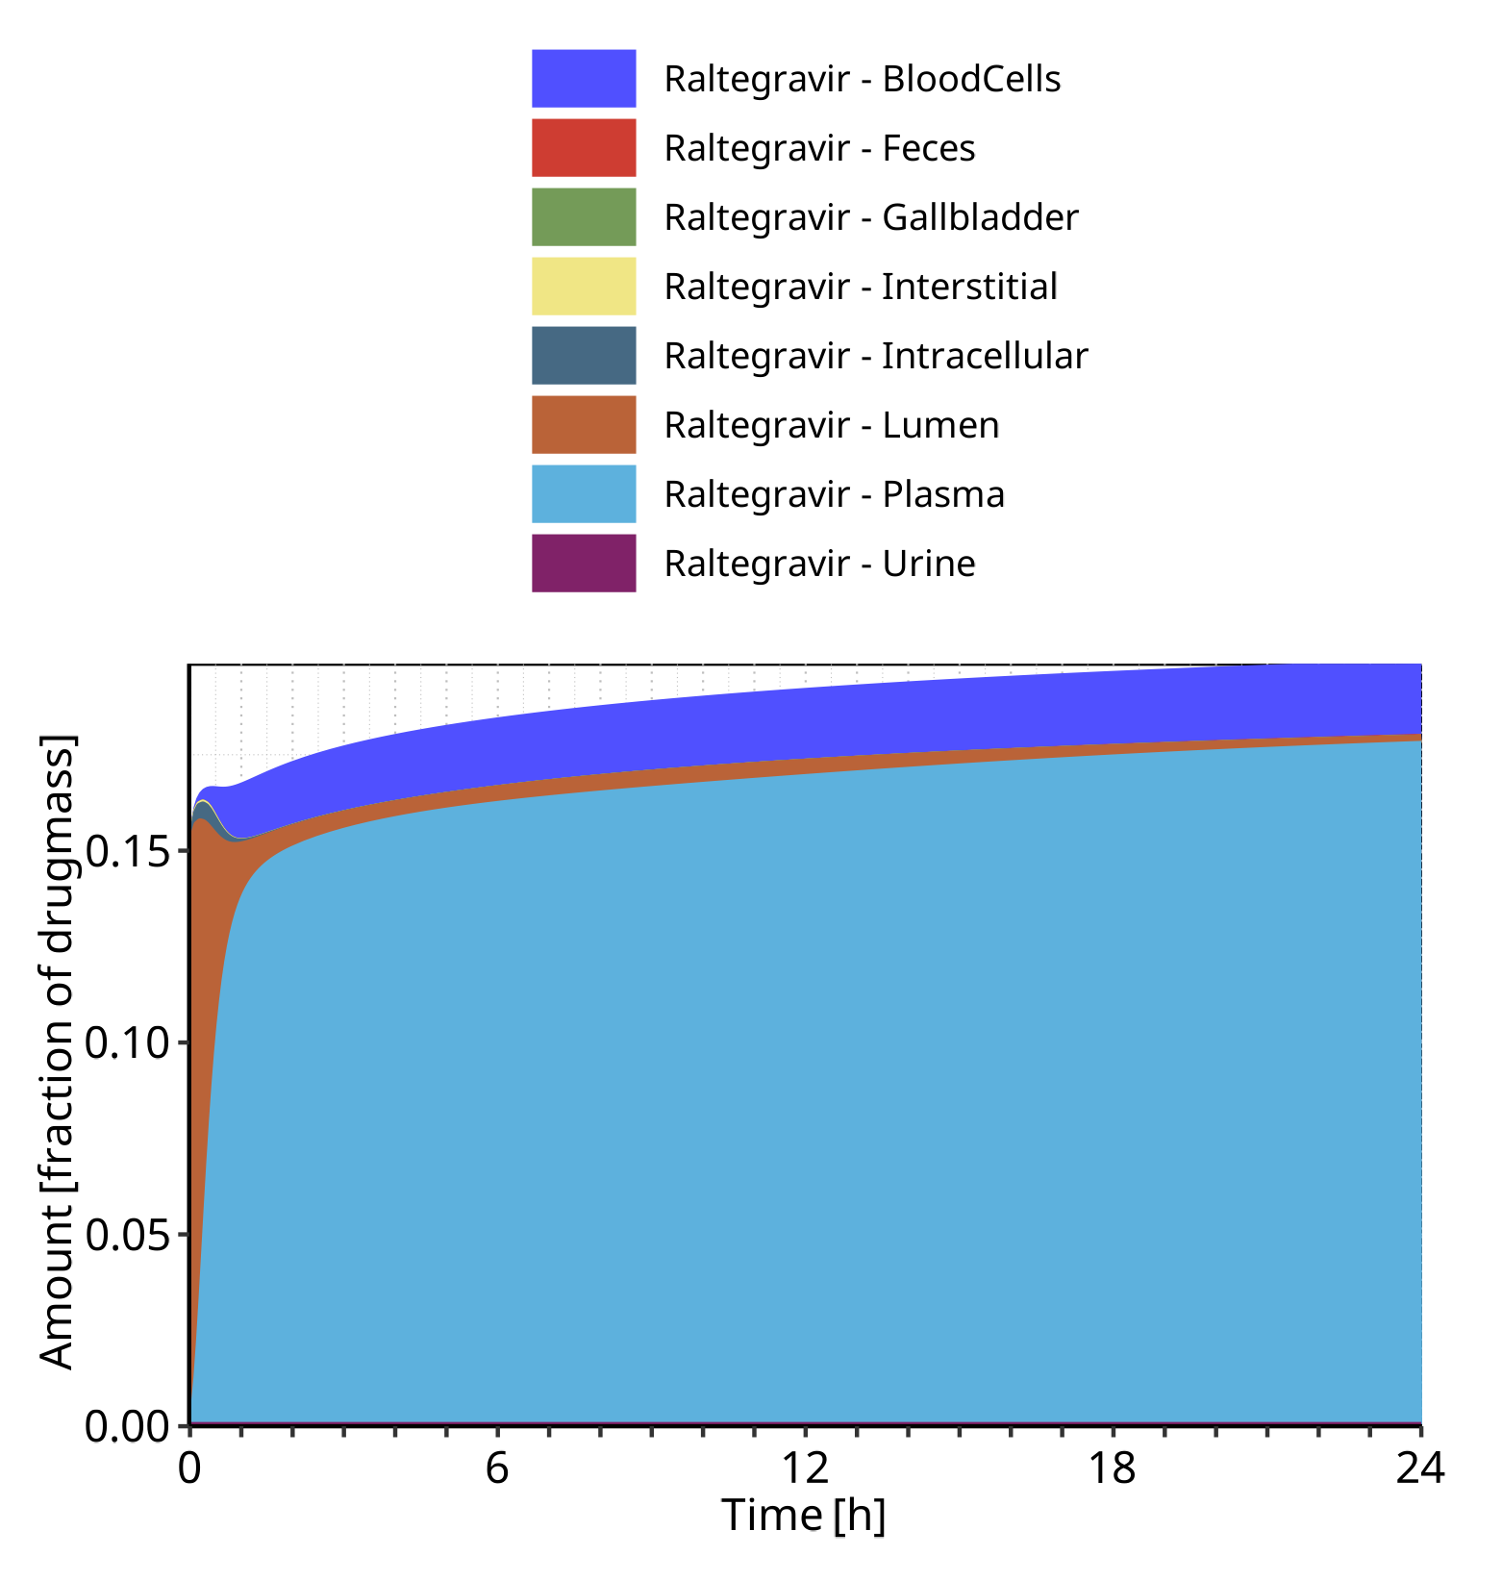

**Figure 4-59: Cumulated amount of drug vs time within the different compartments normalized to applicated drugmass for Raltegravir**

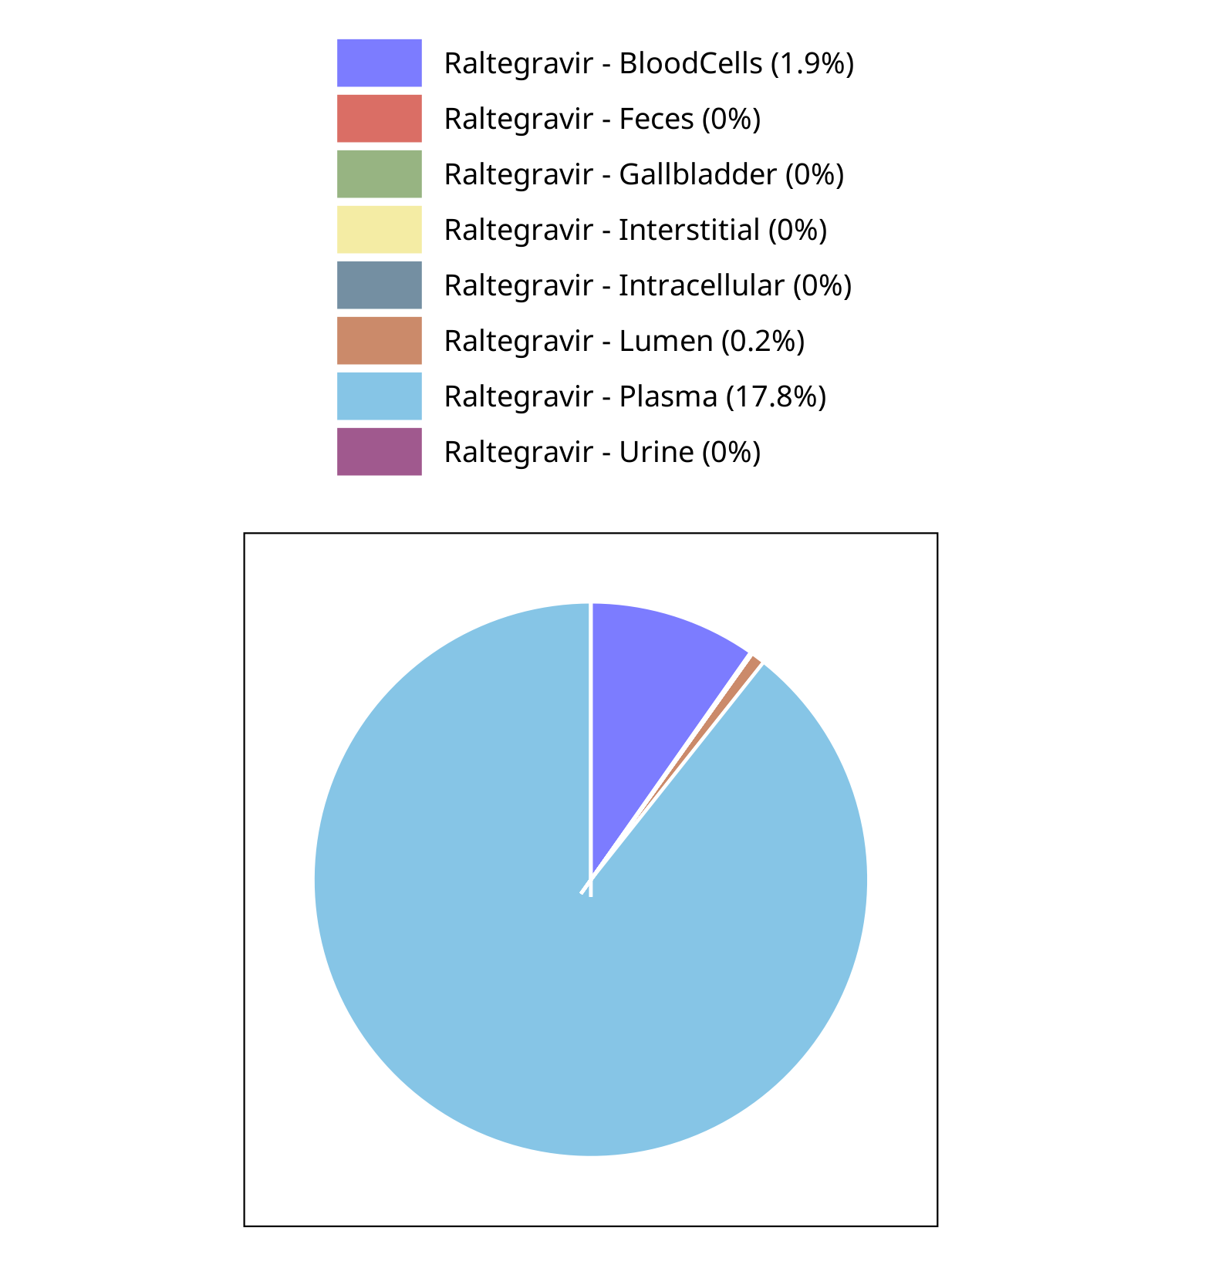

**Figure 4-60: Fraction of drug within the different compartments at 24.00h for Raltegravir**

## Mass Balance for Raltegravir 400 mg filmcoated tablet md

### Mass Balance for Raltegravir

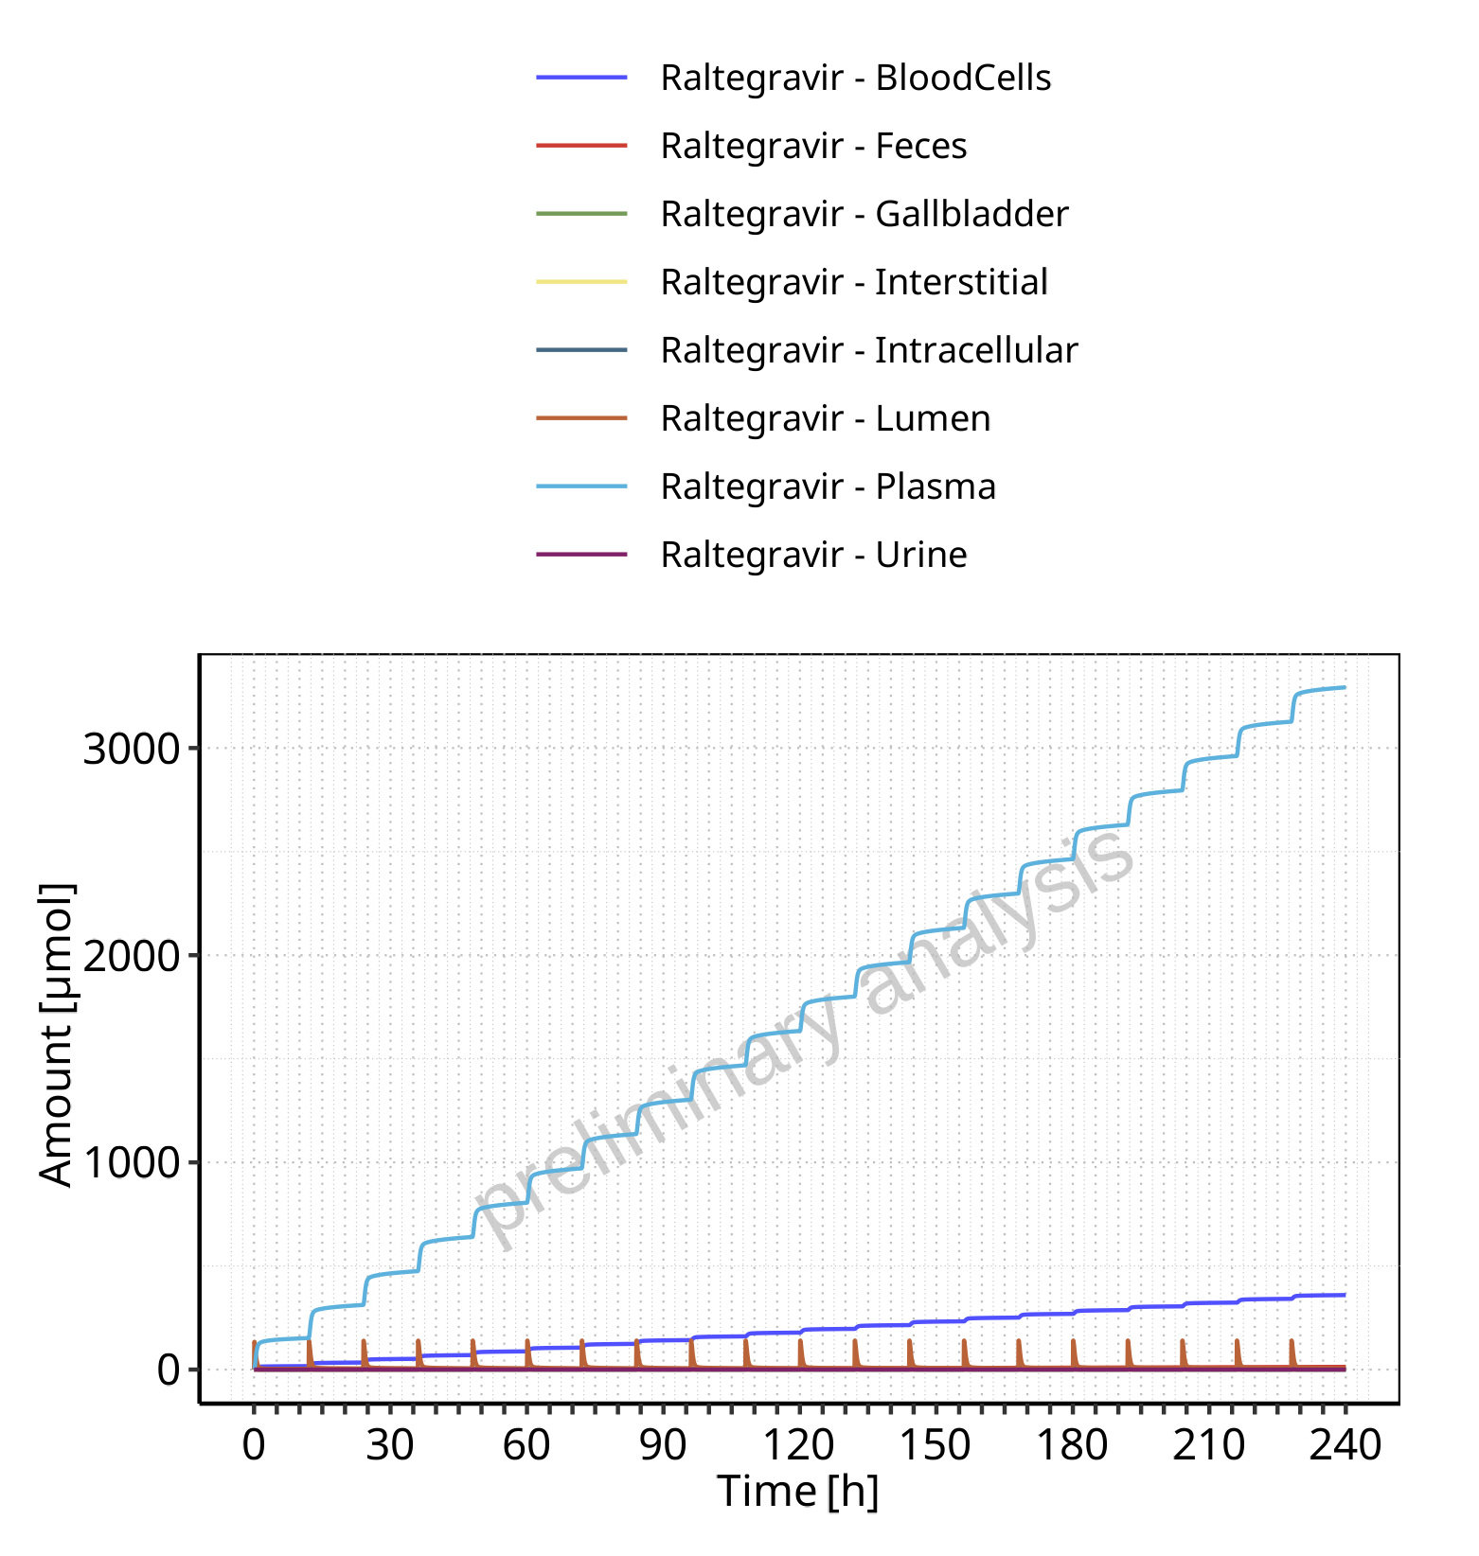

**Figure 4-61: Amount of drug vs time within the different compartments for Raltegravir**

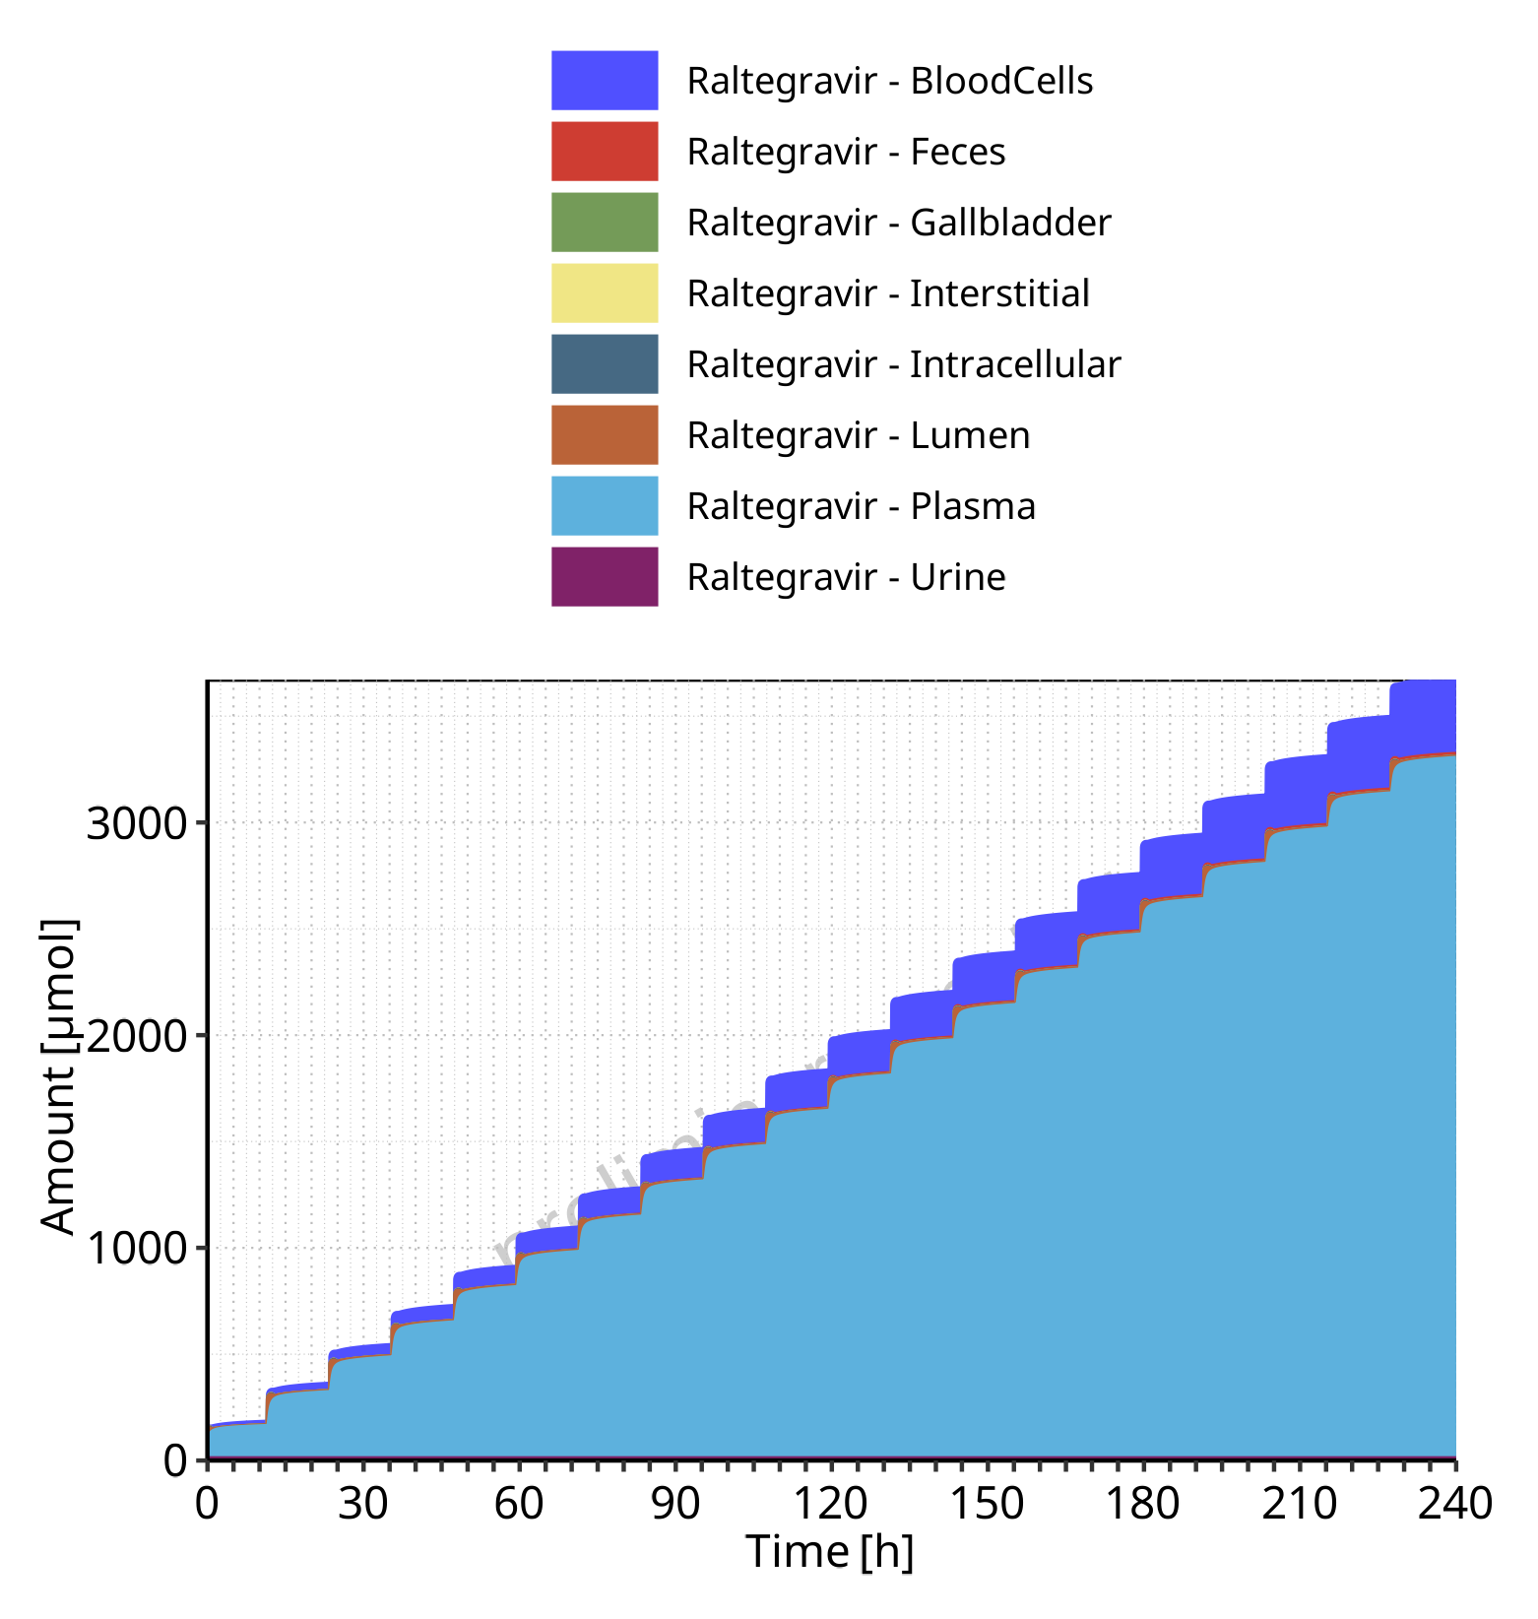

**Figure 4-62: Cumulated amount of drug vs time within the different compartments for Raltegravir**

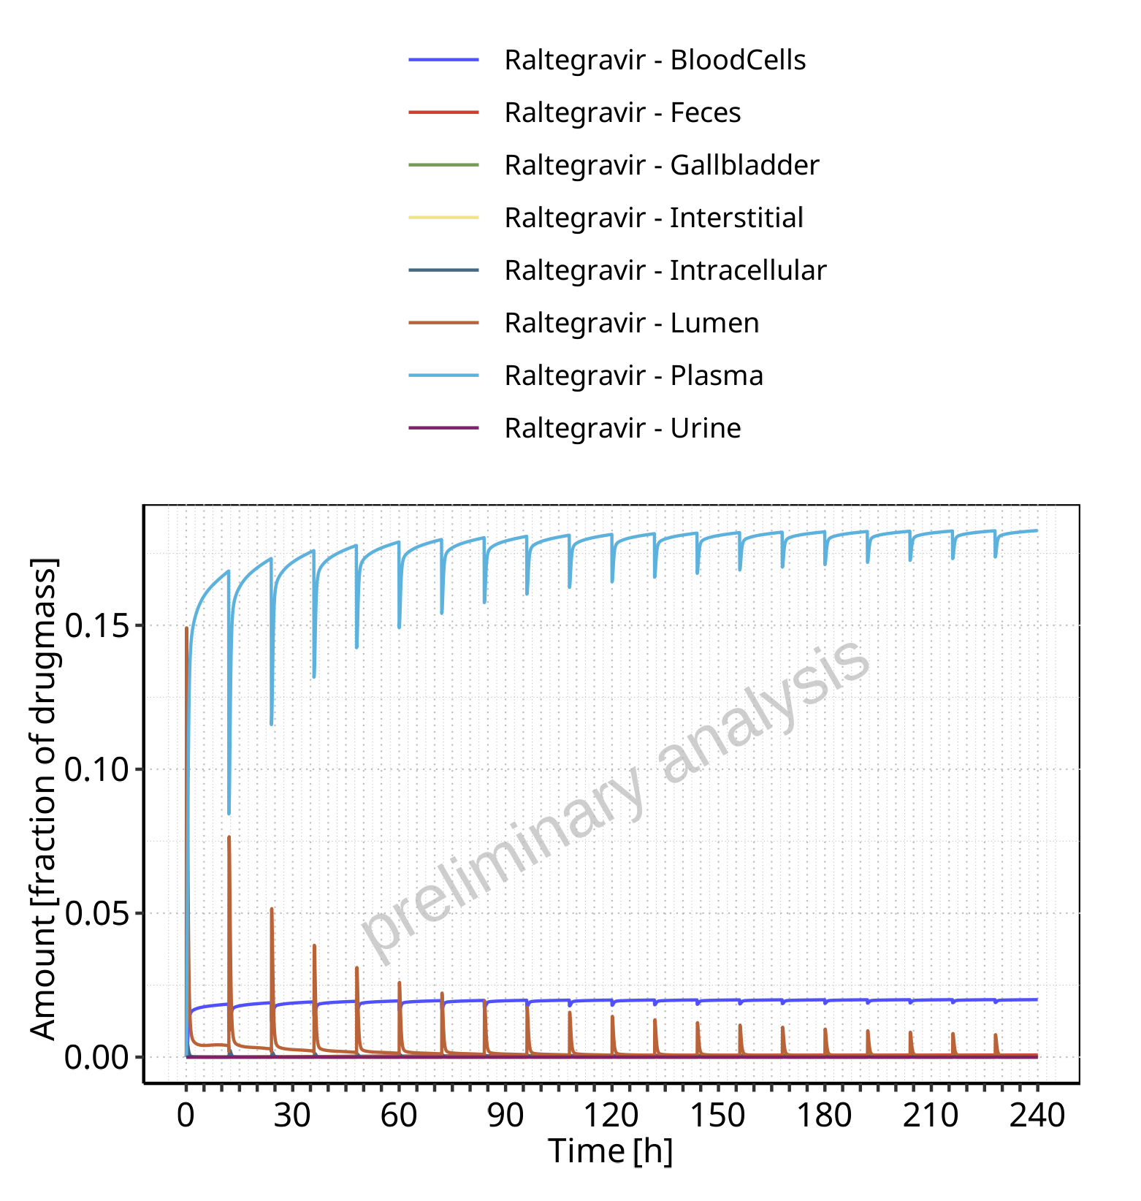

**Figure 4-63: Amount of drug vs time within the different compartments normalized to applicated drugmass for Raltegravir**

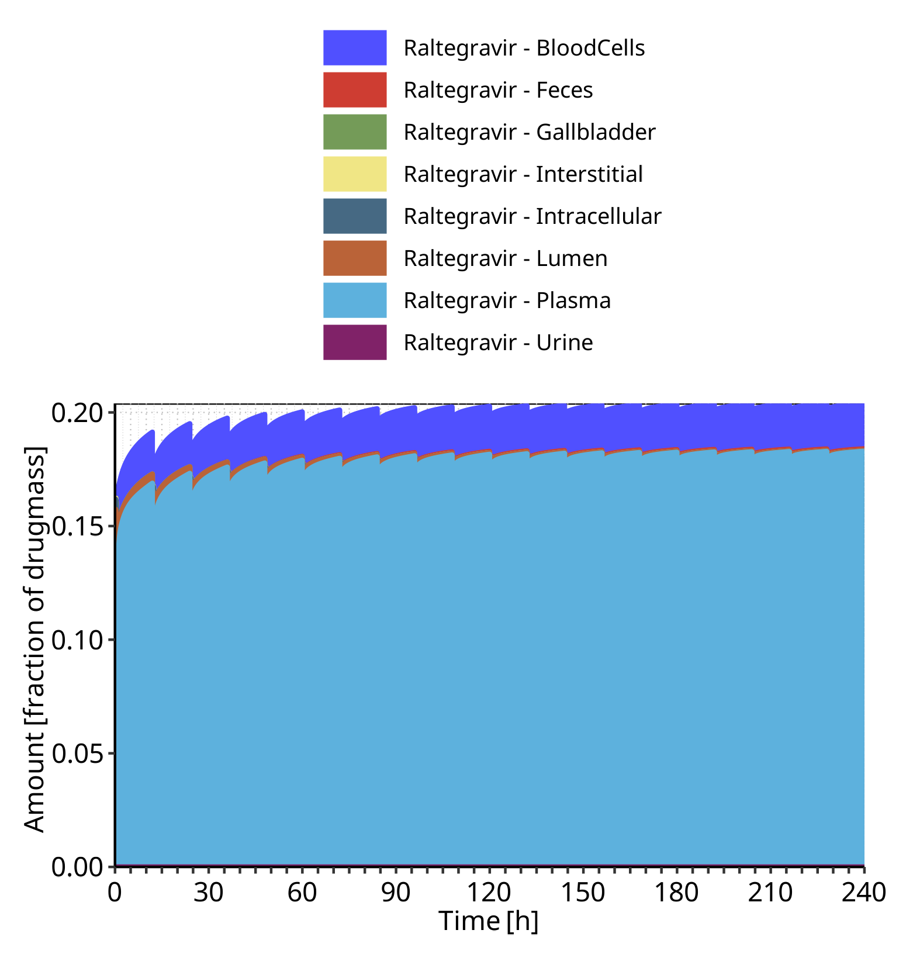

**Figure 4-64: Cumulated amount of drug vs time within the different compartments normalized to applicated drugmass for Raltegravir**

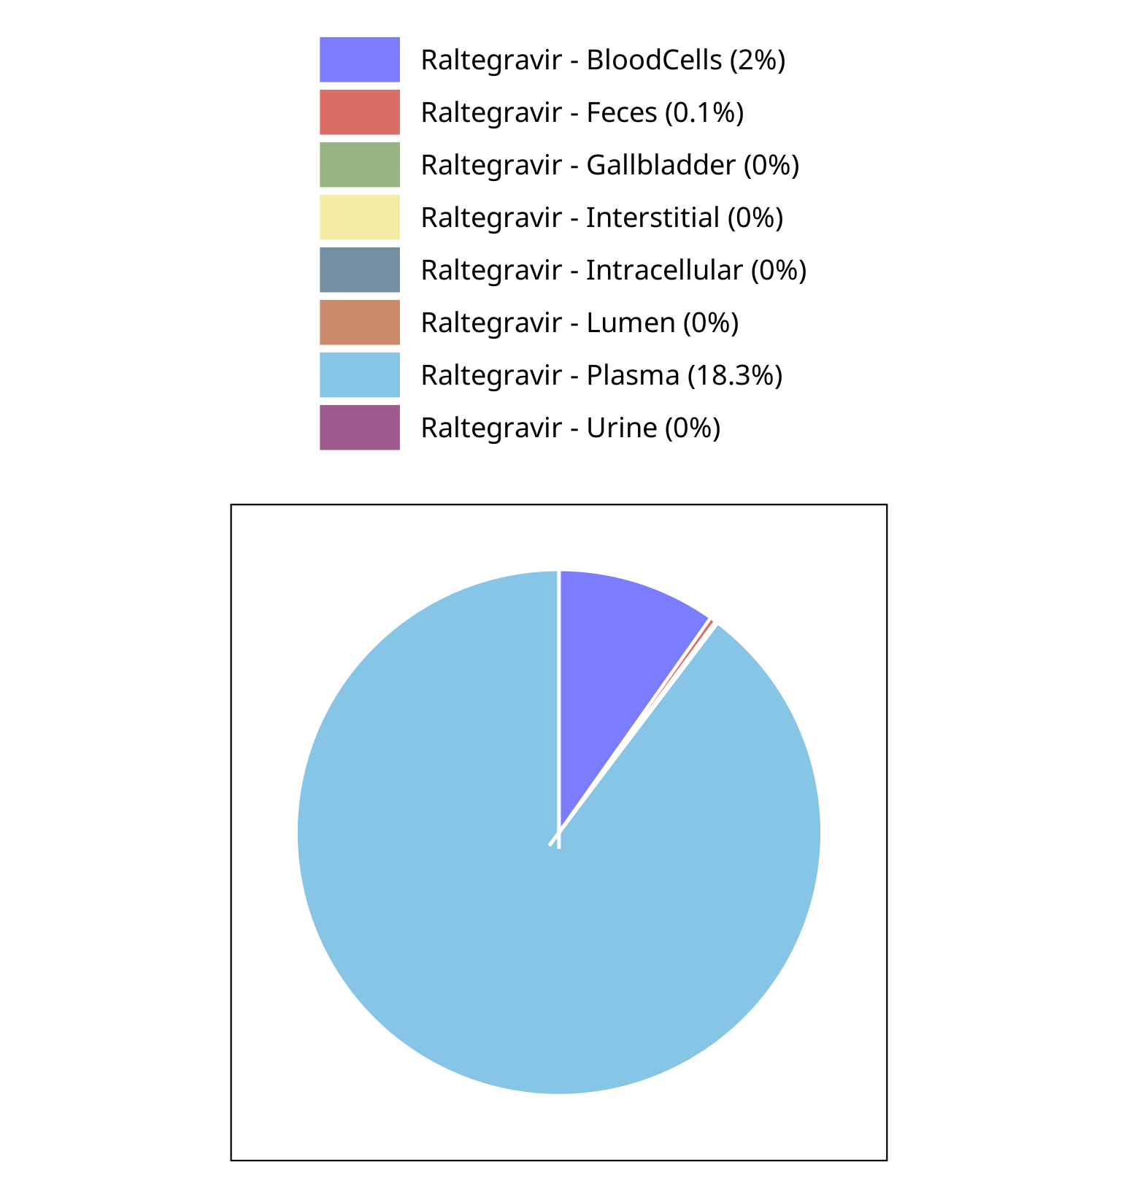

**Figure 4-65: Fraction of drug within the different compartments at 240.00h for Raltegravir**

## Mass Balance for Raltegravir 400mg chewable fasted

### Mass Balance for Raltegravir

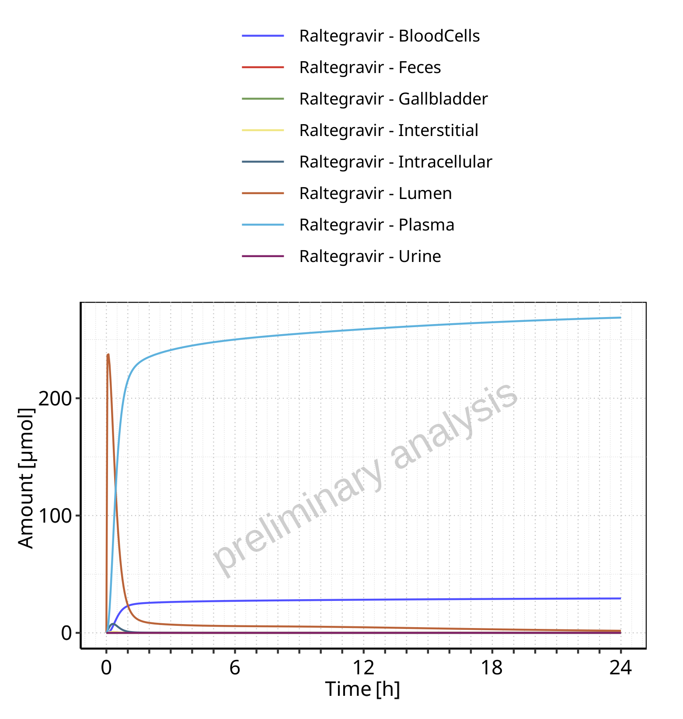

**Figure 4-66: Amount of drug vs time within the different compartments for Raltegravir**

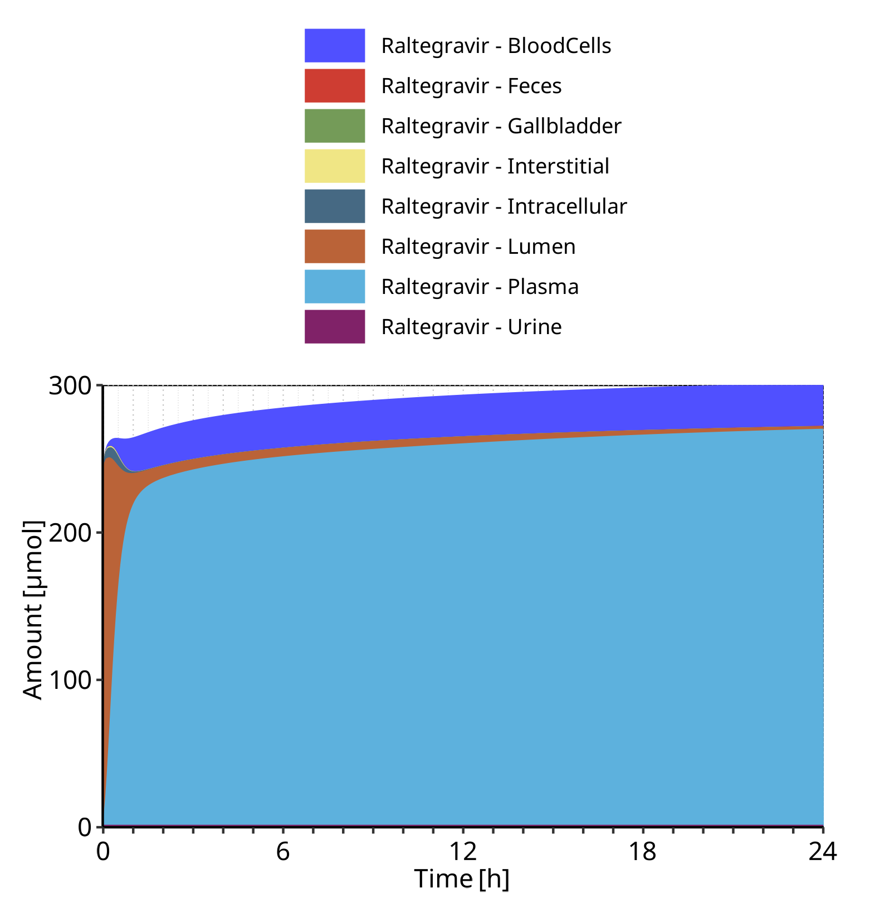

**Figure 4-67: Cumulated amount of drug vs time within the different compartments for Raltegravir**

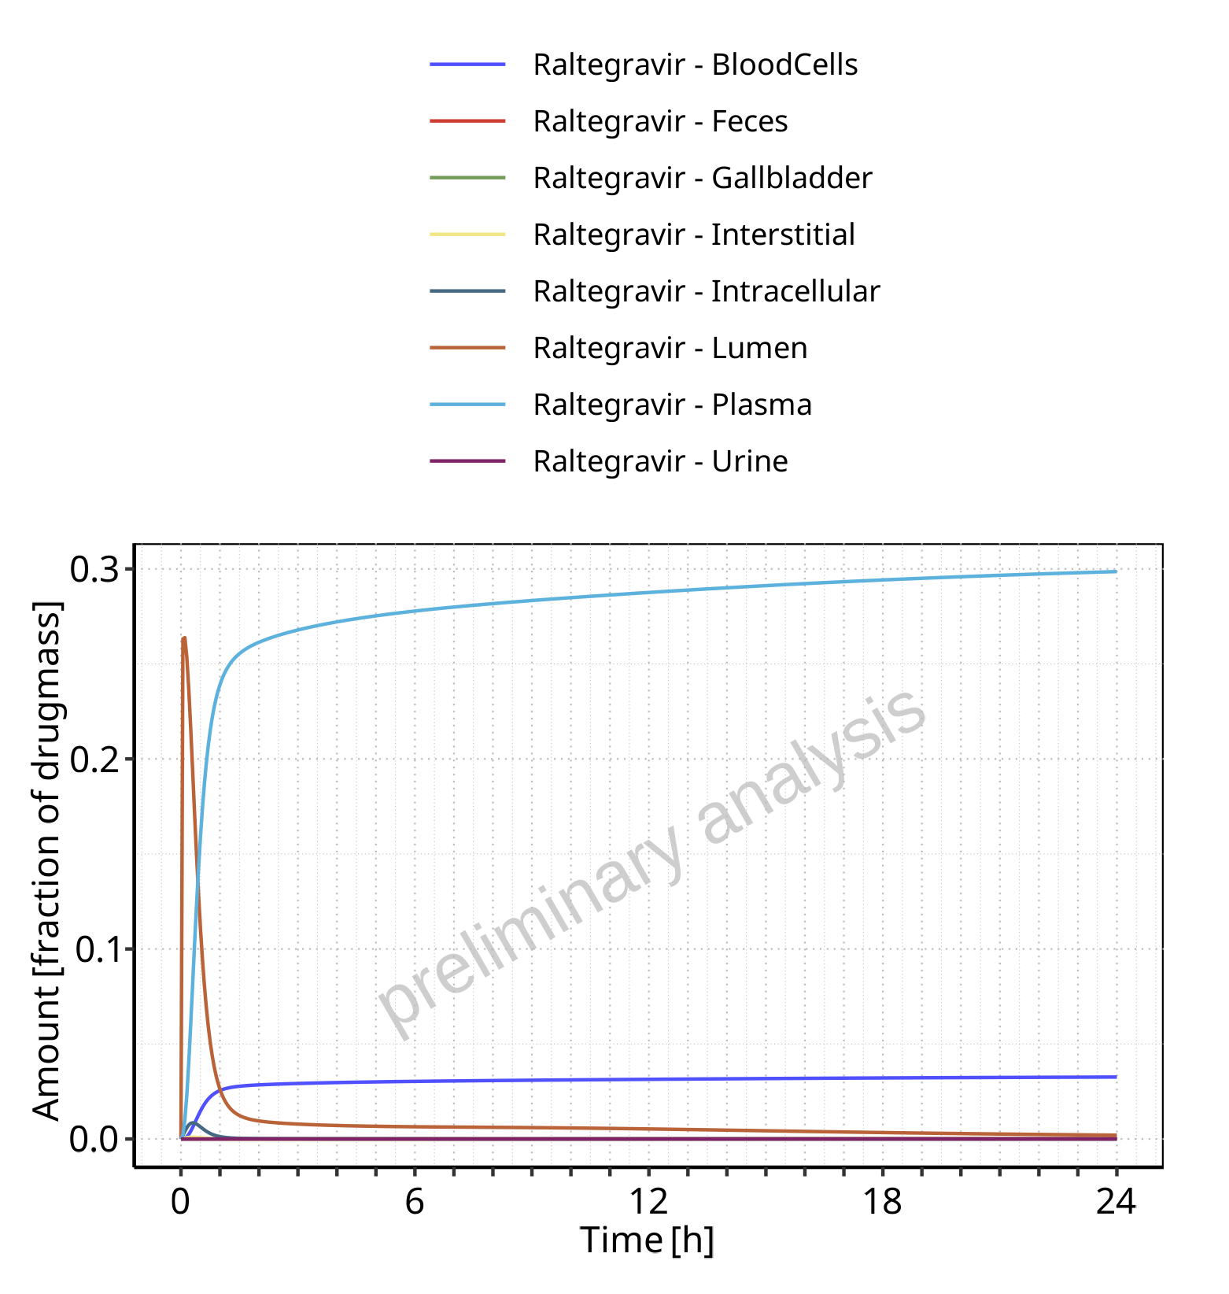

**Figure 4-68: Amount of drug vs time within the different compartments normalized to applicated drugmass for Raltegravir**

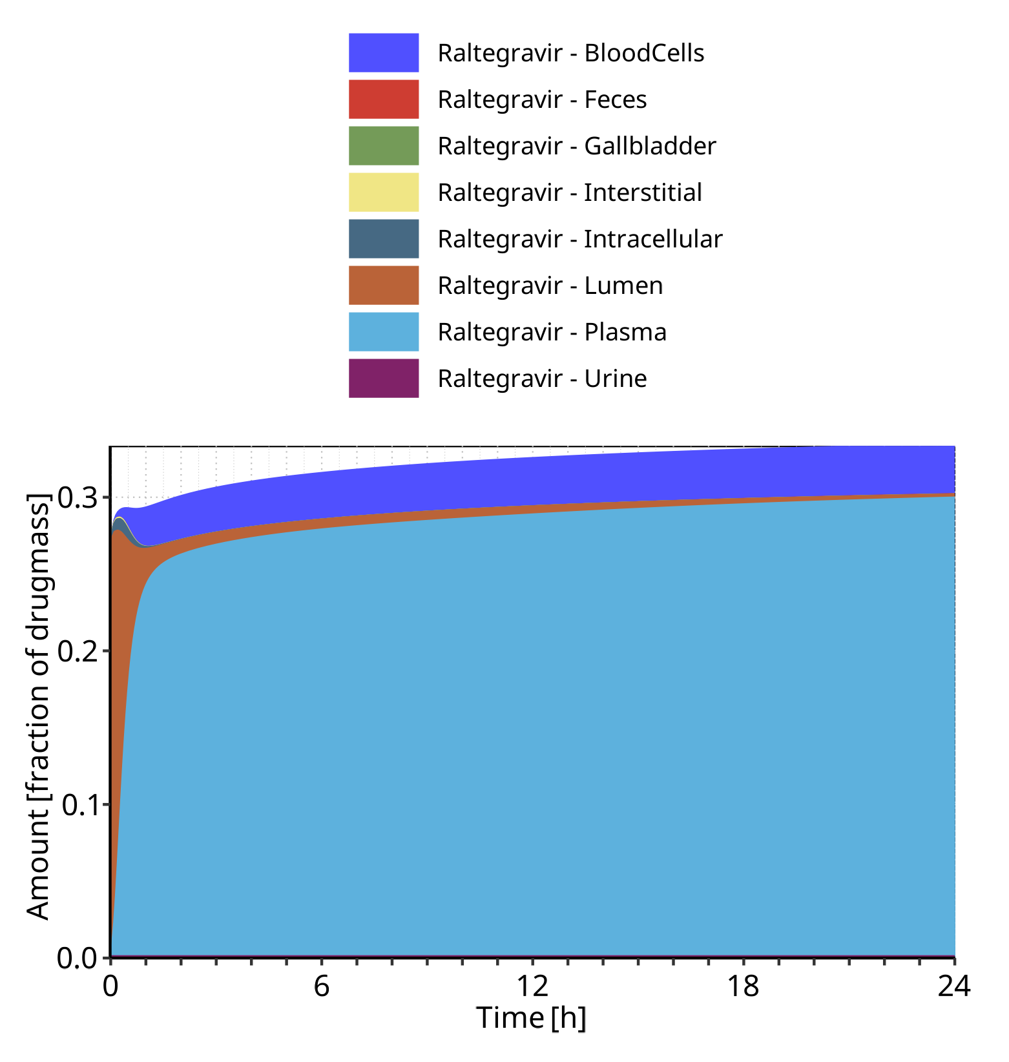

**Figure 4-69: Cumulated amount of drug vs time within the different compartments normalized to applicated drugmass for Raltegravir**

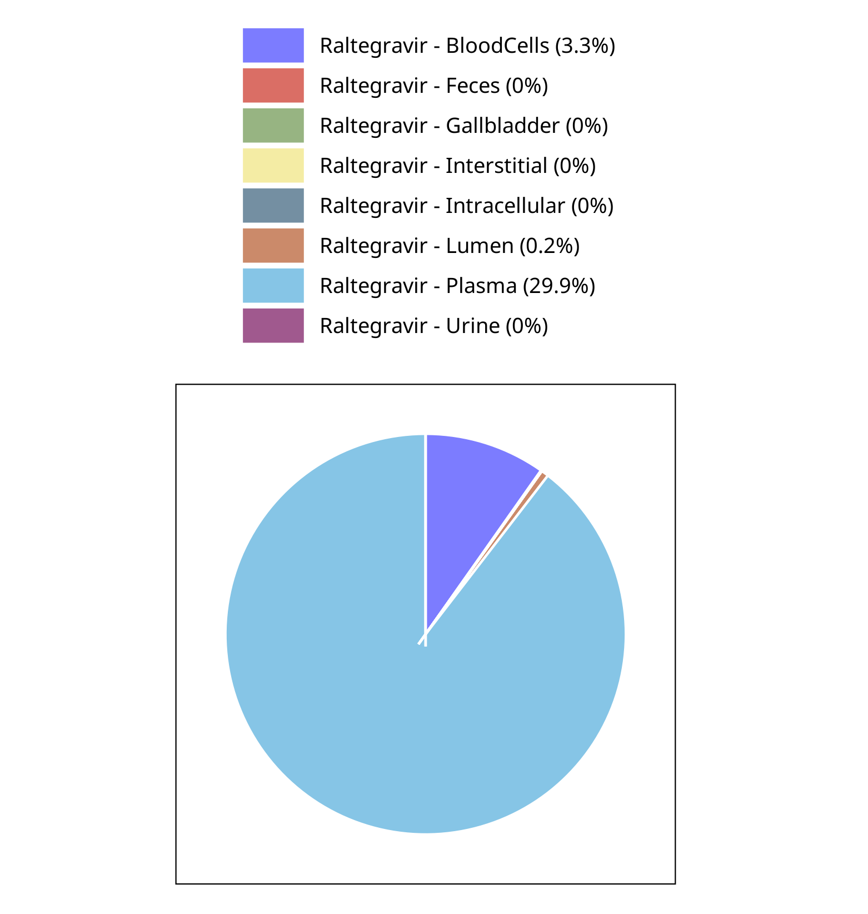

**Figure 4-70: Fraction of drug within the different compartments at 24.00h for Raltegravir**

## Mass Balance for Raltegravir 400mg chewable fed

### Mass Balance for Raltegravir

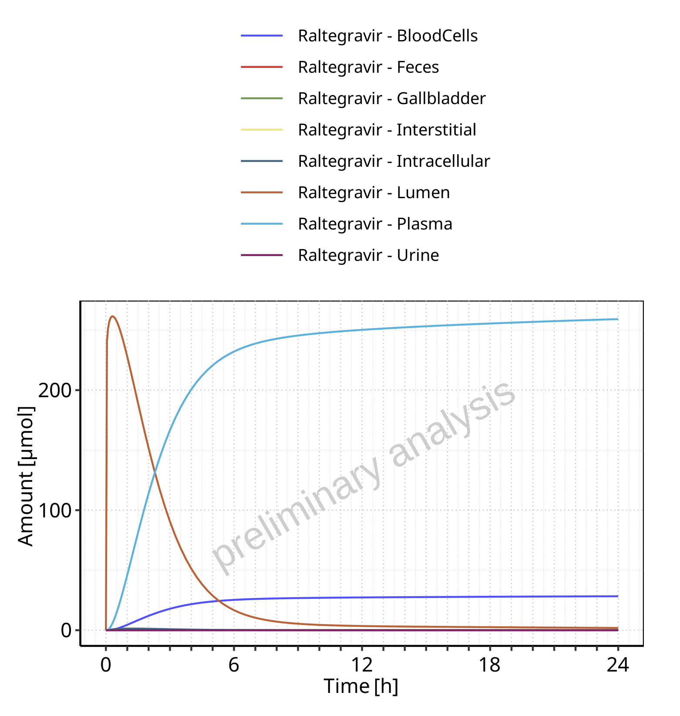

**Figure 4-71: Amount of drug vs time within the different compartments for Raltegravir**

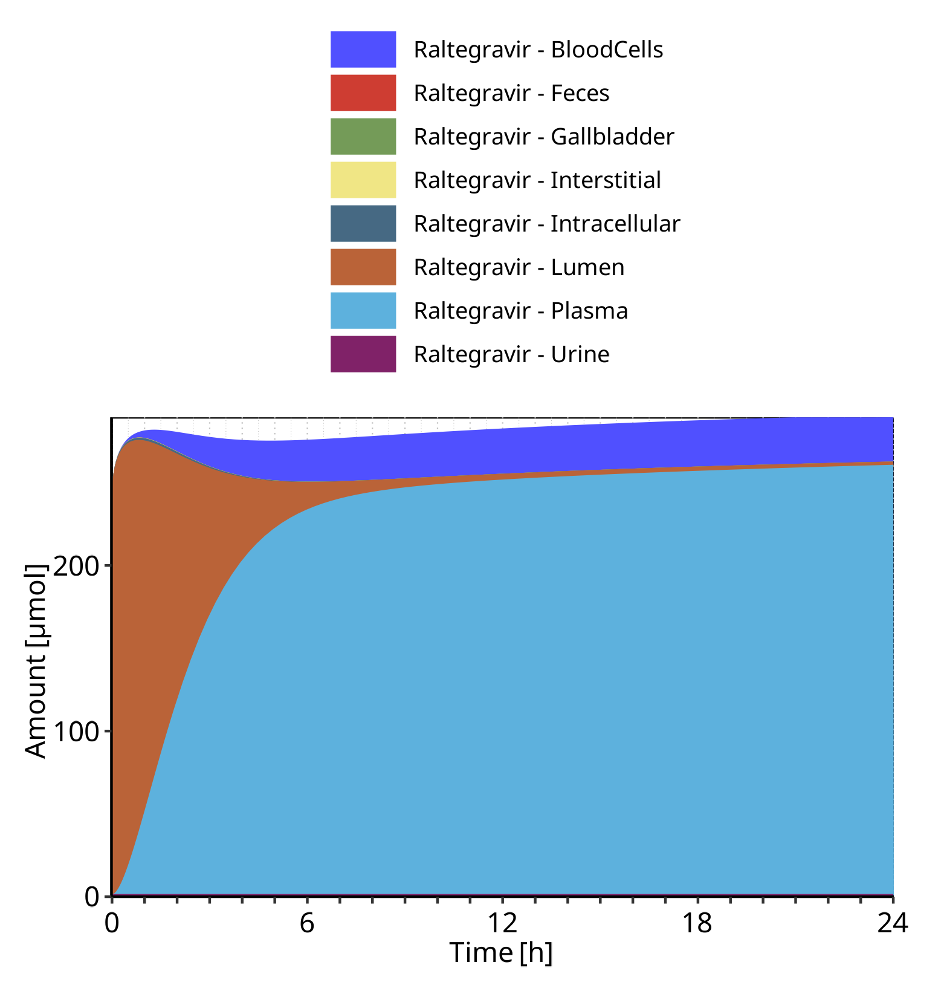

**Figure 4-72: Cumulated amount of drug vs time within the different compartments for Raltegravir**

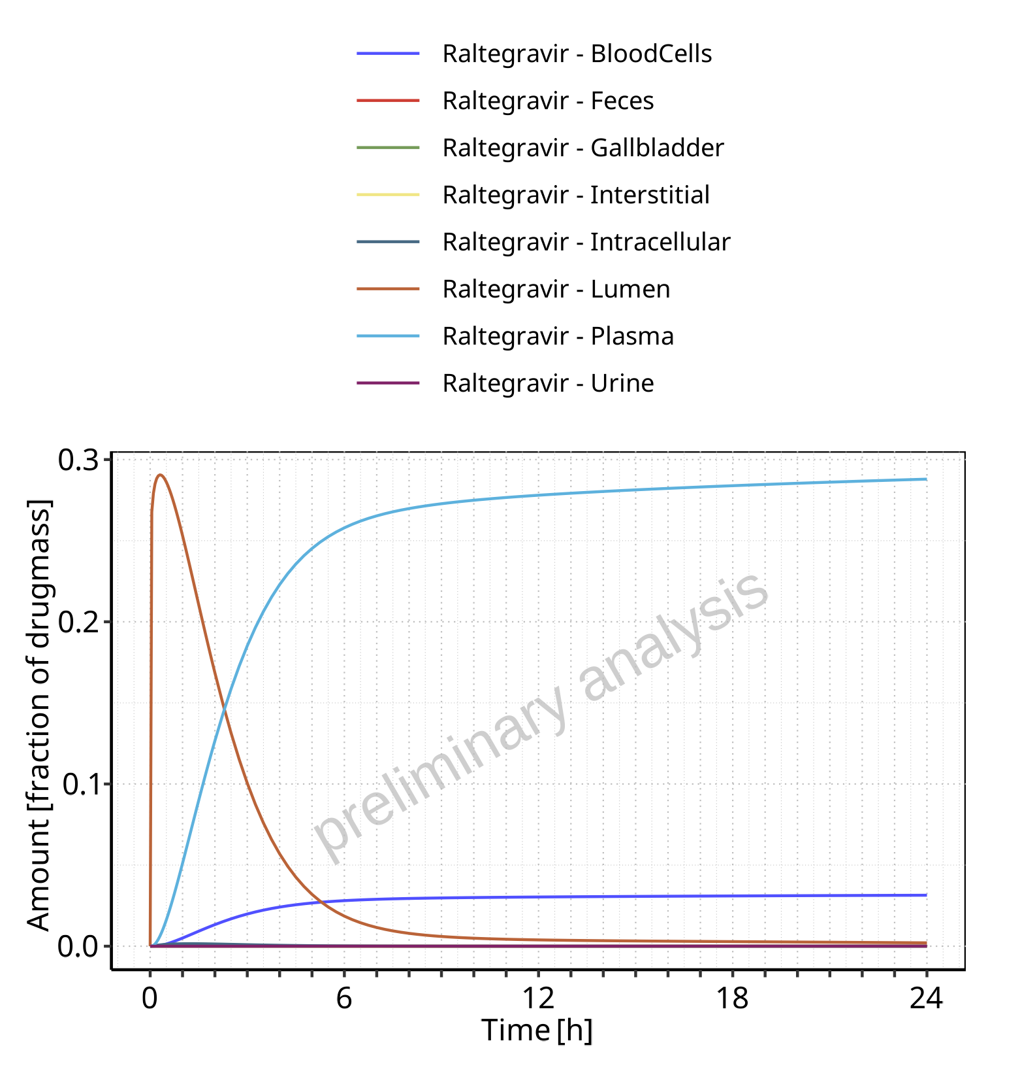

**Figure 4-73: Amount of drug vs time within the different compartments normalized to applicated drugmass for Raltegravir**

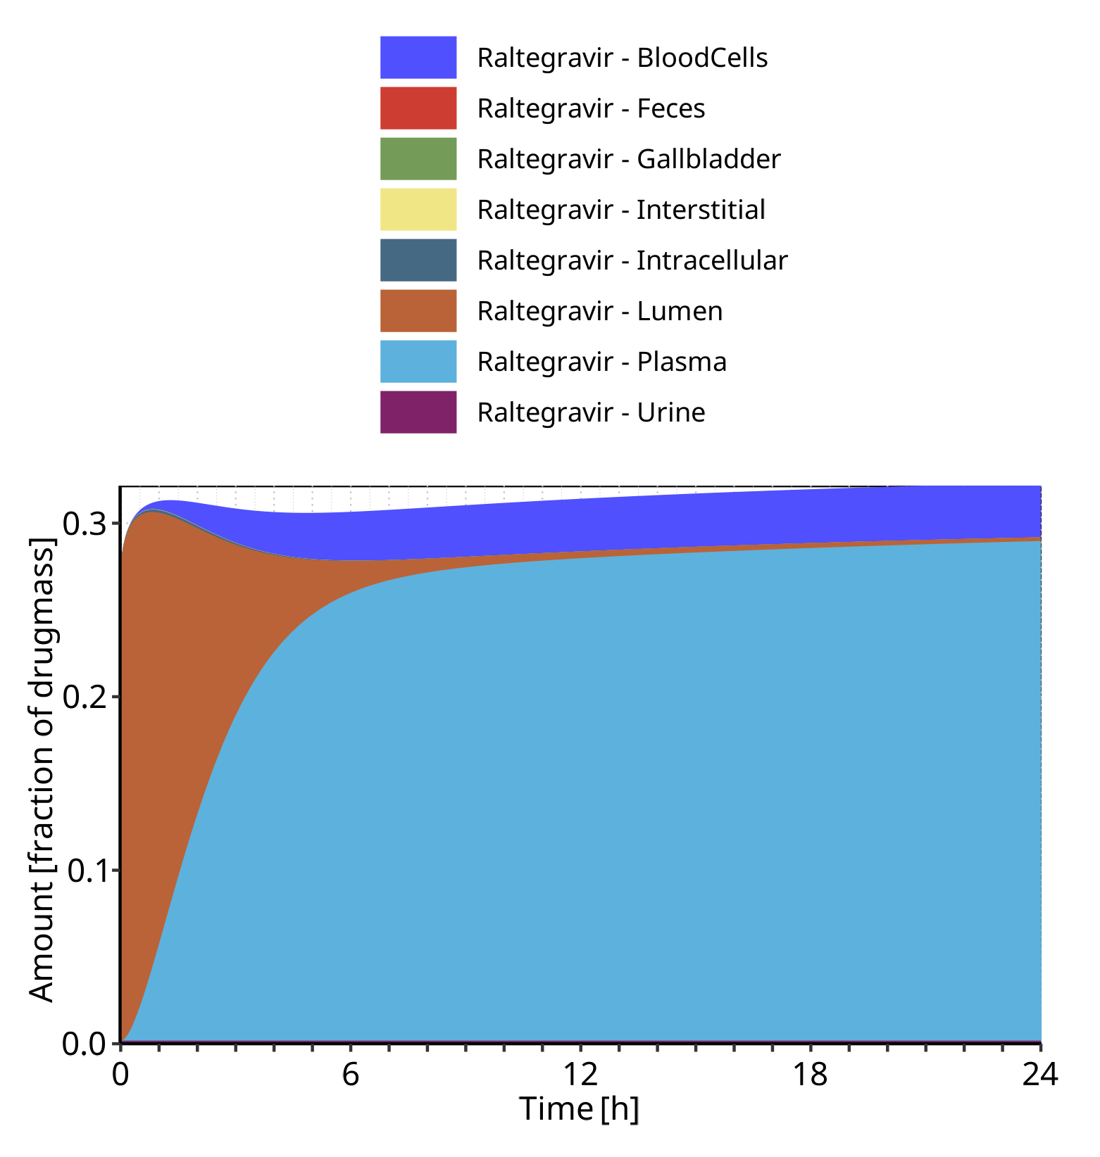

**Figure 4-74: Cumulated amount of drug vs time within the different compartments normalized to applicated drugmass for Raltegravir**

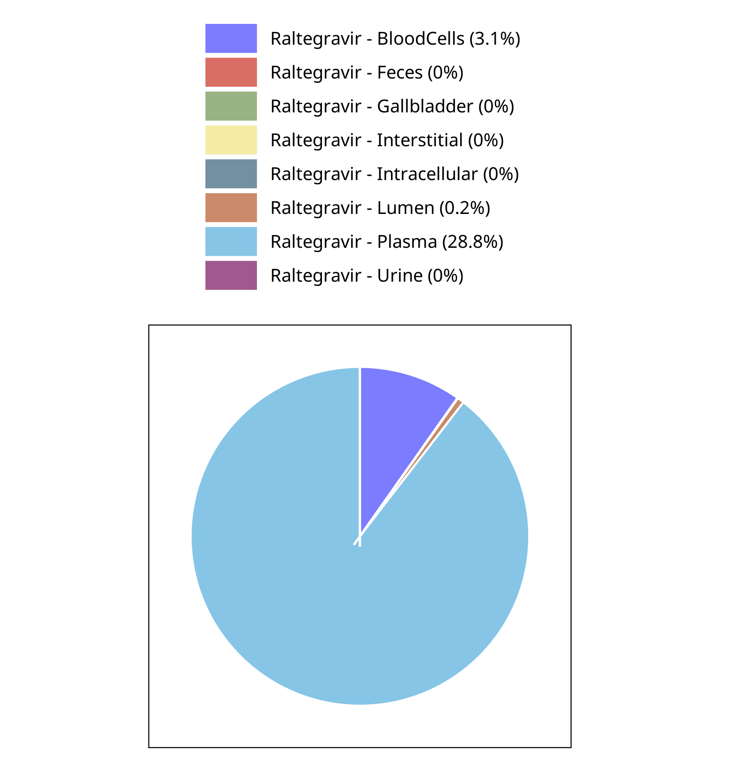

**Figure 4-75: Fraction of drug within the different compartments at 24.00h for Raltegravir**

## Mass Balance for Raltegravir 400mg (granules in suspension)

### Mass Balance for Raltegravir

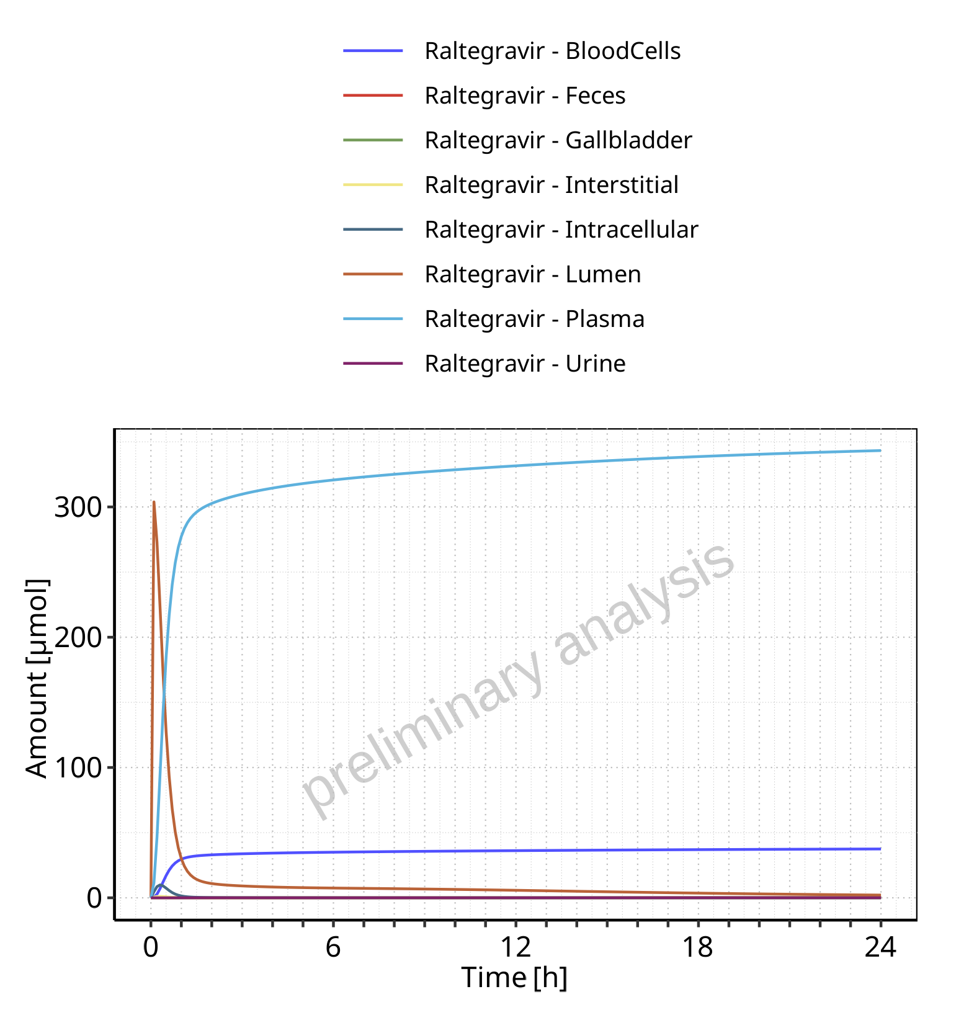

**Figure 4-76: Amount of drug vs time within the different compartments for Raltegravir**

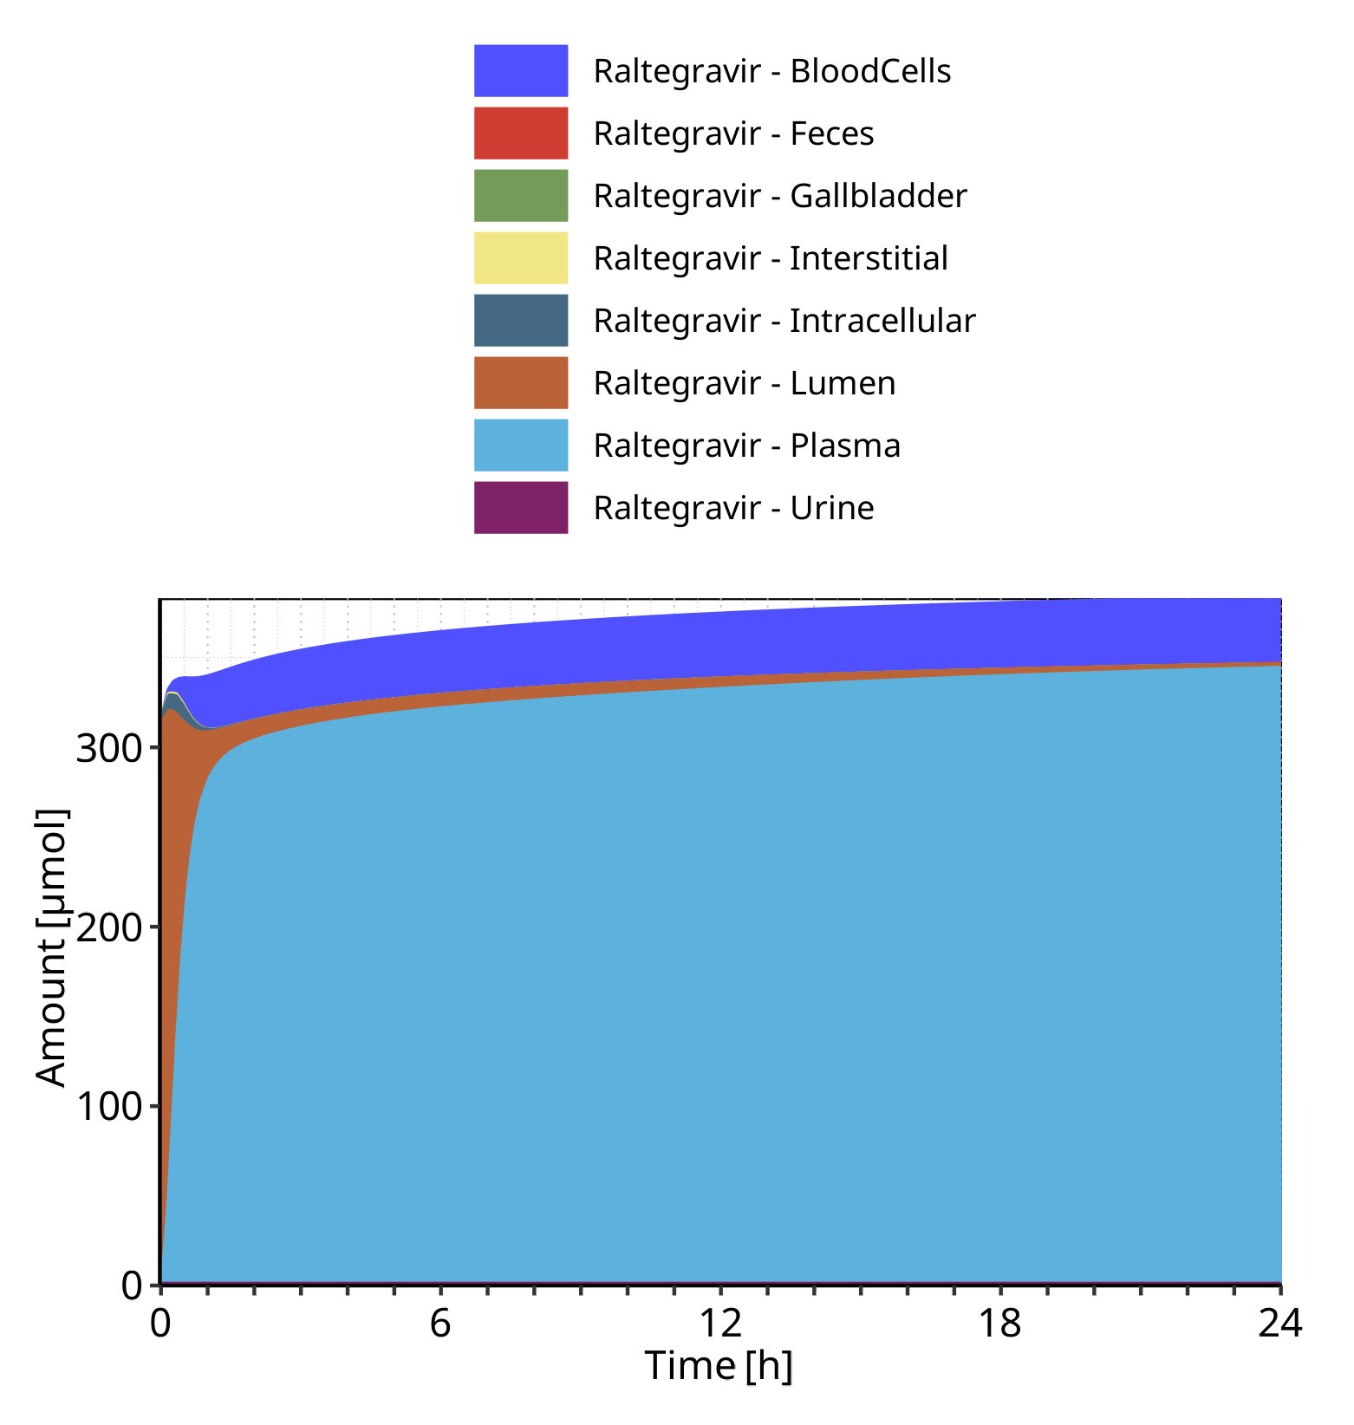

**Figure 4-77: Cumulated amount of drug vs time within the different compartments for Raltegravir**

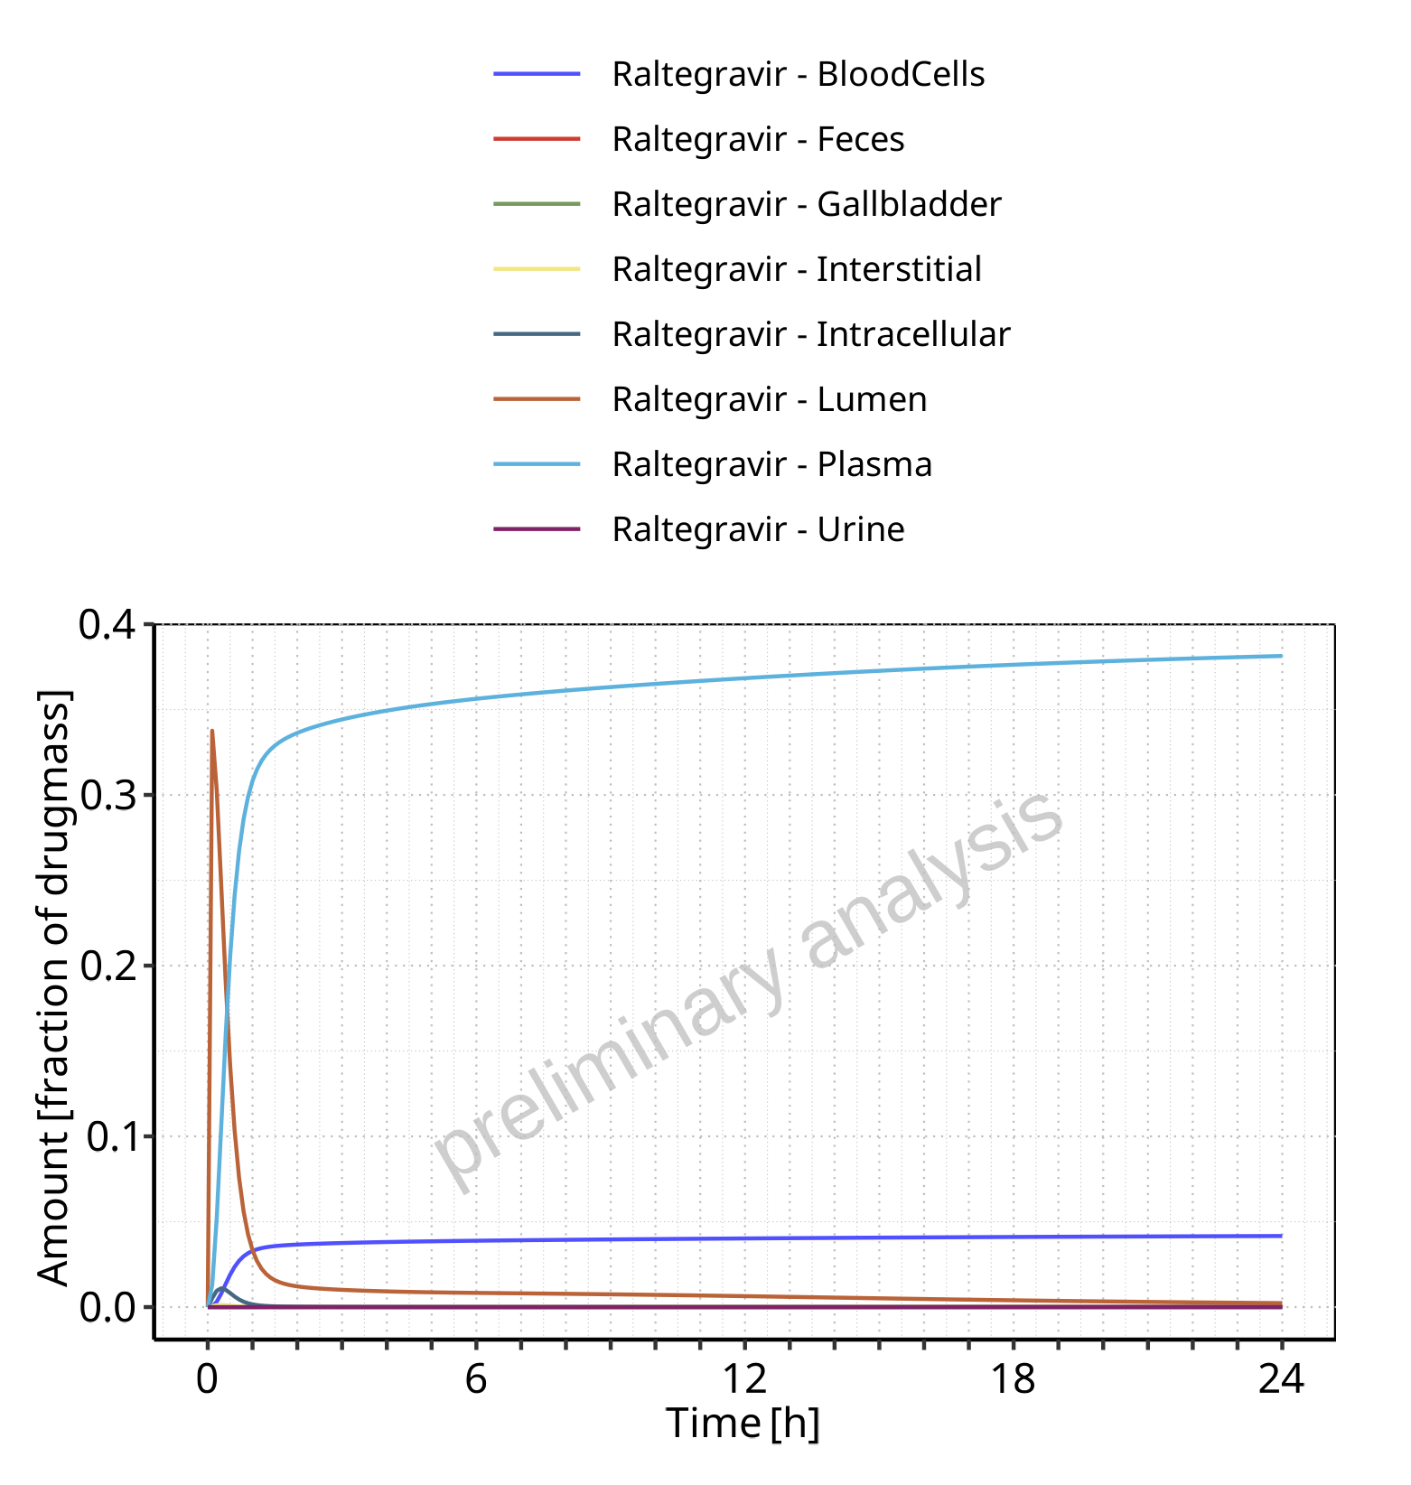

**Figure 4-78: Amount of drug vs time within the different compartments normalized to applicated drugmass for Raltegravir**

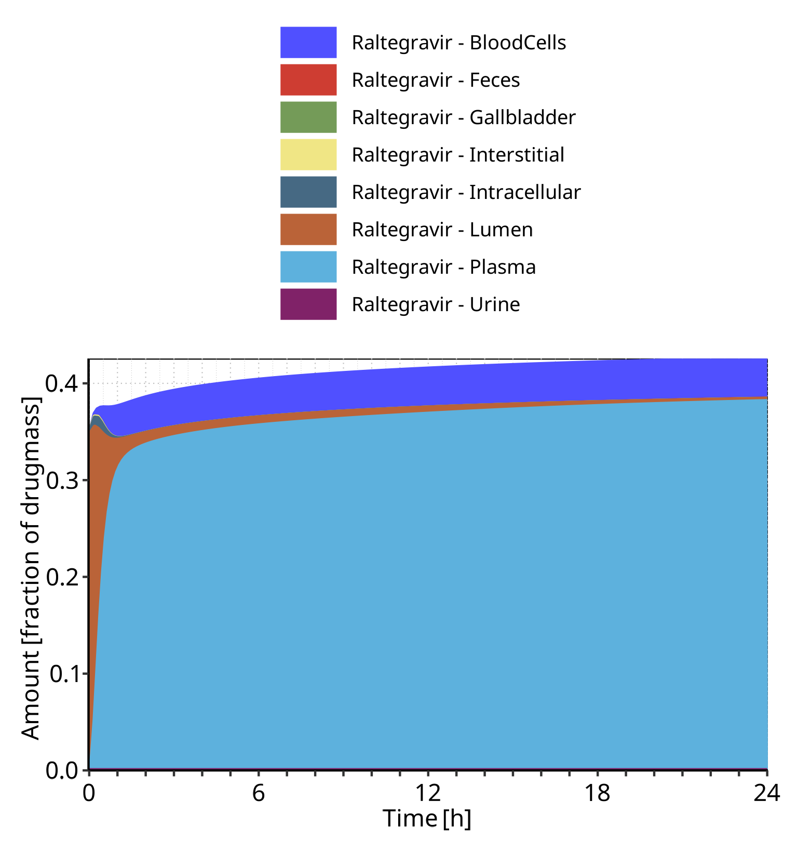

**Figure 4-79: Cumulated amount of drug vs time within the different compartments normalized to applicated drugmass for Raltegravir**

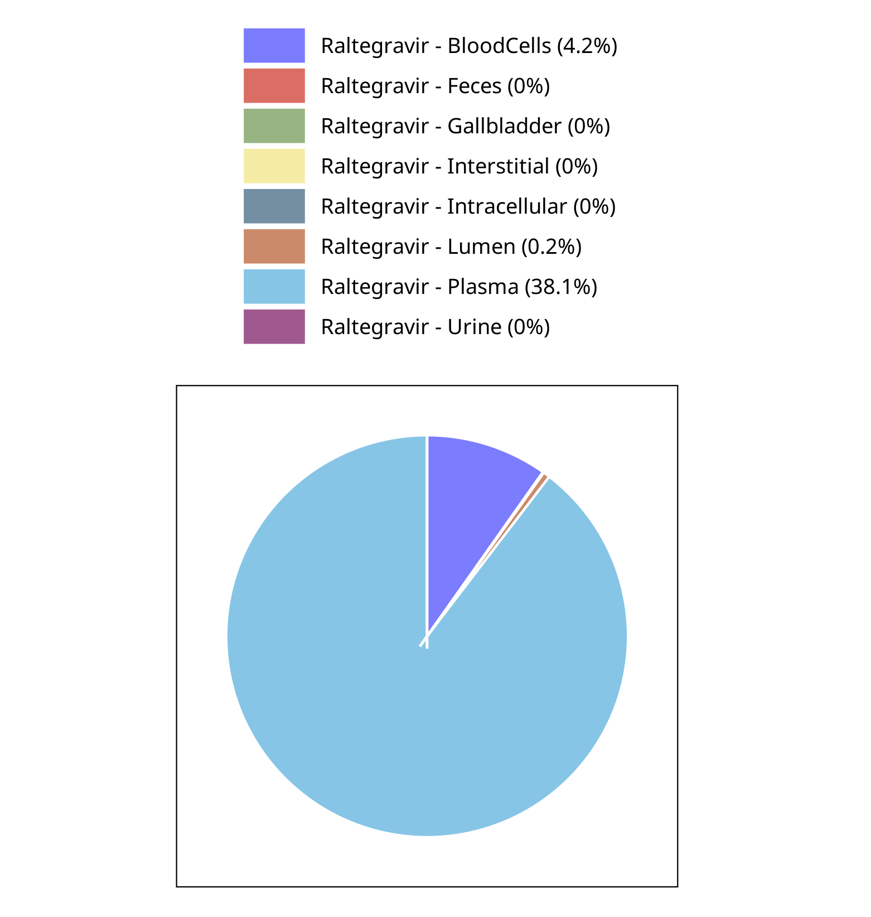

**Figure 4-80: Fraction of drug within the different compartments at 24.00h for Raltegravir**

# Time profiles and residual plots

## Time profiles and residual plots for Raltegravir 10 mg (lactose formulation)

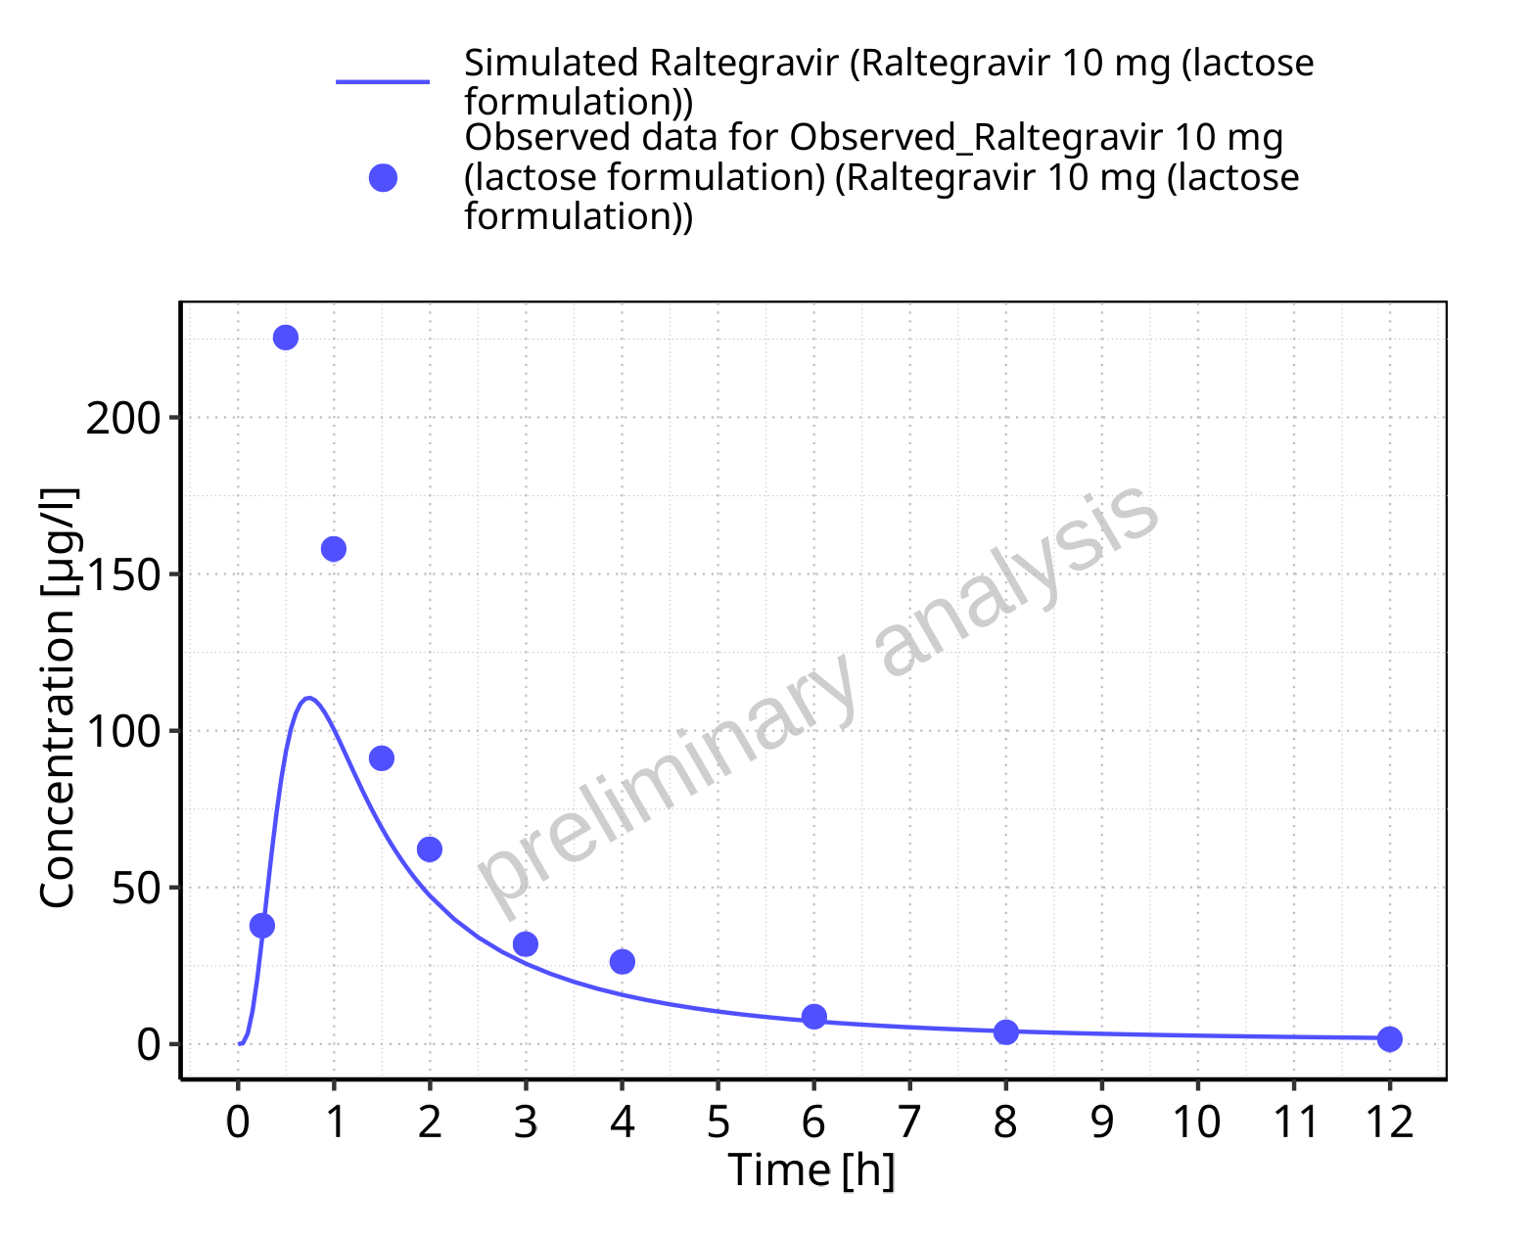

**Figure 5-1: Time profiles for Raltegravir 10 mg (lactose formulation). Data source: Data/Raltegravir_PK.txt. Time profiles are plotted in a linear scale.**

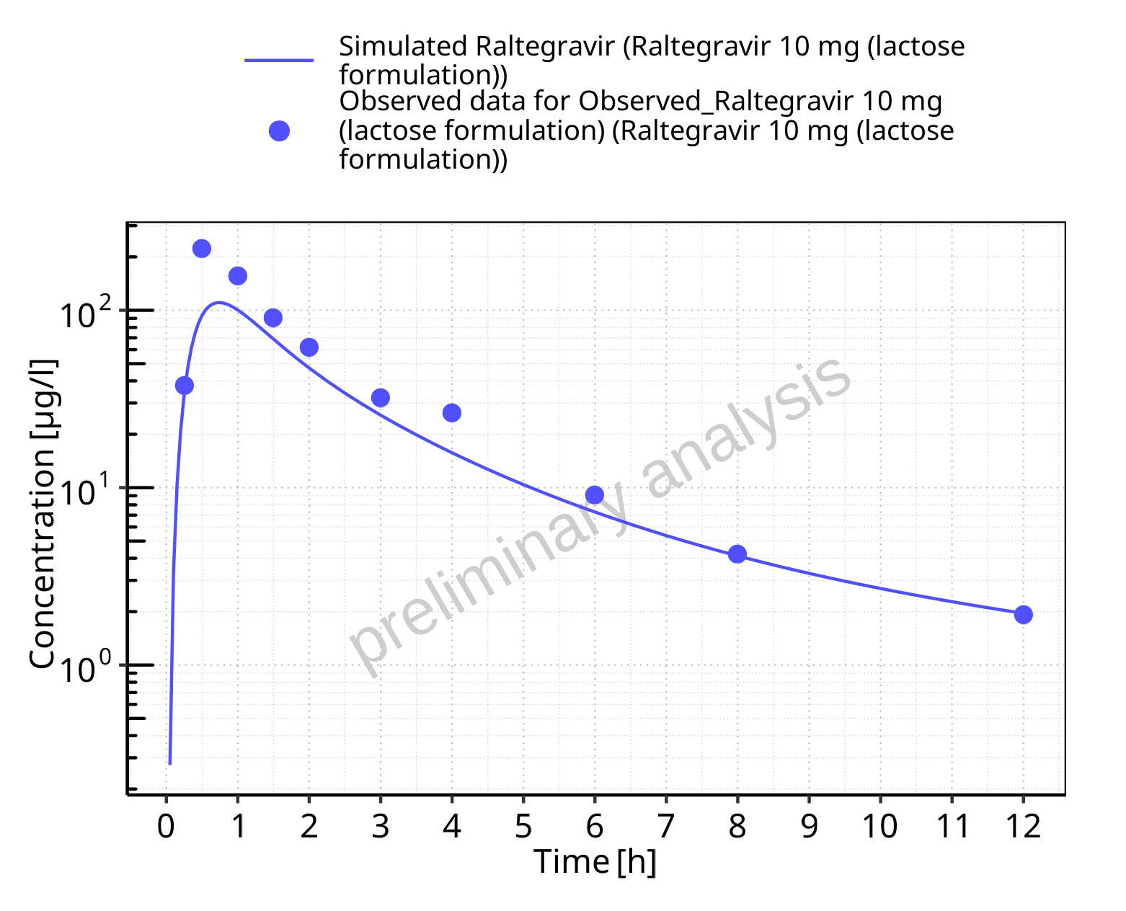

**Figure 5-2: Time profiles for Raltegravir 10 mg (lactose formulation). Data source: Data/Raltegravir_PK.txt. Time profiles are plotted in a logarithmic scale.**

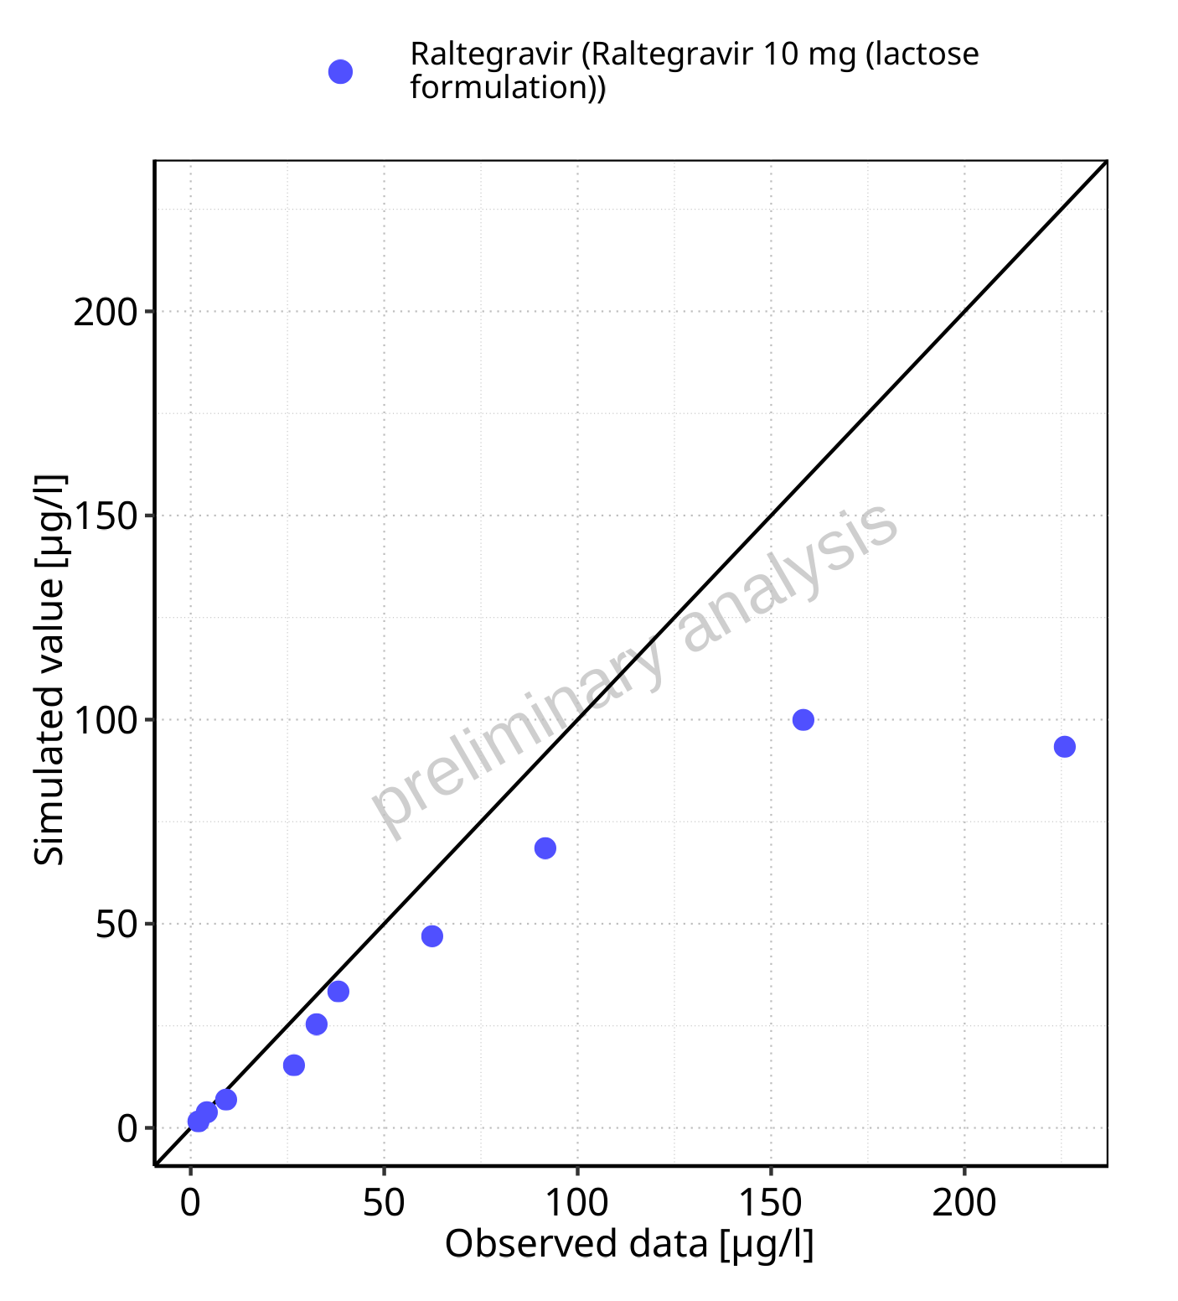

**Figure 5-3: Predicted vs observed for Raltegravir 10 mg (lactose formulation). Data source: Data/Raltegravir_PK.txt. Predictions and observations are plotted in a linear scale.**



**Figure 5-4: Predicted vs observed for Raltegravir 10 mg (lactose formulation). Data source: Data/Raltegravir_PK.txt. Predictions and observations are plotted in a logarithmic scale.**

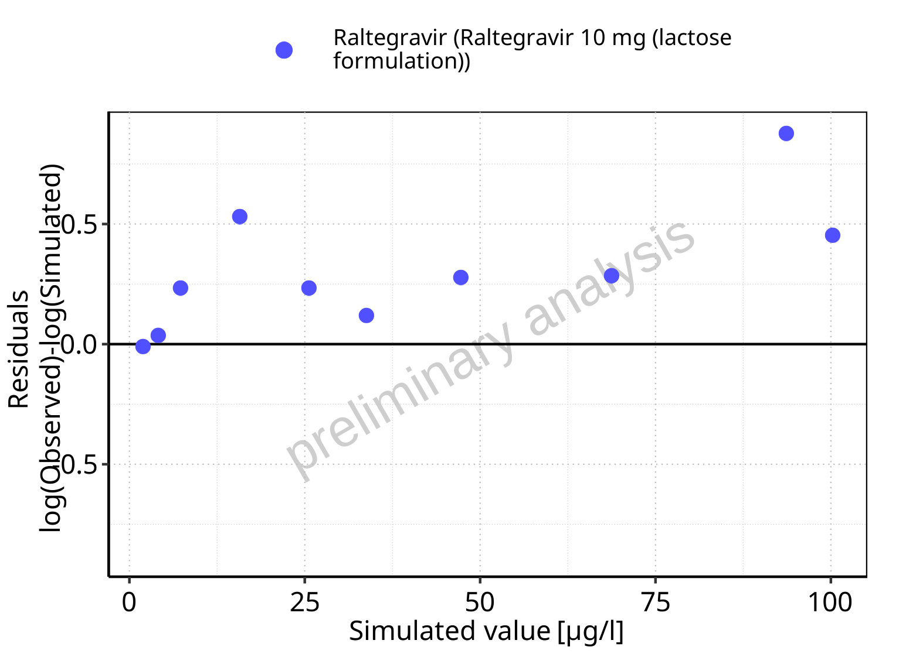

**Figure 5-5: Logarithmic residuals vs predicted values for Raltegravir 10 mg (lactose formulation). Data source: Data/Raltegravir_PK.txt.**

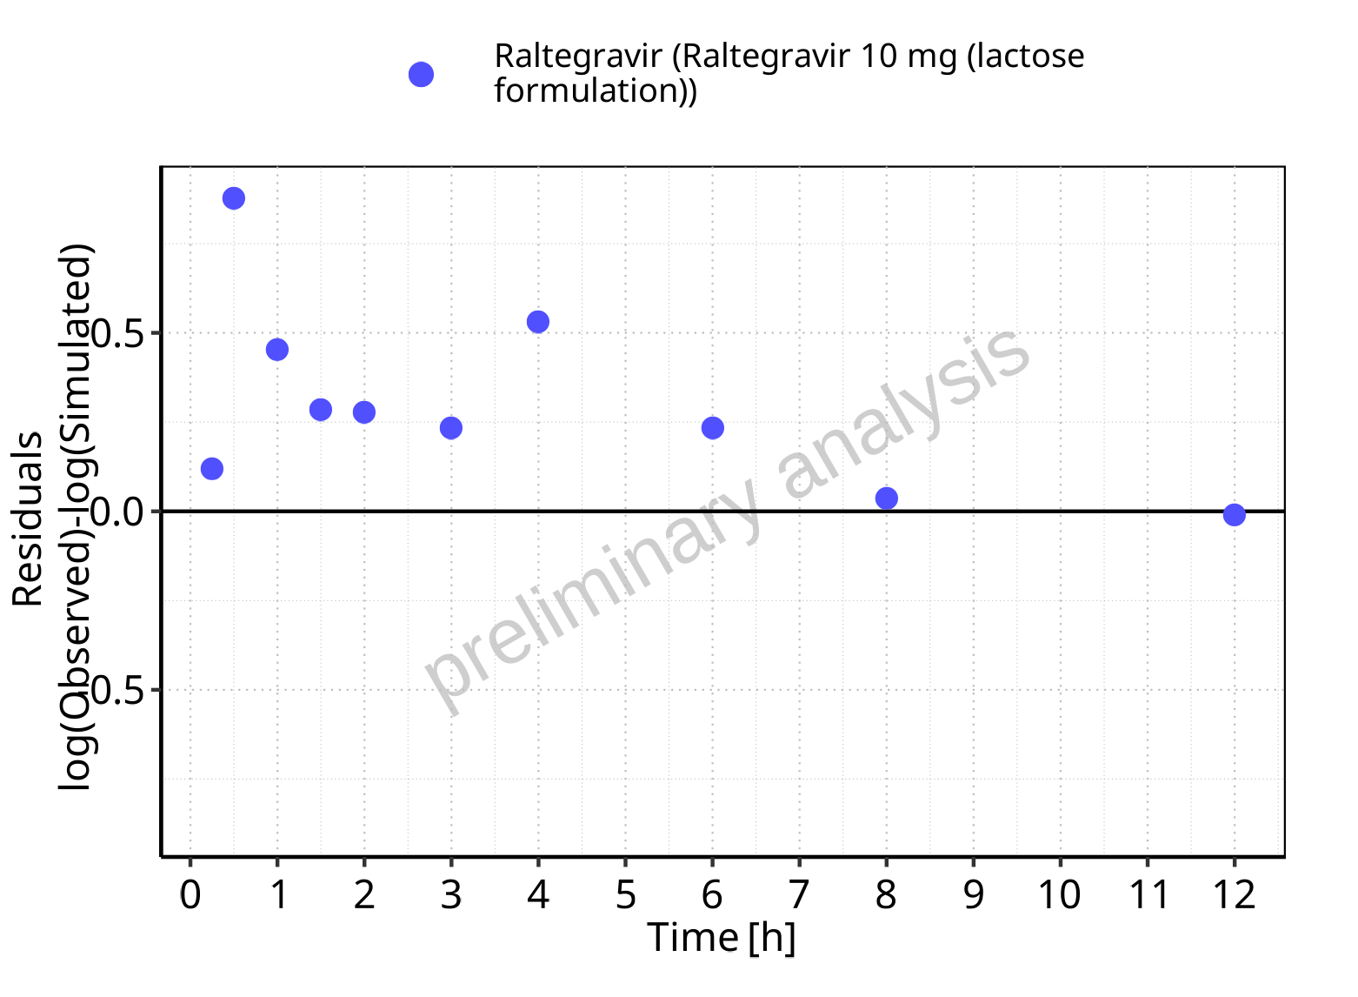

**Figure 5-6: Logarithmic residuals vs time values for Raltegravir 10 mg (lactose formulation). Data source: Data/Raltegravir_PK.txt.**

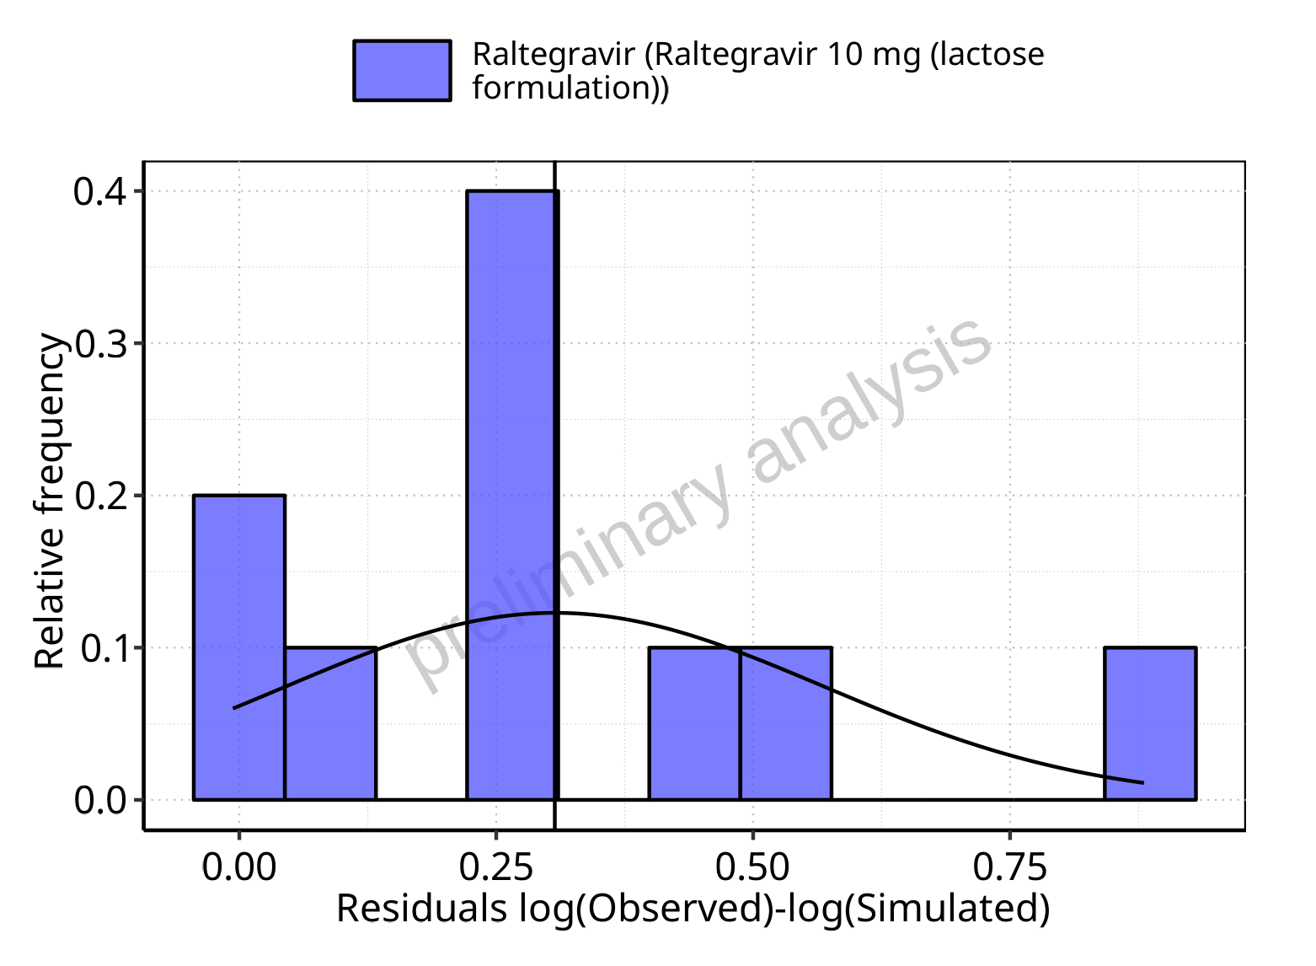

**Figure 5-7: Logarithmic residuals distribution (stacked) for Raltegravir 10 mg (lactose formulation). Data source: Data/Raltegravir_PK.txt.**

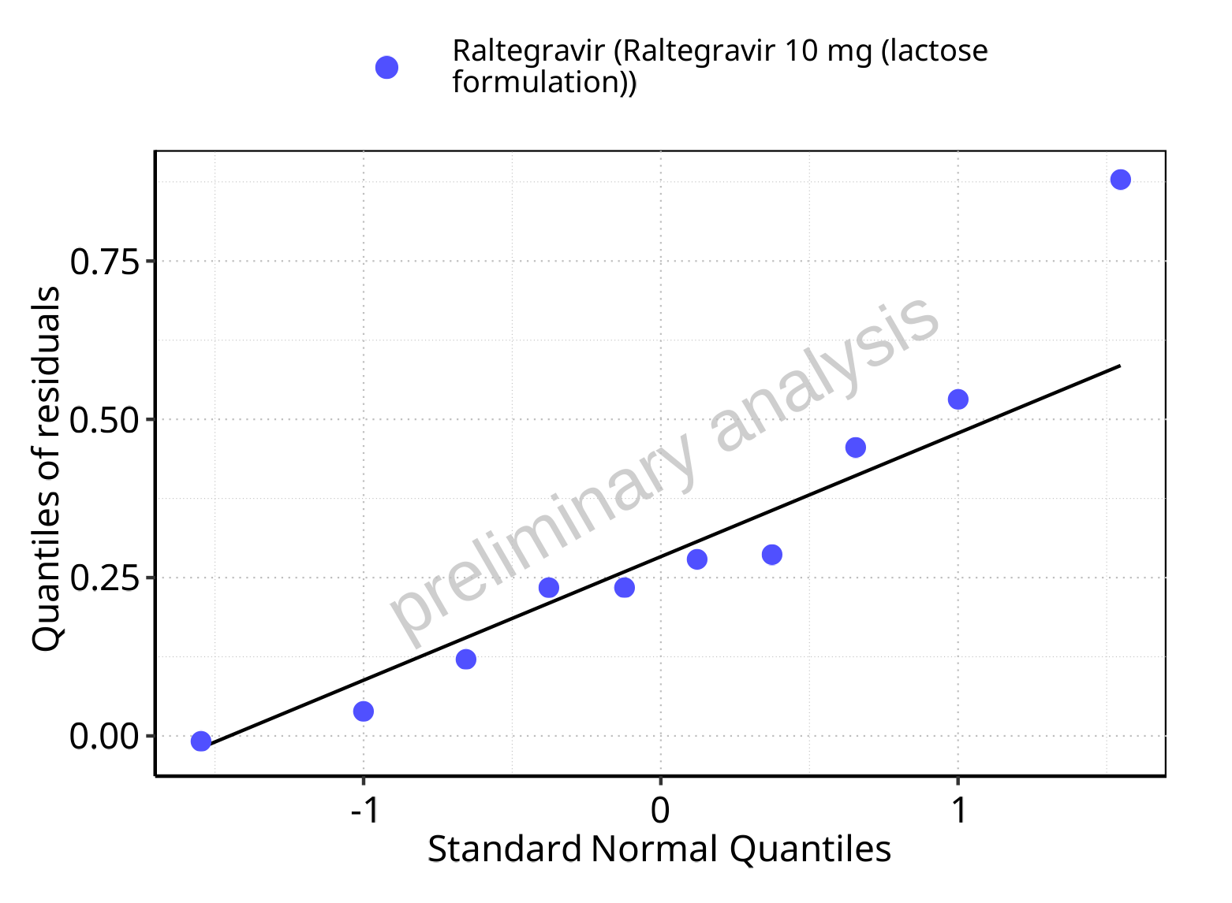

**Figure 5-8: Logarithmic residuals for Raltegravir 10 mg (lactose formulation) as quantile-quantile plot. Data source: Data/Raltegravir_PK.txt.**

## Time profiles and residual plots for Raltegravir 25 mg (lactose formulation)

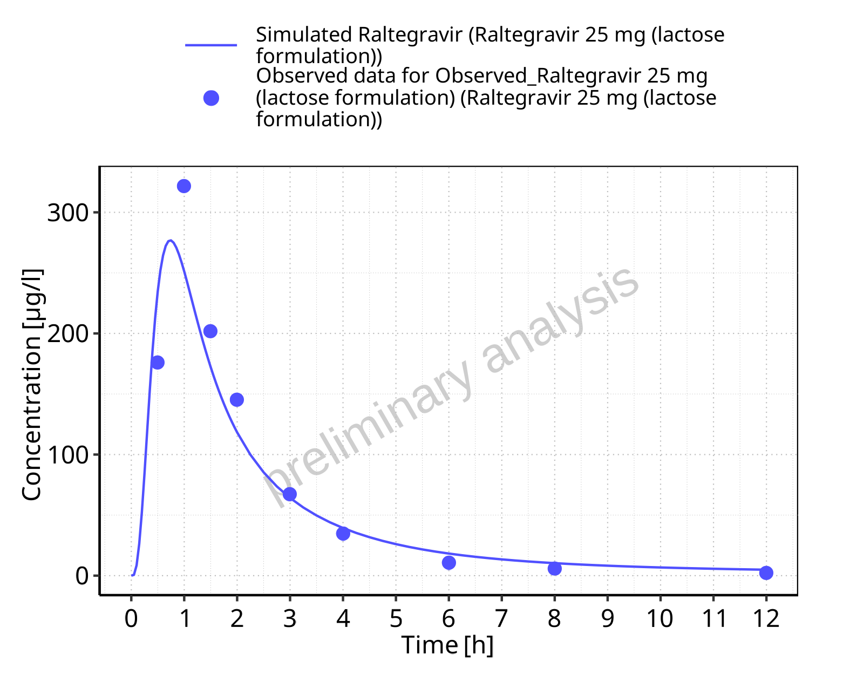

**Figure 5-9: Time profiles for Raltegravir 25 mg (lactose formulation). Data source: Data/Raltegravir_PK.txt. Time profiles are plotted in a linear scale.**

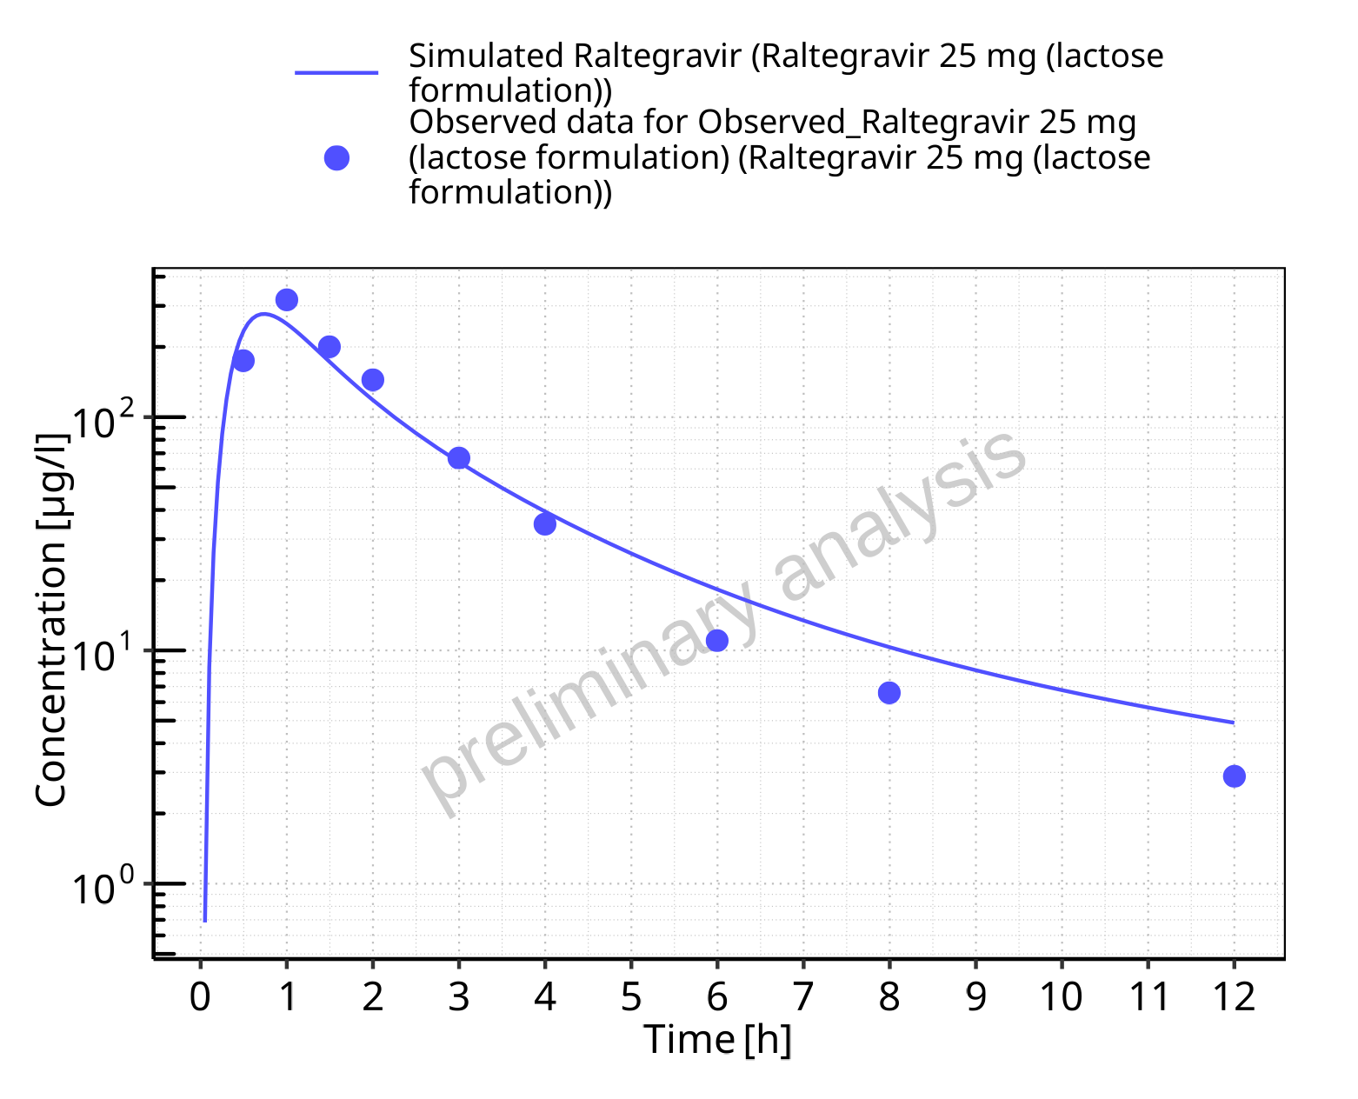

**Figure 5-10: Time profiles for Raltegravir 25 mg (lactose formulation). Data source: Data/Raltegravir_PK.txt. Time profiles are plotted in a logarithmic scale.**

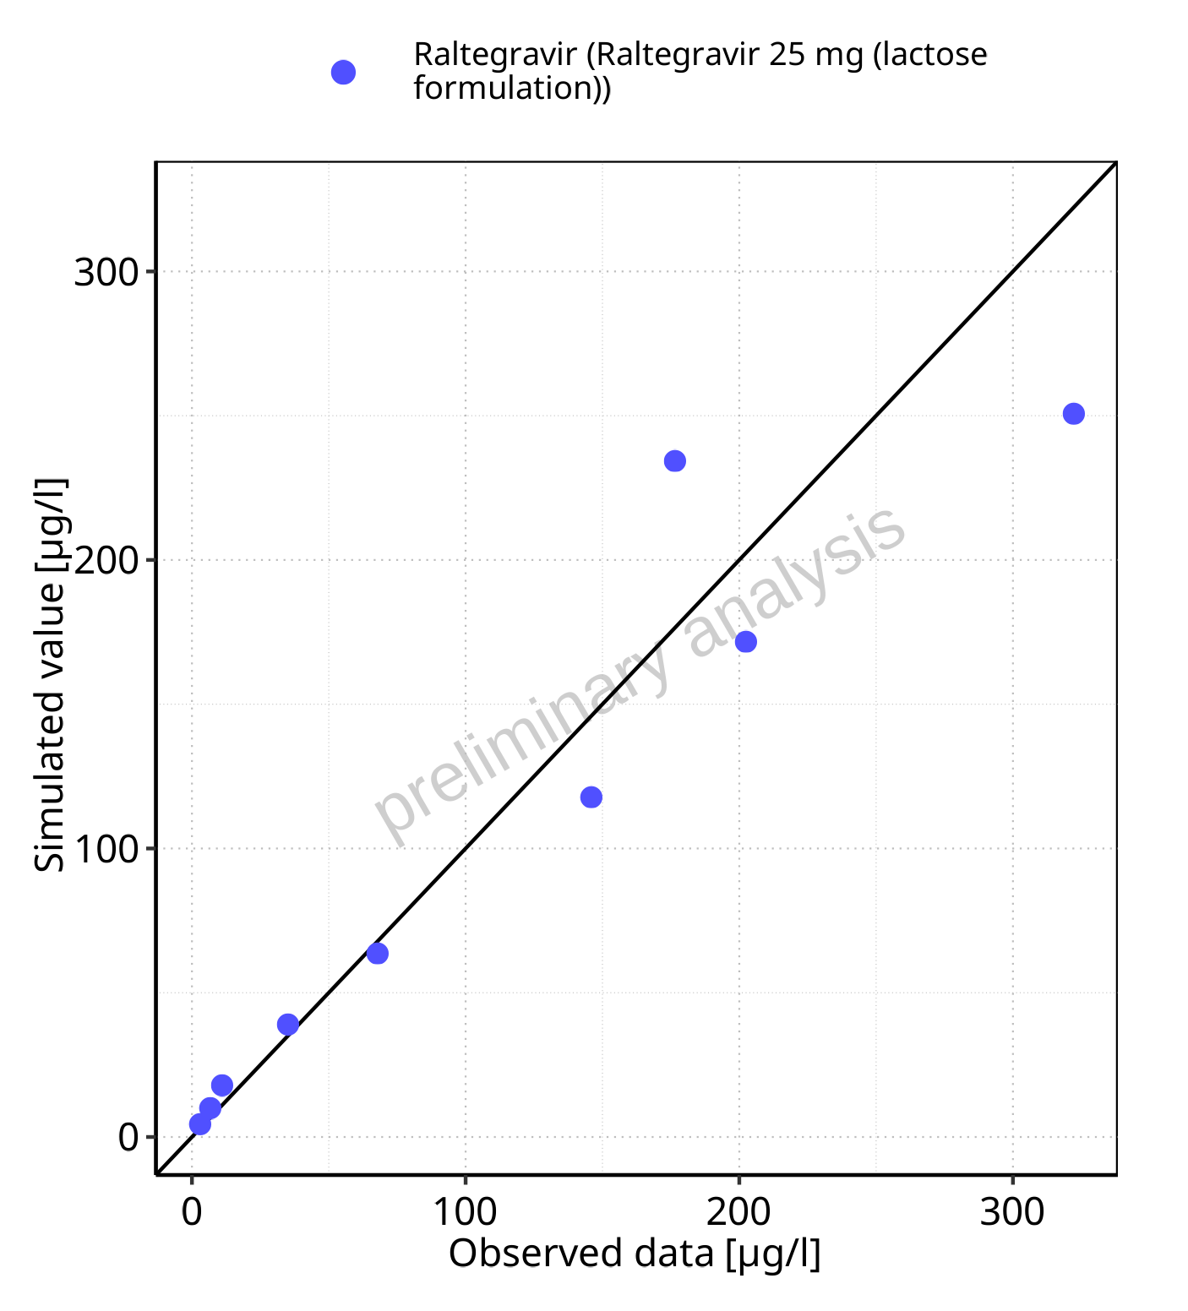

**Figure 5-11: Predicted vs observed for Raltegravir 25 mg (lactose formulation). Data source: Data/Raltegravir_PK.txt. Predictions and observations are plotted in a linear scale.**



**Figure 5-12: Predicted vs observed for Raltegravir 25 mg (lactose formulation). Data source: Data/Raltegravir_PK.txt. Predictions and observations are plotted in a logarithmic scale.**

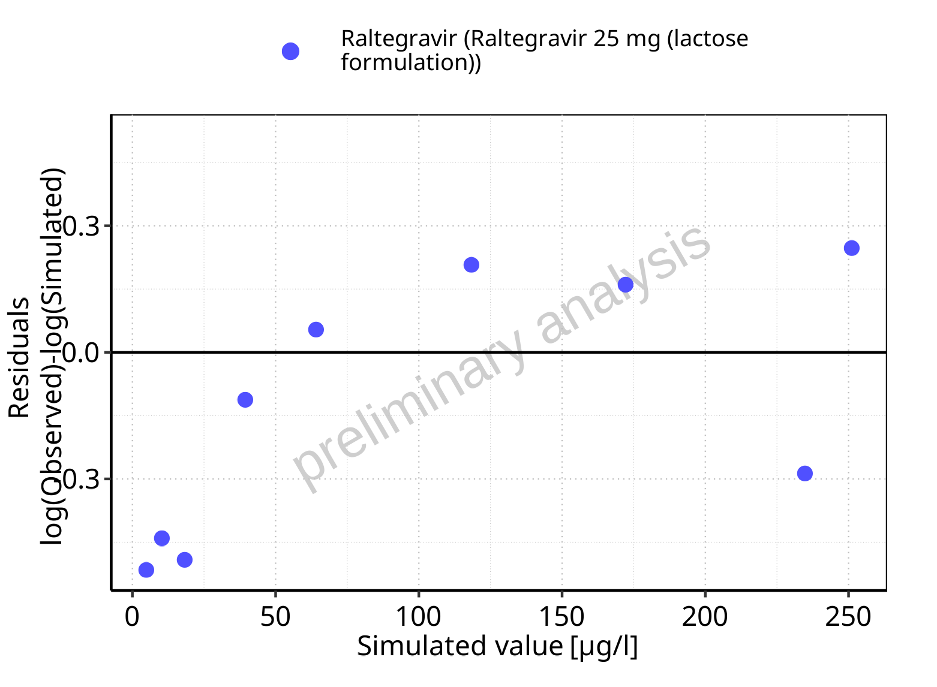

**Figure 5-13: Logarithmic residuals vs predicted values for Raltegravir 25 mg (lactose formulation). Data source: Data/Raltegravir_PK.txt.**

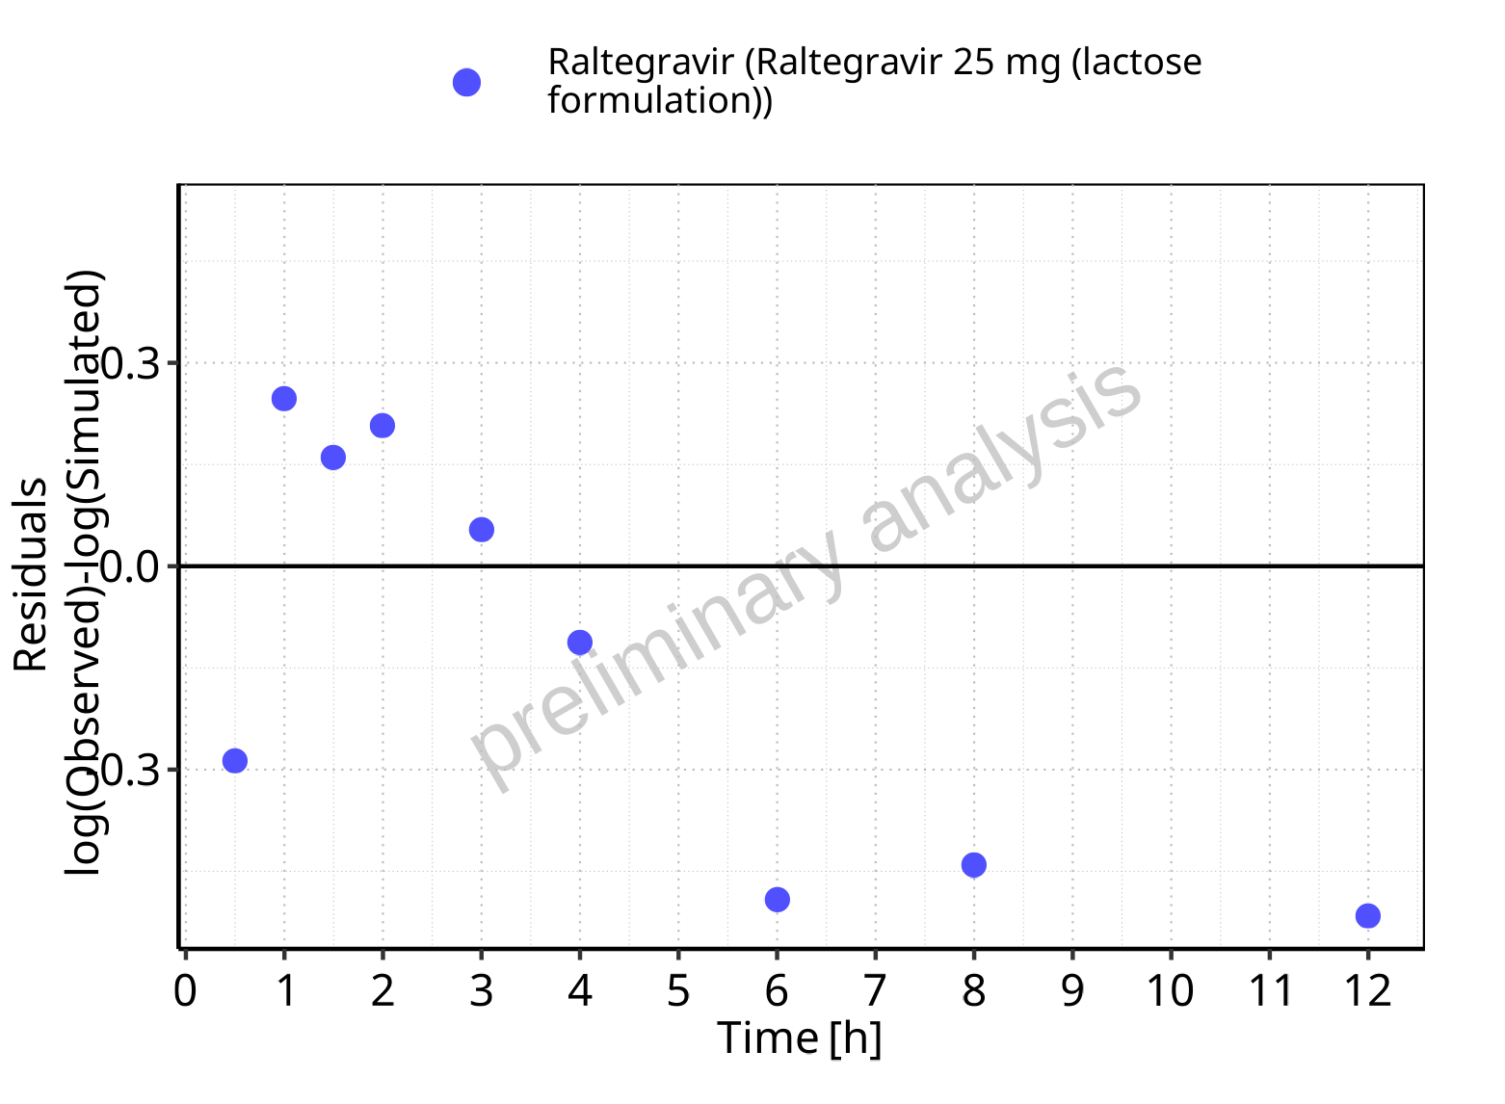

**Figure 5-14: Logarithmic residuals vs time values for Raltegravir 25 mg (lactose formulation). Data source: Data/Raltegravir_PK.txt.**

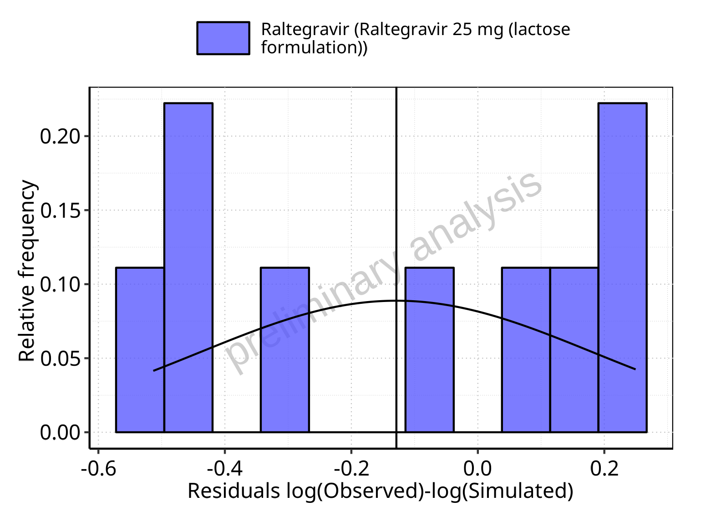

**Figure 5-15: Logarithmic residuals distribution (stacked) for Raltegravir 25 mg (lactose formulation). Data source: Data/Raltegravir_PK.txt.**

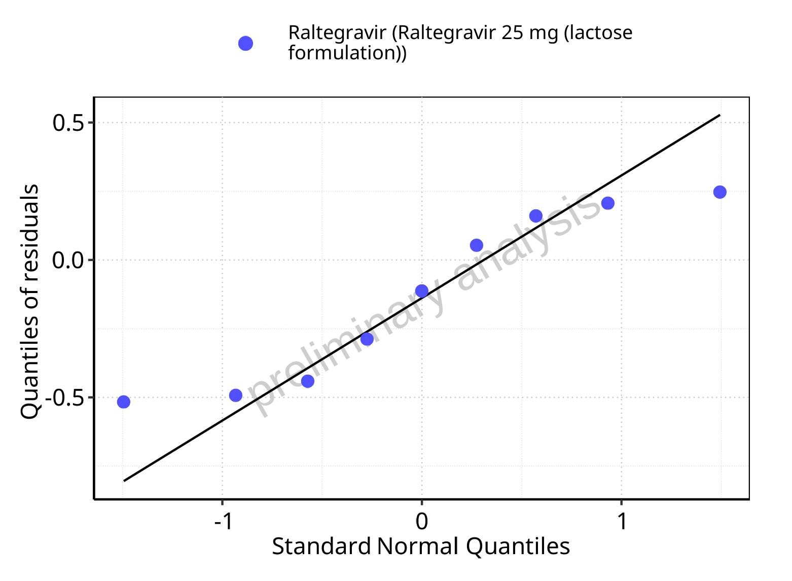

**Figure 5-16: Logarithmic residuals for Raltegravir 25 mg (lactose formulation) as quantile-quantile plot. Data source: Data/Raltegravir_PK.txt.**

## Time profiles and residual plots for Raltegravir 50 mg (lactose formulation)

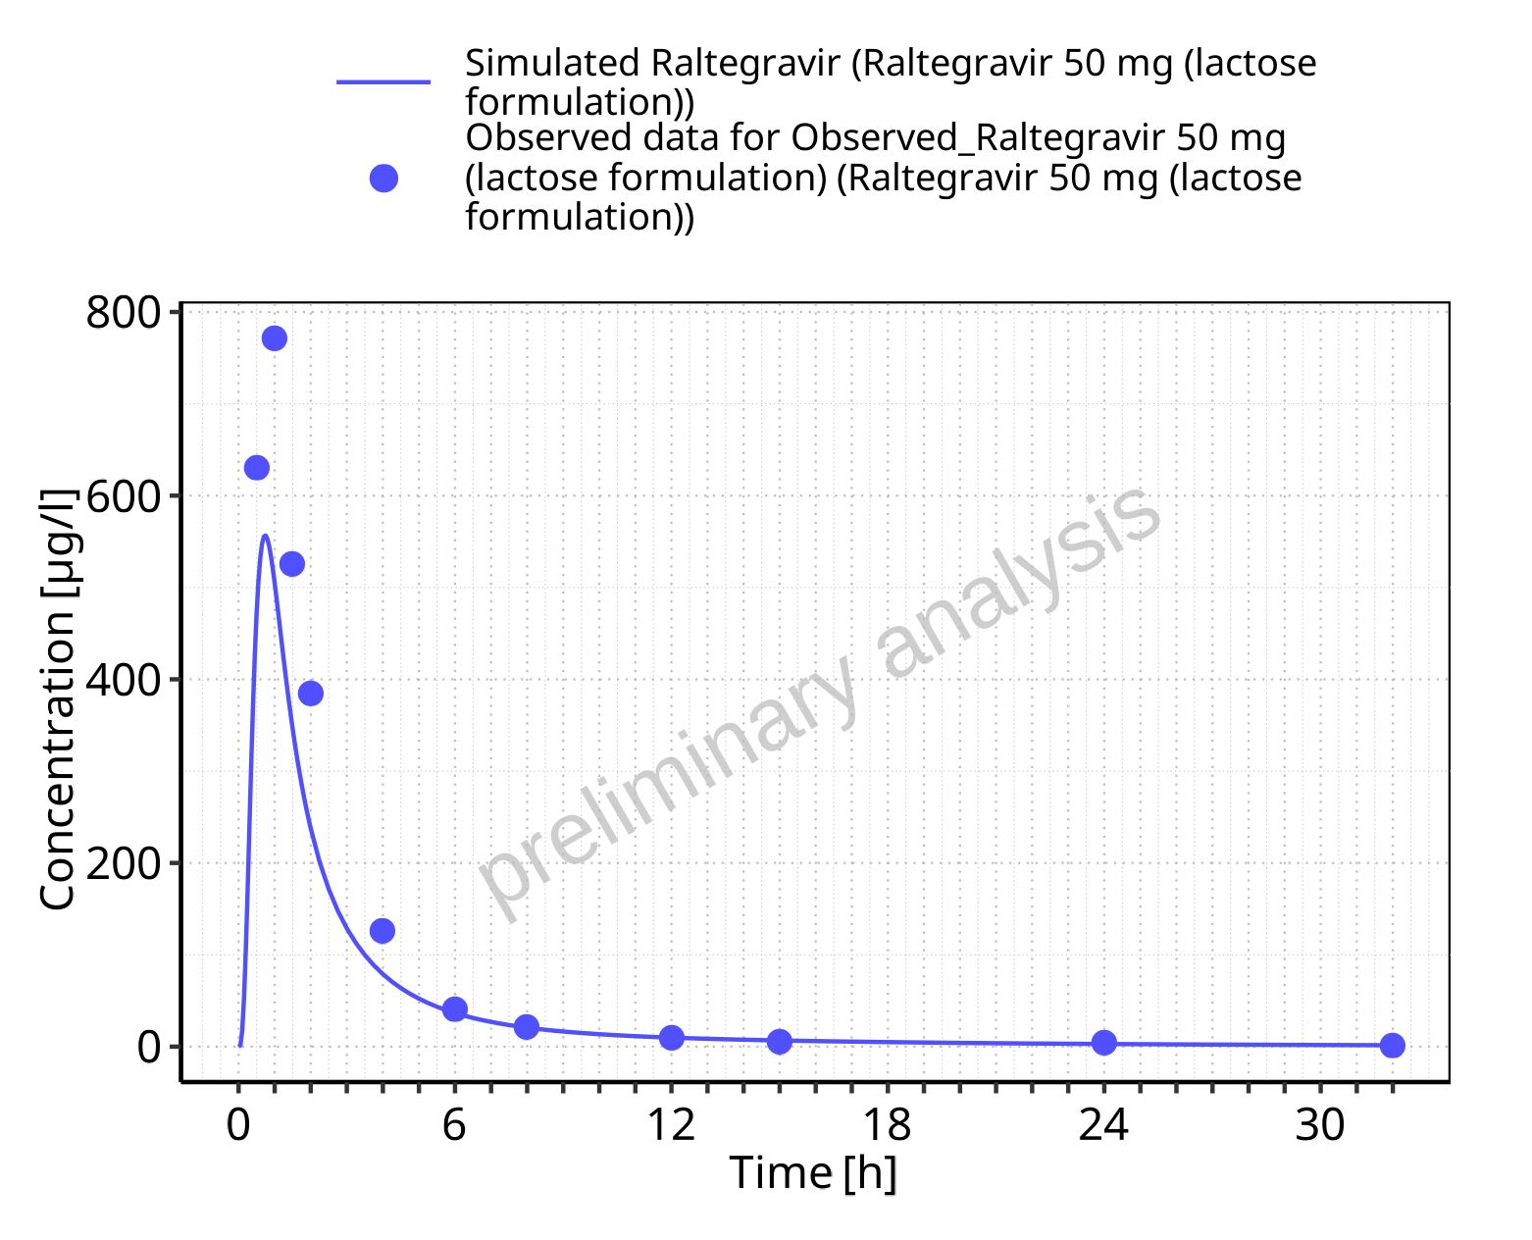

**Figure 5-17: Time profiles for Raltegravir 50 mg (lactose formulation). Data source: Data/Raltegravir_PK.txt. Time profiles are plotted in a linear scale.**

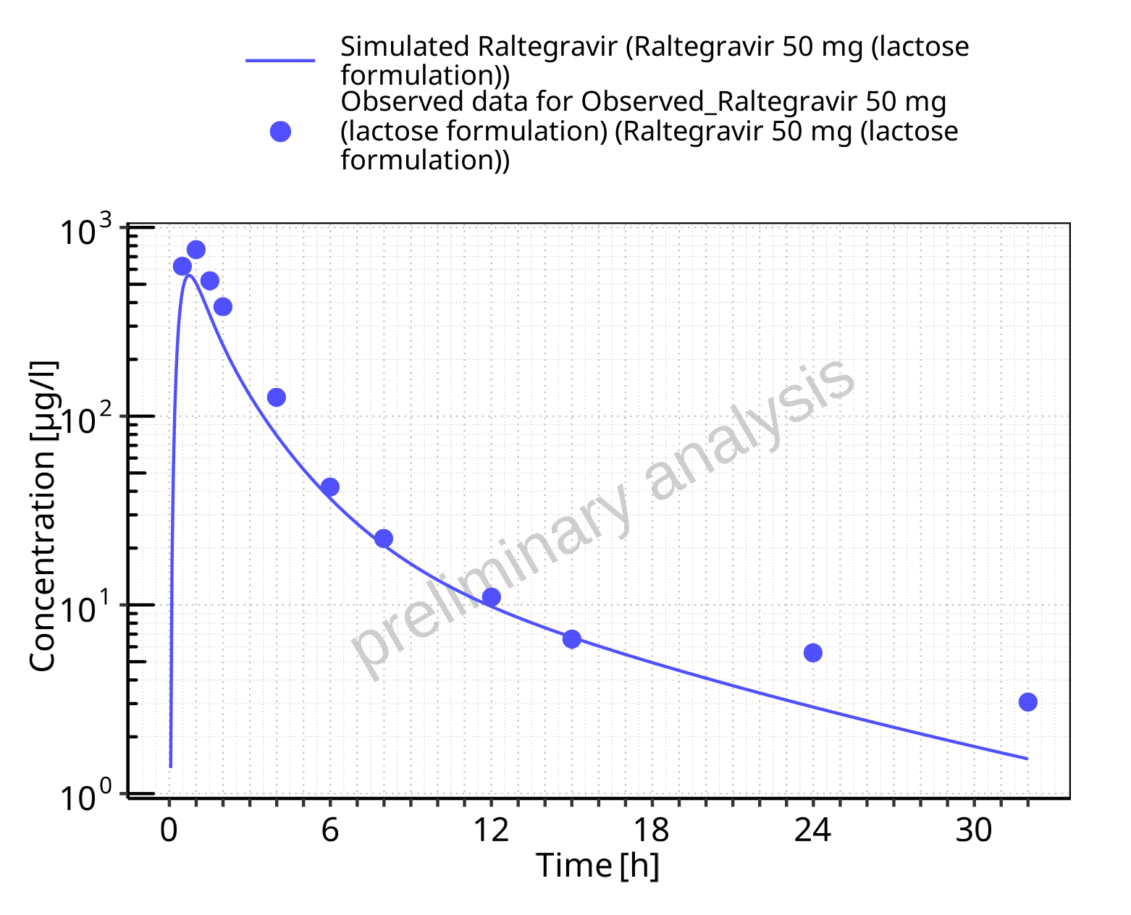

**Figure 5-18: Time profiles for Raltegravir 50 mg (lactose formulation). Data source: Data/Raltegravir_PK.txt. Time profiles are plotted in a logarithmic scale.**

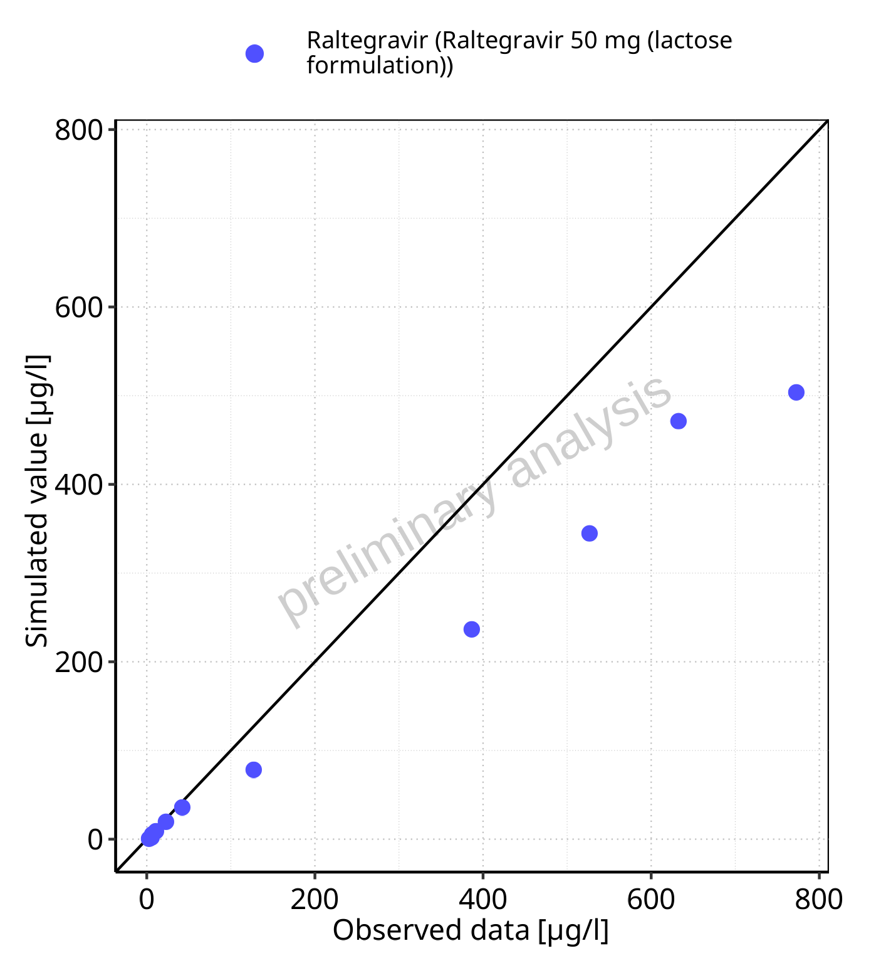

**Figure 5-19: Predicted vs observed for Raltegravir 50 mg (lactose formulation). Data source: Data/Raltegravir_PK.txt. Predictions and observations are plotted in a linear scale.**



**Figure 5-20: Predicted vs observed for Raltegravir 50 mg (lactose formulation). Data source: Data/Raltegravir_PK.txt. Predictions and observations are plotted in a logarithmic scale.**

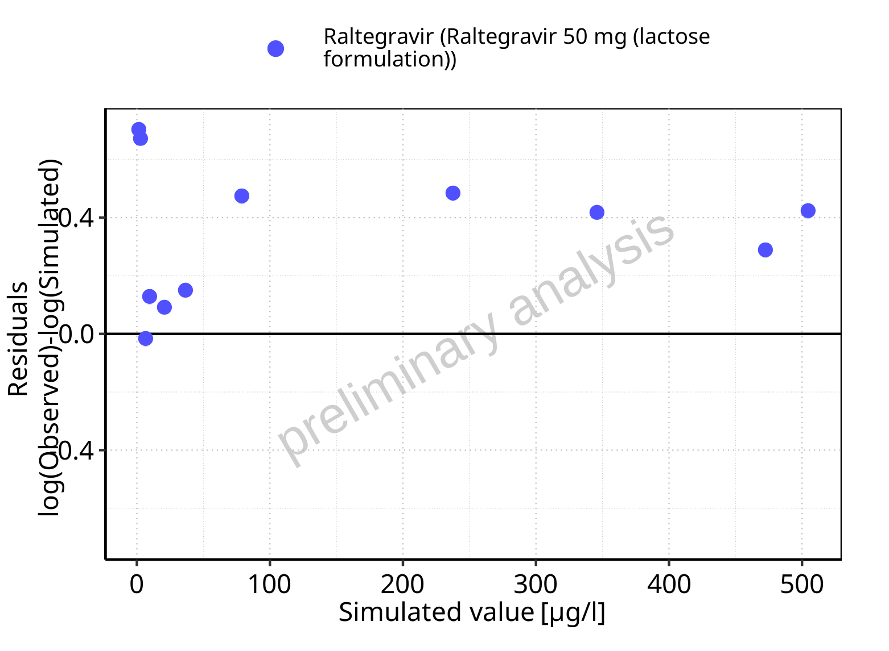

**Figure 5-21: Logarithmic residuals vs predicted values for Raltegravir 50 mg (lactose formulation). Data source: Data/Raltegravir_PK.txt.**

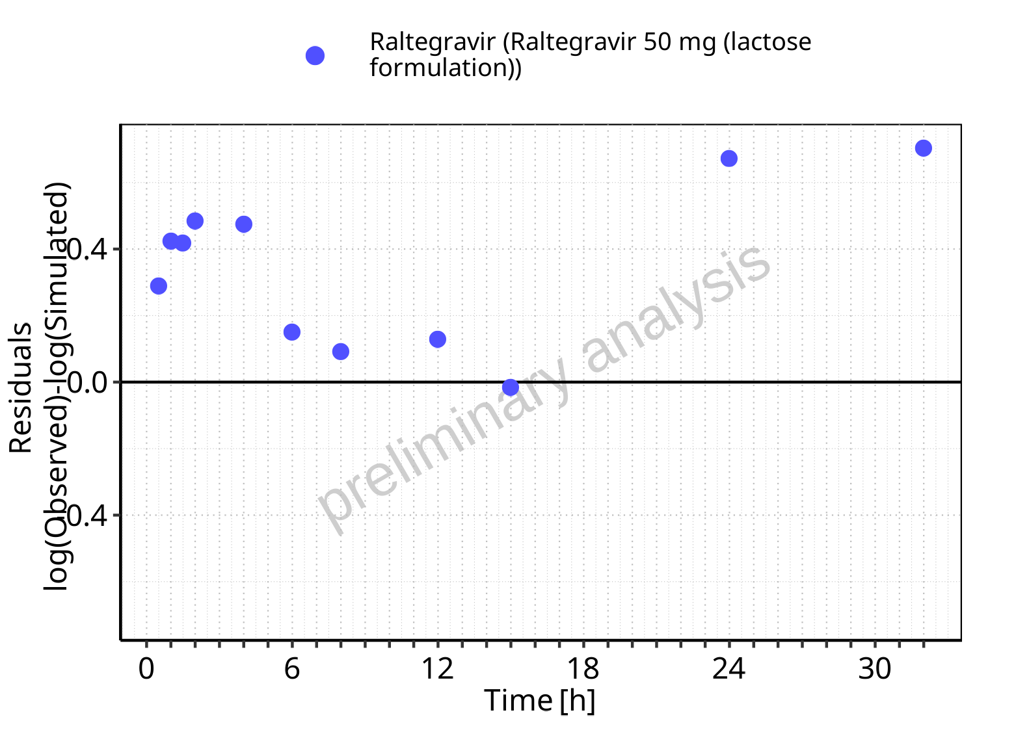

**Figure 5-22: Logarithmic residuals vs time values for Raltegravir 50 mg (lactose formulation). Data source: Data/Raltegravir_PK.txt.**

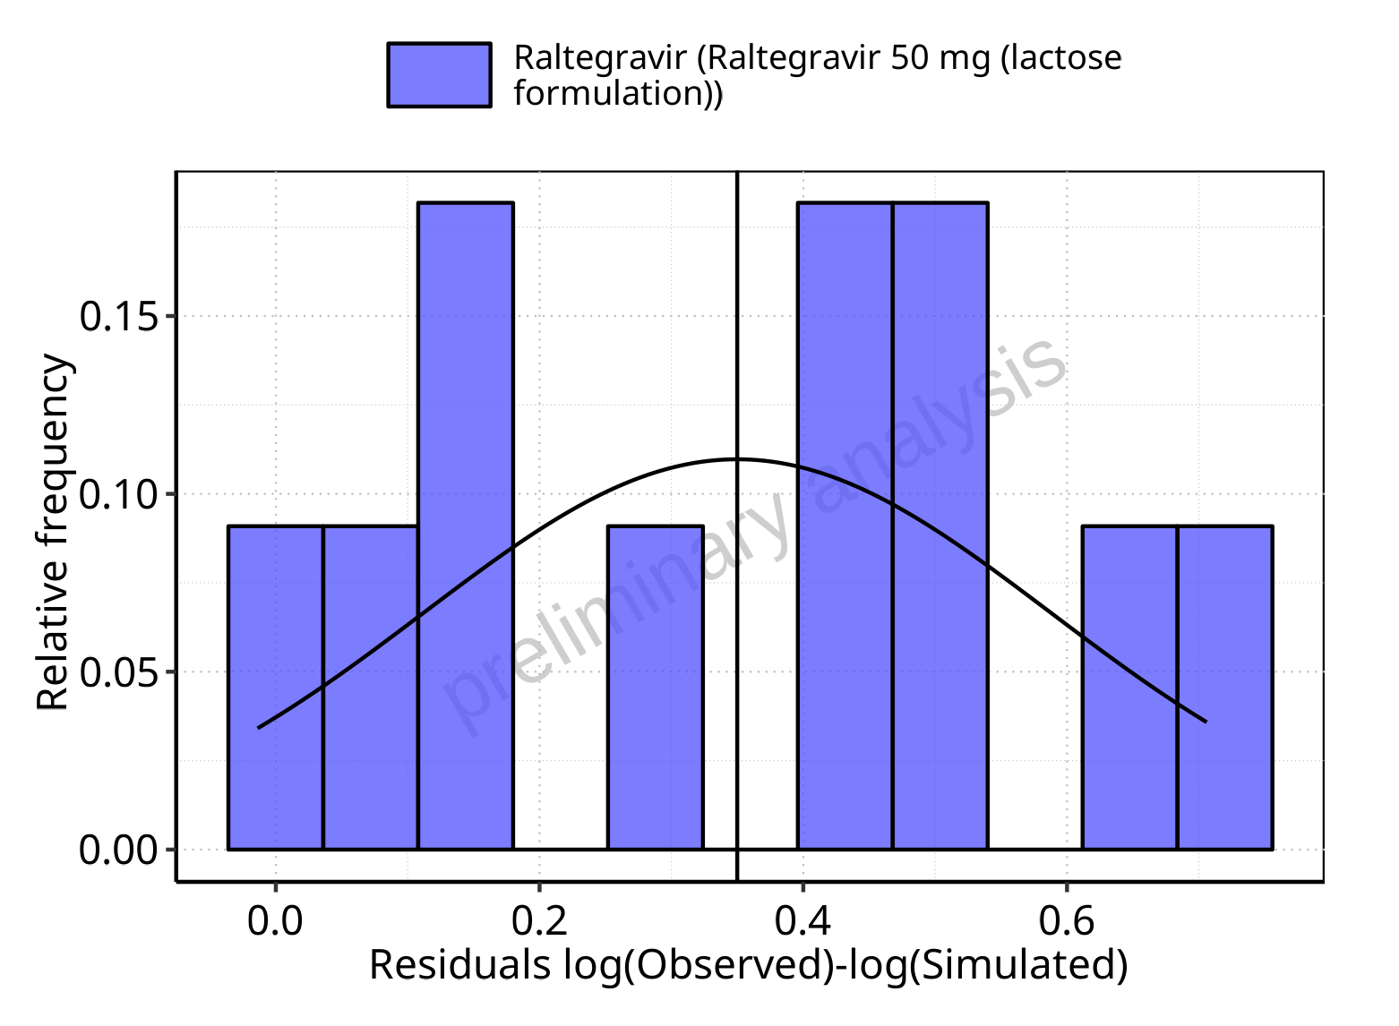

**Figure 5-23: Logarithmic residuals distribution (stacked) for Raltegravir 50 mg (lactose formulation). Data source: Data/Raltegravir_PK.txt.**

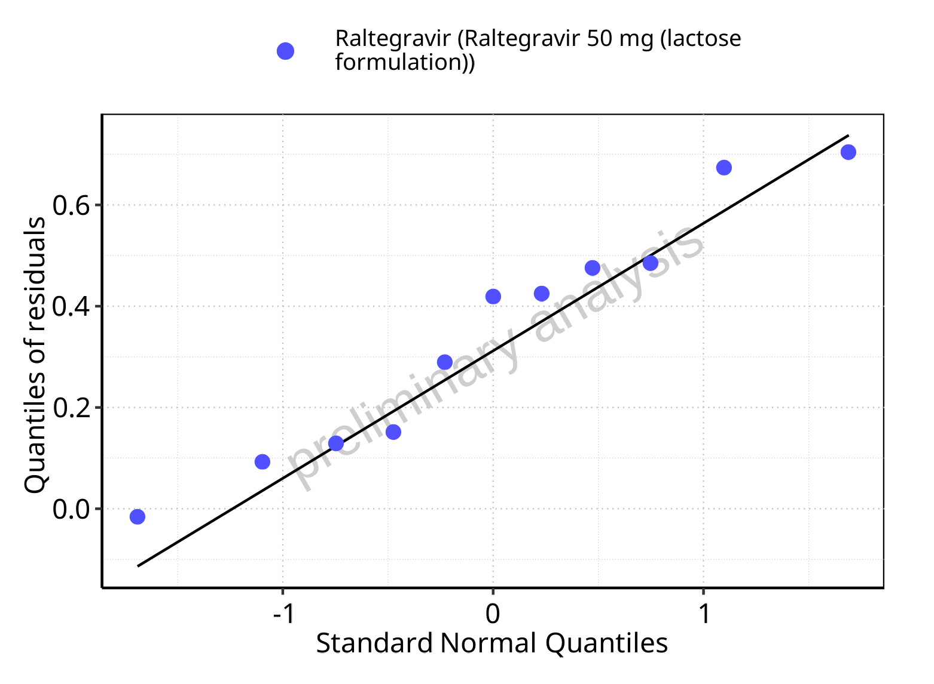

**Figure 5-24: Logarithmic residuals for Raltegravir 50 mg (lactose formulation) as quantile-quantile plot. Data source: Data/Raltegravir_PK.txt.**

## Time profiles and residual plots for Raltegravir 100 mg (lactose formulation)

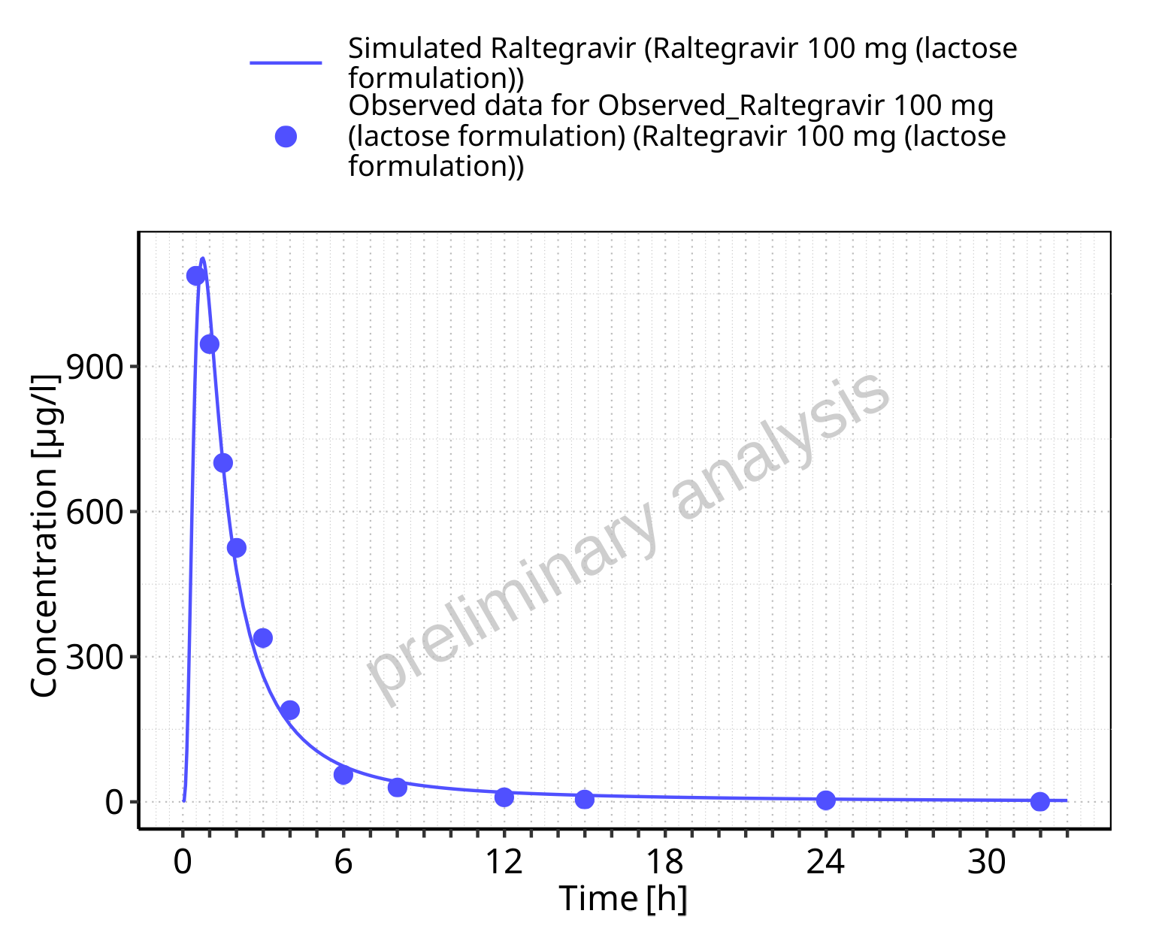

**Figure 5-25: Time profiles for Raltegravir 100 mg (lactose formulation). Data source: Data/Raltegravir_PK.txt. Time profiles are plotted in a linear scale.**

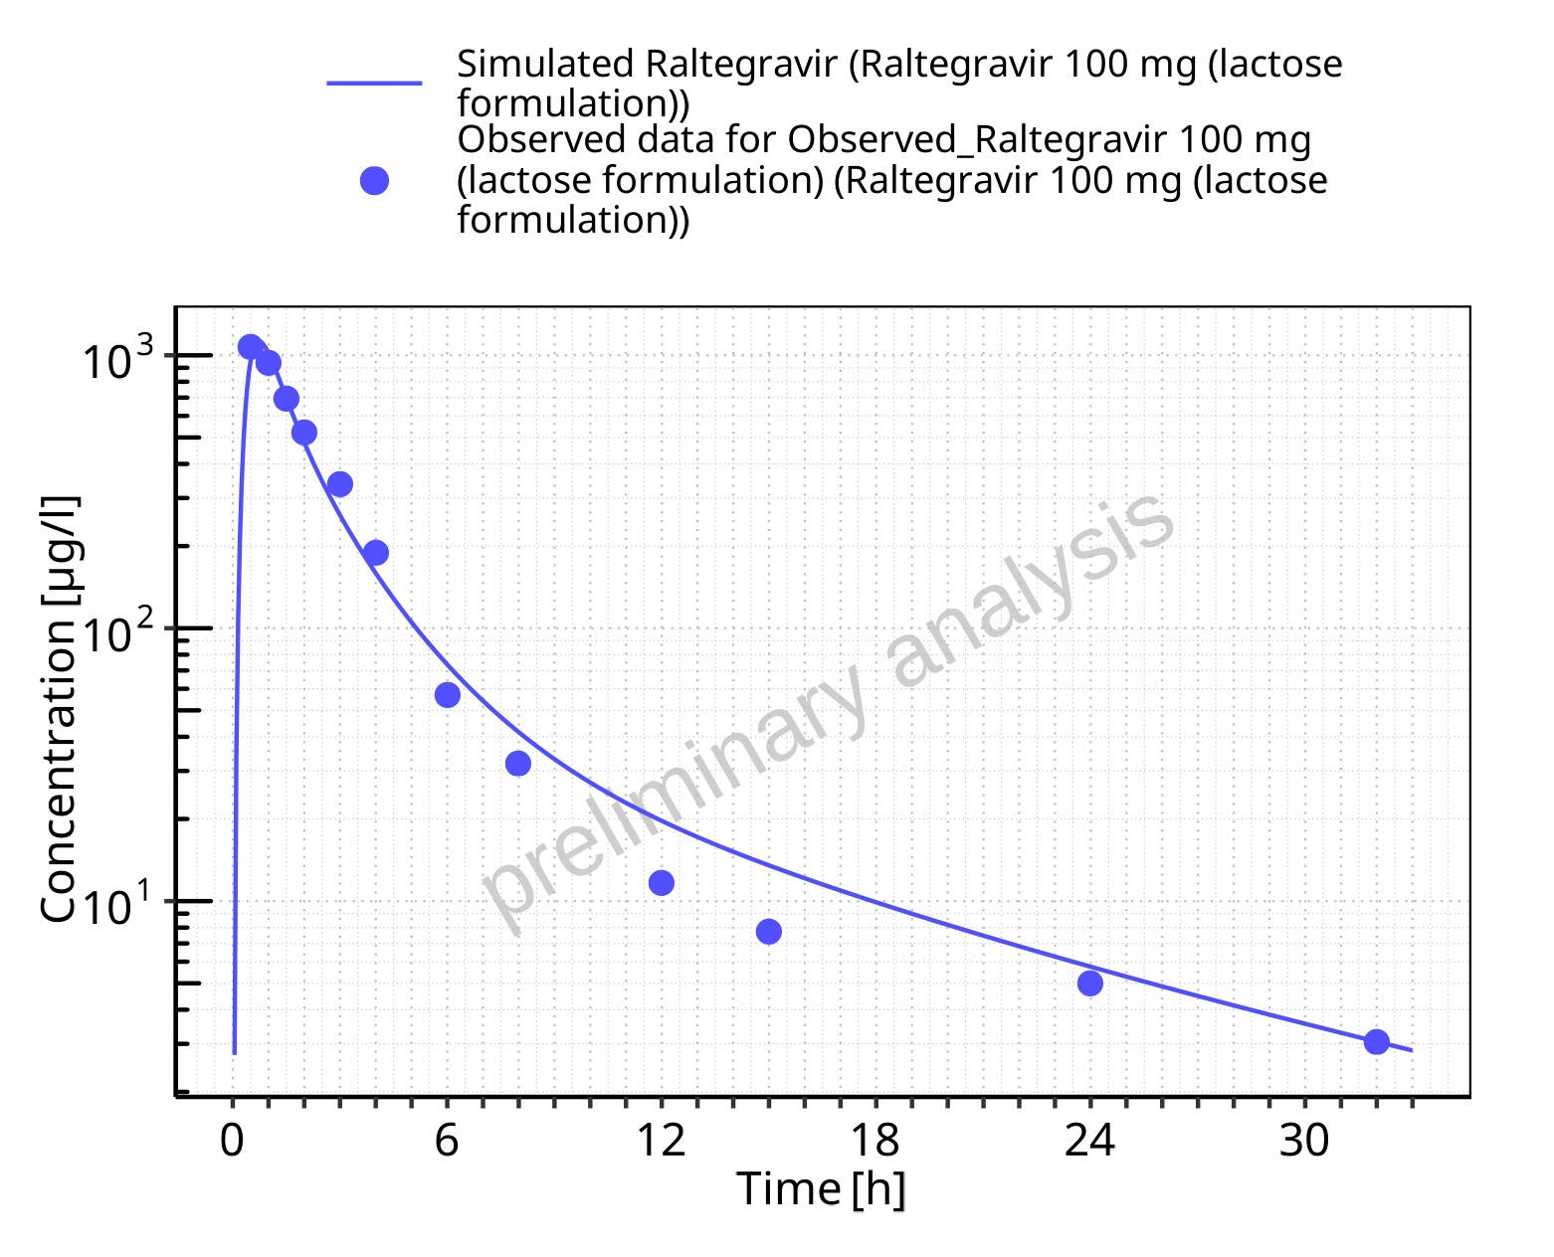

**Figure 5-26: Time profiles for Raltegravir 100 mg (lactose formulation). Data source: Data/Raltegravir_PK.txt. Time profiles are plotted in a logarithmic scale.**

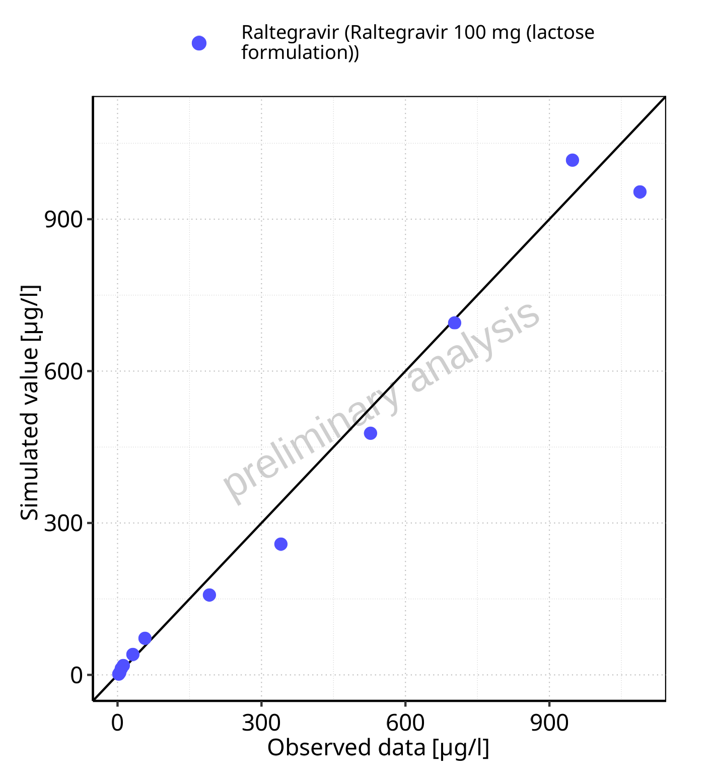

**Figure 5-27: Predicted vs observed for Raltegravir 100 mg (lactose formulation). Data source: Data/Raltegravir_PK.txt. Predictions and observations are plotted in a linear scale.**



**Figure 5-28: Predicted vs observed for Raltegravir 100 mg (lactose formulation). Data source: Data/Raltegravir_PK.txt. Predictions and observations are plotted in a logarithmic scale.**

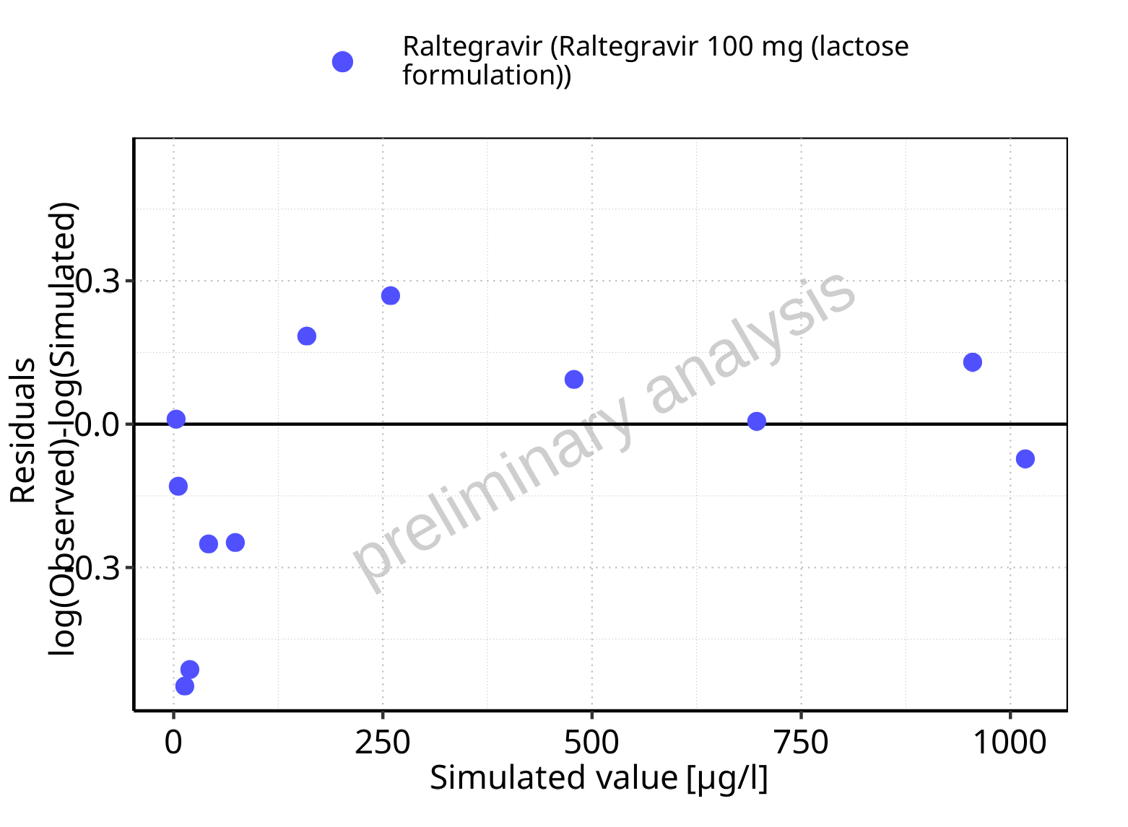

**Figure 5-29: Logarithmic residuals vs predicted values for Raltegravir 100 mg (lactose formulation). Data source: Data/Raltegravir_PK.txt.**

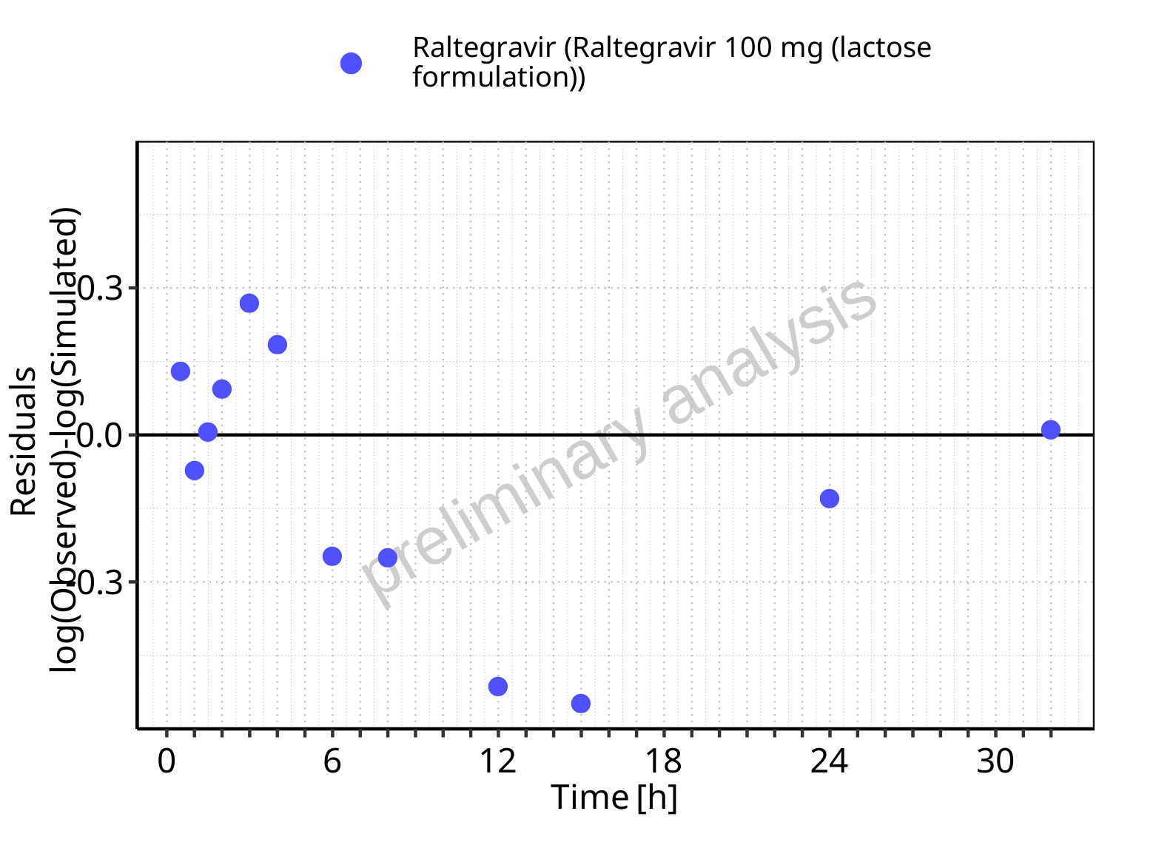

**Figure 5-30: Logarithmic residuals vs time values for Raltegravir 100 mg (lactose formulation). Data source: Data/Raltegravir_PK.txt.**

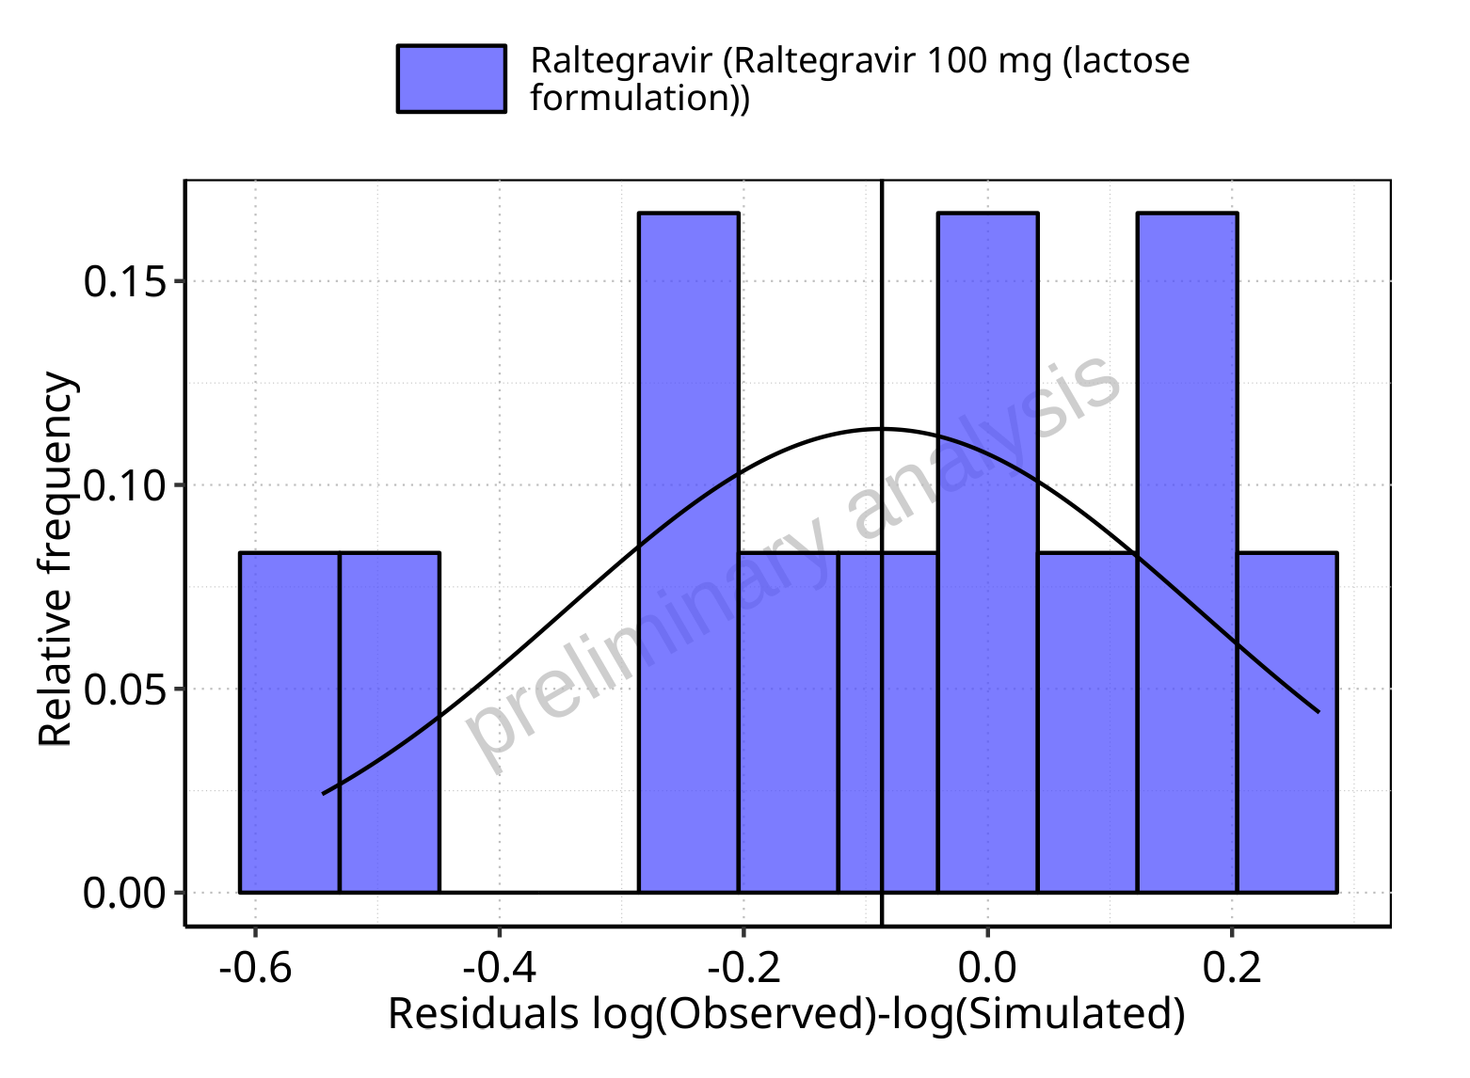

**Figure 5-31: Logarithmic residuals distribution (stacked) for Raltegravir 100 mg (lactose formulation). Data source: Data/Raltegravir_PK.txt.**

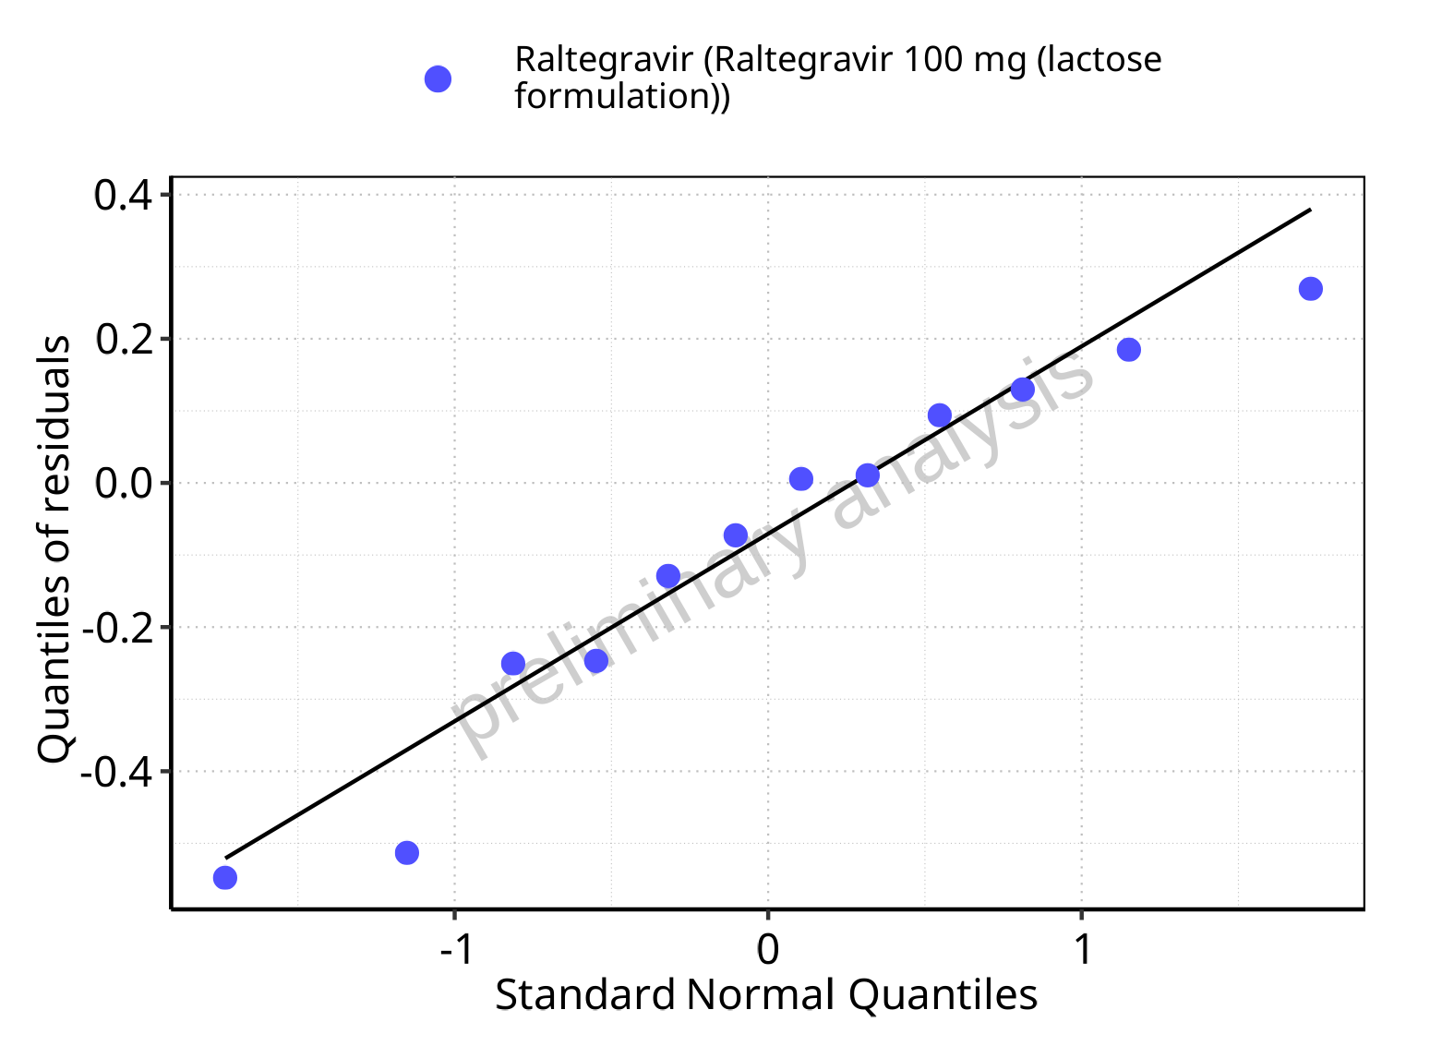

**Figure 5-32: Logarithmic residuals for Raltegravir 100 mg (lactose formulation) as quantile-quantile plot. Data source: Data/Raltegravir_PK.txt.**

## Time profiles and residual plots for Raltegravir 200 mg (lactose formulation)

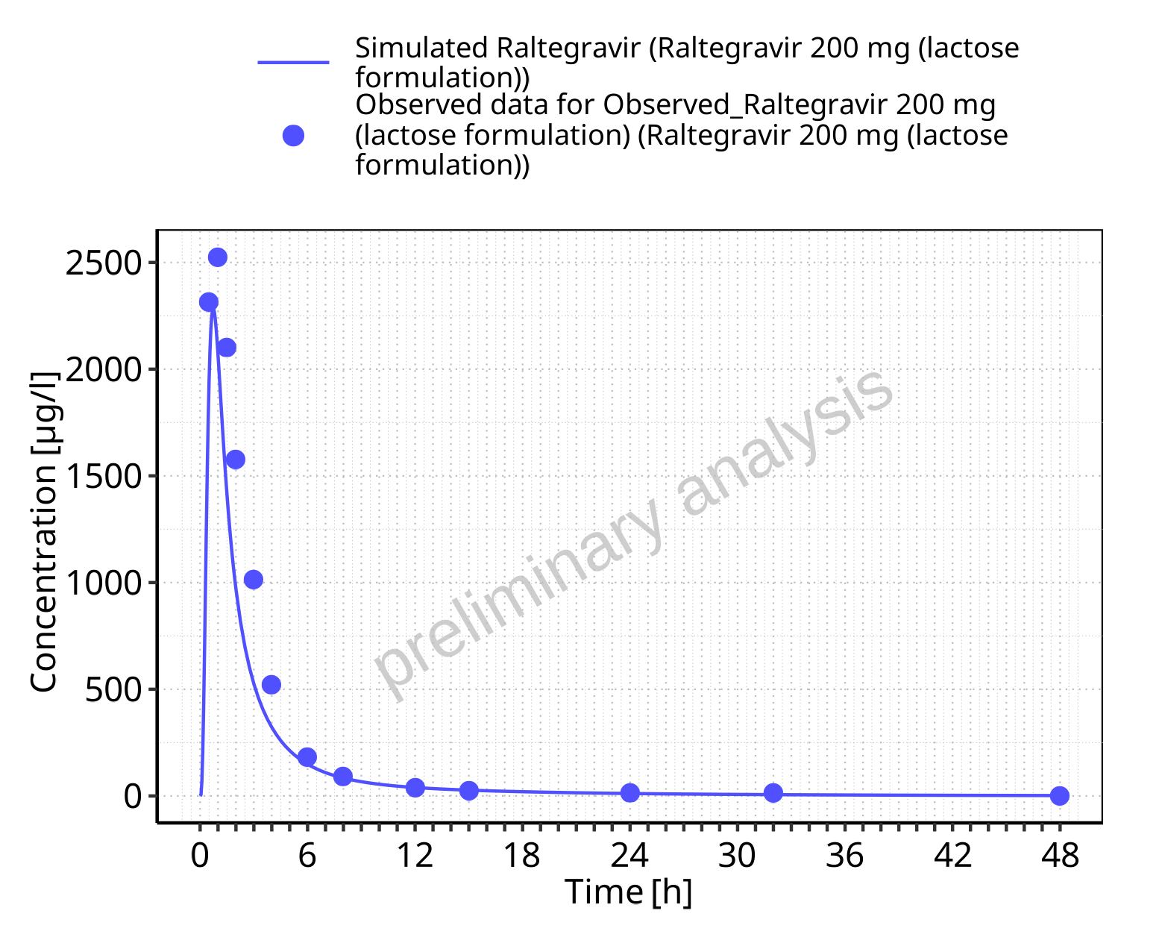

**Figure 5-33: Time profiles for Raltegravir 200 mg (lactose formulation). Data source: Data/Raltegravir_PK.txt. Time profiles are plotted in a linear scale.**

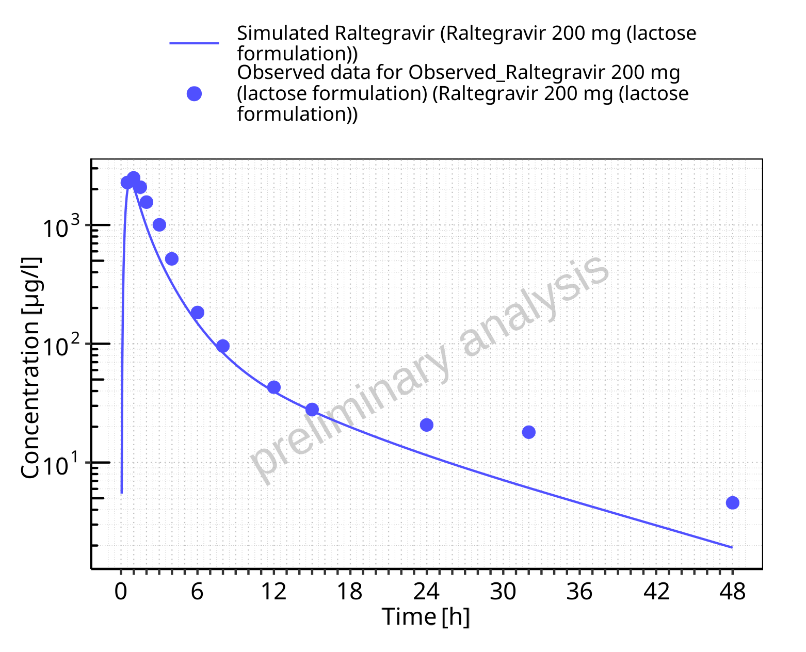

**Figure 5-34: Time profiles for Raltegravir 200 mg (lactose formulation). Data source: Data/Raltegravir_PK.txt. Time profiles are plotted in a logarithmic scale.**

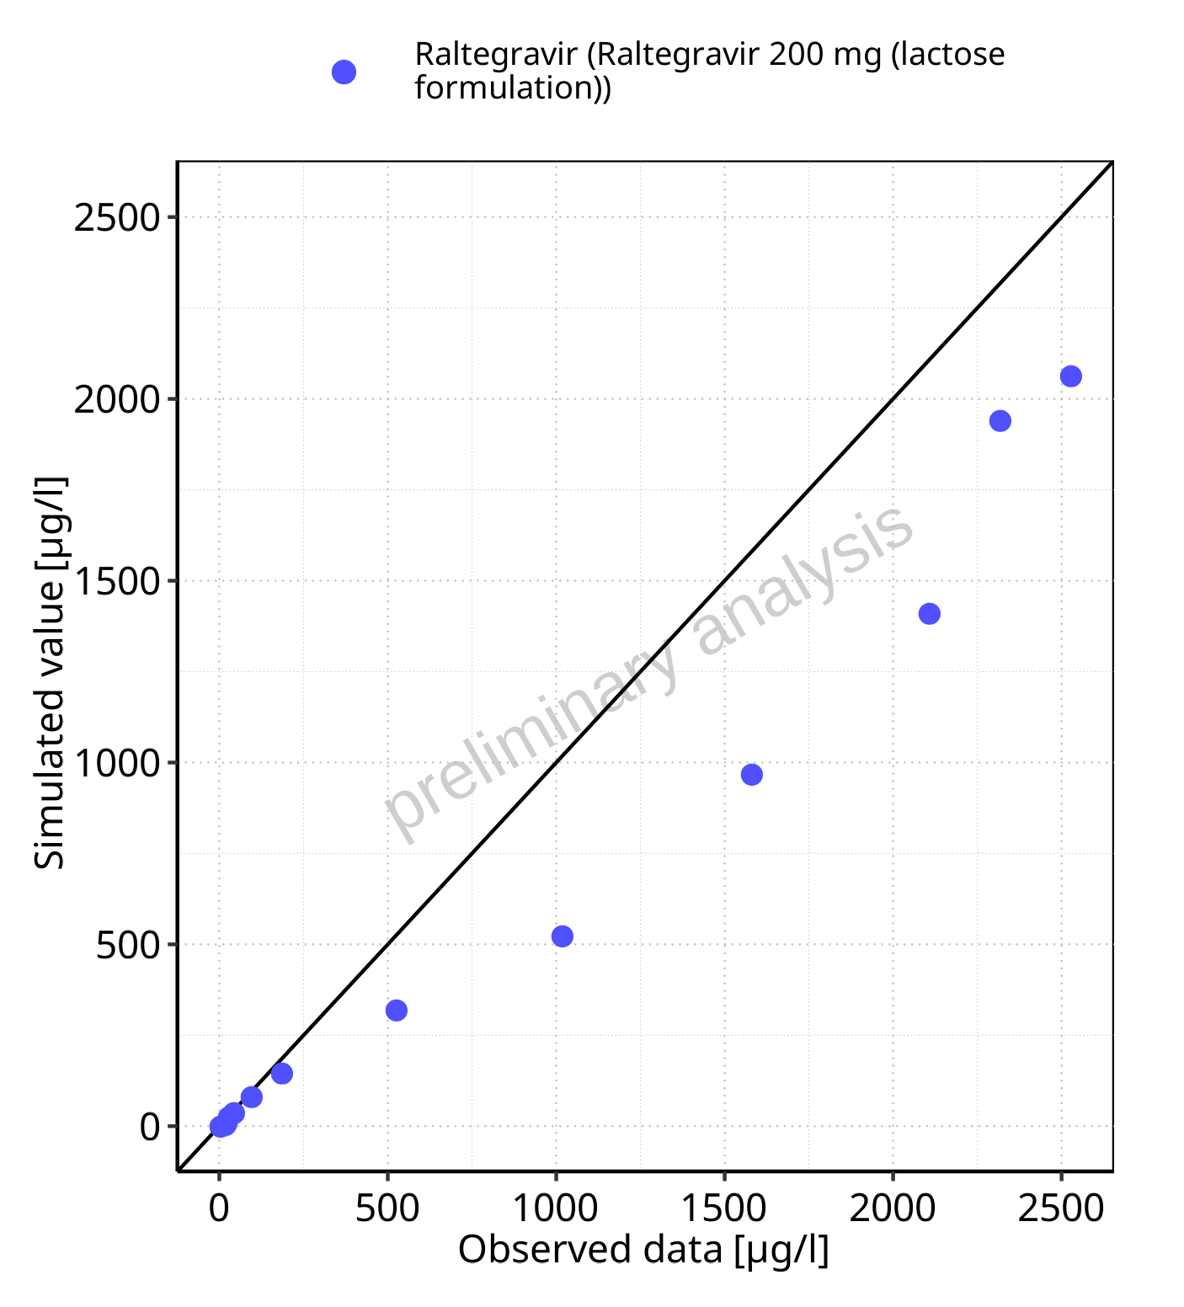

**Figure 5-35: Predicted vs observed for Raltegravir 200 mg (lactose formulation). Data source: Data/Raltegravir_PK.txt. Predictions and observations are plotted in a linear scale.**



**Figure 5-36: Predicted vs observed for Raltegravir 200 mg (lactose formulation). Data source: Data/Raltegravir_PK.txt. Predictions and observations are plotted in a logarithmic scale.**

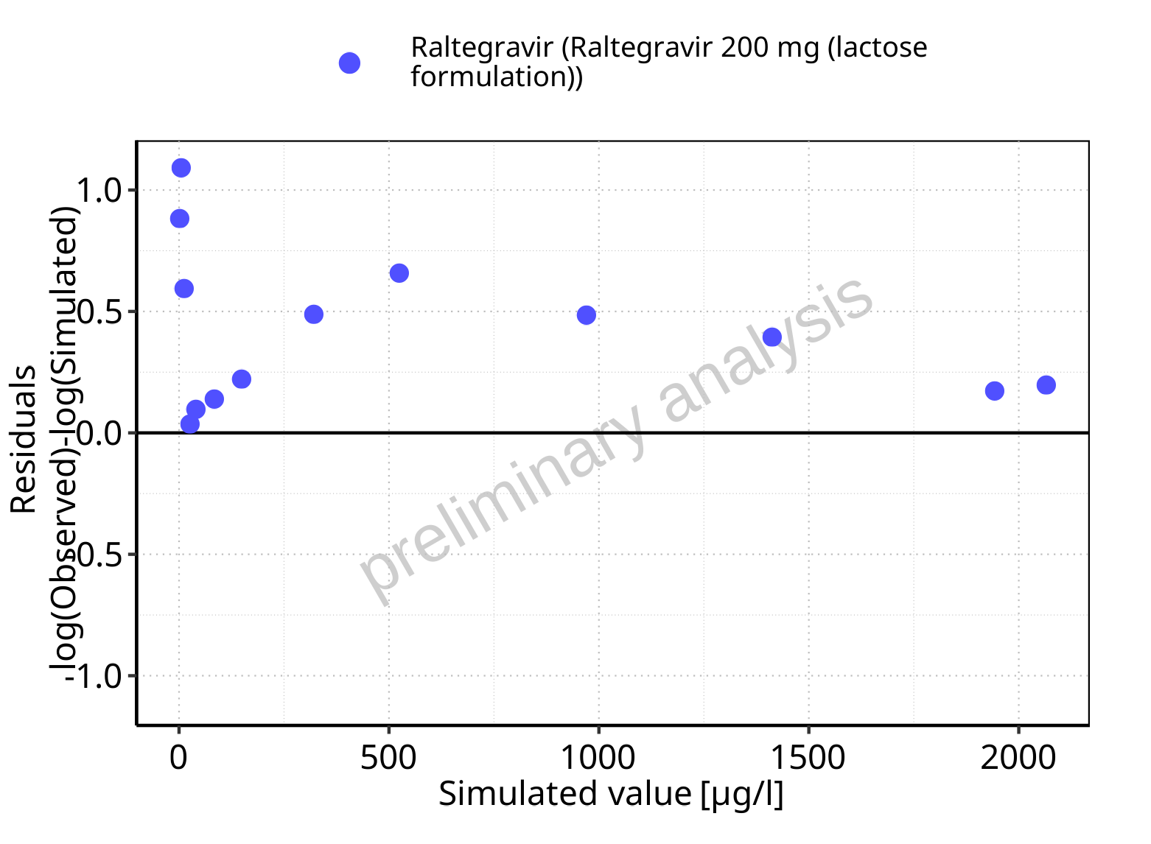

**Figure 5-37: Logarithmic residuals vs predicted values for Raltegravir 200 mg (lactose formulation). Data source: Data/Raltegravir_PK.txt.**

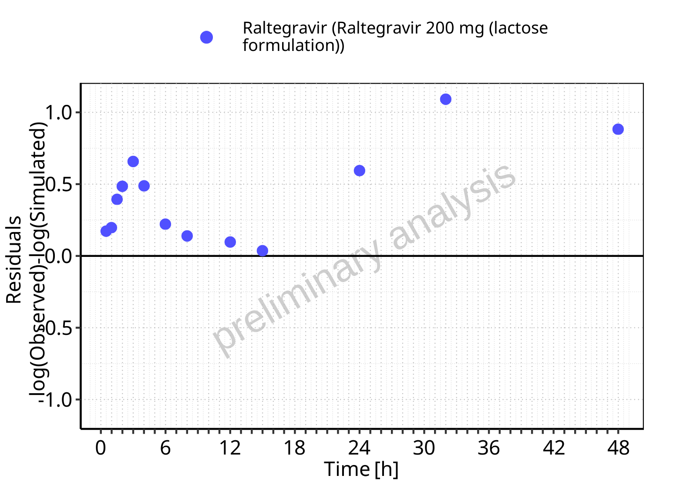

**Figure 5-38: Logarithmic residuals vs time values for Raltegravir 200 mg (lactose formulation). Data source: Data/Raltegravir_PK.txt.**

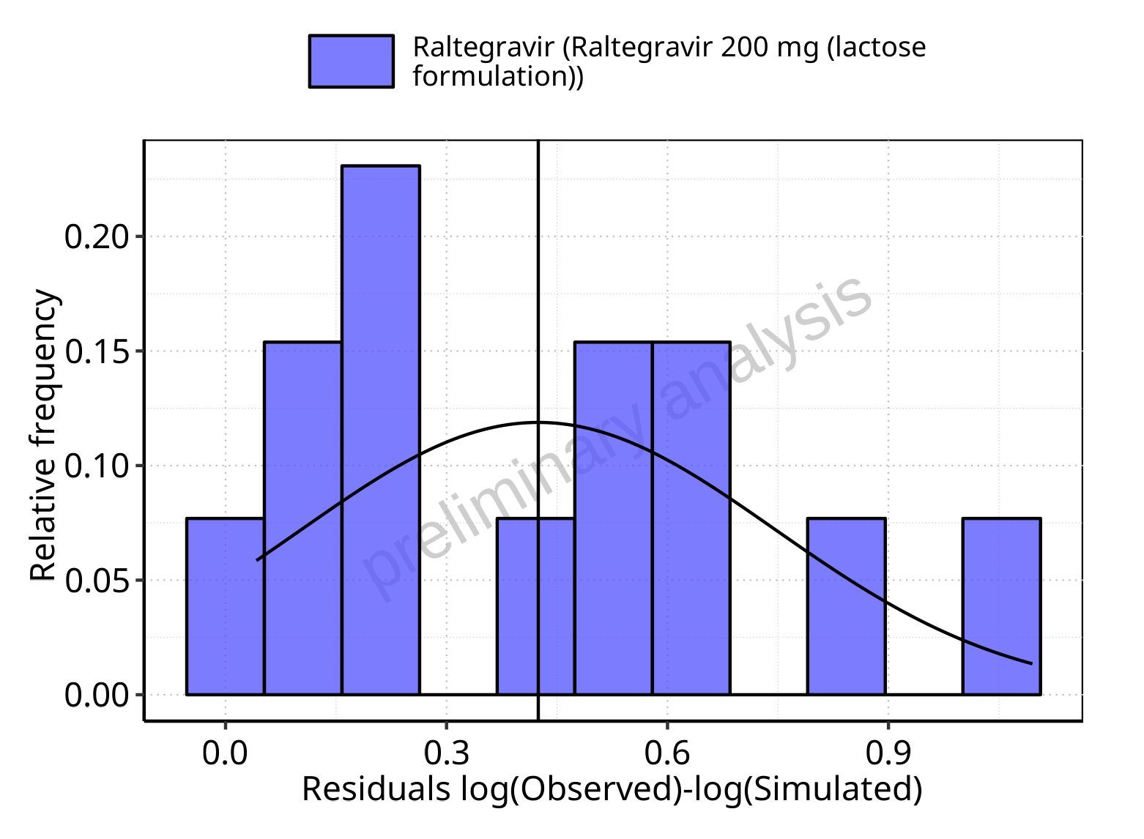

**Figure 5-39: Logarithmic residuals distribution (stacked) for Raltegravir 200 mg (lactose formulation). Data source: Data/Raltegravir_PK.txt.**

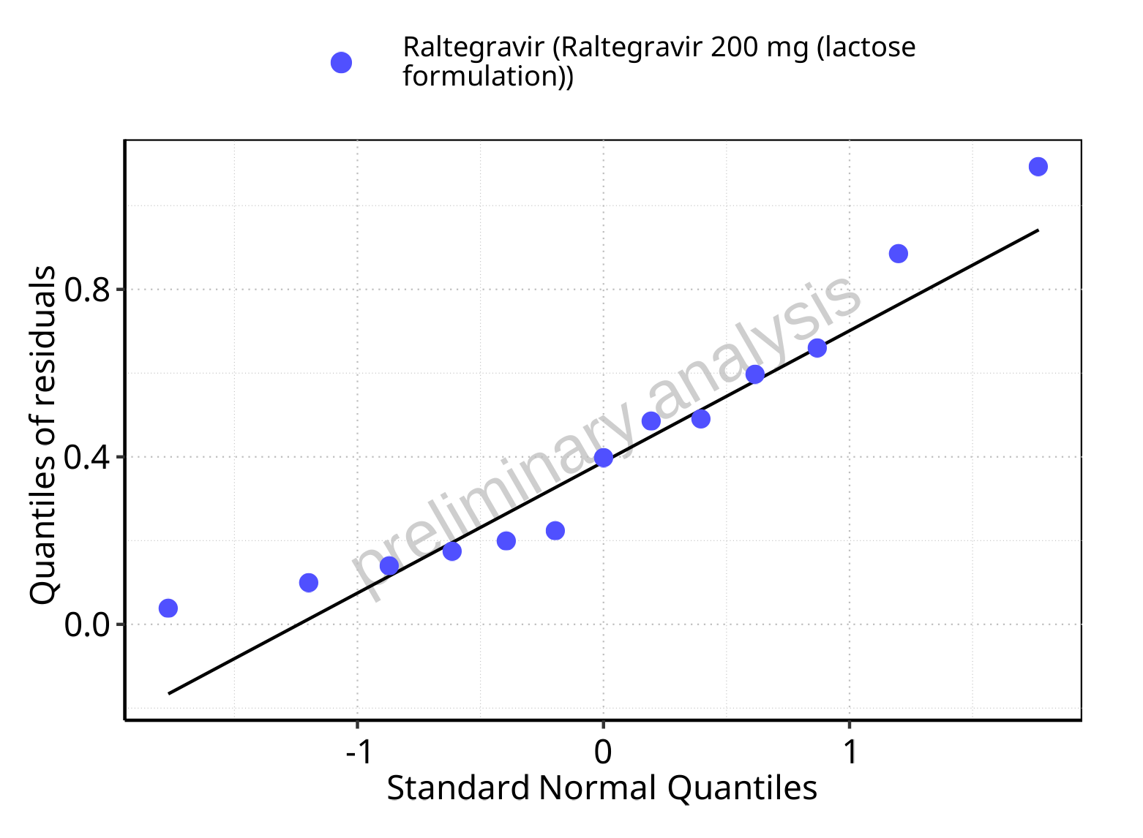

**Figure 5-40: Logarithmic residuals for Raltegravir 200 mg (lactose formulation) as quantile-quantile plot. Data source: Data/Raltegravir_PK.txt.**

## Time profiles and residual plots for Raltegravir 400mg (lactose formulation)

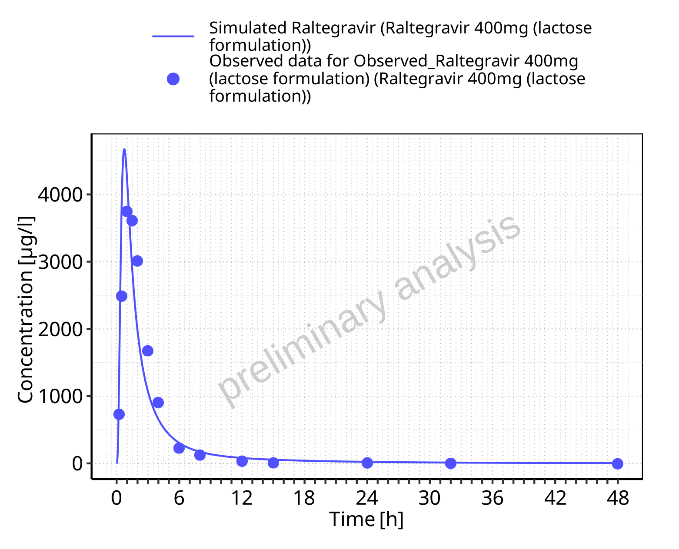

**Figure 5-41: Time profiles for Raltegravir 400mg (lactose formulation). Data source: Data/Raltegravir_PK.txt. Time profiles are plotted in a linear scale.**

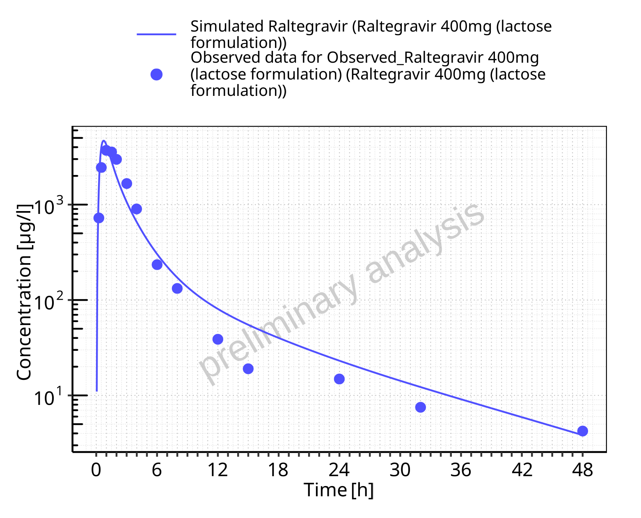

**Figure 5-42: Time profiles for Raltegravir 400mg (lactose formulation). Data source: Data/Raltegravir_PK.txt. Time profiles are plotted in a logarithmic scale.**

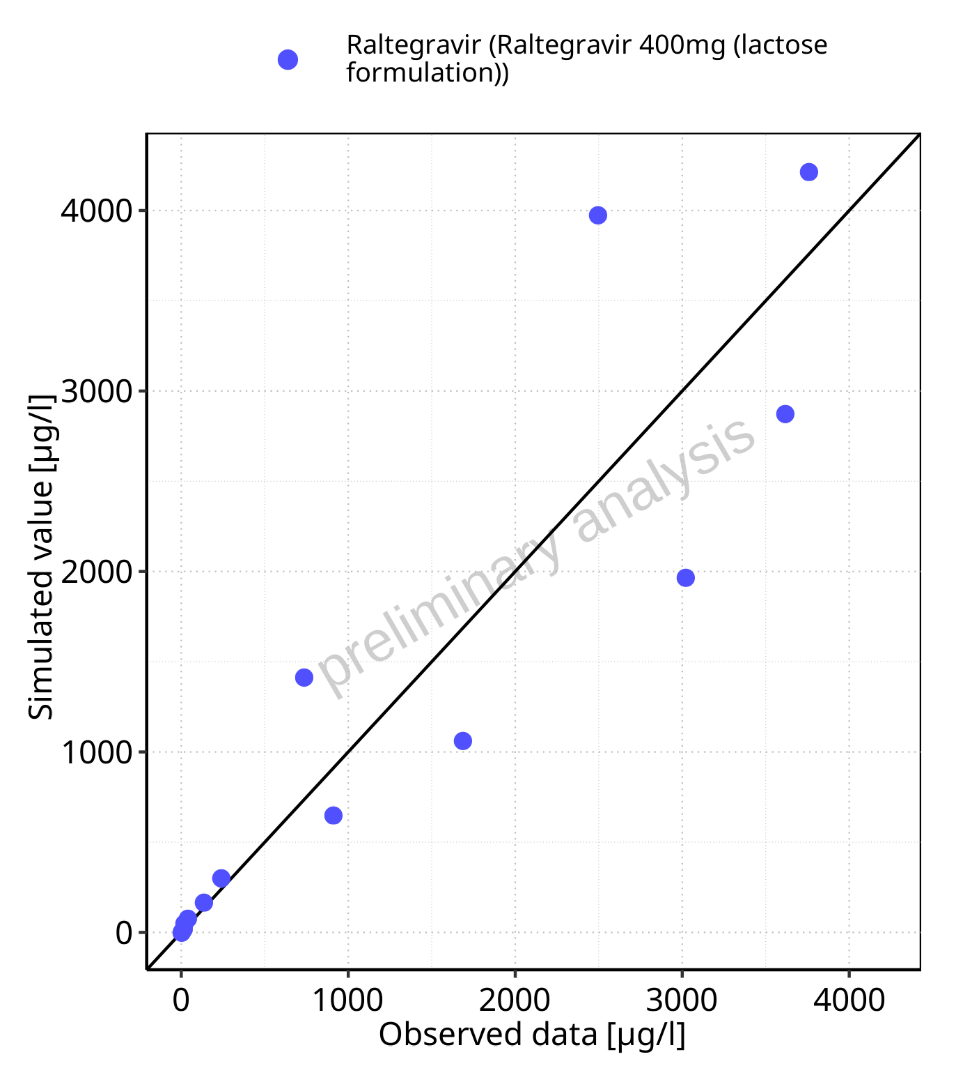

**Figure 5-43: Predicted vs observed for Raltegravir 400mg (lactose formulation). Data source: Data/Raltegravir_PK.txt. Predictions and observations are plotted in a linear scale.**



**Figure 5-44: Predicted vs observed for Raltegravir 400mg (lactose formulation). Data source: Data/Raltegravir_PK.txt. Predictions and observations are plotted in a logarithmic scale.**

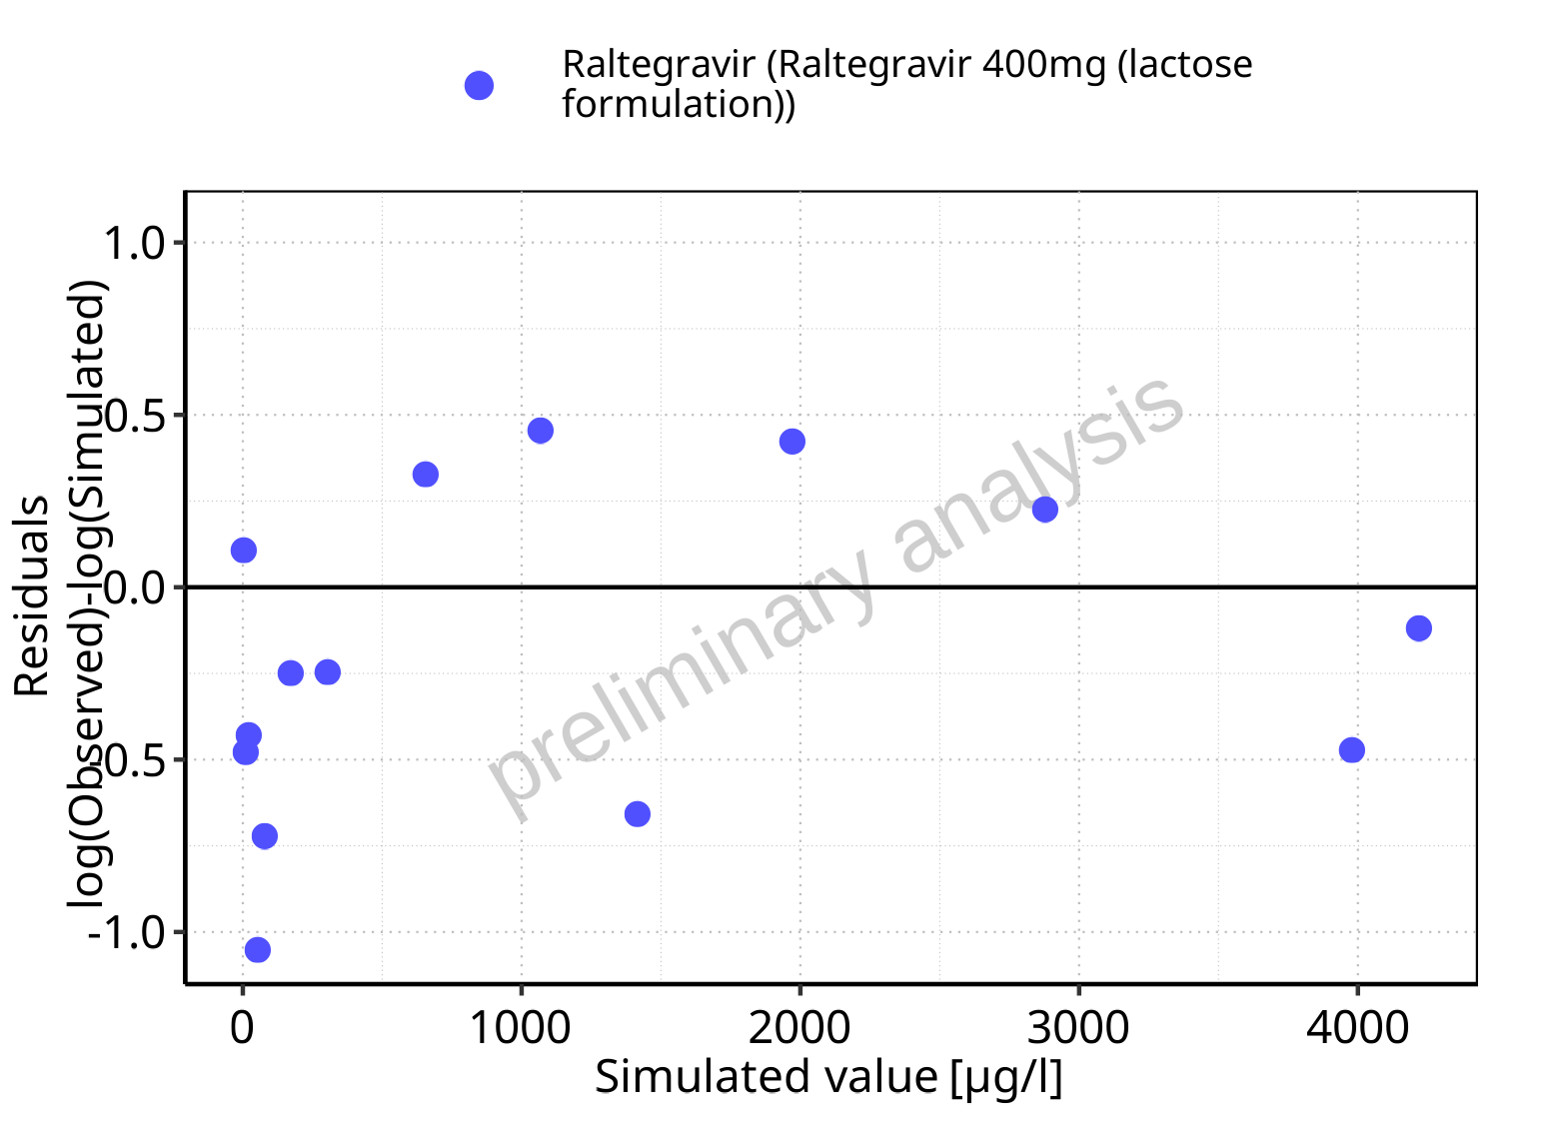

**Figure 5-45: Logarithmic residuals vs predicted values for Raltegravir 400mg (lactose formulation). Data source: Data/Raltegravir_PK.txt.**

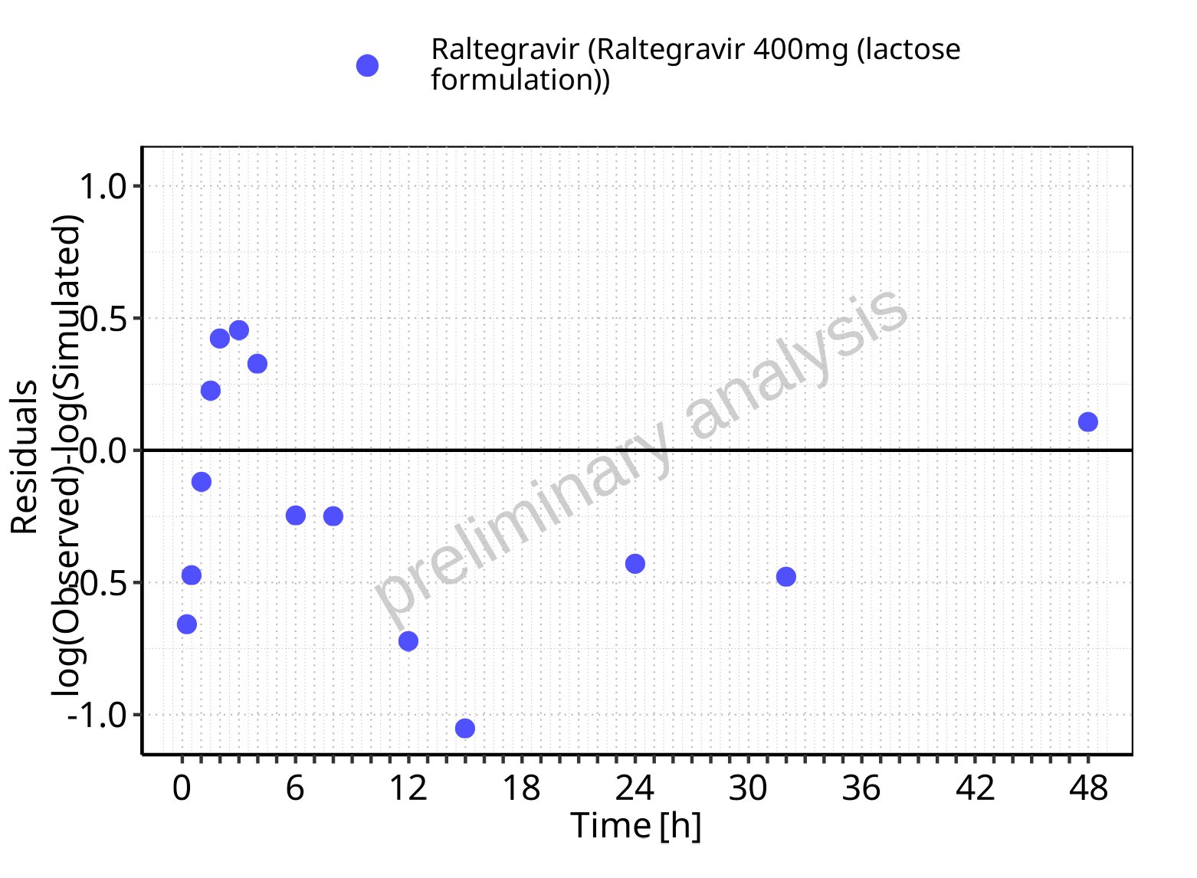

**Figure 5-46: Logarithmic residuals vs time values for Raltegravir 400mg (lactose formulation). Data source: Data/Raltegravir_PK.txt.**

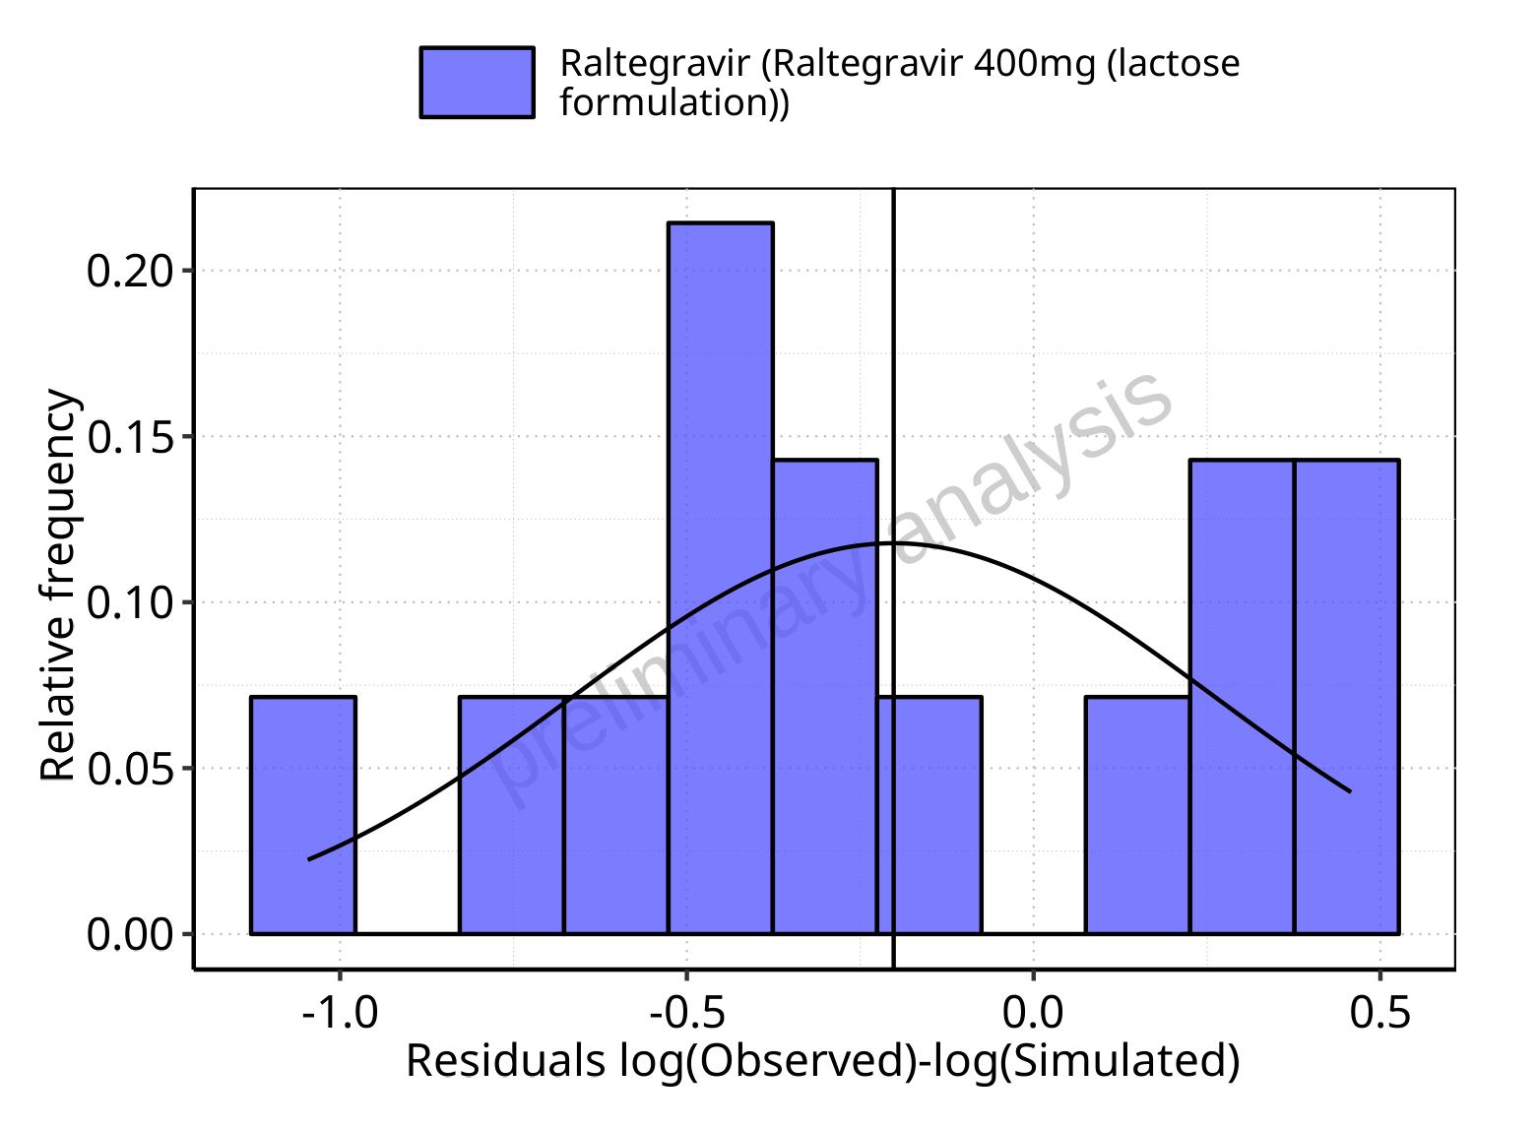

**Figure 5-47: Logarithmic residuals distribution (stacked) for Raltegravir 400mg (lactose formulation). Data source: Data/Raltegravir_PK.txt.**

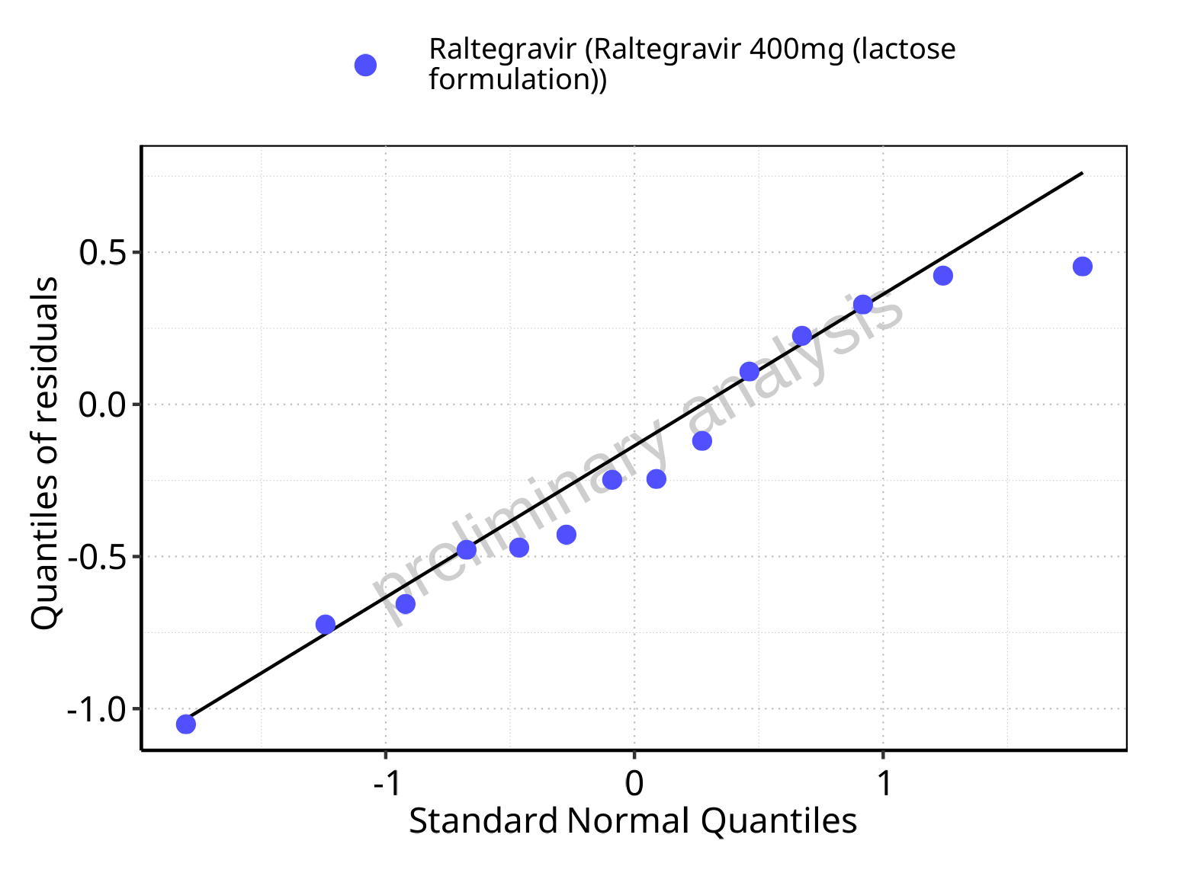

**Figure 5-48: Logarithmic residuals for Raltegravir 400mg (lactose formulation) as quantile-quantile plot. Data source: Data/Raltegravir_PK.txt.**

## Time profiles and residual plots for Raltegravir 800 mg (lactose formulation)

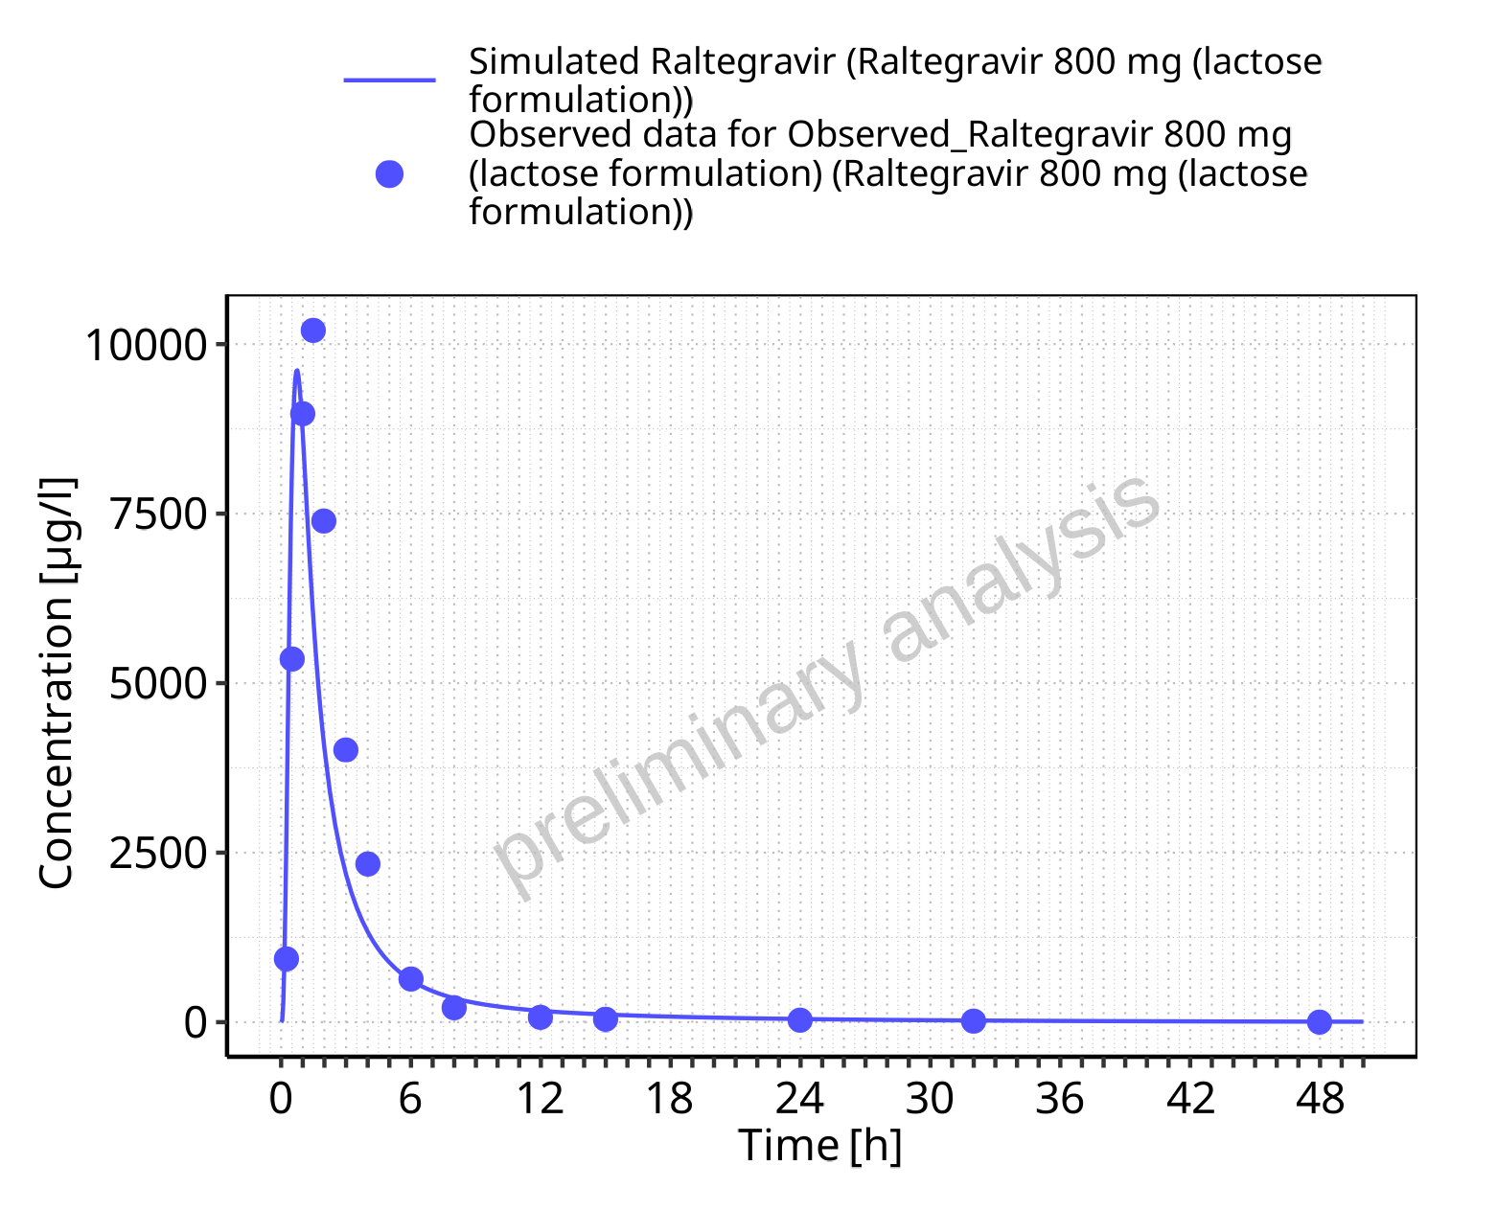

**Figure 5-49: Time profiles for Raltegravir 800 mg (lactose formulation). Data source: Data/Raltegravir_PK.txt. Time profiles are plotted in a linear scale.**

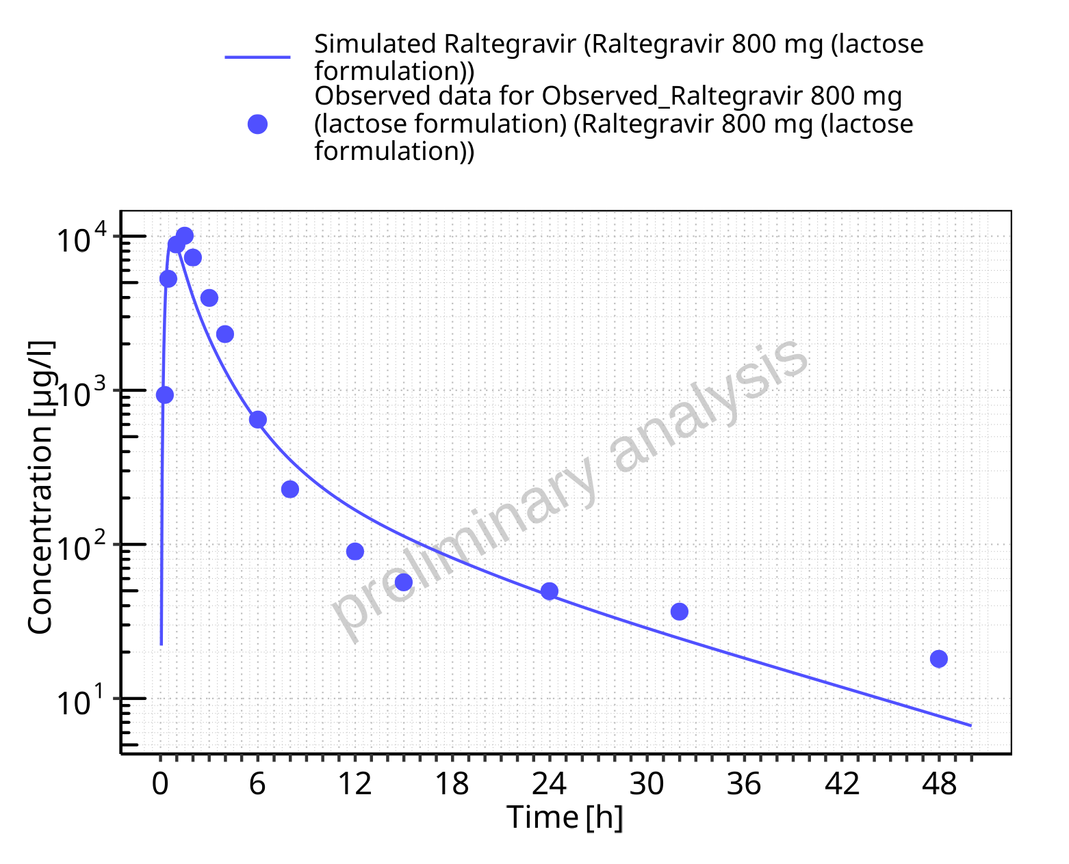

**Figure 5-50: Time profiles for Raltegravir 800 mg (lactose formulation). Data source: Data/Raltegravir_PK.txt. Time profiles are plotted in a logarithmic scale.**

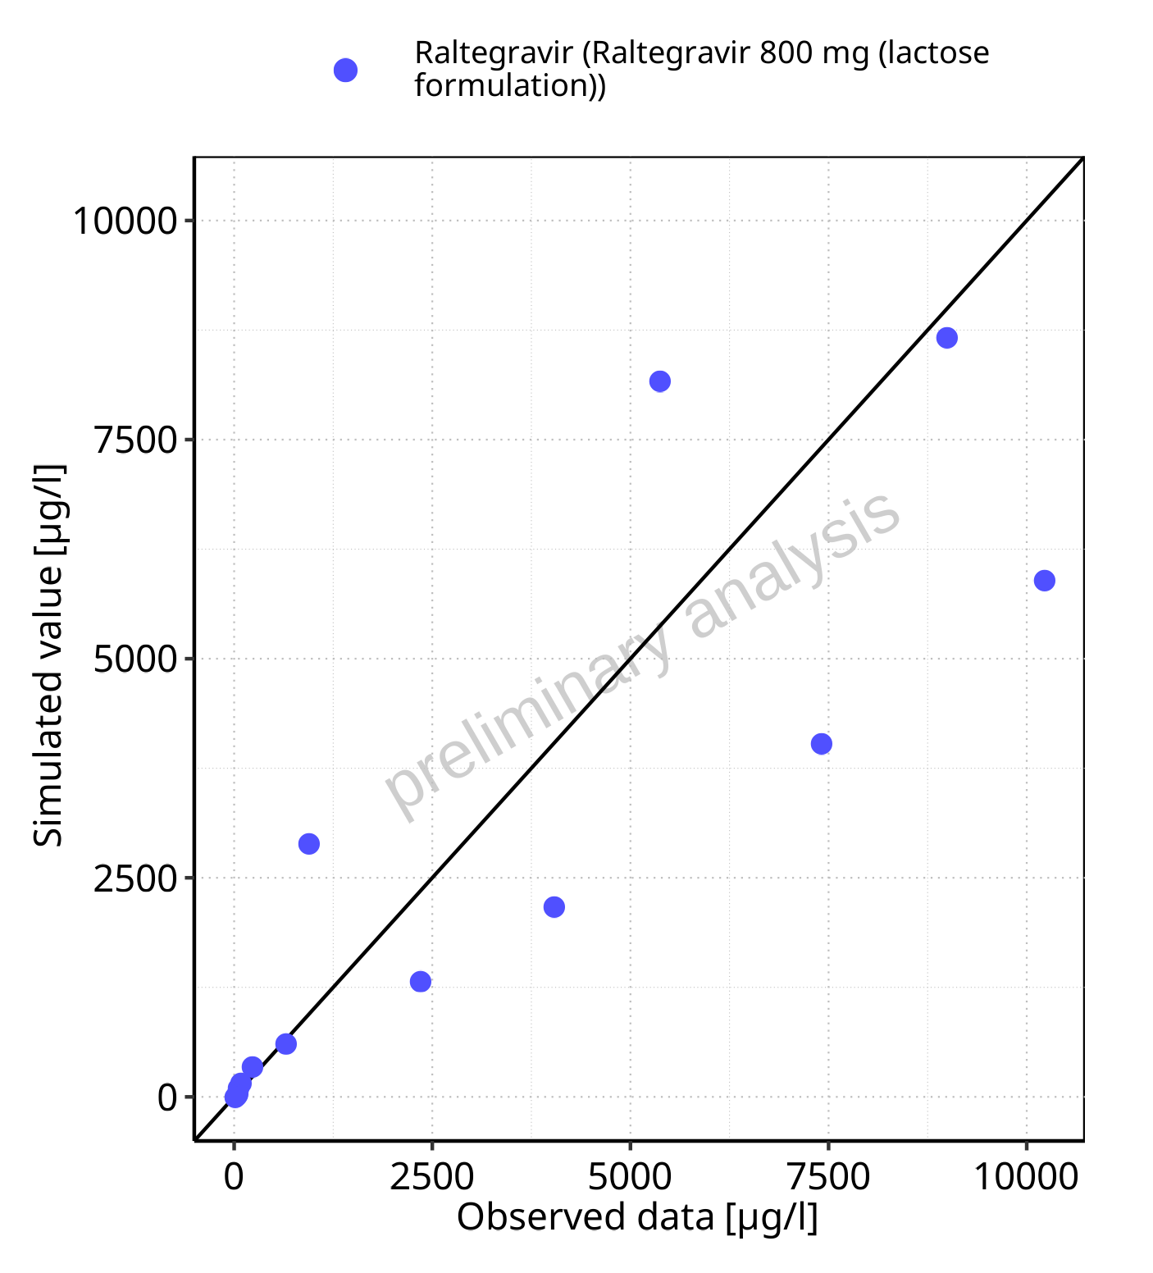

**Figure 5-51: Predicted vs observed for Raltegravir 800 mg (lactose formulation). Data source: Data/Raltegravir_PK.txt. Predictions and observations are plotted in a linear scale.**



**Figure 5-52: Predicted vs observed for Raltegravir 800 mg (lactose formulation). Data source: Data/Raltegravir_PK.txt. Predictions and observations are plotted in a logarithmic scale.**

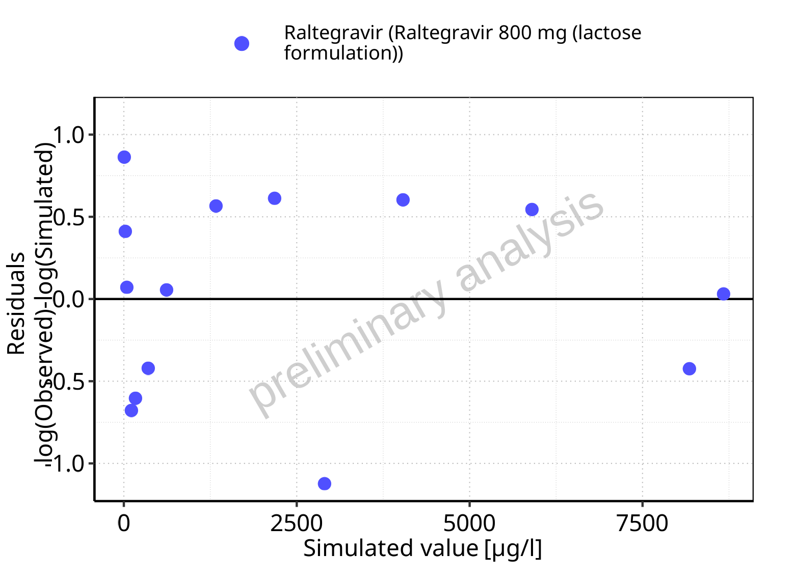

**Figure 5-53: Logarithmic residuals vs predicted values for Raltegravir 800 mg (lactose formulation). Data source: Data/Raltegravir_PK.txt.**

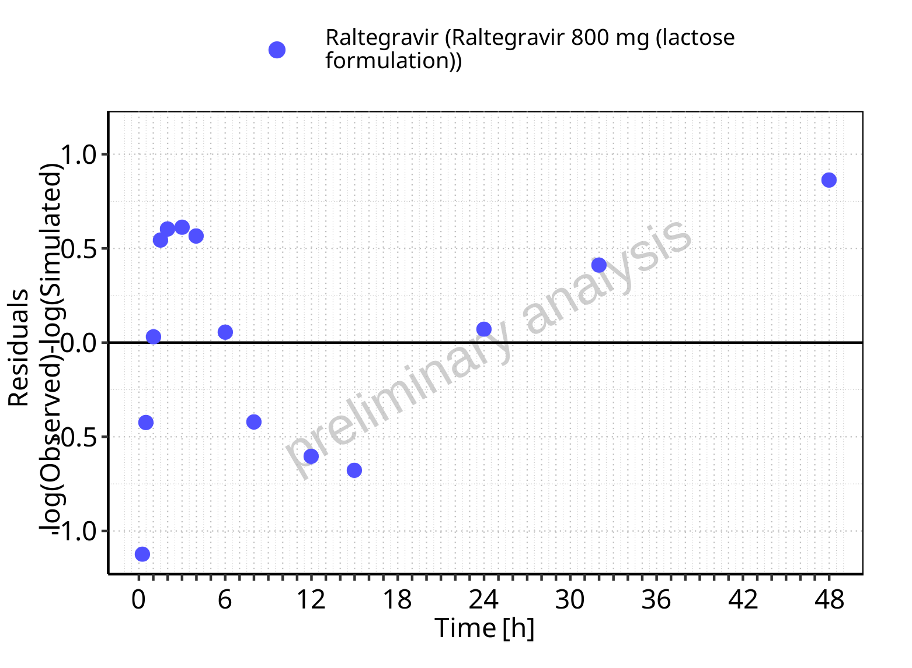

**Figure 5-54: Logarithmic residuals vs time values for Raltegravir 800 mg (lactose formulation). Data source: Data/Raltegravir_PK.txt.**

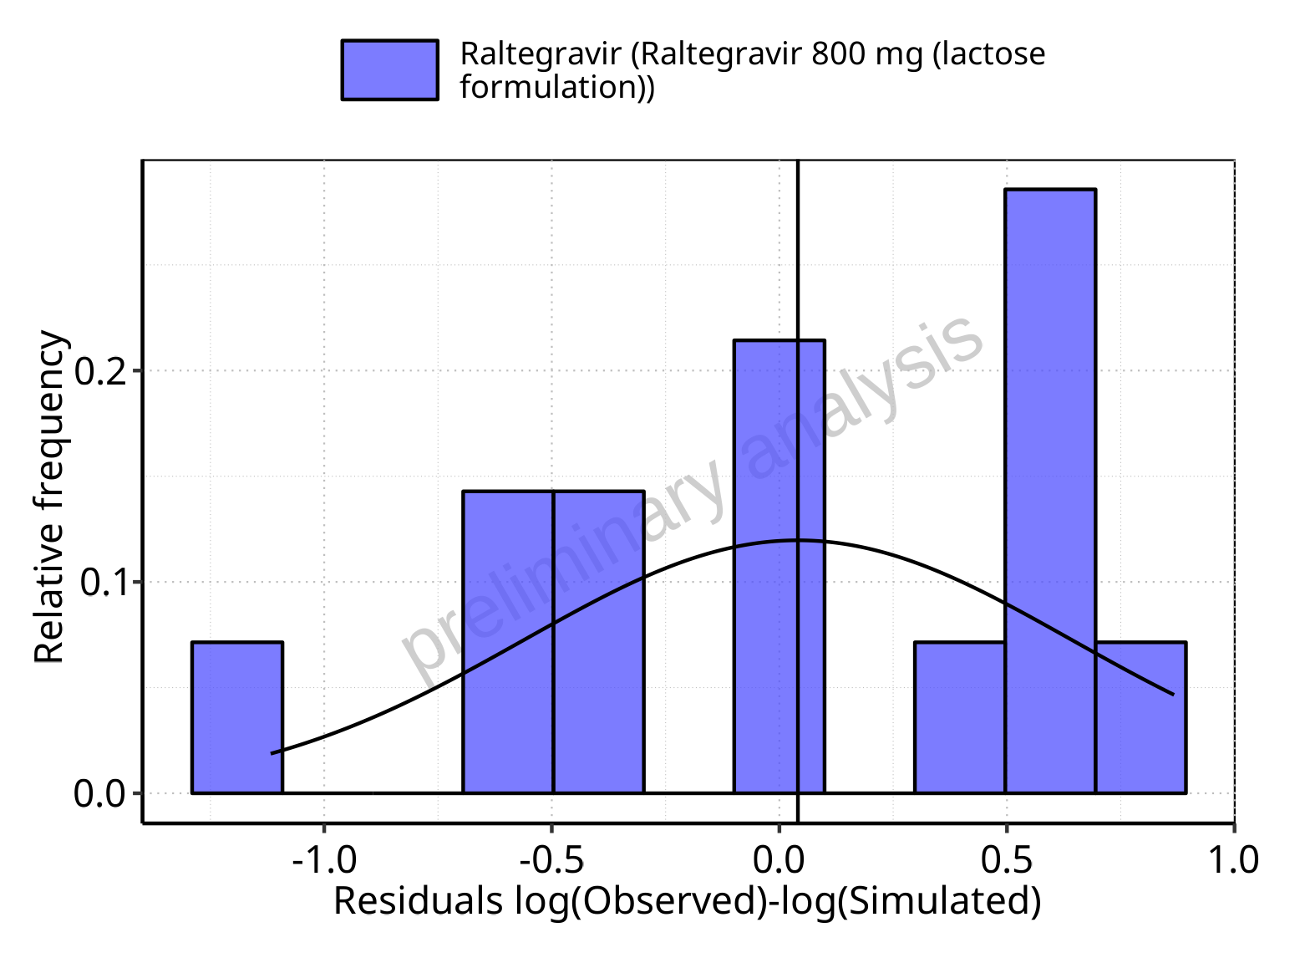

**Figure 5-55: Logarithmic residuals distribution (stacked) for Raltegravir 800 mg (lactose formulation). Data source: Data/Raltegravir_PK.txt.**

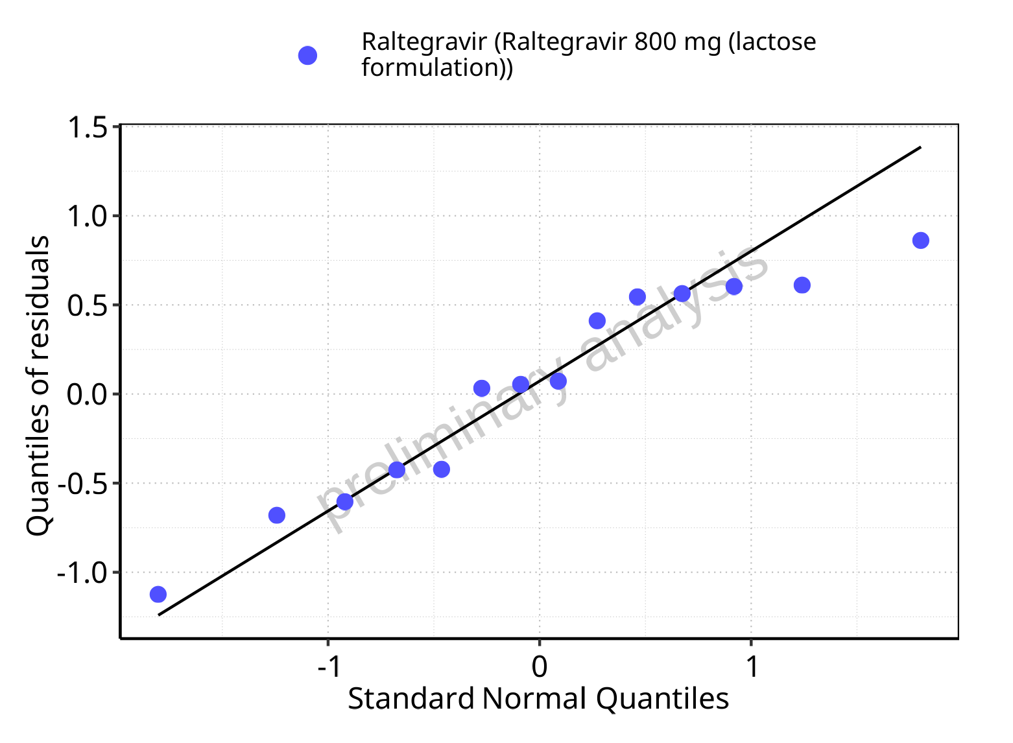

**Figure 5-56: Logarithmic residuals for Raltegravir 800 mg (lactose formulation) as quantile-quantile plot. Data source: Data/Raltegravir_PK.txt.**

## Time profiles and residual plots for Raltegravir 1200 mg (lactose formulation)

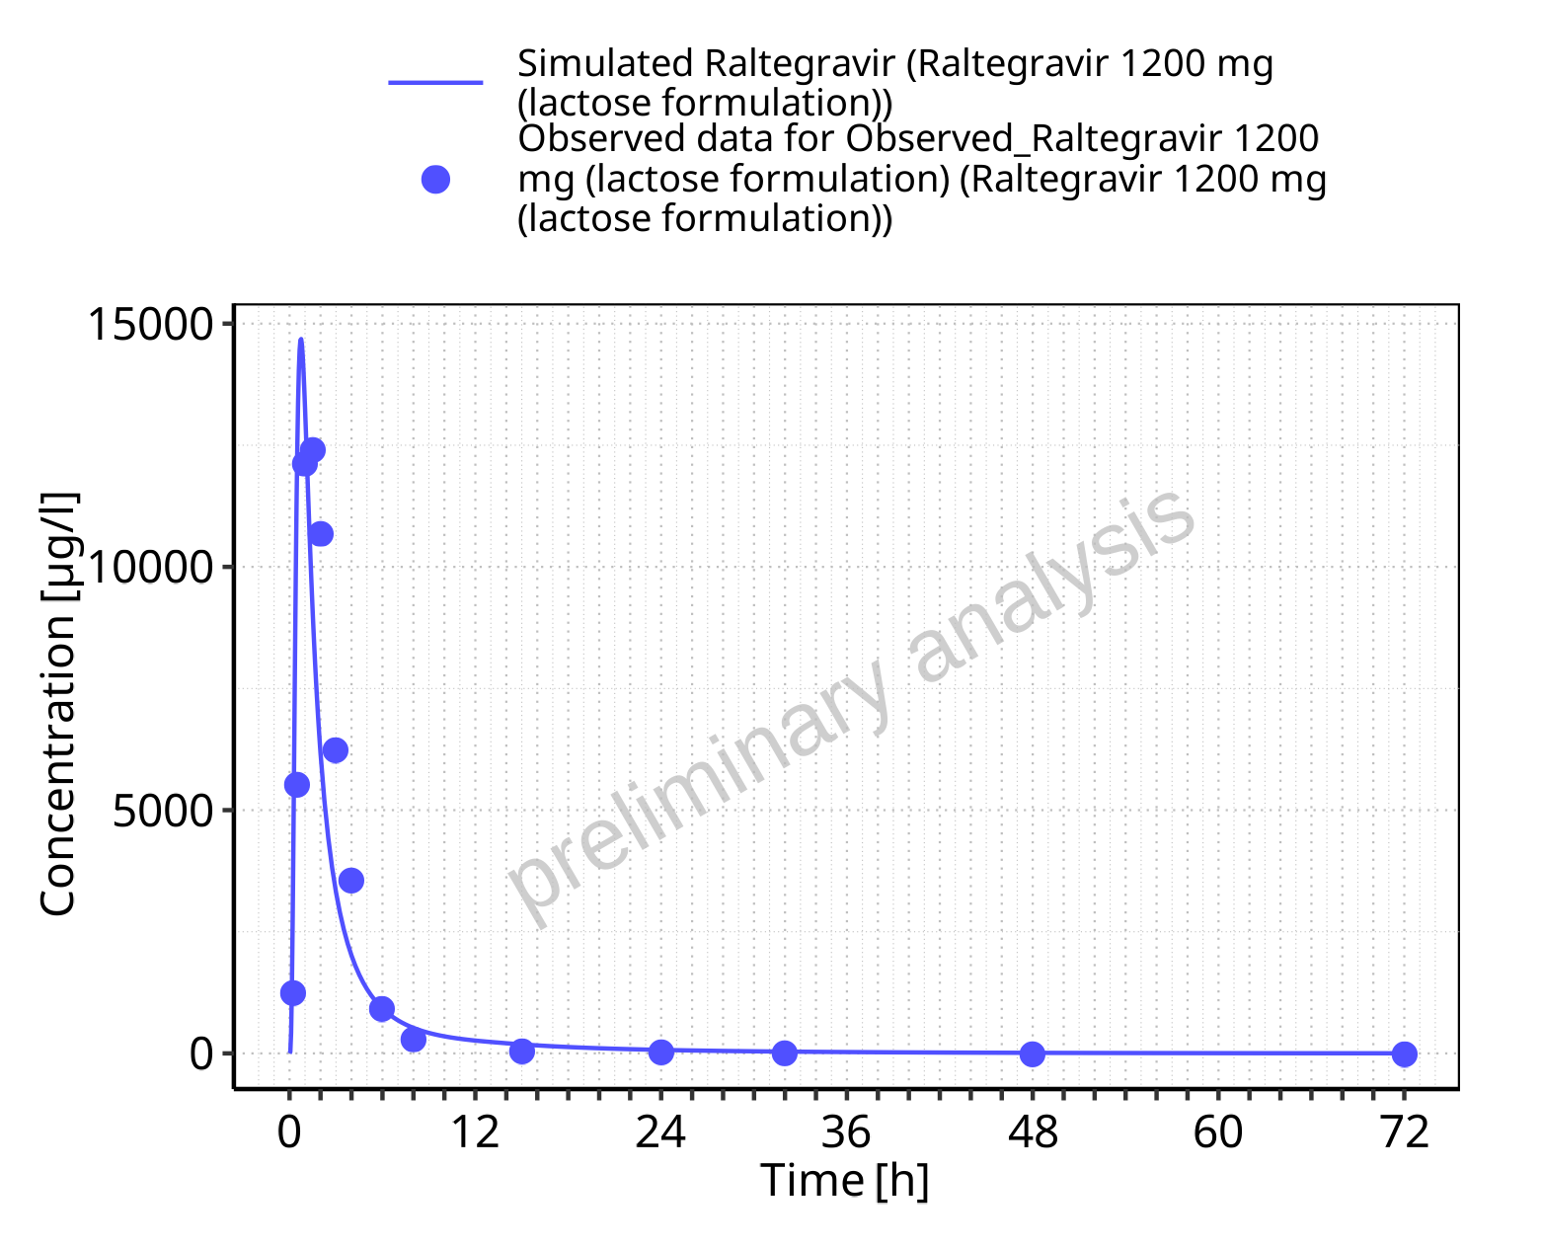

**Figure 5-57: Time profiles for Raltegravir 1200 mg (lactose formulation). Data source: Data/Raltegravir_PK.txt. Time profiles are plotted in a linear scale.**

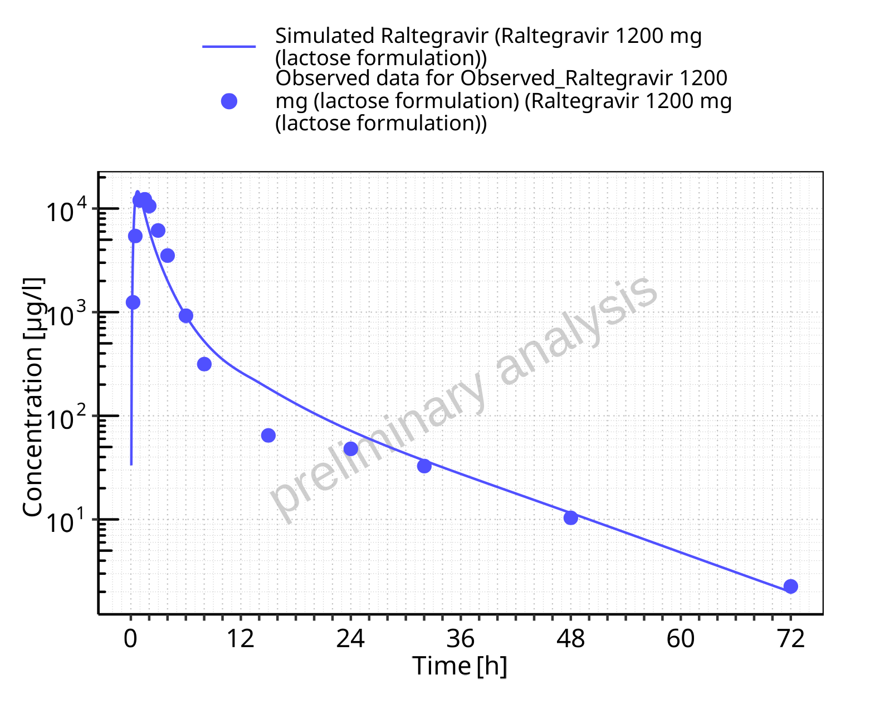

**Figure 5-58: Time profiles for Raltegravir 1200 mg (lactose formulation). Data source: Data/Raltegravir_PK.txt. Time profiles are plotted in a logarithmic scale.**

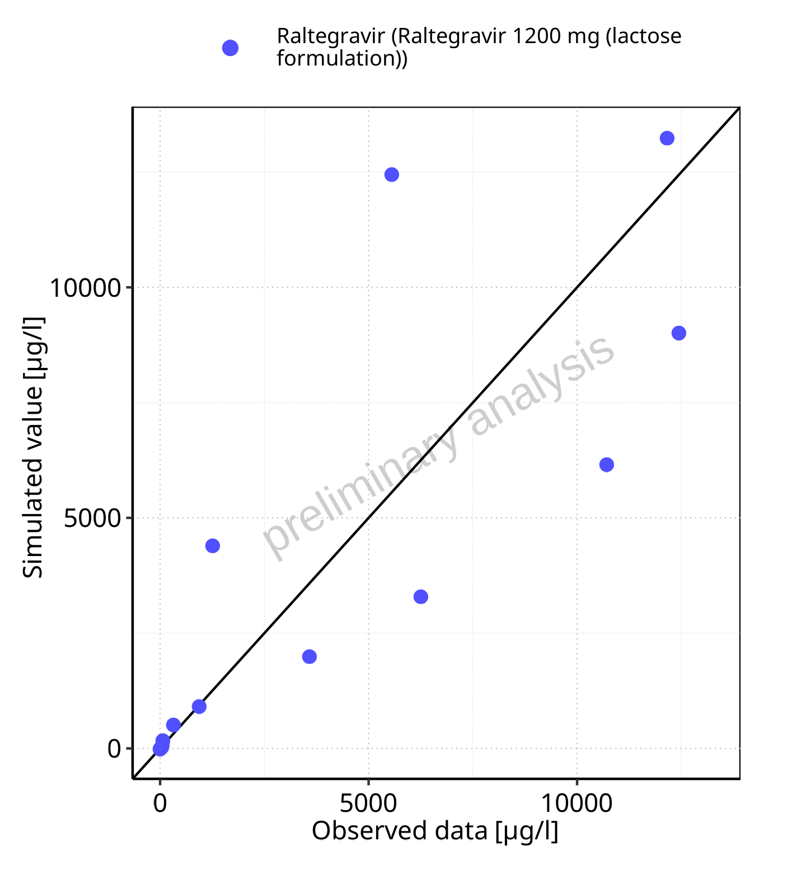

**Figure 5-59: Predicted vs observed for Raltegravir 1200 mg (lactose formulation). Data source: Data/Raltegravir_PK.txt. Predictions and observations are plotted in a linear scale.**



**Figure 5-60: Predicted vs observed for Raltegravir 1200 mg (lactose formulation). Data source: Data/Raltegravir_PK.txt. Predictions and observations are plotted in a logarithmic scale.**

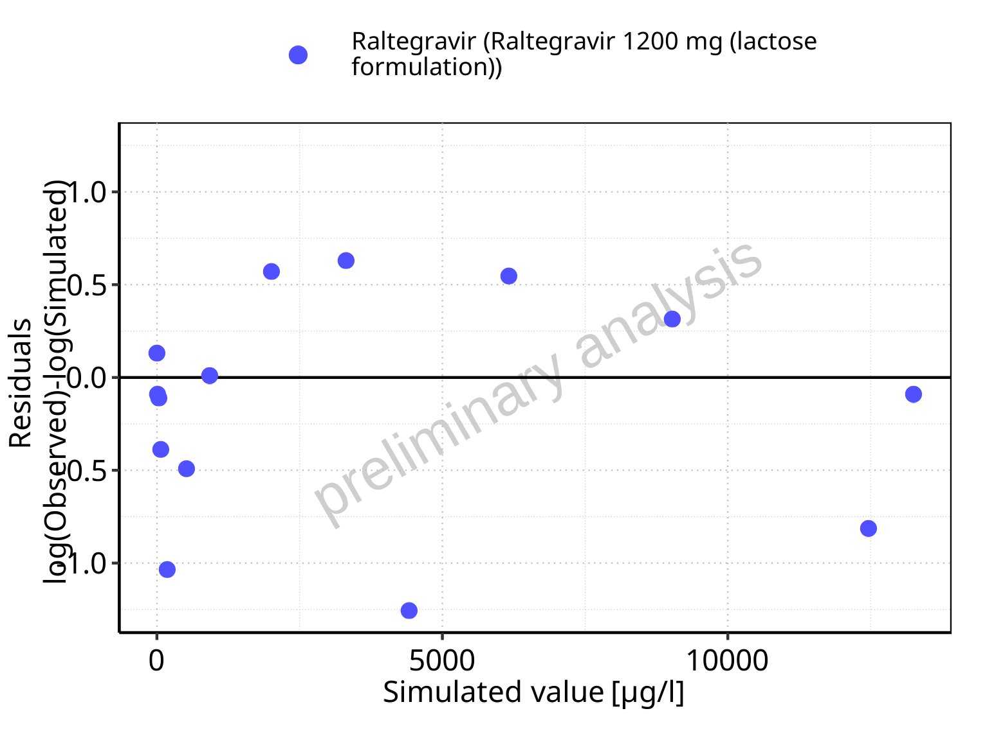

**Figure 5-61: Logarithmic residuals vs predicted values for Raltegravir 1200 mg (lactose formulation). Data source: Data/Raltegravir_PK.txt.**

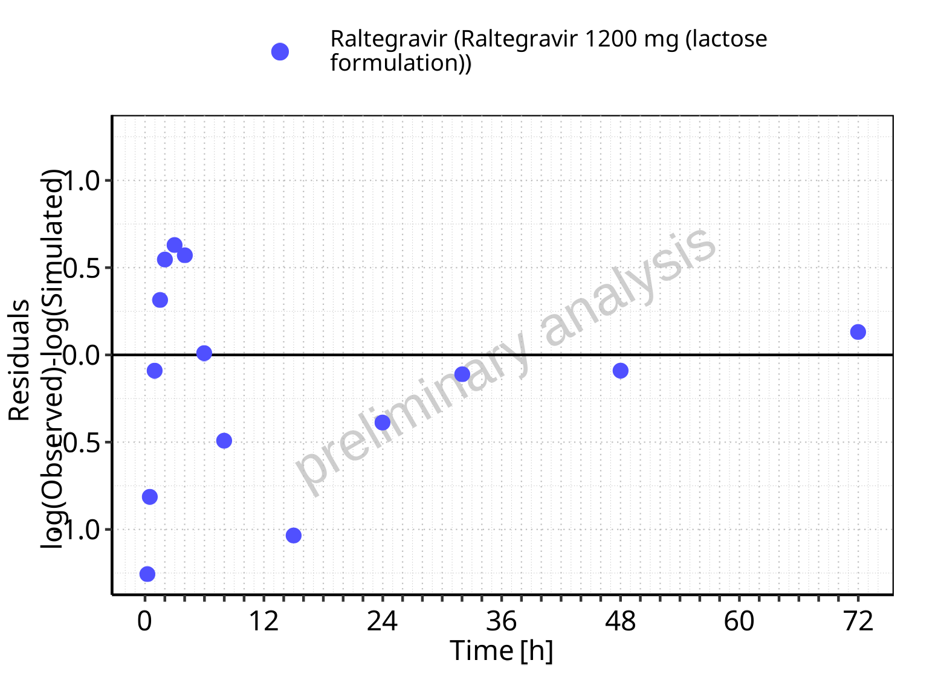

**Figure 5-62: Logarithmic residuals vs time values for Raltegravir 1200 mg (lactose formulation). Data source: Data/Raltegravir_PK.txt.**

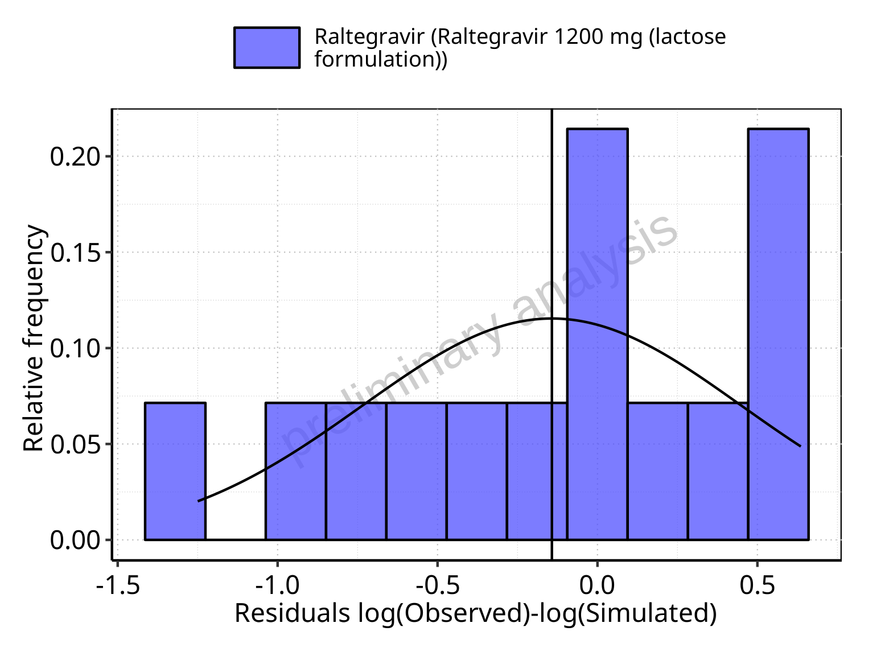

**Figure 5-63: Logarithmic residuals distribution (stacked) for Raltegravir 1200 mg (lactose formulation). Data source: Data/Raltegravir_PK.txt.**

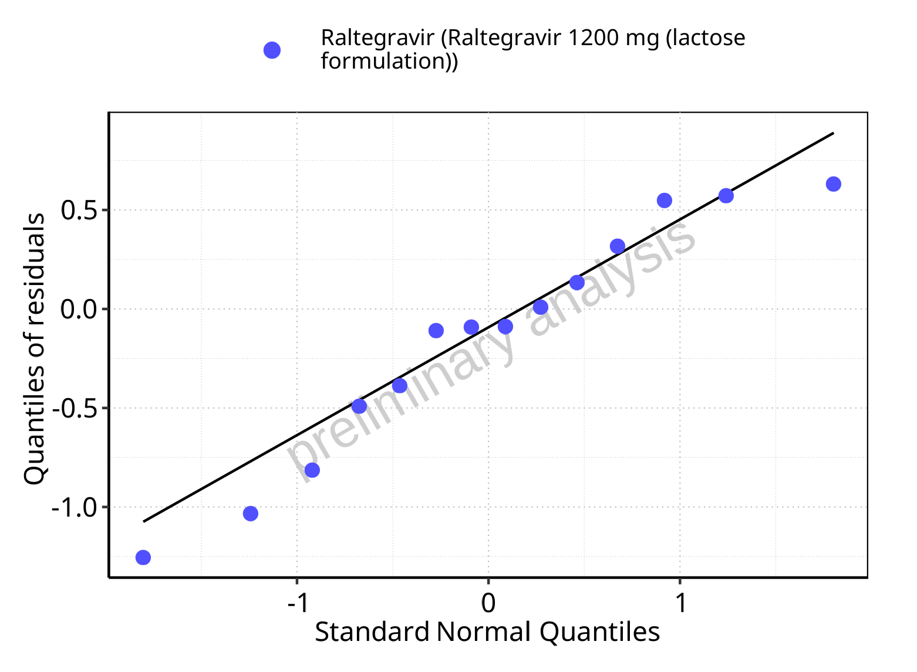

**Figure 5-64: Logarithmic residuals for Raltegravir 1200 mg (lactose formulation) as quantile-quantile plot. Data source: Data/Raltegravir_PK.txt.**

## Time profiles and residual plots for Raltegravir 1600 mg (lactose formulation)

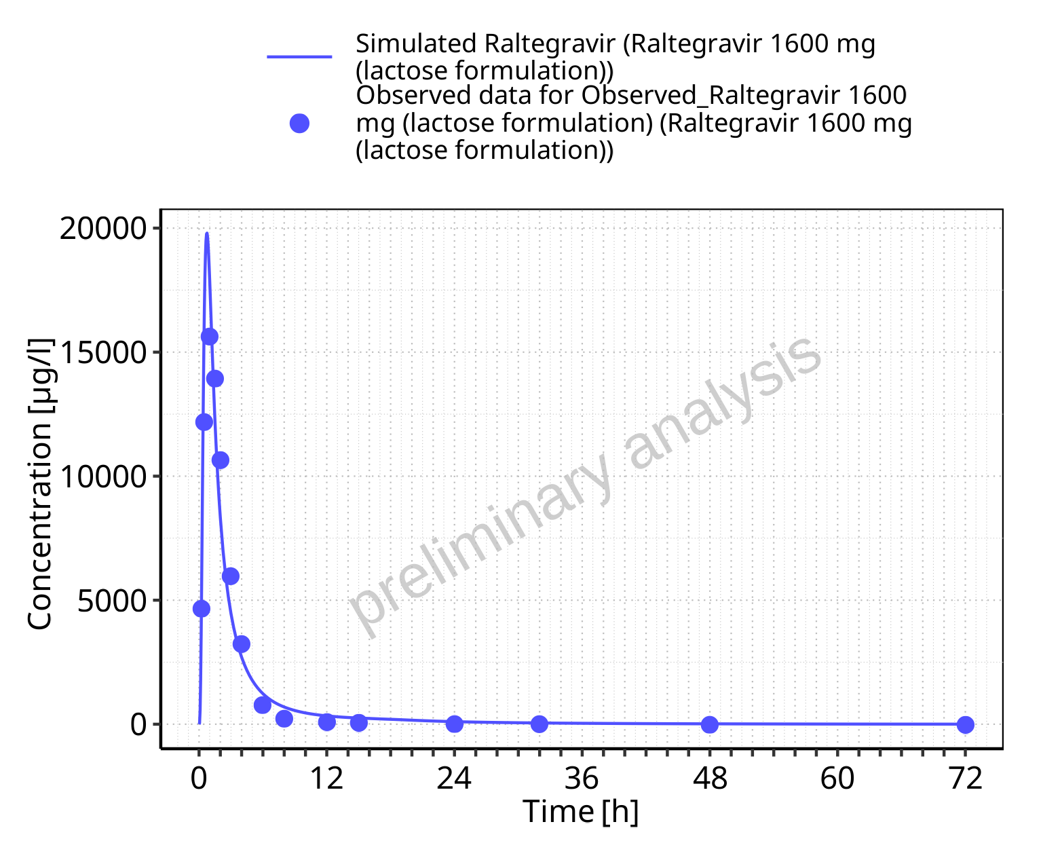

**Figure 5-65: Time profiles for Raltegravir 1600 mg (lactose formulation). Data source: Data/Raltegravir_PK.txt. Time profiles are plotted in a linear scale.**

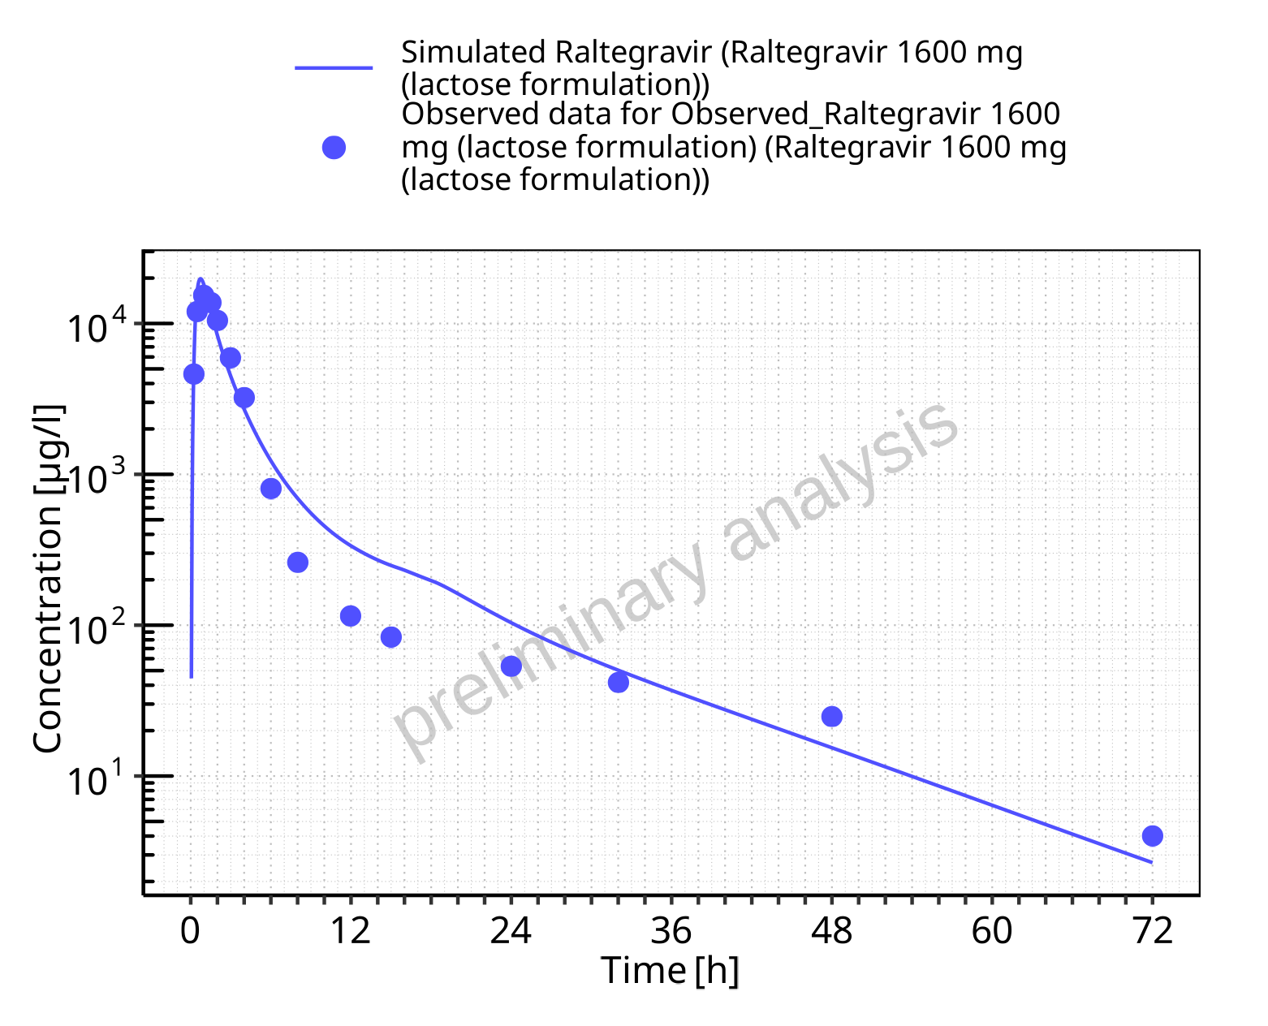

**Figure 5-66: Time profiles for Raltegravir 1600 mg (lactose formulation). Data source: Data/Raltegravir_PK.txt. Time profiles are plotted in a logarithmic scale.**

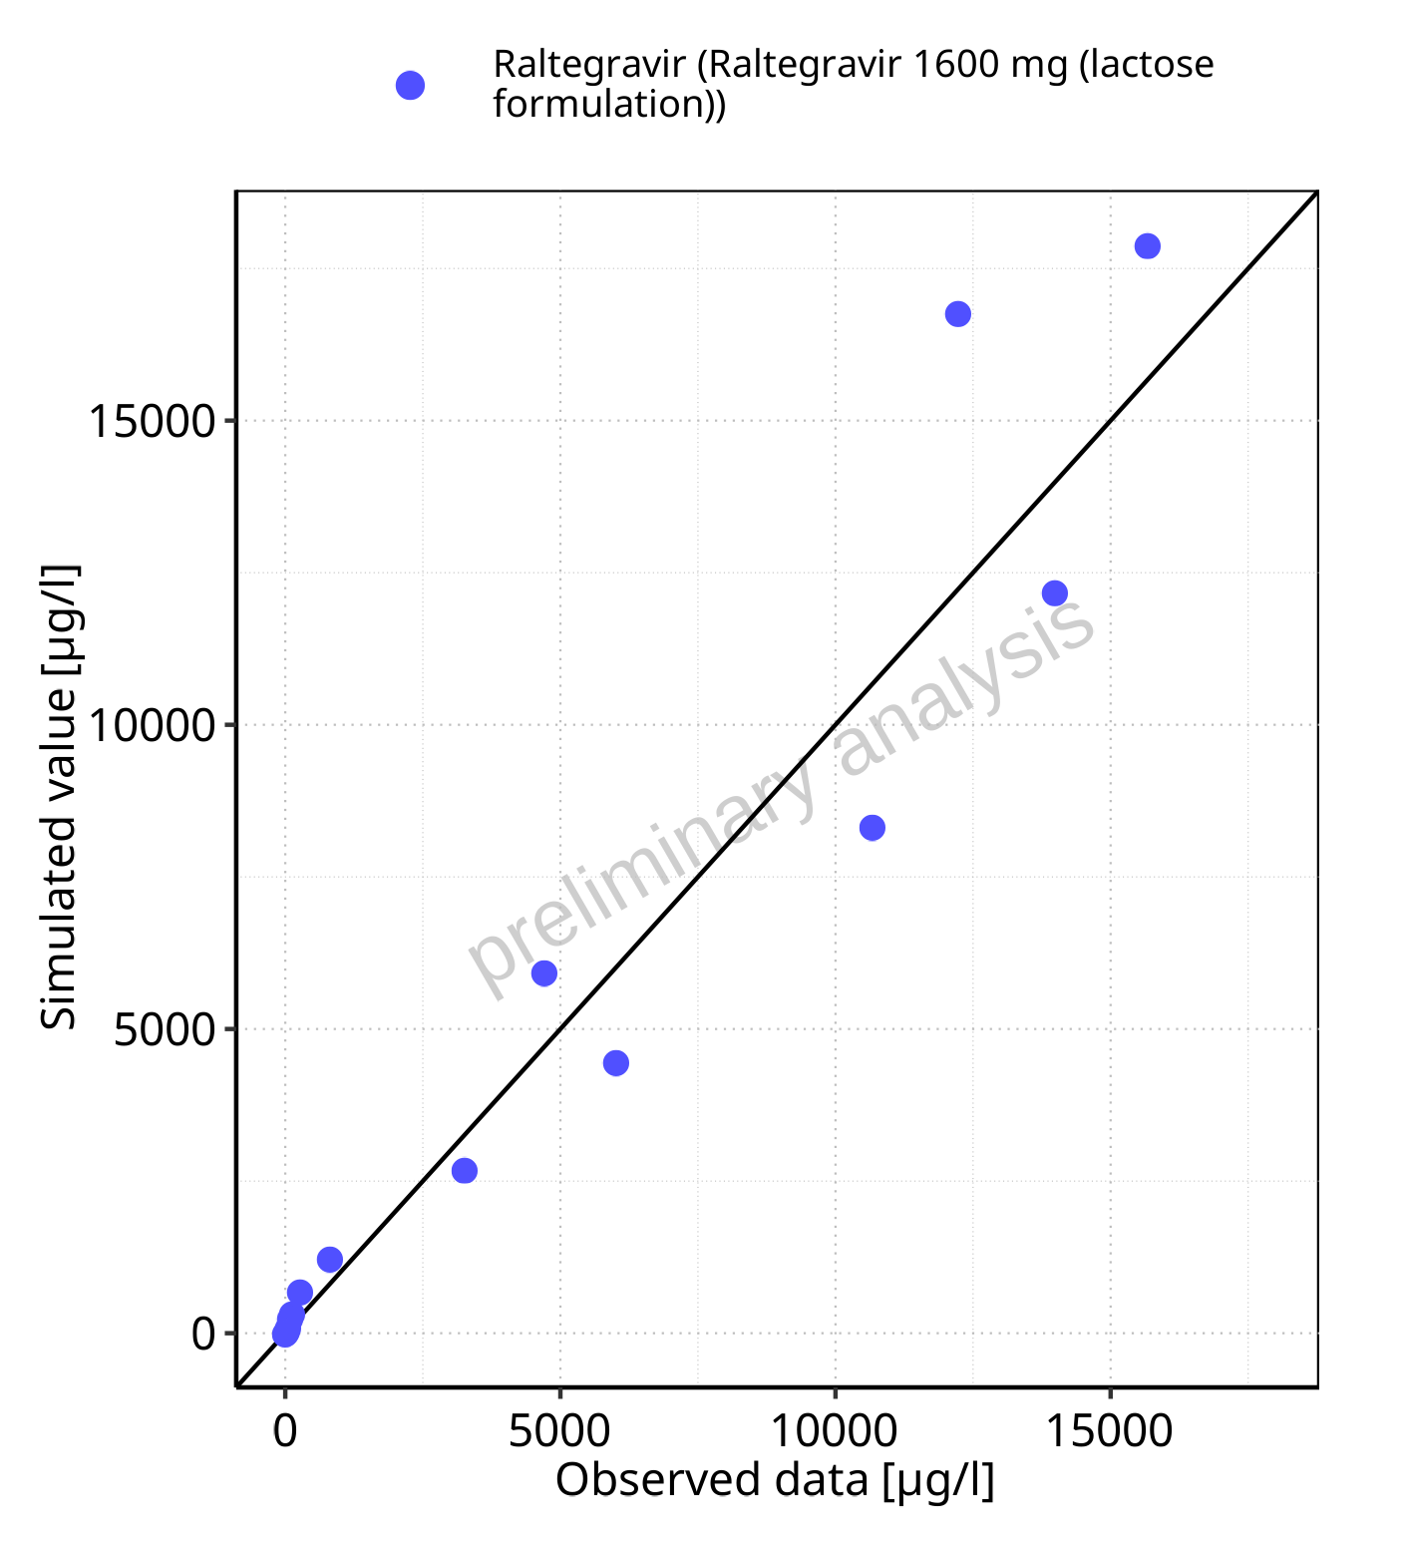

**Figure 5-67: Predicted vs observed for Raltegravir 1600 mg (lactose formulation). Data source: Data/Raltegravir_PK.txt. Predictions and observations are plotted in a linear scale.**



**Figure 5-68: Predicted vs observed for Raltegravir 1600 mg (lactose formulation). Data source: Data/Raltegravir_PK.txt. Predictions and observations are plotted in a logarithmic scale.**

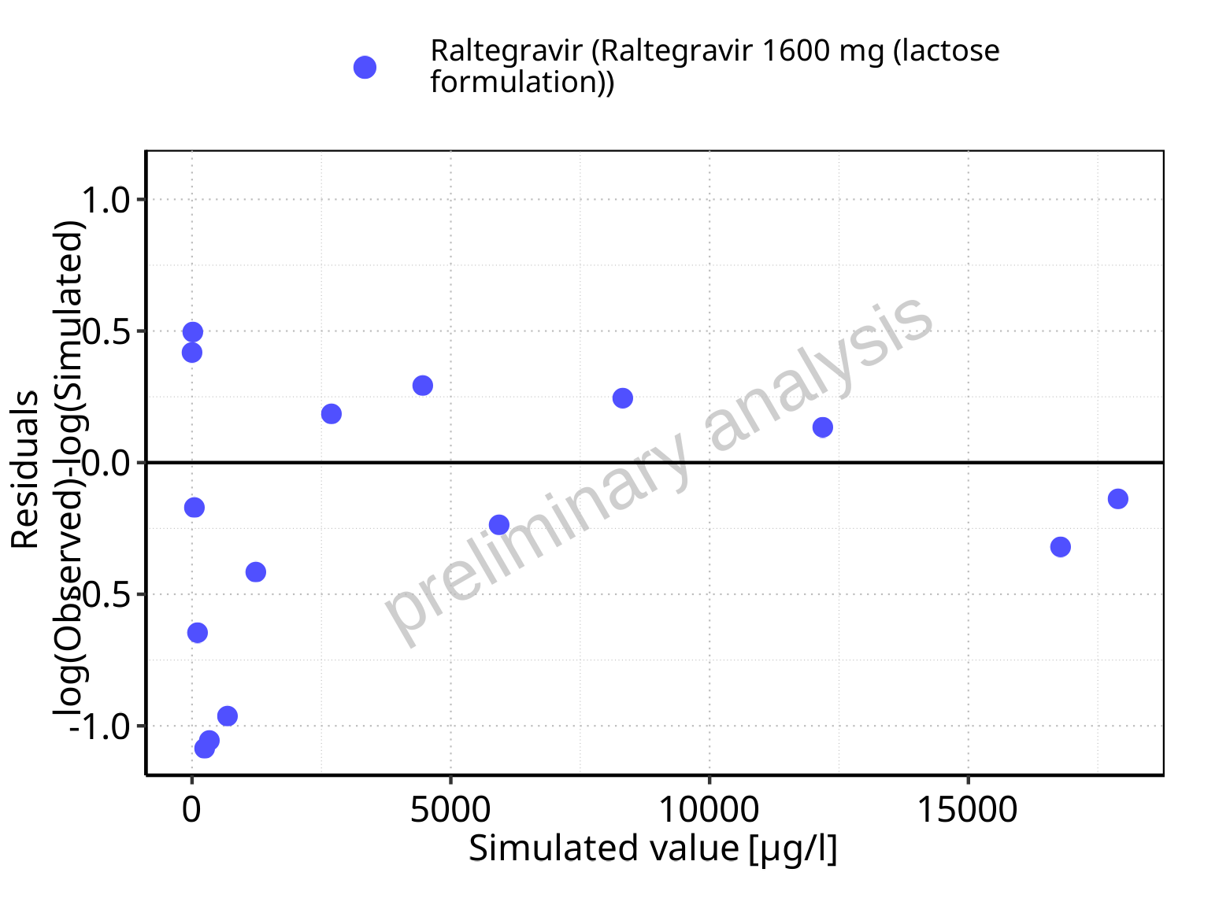

**Figure 5-69: Logarithmic residuals vs predicted values for Raltegravir 1600 mg (lactose formulation). Data source: Data/Raltegravir_PK.txt.**

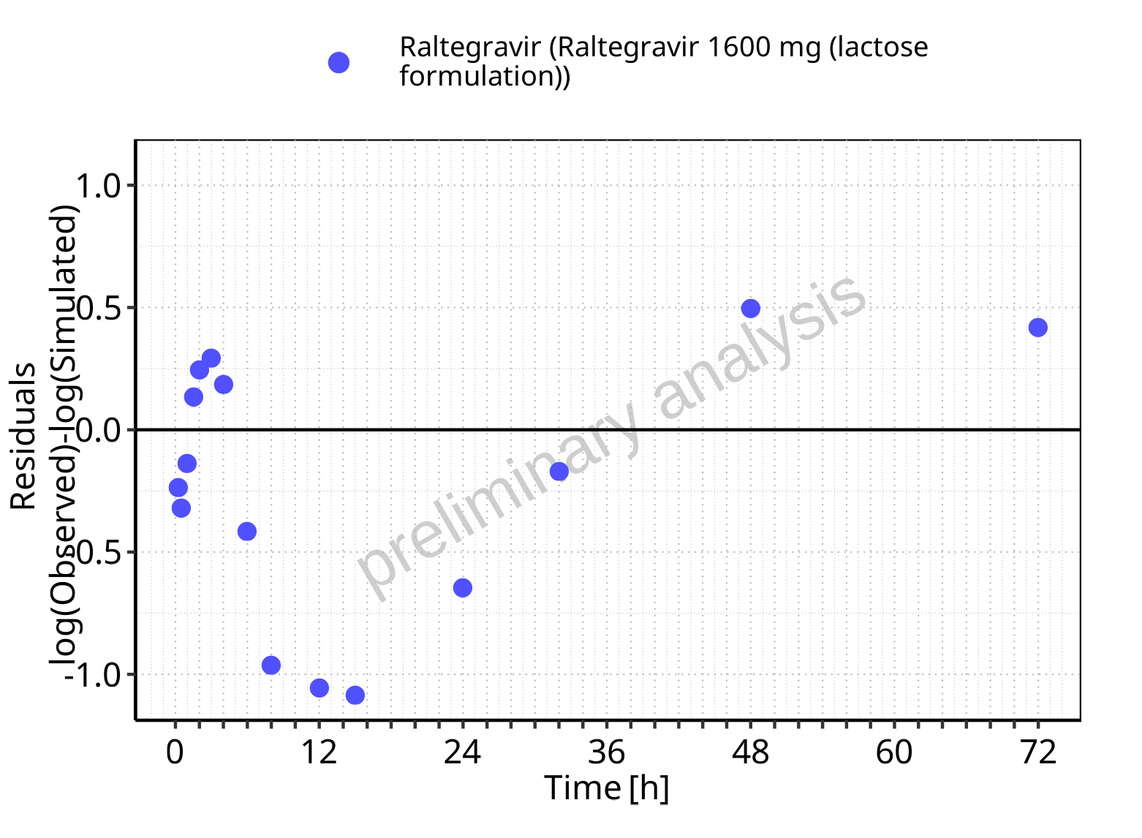

**Figure 5-70: Logarithmic residuals vs time values for Raltegravir 1600 mg (lactose formulation). Data source: Data/Raltegravir_PK.txt.**

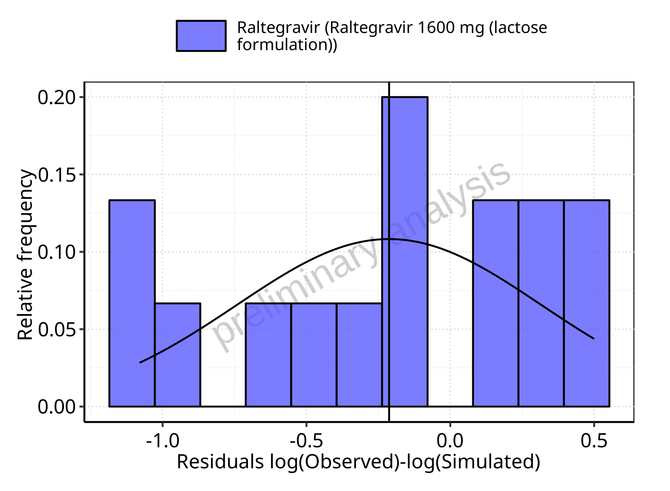

**Figure 5-71: Logarithmic residuals distribution (stacked) for Raltegravir 1600 mg (lactose formulation). Data source: Data/Raltegravir_PK.txt.**

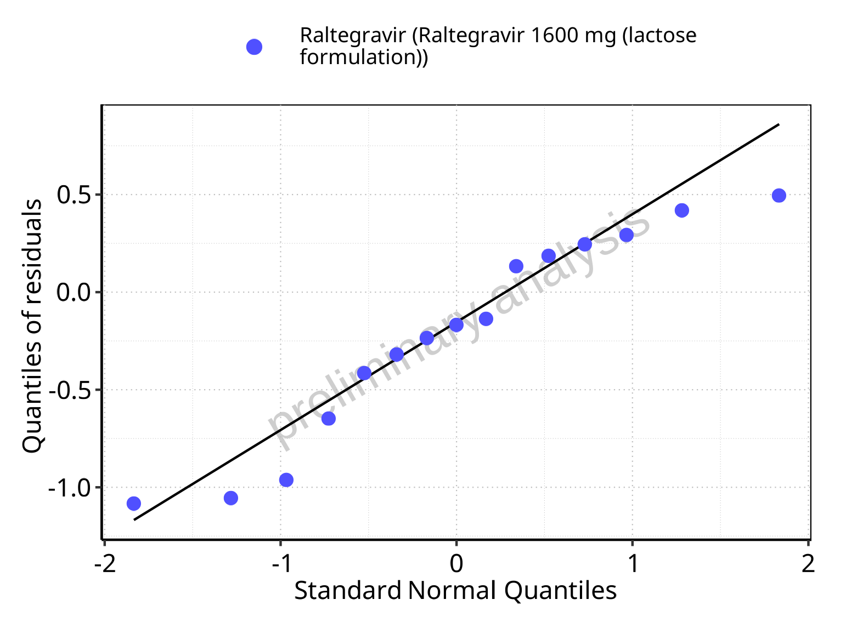

**Figure 5-72: Logarithmic residuals for Raltegravir 1600 mg (lactose formulation) as quantile-quantile plot. Data source: Data/Raltegravir_PK.txt.**

## Time profiles and residual plots for Raltegravir 100 mg filmcoated tablet md

### For total simulation time range

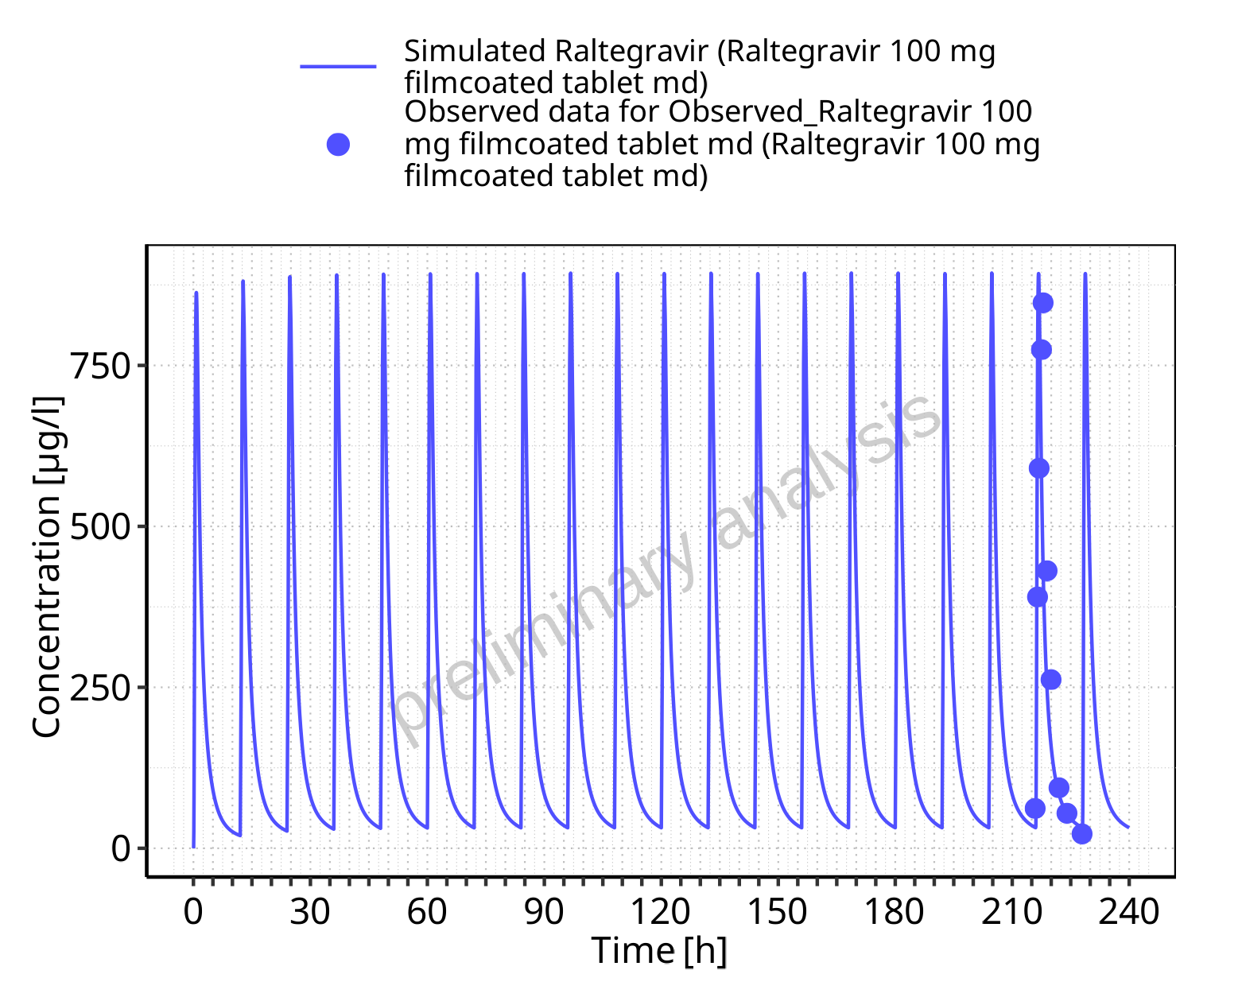

**Figure 5-73: Time profiles for Raltegravir 100 mg filmcoated tablet md. Data source: Data/Raltegravir_PK.txt. Time profiles are plotted in a linear scale.**

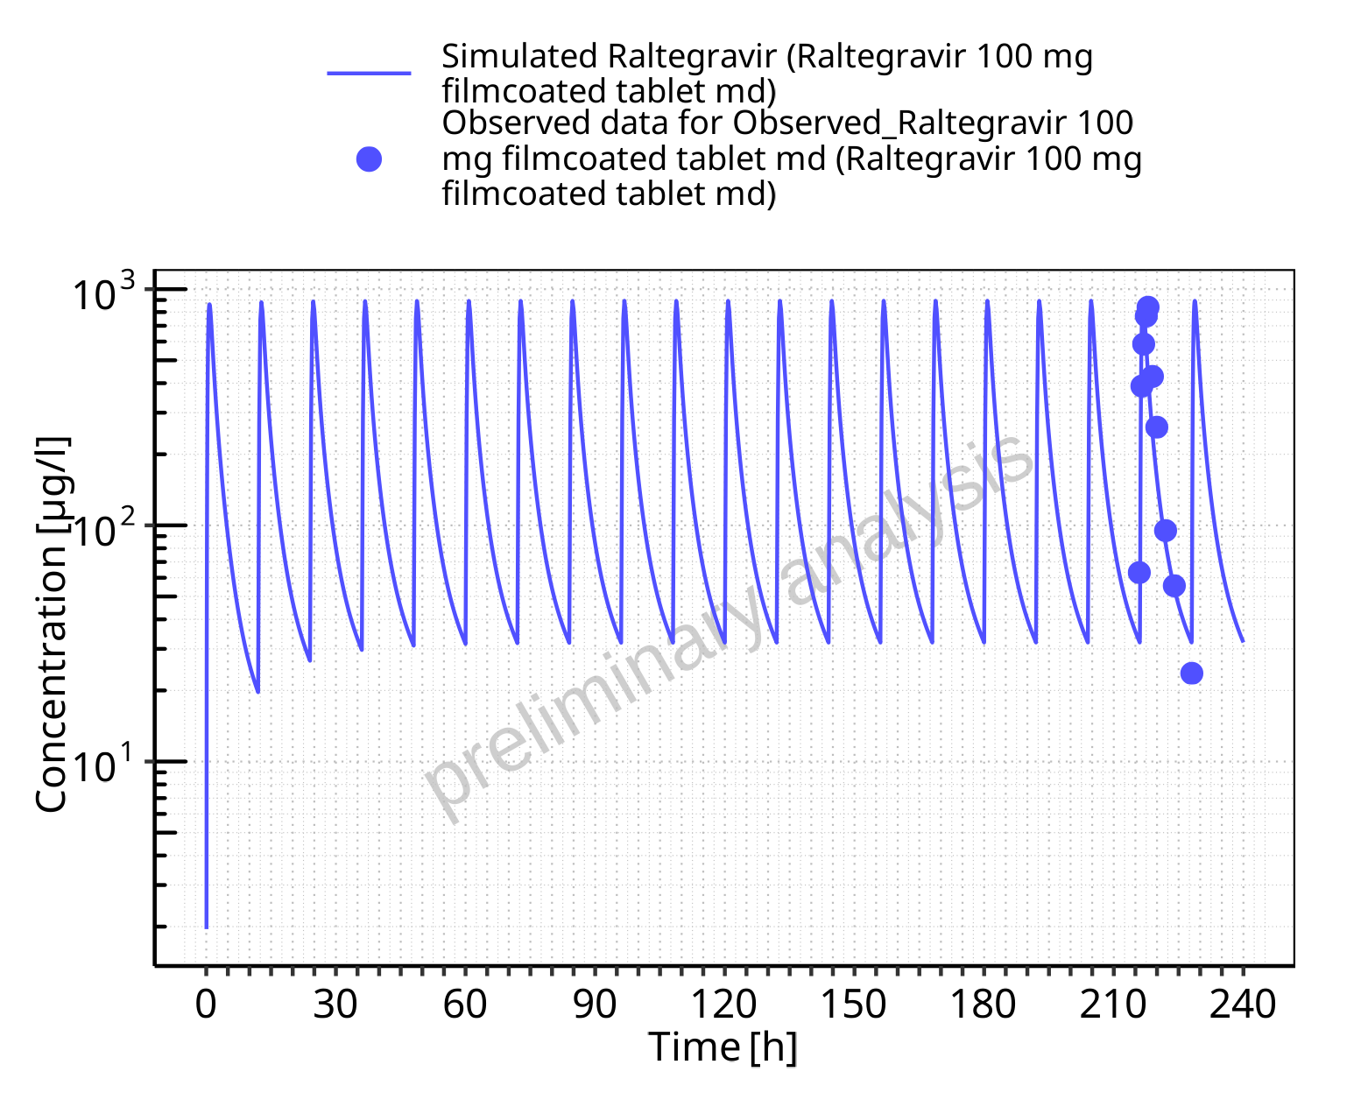

**Figure 5-74: Time profiles for Raltegravir 100 mg filmcoated tablet md. Data source: Data/Raltegravir_PK.txt. Time profiles are plotted in a logarithmic scale.**

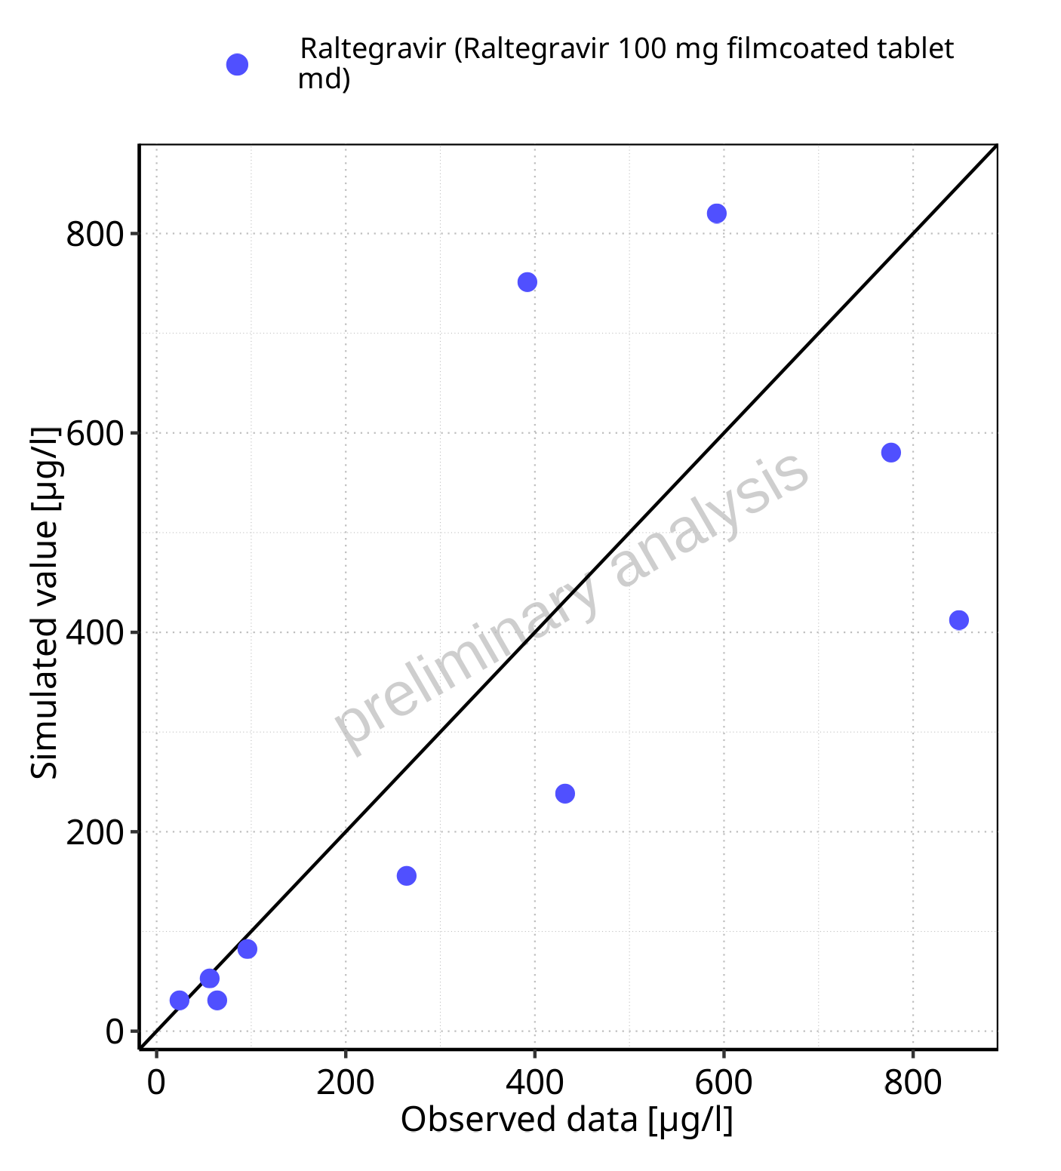

**Figure 5-75: Predicted vs observed for Raltegravir 100 mg filmcoated tablet md. Data source: Data/Raltegravir_PK.txt. Predictions and observations are plotted in a linear scale.**



**Figure 5-76: Predicted vs observed for Raltegravir 100 mg filmcoated tablet md. Data source: Data/Raltegravir_PK.txt. Predictions and observations are plotted in a logarithmic scale.**

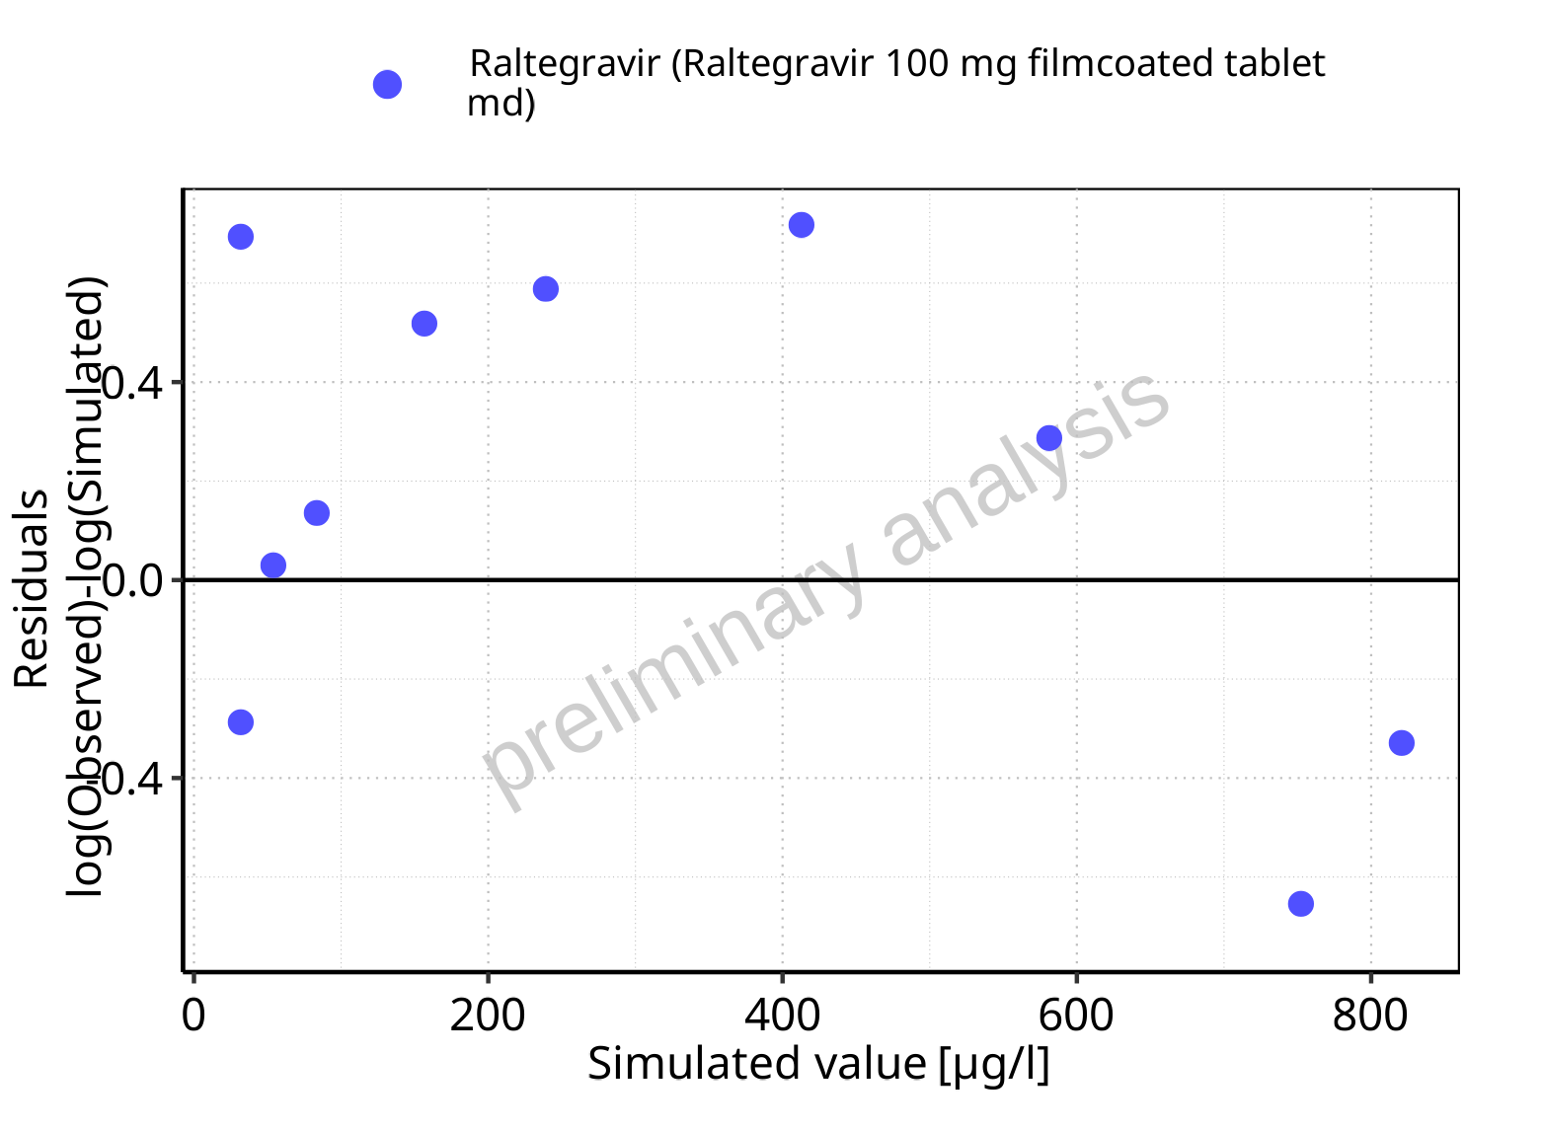

**Figure 5-77: Logarithmic residuals vs predicted values for Raltegravir 100 mg filmcoated tablet md. Data source: Data/Raltegravir_PK.txt.**

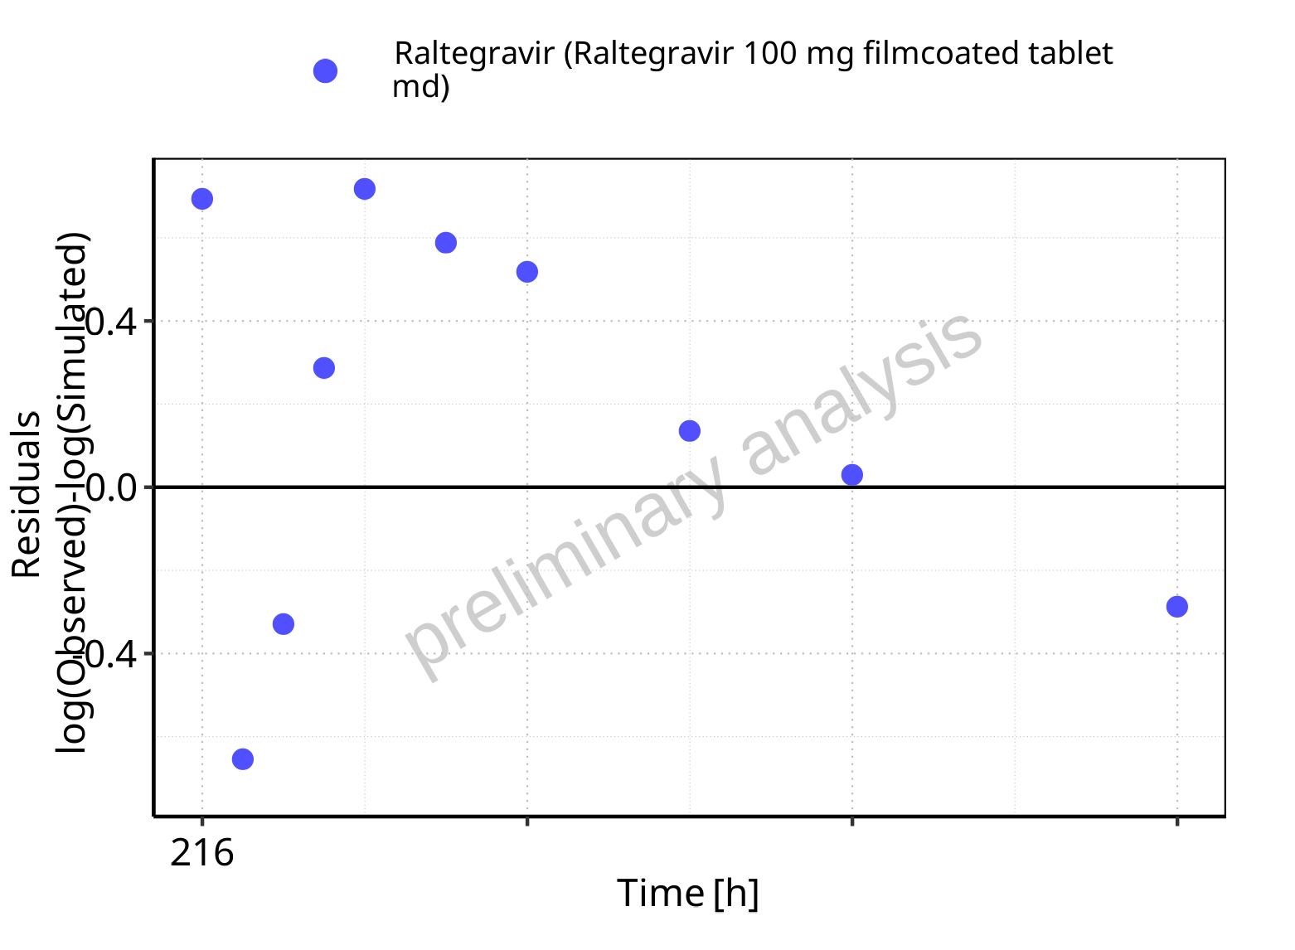

**Figure 5-78: Logarithmic residuals vs time values for Raltegravir 100 mg filmcoated tablet md. Data source: Data/Raltegravir_PK.txt.**

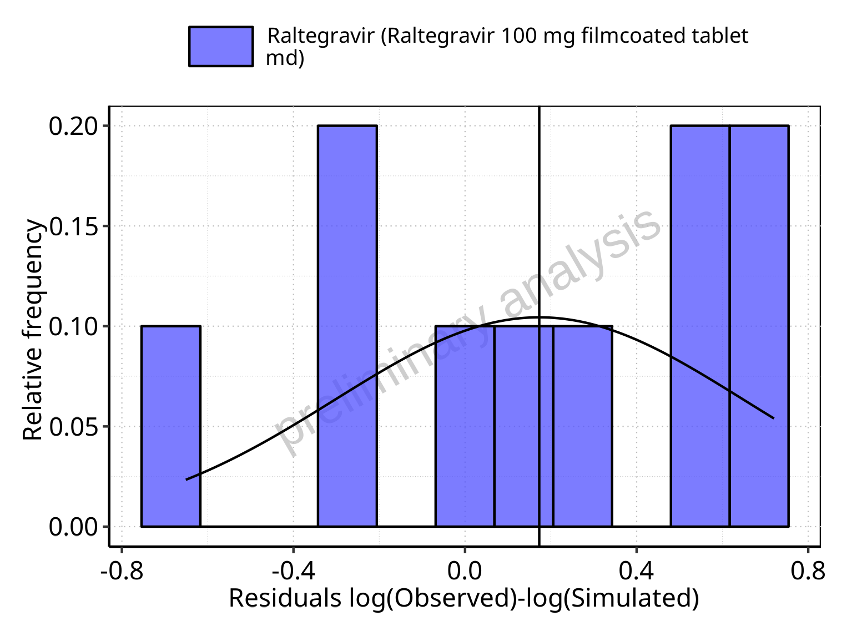

**Figure 5-79: Logarithmic residuals distribution (stacked) for Raltegravir 100 mg filmcoated tablet md. Data source: Data/Raltegravir_PK.txt.**

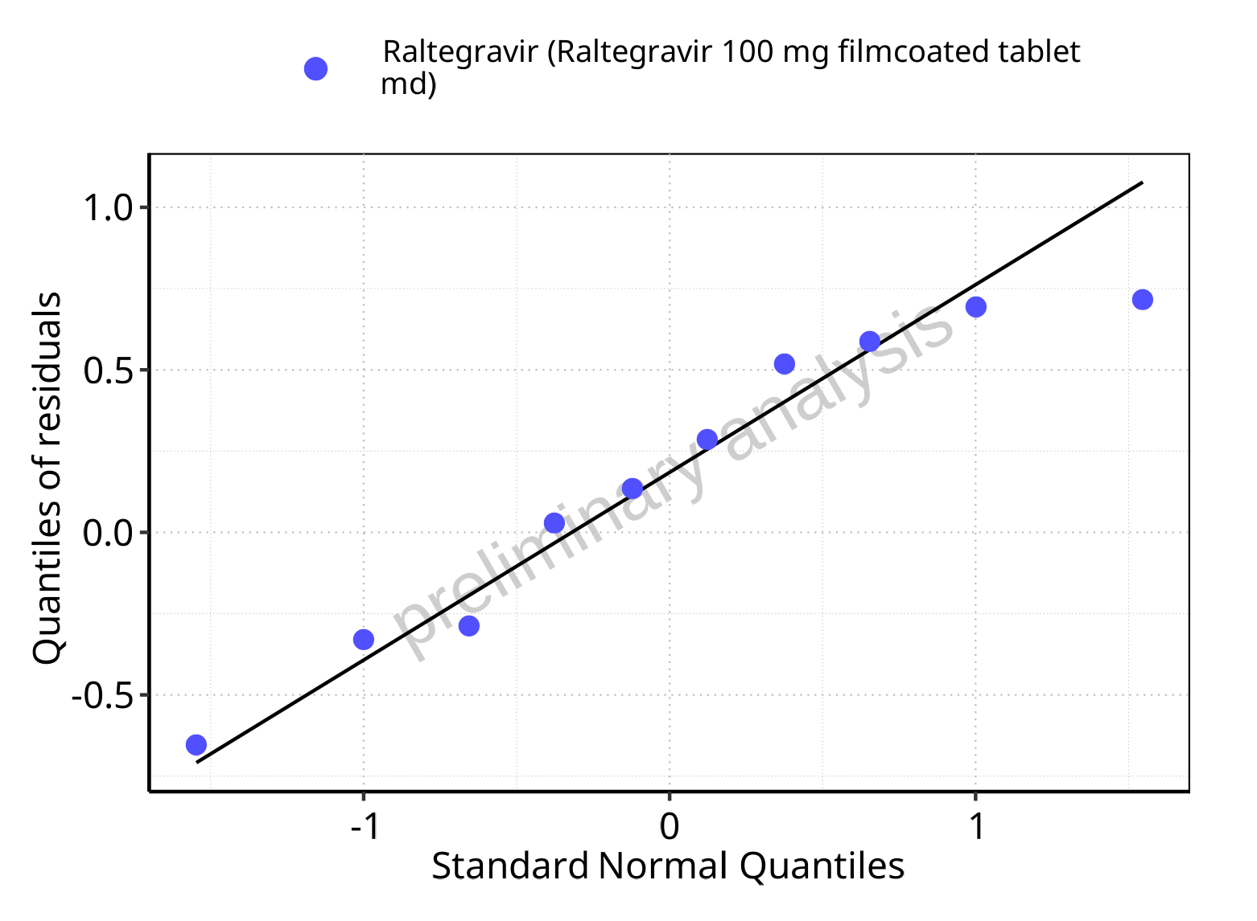

**Figure 5-80: Logarithmic residuals for Raltegravir 100 mg filmcoated tablet md as quantile-quantile plot. Data source: Data/Raltegravir_PK.txt.**

### For first application range

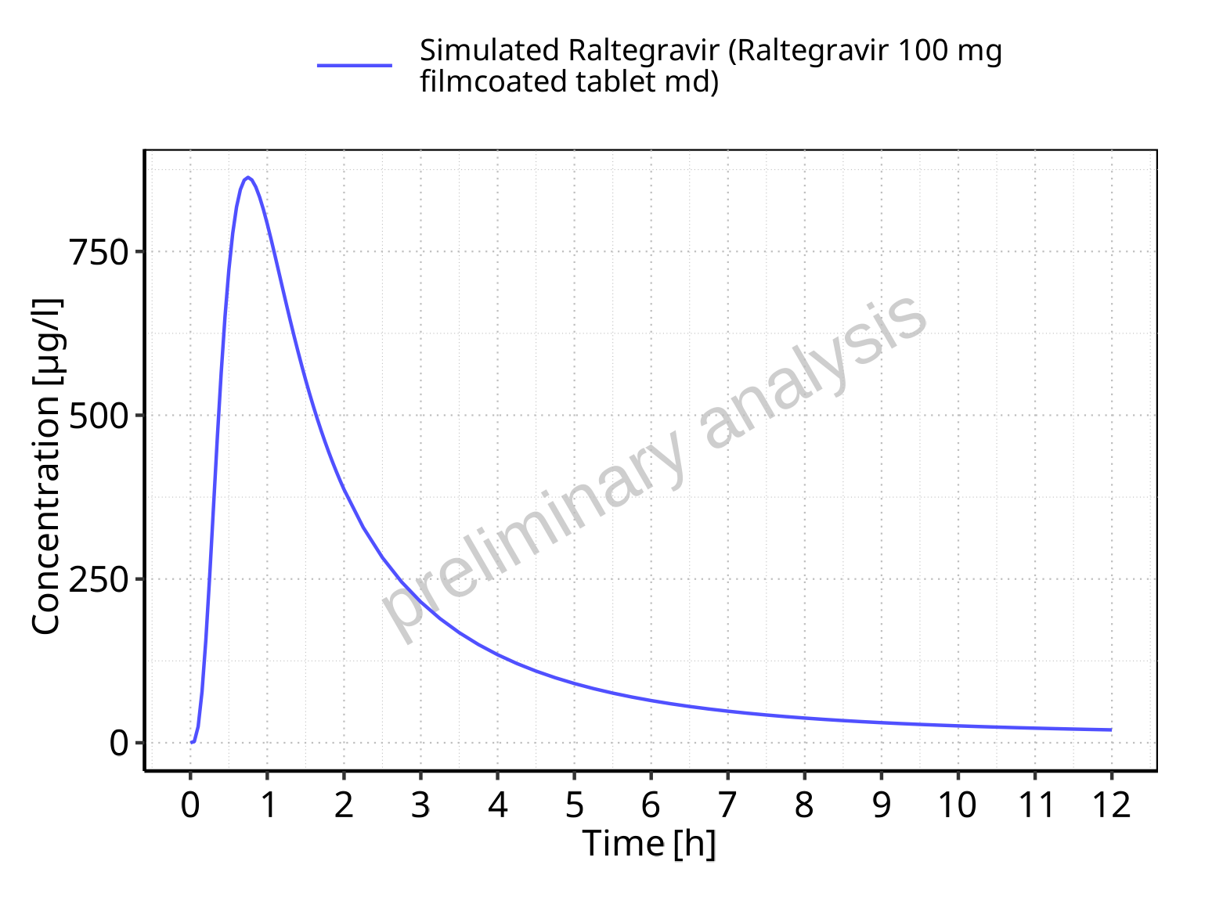

**Figure 5-81: Time profiles for Raltegravir 100 mg filmcoated tablet md. Data source: Data/Raltegravir_PK.txt. Time profiles are plotted in a linear scale.**

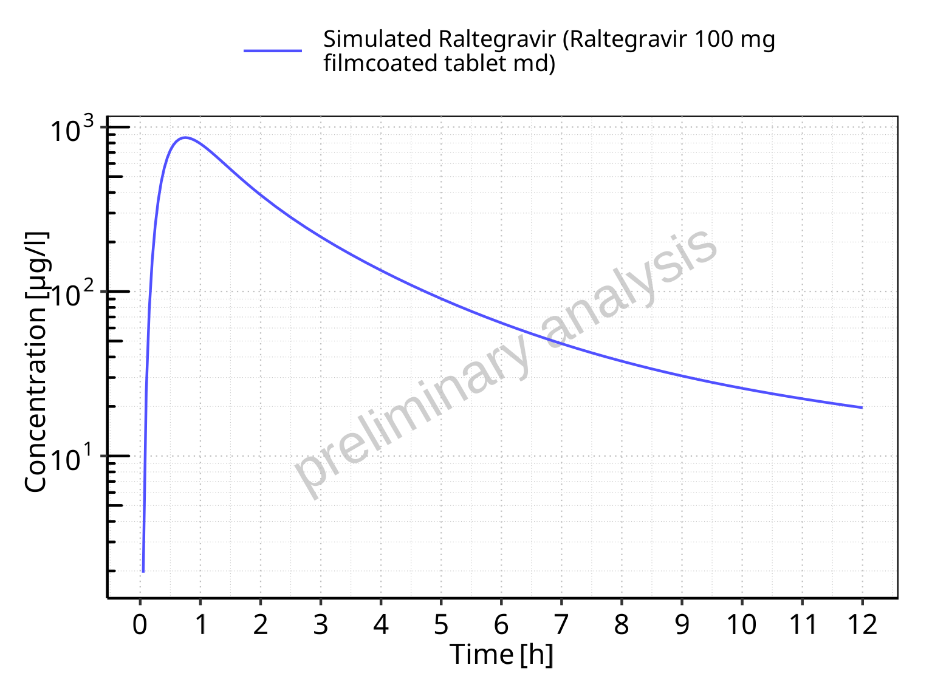

**Figure 5-82: Time profiles for Raltegravir 100 mg filmcoated tablet md. Data source: Data/Raltegravir_PK.txt. Time profiles are plotted in a logarithmic scale.**

### For last application range

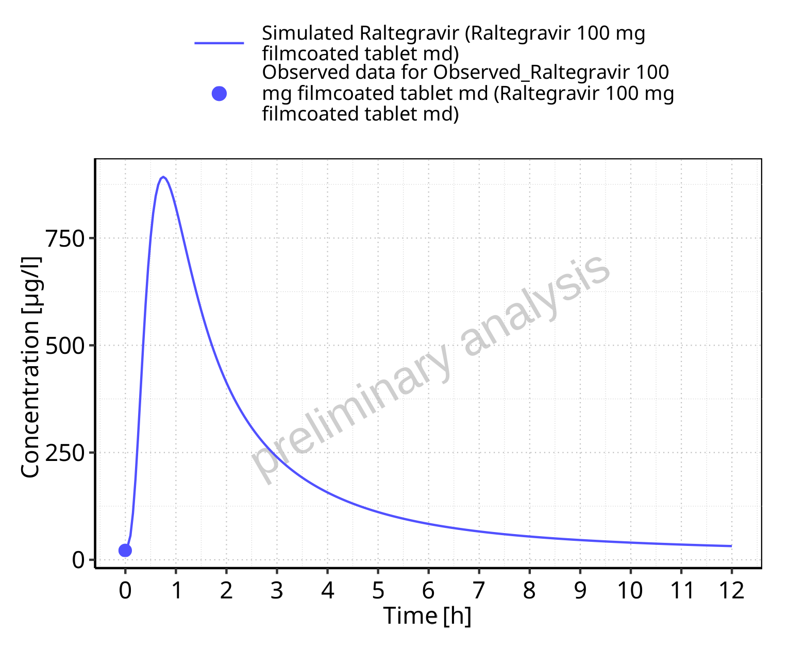

**Figure 5-83: Time profiles for Raltegravir 100 mg filmcoated tablet md. Data source: Data/Raltegravir_PK.txt. Time profiles are plotted in a linear scale.**

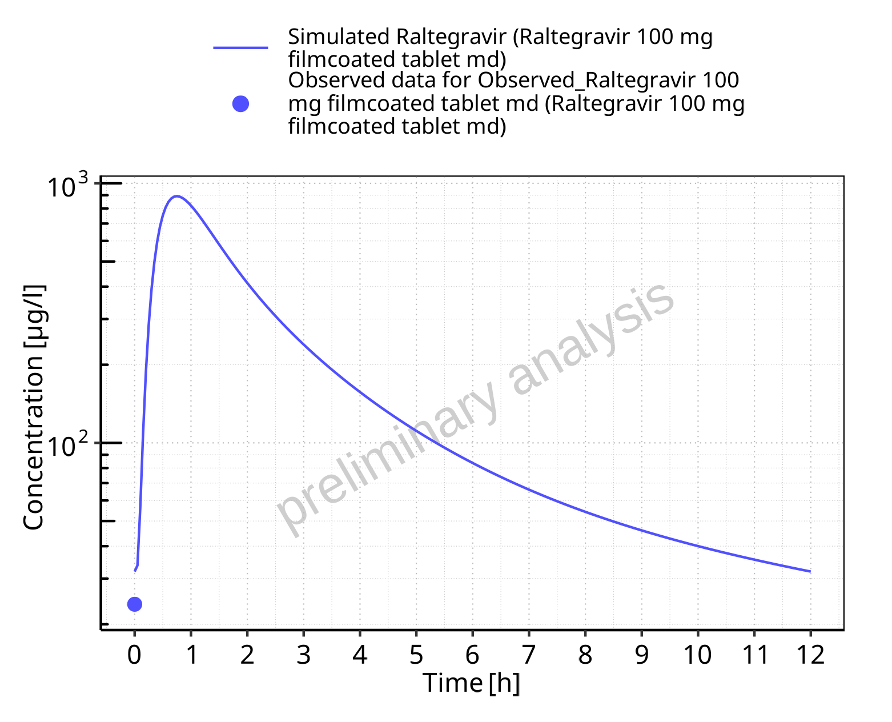

**Figure 5-84: Time profiles for Raltegravir 100 mg filmcoated tablet md. Data source: Data/Raltegravir_PK.txt. Time profiles are plotted in a logarithmic scale.**

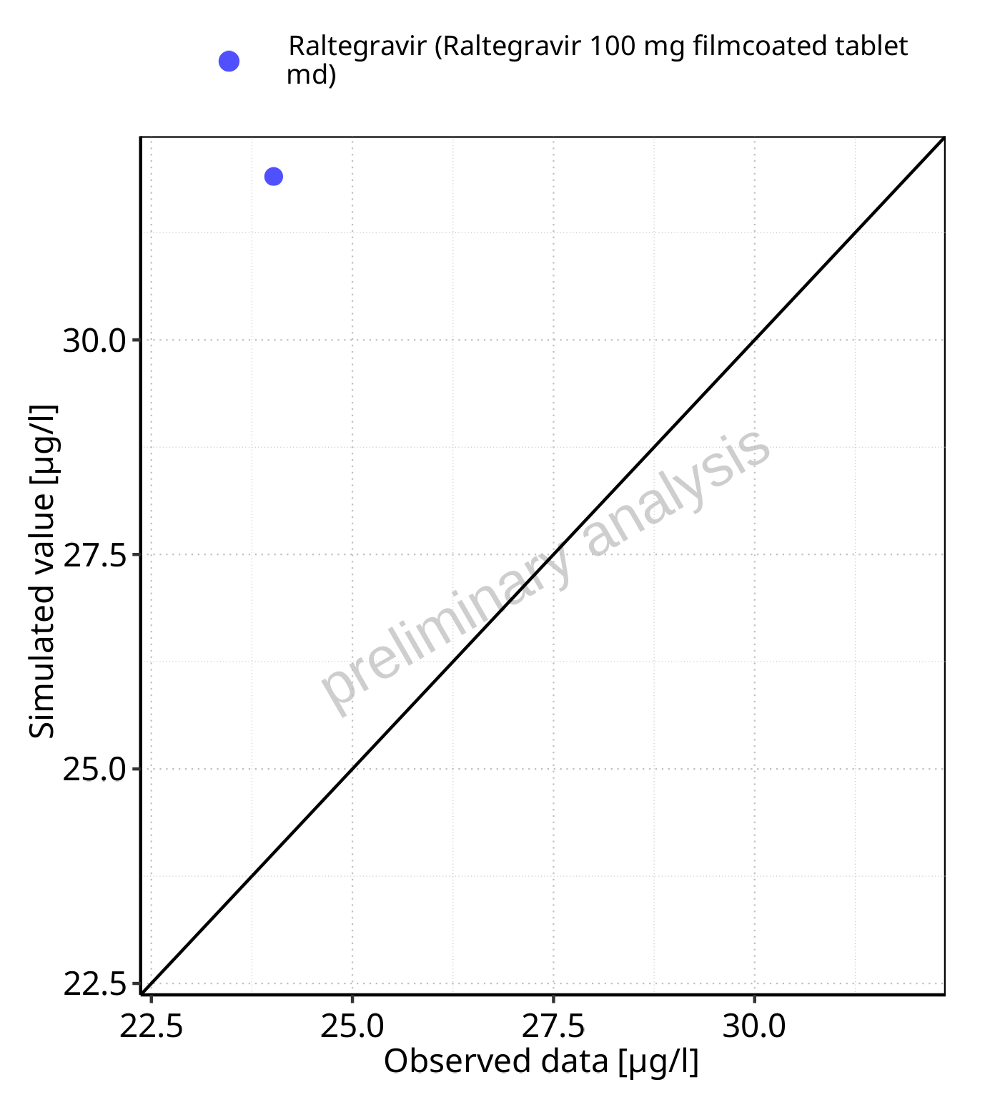

**Figure 5-85: Predicted vs observed for Raltegravir 100 mg filmcoated tablet md. Data source: Data/Raltegravir_PK.txt. Predictions and observations are plotted in a linear scale.**



**Figure 5-86: Predicted vs observed for Raltegravir 100 mg filmcoated tablet md. Data source: Data/Raltegravir_PK.txt. Predictions and observations are plotted in a logarithmic scale.**

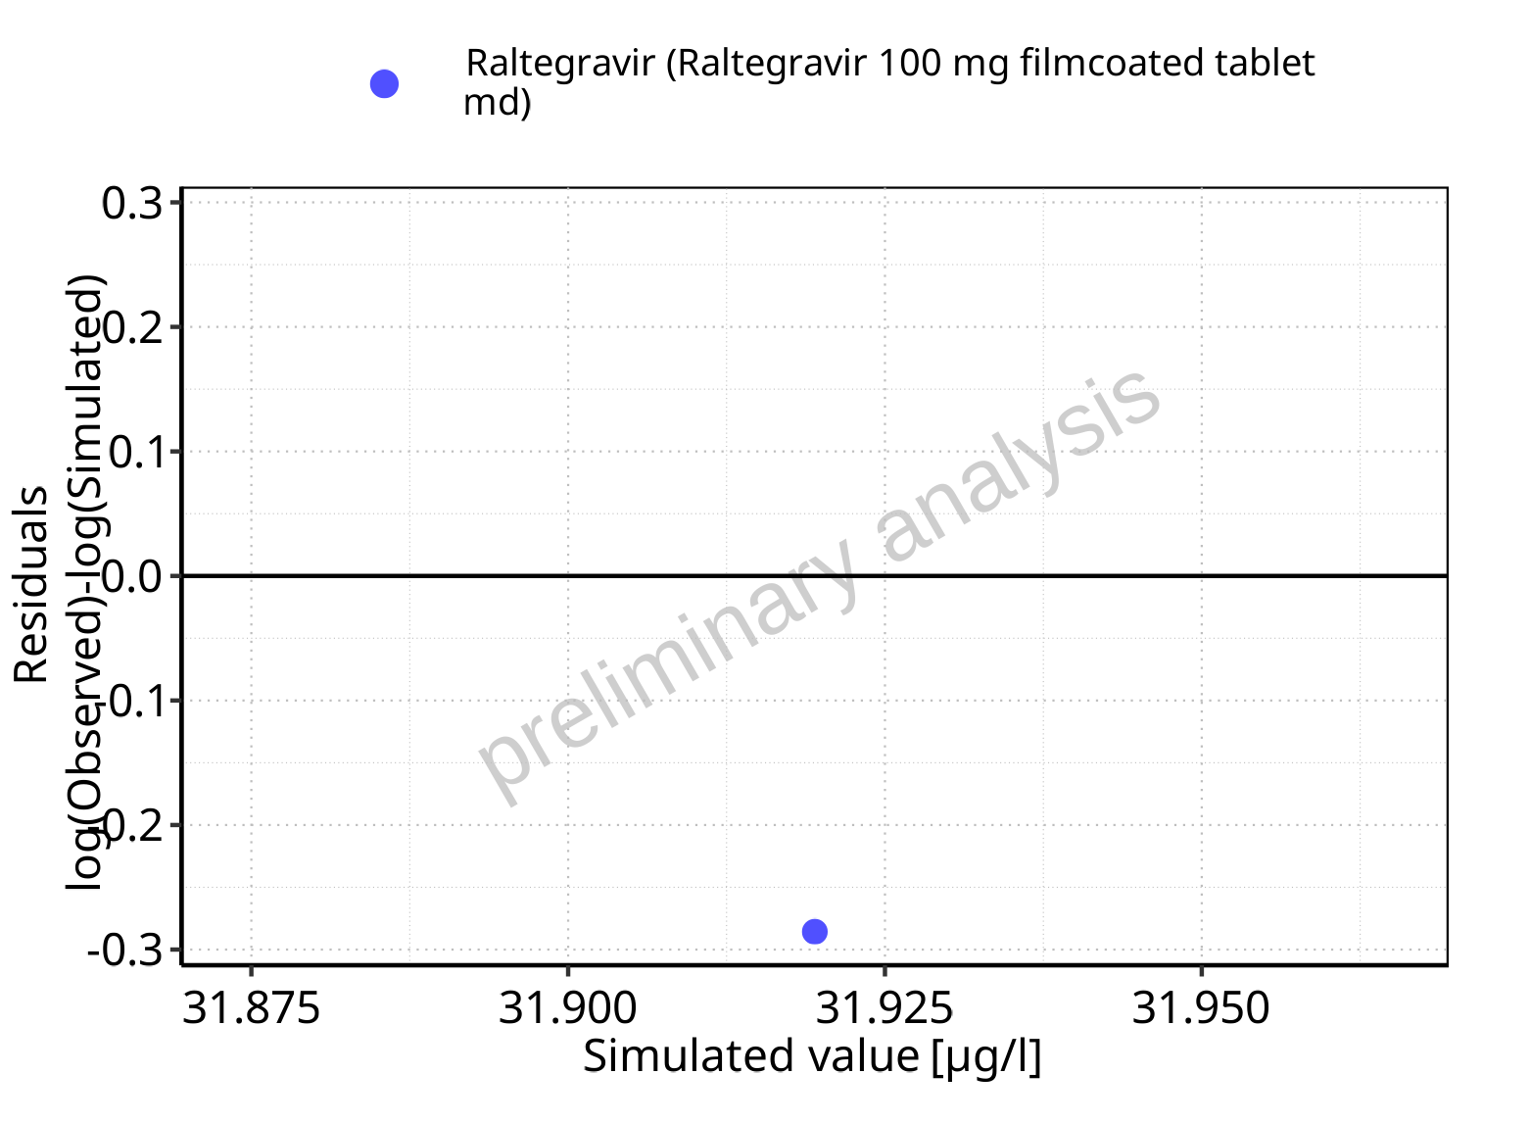

**Figure 5-87: Logarithmic residuals vs predicted values for Raltegravir 100 mg filmcoated tablet md. Data source: Data/Raltegravir_PK.txt.**

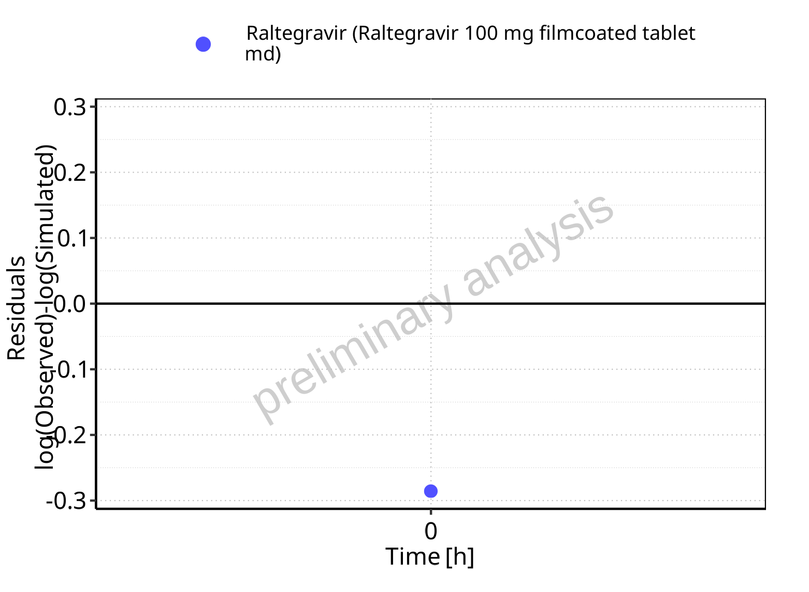

**Figure 5-88: Logarithmic residuals vs time values for Raltegravir 100 mg filmcoated tablet md. Data source: Data/Raltegravir_PK.txt.**

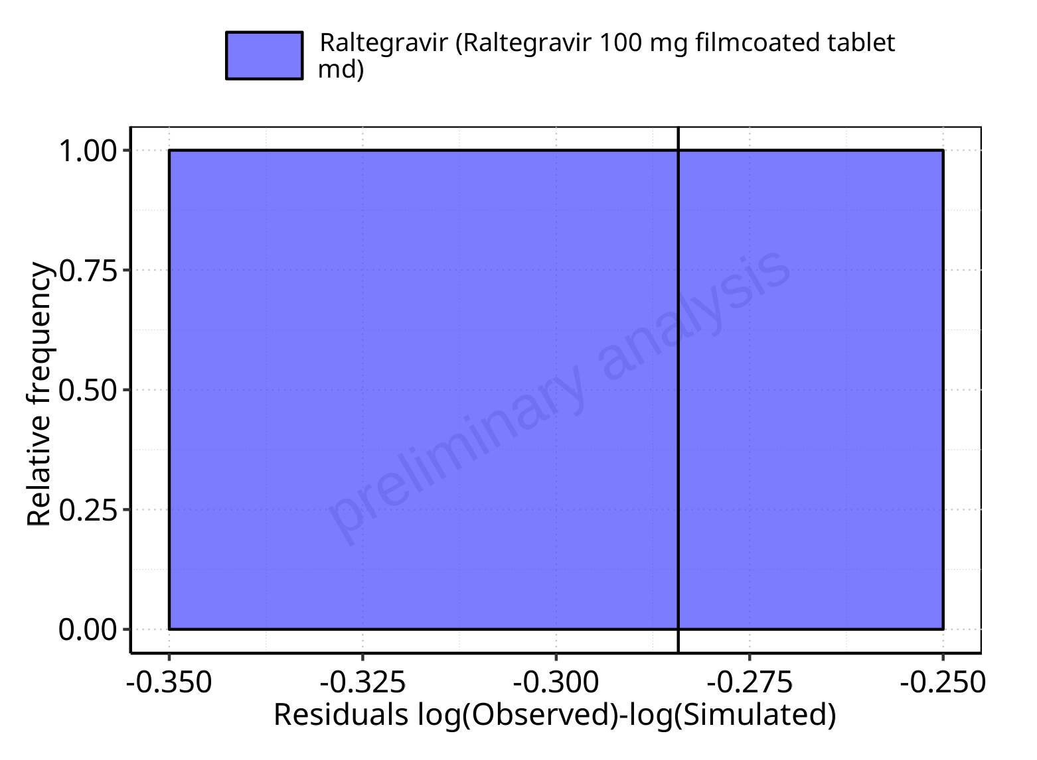

**Figure 5-89: Logarithmic residuals distribution (stacked) for Raltegravir 100 mg filmcoated tablet md. Data source: Data/Raltegravir_PK.txt.**

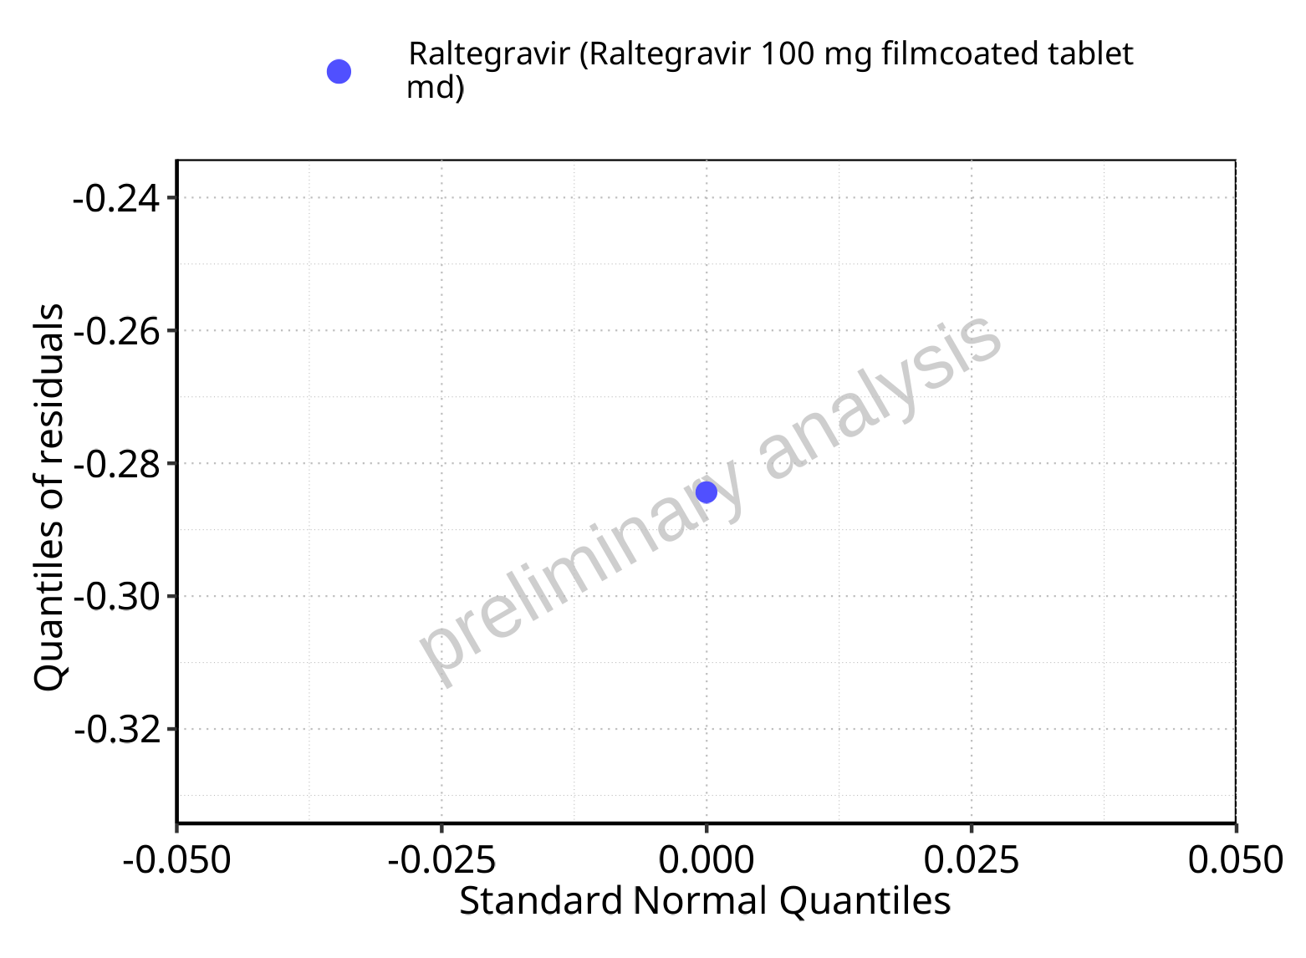

**Figure 5-90: Logarithmic residuals for Raltegravir 100 mg filmcoated tablet md as quantile-quantile plot. Data source: Data/Raltegravir_PK.txt.**

## Time profiles and residual plots for Raltegravir 200 mg filmcoated tablet md

### For total simulation time range

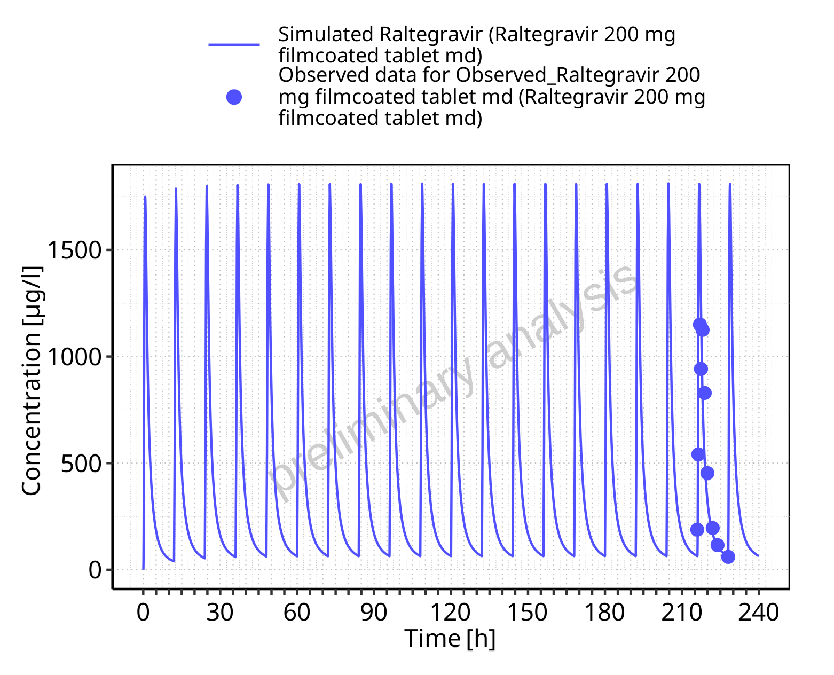

**Figure 5-91: Time profiles for Raltegravir 200 mg filmcoated tablet md. Data source: Data/Raltegravir_PK.txt. Time profiles are plotted in a linear scale.**

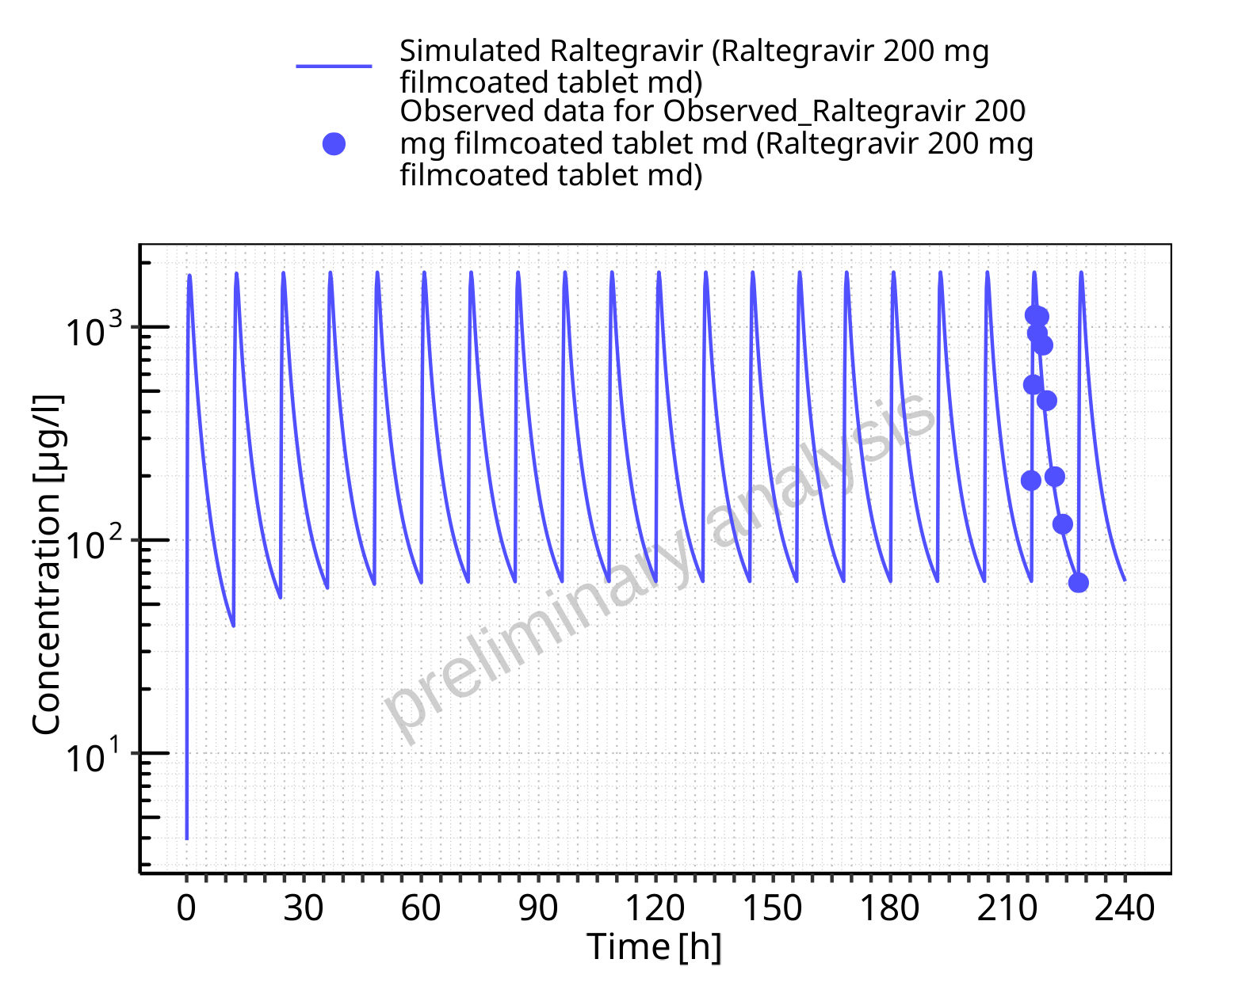

**Figure 5-92: Time profiles for Raltegravir 200 mg filmcoated tablet md. Data source: Data/Raltegravir_PK.txt. Time profiles are plotted in a logarithmic scale.**

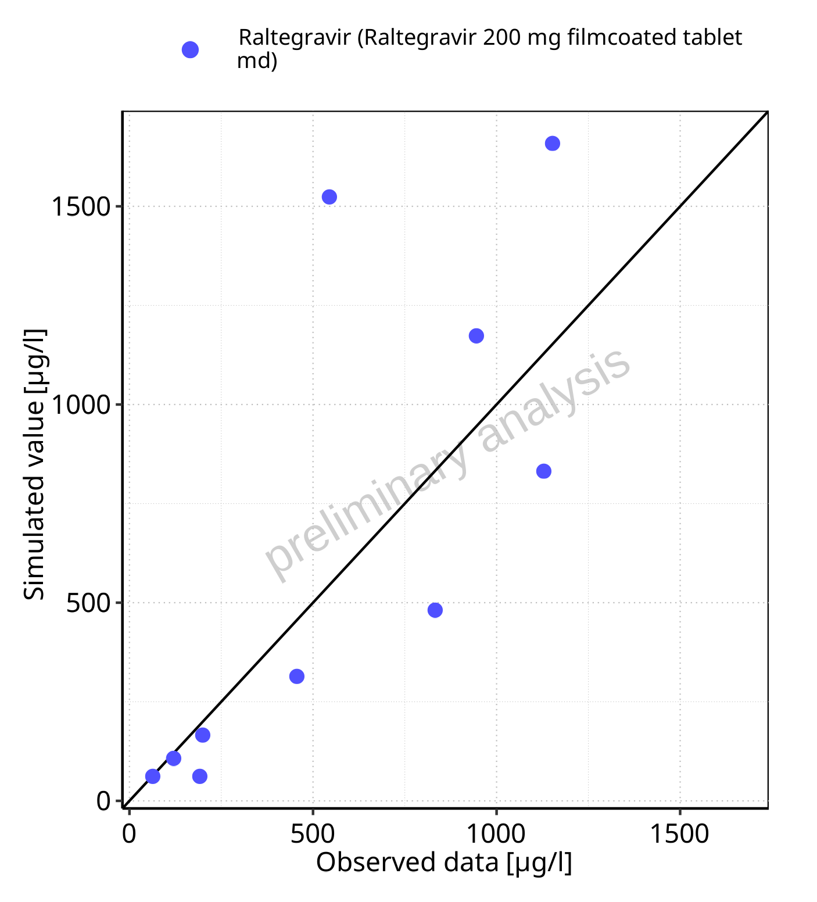

**Figure 5-93: Predicted vs observed for Raltegravir 200 mg filmcoated tablet md. Data source: Data/Raltegravir_PK.txt. Predictions and observations are plotted in a linear scale.**



**Figure 5-94: Predicted vs observed for Raltegravir 200 mg filmcoated tablet md. Data source: Data/Raltegravir_PK.txt. Predictions and observations are plotted in a logarithmic scale.**

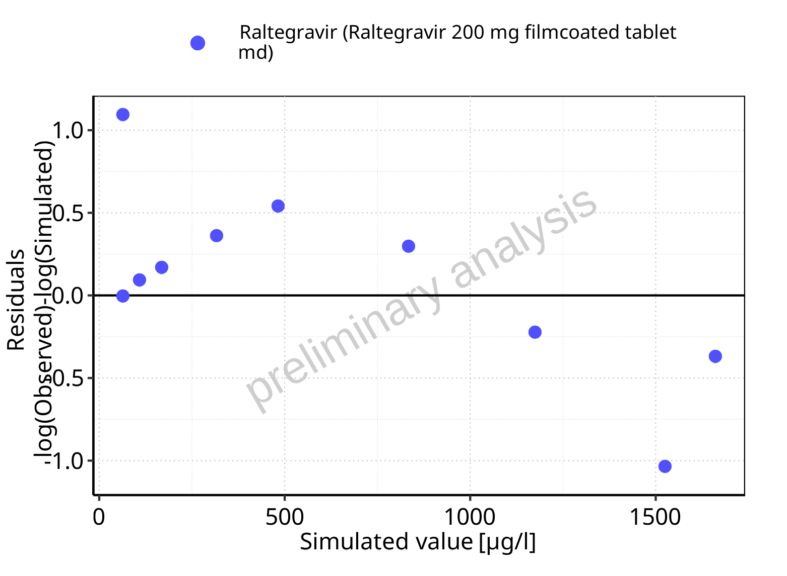

**Figure 5-95: Logarithmic residuals vs predicted values for Raltegravir 200 mg filmcoated tablet md. Data source: Data/Raltegravir_PK.txt.**

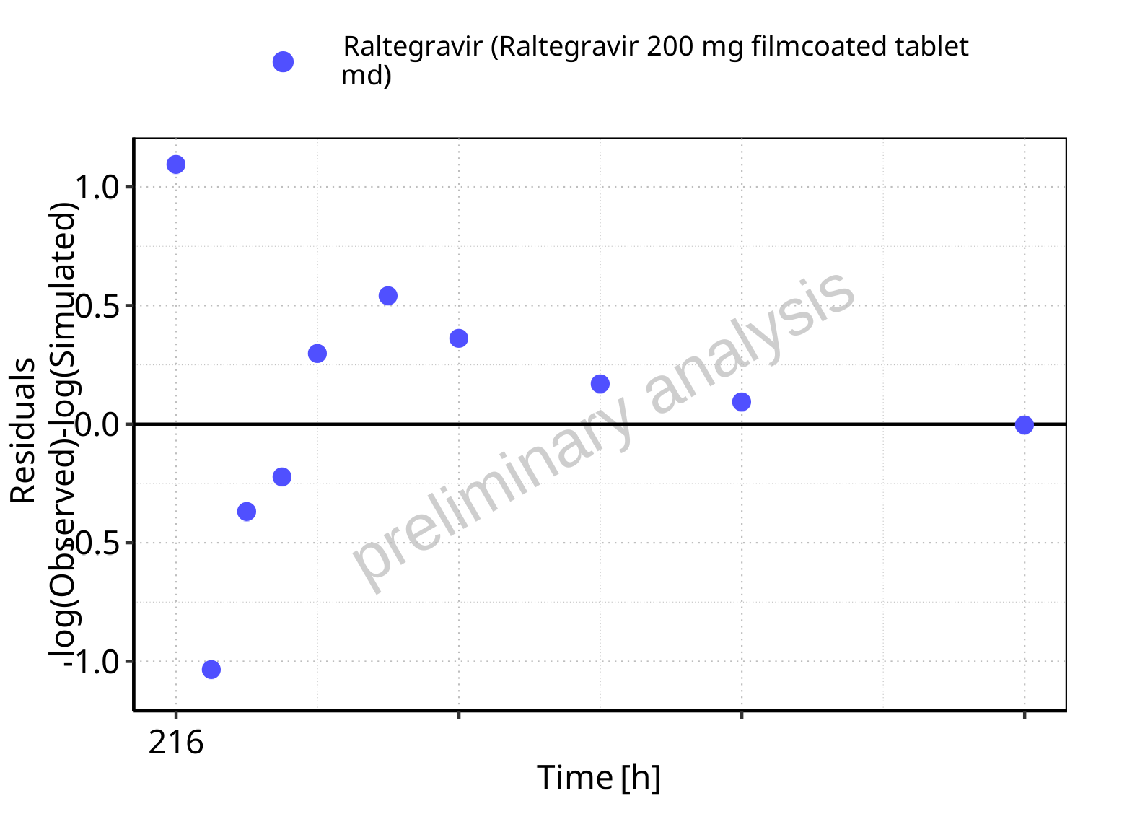

**Figure 5-96: Logarithmic residuals vs time values for Raltegravir 200 mg filmcoated tablet md. Data source: Data/Raltegravir_PK.txt.**

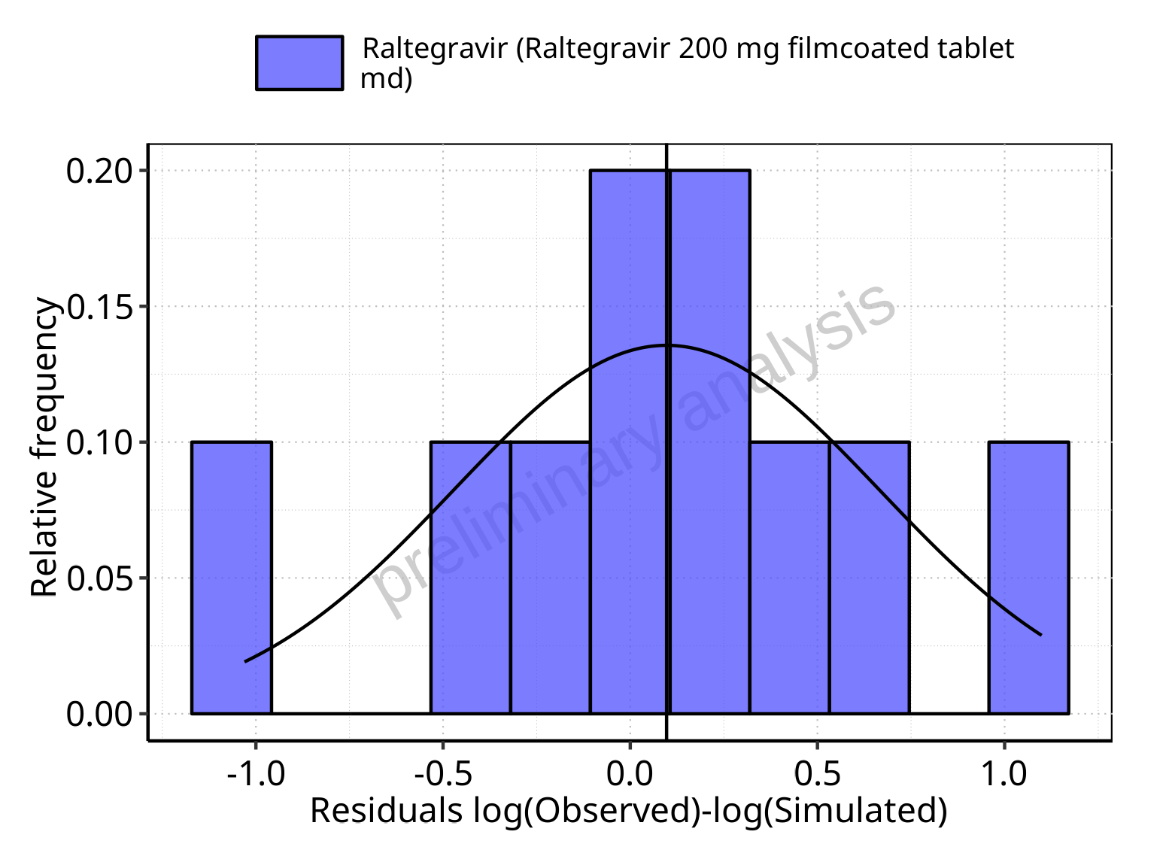

**Figure 5-97: Logarithmic residuals distribution (stacked) for Raltegravir 200 mg filmcoated tablet md. Data source: Data/Raltegravir_PK.txt.**

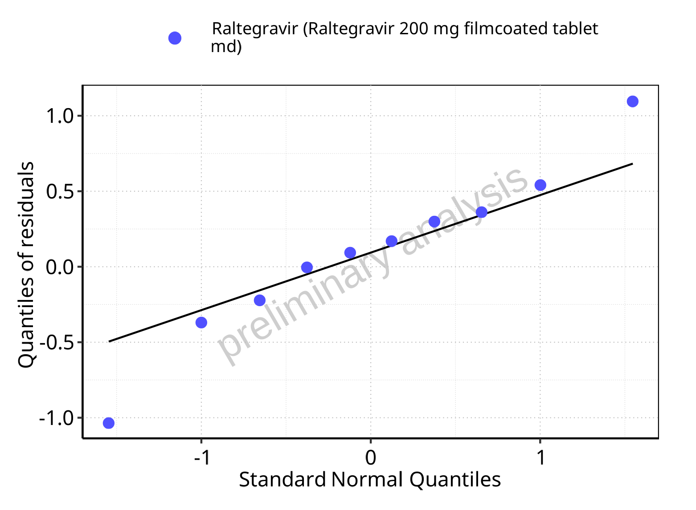

**Figure 5-98: Logarithmic residuals for Raltegravir 200 mg filmcoated tablet md as quantile-quantile plot. Data source: Data/Raltegravir_PK.txt.**

### For first application range

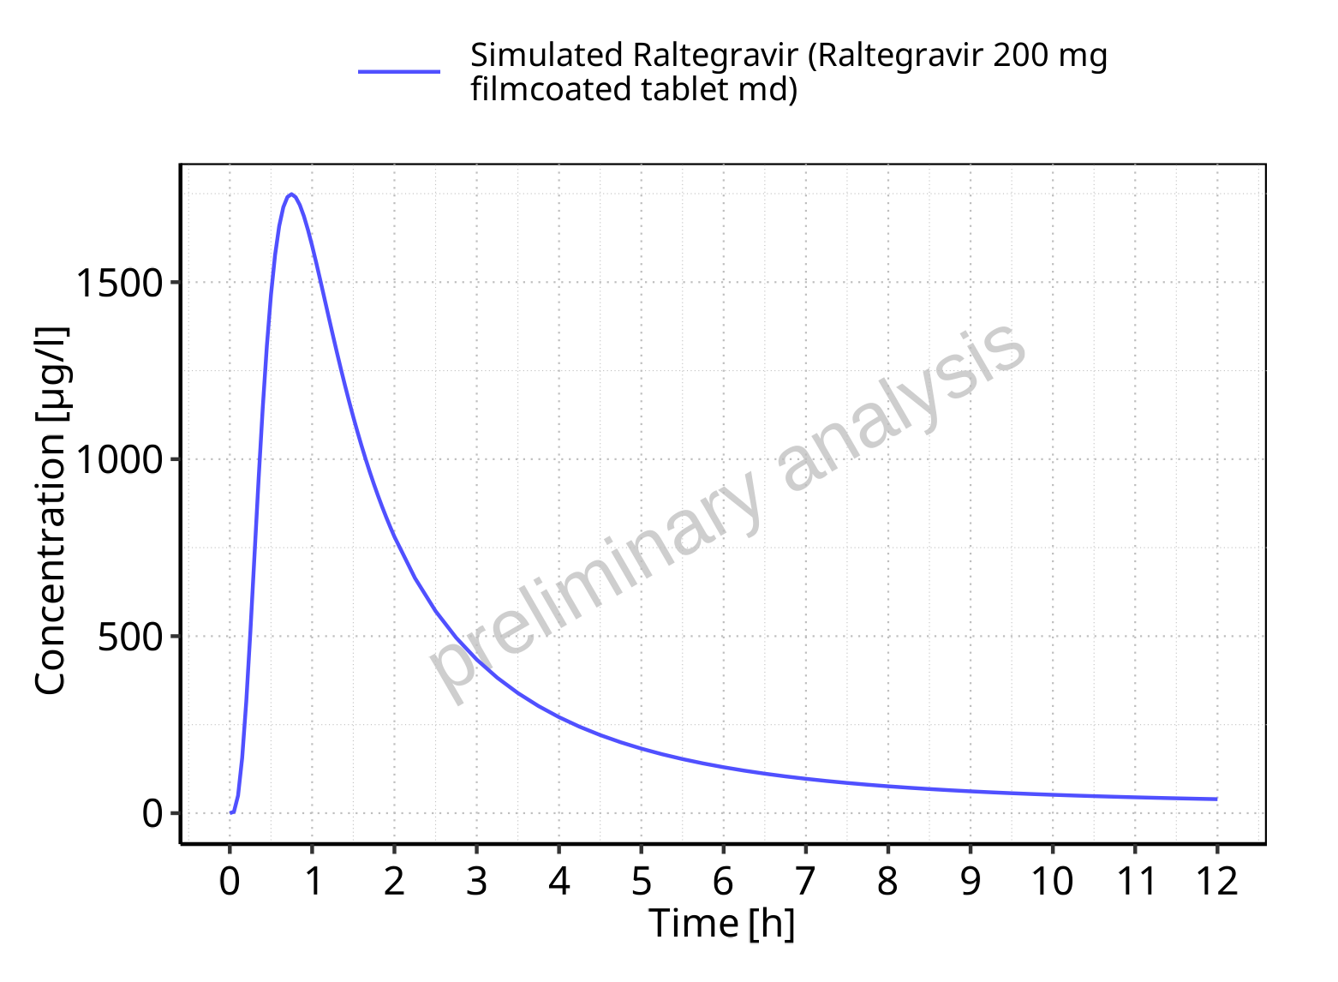

**Figure 5-99: Time profiles for Raltegravir 200 mg filmcoated tablet md. Data source: Data/Raltegravir_PK.txt. Time profiles are plotted in a linear scale.**

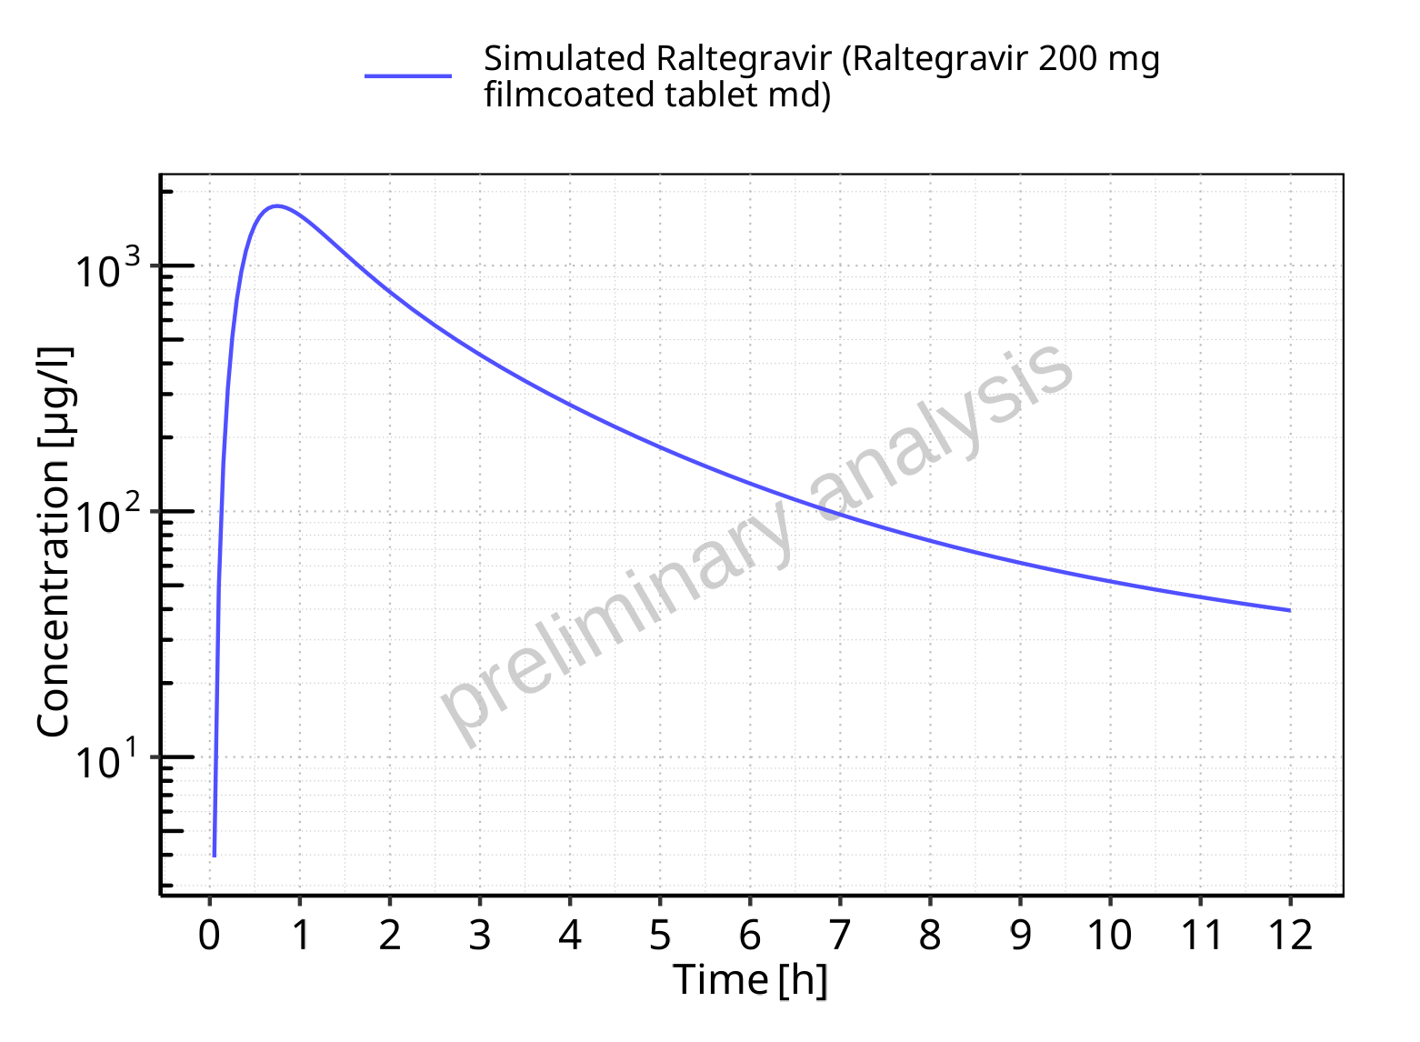

**Figure 5-100: Time profiles for Raltegravir 200 mg filmcoated tablet md. Data source: Data/Raltegravir_PK.txt. Time profiles are plotted in a logarithmic scale.**

### For last application range

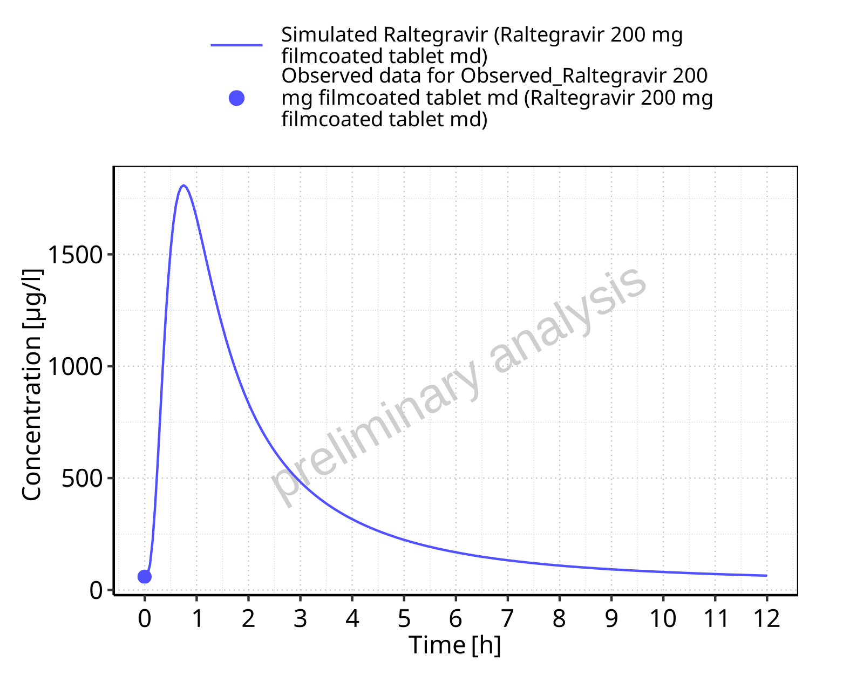

**Figure 5-101: Time profiles for Raltegravir 200 mg filmcoated tablet md. Data source: Data/Raltegravir_PK.txt. Time profiles are plotted in a linear scale.**

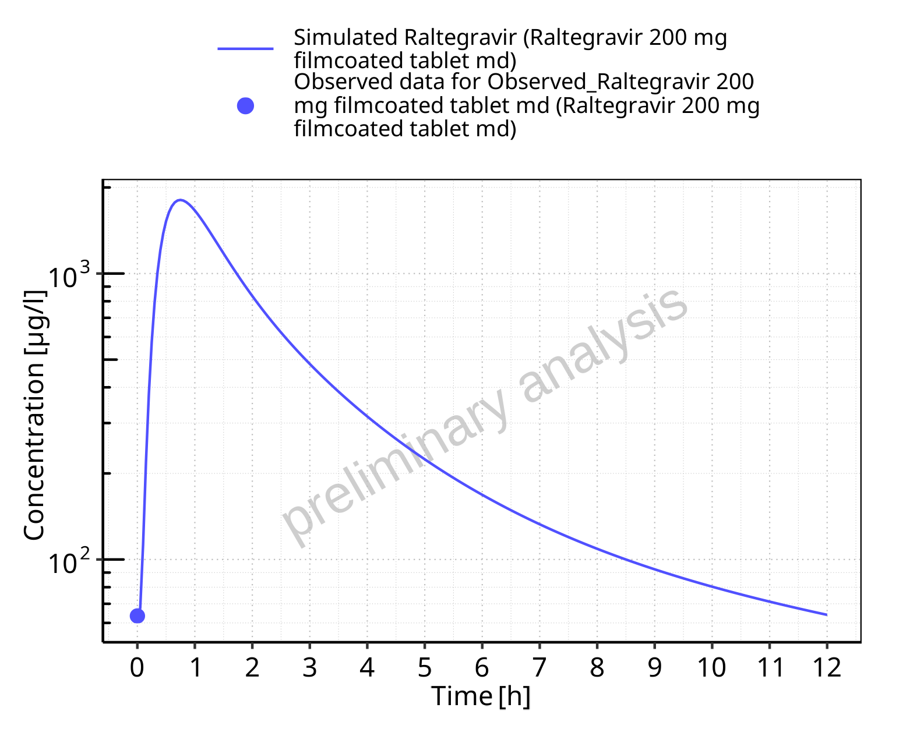

**Figure 5-102: Time profiles for Raltegravir 200 mg filmcoated tablet md. Data source: Data/Raltegravir_PK.txt. Time profiles are plotted in a logarithmic scale.**

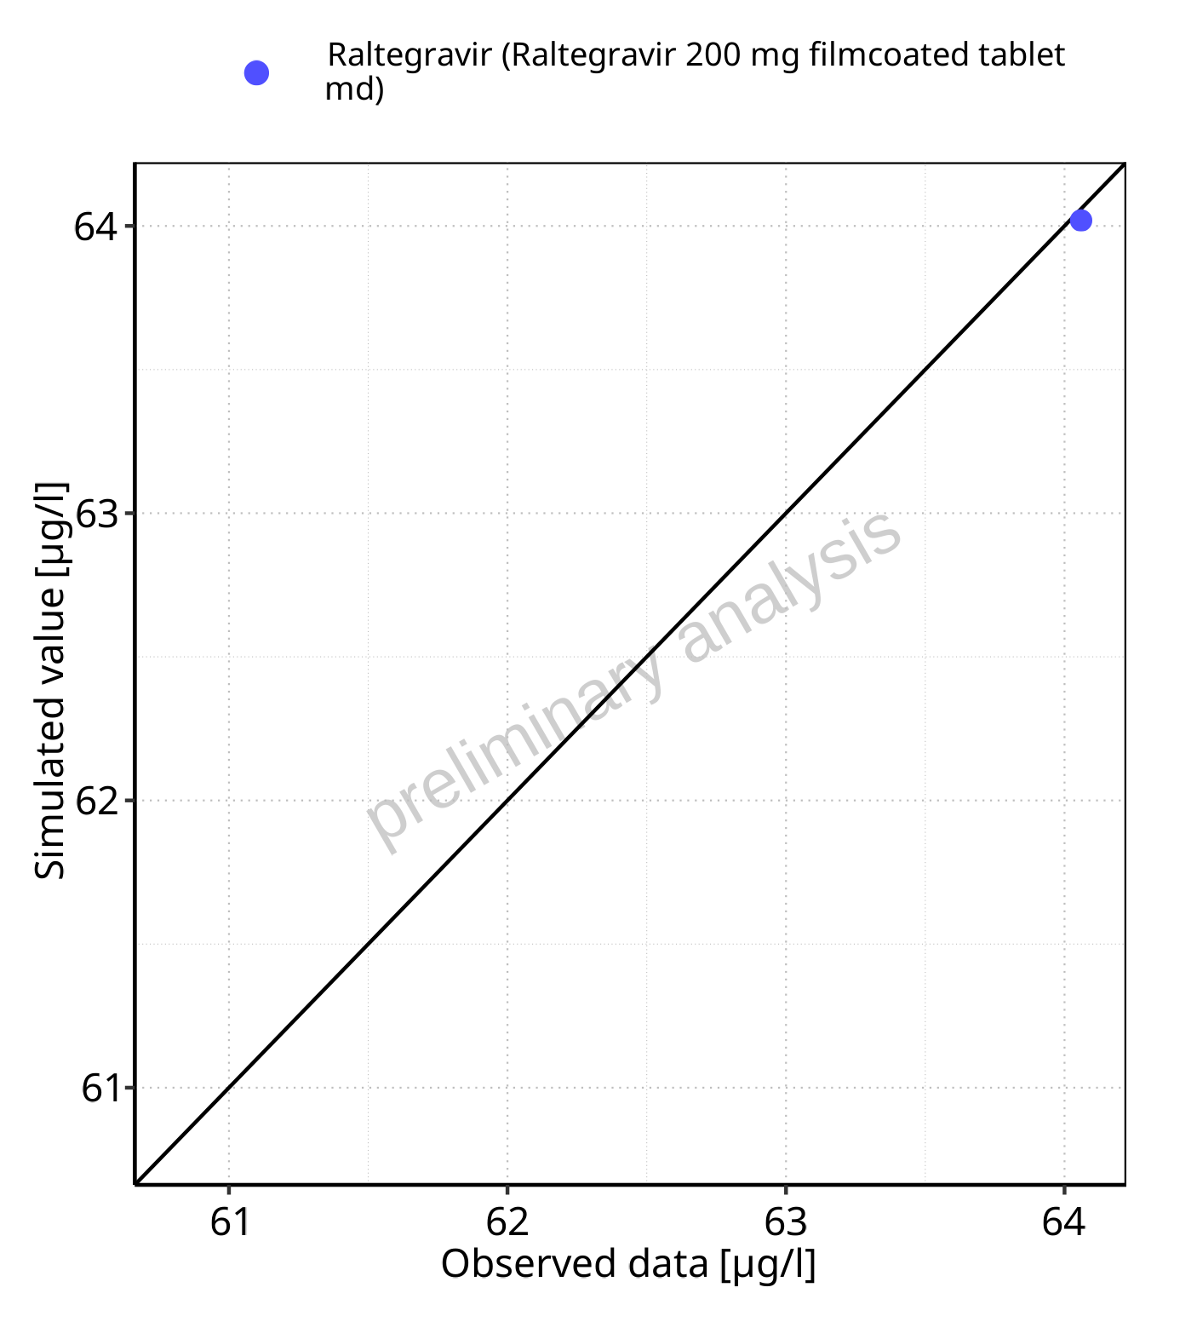

**Figure 5-103: Predicted vs observed for Raltegravir 200 mg filmcoated tablet md. Data source: Data/Raltegravir_PK.txt. Predictions and observations are plotted in a linear scale.**



**Figure 5-104: Predicted vs observed for Raltegravir 200 mg filmcoated tablet md. Data source: Data/Raltegravir_PK.txt. Predictions and observations are plotted in a logarithmic scale.**

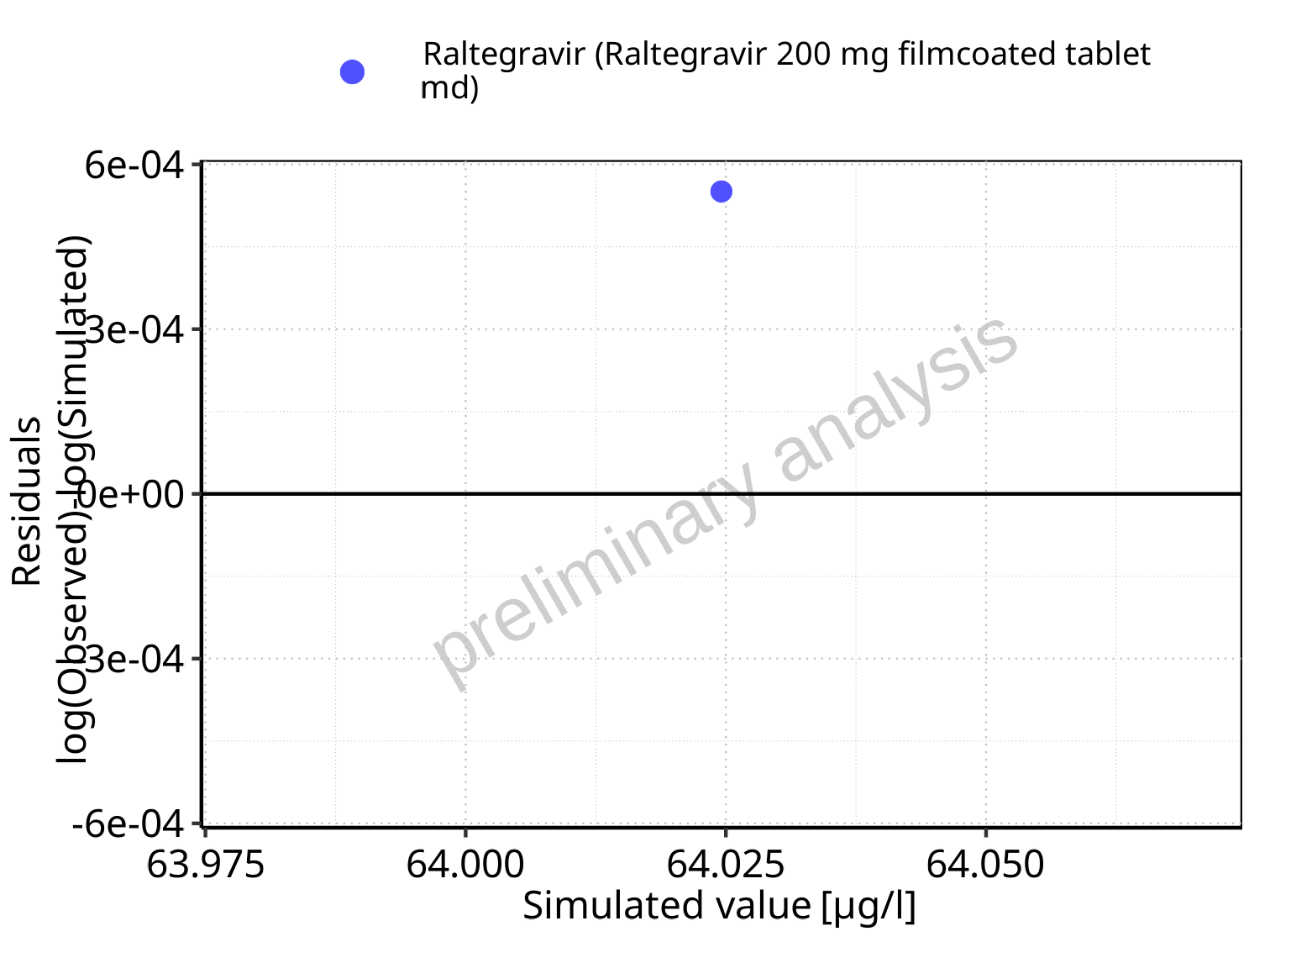

**Figure 5-105: Logarithmic residuals vs predicted values for Raltegravir 200 mg filmcoated tablet md. Data source: Data/Raltegravir_PK.txt.**

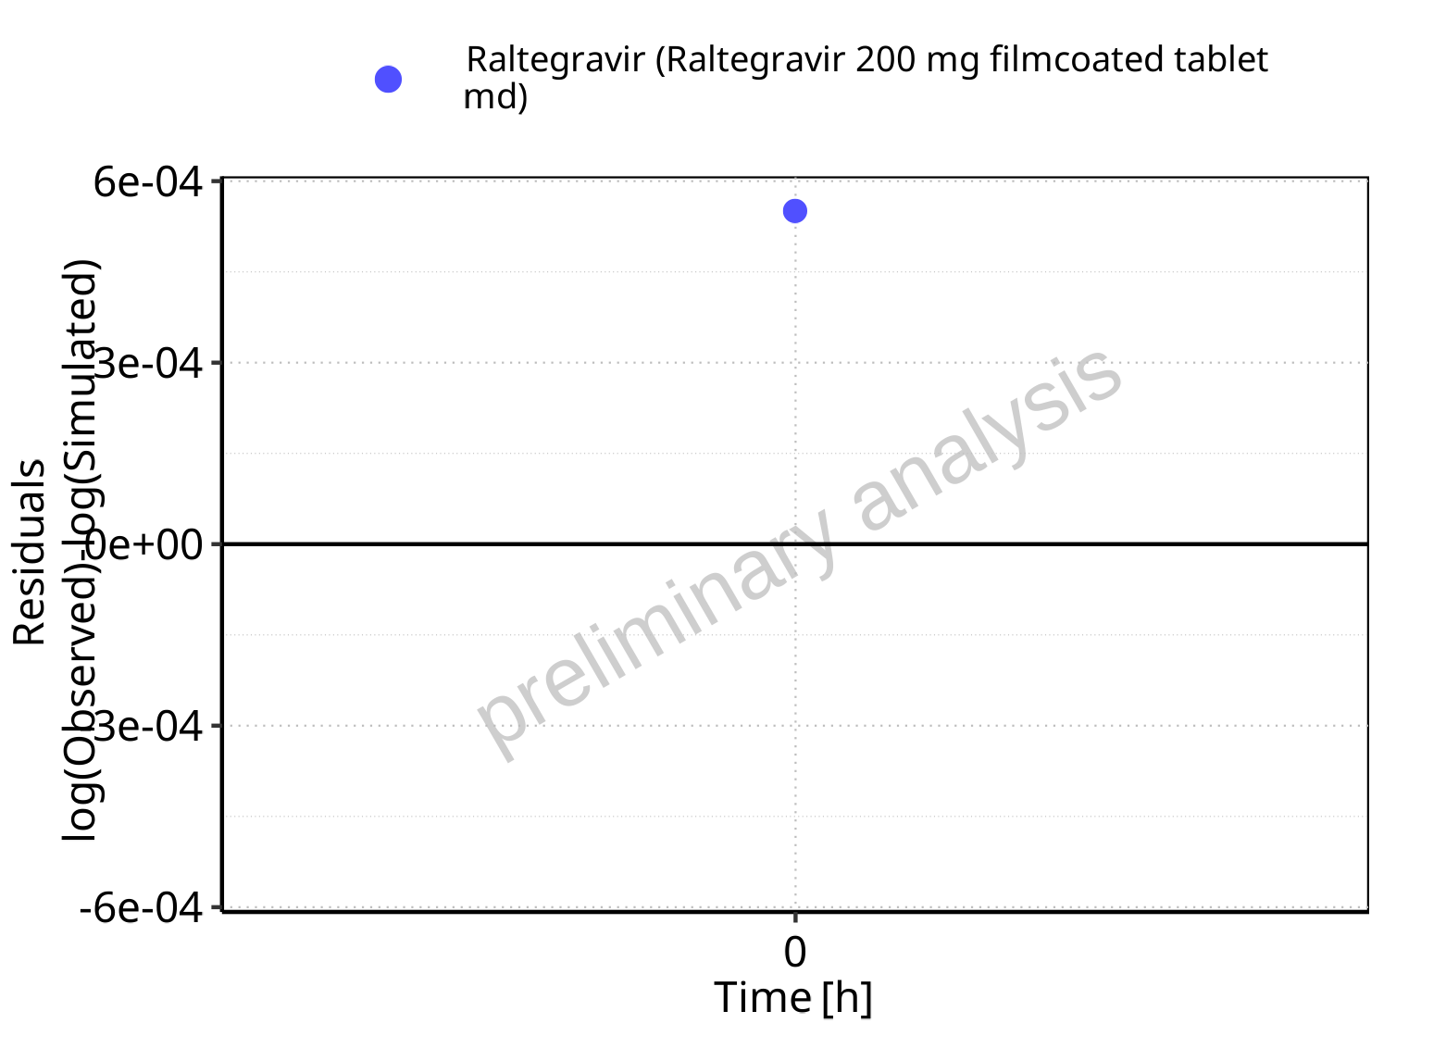

**Figure 5-106: Logarithmic residuals vs time values for Raltegravir 200 mg filmcoated tablet md. Data source: Data/Raltegravir_PK.txt.**

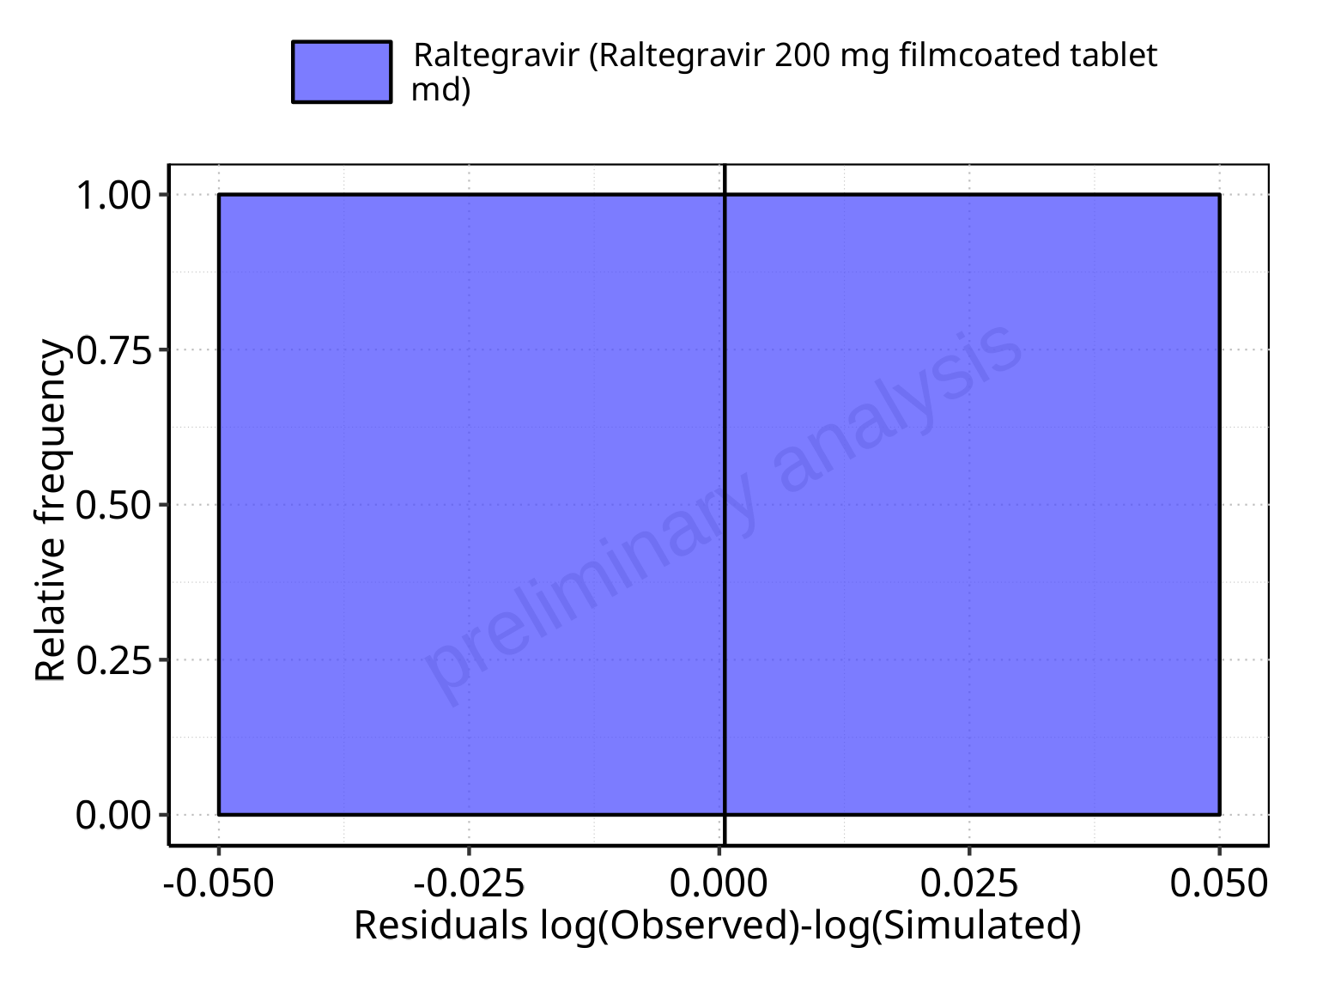

**Figure 5-107: Logarithmic residuals distribution (stacked) for Raltegravir 200 mg filmcoated tablet md. Data source: Data/Raltegravir_PK.txt.**

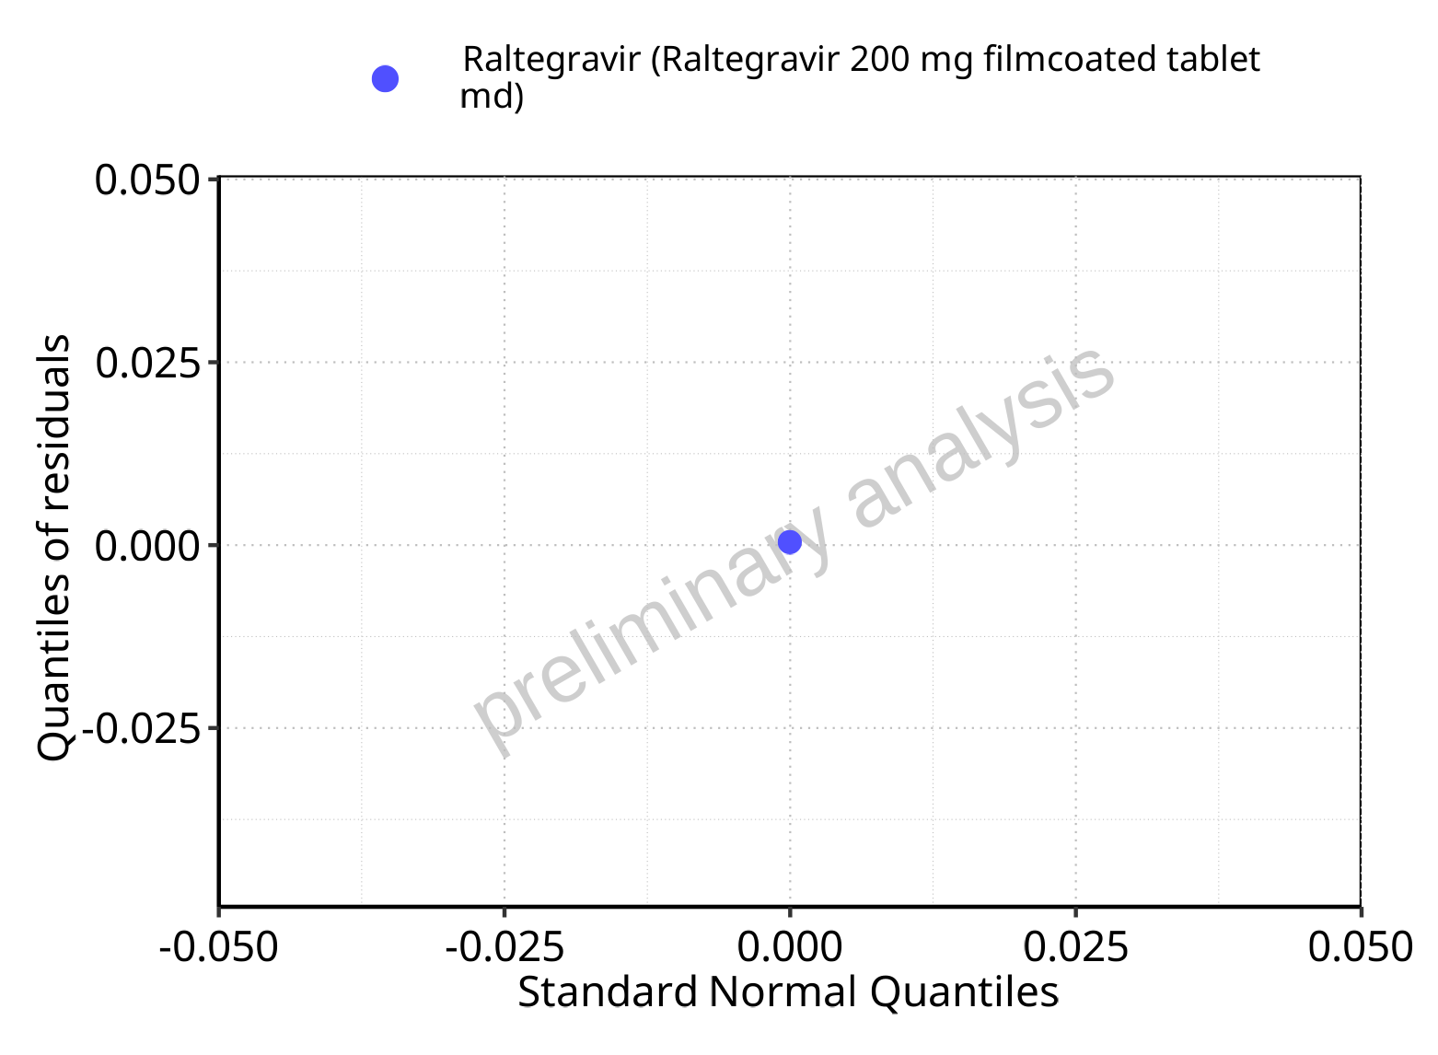

**Figure 5-108: Logarithmic residuals for Raltegravir 200 mg filmcoated tablet md as quantile-quantile plot. Data source: Data/Raltegravir_PK.txt.**

## Time profiles and residual plots for Filmcoated_tablet_400mg_sd

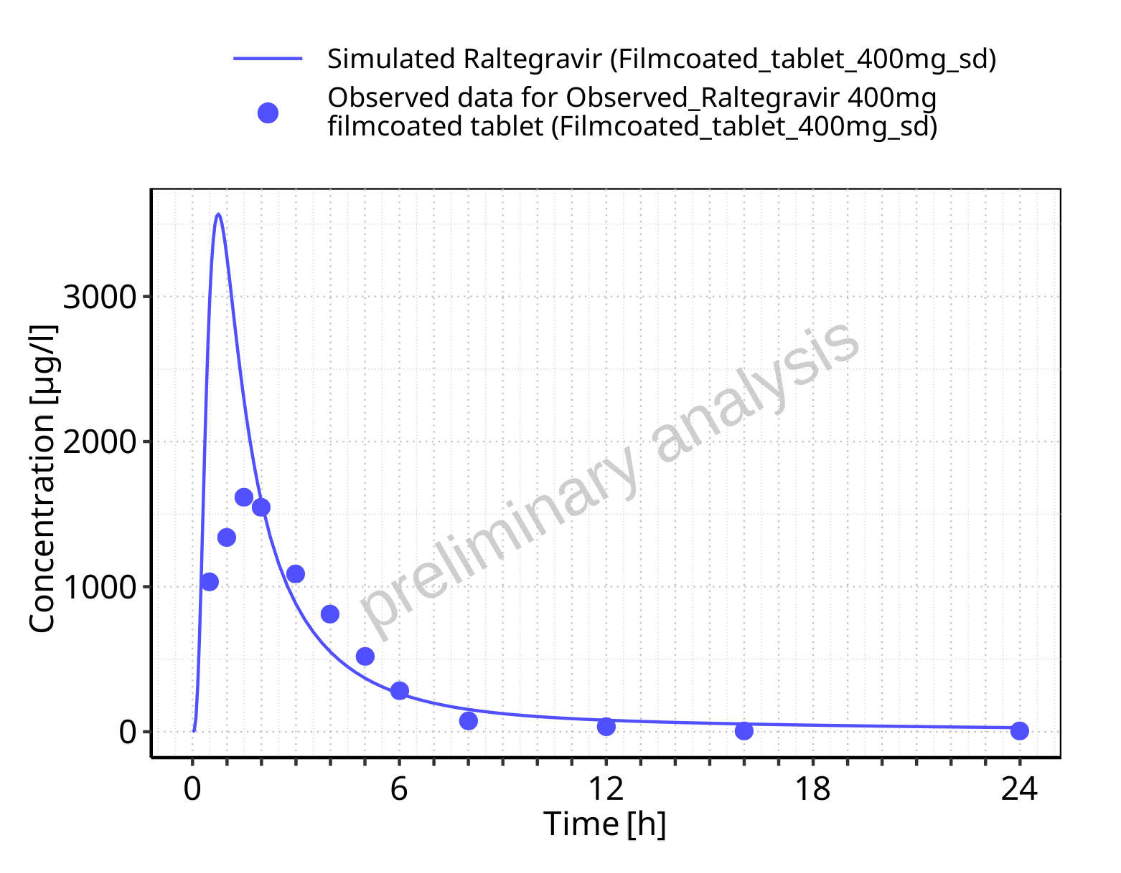

**Figure 5-109: Time profiles for Filmcoated_tablet_400mg_sd. Data source: Data/Raltegravir_PK.txt. Time profiles are plotted in a linear scale.**

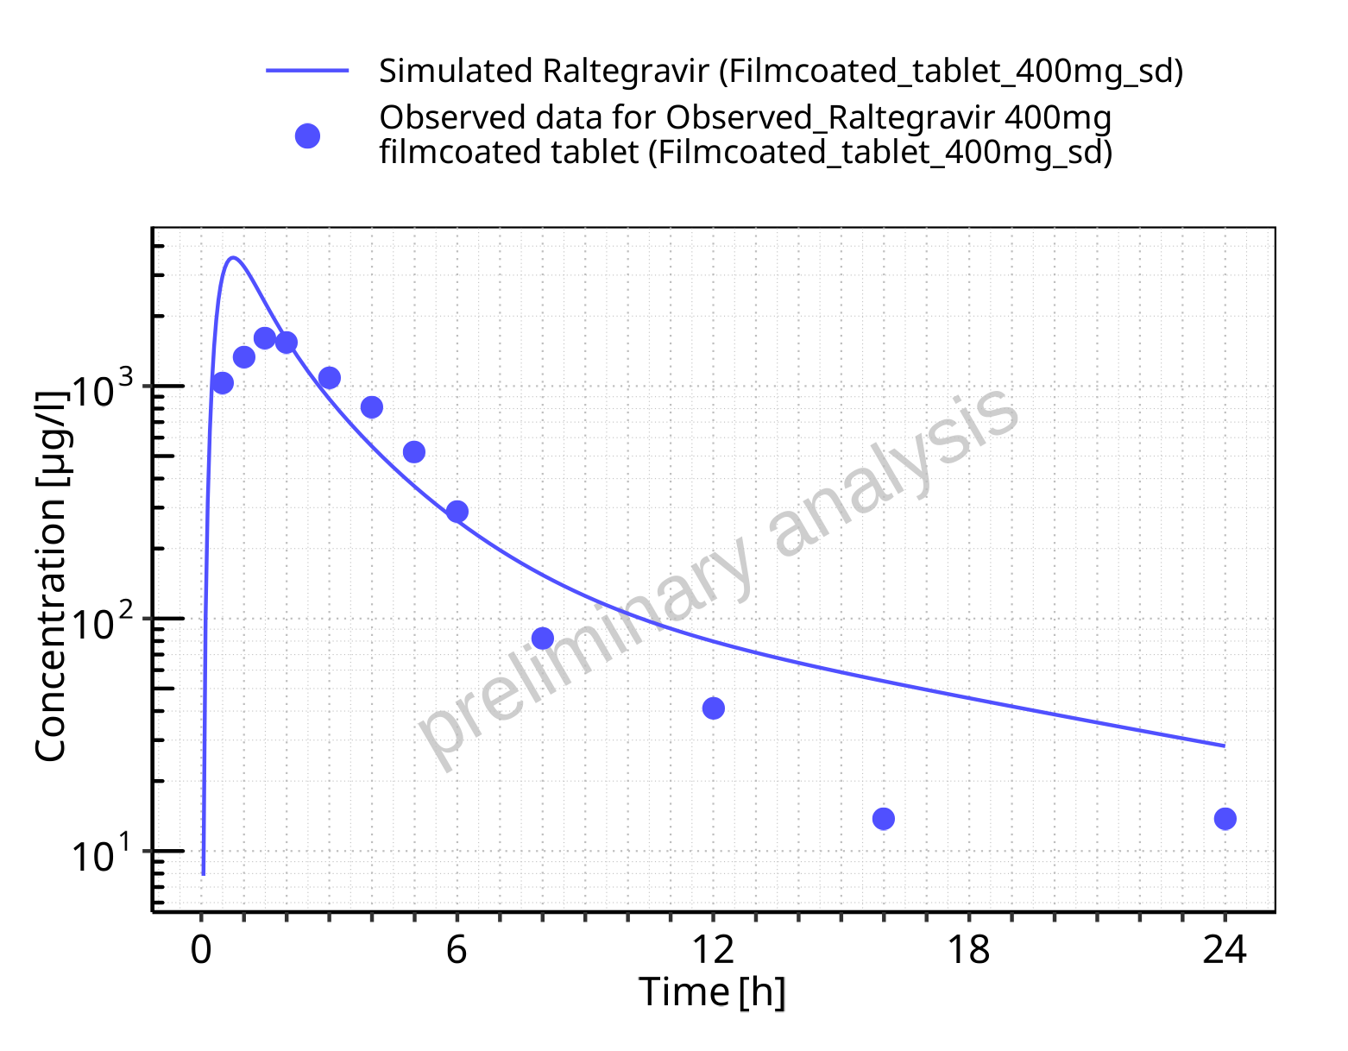

**Figure 5-110: Time profiles for Filmcoated_tablet_400mg_sd. Data source: Data/Raltegravir_PK.txt. Time profiles are plotted in a logarithmic scale.**

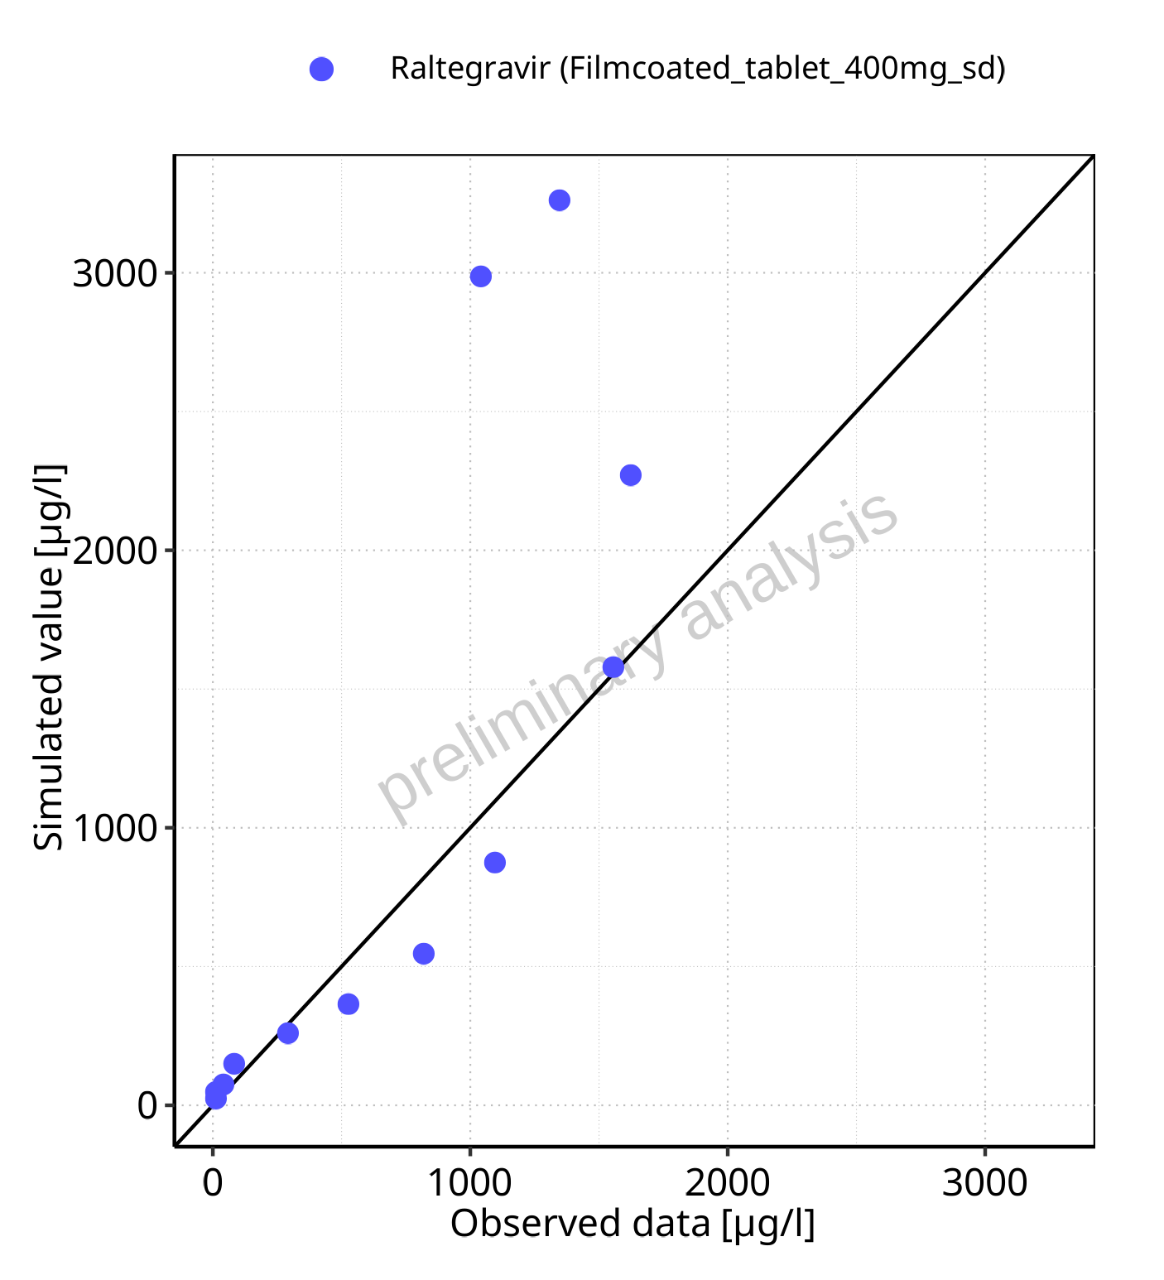

**Figure 5-111: Predicted vs observed for Filmcoated_tablet_400mg_sd. Data source: Data/Raltegravir_PK.txt. Predictions and observations are plotted in a linear scale.**



**Figure 5-112: Predicted vs observed for Filmcoated_tablet_400mg_sd. Data source: Data/Raltegravir_PK.txt. Predictions and observations are plotted in a logarithmic scale.**

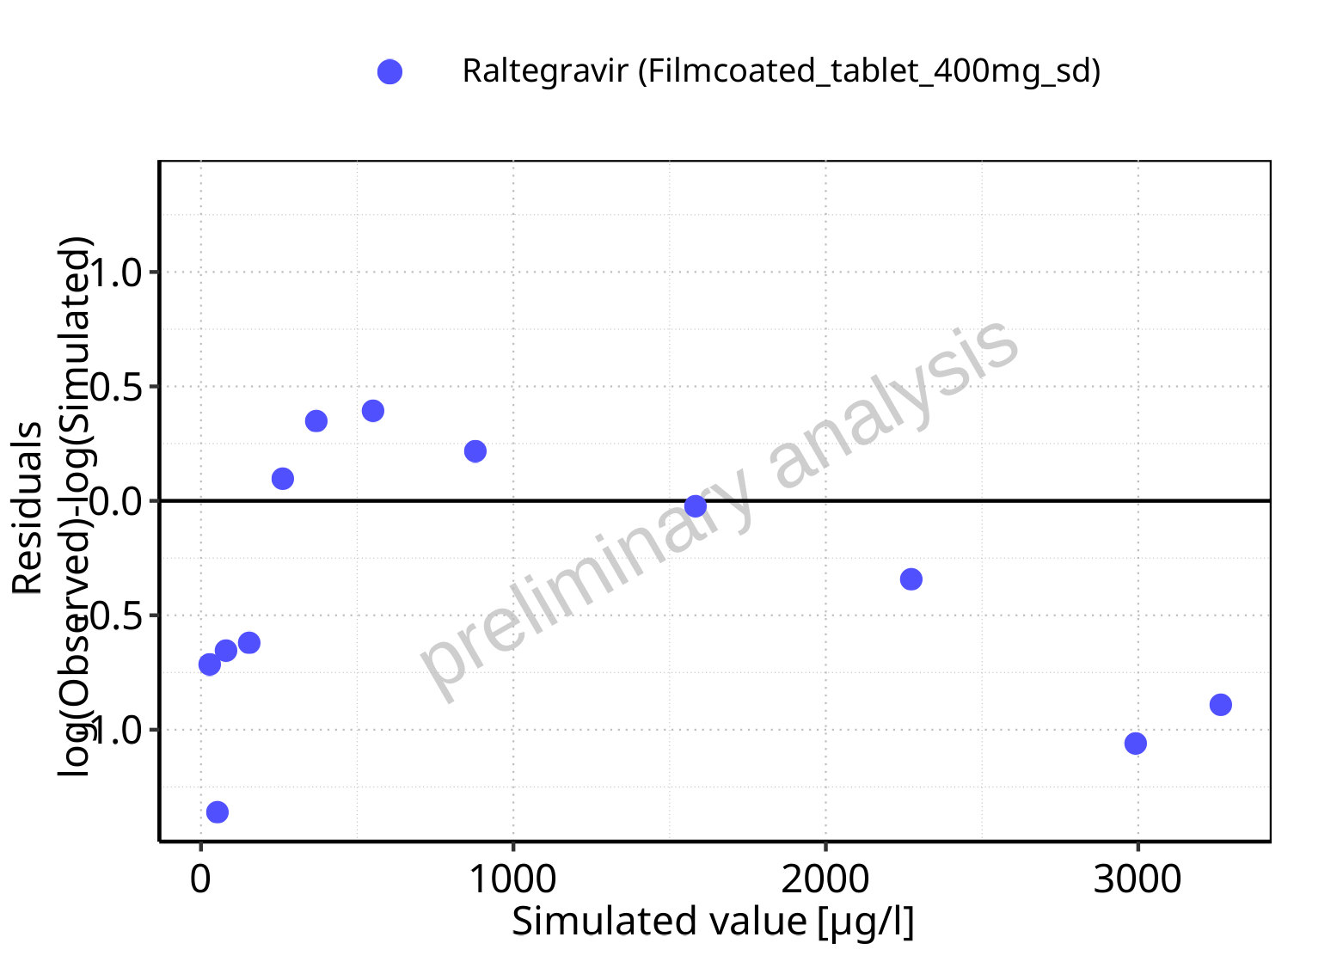

**Figure 5-113: Logarithmic residuals vs predicted values for Filmcoated_tablet_400mg_sd. Data source: Data/Raltegravir_PK.txt.**

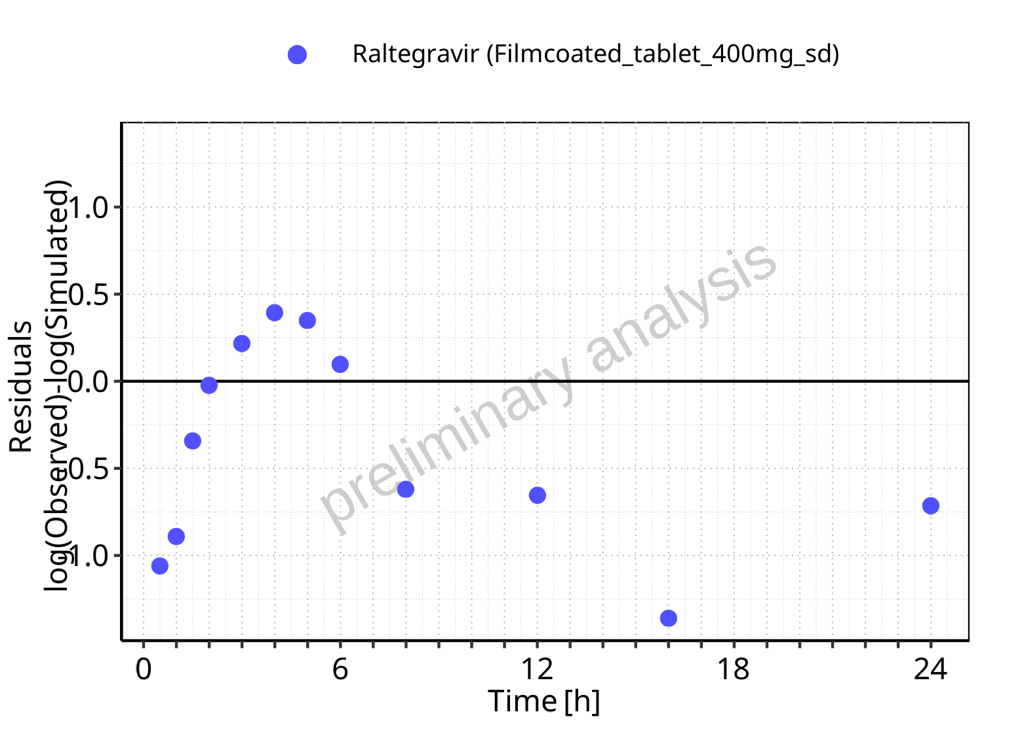

**Figure 5-114: Logarithmic residuals vs time values for Filmcoated_tablet_400mg_sd. Data source: Data/Raltegravir_PK.txt.**

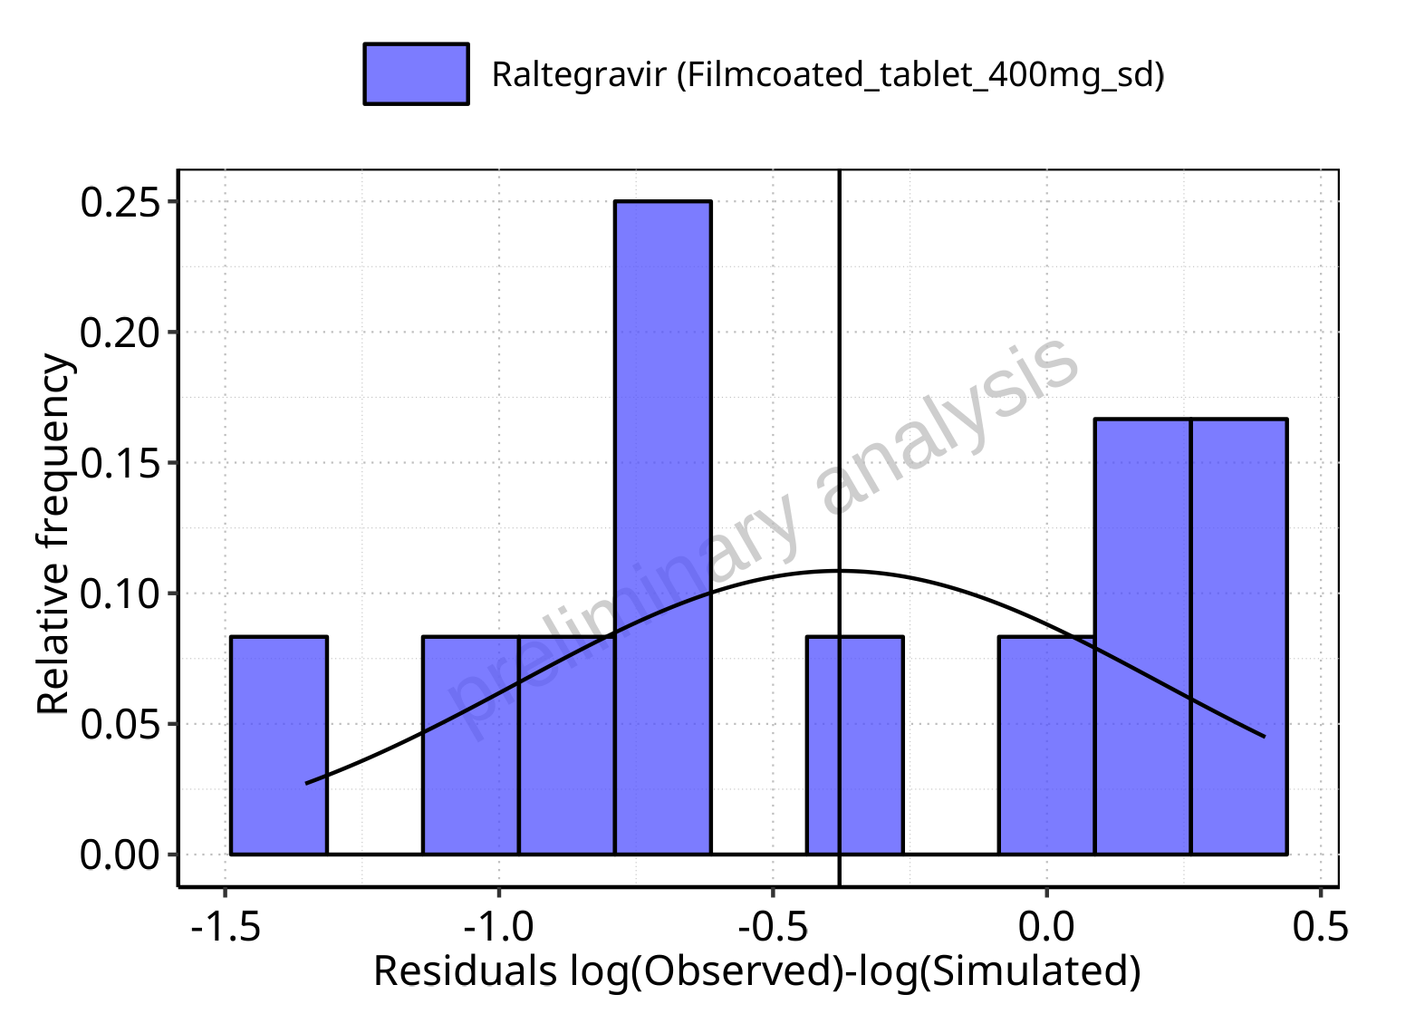

**Figure 5-115: Logarithmic residuals distribution (stacked) for Filmcoated_tablet_400mg_sd. Data source: Data/Raltegravir_PK.txt.**

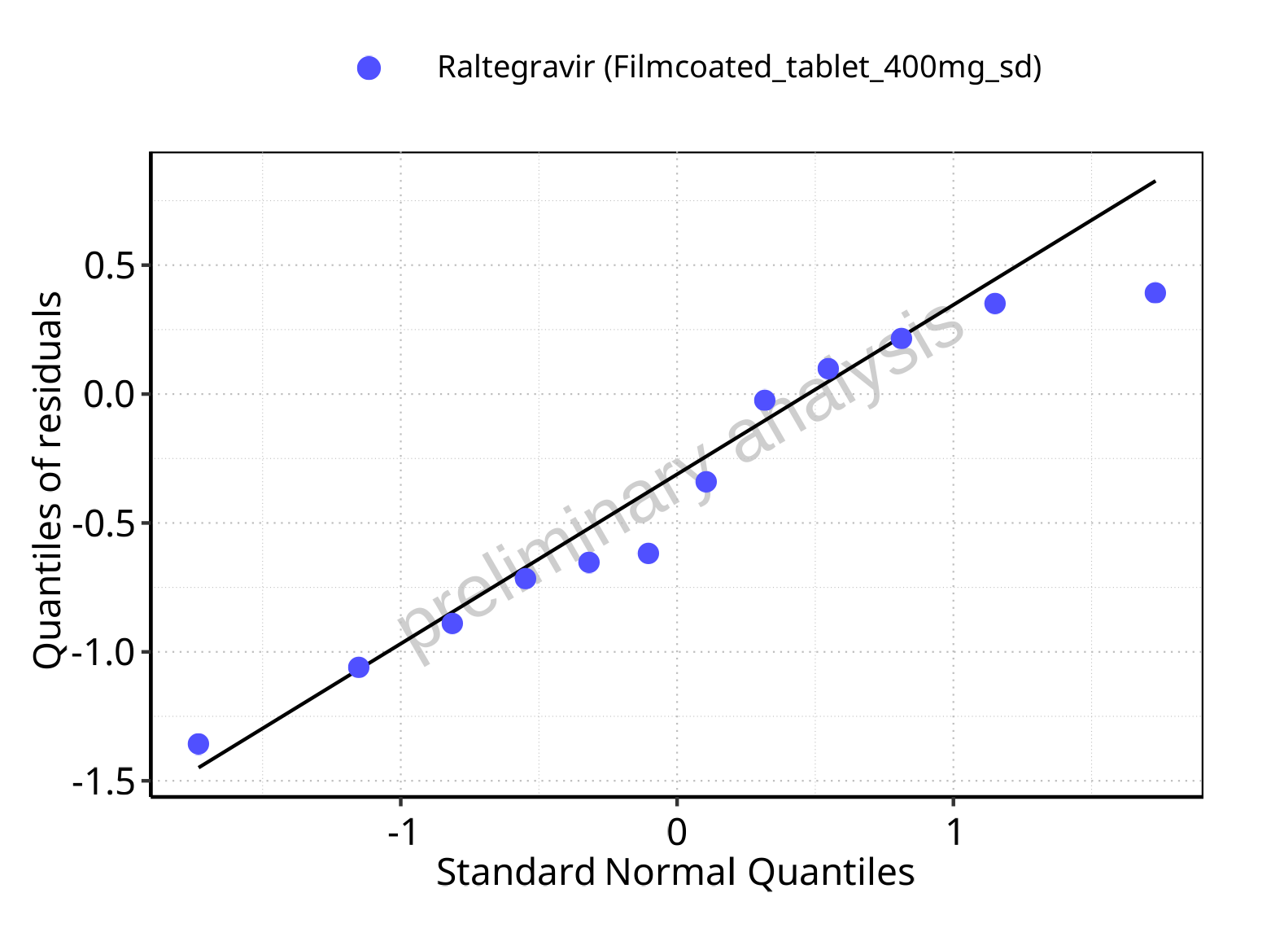

**Figure 5-116: Logarithmic residuals for Filmcoated_tablet_400mg_sd as quantile-quantile plot. Data source: Data/Raltegravir_PK.txt.**

## Time profiles and residual plots for Raltegravir 400 mg filmcoated tablet md

### For total simulation time range

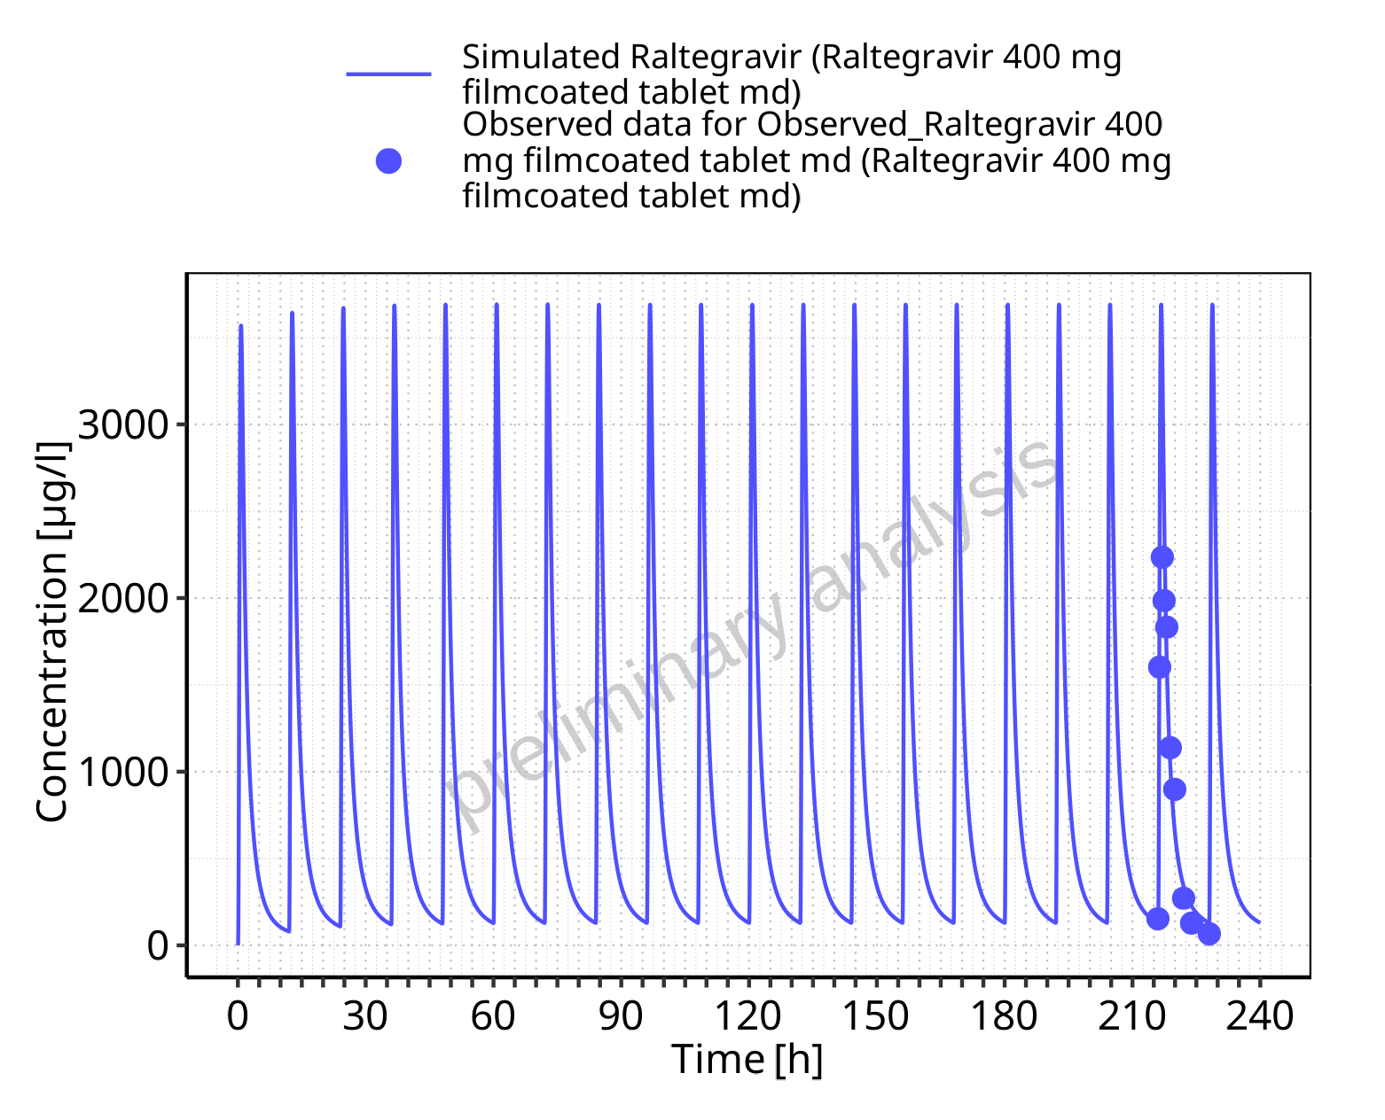

**Figure 5-117: Time profiles for Raltegravir 400 mg filmcoated tablet md. Data source: Data/Raltegravir_PK.txt. Time profiles are plotted in a linear scale.**

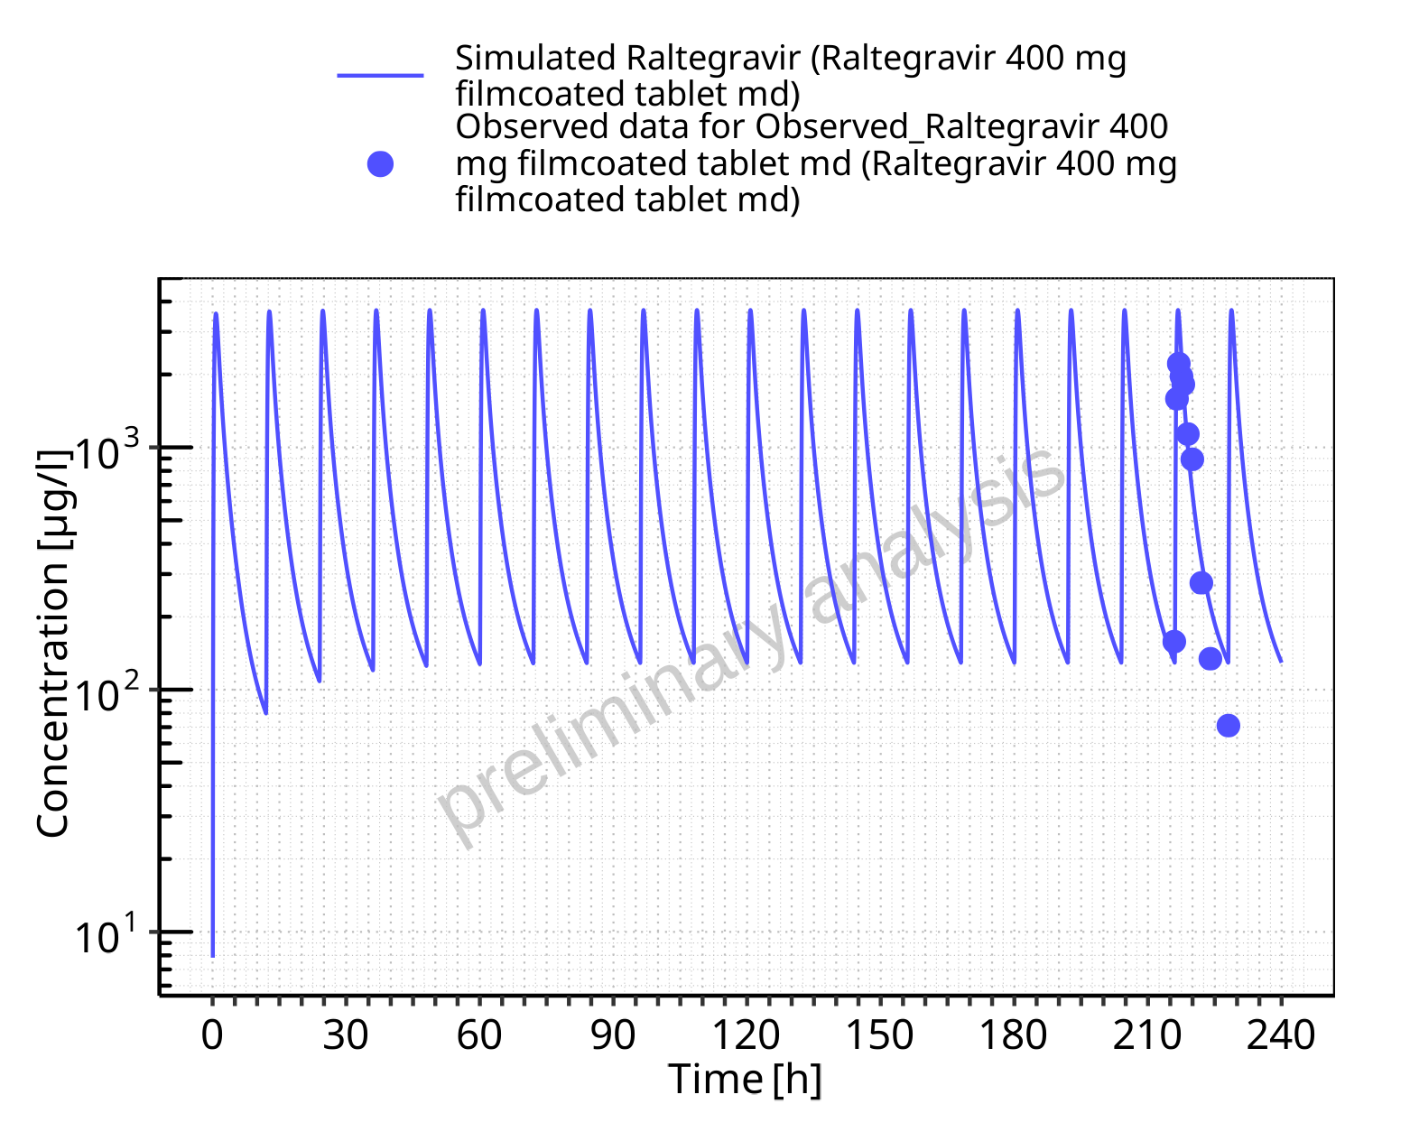

**Figure 5-118: Time profiles for Raltegravir 400 mg filmcoated tablet md. Data source: Data/Raltegravir_PK.txt. Time profiles are plotted in a logarithmic scale.**

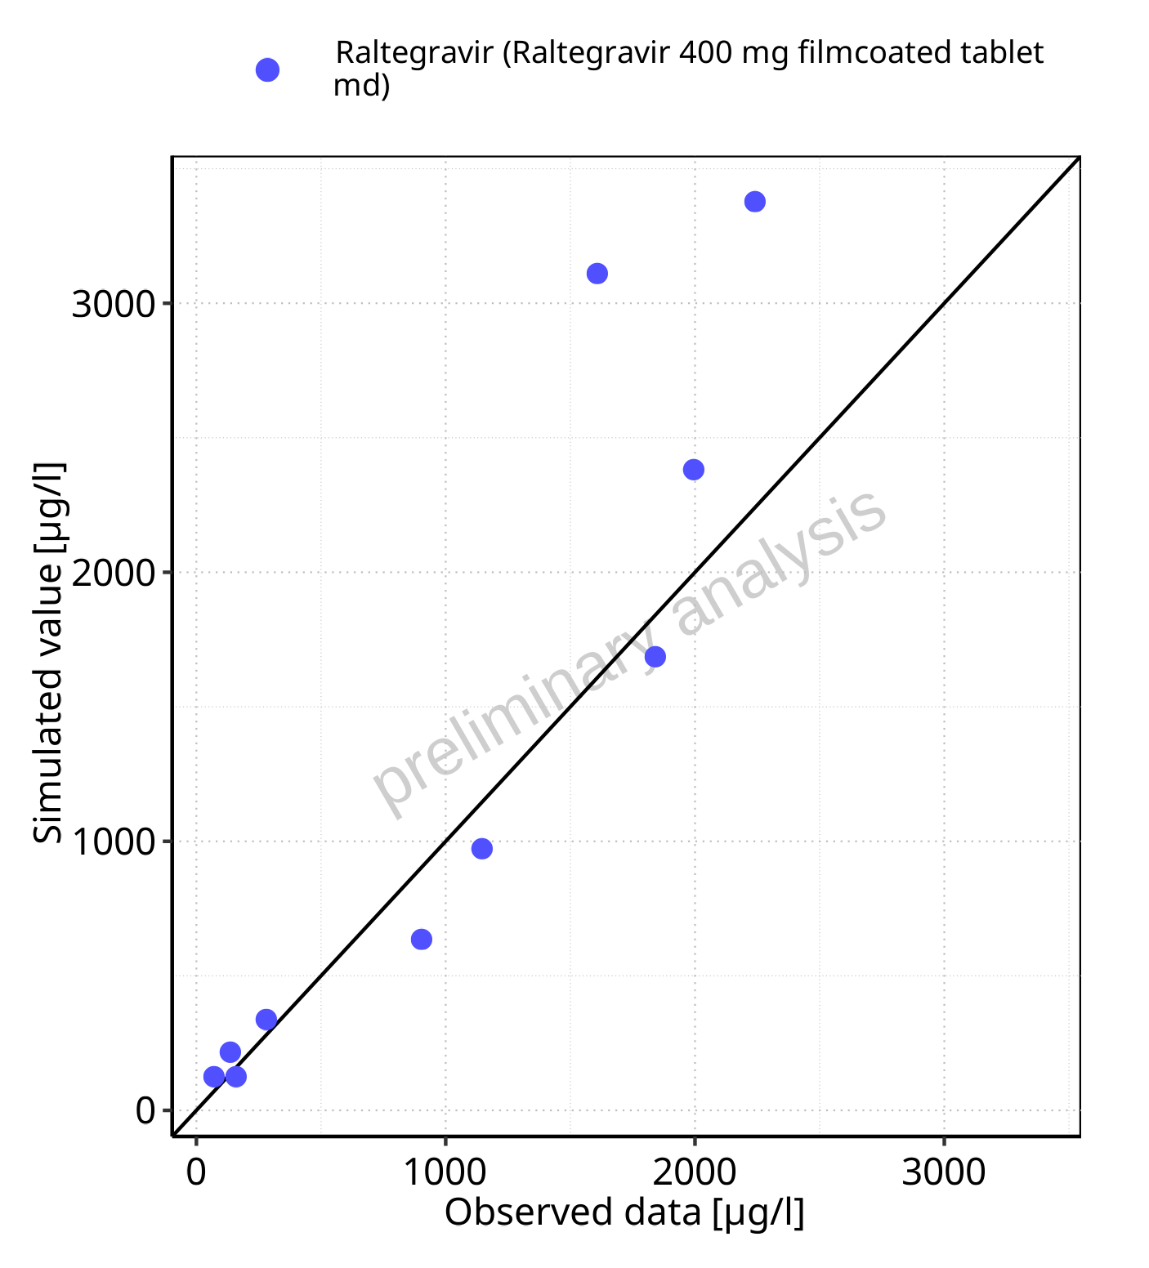

**Figure 5-119: Predicted vs observed for Raltegravir 400 mg filmcoated tablet md. Data source: Data/Raltegravir_PK.txt. Predictions and observations are plotted in a linear scale.**



**Figure 5-120: Predicted vs observed for Raltegravir 400 mg filmcoated tablet md. Data source: Data/Raltegravir_PK.txt. Predictions and observations are plotted in a logarithmic scale.**

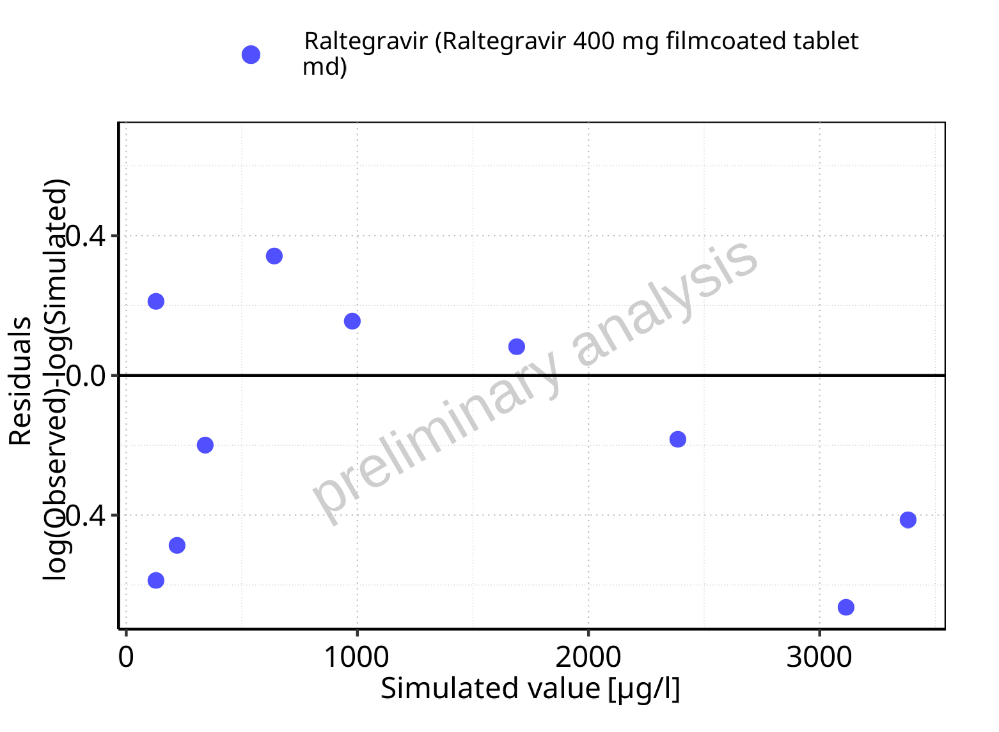

**Figure 5-121: Logarithmic residuals vs predicted values for Raltegravir 400 mg filmcoated tablet md. Data source: Data/Raltegravir_PK.txt.**

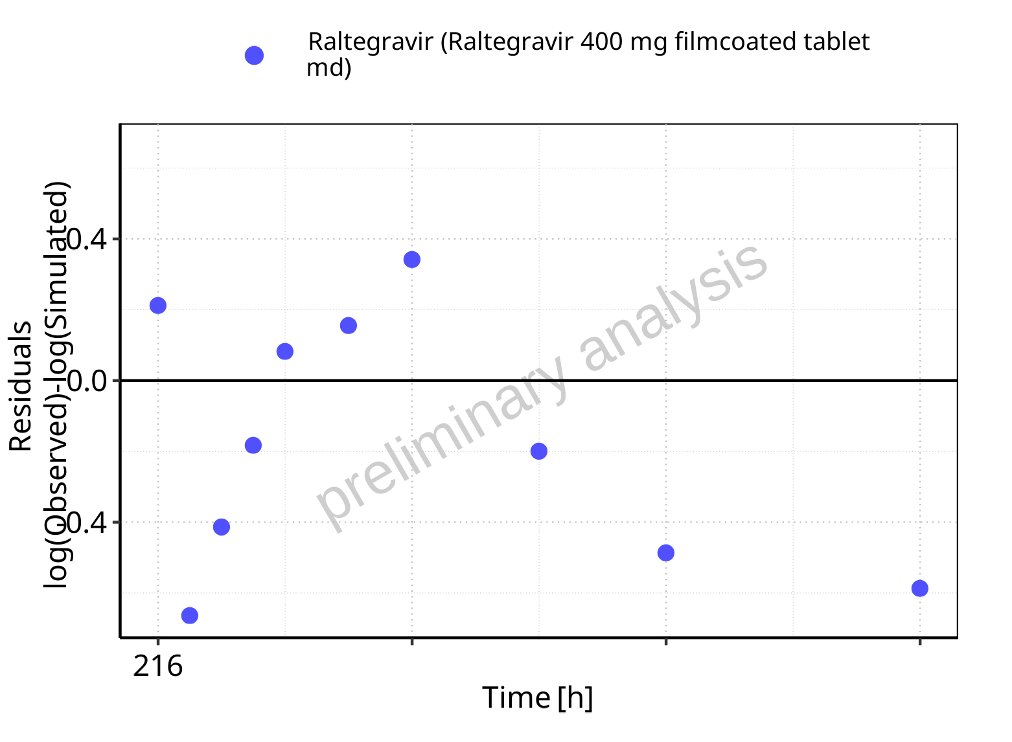

**Figure 5-122: Logarithmic residuals vs time values for Raltegravir 400 mg filmcoated tablet md. Data source: Data/Raltegravir_PK.txt.**

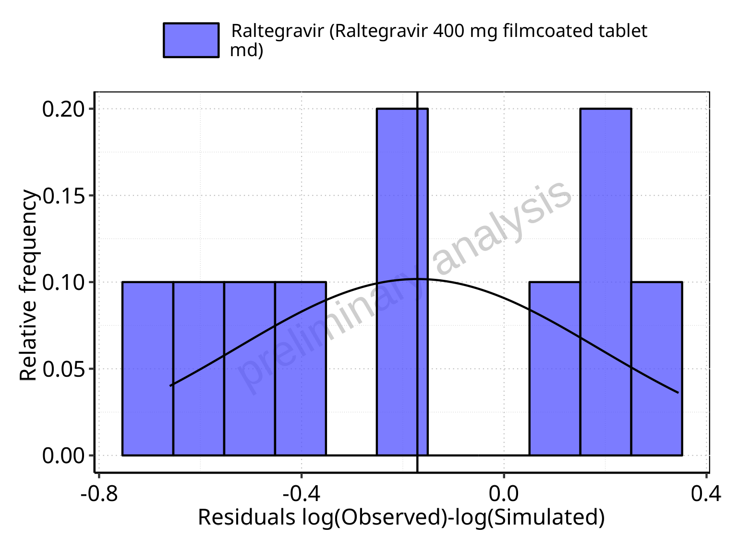

**Figure 5-123: Logarithmic residuals distribution (stacked) for Raltegravir 400 mg filmcoated tablet md. Data source: Data/Raltegravir_PK.txt.**

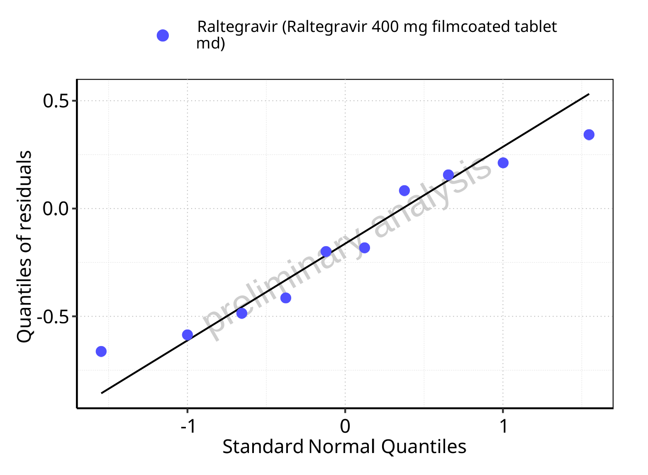

**Figure 5-124: Logarithmic residuals for Raltegravir 400 mg filmcoated tablet md as quantile-quantile plot. Data source: Data/Raltegravir_PK.txt.**

### For first application range

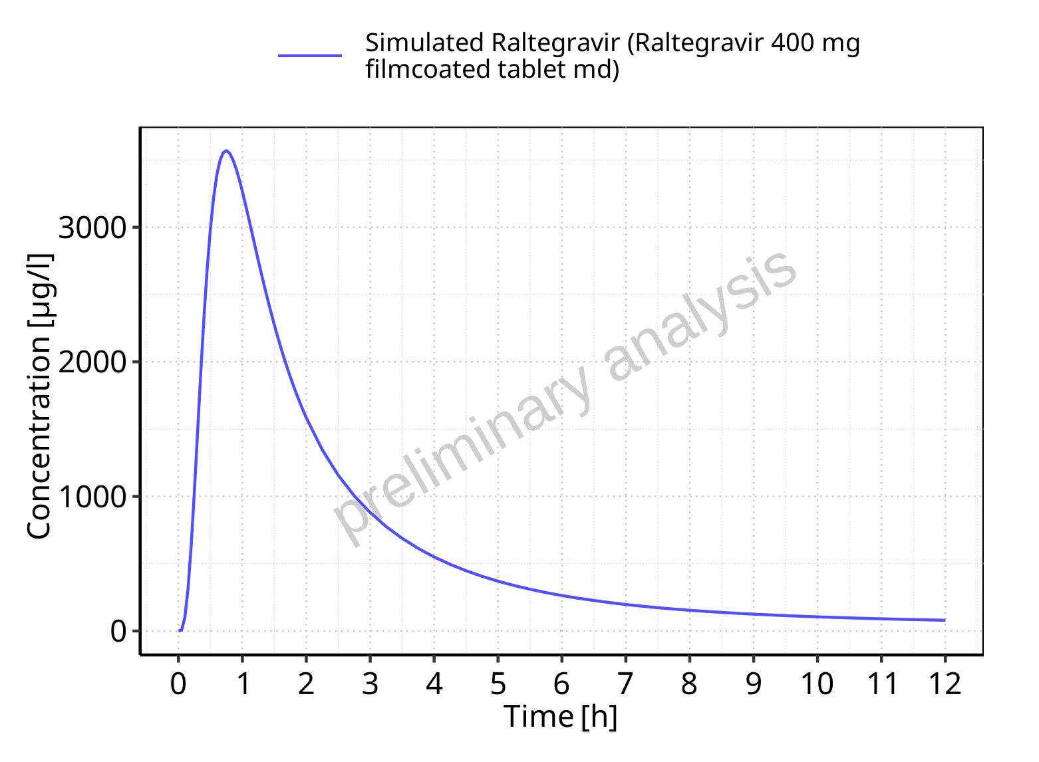

**Figure 5-125: Time profiles for Raltegravir 400 mg filmcoated tablet md. Data source: Data/Raltegravir_PK.txt. Time profiles are plotted in a linear scale.**

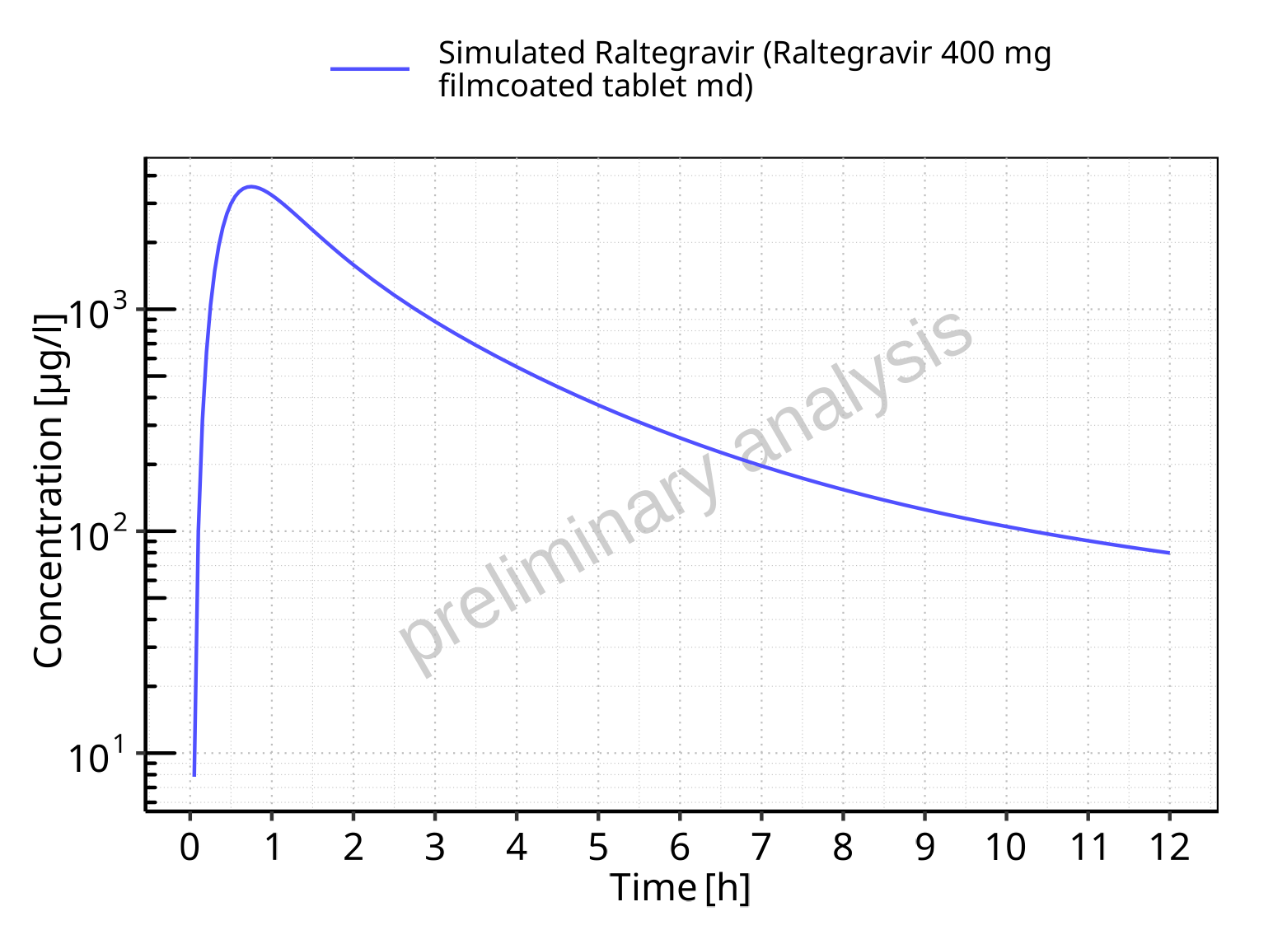

**Figure 5-126: Time profiles for Raltegravir 400 mg filmcoated tablet md. Data source: Data/Raltegravir_PK.txt. Time profiles are plotted in a logarithmic scale.**

### For last application range

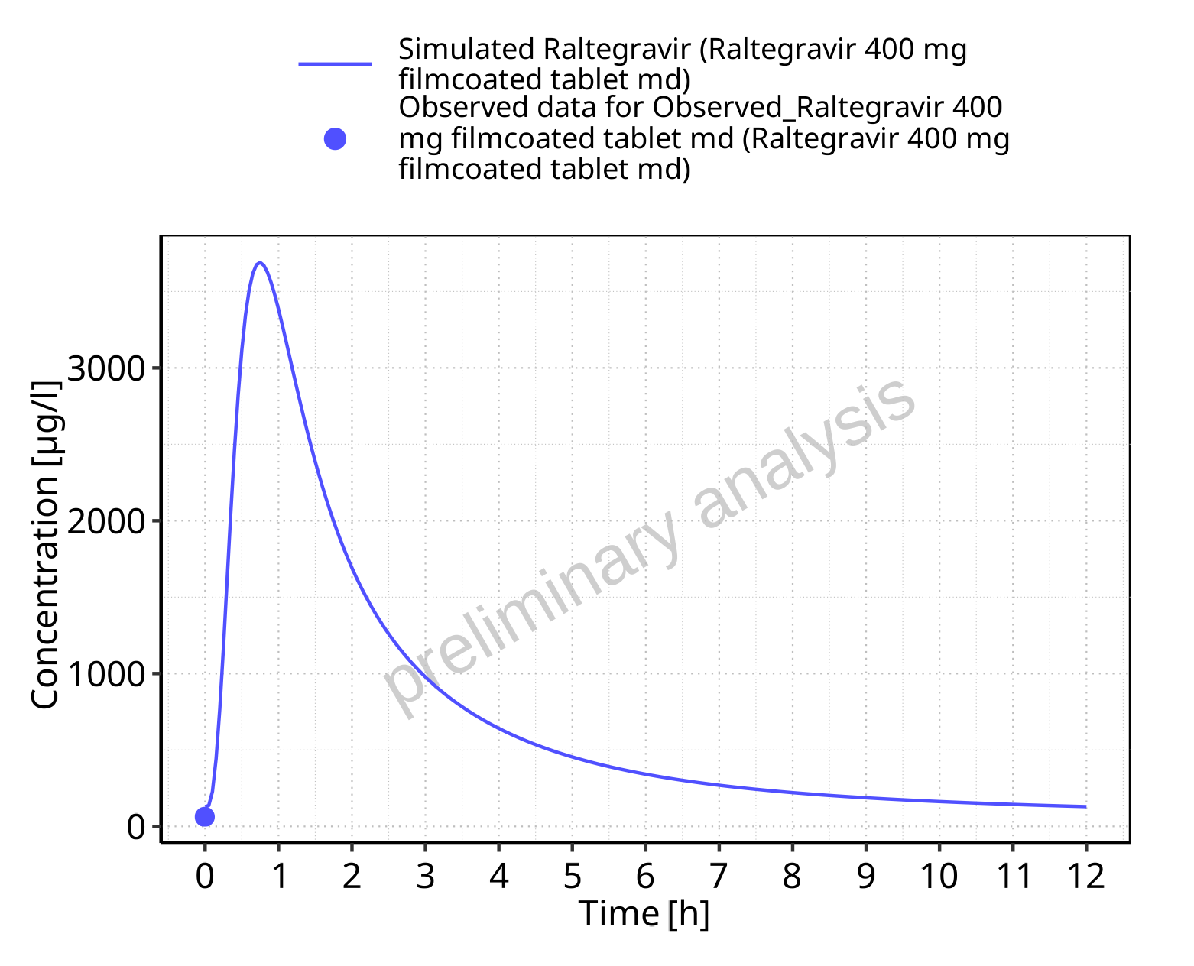

**Figure 5-127: Time profiles for Raltegravir 400 mg filmcoated tablet md. Data source: Data/Raltegravir_PK.txt. Time profiles are plotted in a linear scale.**

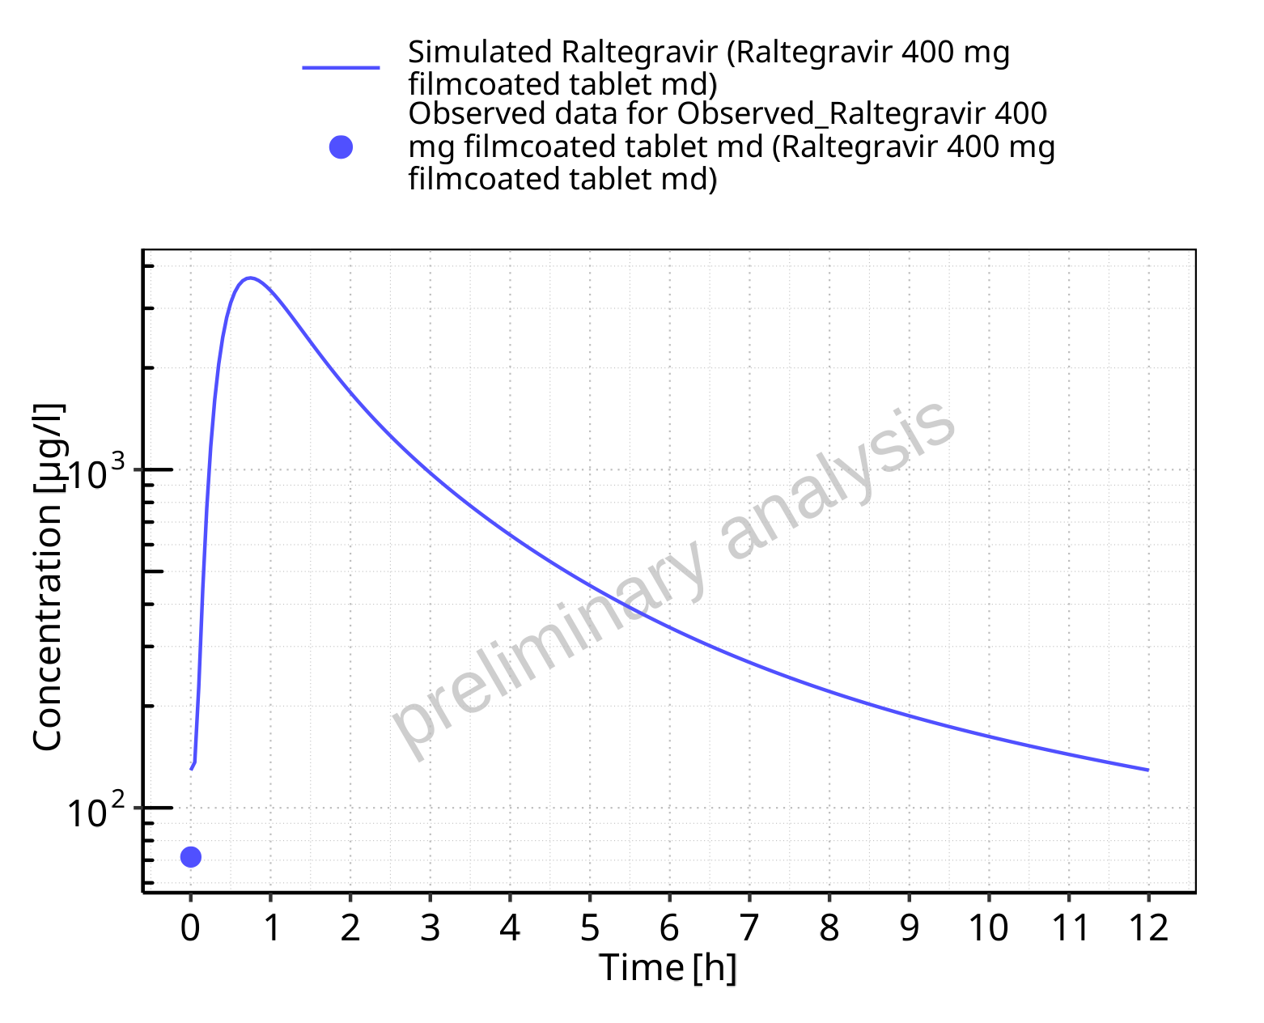

**Figure 5-128: Time profiles for Raltegravir 400 mg filmcoated tablet md. Data source: Data/Raltegravir_PK.txt. Time profiles are plotted in a logarithmic scale.**

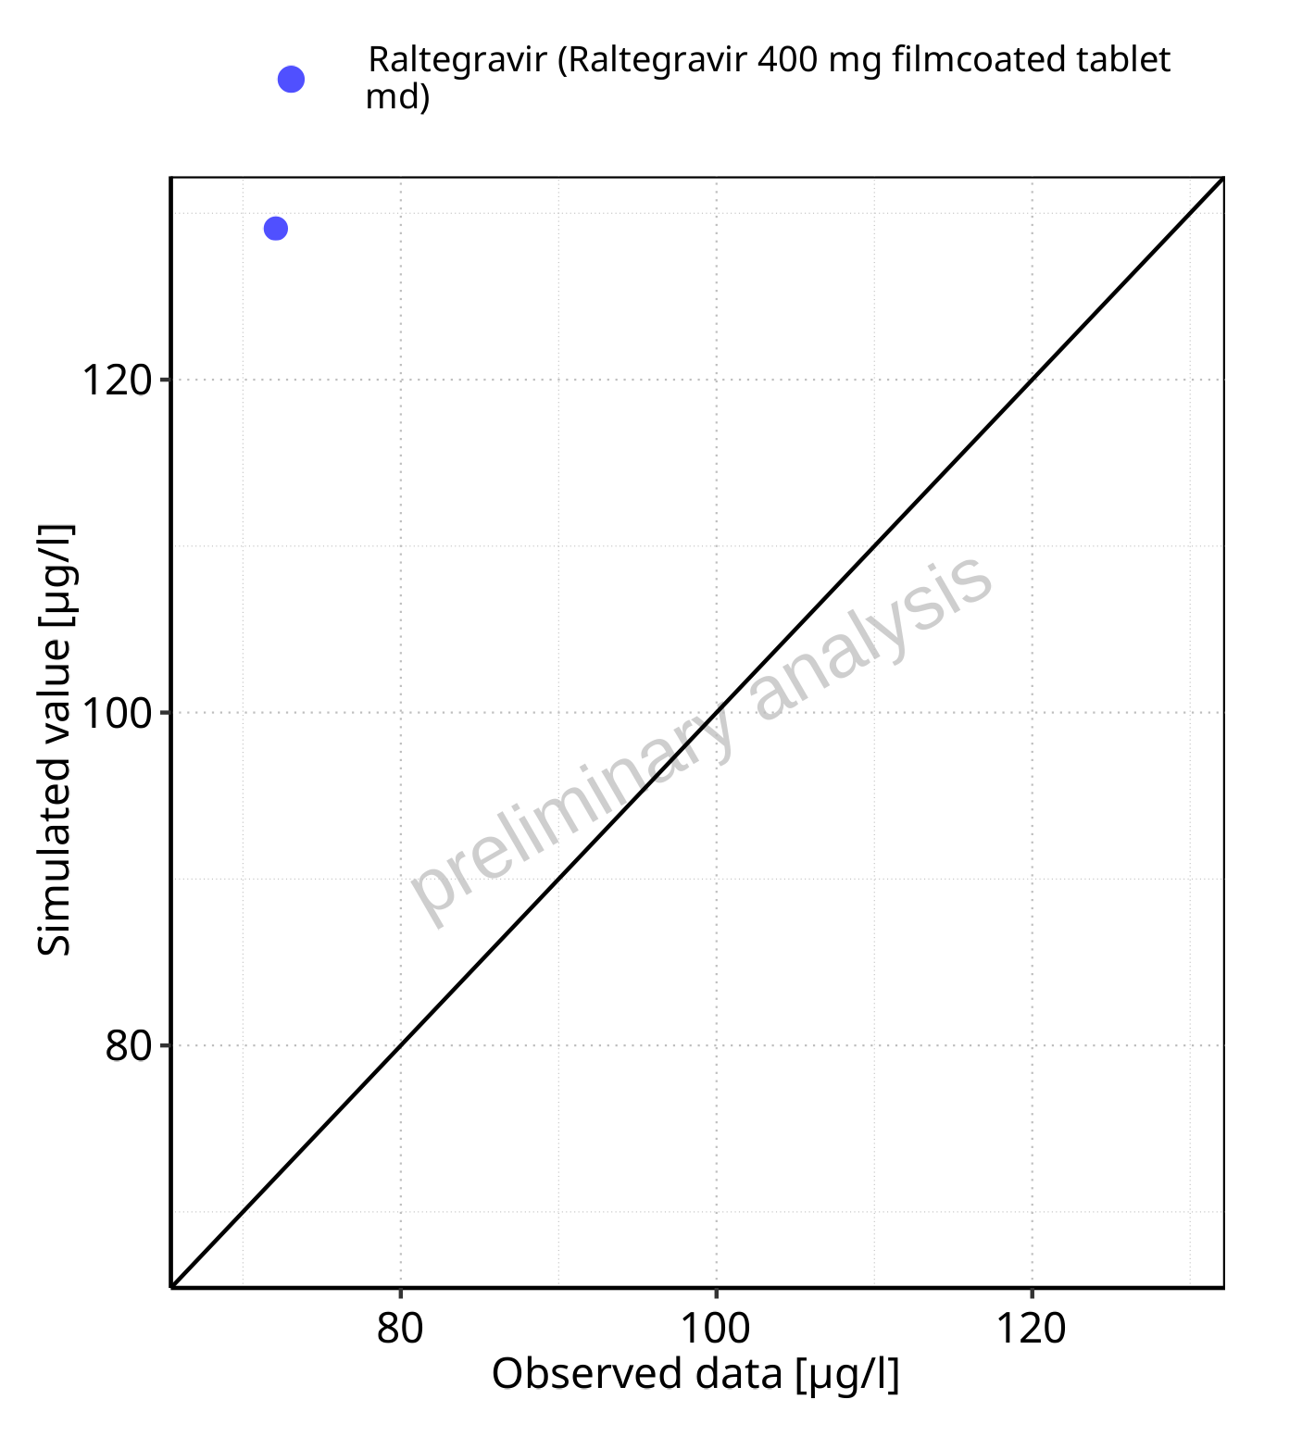

**Figure 5-129: Predicted vs observed for Raltegravir 400 mg filmcoated tablet md. Data source: Data/Raltegravir_PK.txt. Predictions and observations are plotted in a linear scale.**



**Figure 5-130: Predicted vs observed for Raltegravir 400 mg filmcoated tablet md. Data source: Data/Raltegravir_PK.txt. Predictions and observations are plotted in a logarithmic scale.**

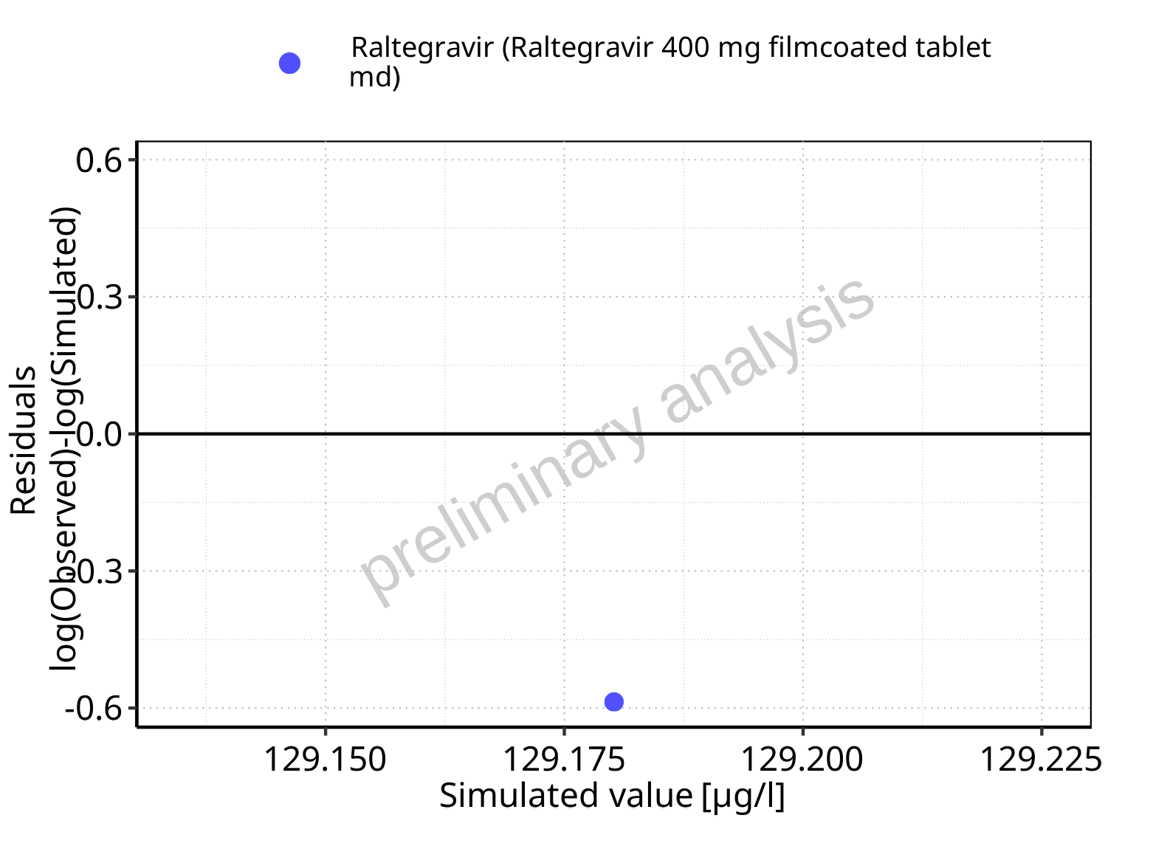

**Figure 5-131: Logarithmic residuals vs predicted values for Raltegravir 400 mg filmcoated tablet md. Data source: Data/Raltegravir_PK.txt.**

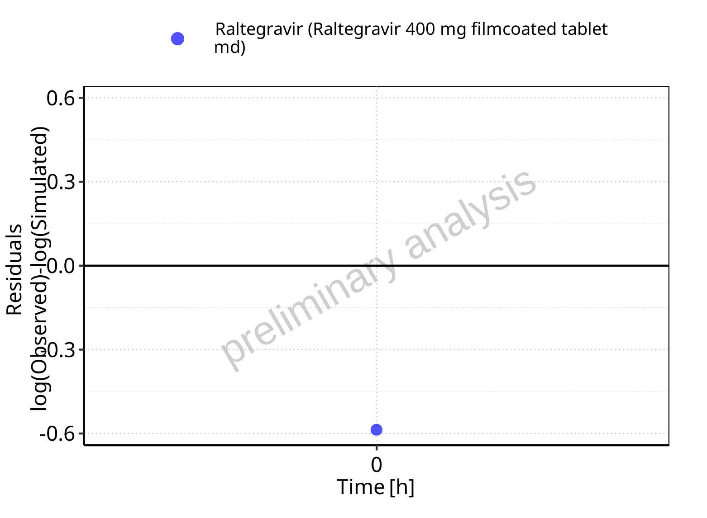

**Figure 5-132: Logarithmic residuals vs time values for Raltegravir 400 mg filmcoated tablet md. Data source: Data/Raltegravir_PK.txt.**

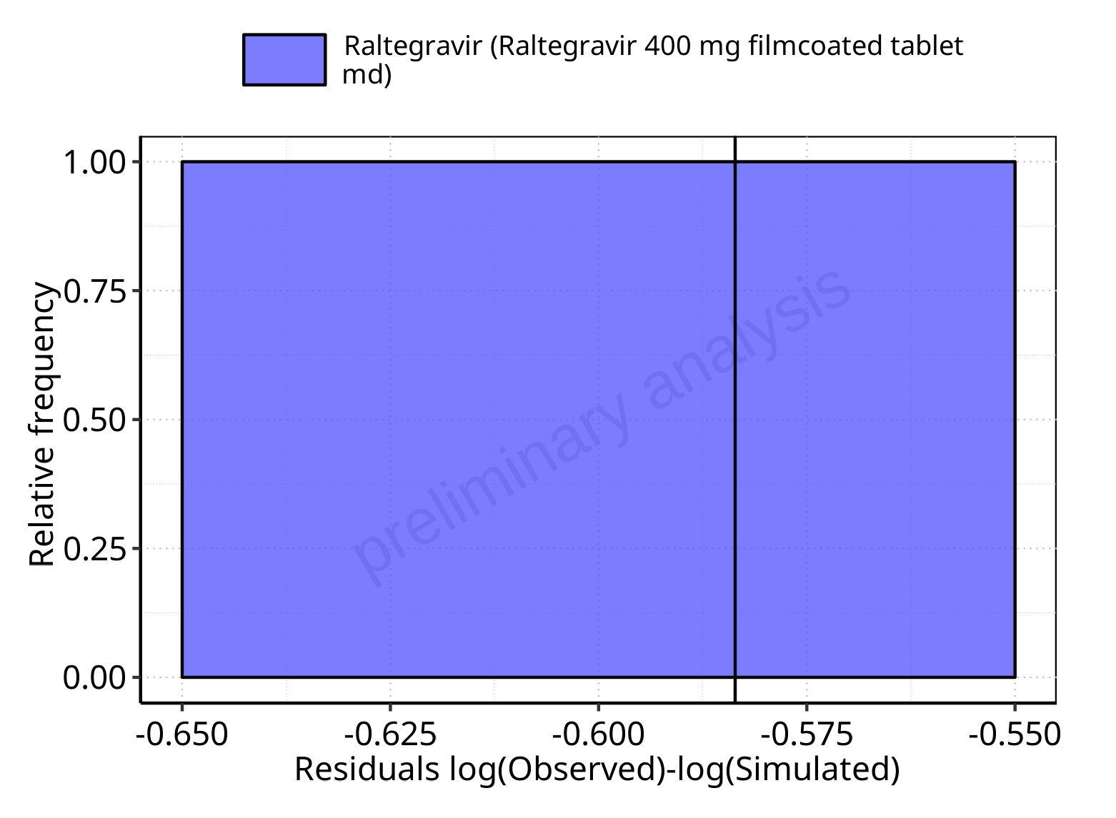

**Figure 5-133: Logarithmic residuals distribution (stacked) for Raltegravir 400 mg filmcoated tablet md. Data source: Data/Raltegravir_PK.txt.**

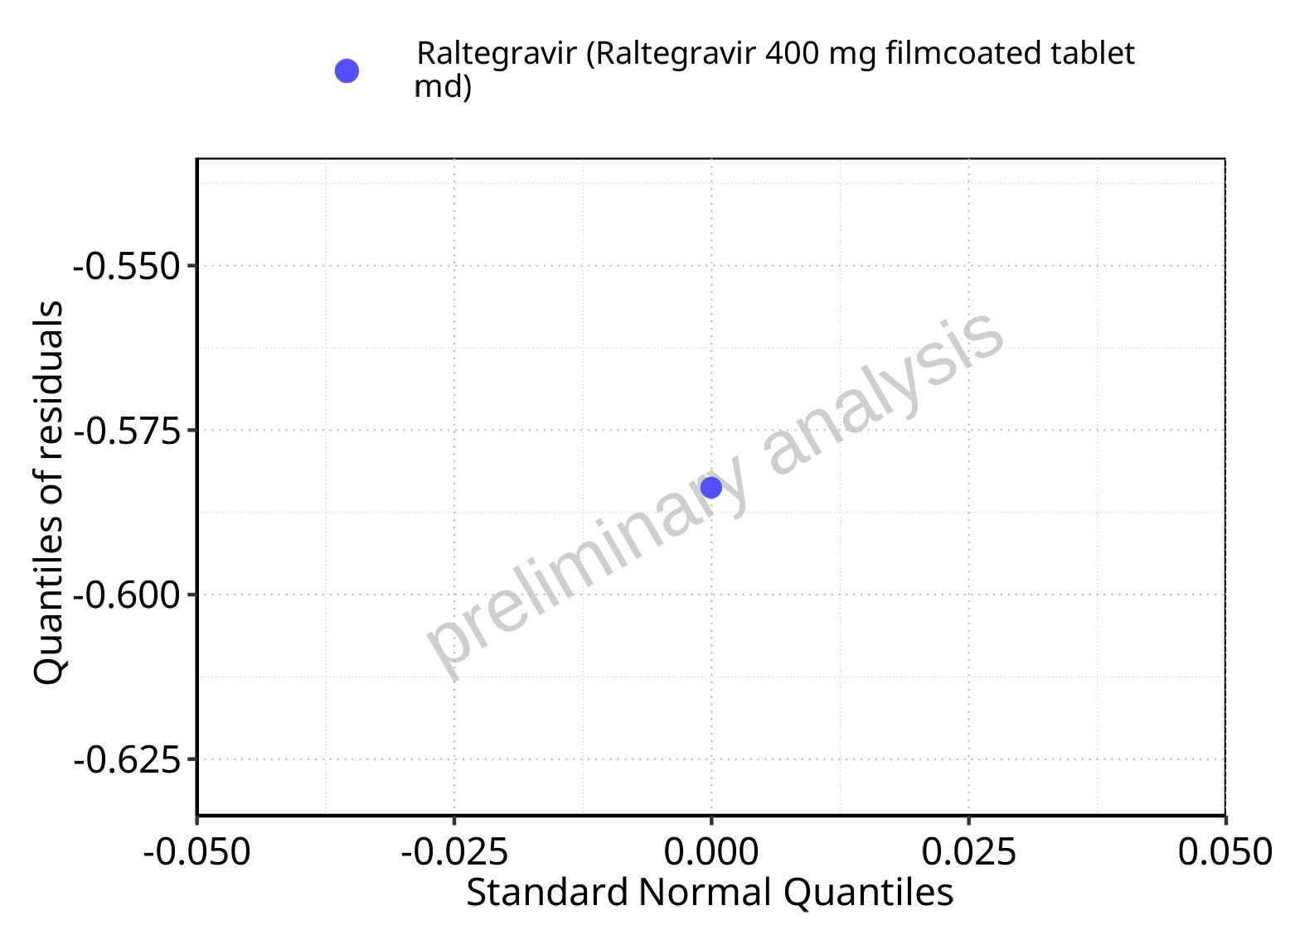

**Figure 5-134: Logarithmic residuals for Raltegravir 400 mg filmcoated tablet md as quantile-quantile plot. Data source: Data/Raltegravir_PK.txt.**

## Time profiles and residual plots for Raltegravir 400mg chewable fasted

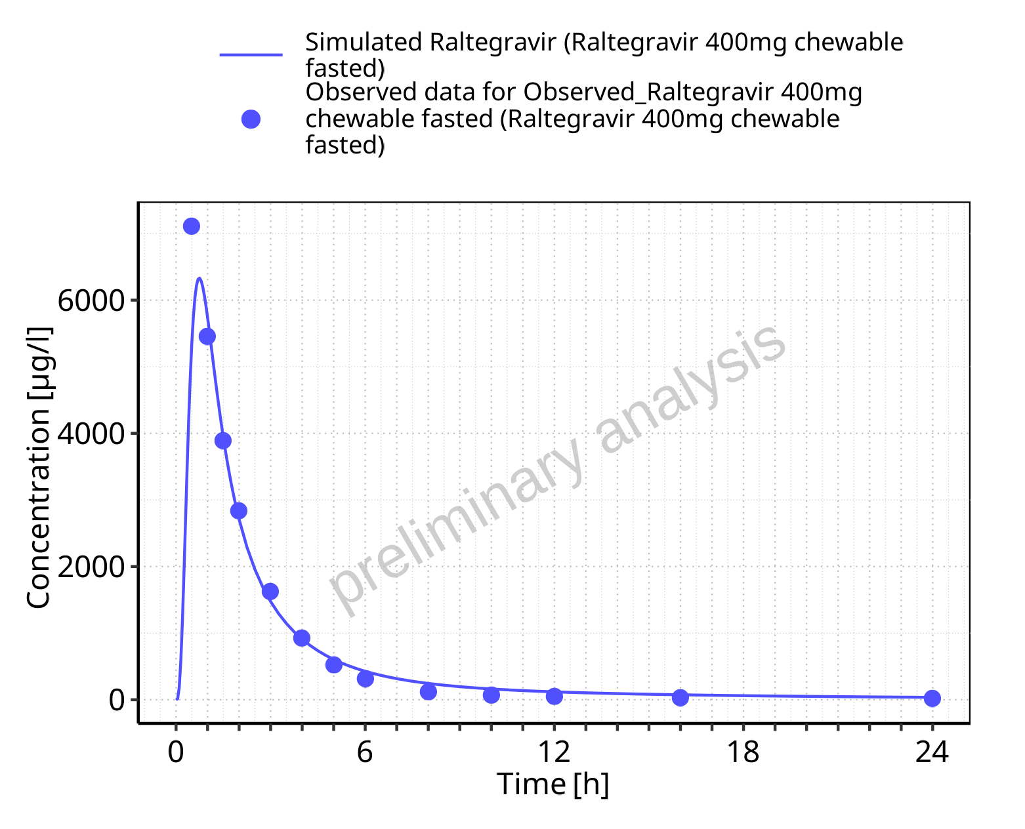

**Figure 5-135: Time profiles for Raltegravir 400mg chewable fasted. Data source: Data/Raltegravir_PK.txt. Time profiles are plotted in a linear scale.**

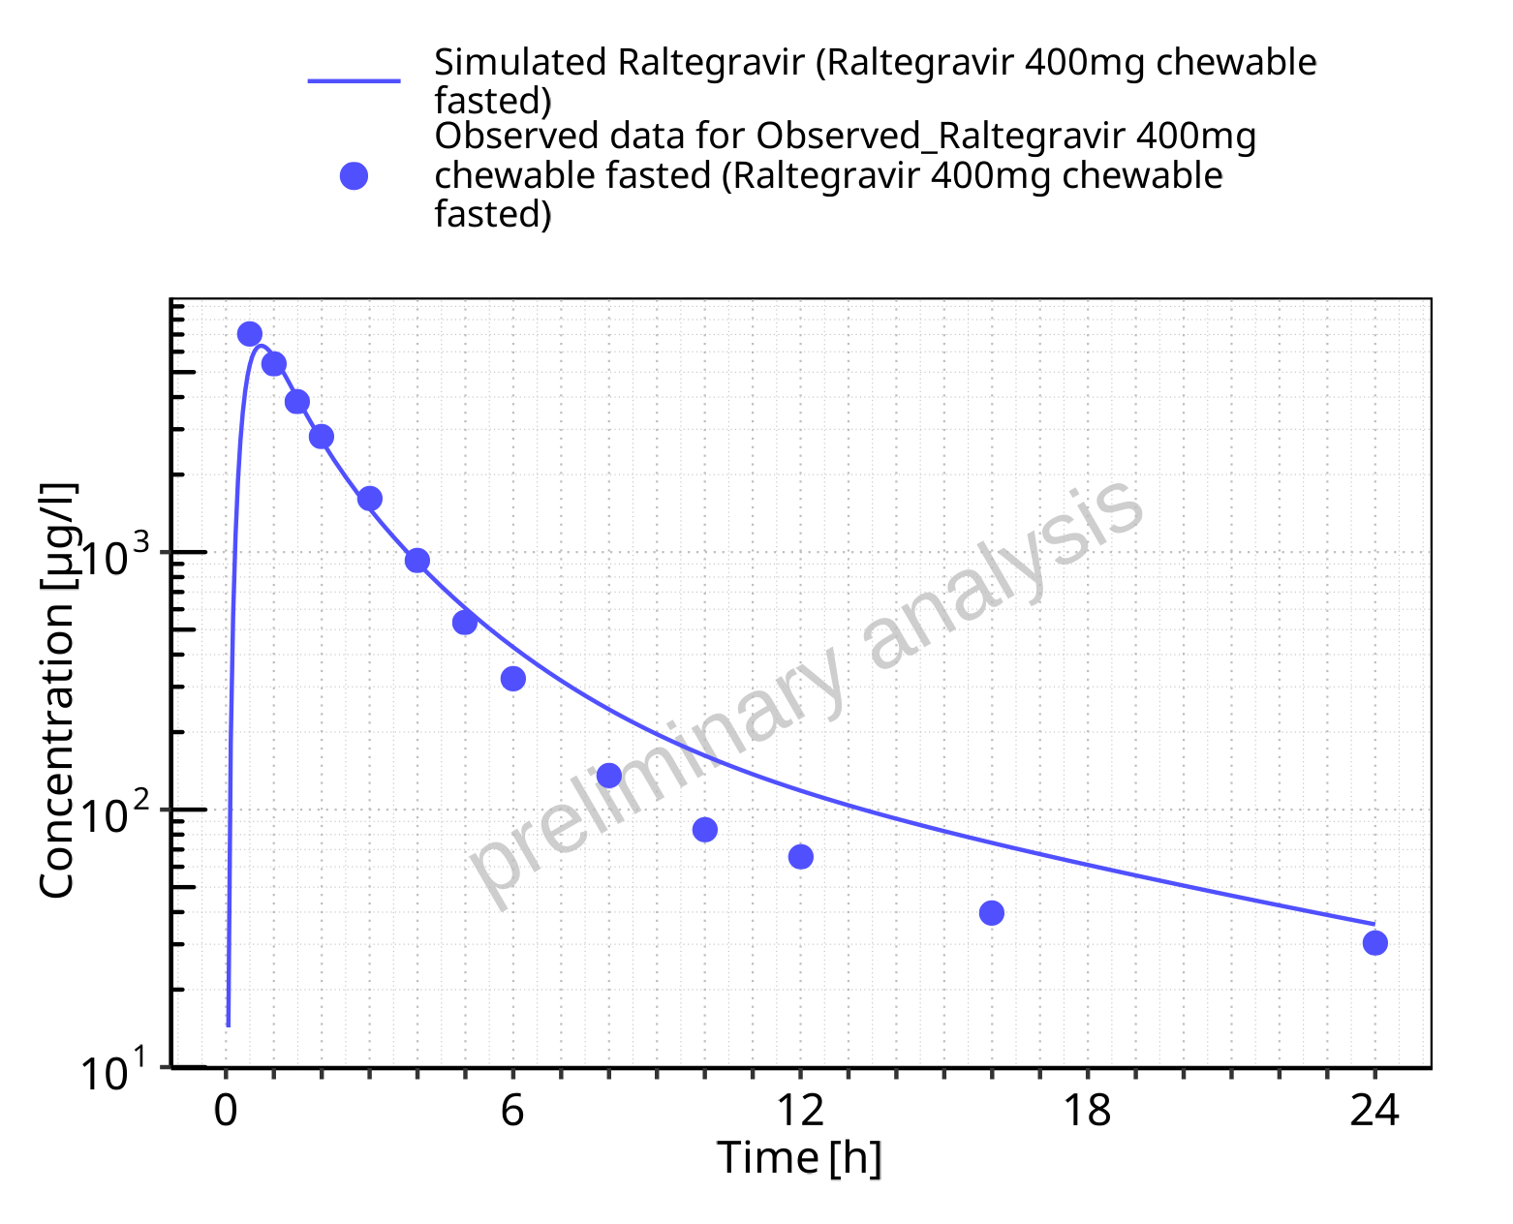

**Figure 5-136: Time profiles for Raltegravir 400mg chewable fasted. Data source: Data/Raltegravir_PK.txt. Time profiles are plotted in a logarithmic scale.**

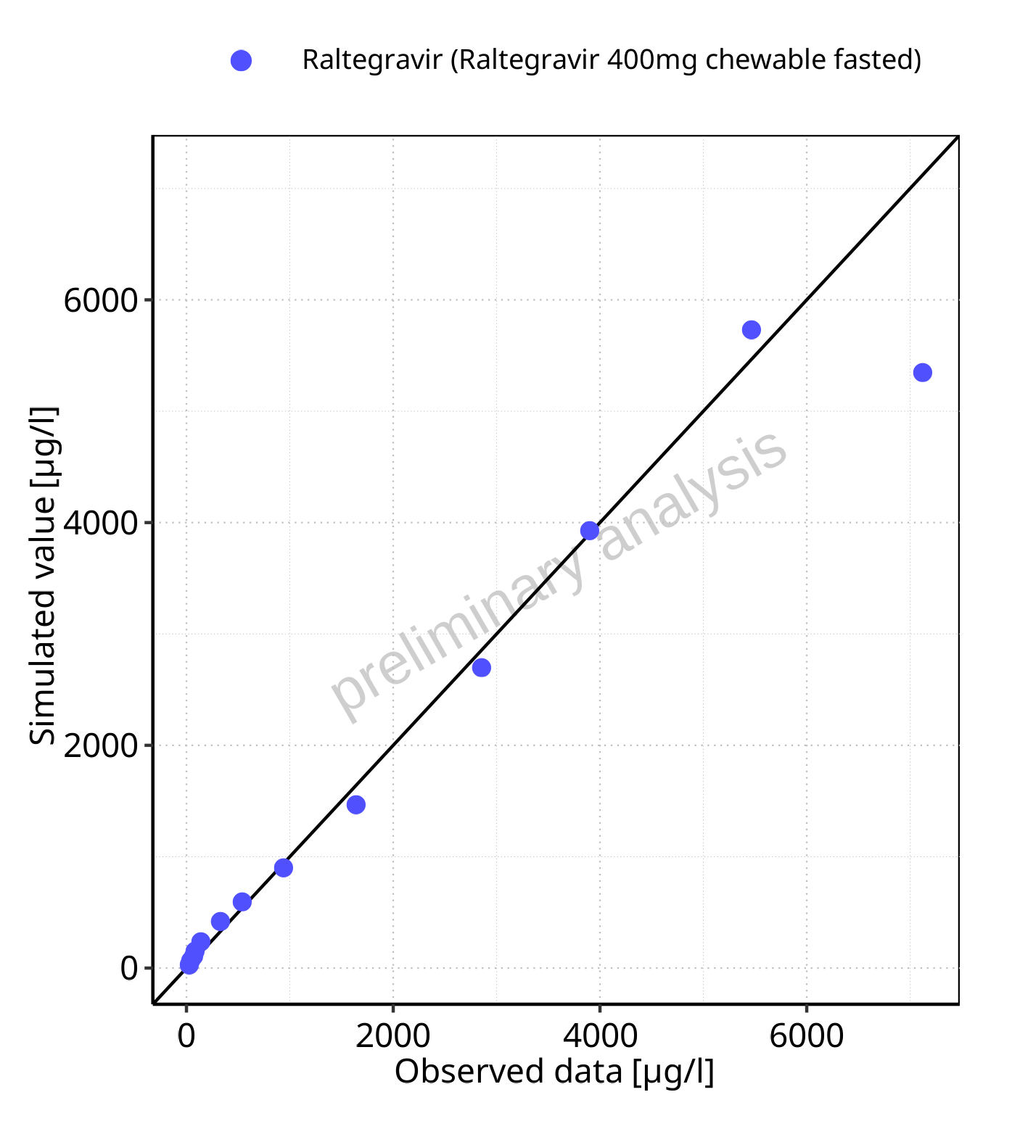

**Figure 5-137: Predicted vs observed for Raltegravir 400mg chewable fasted. Data source: Data/Raltegravir_PK.txt. Predictions and observations are plotted in a linear scale.**



**Figure 5-138: Predicted vs observed for Raltegravir 400mg chewable fasted. Data source: Data/Raltegravir_PK.txt. Predictions and observations are plotted in a logarithmic scale.**

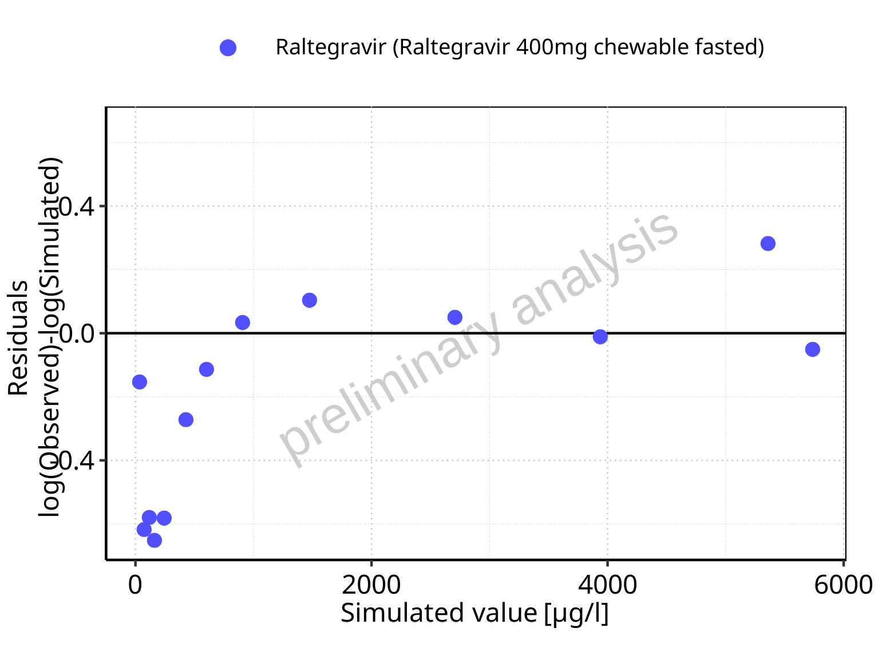

**Figure 5-139: Logarithmic residuals vs predicted values for Raltegravir 400mg chewable fasted. Data source: Data/Raltegravir_PK.txt.**

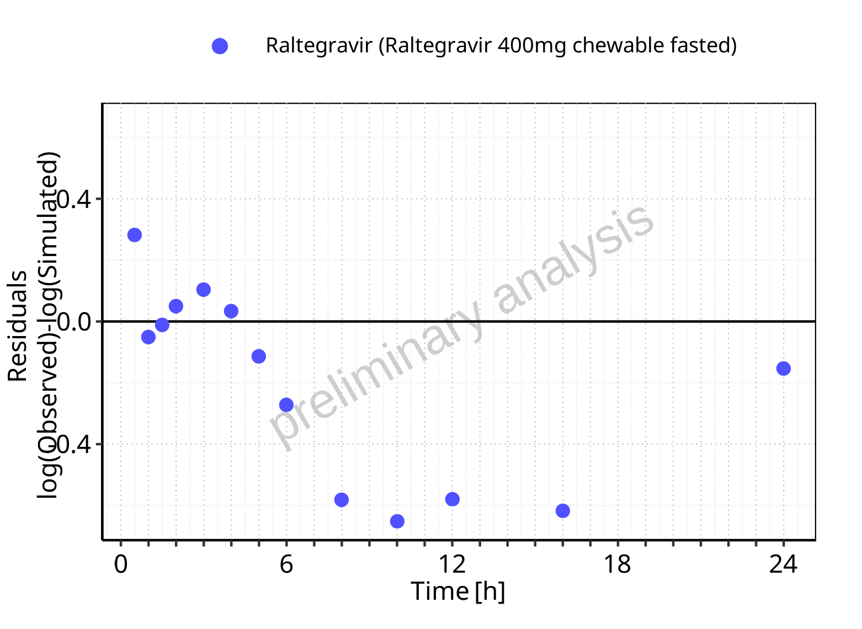

**Figure 5-140: Logarithmic residuals vs time values for Raltegravir 400mg chewable fasted. Data source: Data/Raltegravir_PK.txt.**

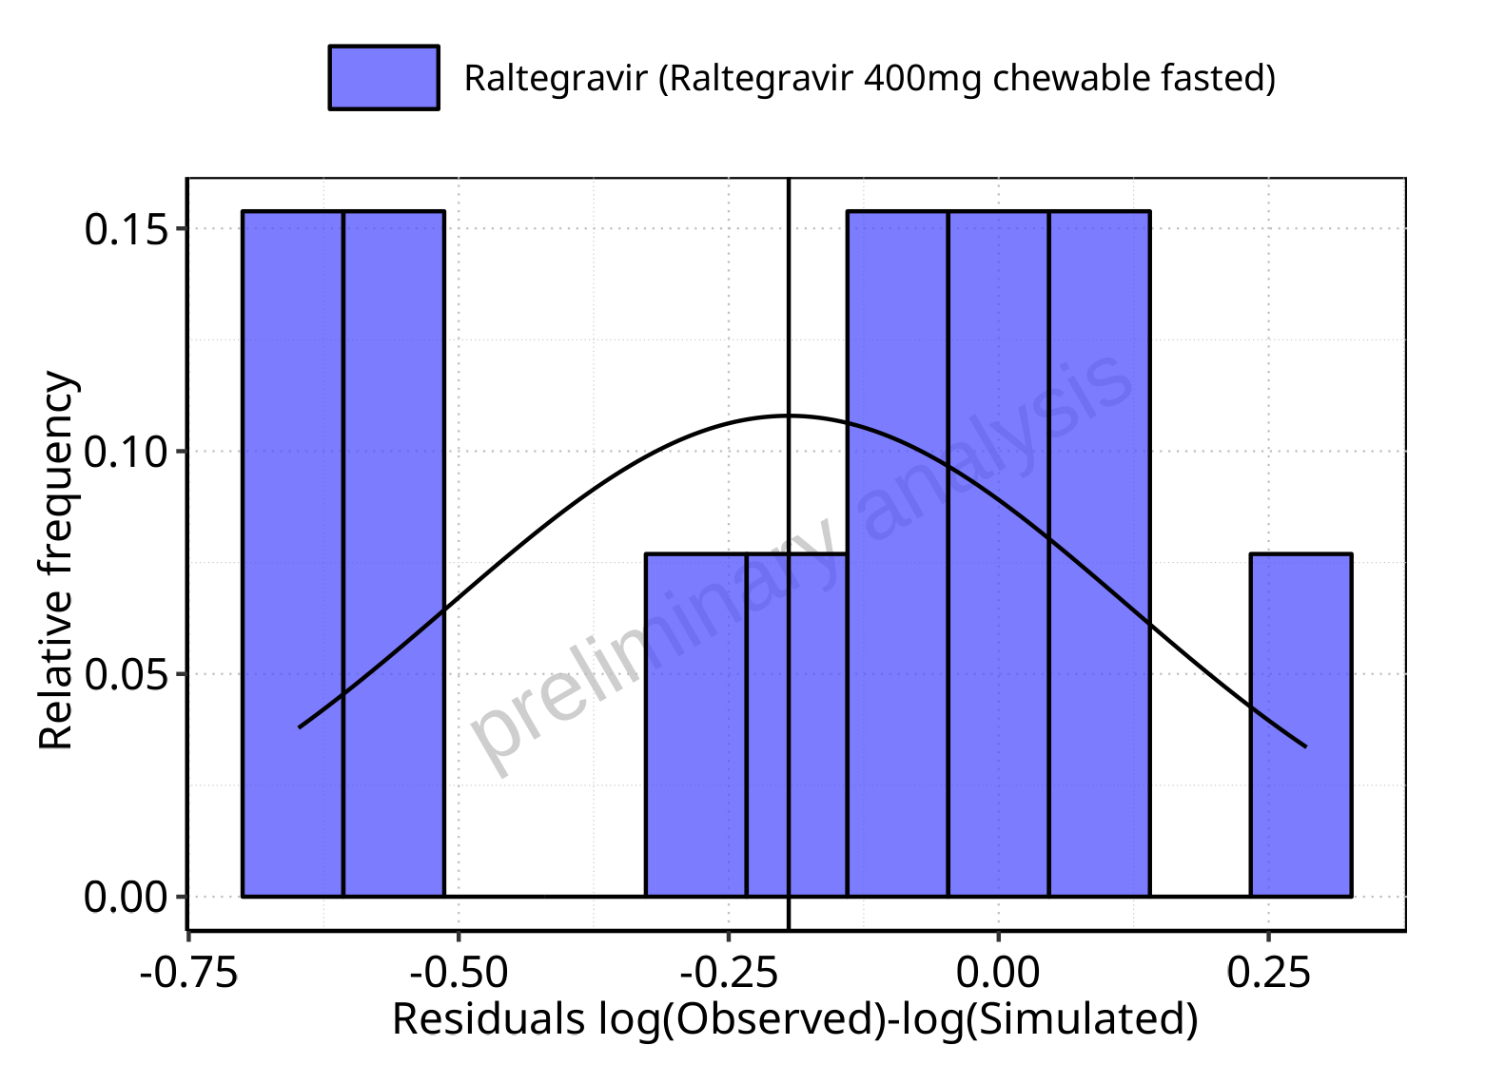

**Figure 5-141: Logarithmic residuals distribution (stacked) for Raltegravir 400mg chewable fasted. Data source: Data/Raltegravir_PK.txt.**

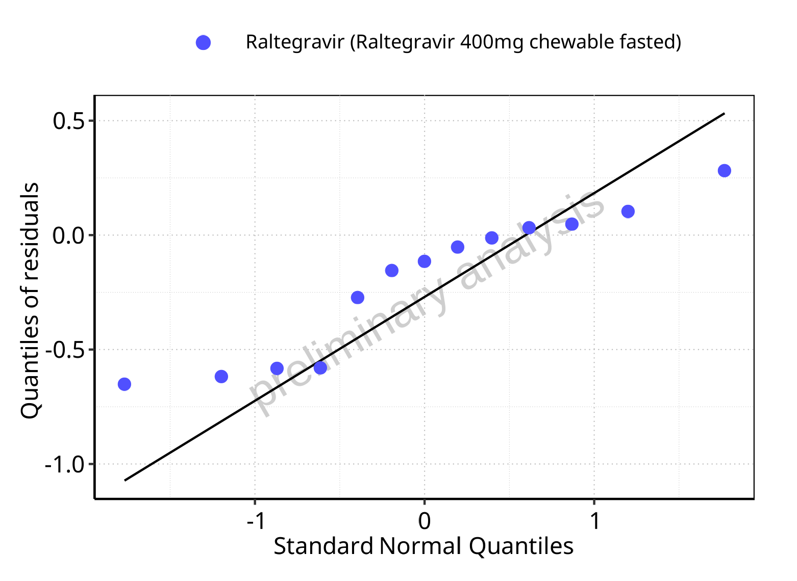

**Figure 5-142: Logarithmic residuals for Raltegravir 400mg chewable fasted as quantile-quantile plot. Data source: Data/Raltegravir_PK.txt.**

## Time profiles and residual plots for Raltegravir 400mg chewable fed

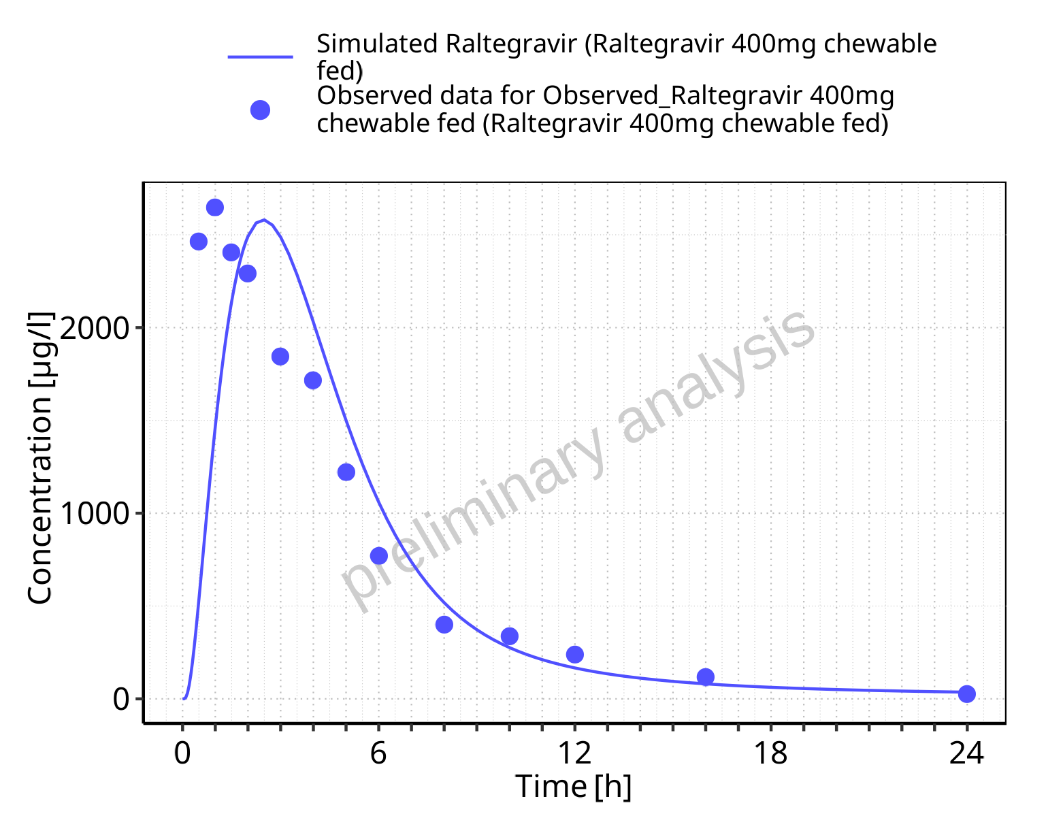

**Figure 5-143: Time profiles for Raltegravir 400mg chewable fed. Data source: Data/Raltegravir_PK.txt. Time profiles are plotted in a linear scale.**

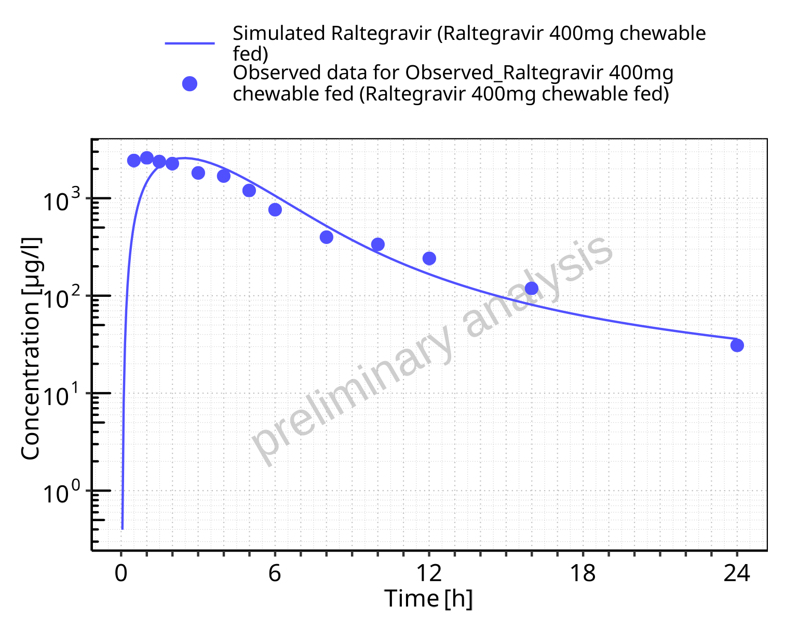

**Figure 5-144: Time profiles for Raltegravir 400mg chewable fed. Data source: Data/Raltegravir_PK.txt. Time profiles are plotted in a logarithmic scale.**

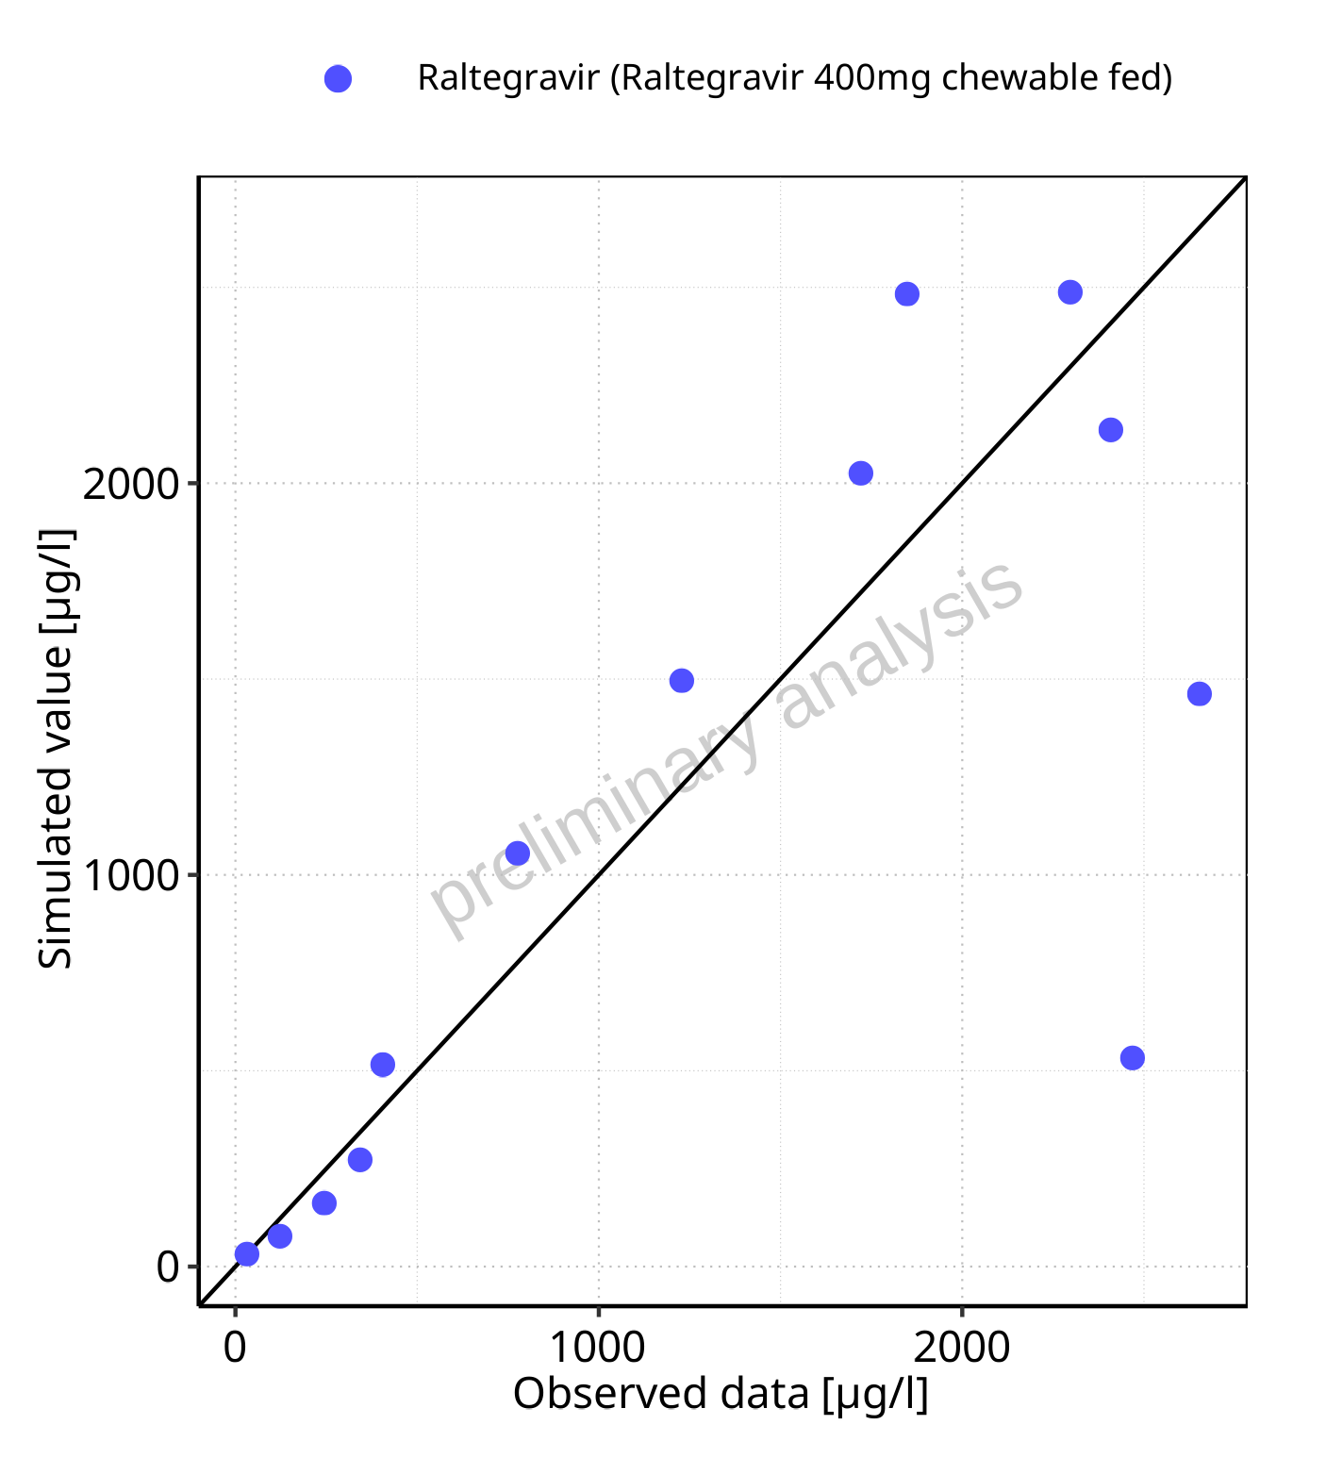

**Figure 5-145: Predicted vs observed for Raltegravir 400mg chewable fed. Data source: Data/Raltegravir_PK.txt. Predictions and observations are plotted in a linear scale.**



**Figure 5-146: Predicted vs observed for Raltegravir 400mg chewable fed. Data source: Data/Raltegravir_PK.txt. Predictions and observations are plotted in a logarithmic scale.**

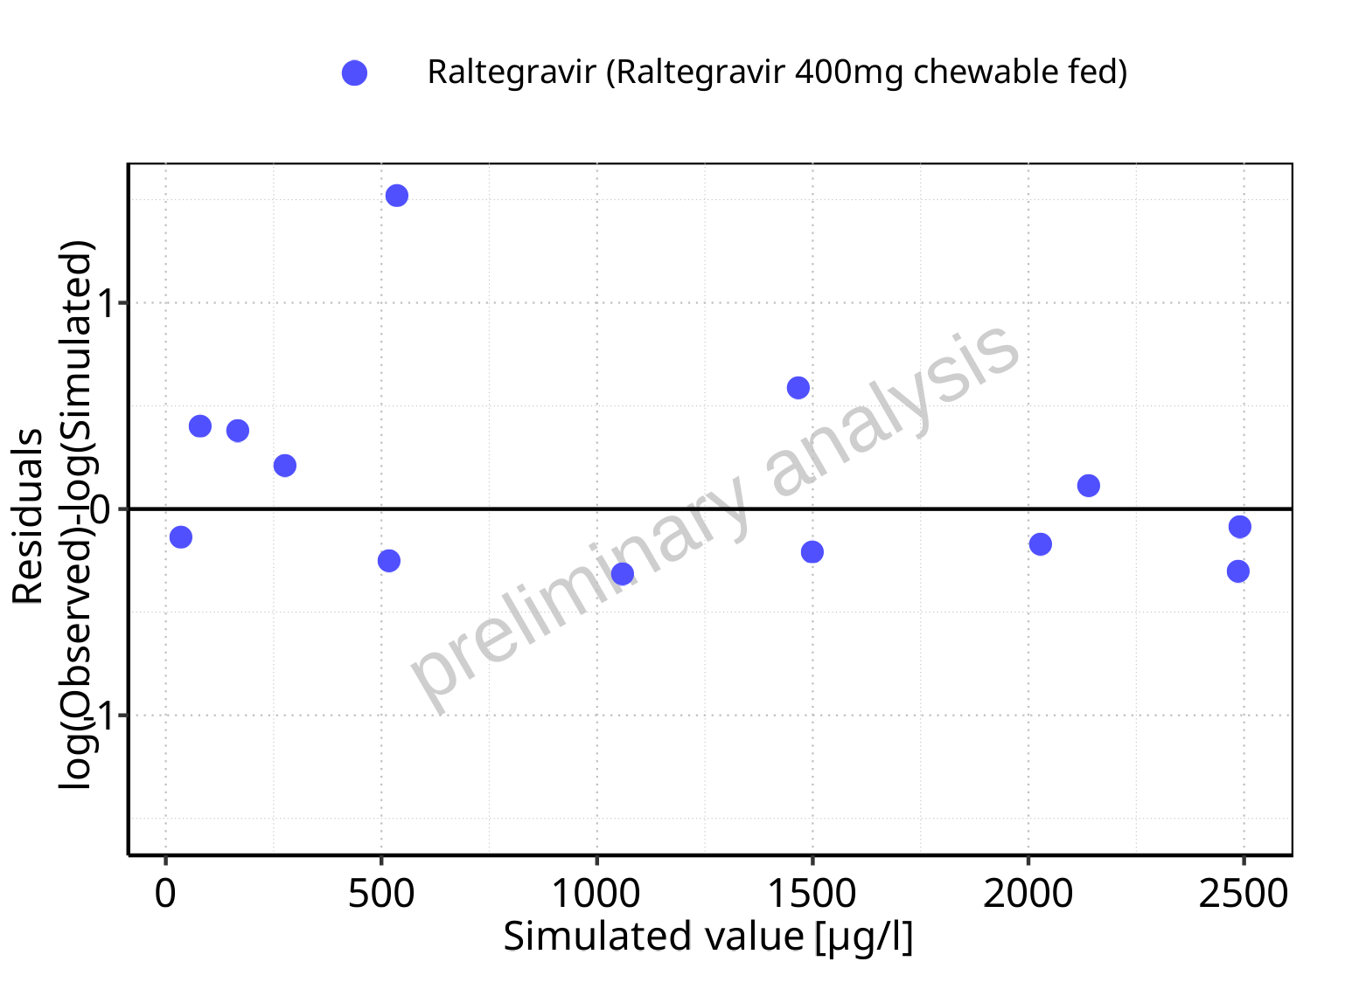

**Figure 5-147: Logarithmic residuals vs predicted values for Raltegravir 400mg chewable fed. Data source: Data/Raltegravir_PK.txt.**

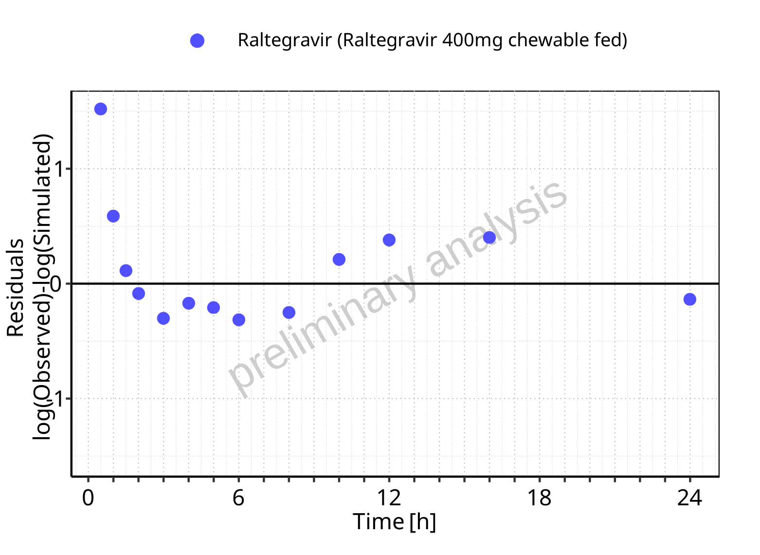

**Figure 5-148: Logarithmic residuals vs time values for Raltegravir 400mg chewable fed. Data source: Data/Raltegravir_PK.txt.**

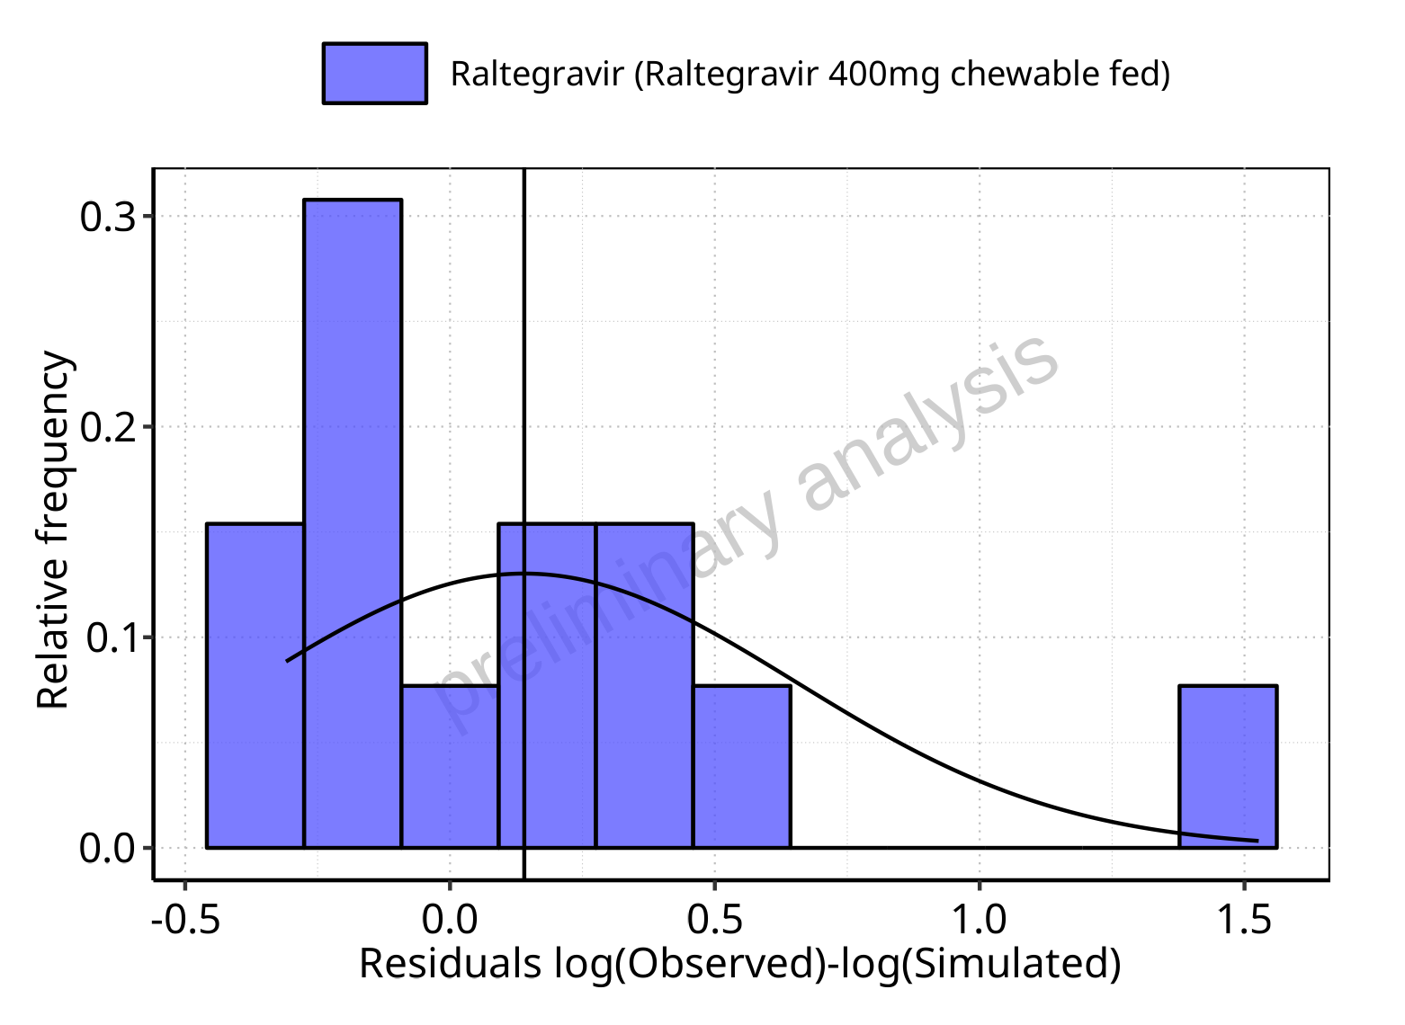

**Figure 5-149: Logarithmic residuals distribution (stacked) for Raltegravir 400mg chewable fed. Data source: Data/Raltegravir_PK.txt.**

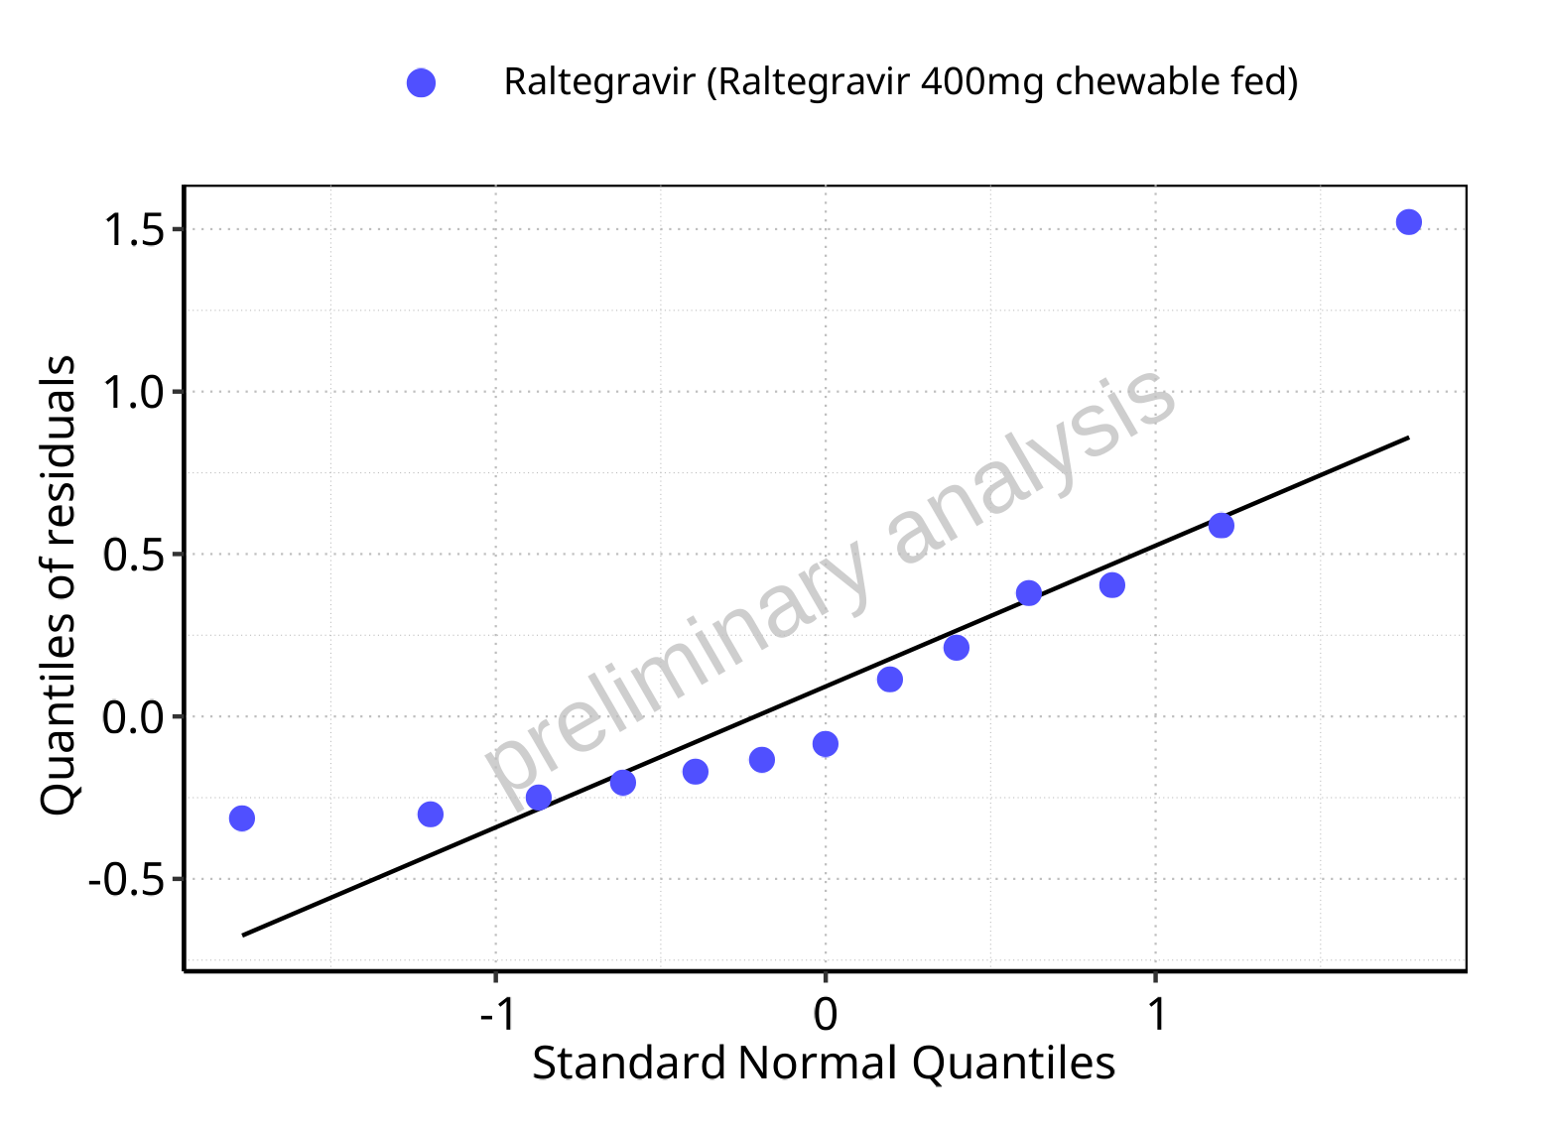

**Figure 5-150: Logarithmic residuals for Raltegravir 400mg chewable fed as quantile-quantile plot. Data source: Data/Raltegravir_PK.txt.**

## Time profiles and residual plots for Raltegravir 400mg (granules in suspension)

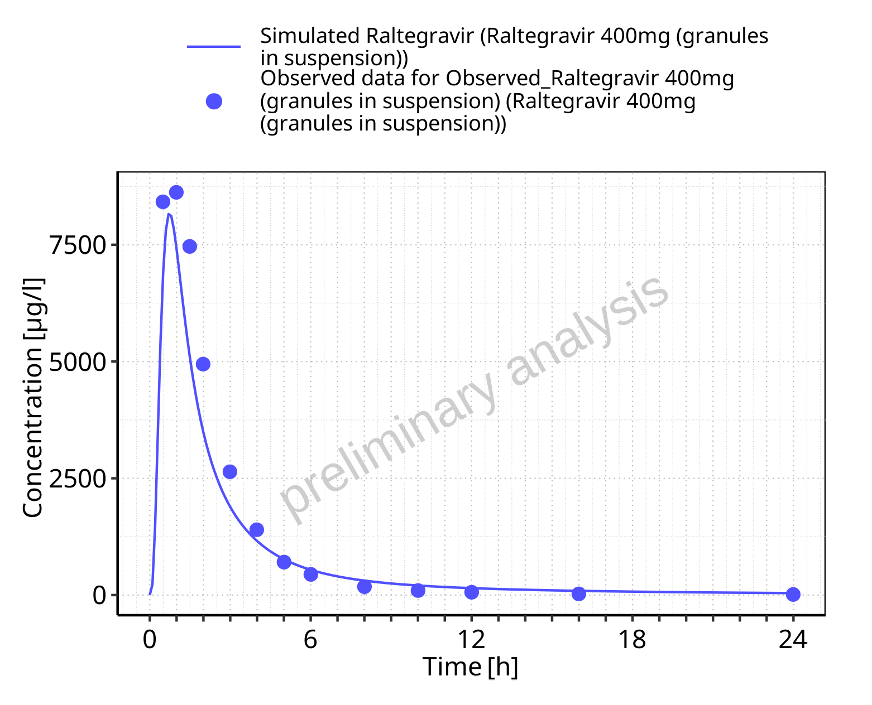

**Figure 5-151: Time profiles for Raltegravir 400mg (granules in suspension). Data source: Data/Raltegravir_PK.txt. Time profiles are plotted in a linear scale.**

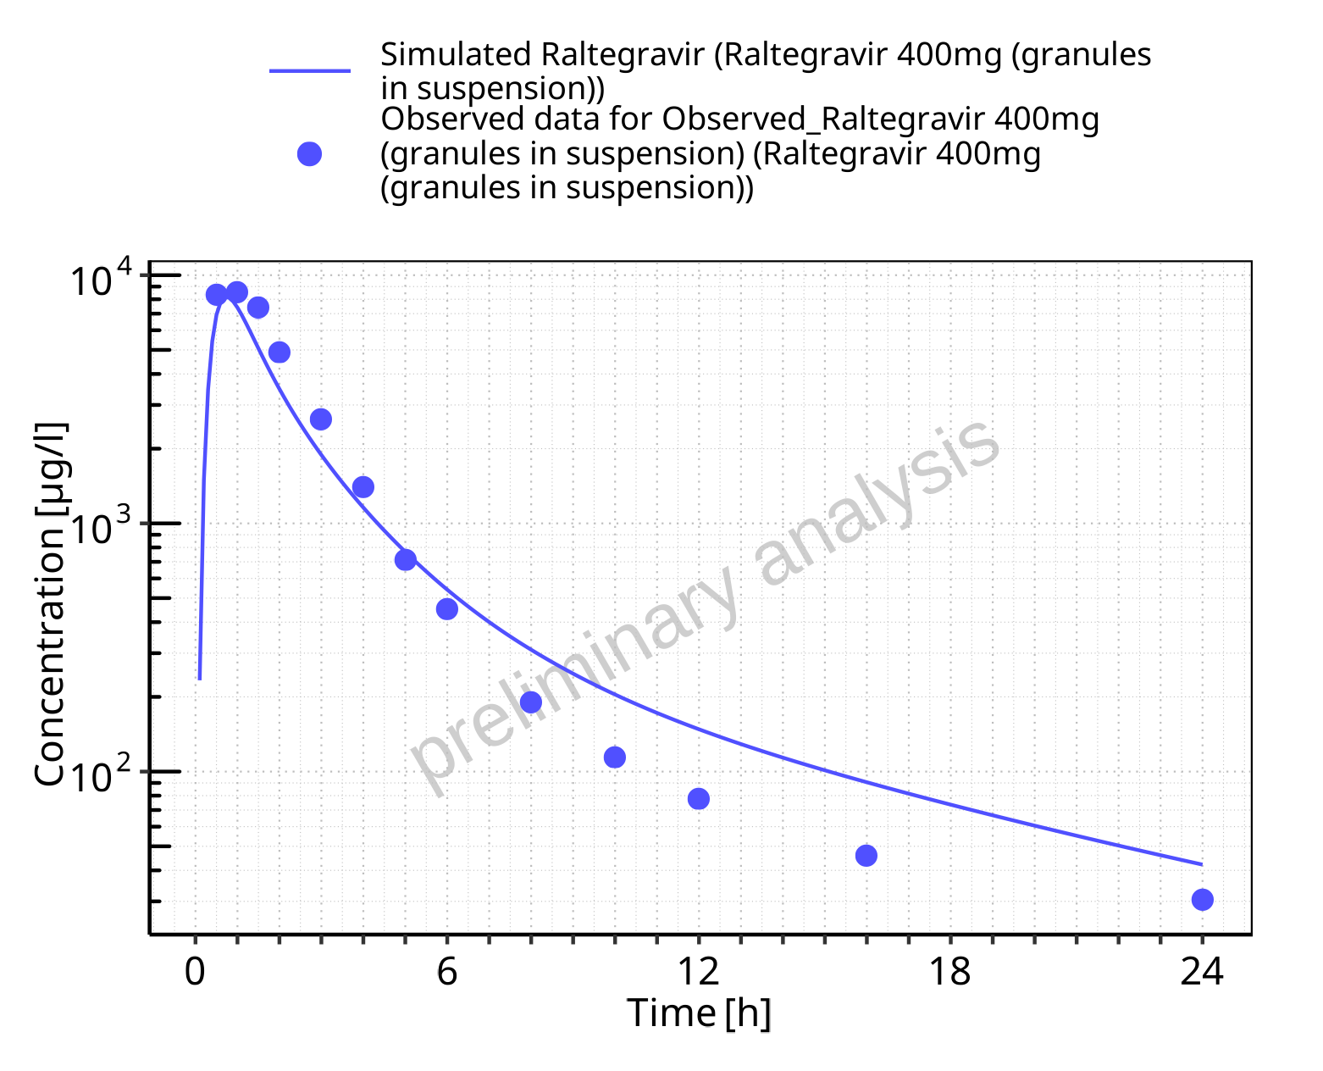

**Figure 5-152: Time profiles for Raltegravir 400mg (granules in suspension). Data source: Data/Raltegravir_PK.txt. Time profiles are plotted in a logarithmic scale.**

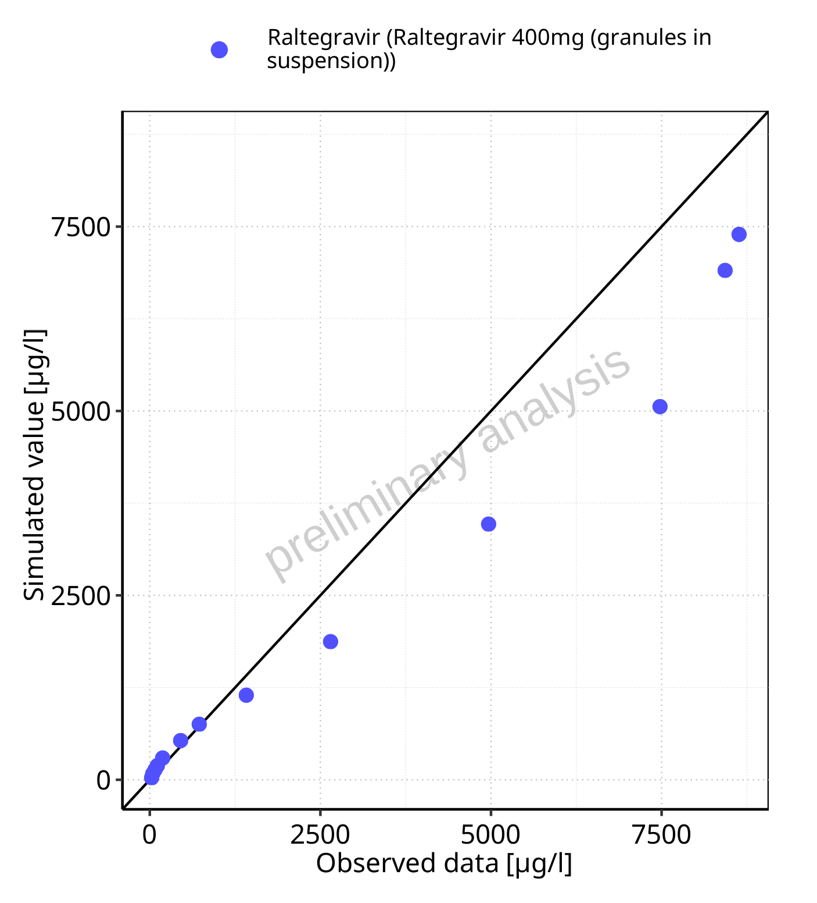

**Figure 5-153: Predicted vs observed for Raltegravir 400mg (granules in suspension). Data source: Data/Raltegravir_PK.txt. Predictions and observations are plotted in a linear scale.**



**Figure 5-154: Predicted vs observed for Raltegravir 400mg (granules in suspension). Data source: Data/Raltegravir_PK.txt. Predictions and observations are plotted in a logarithmic scale.**

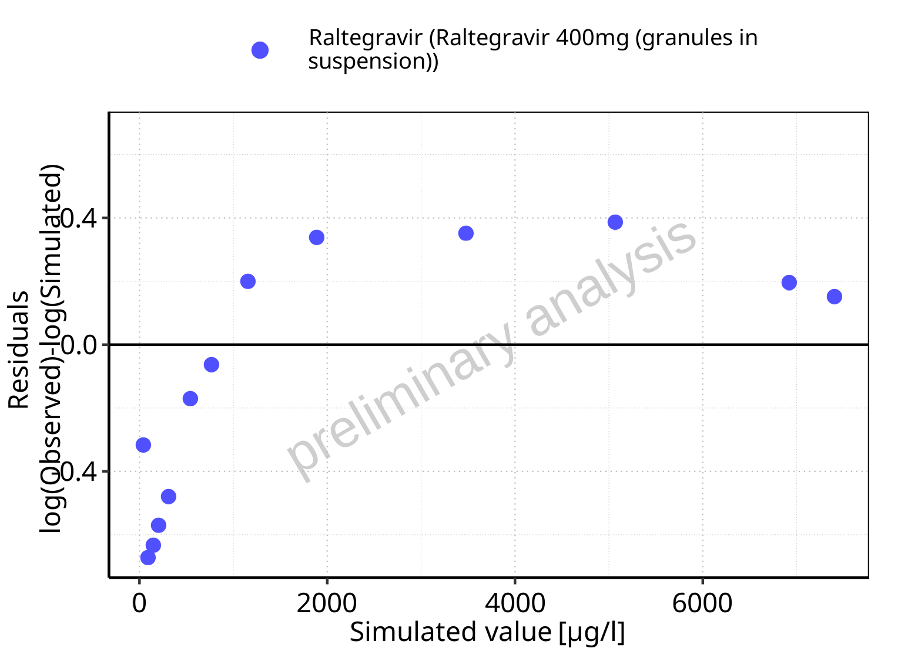

**Figure 5-155: Logarithmic residuals vs predicted values for Raltegravir 400mg (granules in suspension). Data source: Data/Raltegravir_PK.txt.**

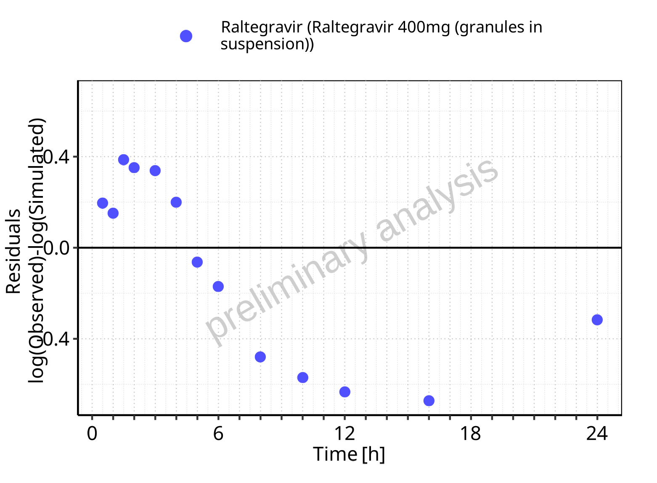

**Figure 5-156: Logarithmic residuals vs time values for Raltegravir 400mg (granules in suspension). Data source: Data/Raltegravir_PK.txt.**

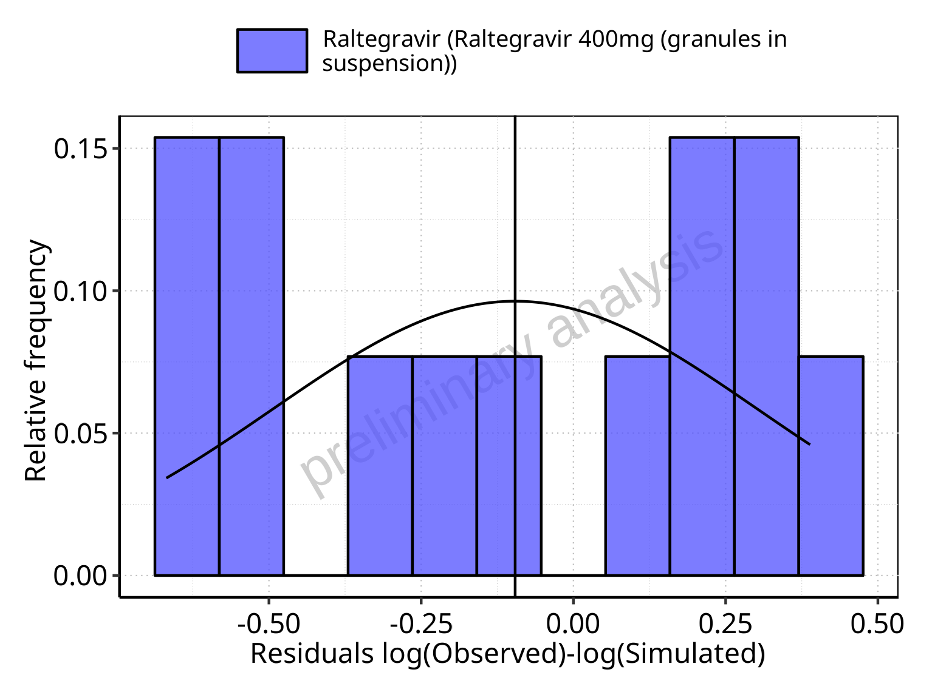

**Figure 5-157: Logarithmic residuals distribution (stacked) for Raltegravir 400mg (granules in suspension). Data source: Data/Raltegravir_PK.txt.**

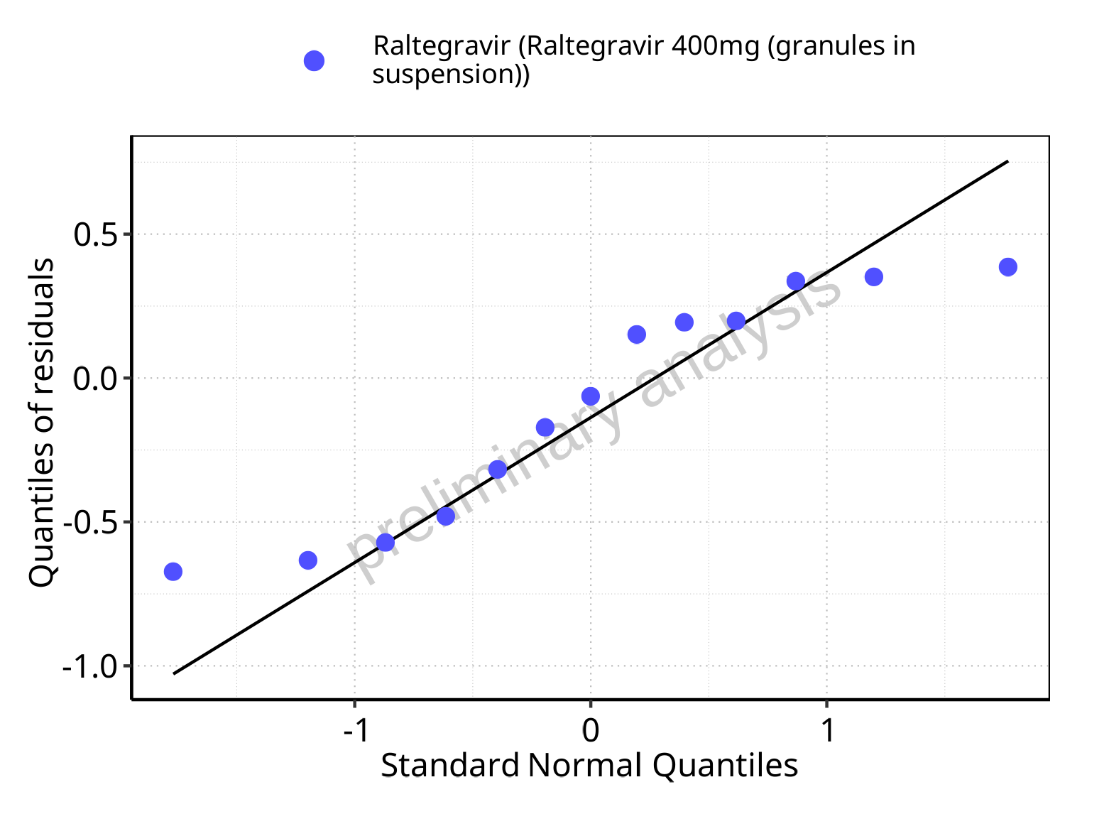

**Figure 5-158: Logarithmic residuals for Raltegravir 400mg (granules in suspension) as quantile-quantile plot. Data source: Data/Raltegravir_PK.txt.**

## Residuals across all simulations

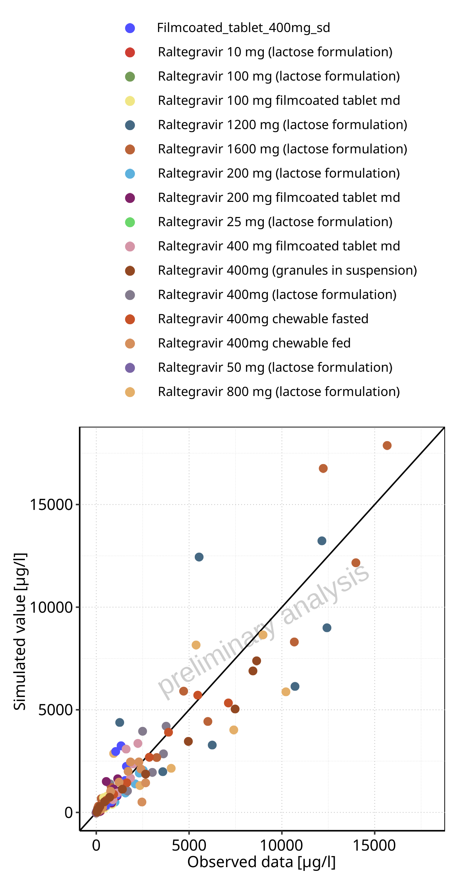

**Figure 5-159: Predicted vs observed for Raltegravir across Raltegravir 10 mg (lactose formulation), Raltegravir 25 mg (lactose formulation), Raltegravir 50 mg (lactose formulation), Raltegravir 100 mg (lactose formulation), Raltegravir 200 mg (lactose formulation), Raltegravir 400mg (lactose formulation), Raltegravir 800 mg (lactose formulation), Raltegravir 1200 mg (lactose formulation), Raltegravir 1600 mg (lactose formulation), Raltegravir 100 mg filmcoated tablet md, Raltegravir 200 mg filmcoated tablet md, Filmcoated_tablet_400mg_sd, Raltegravir 400 mg filmcoated tablet md, Raltegravir 400mg chewable fasted, Raltegravir 400mg chewable fed, Raltegravir 400mg (granules in suspension). Predictions and observations are plotted in a linear scale.**

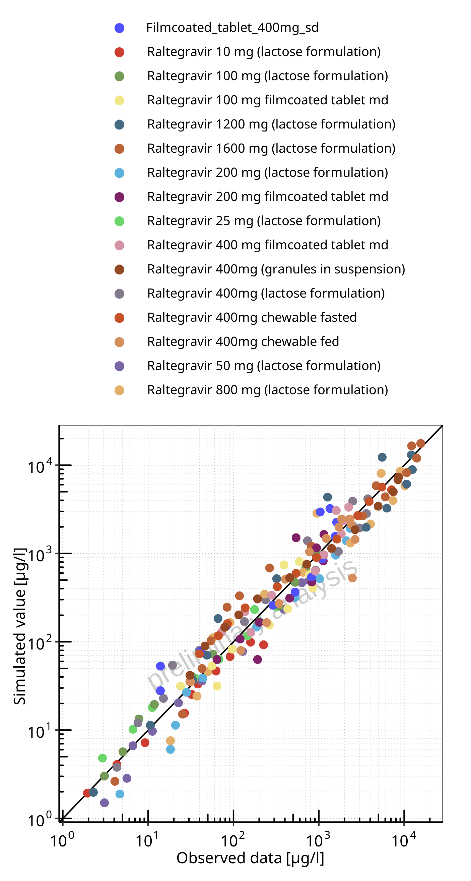

**Figure 5-160: Predicted vs observed for Raltegravir across Raltegravir 10 mg (lactose formulation), Raltegravir 25 mg (lactose formulation), Raltegravir 50 mg (lactose formulation), Raltegravir 100 mg (lactose formulation), Raltegravir 200 mg (lactose formulation), Raltegravir 400mg (lactose formulation), Raltegravir 800 mg (lactose formulation), Raltegravir 1200 mg (lactose formulation), Raltegravir 1600 mg (lactose formulation), Raltegravir 100 mg filmcoated tablet md, Raltegravir 200 mg filmcoated tablet md, Filmcoated_tablet_400mg_sd, Raltegravir 400 mg filmcoated tablet md, Raltegravir 400mg chewable fasted, Raltegravir 400mg chewable fed, Raltegravir 400mg (granules in suspension). Predictions and observations are plotted in a logarithmic scale.**

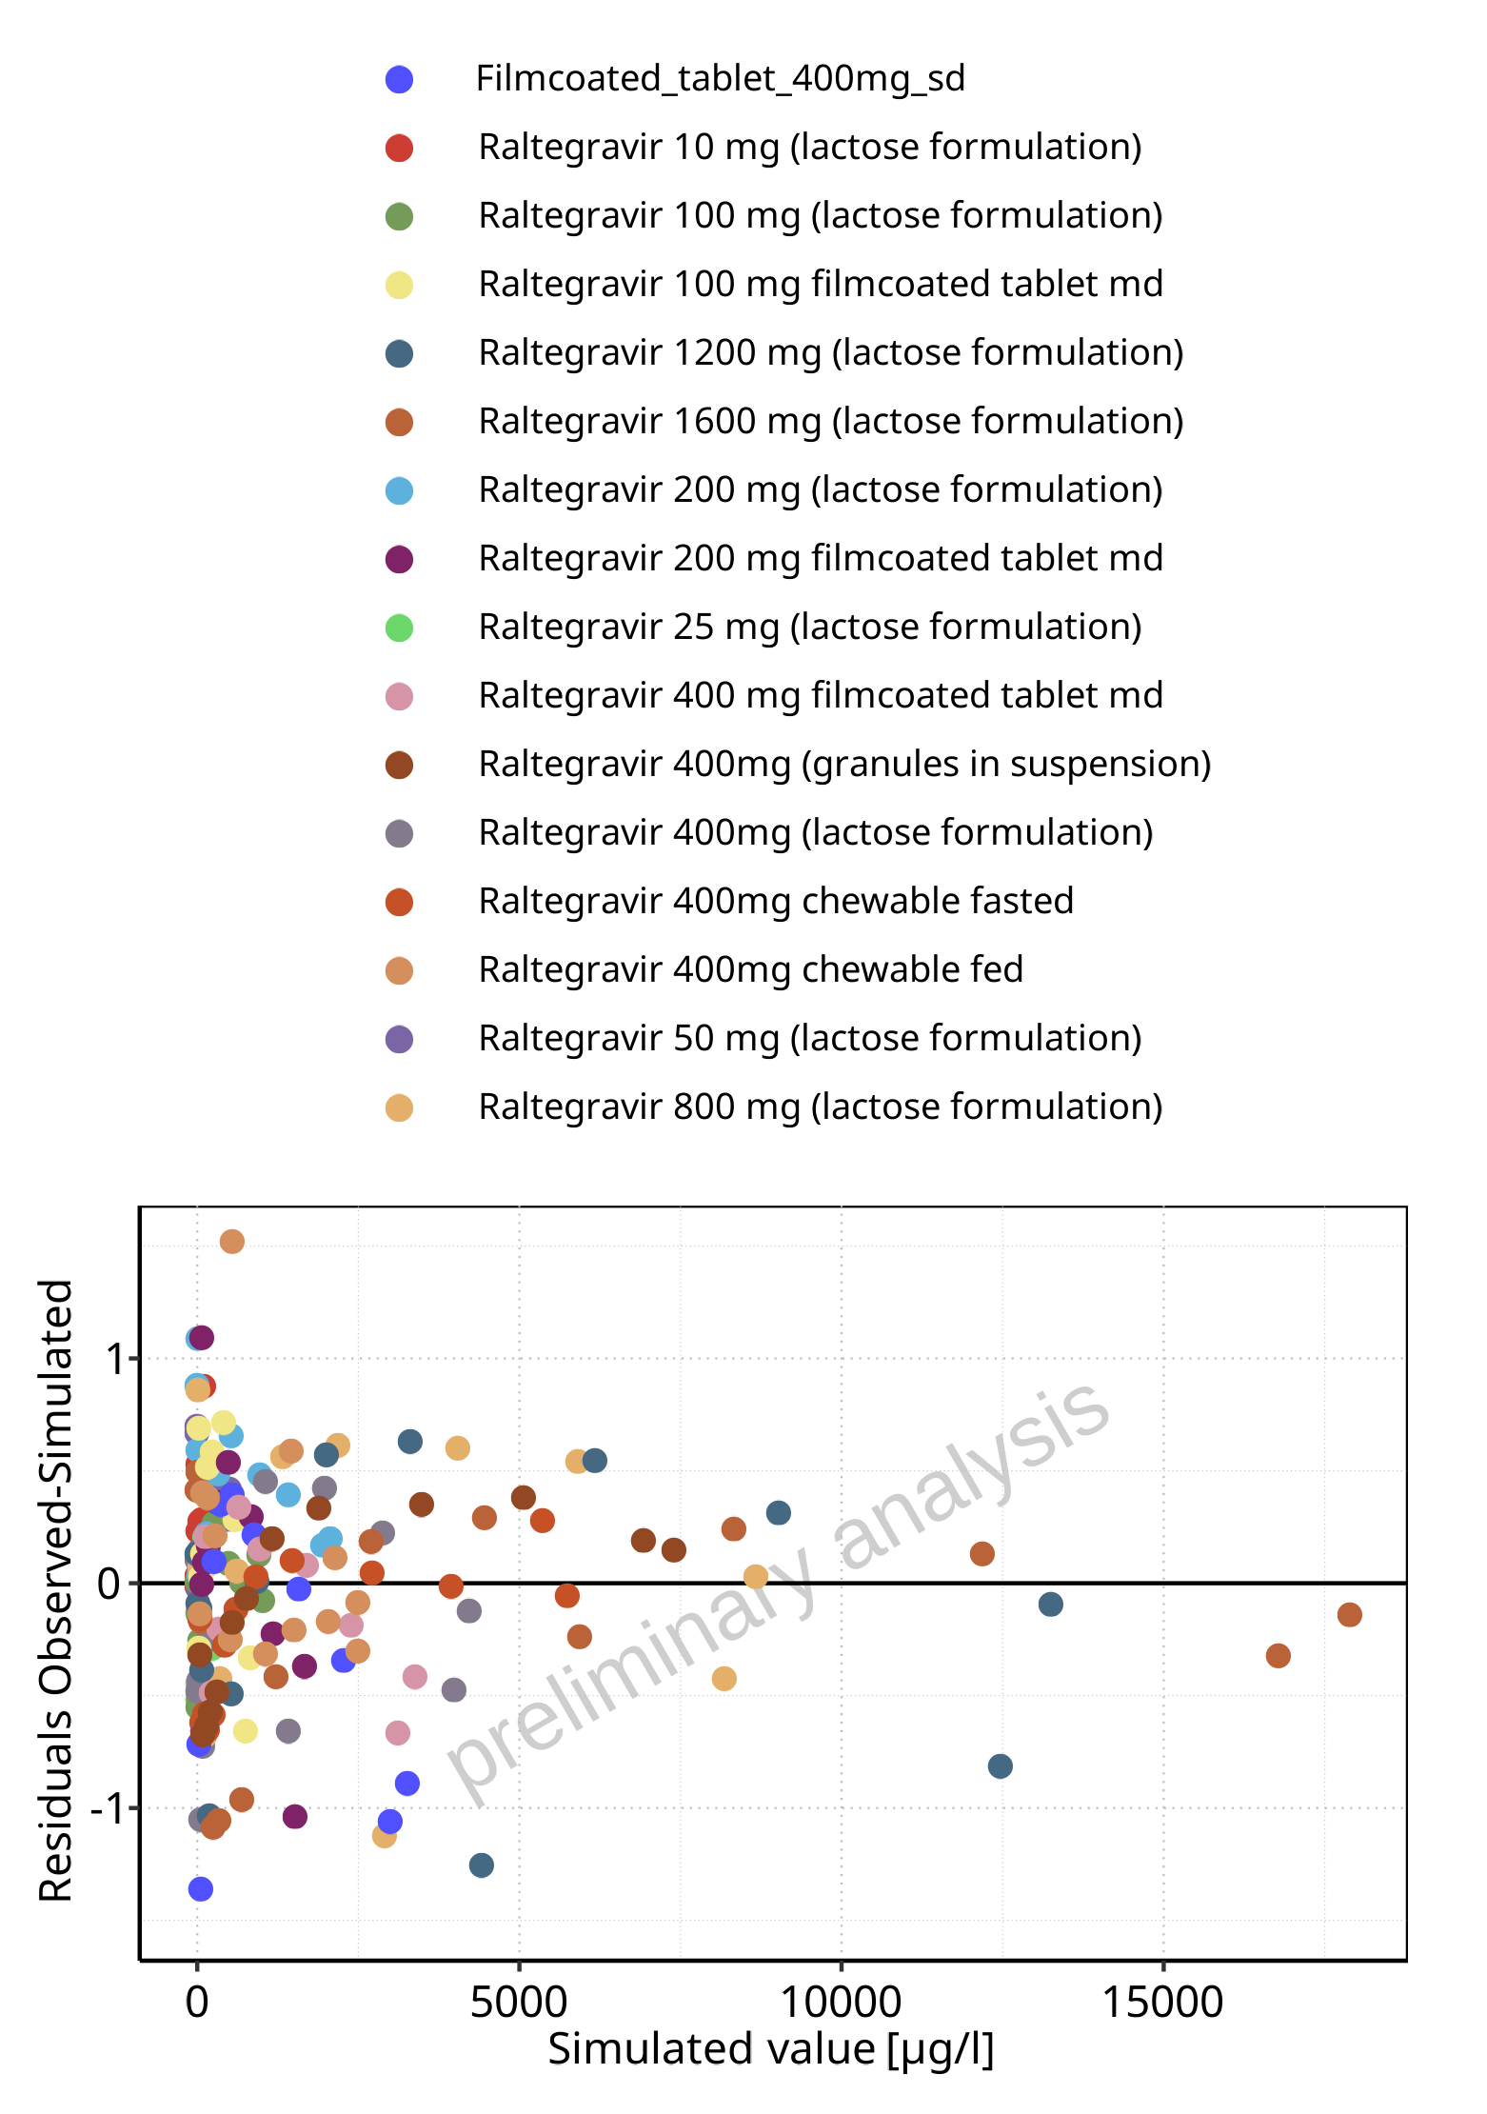

**Figure 5-161: Logarithmic residuals vs predicted values for Raltegravir across Raltegravir 10 mg (lactose formulation), Raltegravir 25 mg (lactose formulation), Raltegravir 50 mg (lactose formulation), Raltegravir 100 mg (lactose formulation), Raltegravir 200 mg (lactose formulation), Raltegravir 400mg (lactose formulation), Raltegravir 800 mg (lactose formulation), Raltegravir 1200 mg (lactose formulation), Raltegravir 1600 mg (lactose formulation), Raltegravir 100 mg filmcoated tablet md, Raltegravir 200 mg filmcoated tablet md, Filmcoated_tablet_400mg_sd, Raltegravir 400 mg filmcoated tablet md, Raltegravir 400mg chewable fasted, Raltegravir 400mg chewable fed, Raltegravir 400mg (granules in suspension).**

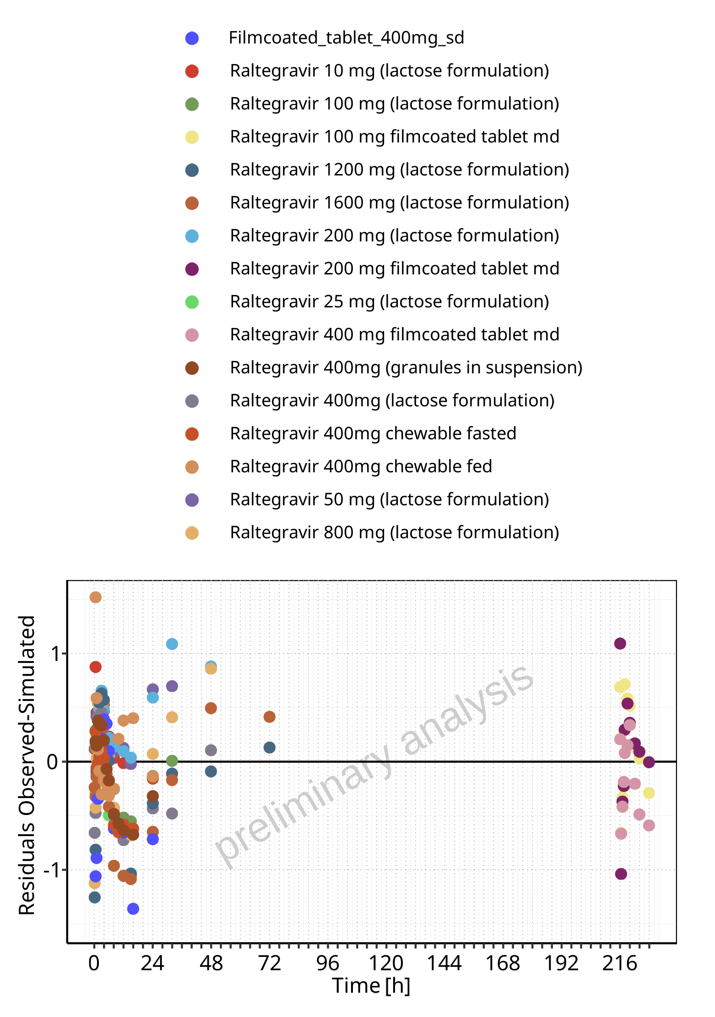

**Figure 5-162: Logarithmic residuals vs time values for Raltegravir across Raltegravir 10 mg (lactose formulation), Raltegravir 25 mg (lactose formulation), Raltegravir 50 mg (lactose formulation), Raltegravir 100 mg (lactose formulation), Raltegravir 200 mg (lactose formulation), Raltegravir 400mg (lactose formulation), Raltegravir 800 mg (lactose formulation), Raltegravir 1200 mg (lactose formulation), Raltegravir 1600 mg (lactose formulation), Raltegravir 100 mg filmcoated tablet md, Raltegravir 200 mg filmcoated tablet md, Filmcoated_tablet_400mg_sd, Raltegravir 400 mg filmcoated tablet md, Raltegravir 400mg chewable fasted, Raltegravir 400mg chewable fed, Raltegravir 400mg (granules in suspension).**

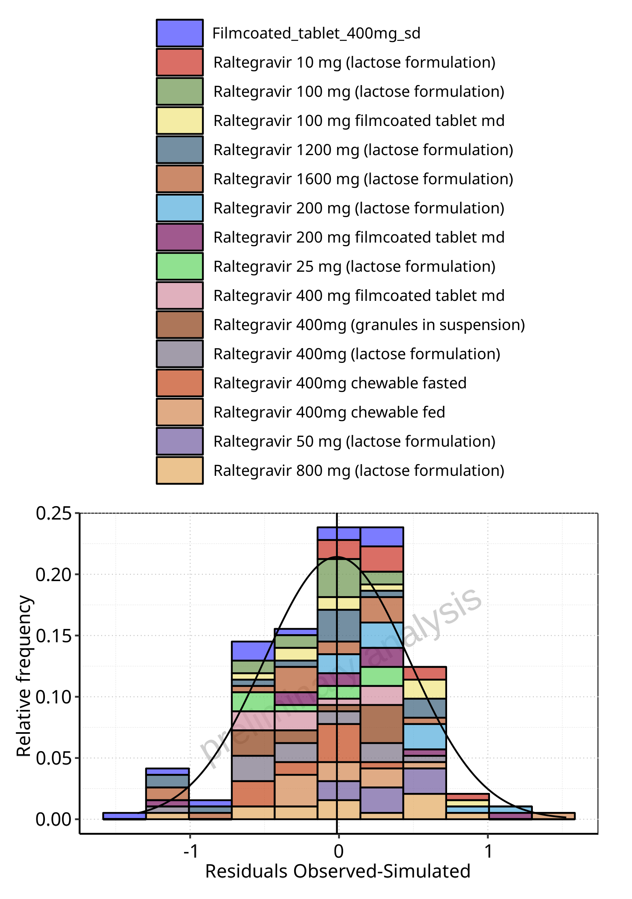

**Figure 5-163: Logarithmic residuals distribution (stacked) for Raltegravir across Raltegravir 10 mg (lactose formulation), Raltegravir 25 mg (lactose formulation), Raltegravir 50 mg (lactose formulation), Raltegravir 100 mg (lactose formulation), Raltegravir 200 mg (lactose formulation), Raltegravir 400mg (lactose formulation), Raltegravir 800 mg (lactose formulation), Raltegravir 1200 mg (lactose formulation), Raltegravir 1600 mg (lactose formulation), Raltegravir 100 mg filmcoated tablet md, Raltegravir 200 mg filmcoated tablet md, Filmcoated_tablet_400mg_sd, Raltegravir 400 mg filmcoated tablet md, Raltegravir 400mg chewable fasted, Raltegravir 400mg chewable fed, Raltegravir 400mg (granules in suspension).**

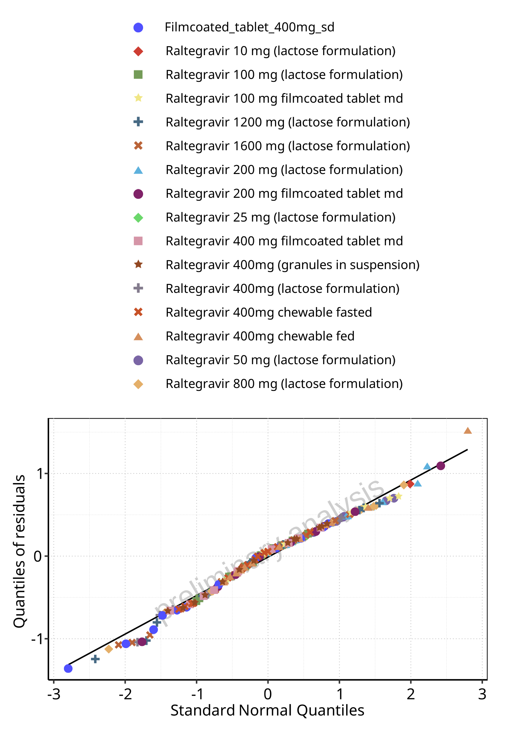

**Figure 5-164: Logarithmic residuals for Raltegravir across Raltegravir 10 mg (lactose formulation), Raltegravir 25 mg (lactose formulation), Raltegravir 50 mg (lactose formulation), Raltegravir 100 mg (lactose formulation), Raltegravir 200 mg (lactose formulation), Raltegravir 400mg (lactose formulation), Raltegravir 800 mg (lactose formulation), Raltegravir 1200 mg (lactose formulation), Raltegravir 1600 mg (lactose formulation), Raltegravir 100 mg filmcoated tablet md, Raltegravir 200 mg filmcoated tablet md, Filmcoated_tablet_400mg_sd, Raltegravir 400 mg filmcoated tablet md, Raltegravir 400mg chewable fasted, Raltegravir 400mg chewable fed, Raltegravir 400mg (granules in suspension) as quantile-quantile plot.**